
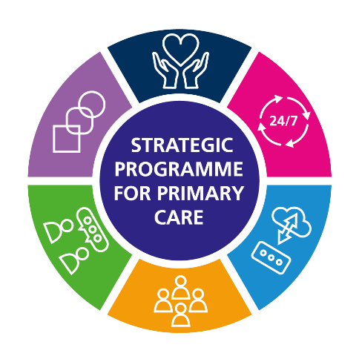
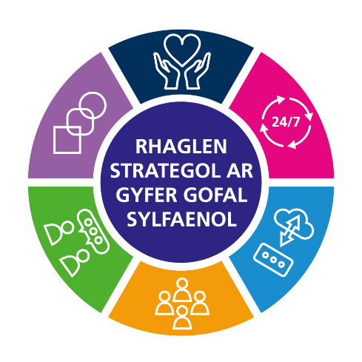

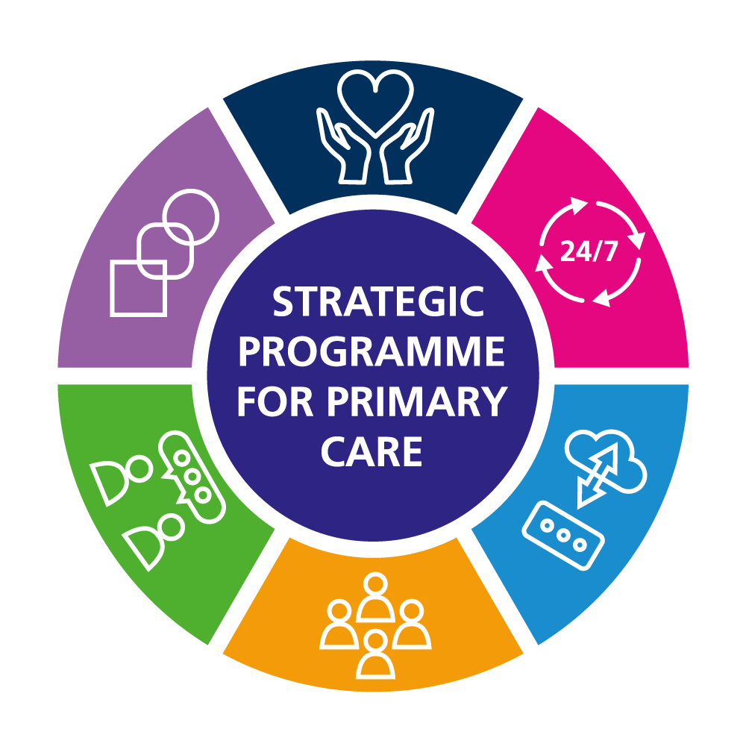
SPPC Mid-year report
1 April 2024 – 30 September 2024
An All-Wales Health Board-led programme that works in collaboration with Welsh Government and responds to A Healthier Wales.

Executive Summary
Sue Morgan, National Director for Primary Care

This report provides an overview of progress of the Strategic Programme for Primary Care from 1 April to 30 September 2024, and a look ahead of the programme of work until the 31 March 2025. The report highlights some key products that have been delivered in collaboration with other partners, for example the Strategic Workforce Plan for Primary Care and Primary and Community Care Compendium in collaboration with Health Education and Improvement Wales (HEIW). A key area of work commenced has been the challenge of the Primary Care Model for Wales, whether the model is still the right one and understanding the barriers to implementation. We have welcomed the challenge and the level of interest from those in and beyond primary care in this work. The Community Infrastructure programme continues to deliver at pace, an important component of whole system resilience going forward. It is good to see the progress being made to ensure that primary and community care is key to whole system planning and in wider performance and escalation discussions.

The Strategic Programme for Primary Care team transferred into the NHS Executive on 1st April 2024 to work alongside the other National Programmes and NHS Executive Directorates to discharge the duties and functions of the NHS Executive.
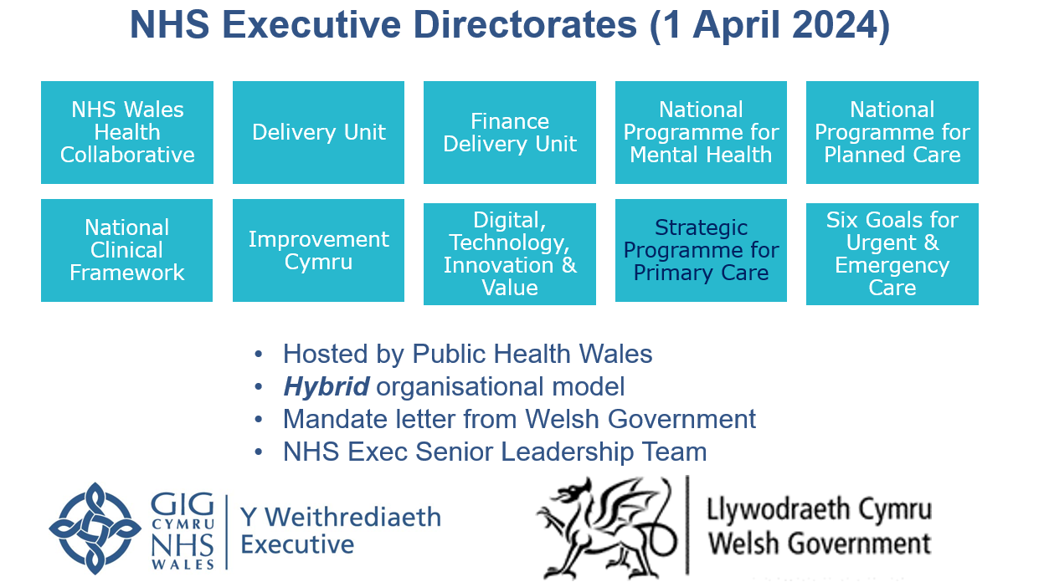

Within the NHS Executive Remit letter there are two expectations that have been assigned to the National Director and Strategic Programme Lead for Primary to coordinated delivery through the Strategic Programme for Primary Care:
- Number 3: Primary and Community Care - Demonstrate a focus on improving access and shifting resources into primary and community care.
- Number 5: Enhanced Care in the Community - reduce delays for patients, enhance community care, improve care closer to home and support the transfer of resources into primary and community care.

I would like to take this opportunity to thank all those that have supported the work over the last six months, both within primary care and the partners we’ve worked with and look forward to working with you to continue the progress already made.

Work Delivered

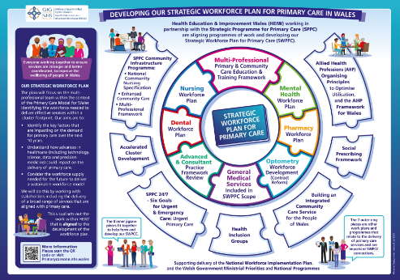
Strategic Workforce Plan for Primary Care in Wales –Formally launched 15 May 2024 at the HEIW Primary and Community Care Education and Training Conference in Cardiff.

The Strategic Programme for Primary Care and HEIW jointly developed the Strategic Workforce Plan for Primary Care, in collaboration with a wide range of stakeholders, to support the full implementation of the Primary Care Model for Wales (PCMW), and the actions set out in A Healthier Wales. The plan aligns with the themes in the Health and Social Care Workforce Strategy.

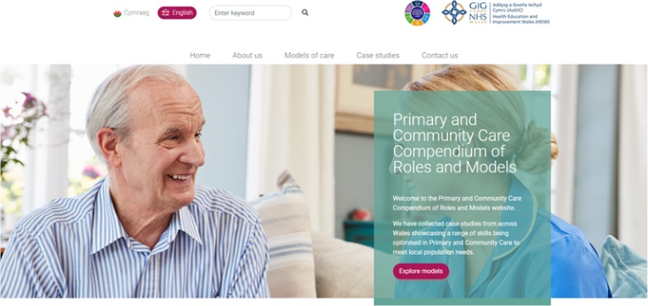
Primary and Community Care Compendium – working with HEIW the Primary Community Care Compendium was formally launched 15 May 2024 at the HEIW Primary and Community Care Education and Training Conference.

This website is a once for Wales platform for the sharing of innovative and unique models of primary and community care provision. It has been produced on behalf of the Workforce and Organisational Development workstream of the Strategic Programme for Primary Care in collaboration with HEIW. The intention is for website to be used to share good practice by reviewing tried and tested examples before the commissioning of new services to meet local population needs.

Primary Care Model for Wales Challenge Summary of Cluster Peer Review, Self-Reflection and PCMW Workshops
Cluster peer review (Annex 1) and cluster self-reflection (Annex 2) are agreed methods to evaluate the progress of cluster working to support implementation of the Primary Care Model for Wales. These papers, published in August, describes the main findings from these two evaluative processes, plus the insight gathered from two PCMW workshops (Annex 3), which explored whether the PCMW was fit for purpose in 2024, why implementation had been patchy and how more consistent progress could be made with specific actions from Welsh Government (WG), NHS Executive, Health Boards and Regional Partnership Boards (RPB).The findings have been triangulated in this report, to provide a summary of the progress of cluster working towards the PCMW, highlighting the elements that are working well and the great work being undertaken by those working within or with clusters, the elements that require strengthening and some suggested areas for collective action.

Accelerated Cluster Development: Cluster Leadership Programme Following the successful delivery of Cohort one, a second Confident Leader cohort for Cluster and Collaborative Leads was commissioned for delivery between June 2024 and October 2024. Building on the feedback from Cohort one, the course has been refined and participation expanded to include Professional Collaborative Leads as well as Cluster Leads.


Primary Care Governance: Clinical Governance Practice Self-Assessment Tool (CGPSAT) Formally launched 1 May 2024. This replaced the previous CGPSAT and is hosted in the same location as its predecessor, under the ‘Tools’ tab on the Primary Care One website. The tool has been redesigned to reflect The Duty of Quality Statutory Guidance 2023 and Health and Care Quality Standards 2023.

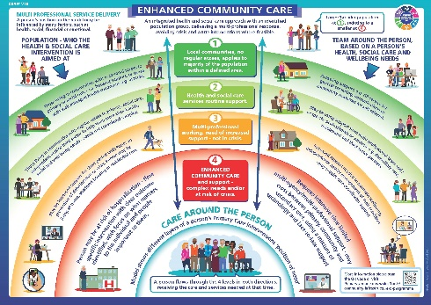
Enhanced Community Care (ECC) – This work provides the Once for Wales agreed definition, core standards, underpinning quality statements and evaluation framework which includes a set of measures and outcomes. This sets out how services can deliver high-quality evidence-based person-centred care to people requiring enhanced community care. This enables services to demonstrate the value and effectiveness of their ECC model of care in a consistent way across Wales. ECC continues to be a priority area with regular reporting into the Care Action Committee.

Primary Care and Community Nursing Framework although published in February the actions generated through this collaborative piece of work is a priority area for delivery this year. The Primary Care and Community Nursing Framework was developed via engagement with 500 nurses and stakeholders across Wales, and outlines how they will contribute to achieving the ambitions of A Healthier Wales and the Primary Care Model for Wales. The framework provides a vision for primary care and community nursing services that focuses on the person, what matters to them and how they are enabled to live well and take ownership of their health and well-being needs at all stages of their life. . This has led to the development of eight themes each with a set of actions, which reflect and align to the CNO’s five priorities for Nursing (2022), The Duty of Quality (2023), Health and Care Quality Standards (2023) and requirements outlined in the National Community Nursing Specification (2022), placing the person, provision of high quality safe care and improved outcomes for the population, at the frameworks center. In total 47 actions were identified, 18 of which are considered a priority for the next 18 months.

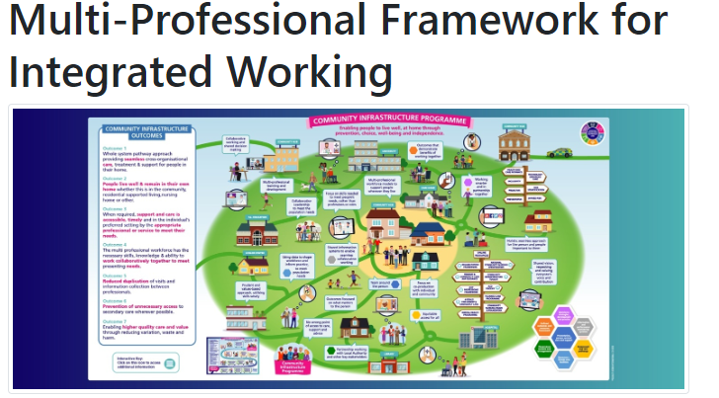
Multi-professional Framework for Integrated Working (MPF) - launched with a ‘Once for Wales’ agreed definition, core standards with underpinning quality statements and now updated with an electronic, interactive version of the evaluation tool. The purpose of the framework is to provide an evidence-based approach for community services to deliver a multi-professional model of integrated assessment and support, providing person centred, effective, and seamless care. This is essential to realising the ambition of place-based health and care, in Wales, enabling people to live well, closer to home.


Greener Primary Care Wales Framework and Award Scheme – the Green Primary Care team have won two prestigious Welsh awards this year – An NHS Sustainability Healthier Wales Award for the Framework and Award scheme (June) and a Welsh Pharmacy award in September for the work on inhaler prescribing in Wales in collaboration with AWTTC. The team have also had a long read case study published in the Alliance for Transformative Action on Climate and Health (ATACH), World Health Organisation and has a spotlight feature to explain the impact of the award scheme in the Welsh NHS Confederation Climate Good Practice briefing.

Reducing Health Inequalities through Primary Care programme of work has been established in the Primary Care Division, Public Health Wales to provide insight, resources and evidence informed action that can be undertaken at practice, cluster and pan-cluster level to mitigate and reduce inequalities in primary care across Wales. Resources on the webpages here.

Mid-year SPPC work delivered
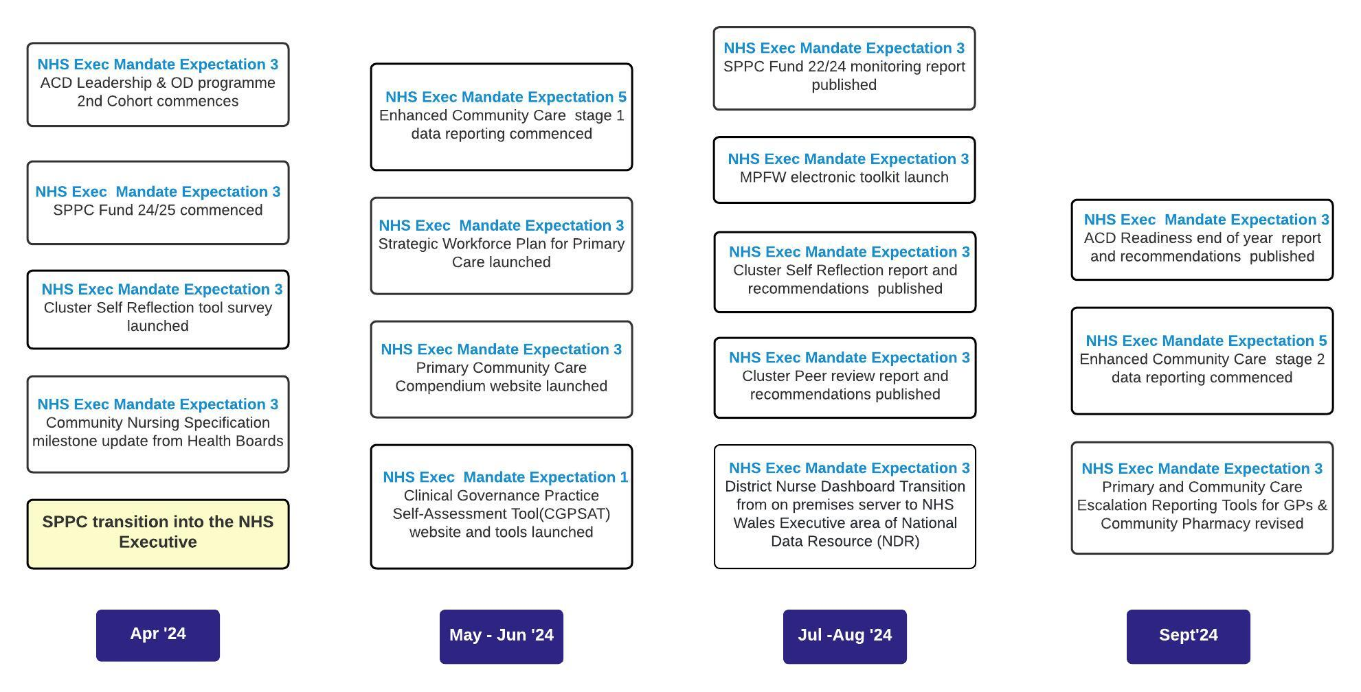

Work in Progress / Look Forward

The over-arching context to the work of the SPPC going forward is the work on embedding the Primary Care Model for Wales in order to build buildia robust placed based, population health focussed, community service offer. An action plan support this which is sponsored by the lead Chief Executive for Primary Care, WG Director of Primary Care, Mental Health & Early Years and the National Director.

Early areas of work include:
- targeted action to improve GMS access
- Building resilience in community services (ECC and Community Nursing specifically)
- Developing the requirements that underpin the implementation of the Primary Care Model for Wales
Other areas of ongoing work via the workstreams are:

PC Contractor Performance Concerns SOP Initial draft of the unified process delivered to the task and finish group for further development. Due to be delivered in Q3

Healthy Days at Home Wales Next steps Plan on a Page was drafted to outline actions required to deliver HDAHW into business-as-usual. An initial audit was undertaken to understand the current status of each dashboard as a benchmark to measure progress against.

GMS Demand and Capacity Tool Plan on a Page was revised, and Project Steering Group and Clinical Reference Group established. 2024-25 priorities reviewed and emerging themes considered. Hywel Dda Pathfinder Pilot established to deliver proof-of-concept model.

Additional Work from the SPPC

Full list of SPPC products released April-September 2024 with links:

Product Name | Release Date
Directory of Education and Training in Inclusion Health for Health Professionals - Primary Care One (nhs.wales) | April 2024
Formal Launch - Clinical Governance Practice Self-Assessment Toolkit | May 2024
Formal Launch - Strategic Workforce Plan for Primary Care | May 2024
Formal Launch - Primary and Community Care Compendium: | May 2024
SPPC End of Year Report 2023-24 | June 2024
Summary of Cluster Peer Review, Self-Reflection and PCMW Professional Workshops  Annex 1 Peer review report  Annex 2 Cluster Self Reflection  Annex 3 The Primary Care Model for Wales Implementation Challenge Meetings | August 2024
Cluster pages on PCONE refresh to Resources for Cluster Working and an updated Cluster Planning portal | July 2024
Reducing Health Inequalities through Primary Care webpages on PCONE | July 2024

Find out More

To learn more about the work of the Strategic Programme for Primary Care visit:

  Email us at: SPPC@wales.nhs.uk |   Follow us: @SPPCWales
 Keep up to date on our work at : https://primarycareone.nhs.wales/topics1/strategic-programme/ |  Watch videos on our YouTube channel: https://www.youtube.com/channel/UCdoNfzDbWcnIUVEbxX7XnUg

