Strategic Programme for Primary Care

End of Year Report April 2024 – March 2025


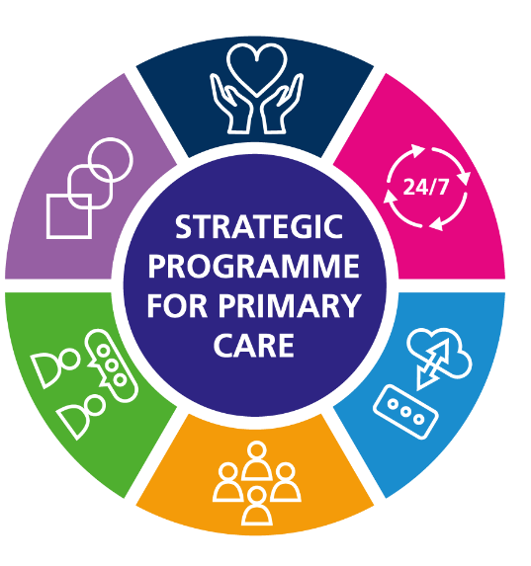



Contents

1. Introduction 3
2. Notable Progress: April 2024 - March 2024 4
3. NHS Executive 5
4. SPPC Delivery in 2024/25 6
4.1 Clarity 6
4.2 Accountability 6
4.3 Rebalance 7
4.4 Delivery 8
4.5 Other Notable Areas of Progress 8
4.5.1 Accelerated Cluster Development 8
4.5.2 Multi-Professional Working 9
4.5.3 Primary Care Governance Framework 9
4.5.4 Greener Primary Care 10
4.5.5 Health Inequalities & Inclusion Health 10
4.5.6 Primary Care Prevention Programmes 10
4.6 Workforce and Organisational Development 11
5. SPPC Fund 2024 -2026 11
6. Look Forward to 2025/26 12
How the SPPC will support improvements (internal) in NHS Executive outcomes in 2025-26 12
How SPPC will support improvements in (external) system outcomes in 2025/26 12
7. Contact Information 13
8. Appendix 1 SPPC high level timeline of work for 2025/26 13
9. Appendix 2 - Published SPPC products 2023-2025 14


Sue Morgan
National Director & Strategic Programme Lead for Primary & Community Care

I am pleased to introduce the end of year report (2024/25) from the Strategic Programme for Primary Care. It was a challenging year given the financial pressures, but it has been encouraging to see progress made across all the key priority areas. One of the most notable developments has been the work with wider stakeholders via the NHS Executive and, as we move forward, we intend to build on this.
I would like to take this opportunity to thank all those that have supported the work over the last year and look forward to continuing the progress already made.


Alex Slade
Director for Primary Care, Mental Health and Early Years Welsh Government

During 2024/25, the main focus of the Strategic Programme for Primary Care (SPPC) has been to engage with stakeholders across the health and care system in response to the challenge in Spring 2024 to the Primary Care Model for Wales (PCMW).
The clear message from this work was that the full benefits of the implementation of the PCMW would not be realised until primary and community care was recognised for its role within the wider system and not regarded in isolation. By highlighting the amount of activity in primary and community care and therefore the opportunity for the whole system the SPPC has successfully secured traction on the PCMW with Health Board Executive Directors and at a national level with NHS Executive colleagues.
To capitalise on this achievement, Sue Morgan and her team are now progressing a number of key actions under the themes of CLARITY, ACCOUNTABILITY, REBALANCE and DELIVERY. Key actions include clarifying the PCMW and agreeing a set of key indicators to measure implementation.
Alongside its own work, the SPPC can continue to reap the benefits of being part of the NHS Executive which enables stronger collaboration with other national activity designed to change the focus of local leadership and culture. Under the theme of REBALANCE, the Community by Design work is critical to embedding care closer to home.
And under the theme of DELIVERY, the SPPC, working with other national partners, also has important work to support the development of proactive care and to accelerate recognition locally of pan cluster planning groups as commissioners of services from clusters as delivery vehicles

Paul Mears
Chief Executive, Cwm Taff Morgannwg University Health Board
I was delighted to take up the role of the lead Chief Executive for Primary Care in September 2024. It feels timely to review where we are with the Primary Care Model for Wales and what we need to do maximise the potential that we have in Wales with Integrated Health Boards. There appears to be a real appetite across the system for placed based care, to share the learning of what works and to address the barriers to fully embed cluster working. I look forward to working with you all in 2025/26 on this.

Introduction

This report provides an overview of progress of the Strategic Programme for Primary Care from 1 April 2024 to 31 March 2025, and a look ahead of the programme of work for 2025/26. The report highlights some key products that have been delivered in collaboration with other partners, for example the Strategic Workforce Plan for Primary Care and Primary and Community Care Compendium in collaboration with Health Education and Improvement Wales (HEIW). A key area of work commenced has been the challenge of the Primary Care Model for Wales, whether the model is still fit for purpose and understanding the barriers to implementation. The challenge has been welcomed and the level of interest from those in and beyond primary care in this work. The Community Infrastructure programme continues to deliver at pace, an important component of whole system resilience going forward. It is good to see the progress being made to ensure that primary and community care is key to whole system planning and in wider performance and escalation discussions.

A new workstream architecture for the SPPC was introduced in June 2024. Membership and terms of reference for each workstream was refreshed and updated. Governance and accountability for the programme continues to be maintained through a Strategic Programme Board that reports to the National Primary Care Board.
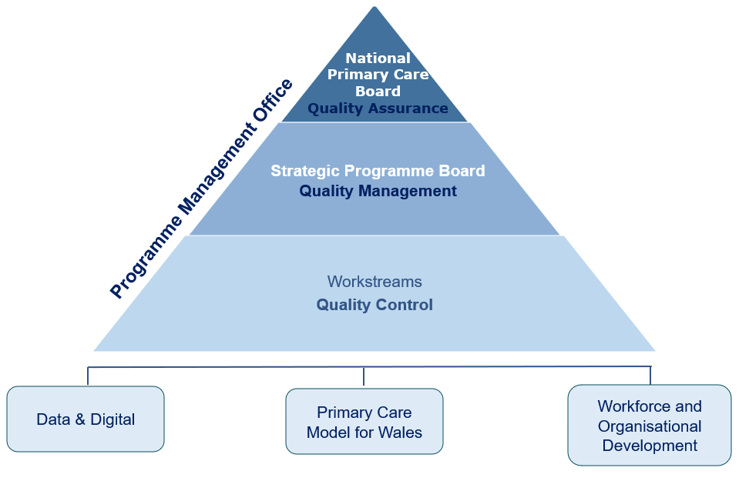
Figure 1: Strategic Programme for Primary Care Quality and Governance Structure 2024 - 2025

The main principles that underpinned the work for the SPPC in 2024/25 include:
- Working collaboratively with NHS Wales leadership (notably the newly established NHS Executive)
- Building resilient primary and community care services aligned to Building Community Capacity
- Working collaboratively with social care leadership (policy, service and Social Care Wales) to develop the model for Integrated Community Care System in Wales (ICCS)
- Continuing to embed the Primary Care Model for Wales and building a robust placed based, population health focussed, community service offer
- Identifying solutions for system wide resilience
- Work to promote the digital offer for primary and community care
- Working in collaboration with DHCW, HEIW, NHSWSSP, PHW and WAST to ensure strategic alignment across programmes of work
- Continue work to align the SPPC programme of work across to other national programmes (Six Goals, Planned Care, Mental Health)

Notable Progress: April 2024 - March 2024

The SPPC is working to ensure primary care is at the forefront of developing innovative and resilient services to support system wide working through the following:
Prioritised and monitored use of the £3.8m SPPC Fund to continue to support implementation of ACD and Obesity Prevention

Joint working with the Urgent and Emergency Care National Programme to articulate the Urgent Care model for Wales
Working in partnership with Health Education and Improvement Wales (HEIW) the Primary Community Care Compendium has continued to grow following a formal launch on the 15th May 2024

Working in partnership Public Health Wales supported the development of Prevention Based Health and Care the approach to embedding prevention across the health and care system in Wales
In partnership with Public Health Wales The refreshed Planning Portal for Cluster Working has gone live

Extended the team with the creation of a National Cluster Lead Advisor post.

Development of the ‘Community by Design’ approach. The overarching focus is for required care to be delivered closer to home where possible and prudent to do so, starting with the premise of community by default

Working in partnership with Public Health Wales launched Health Equity and Inclusion Health toolkit for Primary Care in Wales. The toolkit includes:
- The Equity Checklist
- Placed based primary care: inclusion health services tool
- Health equity assessment support tool

Following the publication of The Primary Care and Community Nursing Framework work during the year has progressed through the many actions identified, including peer review meetings with all Health Boards

Data and Digital workstream coordinated a portfolio of work including development of Primary Care metrics, Healthy Days at Home Wales (HDAHW), refresh of the Primary Care Information Portal (PCIP) and escalation framework and established GMS Demand and Capacity modelling programme

A focus on building resilient primary and community care services aligned to Building Community Capacity Work
Launched the digital Multi-professional Framework for Integrated Working (MPF) - once for Wales agreed definition, core standards with underpinning quality statements and evaluation tool

District Nurse Data - throughout 2024-25, continued to support Health Boards with their monthly submission of activity and capacity data

Continued the Enhanced Community Care work and collected a full year of Health Board data throughout 2024-25 – working closely with Health Boards supporting them in this work through drop in events, teams channel offering support and guidance

Continuing to embed the Primary Care Model for Wales through information and resources for stakeholders to support understanding to build a robust community service offer
.
Working collaboratively with NHS Wales leadership (notably the newly established NHS Executive)

Delivered a series of stakeholder events to support the communication of key programmes through national information sharing.

In partnership with the Public Health Wales Greener Primary Care Framework has continued in 2024/25 and received a number of awards

Formally launched the Strategic Workforce plan for Primary Care in partnership with HEIW in May 2024.

Accelerated Cluster Development: Cluster Leadership Programme Following the successful delivery of Cohort one, a second Confident Leader cohort for Cluster and Collaborative Leads was delivered during June and October 2024


NHS Executive

On 1 April 2024, the Strategic Programme for Primary Care moved into the newly established NHS Executive. The decision to establish an executive function was first announced in A Healthier Wales in 2018, and then reconfirmed in the latest Programme for Government. This decision was based on the findings and recommendations of both the 2016 Organisation for Economic Cooperation and Delivery (OECD) Quality Review and the 2018 Parliamentary Review of the long-term future of Health and Social Care .
The key purpose of the NHS Executive is to drive improvements in the quality and safety of care, resulting in better and more equitable outcomes, access and patient experience, reduced variation, and improvements in population health. The Governance, Accountability and Operating model of the NHS Executive is set out in Figure 2 . It sets out the positioning of the NHS Executive to “provide a central guiding hand, working in partnership for and on behalf and Welsh Government in and with the NHS in Wales.”
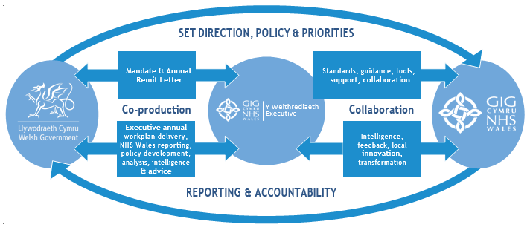Figure 2. The Governance, Accountability and Operating model of the NHS Executive
Issued on 27th March 2024 the NHS Executive remit letter 2024-25 laid out the Welsh Government's priorities for NHS Wales, aligning with the 2024-2027 Planning Framework. It emphasised:
- Ministerial Priorities: These drive the formulation of objectives for the NHS Executive's work program and Senior Leadership Team (SLT).
- Individual Accountability: National Directors within the SLT must align their local work plans and objectives to deliver clear accountability and outcomes.
- Quality and Evidence-Based Improvements: Emphasis on healthcare quality, patient safety, and embedding research and development to enhance care delivery.
- Climate Commitments: NHS Wales is tasked with addressing climate resilience, adhering to legislative decarbonization targets, and contributing to broader social value goals, supporting the Well-being of Future Generations Act.
- Primary and Community Care: A focus on seamless health and social care models that are robust and well-integrated at all levels.

The Strategic Programme for Primary Care has a critical role within the 18 expectations detailed in the remit letter. Its responsibility for two of these expectations underscores the importance of primary care in achieving the overarching goals of the NHS Executive for 2024/25.
Number 3: Primary and Community Care - Demonstrate a focus on improving access and shifting resources into primary and community care.
Number 5: Enhanced Care in the Community - reduce delays for patients, enhance community care, improve care closer to home and support the transfer of resources into primary and community care.

SPPC Delivery in 2024/25

During 2024-25, the main focus has been to engage with stakeholders across the health and care system in response to the challenge in Spring 2024 to the Primary Care Model for Wales (PCMW). The clear message from this work was that the full benefits of the implementation of the PCMW would not be realised until primary and community care was recognised for its role within the wider system and not regarded in isolation. SPPC responded by demonstrating the proportion of primary and community care activity of NHS Wales activity and therefore the opportunity for the whole system if the PCMW was fully implemented. This gained traction with Health Board Executive Directors and at a national level with NHS Executive colleagues.
A number of key actions under the themes of CLARITY, ACCOUNTABILITY, REBALANCE and DELIVERY were identified to support the full implementation and embedding of the PCMW.

Clarity

Through the challenge work, it became evident that work was required to improve the level of awareness and understanding of the PCMW.
A simplified explanation of the PCMW, including the ‘why’ and the ‘how’ has been developed and will be available in June 2025. All of the component parts of the Primary Care Model for Wales are being delivered in areas across Wales, but the focus now is to work towards universal provision. Examples of Cluster innovations will be illustrated in a reference document ‘Primary Care Clusters throughout Wales’, to be published in the summer of 2025. Analysis of the use of Cluster Funds has highlighted themes that have been prioritised by Clusters. These include Tier 0 and Tier 1 mental health, musculoskeletal, medicines management, chronic diseases and digital solutions. A clear narrative together the ‘Primary Care Clusters throughout Wales’’ reference document will provide clarity on the aims, proposed outcomes and progress to date.

4.2 Accountability
The challenge work identified the need to strengthen governance and accountability, including reinforcement of Executive level responsibility for Primary Care and metrics as part of mainstream reporting. Whilst some of this sits with Health Boards, the development of metrics has been led by SPPC. In 2024/25, the following developments has been progressed.

PCC Escalation Framework The escalation tools support the measurement of whole system pressures across health and care services in Wales, raising the profile of primary and community services. The PCC Escalation Framework and Action Card Compendium of Good Practice are being refreshed for launch in Summer 2025. This will coincide with the release of the updated escalation reporting tools for GP and community pharmacy. Similar work is being scoped for primary care dental and optometry services.
“As Chair of the Data Digital Technology Workstream, it is important to recognise the significant challenges faced over the past year in this area. Despite these obstacles, workstream members and broader teams across Wales have remained committed to advancing digital transformation. Their dedication is ensuring that our teams within Primary Care and Community Services are heard, and the necessary information and technology to provide exceptional care to our communities is at the forefront of every development being progressed by the Strategic Programme”.
Lloyd Hambridge,
Chair of DDT workstream
Divisional Director of Primary Care, Community Services, ABUHB

Enhanced Community Care This work provides the Once for Wales agreed definition, core standards, underpinning quality statements and evaluation framework which includes a set of measures and outcomes. A full year of Health Board data has been collected in 2024-25. Monthly reports have been submitted to the Care Action Committee to provide analysis and insight. The measures currently reported are – referral data (referrals by source, referral outcomes) discharge data (total number of discharges, discharge destination).
District Nurse Data Throughout 2024-25, SPPC continued to support Health Boards with monthly submission of activity and capacity data. Monthly reports were submitted to the Care Action Committee. Additionally, a district nurse dashboard has been developed. Further focused work (with four Health Boards) has centred upon the collection of granulated “row” level data to allow for the greater analysis and a richer understanding of the community health intervention delivered by district nurses.
I am really pleased with the progress made to compile and publish a District Nursing dashboard and the support this has given to policy, strategic delivery, and operational management of the service. These first steps in building a national picture around the cornerstone community nursing service will enable better understanding and national working of this service that will inevitably lead to better working across the health and care system.
Paul Labourne
Nursing Officer for Primary & Integrated Care
Welsh Government

PCMW Evaluation. A Task and Finish Group has been established to develop a suite of Key Indicators (KIs) to measure progress towards the Primary Care Model for Wales (PCMW) with a first draft being presented to Directors of Primary Care in May 2025.

PCC Metrics Dashboard The PC Metrics project has demonstrated the wealth of primary and community care data available in Wales. The next stage is to deliver easier access (by reducing the need for multiple logs) via a new dashboard enabling access to other primary and community care datasets. A gap analysis will map out the data already available and whether it corresponds with the measures stipulated in the NHS Performance Framework. The first iteration will provide a minimum data set however the dashboard will be iterative with new data sets considered for inclusion as and when.
Healthy Days At Home Wales (HDAHW) Last year saw the launch of the national dashboard and five of the seven health board dashboards. This year has concentrated on supporting the remaining two health boards to launch their local HDAHW platforms. To demonstrate the benefit of having a population measure of healthcare intervention, work is underway to present an example of HDAHW. This should encourage inclusion of more data sets in the future, increasing the value of the HDAHW scores by providing better population context to accompany the results.
The refreshed Planning Portal for Cluster Working has been launched. As part of this initiative, insights from cluster self-reflection have been analysed to identify 'more mature' clusters and to capture valuable learning. For the 2025/26 cycle, the Cluster Self-Reflection process has been agreed upon, incorporating lessons learned and feedback from the 2024 pilot. A Self-Reflection Process Guide has also been developed for circulation across the system. The Primary Care Cluster Dashboard has been released in both English and Welsh, enhancing accessibility for stakeholders.

Improvements have been made to the PCONE website including a review of cluster working pages and with accessibility and Welsh language standards. Discussions have also begun to scope out the development of a national experience survey for primary and community care.

4.3 Rebalance
The challenge work identified the need to have a stronger emphasis on primary and community care services within the planning of services. In response, SPPC developed the Community by Design approach. This planning approach supports the ambition of A Healthier Wales, placing the communities in which people live at the heart of planning. The overarching focus is for required care to be delivered closer to home where possible and prudent to do so, starting with the premise of community by default. Early progress has been made in the areas of Mental Health, Respiratory and Diabetes, with the plan to implement these new pathways in 2025/26.
To support the focus on population health management, it was agreed in the latter part of 2024/25, that the NHS Executive would identify a Risk Segmentation Tool. This is key to ensuring planning is aligned to maximising the health and wellbeing of our population. This will be a priority during 2025/26 as will be a further tool to support a Community by Design approach.
As part of the 50 Day Challenge winter initiative, ten best practice interventions were identified. One of the interventions was the proactive management of identified 0.5% high risk population group by clusters and multiprofessional teams. SPPC worked with regions to support the identification of the group and the development of a care plan approach for this population. Going forward, this way of working should be fully embedded and supports a population health management approach to keep people well in their own homes. The risk segmentation tool will be a key to this and will enable further focussed population work.

4.4 Delivery
The development of population needs based, multi-professional, place-based care was identified, via the challenge work, as needing to be a core foundation of local strategies. Primary care working at scale is a critical enabler to progressing this. Much work has been done to consider alternative delivery solutions and guidance has been developed on how to implement some of these alternative solutions. Working with Welsh Government, the development of contractual levers that enable and incentivise working at scale is well progressed and will feature in 2025/26. These alternative solutions and levers will allow the delivery of a population health management approach and Community by Design.

During 2024/25, SPPC has worked alongside social care colleagues to progress an Integrated Community Care System for Wales. It is evident that there is much common ground between primary care and social care. Work in 2025/26 will move towards a more formalised joined-up approach. The integrated approach to community care has been further reinforced during 2025/26 by Welsh Government via the 50 Day Integrated Winter Challenge that focused on making a differing in improving care through admission avoidance and timely discharge. This winter initiative built on the work of Further Faster and Building Community Capacity.

The provision of resilient primary and community services is a foundation to working at scale. Sustainability of independent contractor services is key to this. Work has commenced in 2024/25 on GMS access and will continue in 2025/26 with a focus on GMS access for those patients presenting with an urgent care need. The other work, referenced in 4.5.2 such as Enhanced Community Care and the Community Nursing, is another key component for providing consistent care seven days a week.

4.5 Other Notable Areas of Progress

4.5.1 Accelerated Cluster Development

The Action Learning Group for Cluster Development continues to provide a dynamic network for exploring challenges and sharing innovation. The group has focussed on the development of professional collaborative groups and has highlighted the importance of digital solutions to enable Cluster working, supported by robust Information Governance. This is further reinforced via the second series of Cluster Peer Reviews that has highlighted where action is required.
A new role within SPPC is the National Cluster Lead Advisor, which Dr James Martin has been appointed to. The All-Wales Cluster Leads Group continues to develop under the leadership of Dr James Martin. The group provides a collective voice for clinical leadership that is central to the delivery of place-based care.
I was delighted to take on the newly created role of cluster lead advisor to the SPPC in December 2024. Having witnessed the benefits as well as the challenges of cluster working over the years, I am keen to help develop the cluster project, to enable it to meet its considerable ambition and potential. In order to unlock this potential, we will need to make progress on empowering cluster to deliver on their plans.
We will continue to encourage the strengthening of collaborative engagement and look at ways to facilitate this. There are a number of key pieces of infrastructure that need to be in place to further collaborative working, including workforce, information technology and data sharing. Work is underway to progress this. Finally Pan Cluster Planning Groups will need re-focussing and re-invigorating, to enable clusters to move towards becoming delivery vehicles for the Primary Care Model for Wales.
Dr James Martin Cluster Lead Advisor

4.5.2 Multi-Professional Working

The Community Nursing Framework although published in February 2024, the actions generated through this collaborative piece of work was a priority area for delivery this year. The Primary Care and Community Nursing Framework was developed via engagement with 500 nurses and stakeholders across Wales, and outlines how they will contribute to achieving the ambitions of A Healthier Wales and the Primary Care Model for Wales.. This has led to the development of eight themes each with a set of actions, which reflect and align to the CNO’s five priorities for Nursing (2022), The Duty of Quality (2023), Health and Care Quality Standards (2023) and requirements outlined in the National Community Nursing Specification (2022), placing the person, provision of high quality safe care and improved outcomes for the population, at the frameworks centre. In total 47 actions were identified, 18 of which were considered a priority for 2024 -2026. During 2024-25, peer review meetings were held with all Health Boards, that provided the foundation for a national session hosted by SPPC. Discussions from the workshop, alongside 244 responses from the Primary Care & Community Nursing Specification survey have been used to develop recommendations for further actions. The recommendations are currently in progress and includes a focus on data and opportunities to share good practice relating to care homes and professional collaboratives.
AHP investment The recurrent £5 million Additional AHP Investment commenced in April 2023 to create additional community and primary care based registered Allied Health Professionals (AHPs) and support worker posts. In line with Accelerated Cluster Development arrangements, under the oversight of Executive Directors of Allied Health Professions and Health Science and Directors of Primary and Community Care, recommendations on how best to use this £5 million were made by pan cluster planning groups (PCPGs), based on cluster and PCPG plans, with endorsement through the Regional Partnership Boards. To date there have been an additional 102.63wte. The end of year report can be found at Additional Allied Health Professions Investment - Primary Care One.
Multi-professional Framework for Integrated Care The Multi-professional Framework for Integrated Care and the corresponding Development Matrix was launched in 2023/24. Further work has being undertaken in 2024/25 to develop a focused webpage to assist with integration and the launch of a electronic version of the matrix to support its use.

4.5.3 Primary Care Governance Framework

The Unified Process for the Management of Performance Issues with Clinicians on Performer Lists in Wales was delivered in February 2025. It was handed over to Welsh Government to formally launch, via a Welsh Health Circular directing Health Boards to implement within six months. This process standardises the approach to recording, investigating and reporting outcomes in relation to concerns raised against any GP, dentist or ophthalmologist on a performer list (or equivalent) providing NHS primary care services in Wales.

4.5.4 Greener Primary Care

The Greener Primary Care Wales Framework and Award Scheme has made significant strides in healthcare sustainability. In 2024, 201 teams, plus 54 Specsavers stores, completed 2,192 climate-friendly actions, earning 54 awards across bronze, silver, gold and corporate award categories. Over three years, 416 practices and two corporate companies contributed to 4554 actions, reducing over 2,760 tonnes of CO²e.
The scheme has gained recognition, winning multiple sustainability awards and contributing to global initiatives like ATACH. Low global warming inhaler prescribing and disposal remains a key focus, with reports evaluating pilot projects to improve respiratory management, inhaler recycling and safe disposal. The Task & Finish Group – Decarbonisation – Inhaler use and disposal is leading efforts to address climate challenges and progress is reported through the Respiratory Dashboard.

4.5.5 Health Inequalities & Inclusion Health

The Health Inequalities programme has made Significant progress in developing a range of resources to reduce inequalities through primary care, including the Health Equity and Inclusion Self-Assessment Toolkit and a rapid review of existing frameworks. An action plan is being co-produced with input from evidence, data, and workshops involving professionals and communities.

The Wales Inclusion Health Programme has published a blueprint for needs-based services for inclusion health, which was launched at a summit by the Minister in March 2024. Public Health Wales (PHW) has developed a suite of resources to support the delivery of blueprint, including existing evidence and infographics, health board-level data, a planning toolkit, and a health inclusion and prison health framework based on the Directory of Education and Training. The national health inclusion nurses and public health networks continue to promote shared learning across Wales while workforce development is also supported through delivery of webinars (six delivered), GP training sessions, and the “Teg i Bawb – Fair for All” training programme for GP receptionists.

4.5.6 Primary Care Prevention Programmes

The Prevention-Based Health and Care (PBHC) framework has been launched alongside a steering group to guide this transition. This framework outlines the approach to be taken in Wales to embed prevention across the health and care system in Wales. The PBHC Framework was presented at the MSK Clinical Network Conference, and collaborative work continues with the Women’s Health Clinical Network, Cardiovascular Network and Diabetes Network in particular, to integrate prevention into their strategies.

The All Wales Diabetes Prevention Programme continues to show positive results, with over 10,000 people attending consultations since the inception of the programme in targeted clusters across Wales. Work is underway to develop a gestational diabetes mellitus (GDM) pathway into AWDPP. A Quality Improvement (QI) projects focused on a prospective delivery model is progressing, including site visits to address operational challenges. Key outputs published for World Diabetes Day 2024 include reports such as All Wales Diabetes Prevention Programme Two Year On, the Equity Toolkit, and Service Users' Experience of the Programme. The outcome evaluation of the AWDPP programme is due to be published in the Summer 2025, which will inform the policy direction for the programme.
Cardiovascular Disease Prevention A person-centred ABCD+ approach (addressing Atrial fibrillation, Blood pressure, Cholesterol, type 2 Diabetes, and health behaviours), aligned to the Prevention Based Health and Care Framework, is in development, led by the CVD Prevention Steering Group, in partnership with the CVD Clinical Network. A Hypertension QI project has been developed and included as a mandatory QI project in the GMS contract for 2025/26. A systematic review of health checks has been completed through a grant collaboration with Newcastle University, with the report due out in the summer 2025. Citizen engagement has been undertaken through PHW’s questions are being developed to better understand attitudes and knowledge around CVD prevention across Wales and an Insight Study into health behaviours that affect service engagement has been commissioned.
Obesity Prevention Following the conclusion of the Primary Care Obesity Prevention Programme in 2023/24 this year we published a report and held a webinar in November detailing significant progress made and recommendations to help build on this progress. A follow-on programme is being established in collaboration with the Women’s Health Network on postnatal health and wellbeing.
Social Prescribing in Wales is continuing to develop which has included the first meeting of the Policy and Implementation Group with RPB Social Prescribing Champions. A Financial Wellbeing Scoping Review is underway, alongside progress in developing an evaluation plan for the Warm Wales initiative, which takes a social prescribing approach to supporting financial and wider wellbeing, in addition to providing warner homes. Efforts to develop a skills and knowledge programme for social prescribing practitioners are underway, grounded in the Competence Framework for Social Prescribing Practitioners in Wales.

4.6 Workforce and Organisational Development

The Strategic Workforce Plan for Primary Care, developed in partnership with Health Education and Improvement Wales (HEIW), was launched in May 2024. The plan identified twenty-six key actions to be delivered over the next five-years . Each action aimed at supporting the development of sustainable workforce models to deliver the Primary Care Model for Wales as outlined in "A Healthier Wales". Fourteen actions were prioritised to be taken forward for implementation in year one (2024-25) these were:
- Dental mentorship
- Supervision guidance
- Improved understanding of multi-professional working
- Improved multi-professional working
- Successful deployment of PAs
- Workforce Demand Modelling
- Leadership Development - Cluster & Collaborative Lead Programmes
- Management & Leadership - development opportunities
- Welsh Language
- Health inclusion
- Mental Health skills
- Urgent care skills
- Foundation doctors experience placements
- Optometry contract reform training Programme

Key achievements include:
- Successfully trained 30 new Dental Foundation Training Educational Supervisors (DFTESs).
- Developed an education-to-employment pipeline dashboard for General Medical Services, facilitating workforce planning decisions based on future demand.
- Increased primary care training placements for foundation doctors by 18, resulting in 50% of foundation doctors gaining early exposure to primary care.
- Delivered four cohorts of the Accelerated Cluster Development Expert Leadership Programme, engaging approximately 100 participants through blended learning, with positive feedback received.
- Commissioned the development of the multi-professional primary care capabilities training and education framework for inclusion, prison, custody suites, and health services in Wales.

Year two (2025-2026) focuses on enhancing staff experience, engagement, and well-being, improving workforce planning and promoting leadership development.

Primary & Community Care Compendium of Roles & Models This once for Wales website provides a platform for sharing innovative models of practice for multi professional working. It was developed in partnership with Health Education and Improvement Wales. Currently the site hosts 24 case studies, each containing interviews with those involved in the set up and operation of the models showcased.

The Accelerated Cluster Development Expert Leadership Programme concluded in March 2025 having successfully delivered four cohorts to over 100 clinicians in Wales. The course, designed and delivered by Primary Care Commissioning Community Interest Company (PCC), was aimed at Cluster Leads and Professional Collaborative Leads, with a focus on confident leadership, collaborative working, leading with influence and leading change.

SPPC Fund 2024 -2026

The £3.8 million Strategic Programme for Primary Care Fund (SPPC Fund) commenced in April 2022. The SPPC Fund replaced the Pacesetter/Pathfinder funding stream that was available to Health Boards across Wales from 2015-2022. The governance for the SPPC Fund sits with the Strategic Programme for Primary Care Programme Board and National Primary Care Board (NPCB). A total of 19 investment proposals, under five category areas, have been endorsed for 2024/26:
- Six health boards have prioritised investment to support the delivery of the Accelerated Cluster Development Programme; six projects with a combined value of £1.76m
- Six health boards have prioritised investment into Obesity Prevention / All Wales Diabetes Prevention Progamme; seven projects in total with a combined value of £1.15m
- Five health boards have prioritised investment to support delivery of the Strategic Workforce Plan for Primary Care; five projects in total with a combined value of £0.848m
- One health board has prioritised investment to support the delivery of the Community Infrastructure programme at a value of £30,000

The SPPC Fund investment continues to provide critical infrastructure within health boards to support the delivery of the ACD Progamme and the transformational change required to fully mature integrated planning across the health and social care interface. The new investment in 2024/25 into workforce training and development has supported health boards to deliver components of the Strategic Workforce Plan for Primary Care and has been mapped against the workforce plan priority group actions. A detailed end of year two evaluation report will be published in 2026. The final report will include progress against the agreed benefits and outputs/outcomes for each project, insight and learning, as well as quantitive metrics and financial spend.

Look Forward to 2025/26

As the NHS Executive moves into it’s second year, it’s important to set out the role of SPPC within the NHS Executive.

How the SPPC will support improvements (internal) in NHS Executive outcomes in 2025-26
- Work with NHS Executive directorate colleagues to increase the awareness of primary care in order to full understand the opportunities and challenges that primary care presents to the whole system
- Ensure ‘Community by Design’ is embedded in planning across the NHS Executive. Of particular note, work with the Strategic Programme for Mental Health to embed a ‘Community by Design’ approach and work with clinical network colleagues on the development and embedding of the ‘Community by Design’ approach. For 2025/26, the focus will be Respiratory/Breathlessness and Diabetes.
- Joint work with Urgent and Emergency Care National Programme on the Urgent Care model for Wales
- Work with Performance & Assurance to develop a primary and community care dashboard
- Work with Quality & Safety Improvement colleagues on Urgent Primary Care
- Establish a primary care clinical leads network across the NHS Executive, notably supporting primary care clinical leads in other directorates such as Planned Care and Networks.

How SPPC will support improvements in (external) system outcomes in 2025/26
- The collation of the contract reform mandate priorities for NHS Wales for General Medical Services, General Dental Services, Community Pharmacy and Optometry
- Joint implementation with HEIW of the Strategic Workforce Plan for Primary Care action plan
- Implementing and monitoring pathways developed through the Community by Design approach
- Supporting Health Boards to ensure that care plans are in place for the 0.5% highest risk population.
- Readily accessible primary and community care metrics
- Supporting Health Boards on data sharing with the Information Governance action plan

The figure overpage sets out a high level timeline of work for 2025/26.

Contact Information



Email us: SPPC@wales.nhs.uk Watch our YouTube videos- YouTube channel
Keep up to date on our work at Strategic Programme - Primary Care One

Appendix 1 SPPC high level timeline of work for 2025/26
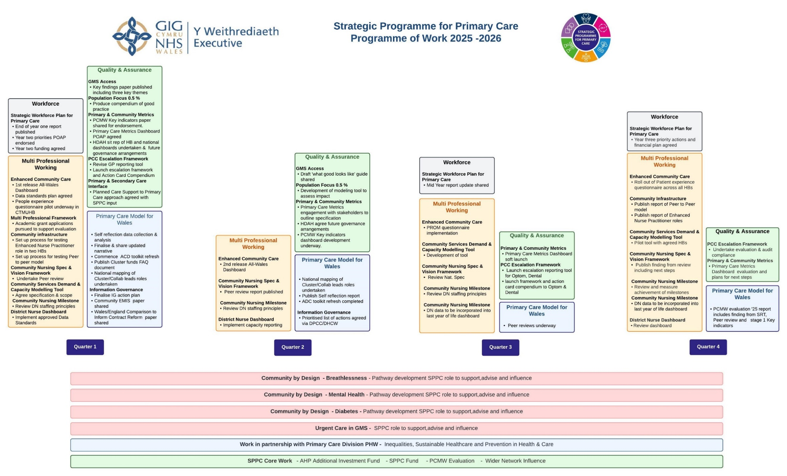

Appendix 2 - Published SPPC products 2023-2025
Product Name | Release Date
Greener Primary Care End of Year Report | April 2023
PCC Compendium Website Phase 1 Soft Launch | April 2023
National Framework for Urgent Primary Care | May 2023
Phase 1 Enhanced Community Care | May 2023
Developing a Nursing Home Immunisation Model | May 2023
Optometry Professional Collaborative Pilot (CTMUHB) Summary Report | May 2023
ACD Transition Year Readiness Checklist; Updated Position Reported as of 31st March | May 2023
Peer Review Primary Care Clusters | May 2023
SPPC End of year report 2022-2023 | May 2023
Multi professional Framework for Integrated working | Aug 2023
Phase 2 Enhanced Community Care | Aug 2023
Healthy Days at Home Wales national dashboard | Aug 2023
WONCA Welsh Delegate Report Summary Note | Aug 2023
SPPC Mid-year report | Oct 2023
Urgent Primary Care Centre Final Report & Short video | Oct 2023
UPC Development Matrix | Oct 2023
New Service Developments Guidance for engagement and consultation | Oct 2023
Healthy Days At Home Wales user guide | Dec 2023
Glossary of Terms for Social Prescribing in Wales | Dec 2023
Social Prescribing - Public Health Wales – case study examples | Dec 2023
Supporting Healthy Behaviours: A Guide for General Practice  A guide for Optometry | Jan 2024
The Welsh Government Quality and Safety Framework (2020): What it means for Primary Care, and what has been achieved so far . (Internal) & Welsh Government Quality and Safety Framework - Action Plan (Internal) | Feb 2024
Report on Models of Effective Learning in Primary Care (Internal paper) | Feb 2024
The Primary Care and Community Nursing framework | Feb 2024
Cluster Self Reflection Framework | Mar 2024
Greener Primary Care End of Year Two report (internal paper) | Mar 2024
Directory of Education & Training in Inclusion Health for Health Professionals - Primary Care One (NHS. Wales) | Apr 2024
Clinical Governance Practice Self-Assessment Toolkit | May 2024
Strategic Workforce Plan for Primary Care | May 2024
Primary and Community Care Compendium | May 2024
SPPC End of Year Report 2023-24 | Jun 2024
Cluster pages on PCONE refresh to Resources for Cluster Working and an updated Cluster Planning portal | Jul 2024
Reducing Health Inequalities through Primary Care webpages on PCONE | Jul 2024
Summary of Cluster Peer Review, Self-Reflection and PCMW Professional Workshops  Annex 1 Peer review report  Annex 2 Cluster Self Reflection  Annex 3 The Primary Care Model for Wales Implementation Challenge Meetings | Oct 2024
SPPC Mid-year report | Nov 2024

