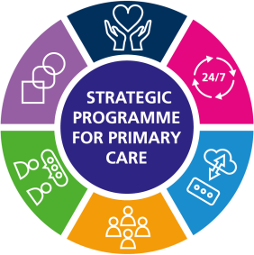
STRATEGIC PROGRAMME FOR PRIMARY CARE
A regular newsletter brought to you by the SPPC
AUTUMN 2023

Recent publications
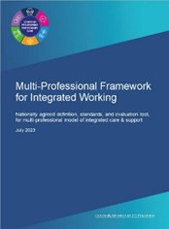
Multi-professional Framework for Integrated Working - with a Once for Wales agreed definition, core standards with underpinning quality statements, and evaluation tool. This framework provides an evidence-based approach for community services to deliver a collaborative, multi- professional model of integrated assessment and sup- port, providing person centred, effective, and seamless care.
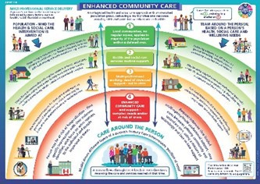
Enhanced Community Care – This work pro- vides the Once for Wales agreed definition, core standards, underpinning quality statements and evaluation framework which includes a set of measures and outcomes. Providing a base from which community based services can deliv- er high-quality evidence-based care to people and populations requiring enhanced community care. This enables services to demonstrate the value and effectiveness of their ECC model of care and support in a consistent way across Wales.
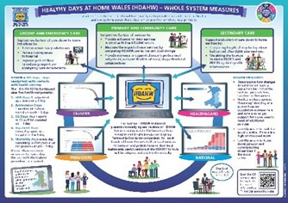
Healthy Days at Home Wales national dash-
board - The Strategic Programme for Primary Care (SPPC) in conjunction with Digital Health and Care Wales (DHCW) formally launched the Healthy Days at Home Wales (HDAHW) Nation- al Dashboard in August 2023.
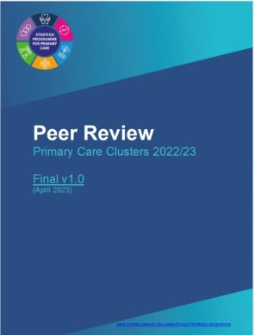
Peer review Primary Care Clusters 2023/24 In 2022/23 a series of peer review meetings were held to assess pro- gress across clusters with implementing the Primary Care Model for Wales and the Accelerated Cluster Develop- ment Programme. This report summa-rises the learning from these discussions and provides recommendations for the further development of the Cluster Peer Review Pro- gramme for 2024.

S trategic Workforce Plan for Primary Care Working in partnership with Health Education and Improvement Wales (HEIW) we are developing a Strategic Workforce Plan for Primary Care. Wide Engagement with key stakeholders has taken place during quarter 1 and 2 of 2023. This plan, due to be published in the winter will consider the shape and size of the workforce needed to meet population health and to address supply-side issues for the future.
The engagement phase of the Strategic Workforce Plan for Primary Care started in March 2023 and culminated in the National Primary Care Workforce Conference held on 18 July 2023. This day was a great suc- cess with over 200 people present in Cardiff and over 30 in a satellite event held in North Wales.
The slide deck used on the day and a short summary of the event are available on the Primary Care One website here.

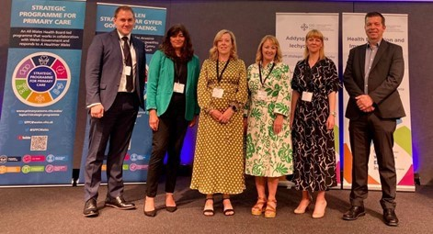
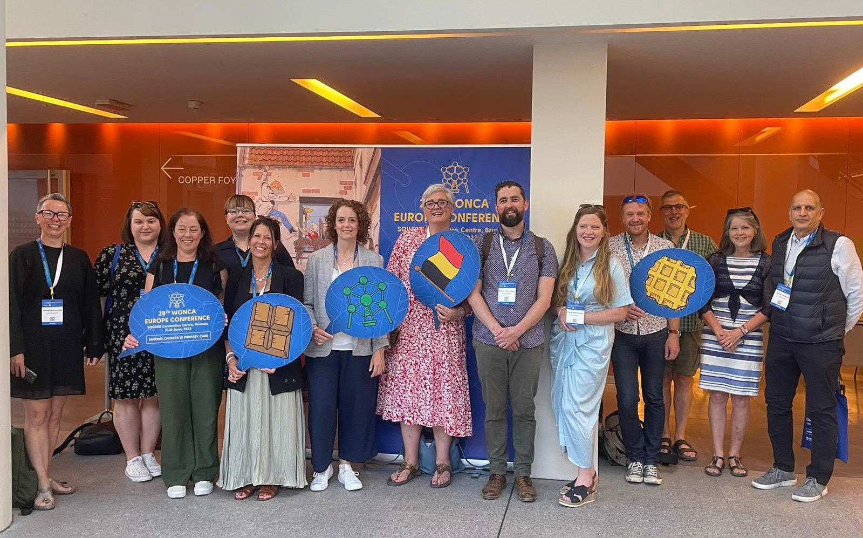

WONCA
The SPPC supported a small multi professional working group to attend the 2023 Europe Conference to capture the learning from the extensive research agenda for primary care practice.
A report from the conference capturing reflections from the Welsh team can be found here.

Recent publications you may have missed

Product Name | Release Date
G reener Primary Care End of Year Report | April 2023
P CC Compendium Website Phase 1 Soft Launch | April 2023
N ational Framework for Urgent Primary Care | May 2023
P hase 1 Enhanced Community Care | May 2023
D eveloping a Nursing Home Immunisation Model | May 2023
O ptometry Professional Collaborative Pilot (CTMUHB) Summary Report | May 2023
A CD Transition Year Readiness Checklist; Updated Position Reported as of 31st March | May 2023
P eer Review Primary Care Clusters | May 2023
S PPC End of year report 2022-2023 | May 2023
M ulti professional Framework for Integrated working | Aug 2023
P hase 2 Enhanced Community Care | Aug 2023
H ealthy Days at Home Wales national dashboard | Aug 2023
Coming Soon
The Strategic Programme for Primary Care 2023/24 Mid-Year Update is due to be published at the end of November and will be a key feature in the next newsletter

OTHER NEWS

Health and Care Pathways programme

The 17th September marked 200 days of the national implementation of the Health and Care Pathways programme, which is building on all the fantastic work undertaken in Cardiff and Vale in previous years. The programme is being delivered in partnership with the Strategic programme for planned care (NHS Executive), Pathway Alliance LTD and all Health Boards in Wales. Within 200 days the Health and Care Pathways Programme have delivered 10 pathways available on the Wales Collaboration site for localisation, with a further 147 pathways in progress across the 4 trained and active Health Boards (CVUHB, HBUHB, SBUHB and CTMUHB). A huge
achievement!
You can read more here.



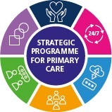
KEEP IN TOUCH
Email us : sppc@wales.nhs.uk

Follow us on Twitter @SPPCWales

Click here to visit our videos & recordings from events
Visit our website :Strategic Programme - Primary

Care One (nhs.wales)

