
Greener Primary Care Wales Framework and Award Scheme
2024

General Practice
Resource Pack



Purpose of this resource pack

This resource pack has been put together to help General Practice consider how they can become more climate-friendly by participating in the Greener Primary Care Wales Scheme.

It provides an easy way for practices to decide “what can we do in our practice?”.
It lists over 50 actions practices can take to improve their environmental sustainability. It also provides useful resources and tips on where to start for every action. You can select as many actions as you wish, and in any order, and you may even qualify for an award depending on the number of actions you implement. Hear about what others have done in the 2022 Yearbook.

This pack is intended to be suitable for not only individual general practice teams but also for actions across professional collaboratives.

By participating in the Scheme, you will be taking action against the harmful effects of climate change and contributing towards the Welsh Government’s Net Zero targets. Where possible, all actions are mapped to goals within the Wellbeing of Future Generations (Wales) Act 2015, demonstrating compliance with the Act. Many of the actions also align with the NHS Wales Decarbonisation Strategic Delivery Plan.

We hope the resources within this pack will support your green endeavours!

Contents
- List of 2024 framework actions
- Promotional flyer
- Instructions on how to register with the Scheme for 2024
- Greener Primary Care Wales animation
- Greener Primary Care Wales 2022 Yearbook
- General Practice Video Case Study
- Digital & Social Media Asset Packs
- Greener Primary Care Wales FAQ
- Slides used at the 2024 relaunch webinar
- Recording of 2024 relaunch webinar
- Further information
- Contact us

- List of 2024 framework actions
A list of actions from the 2024 framework is provided below.
Each action is accompanied by further information on the framework website to support its implementation. Practices can pick and mix the actions they prefer.
Greener Primary Care Wales Framework and Award Scheme 2024

Adaption

The practice has a Business Continuity Plan in place which staff are aware of and able to implement in the event of interruption to services due to the impact of climate change.
The practice has undertaken a practice-based risk assessment to understand the impact climate change could have on the practice and has developed adaptation action(s) to respond to the risk.
The practice has a system in place to inform and alert patients about access to the practice and/or information about self-care in the event of extreme weather or disaster affecting the practice.
The practice has put in place an adaptation action not covered in this framework, to ensure their service and patients are protected and avoid unnecessary harm due to extreme weather conditions.
Buildings & Estates

The practice adopts, wherever possible, the use of energy efficient lighting options.
The practice has made physical improvements to the building to make it more environmentally sustainable.
The practice ensures that the last person out of the work area switches off all appropriate equipment and lights, and that there is a shutdown plan for holiday periods (if applicable).
The practice regularly monitors its energy use and is making progress to reduce the amount of energy used from various sources within the practice.
The practice has optimised and maintains its outside areas and green spaces for biodiversity and has increased the opportunities available for local wildlife to thrive, as well as supporting the benefits of green spaces to health and wellbeing.
Carbon Management

The practice has identified a named lead within the practice to encourage and engage practice staff to promote participation in the Greener Primary Care Wales Scheme and to work together to implement practice based actions to qualify for an award.
The practice communicates and promotes (to patients, the public and local community) the practice's participation in the Greener Primary Care Wales Framework and Award Scheme.
There is a regular discussion with the practice staff and wider MDT about the health impacts of climate change, raising awareness of the adaptation and mitigation required. The discussion includes which actions they can take personally as well as within a work context.
The practice supports its respective professional bodies' and/or the Welsh Government's declaration of a climate emergency. The practice may also choose to declare a climate emergency more locally as part of a local cluster or professional collaborative.
The practice spreads its influence to a wider group of people including local practices, professional collaboratives, clusters and/or further afield.
The practice has a Green/Environmental Sustainability policy in place, has put it into practice and communicates this to its practice staff and wider MDT.
The practice can show evidence of ongoing learning around carbon literacy for practice staff and the wider MDT. At least one member of staff has accessed learning on climate change and healthcare and cascades their learning to new and existing practice staff and wider MDT by relevant methods.
The practice has taken action to identify how sustainable their practice is by measuring their carbon footprint annually.
Share an example of best practice! Produce a short written case study or mini guide to what you have been working on and how you have implemented this in your practice.
Change the default search engine on practice computers to a climate-friendly alternative.

Healthy Behaviours

Staff and the wider MDT are regularly encouraged and supported in the behaviours that promote better health. These behaviours are also actively
promoted to patients.
The practice promotes physical exercise and active travel to patients, staff and the wider MDT and promotes a culture of physical activity and role modelling through a range of everyday activities.
A member of the practice staff or wider MDT has learnt about brief interventions and motivational interviewing via Making Every Contact Count and shares their learning with other staff.
Innovation & Co-Production

The practice has tested, introduced and measured a 'green' innovation not covered in this framework.
The practice has tested, introduced and measured a SECOND 'green' innovation not covered in this framework.
The practice actively involves and seeks feedback from patients groups and/or the local community on any changes to adopt a more environmentally sustainable practice.
Procurement

The practice reviews its energy provider and if necessary changes to a more environmentally sustainable provider if not already in place.
The practice preferentially buys sustainable stationary and office consumables.
All tea and coffee purchased by the practice for staff and the wider MDT is Fairtrade certified. N.B. This only refers to tea or coffee bought with practice money, not products bought by staff. Staff and the wider MDT are however encouraged to purchase Fairtrade refreshments.
The practice has developed and introduced a stock-taking system for ordering materials to ensure low wastage. This may include stationery, pharmaceuticals or any other materials that are ordered on a regular basis.
Plastic products and packaging procured are re-usable or recyclable and incorporate recycled content, wherever technically and clinically appropriate.
The practice has reviewed its choice of business bank and if necessary changed to a more environmentally sustainable provider if not already in place.
Transport & Smart Working

The practice regularly encourages and promotes more environmentally friendly/sustainable modes of transport for practice staff, the wider MDT and patients.
The practice carries out an annual staff travel audit for members of the practice team.
The practice makes efforts to minimise patient, practice staff, wider MDT and cross practice travel.
Waste

The practice preferentially buys rechargeable batteries as opposed to single use batteries to minimise its waste. Where this is not possible, single use batteries are recycled appropriately.
The practice is minimising the number of paper letters sent out by, or on behalf of, the practice. Where posting letters is necessary, the practice avoids using envelopes that contain plastic windows by using alternatives, such as purely paper based envelopes or biodegradable options.
The practice recycles hard to recycle materials and/or becomes a collection point for patients.
Printing, copying and faxing is only used when necessary. Where it is necessary double sided printing and paper made from recyclable sources is utilised.
The practice moves to paperless clinical records.
General Practice Specific

The practice reviews and takes action to increase the proportion of dry powder inhalers (DPIs) and soft-mist inhalers (SMIs) prescribed compared to metered dose inhalers (MDIs), where clinically appropriate.
The practice reviews the proportion of carbon-intensive and high global warming potential (GWP) Salbutamol MDIs compared to alternative lower GWP inhaler types prescribed and takes action to reduce the proportion of high GWP Salbutamol MDIs initiated and prescribed on repeat prescription.
The practice has a system in place to regularly audit the prescribing of 'reliever' inhalers for all patients and only prescribe repeat prescriptions for those patients with a recorded clinical diagnosis and a clinical review within the last 12 months.
The practice actively socially prescribes, where appropriate, and refers patients to social prescribers, care navigators and / or community connectors etc. to identify the most appropriate non-clinical intervention to meet their need.
The practice promotes reproductive choice and education for women by providing timely access to contraception, emergency contraception and other services to prevent unplanned pregnancy.
The practice has a repeat prescribing system in place which ensures patients only receive the medicines they require, are not regularly receiving non-repeat items and where possible medicines supply is synchronised.

- Promotional Flyer

A promotional flyer has been prepared to give you a snapshot of what the Scheme is about. A copy of the flyer is embedded below and is also available in English and Welsh on the Primary Care One website. The flyer can be used to spread the word about the Scheme and why practices should get involved.
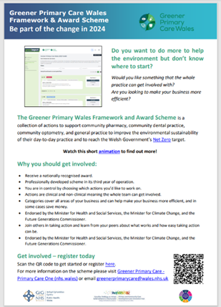

- Instructions on how to register with the Scheme
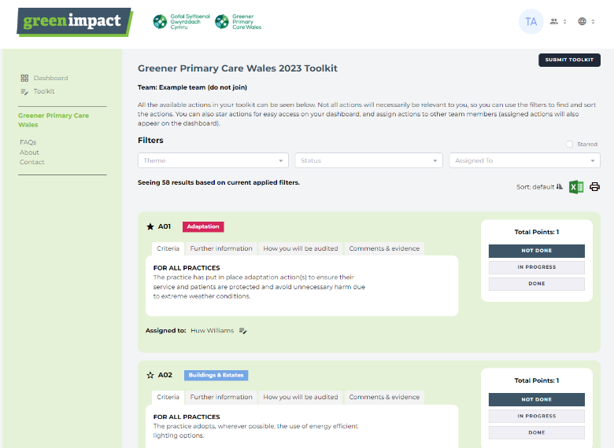

- Go to the toolkit site here.
- Click register at the bottom of the log-in box and fill in your details with your email address and create a unique password.
- Once you have set up your account, click ‘toolkit’ and you will then be prompted to create or join a team.
- If you are the first person joining one of these teams or creating a new team you will be prompted to fill in the information for that team (Practice name, postcode, contractor type, health board and type of work conducted). Subsequent members will see your team and be able to join upon registration.
- You will then have access to the framework and begin working towards your award.
- Greener Primary Care Wales Animation
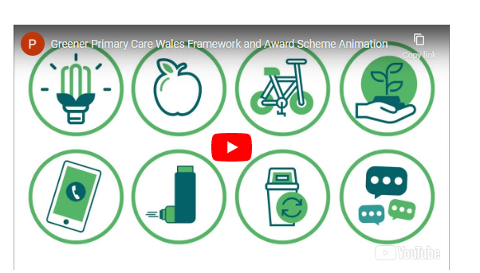
This short animation provides a high-level summary of the Scheme, including instructions on how to register and start implementing actions.

To access the resource click here.

- Greener Primary Care Wales 2022 Yearbook
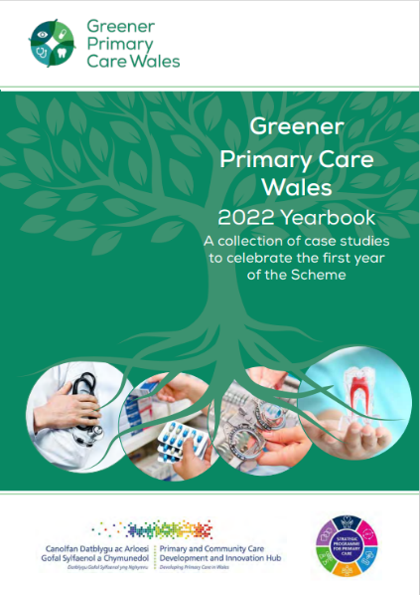
The ‘2022 Yearbook’ was developed by the Primary Care Division with funding from the Welsh Government decarbonisation fund. It highlights a number of real-life case studies from primary care practices, including general practice, across Wales who participated in the Scheme during 2022. The document is both a celebration of these teams’ achievements as well as a motivational tool for practices considering registering.

To access the resource click here.

- Video Case Study

A video case study of a general practice that participated in the Greener Primary Care Framework and Award Scheme.
Video Case Study: General Practice
- Digital & Social Media Asset Packs

The Digital and Social Media Asset packs outlined below have been designed to support registered users to promote their practice's participation in the Greener Primary Care Wales Framework and Award Scheme. Various digital and social media assets outlined in the pack can be downloaded, saved, and uploaded to various online platforms.
Guidance on how to utilise these resources is available in each of the specific social media packs here. Using these resources will support you in achieving action A11 of the framework:
“The practice communicates and promotes (to patients, the public, and the local community) the practice’s participation in the Greener Primary Care Wales Framework and Award Scheme.”
The pack contains a series of still and moving images (otherwise referred to as GIFs), for you to download and use across your website and social media accounts, along with further information on downloading video clips from Vimeo and the Greener Primary Care Gwella Peer Support Network.
To note, the imagery provided in this pack has been specifically separated by the appropriate image specification/resolution for each of the highlighted social media platforms to ensure optimum upload quality.
The pack is available to view online here: Digital & Social Media Asset Packs - Primary Care One (nhs.wales)

- Greener Primary Care Wales FAQs
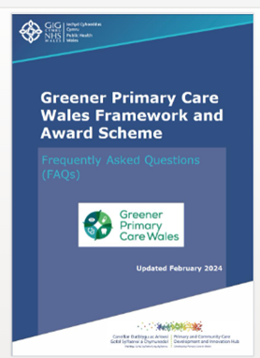
The ‘Frequently asked questions’ (FAQ) resource was updated in 2024 to provide answers and support to new teams registering for the first time in 2024, as well as returning teams from Years 1 (2022) and 2 (2023) of the Scheme.

To access the resource click here.

- Slides used at 2024 relaunch webinar
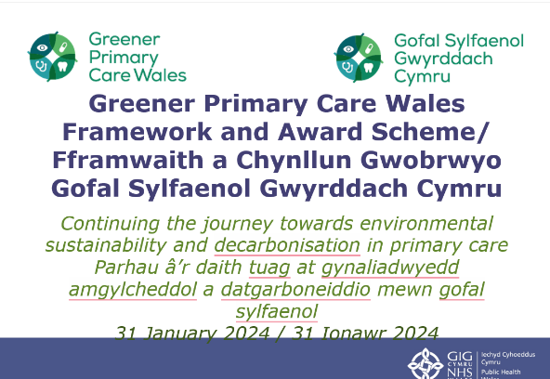
A copy of the slides that were used at the 2024 relaunch webinar of the Greener Primary Care Wales Framework and Award Scheme.

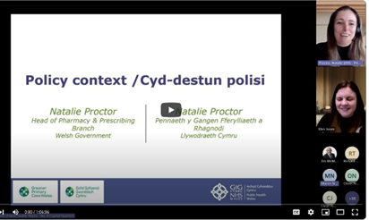
- Recording of 2024 relaunch
A recording of the Greener Primary Care Wales 2024 relaunch webinar is available on the PC One website, which includes presentations from the Welsh Government, Primary Care Division, and in practice examples from community pharmacy and general practice. The duration of the webinar is 1 hour 7 minutes.

- Further information
Further information and access to the resources in Welsh can be found on the Greener Primary Care Wales pages of the Primary Care One website.

Scan the OR code to get started Welsh English
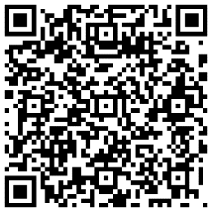

- Contact us
To contact us please email greenerprimarycare@wales.nhs.uk and a member of the team will respond to you as soon as possible.

Alternatively, if you have a query relating to the framework’s website or functionality, please email Celine Clark from SOS-UK Green Impact.

