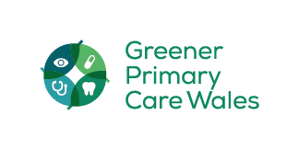
Th
Greener Primary Care Wales
Framework & Award Scheme
Be part of the change in 2023

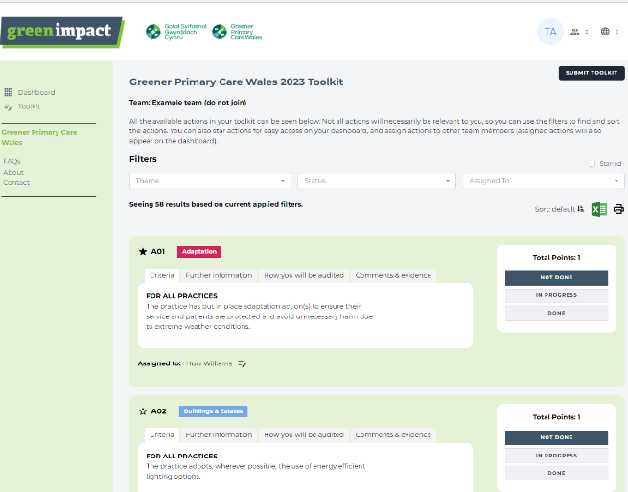
Do you want to do more to help the environment but don’t know where to start?

Would you like something that the whole practice can get involved with?

Are you looking to make your business more efficient?

The Greener Primary Wales Framework and Award Scheme is a collection of actions to support community pharmacy, community dental practice, community optometry and general practice to improve the environmental sustainability of their day-to-day practice and to reach the Welsh Government’s Net Zero target.

Watch this short animation to find out more!

Why you should get involved:
- It’s free!
- Join others taking action and learn from your peers about what works and how easy taking action can be
- You are in control by choosing which actions you’d like to work on
- Actions are clinical and non-clinical meaning the whole team can get involved
- Categories cover all areas of your business and can help make your business more efficient, and in some cases save money
- Endorsed by the Minister for Health and Social Services, the Minister for Climate Change and the Future Generations Commissioner
- Receive a nationally recognised award

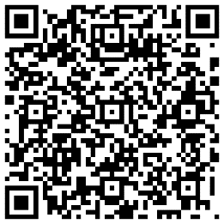
Get involved – register today
Scan the QR code to get started or register here.
For more information on the scheme please visit Greener Primary Care - Primary Care One (nhs.wales) or email greenerprimarycare@wales.nhs.uk

