Exemplar Models:
Ty Elli Practice Model

Exemplar models: Ty Elli Practice Model

Introduction
The Development Matrix for Multi Professional Working support the development of new models of care – to stabilise and develop local services . The Ty Elli Practice in Llanelli responded to significant recruitment challenges by creating new ways of working that benefit the local community and the practice team.

Setting the context
Llanelli has a population of 62 000 and General Practice care is provided by 7 practices that work with local health and care services through the Llanelli Cluster Home | Llanelli Cluster. There is a County Integrated Locality Plan that supports joint working between the Health Board and Local Authority.

Therapy, Social Care and Specialist Nursing workforce are organised at County level and integrated Community Teams are aligned with the Clusters to ensure that care for the local population is coordinated between health and social care teams.

Ty Elli practice has a registered population of over 14 000 and serves a socio economically deprived population, mostly resident in the urban area. In a ranking of GP practices serving the most deprived populations Ty Elli is currently at 116 of 382 practices as just over 30% of their patients are resident in the most deprived 20% of local areas.

31% of the local population is unemployed, with 21% having no recognised qualification. The area has developed from old mining settlements and there remains a legacy of increased prevalence of chronic disease in the local population. It is also notable that over 34% of people who are over 65 years live alone in the community. Despite these significant needs the staffing levels within the practice have historically been 20% below the Hywel Dda average with 35% fewer GPs than in neighbouring Clusters.

The Ty Elli journey
The practice followed a traditional GP led approach, with a strong nursing team and close working relationships with the community nursing teams.

In the early 2000’s GP recruitment was straightforward though there was an increasing reluctance from new partners to buy into the practice premises. As service volume and complexity increased, the team began to introduce new roles and systems, in an attempt to keep pace with demand.

An Advanced Nurse Practitioner quickly established herself within the team, alleviating pressure on access and demonstrating the potential of advanced nursing roles in primary care. 18 months later a Triage Nurse was recruited- reflecting the increased recognition of the importance of effective triage and signposting for patients.

The adoption of a cloud -based telephone system offered additional capacity, comprehensive statistics and dedicated customer service. The data provided allows the practice to anticipate demand and schedule appropriate staffing levels.

Despite a continuing commitment to innovation, a combination of retirements and resignations in 2017 led to a 60% decrease in clinical sessions. GPs were facing escalating demand and chose to move to alternative career roles. These changes were compounded by increasing recruitment difficulties as General Practice was increasingly seen as an unattractive career option. Escalating locum costs threatened the viability of many practices at that time.

Risk management
With the agreement of the Health Board the practice chose to close its practice list for nine months. Enhanced services were reduced or suspended, and GP student training was discontinued.
This period of reflection allowed the practice team to acknowledge the need for significant change to meet the evolving demands. Team members sought out examples of initiatives and role developments from across the UK.

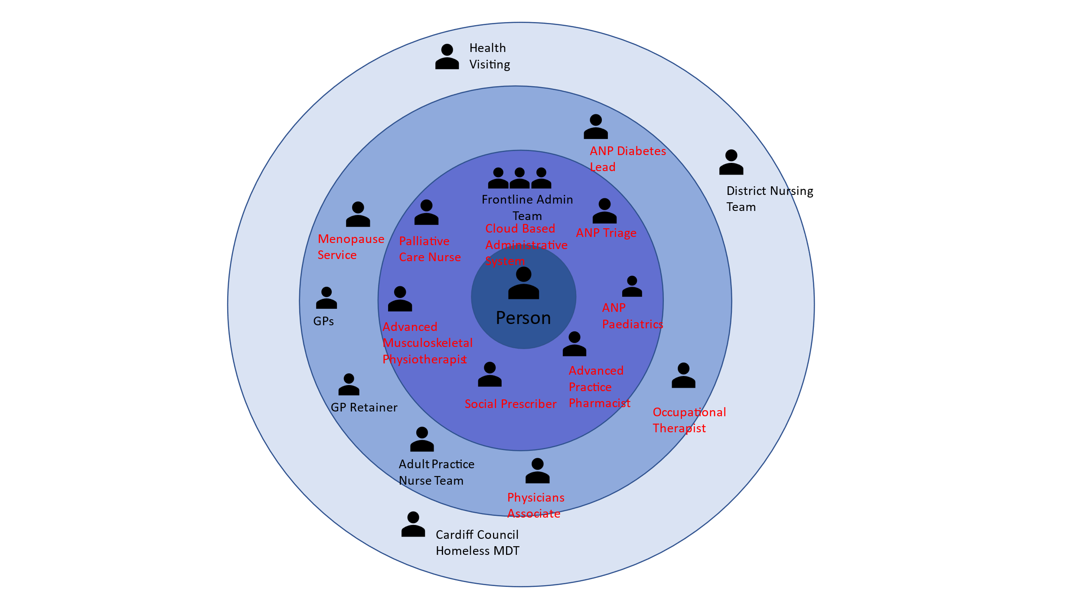
Recruitment of new team members
New roles were introduced to strengthen the practice team. This allowed the GPs to provide longer consultations to ensure holistic, personalised care and has created an innovative team culture.
Patients now have access to a wider range of professionals that they can contact directly. Clear definition of team roles has encouraged a proactive and structured approach to care needs (including chronic diseases and for vulnerable groups such as individuals with Learning Disabilities).

The image illustrates the model, with new roles highlighted in red.
All roles were funded by the practice – some directly employed and others sourced through a service level agreement with the Health Board.
There has been a further service development of a Menopause Service, led by one of the practice GPs.

Benefits
The transformation of the team has significantly reduced workload pressure for GPs. Appointment times have been extended to 15minutes and urgent care demand can be accommodated on the same day.
- All End-of-Life care is coordinated by the lead nurse ensuring consistency and continuity of care.
- Paediatric care is provided by an Advanced Nurse Practitioner with significant experience in paediatrics.
- There is a Diabetes Lead, to provide continuity of care and to ensure that all recommended care processes are completed.
- The Enhanced Service for Learning Disability is now fully managed by the Physicians Associate. The LD Register has been updated and there is s consistent system to schedule appropriate testes and reviews.
- The Occupational Therapist has a significant coordinating role, particularly for palliative care and social prescribing.

Risks
As a reasonably large practice, it was possible for the team to release income from vacant GP sessions to resource new roles. This would be more challenging for smaller practices but could be achieved through shared roles between practices. Uncertainty surrounding the agreement of the GMS contract is a significant risk to the sustainability of the practice team, particularly at a time when other NHS staff have received backdated pay increases.

The limited capacity of GP premises has been recognised for many years. The team has expanded so significantly that District Nursing services can no longer be hosted on site. This is a barrier to closer working, collaboration and communication.

One of the most significant service gaps highlighted by practices is the provision of mental health support.

How does this fit with Cluster working?
Dr Alan Williams has a senior leadership role within the practice and as Cluster Lead for Llanelli Cluster for over 10 years. The Cluster has always embraced a multiprofessional approach. Current priorities include Mental Health, Dementia and Domestic Abuse. Successful developments at practice level are shared between practices and following the role out of MSK physiotherapy the Cluster would be keen to expand the provision of Occupational Therapy across the Health Board area.

Clusters have made significant investments in mental health services, including an ongoing partnership with MIND in Llanelli. In addition to the need to respond to high levels of anxiety and depression, it is increasingly recognised that psychological support is critical to many aspects of wellbeing, engagement with healthy lifestyle choices and the effectiveness of chronic disease management.

What can we learn from this model?
- The practice approached significant challenges with a shared commitment to adapt
- Team members actively sought examples of new ways of working – learning from others
- The practice took a pragmatic approach – recognising that they needed to consider the workforce that was available to them and that a primary care team could be constituted in different ways
- The practice has recruited new roles into the Independent Contractor team – delays to agreement of the GMS contract create a particular risk to sustainability
- Primary care is a complex environment and clinicians often work independently. Clinical experience and advanced practice skills are extremely valuable/ necessary
- The value of the ‘coffee break’- regular opportunities for face-to-face discussion away from immediate service pressures

Where next?
It is anticipated that roles that demonstrate system value will be mainstreamed by the Health Board, and this has already been achieved for the MSK physiotherapy roles.
Estates development will be through portacabins- allowing rapid expansion of affordable clinical space

For any queries or comments please contact Alan.Lawrie@wales.nhs.uk

Development Matrix for MPFW Version 1_.docx (live.com)

