


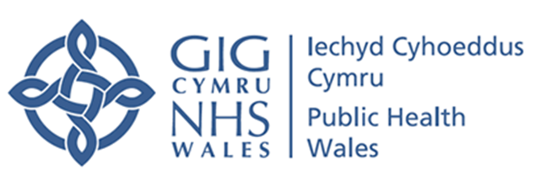
Cluster self-reflection
2024/25
FINAL V1.0 15/08/24
primarycareone.nhs.wales
24/7
STRATEGIC PROGRAMME FOR PRIMARY CARE
Contents
Executive Summary 4
Introduction 5
Context 5
Development of cluster self-reflection 5
Results 6
Respondents 6
Primary Care Model for Wales Maturity 7
Accelerated Cluster Development Maturity 10
Team Development 12
Barriers to Cluster Working 13
Impact of Barriers 15
Overcoming Barriers 16
Enablers to Cluster Working 16
Impact of Enablers 18
Factors which Support Progress 18
Discussion 19
Limitations 22
Opportunities for action 22
1. Improving primary and community care data and insight 22
2. Implementing the Primary Care Model for Wales 22
3. Keeping the strategy under review 23
4. Strengthening clusters 23
5. Shifting resources to primary care 23
6. Developing the evaluation of the Primary Care Model for Wales 24
Acknowledgments 24
Appendicies 25
Appendix 1: PCMW outcomes 25
Appendix 2: ACD outcomes 26
Appendix 3: Development and implementation of the cluster self-reflection process 27
Appendix 4: Statements to measure maturity of cluster working towards the PCMW outcomes 29
Appendix 5: Statements to measure maturity of cluster working towards the ACD outcomes 30
Appendix 6: Tuckman’s stages of team development 31
Appendix 7: Opportunities for action 32
Appendix 8: PCMW Results 33
Appendix 9: ACD responses 37
Appendix 10: Index of Abbreviations 39

Tables
Table 1: Number of clusters per maturity level for all PCMW outcomes 8
Table 2: PCMW outcome 8 Directly accesses services 8
Table 3: PCMW outcome 4 Local service 9
Table 4: PCMW outcome 12 Ease of access to community diagnostics supporting high quality care 9
Table 5: PCMW outcome 7 Safe and quality out of hours care 9
Table 6: All responses against all ACD outcomes 11
Table 7: ACD outcome 7 Empowered clusters with increased autonomy, flexibility, and vision 12
Table 8: ACD outcome 2 Wider range of services delivered across a cluster, meeting population priorities and need, closer to home 12
Table 9: Tuckman’s Model of Team Development 13

Executive Summary
- Cluster self-reflection is one of the measures for monitoring and evaluation of the Primary Care Model for Wales (PCMW) and Accelerated Cluster Development (ACD) and aimed to provide a baseline of the maturity of cluster working and to identify system barriers and enablers
- Forty six of the 60 clusters submitted responses and a wide range of professional groups engaged in the process, providing confidence that the results are representative of the current situation for cluster working in Wales
- The majority of clusters rated themselves as either foundation or developing across all PCMW and ACD outcomes
- No PMW or ACD outcome was identified overall as mature by clusters
- Three outcomes were rated overall as pre-foundation (PCMW outcome 7: Quality Out of Hours, PCMW outcome 12: Ease of access to community diagnostics supporting high quality care and ACD outcome 7: Empowered clusters with increased autonomy, flexibility, and vision)
- Most clusters reported their team development stage as norming (n=26) and only four clusters described their team development as performing
- Five system barriers were identified: funding, engagement, lack of clarity, lack of time and bureaucracy
- 37 out of 46 responses listed funding as a significant barrier to cluster working
- The barriers to cluster working were identified as having a negative impact on innovation, project development and implementation, a negative impact on staff morale and subsequently a negative impact on patients
- Five enablers were identified: ways of working, interprofessional working relationships, leadership, engagement with stakeholders outside of the cluster and the value of individuals
- Clusters identified that increased autonomy to make decisions and manage finances, reduced bureaucracy, access to sustainable resources, agreed and established ways of working, and strengthening the role of the cluster would all strengthen cluster working.

Introduction
This report summarises the outputs from cluster self-reflection at an all-Wales level. Cluster self-reflection aimed to enable cluster leads and cluster members to come together to reflect on their experiences of cluster working and team development, and identify existing barriers and enablers which inhibit or drive cluster working to deliver the Primary Care Model for Wales (PCMW) and achieve A Healthier Wales.

Context
Cluster self-reflection is one of the measures for the monitoring and evaluation of the PCMW. In 2022/23 initial peer review meetings were held to bring together clusters from differing Health Board areas to share and learn. These meetings were identified as being productive, fostering good practice and informing local and national action. It was agreed a further cycle of peer review would be undertaken in 2023/24 along with launching cluster self-reflection and the development of a suite of key indicators, collectively evaluating the progress of clusters in working towards the PCMW.
The PCMW has 13 outcomes (Appendix 1). Cluster self-reflection sought to understand how clusters view their own progress. The process was also identified as an appropriate opportunity to measure the progress of Accelerated Cluster Development (ACD). ACD has seven outcomes (Appendix 2), therefore 20 outcomes are included in cluster self-reflection.

Development of cluster self-reflection
In Autumn 2023, the Primary Care Division (PCD) in Public Health Wales (PHW) established a small project team to develop the cluster self-reflection process, resources and tools. It was agreed that any tool or process needed to be developed in collaboration with colleagues across Wales who are working in and/or with clusters. Meetings and engagement sessions were planned with colleagues during November/ December 2023. The appraoch taken to develop and implement the self-reflection process is available in appendix 3.
Methodology
Cluster self-reflection was launched on 01st April 2024 and was available for clusters to complete over a two month period, closing on 31st May 2024. Clusters were asked to self-reflect against the PCMW and ACD outcomes, reflect on the stage of their cluster teams development and to provide insight on the system barriers and enablers to cluster working. Their reflections were submitted to PHW using an online tool.
Quantitative and qualitative analysis was undertaken on the annonymised data. The quantifiable results from cluster self-reflection include a breakdown of the characteristics of respondents and clusters, and analysis of maturity across the 20 outcomes of the PCMW and ACD.
As this is the first cluster self-reflection, a key aim of quantitative analysis is to establish a baseline measure at an all Wales level for cluster maturity against PCMW and ACD outcomes.
The cluster self-reflection submissions contained six questions (on barriers and enablers) that required a qualitative response. Thematic analysis was used to analyse the participant responses to draw out the main points of discussion and the common themes.

Results

Respondents
Forty six out of 60 clusters across Wales submitted responses and a wide range of professional groups engaged in cluster self-reflection. Cluster leads were engaged in every response received, Health Board colleagues were the next most reported cluster member completing self-reflection, and all four professional collaboratives had input across a number of responses.
The range of engagement from cluster members and the high response rate provides confidence that the results are representative of the current situation for cluster working in Wales.

Primary Care Model for Wales Maturity
Cluster self-reflection sought to understand how clusters view their own progress against 13 outcomes of PCMW. Four stages of maturity were given to each cluster to mark themselves against;
- Mature - The cluster can demonstrate sustained good practice and innovation across the cluster and wider system in this area of work
- Developing - The cluster are /have developed plans and processes and can demonstrate progress in this area of work
- Foundation - Cluster members have common understanding of this area of work
- Pre-Foundation - The cluster has not focused on/ taken forward this are of work
The responses for each PCMW outcome can be found in Table 1. The key findings are as follows:
- The majority of clusters rated themselves as either foundation or developing across all PCMW outcomes
- None of the PCMW outcomes were overall rated as mature
- Pre-foundation was the most frequently reported against 2 outcomes
- Foundation was the most frequently reported against 5 outcomes
- Developing was the most frequently reported against 6 outcomes

Table 1: Number of clusters per maturity level for all PCMW outcomes
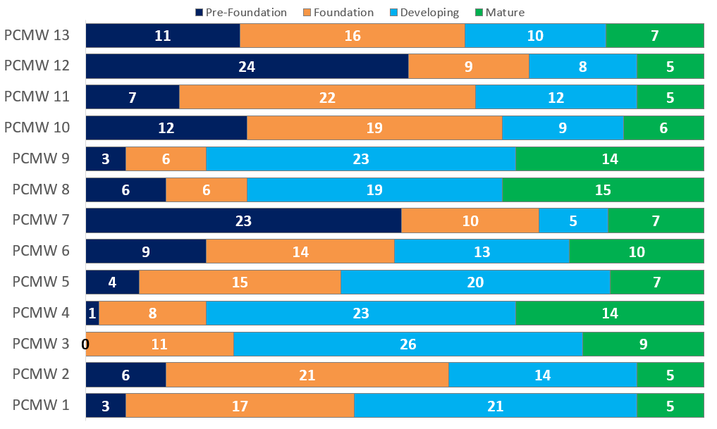
Analysing PCMW outcomes individually, the outcomes reported most frequently as mature were PCMW outcome 8: Directly accessed services (33% of clusters who responded, n=15), followed by PCMW outcome 4: Local Services (31% of clusters who responded, n=14).
Table 2: PCMW outcome 8 Directly accesses services

Table 3: PCMW outcome 4 Local service

Two outcomes saw over 50% of clusters reporting as pre-foundation. These were PCMW outcome 12: Ease of access to community diagnostics supporting high quality care (n=24), and PCMW outcome 7: Safe and Quality Out of Hours (n=23), suggesting that these areas require further focus.
Table 4: PCMW outcome 12 Ease of access to community diagnostics supporting high quality care
Table 5: PCMW outcome 7 Safe and quality out of hours care

Accelerated Cluster Development Maturity
Cluster self-reflection sought to understand how clusters view their own progress against the seven ACD Outcomes. Four stages of maturity were given to each cluster to mark themselves against:
- Mature - The cluster and strategic partners can demonstrate sustained good practice and innovation across the system
- Developing - The cluster and strategic partners are/ have devleoped plans and processes, and progress is being made
- Foundation The cluster and strategic partners have a common understanding of this element of ACD
- Pre- Foundation - The cluster are not aware that progress has been made
The responses for each ACD outcome can be found in Table 6. The key findings are as follows:
- The most reported stage of maturity across all ACD outcomes is either foundation or developing
- ACD outcomes 1, 3, 4 and 6 were identified as mature by three or less clusters
- None of the ACD outcomes were reported overall as mature
Table 6: All responses against all ACD outcomes
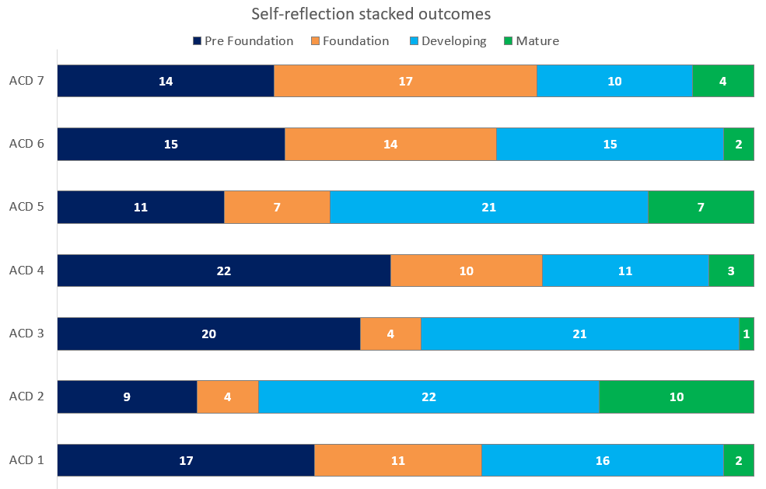
Key: Clusters self-reflected level of maturity
Mature
Developing
Foundation
Pre-Foundation
Analysing ACD outcomes individually, ACD Outcome 7: Empowered clusters with increased autonomy, flexibility and vision was the outcome with the highest percentage (37% of clusters who responded, n=17) of clusters identifying themselves as pre-foundation, suggesting this is the least progressed outcome in realising ACD across Wales.

Table 7: ACD outcome 7 Empowered clusters with increased autonomy, flexibility, and vision

No ACD outcome was identified overall as mature by clusters. Furthermore, asides from ACD Outcome 2: Wider ranges of services delivered across a cluster, meeting population priorities and need, closer to home, all outcomes placed mature as the least reported response.
Table 8: ACD outcome 2 Wider range of services delivered across a cluster, meeting population priorities and need, closer to home

Team Development
Tuckman’s model of team development describes four stages: forming, storming, norming and performing. Most clusters reported their team development stage as norming (n=26). This stage is described as the emergence of harmony where members feel able to openly express ideas and opinions. Only four clusters described their team development as performing. This suggests that for the majority of clusters, team development is ongoing.
Table 9: Tuckman’s Model of Team Development

Barriers to Cluster Working
Clusters were asked to reflect on the primary and community care systems in their region and what the biggest barriers to effective cluster working are. Five barriers to cluster working were identified including:
- Funding
- Engagement
- Lack of clarity
- Lack of time
- Bureaucracy
37 out of 46 responses listed funding as a significant barrier to cluster working. Across responses current funding models and arrangements were identified as negatively affecting clusters’ ability to progress. Many responses reflected that need and demand are increasing within primary care but funding has remained static. Generally funding is short term and this is affecting the clusters’ ability to retain staff, mainstream projects and free up cluster budgets for innovation, progress projects and /or deliver sustainable primary care services or drive transformation.

Engagement, lack of clarity and time were also reflected as strong barriers to progressing cluster working. Generally within the feedback these three barriers were closely linked and discussed collectively. There seems to be a general lack of clarity of the unique role and purpose of clusters following the introduction of professional collaboratives and Pan Cluster Planning Groups. Many responses noted clusters are lacking a clear aim, objective, purpose, role and/or understanding of clusters and cluster working.
“The biggest barrier to date has been a lack of shared understanding of the vision, aims and purpose of cluster working. There is a lack of clarity on the extent of the ability of clusters to make financial decisions.”
“Widening the scope of clusters, from being primarily GMS led, to encompass the entirety of primary care, has resulted in a loss of purpose, drive, and interest.”
“Financial constraints - budget, mainstreaming projects and bid approval process. Large proportion of cluster budget is tied up in legacy projects, constraining the potential to introduce new projects and initiatives, and new ways of working.”
Lack of engagement from cluster members, professional collaboratives, practices, and /or social care is inhibiting effective cluster working. Responses suggest contractual concerns, sustainability, digital infrastructure, data, apathy and communication between groups and individuals are reasons for low engagement.
“Constrained engagement across the collaboratives with uncertainty as to how the collaboratives can contribute to effective cluster working if they are unable to introduce new ideas or move anything forward.”
Time to attend cluster meetings, to undertake effective cluster working and deliver successful projects was a common theme across responses. Renumeration for time was also seen as a barrier as well as a perceived lack of consideration of the demand placed on specific roles within cluster working, e.g. cluster lead. Many respondents reflected that good will of cluster members is often required.
Bureaucracy was reflected across responses as a significant barrier to effectively progressing cluster working. Mainstreaming of projects, cluster funding, a lack of understanding about what is and is not a suitable cluster project, contractual limitations, perceived lack of autonomy and Health Board processes were cited as making it difficult to effectively plan or deliver projects at a cluster level. In some instances, the implementation of the ACD programme and its additional structures has posed or exacerbated some challenges of cluster working. Bid processes, employment options, contract reform or contractual limitations, equitable distribution of resources and restrictions on spending all limit the opportunities to progress cluster working effectively.
“The biggest barrier in the 2 years since I took on the post of [XXX] Cluster is the additional bureaucracy involved in the Accelerated Cluster Development Programme. This has exacerbated rather than mitigated many of the pre-existing challenges involved in working in the cluster space.”
“The Pan Cluster Planning Group is a forum without focus or levers to instigate change.”
“The necessity to spend money within one financial year limits the ability to recruit good staff and run sustainable services.”
“Cluster leads are employed for one day a week. Were they to attend all the meetings they are invited to even before the ACD programme they would easily use up all of their allocated day.”
“Another important barrier is time for all involved to attend regular meetings.”

Impact of Barriers
Clusters were asked to consider the impact that the barriers were having on cluster working in their region. Responses included negative impact on innovation, project development and implementation. Most respondents reflected projects stagnated, projects were being prevented from developing or continuing, and that in turn resulted in new projects being stalled or not progressed. With project development stalling, innovation, new ways of working or transforming services cannot be realised.
Negative impact on staff morale was a theme regularly reported. Disengagement from meetings, high staff turnover, low application numbers, constrained working environments, and frustration affect relationships and inhibit new ways of working. These were all identified as the impacts of the ongoing barriers to develop and progress effectively as a cluster.
A number of responses reflected that a lack of progress within projects, bureaucracy, and funding limitations are preventing work from progressing and which consequently has a negative impact on patient care. Widening inequalities, increased inequity of services, resources and access, and clunky referral mechanisms are inhibiting progress which could benefit the health and wellbeing of population groups.

Overcoming Barriers
Cluster self-reflection sought to identify how clusters are overcoming barriers. The majority of responses reflected the barrier had not or had partially been overcome. Some responses reflected working relationships, engaged partners, trust, good communication, face to face interactions and support from the wider system (Health Board, Regional Partnership Boards (RPB) etc.) are actions which can help overcome some of the barriers to effective clusters working.

Enablers to Cluster Working
Analysis of the cluster self-reflection submissions, highlighted five key enablers to effective cluster working in Wales:
- Ways of working
- Interprofessional working relationships
- Leadership
- Engagement with stakeholders outside of the Cluster
- The value of individuals
The most frequently cited enabler came under the umbrella category/term of ‘ways of working’. This included themes such as communication, the ACD programme, allocated funding, and a shared understanding of a common objective. More than half of the respondents believed that these themes contributed positively towards cluster working.
The second most frequently cited enabler was interprofessional working relationships within clusters. The value of the multi-disciplinary team and professional collaborative participation was particularly noted, as was the need for transparency and trust in relationship building.
“Relationships are being developed across collaboratives for the first time - positive engagement at a Collaborative Lead Level – with each collaborative being represented at Cluster Meetings.”
“Getting the right representation around the table and commitment to working together for the benefit of the local population.”
“Proactively building good working relationships that are inclusive and transparent in engaging Primary Care contractors and listening to them to understand the challenges faced by each.”

“Effective communication is key; this is achieved through joined up cluster working across all services and hard work to develop positive working relationships.”
“Protected time, constructive discussions and therefore plans.”
The importance of leadership was also deemed to be a key factor for successful cluster working. Just under half of respondents cited this within their reports. This included the leadership of both professional collaborative leads and cluster leads.
“A well organised cluster meeting which runs smoothly and giving each collaborative time to give updates seems to work well.”
“Strong leadership from the cluster leads to coordinate and engage with all of the different partners drive forward priorities and agenda.”

In addition to the interprofessional relationships within clusters, engagement with stakeholders outside of the cluster was also deemed to be an important factor for several of the respondents. Stakeholders which were mentioned included the local Health Board, Local Authority, condition-specific directorates within Health Boards, and other non-health services.
The final enabler to effective cluster working was found to be the value of individuals within the cluster, specifically the knowledge, skills, positive attitude and experience they brought to the team.
“Better awareness of other (non-health) services and linking in with them.”
“Very effective working relationships with Allied Health professional (AHP) and Mental Health directorate in particular. Engaged partners with a common goal.”

“The biggest enabler remains the enthusiasm and commitment of the people working within the service. The enthusiasm and commitment of the teams involved has meant we have continued to deliver existing projects and develop new ideas though within the limitations outlined previously.”
“The individual personalities of those engaged creates motivation and enthusiasm.”

Impact of Enablers
The survey also asked clusters to consider what impact the enablers were having on cluster working in their region. Responses included the opposite to some of the impacts of barriers outlined in this report, such as supporting innovation, progressing work and being able to make changes at a local level. These impacts were noted despite barriers being present.
Improved communication and the enablement of joint working were also noted as other key impacts from the enablers discussed. Developing positive working relationships was reported to facilitate the development of projects across multiple professional and contractual boundaries. Joined-up working was also conducive to driving forwards the priorities and aims of the cluster.
Ultimately the enablers allowed clusters to deliver improved patient care such as providing support services in a person’s local community and facilitating direct access into services without the need for signposting via another healthcare professional.

Factors which Support Progress
Cluster self-reflection also sought to identify what would help clusters to continue to develop and/or function more effectively towards the Primary Care Model for Wales. Several factors were identified including: being given increased autonomy to make decisions and manage finances; reducing the amount of bureaucracy involved at all levels; access to sustainable resources such as funding, time to participate in cluster work and employment opportunities; agreed and established ways of working; and strengthening the role of the cluster.

Discussion
Forty six clusters in Wales engaged in cluster self-reflection during 2024/25, which has provided a baseline for cluster maturity against the PCMW and ACD outcomes.
For both the PCMW and ACD the most reported level of maturity across all outcomes was either foundation or developing. Positively, this suggests across all PCMW and ACD outcomes effort and progress is being made by clusters in Wales across both models. However, no outcome for either PCMW or ACD was rated as mature as the highest reported stage of progress. This implies there may be some areas where further investment and strategic support for primary care in Wales should be considered.
The findings from the quantitative section of cluster self-reflection identified that the least progressed outcomes of the PCMW are outcome 12: Ease of access to community diagnostics supporting high quality care and outcome 7: Safe and Quality out of hours. It was felt that some areas of the PCMW are outside the control of clusters and require collective input from across the primary care system and/ or actors. These findings highlight where further focus may be required on a once for Wales approach to support clusters in progressing in maturity.
Where sustained and good progress can be evidenced is on outcome 8: Directly accessed services, outcome 4: Local services and outcome 9: Integrated care for people with multiple needs. These received the highest number of clusters reflecting mature as their level of progress. Further work on understanding what actions, innovation and ongoing good practice clusters are delivering could provide opportunities for sharing learning and identifying examples of best practice across Wales.
ACD was identified as both an enabler and barrier to cluster working. Some respondents reflected ACD was a model to monitor development against providing knowledge and guidance. But, for others ACD has confused the system, with further clarity on the role and specific purpose of the cluster in the ACD structure needed. Articulating the specific role and responsibility of clusters may be of benefit to supporting cluster working in Wales.
ACD outcome 2: Wider range of services delivered across a cluster meeting population priorities and need, closer to home is the only ACD outcome where mature was not the lowest reported stage of progress. Suggesting, across ACD there are opportunities on a once for Wales basis to support clusters and the wider cluster system in progressing ways of working in line with ACD.
ACD outcome 7: Empowered clusters with increased autonomy, flexibility and vision is the only outcome where the majority of clusters (37%) identified themselves as pre-foundation across all 20 outcomes. The narrative within the qualitative responses to barriers of cluster working strengthen this finding. Further work on empowered cluster working would be of benefit across Wales.
Finance and/ or funding was the most reported barrier to cluster working (n=37). Responses reflected progress or innovation stalling due to demand on services increasing whilst the funding model remains static. Includign where projects that have proved to be effective are not mainstreamed to release the cluster funds to test further new models. However, 17 clusters in Wales identified themselves as developing (n=10) or mature (n=7) for PCMW outcome 13: Finance systems designed to drive whole system transformative change. This suggests that some clusters and the cluster development/ ACD teams are actively working to influence within their organisation and have been able to overcome in part the barriers to finance and funding. Work to identify what sustained practice and innovation at cluster level is currently ongoing could be useful, with a focus on what were the specific actions taken to overcome finance and funding barriers.
Other barriers included lack of engagement, time limitations, bureaucracy and a lack of clarity. To support clusters in effectively progressing against the PCMW and ACD, clarity of their role and purpose, support to engage the cluster workforce, and the autonomy and time to undertake cluster working should be considered. Similar themes were identified for factors which support progress which strengthens these findings.
The most reported enablers included ways of working, working relationships (between cluster members), engagement with external partners, leadership, and individual skills, knowledge and experiences. These identified enablers suggest the key to thriving cluster working is having the right people engaged. Similarly, the identified themes for overcoming barriers supports these findings and strengthens the case for investment in the cluster workforce to progress cluster working. Therefore a focus on strengthening cluster working and implementation of the PCMW across Wales should continue.
The impacts of barriers on cluster working are reinforced by the themes identified within the impact of enablers on cluster working. Negative impacts included; innovation, project development and implementation stalled or stopped, reduced staff morale, low staff retention, lack of engagement from cluster members and the wider system, and consequences for patient care. Whereas the factors which support progress strengthen the narrative that increased autonomy over decisions and finances, reduced bureaucracy, sustainable resources, established ways of working and strengthening the role of clusters can help clusters to continue to develop and /or function more effectively towards the PCMW and deliver ACD.
The key themes identified within this report which have potential to strengthen the function, efficiency and development of cluster working in Wales and support progress against PCMW and ACD are centred around empowering and investing in the cluster structure and its workforce. Finance is a significant barrier which requires consideration to increase autonomy of clusters and enable cluster projects and innovation to progress. Published evidence on the factors and enablers which support systems working support the findings of custer self-reflection.
Further development of work to articulate and communicate the unique role of clusters and professional collaboratives is important as cluster working continues to mature, with particular focus on the role of clusters within strategic aims and objectives for Health Boards and their partners in RPBs. Engaging with partneres on the roles and remits of clusters and professional collaboratives within the primary care system will also support clusters in effectively progressing.

Limitations
The risk of bias is likely due to the nature of self-reflection. Observer bias, reporting bias and recall bias for both quantitative and qualitative results is likely.
Variation on how clusters undertook self-reflection is likely. The approach was not mandated. Who engaged and how cluster self-reflection was facilitated across Wales will differ.
Analysing results at an All Wales level could potentially hide or mask regional nuances which are significant influences on cluster working at a local level but have not been drawn out within themes at a national level.
Over 75% of clusters responded to cluster self-reflection, this is a significant response rate that allows for generalisability, however, nearly a quarter of clusters in Wales and their experiences of cluster working have not been considered within this report. It was also noted that responses in relation to PCMW outcome 13 and ACD outcomes 2 and 7 were incomplete i.e. maturity ratings were not received from all 46 clusters.

Opportunities for action
The following opportunities for action have been developed based on the insight gathered through the self-reflection process. Where applicable, they have been themed to align with the recommendations of the 2023/24 peer review discussions and the 2019 Auditor General for Wales report ‘Primary Care Services in Wales’. Appendix 7 provides an overview with suggested timescales for action.

Improving primary and community care data and insight
- Health Boards to facilitate, and support clusters in annual cycles of self-reflection to provide assurance of the progress of cluster working

Implementing the Primary Care Model for Wales
- Public Health Wales (PHW) and Strategic Programme for Primary Care (SPPC) to further refine the PCMW and ACD maturity matrix, to better reflect multi-professional cluster working
- Health Boards and clusters to collectively consider the identified barriers, and explore potential solutions both local and where national engagement is required
- SPPC, PHW and Health Education and Improvement Wales (HEIW) to strengthen and communicate opportunities to share and promote examples of innovation and ongoing good practice clusters are delivering, including through the Primary Care One website and HEIW Primary and Community Care Compendium of Roles and Models website

Keeping the strategy under review
- Health Boards and clusters to consider the organisational development needs of the cluster and the professional collaboratives, and putting in place mechanisms for individual and team development
- Health Boards and clusters to consider ways to strengthen the working relationships and communications with strategic partners including within the Health Board and with pan-cluster planning groups (PCPG), and Regional Partnership Boards (RPB)
- Welsh Government, Health Boards and SPPC to consider a review of the recommended time allocation for the cluster lead and professional collaborative lead roles, to determine if this adequate for the leads to fulfil their responsibilities

Strengthening clusters
- SPPC and PHW to strengthen communication of the role and remit of clusters and professional collaboratives in Wales
- Health Boards and clusters to explore ways of identifying and strengthening the local mechanisms that can enable clusters to become autonomous, empowered, and innovative entities
- Welsh Government, Health Boards and SPPC to maintain a focus on strengthening cluster working and implementation of the PCMW across Wales

Shifting resources to primary care
- Welsh Government, Health Boards, SPPC and clusters to consider ways to mitigate against the current finance and funding barriers experienced by clusters

Developing the evaluation of the Primary Care Model for Wales
- Clusters should engage with future self-reflection cycles, providing insight in ways to strengthen cluster working and to inform the evaluation of PCMW

Acknowledgments
Thank you to all colleagues who participated in the cluster self-reflection process.

Appendicies

Appendix 1: PCMW outcomes
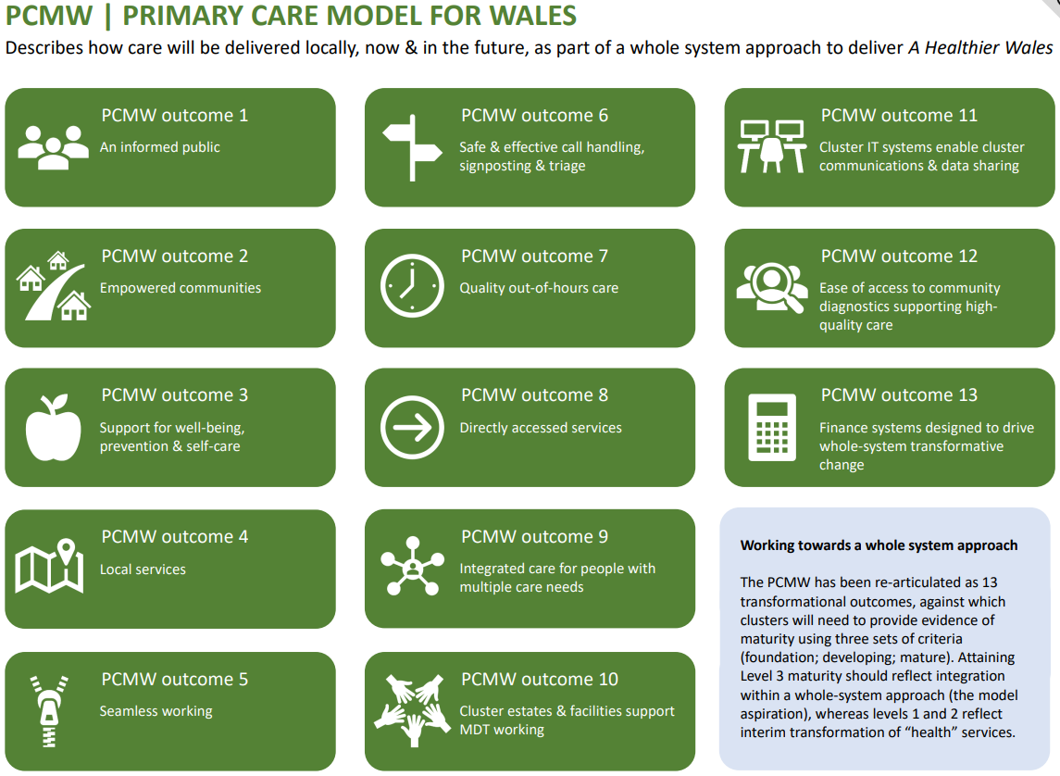

Appendix 2: ACD outcomes
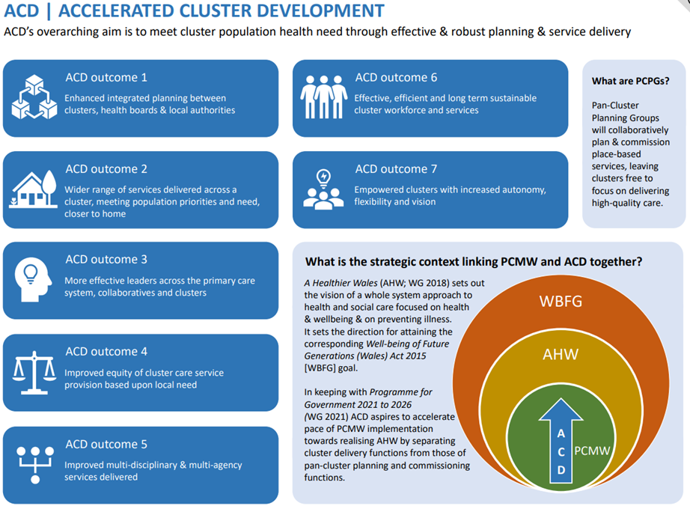

Appendix 3: Development and implementation of the cluster self-reflection process
As a starting point the project team undertook an initial scoping of evidence on self-reflection. Several models for self-reflection were identified and reviewed. The Gibbs Reflective Model and Driscoll’s Model of Self-Reflection were identified as two approaches appropriate for collective self-reflection. Both had strong evidence bases and were already well known as approaches applicable for health care settings and workforces. The project team favoured Driscoll’s Model of Self-Reflection due to its simplicity.
The aim of the engagement sessions and meetings with colleagues was to identify if the project team’s assumption was correct, and if the models identified were appropriate, should be adapted or was a completely new model required. Generally, the models were well received and the consensus was to keep the process as simple as possible, therefore Driscoll’s Model was agreed.
Early in the scoping process a risk was identified by the project team regarding the capacity of clusters to complete the self-reflection process. It was deemed impractical for cluster teams to apply the self-reflection approach to 20 separate outcomes, and given the time commitment, concerns were raised regarding engagement with the process.
A number of different approaches to mitigate the risk were considered including theming PCMW outcomes into three headings and undertaking self-reflection on a small number of the 20 outcomes on a rotation basis. These approaches were identified as unsuitable, as neither would provide a comprehensive overview of the PCMW / ACD outcomes, and comparing results against future self-reflection would not evidence progression or maturity across Wales.
The approach agreed was to break down cluster self-reflection into three sections.
Section one: PCMW and ACD outcomes
  - Scaling questions against each PCMW and ACD outcome using four levels of maturity (pre-foundation, foundation, developing and mature)
  - Statements were developed to reflect the four levels of maturity and respondents asked to mark their current position against each outcome (Appendix 4 and 5)
Section two: System Barriers and Enablers
  - Driscoll’s Model of Self-reflection was recommended for undertaking this section
  - Three questions to elicit the enablers and barriers to cluster working were used to guide clusters in understanding which factors are supportive and which factors inhibit cluster working
Section three: Team Development
  - Following engagement sessions, it was felt including an opportunity for clusters to reflect on themselves as a team would be useful. This would be useful for cluster discussions and provide insight when analysing previous sections of cluster self-reflection.
Feedback from the engagement sessions varied but generally it was felt this method was appropriate. From the meetings it became apparent that approaches to cluster self-reflection would vary between clusters and Health Boards. Following engagement sessions the project group agreed control over how clusters approach and undertake self-reflection was outside the remit of this project but providing the tools and options in undertaking self-reflection was in scope. The cluster self-reflection process document was developed alongside the cluster self-reflection tool. Varying approaches to collecting self-reflection were included, each advocating that all cluster members were given opportunity to feed in.
Tuckman’s Team Development model was amended to support clusters to identify where they are in the stages of team development. Scenarios were provided to clusters using cluster working examples to help teams assess which stage of team development they are (Appendix 5). The link to the full Tuckman’s Team Development questionnaire was shared within cluster self-reflection process document, should clusters wish to explore team development further.
In January 2024, a draft cluster self-reflection tool was shared with colleagues for feedback and changes were made accordingly.
Microsoft Forms was chosen to host the cluster self-reflection tool as it was easy to use, accessible to all, and could be structured to present self-reflection in sections.
It was identified that communications with specific colleagues in clusters would be required to cascade the Microsoft Form. Following advice from the PHW communications team, a communications plan was developed which aimed to cascade relevant information to specific workforces in a timely and informative way. Established mailing lists and communication routes were utilised for this purpose. Three communication emails were sent in advance of cluster self-reflection launching and one reminder email sent a month after launch. These were sent via:
  - Cluster leads via Strategic Programme for Primary Care (SPPC)
  - Cluster Development Officers via Cluster Development Support Officer Network (CDSON)
Following the closure of cluster self-reflection on 31st May 2024 quantitative and qualitative data were separated and exported into Excel spreadsheets for analysis by the project team.
The submissions were equally divided between three members of the Primary Care Team, Public Health Wales, who independently reviewed the data. During this first stage of analysis, any data that included identifiable information was deleted and themes were identified. The second stage of analysis involved the three reviewers collectively discussing and comparing the identified themes. Where there were discrepancies in the themes identified, consensus was gained through discussion. The quantitative and qualitative analysis results were reviewed collectively, and a narrative of the key themes were written into this report.
A process evaluation survey was also sent to participants. This sought to gather feedback on the cluster self-reflection process and communications. The process evaluation results will be used to improve and update the cluster self-reflection tool and communications for the 2025/26 process.

Appendix 4: Statements to measure maturity of cluster working towards the PCMW outcomes
 | The cluster has not focused on / taken forward this area of work. | Cluster members have a common understanding of this area of work. | The cluster are / have developed plans and processes and can demonstrate progress in this area of work. | The cluster can demonstrate sustained good practice and innovation across the cluster and wider system in this area of work.
An Informed Public
Empowered communities
Support for well-being, prevention & self-care
Local Services
Seamless working
Safe & effective call handling, signposting & triage
Quality out-of-hours care
Directly accessed services
Integrated care for people with multiple care needs
Cluster estates & facilities support multi-professional working
Cluster IT systems enable cluster communications & data sharing
Ease of access to community diagnostics supporting high-quality care
Finance systems designed to drive whole-system transformative change

Appendix 5: Statements to measure maturity of cluster working towards the ACD outcomes
 | The cluster are not aware that progress has been made. | The cluster and strategic partners have a common understanding of this element of ACD. | The cluster and strategic partners are/ have developed plans and processes, and progress is being made. | The cluster and strategic partners can demonstrate sustained good practice and innovation across the system.
Enhanced integrated planning between clusters, Health Boards & Local Authorities
Wider range of services delivered across a cluster, meeting population priorities and need, closer to home
More effective leaders across the primary care system, collaboratives, and clusters
Improved equity of cluster care service provision based upon local need
Improved multi-professional & multi-agency services delivered
Effective, efficient, and long-term sustainable cluster workforce and services
Empowered clusters with increased autonomy, flexibility, and vision

Appendix 6: Tuckman’s stages of team development
Tuckman’s stages | Definition | Examples within a cluster
Forming | During this stage, team members establish interpersonal relationships, become familiar with the assigned task, and create ground rules. | - Membership of the cluster has changed and there is a mix of new and old members, or the cluster remains predominantly GMS focused.  - Some cluster roles remain vacant, or attendance is inconsistent.  - Working relationships are in the early stages of development.  - Members do not understand their role in cluster planning and delivery and/or the cluster purpose is not clearly understood.
Storming | This stage marks a time of intragroup conflict due to a lack of group unity. Team members still see themselves as individuals rather than as part of a team and they may resist the formation of a group structure in favour of expressing their individuality. | - Cluster members feel there is a lack of equal engagement and influence between members.  - Members attendance and active engagement at cluster meetings is variable.  - Members feel frustrated, and some are disengaging from the cluster.
Norming | This stage is characterised by the emergence of group harmony where group members begin to openly express ideas and opinions. Members begin to accept each other for who they are, and task-related conflicts are avoided to preserve harmony. | - Cluster meetings are well attended, and members are actively engaged.  - Cluster members understand their role and that of others in the cluster.  - Cluster members feel respected and trusted by others.  - All cluster members share their knowledge and expertise into priority setting and planning.  - New and innovative ways of working are emerging within the cluster.
Performing | This stage reflects a period of productive collaboration in which members demonstrate support for each other and assume roles that will enhance task activities. Constructive attempts are made to resolve any issues related to the completion of project tasks. | - All cluster members share a common vision and purpose for their cluster.  - All cluster members consistently contribute to and collectively deliver the agreed clusters plans.  - Members recognise the valued contribution that each of them brings to the cluster.  - Cluster members understand their role in the primary and community care system and actively engage with strategic partners.

Appendix 7: Opportunities for action
Opportunities for action | Lead organisation/s | Timescale
Health Boards to facilitate, and support clusters in annual cycles of self-reflection to provide assurance of the progress of cluster working | Health Board | April 2025
PHW and SPPC to further refine the PCMW and ACD maturity matrix, to better reflect multi-professional cluster working | PHW / SPPC | December 2025
Health Boards and clusters to collectively consider the identified barriers, and explore potential solutions both local and where national engagement is required | Health Boards/ Clusters | March 2025
PHW, SPPC and HEIW to strengthen and communicate opportunities to share and promote examples of innovation and ongoing good practice clusters are delivering, including through the Primary Care One website and Health Education and Improvement Wales (HEIW) Primary and Community Care Compendium of Roles and Models website | PHW/ SPPC/ HEIW | December 2024
Health Boards and clusters to consider the organisational development needs of the cluster and the professional collaboratives, and putting in place mechanisms for individual and team development | Health Boards/ Clusters | March 2025
Health Boards and clusters to consider ways to strengthen the working relationships and communications with strategic partners including within the health board and with pan-cluster planning groups (PCPG), and Regional Partnership Boards (RPB) | Health Boards/ Clusters | June 2025
Welsh Government, Health Boards and SPPC to consider a review of the recommended time allocation for the cluster lead and professional collaborative lead roles, to determine if this adequate for the leads to fulfil their responsibilities | Welsh Government/ Health Boards/ SPPC | 2025/26
SPPC and PHW to strengthen communication of the role and remit of clusters and professional collaboratives in Wales | SPPC/ PHW | December 2025
Health Boards and clusters to explore ways of identifying and strengthening the local mechanisms that can enable clusters to become autonomous, empowered, and innovative entities | Health Boards/ Clusters | March 2025
Welsh Government, Health Boards and SPPC to maintain a focus on strengthening cluster working and implementation of the PCMW across Wales | Welsh Government/ Health Boards/ SPPC | 2025/26
Welsh Government, Health Boards, SPPC and clusters to consider ways to mitigate against the current finance and funding barriers experienced by clusters | Welsh Government/ Health Boards/ SPPC | 2025/26
Clusters should engage with future self-reflection cycles, providing insight in ways to strengthen cluster working and to inform the evaluation of PCMW | Clusters | April 2025

Appendix 8: PCMW Results

Appendix 9: ACD responses

Appendix 10: Index of Abbreviations
ACD Accelerated Cluster Development
CDSON Cluster Development Support Officer Network
HB Health Board
HEIW Health Education and Improvement Wales
LA Local Authority
PCD Primary Care Division
PCMW Primary Care Model for Wales
PCPG Pan-Cluster Planning Group
PHW Public Health Wales
NHS Exec NHS Executive
RPB Regional Partnership Board
SPPC Strategic Programme for Primary Care
WG Welsh Government

Primary Care Model for Wales
Welsh Government. A healthier Wales: long term plan for health and social care. 2018
Lugten et al. From fragility to resilience: A systems approach to strengthen primary health care Frontiers | From fragility to resilience: A systems approach to strengthen primary health care (frontiersin.org)
Koorts et al. Systems approaches to scaling up: a systematic review and narrative synthesis of evidence for physical activity and other behavioural non-communicable disease risk factors https://ijbnpa.biomedcentral.com/articles/10.1186/s12966-024-01579-6
Stansfield et al. What are the elements of a whole system approach to community-centred public health? A qualitative study with public health leaders in England’s local authority areas https://bmjopen.bmj.com/content/10/8/e036044#F1
Auditor General for Wales report ‘Primary Care Services in Wales’. 2019. Available at Primary care services in Wales | Audit Wales (wao.gov.uk)
Gibbs G (1988). Learning by Doing: A guide to teaching and learning methods. Further Education Unit. Oxford Polytechnic: Oxford.
Driscoll's Model of Reflection (nursinganswers.net)

