

primarycareone.nhs.wales
Cluster Self-Reflection Process Guide
V1 January 2025

24/7
STRATEGIC PROGRAMME FOR PRIMARY CARE
Contents

Executive Summary 3
1. Cluster self-reflection process 4
1.1 Outline of arrangements 4
2. Approaches to self-reflection 4
3. Cluster self-reflection steps 5
3.1 Self-reflection on the progress of cluster working against the PCMW outcomes: 5
3.2 Self-reflection on the progress of cluster working against the ACD outcomes: 5
3.3 Qualitative questions 5
4. Time frame 6
5. Monitoring and evaluation 6
6. Appendices 7
6.1 Appendix 1: PCMW and ACD outcomes 7
6.2 Appendix 2: Statements to measure maturity of cluster working towards the PCMW outcomes. 8
6.3 Appendix 3: Statements to measure maturity of cluster working towards the ACD outcomes. 9
6.4 Appendix 4: Participant information sheet 10

Index of abbreviations
ACD Accelerated Cluster Development
PCMW Primary Care Model for Wales
PCPG Pan-cluster planning groups
RPB Regional Partnership Board
SPPC Strategic Programme for Primary Care

Executive Summary

- Cluster self-reflection is one of three agreed methods to evaluate cluster working towards the Primary Care Model for Wales (PCMW) and Accelerated Cluster Development (ACD), alongside cluster peer review and the PCMW key indicators (under development).
- Cluster self-reflection aims to:
  - Understand the maturity of cluster working across Wales
  - Identify system level barriers or enablers which affect cluster working.
- The cluster self-reflection process focuses on four areas:
  - Self-reflection on the progress of cluster working against the PCMW outcomes
  - Self-reflection on the progress of cluster working against the ACD outcomes
  - Reflection on the role and purpose of clusters and
  - The time required to effectively undertake cluster activities.
- Cluster self-reflection is not a performance measure of clusters. It is an approach to reviewing and thinking analytically about our own actions, and the practice is supported across regulators codes of practice.
- All clusters in Wales are expected to complete the annual cluster self-reflection process.
- Ideally the cluster self-reflection will be undertaken as part of a facilitated discussion, including all cluster members or representation from the broad range of professionals within the cluster.
- Clusters will receive the cluster self-reflection process document, and a link to the online survey in readiness for the survey opening on 1st April 2025.
- Clusters will have eight weeks to complete self-reflection process and complete the online survey. The survey will close on 31/05/2025. Only one submission per cluster is required.
- Submissions will be collated, anonymised, and analysed by the Primary Care Division, Public Health Wales and fed back through the National Primary Care Board and Strategic Programme Board governance processes.
- Cluster self-reflection findings will support the annual cluster peer-review process that is due to commence Autumn 2025.

1. Cluster self-reflection process

1.1 Outline of arrangements
All clusters in Wales are expected to complete the annual cluster self-reflection process. It is proposed that the cluster self-reflection be undertaken as part of a facilitated discussion. Ideally, this discussion should include all cluster members or representation from the broad range of professionals within the cluster. However, it is appreciated several factors would affect the levels of engagement available. Therefore, if this is not possible the cluster lead or a nominated deputy should complete the cluster self-reflection.
The findings from the self-reflection discussion should be submitted to the Primary Care Division, Public Health Wales, using the online survey tool. Only one online submission per self-reflection cycle is required per cluster. Evidence of how the self-reflection process was carried out is not required.
The cluster self-reflection process document, the Cluster Development Framework (which contains the maturity matrix) and the link to the online survey will be available on the Primary Care One website, within the Primary Care Model for Wales page.

2. Approaches to self-reflection
Clusters and health boards can agree the method they wish to use to undertake the cluster self-reflection discussion. Suggested approaches include:
- Facilitated discussion: A facilitated discussion utilises an external person who will support a group of people in their thinking, planning and decision-making processes. For some clusters it may be beneficial to have health board support to facilitate the cluster self-reflection discussion. Ideally the facilitated discussion will include all members or representation from a broad range of professionals within the cluster.
- Collective discussion: Where facilitator support is not available, the cluster lead may choose to chair the cluster through a self-reflection discussion. Ideally the discussion will include all members or representation from a broad range of professionals within the cluster.
- One to one / small group discussion: Where collective discussion is not possible, a one to one or small group approach to cluster self-reflection may be of benefit. Cluster leads may want to work with the health board or a small number of cluster members to complete cluster self-reflection process.
- Single nominated person: Where all forms of collaborative cluster self-reflection are not available to the cluster, the cluster lead, or a nominated deputy will complete the cluster self-reflection process on their own. Requesting input and opinions from colleagues, in advance of undertaking the process, may be of benefit.

3. Cluster self-reflection steps
The cluster self-reflection discussions will focus on four development levels against Primary Care Model for Wales (PCMW) and Accelerated Cluster Development (ACD) outcomes (appendix one):

3.1 Self-reflection on the progress of cluster working against the PCMW outcomes:
The PCMW maturity matrix outlines criteria for each outcome, categorising actions as pre-foundation, foundation, developing, or mature, helping clusters in assessing their maturity level.
Four statements have been developed to capture these levels of maturity. Clusters must select the maturity level that accurately represents their current stage of development. This will be repeated for all the 13 PCMW outcomes (appendix two). For example:
- Pre-Foundation (The cluster has not focused on / taken forward this area of work) - If the cluster is not progressing towards this PCMW outcomes in this area, it should be marked as pre-foundation.
- Foundation (Cluster members have a common understanding of this area of work) - if the cluster feel they are meeting some or all foundation criteria within the maturity matrix, it should be marked as foundation.
- Developing (The cluster are / have developed plans and processes and can demonstrate progress in this area of work) - if the cluster feel they are meeting some or all developing criteria within the maturity matrix in this level, it should be marked as developing.
- Mature (The cluster can demonstrate sustained good practice and innovation across the cluster and wider system in this area of work) - if the cluster feel they are meeting some or all criteria within this level, it should be marked as mature.
A cluster can progress activities to the next maturity level without fulfilling all criteria of the current level.

3.2 Self-reflection on the progress of cluster working against the ACD outcomes:
The seven ACD outcomes describe how clusters and strategic partners should be working within the primary and community care system. The four statements in this section have been amended to reflect this (appendix three). For example:
- Pre-Foundation (The cluster are not aware that progress has been made) - if clusters are not engaged with strategic partners for that outcome, it should be marked as pre-foundation.
- Foundation (The cluster and strategic partners have a common understanding of this element of ACD) - if clusters are in dialogue with strategic partners and have a shared understanding of the outcome, it should be marked as foundation.
- Developing (The cluster and strategic partners are/ have developed plans and processes, and progress is being made) - if the cluster is working with strategic partners for the outcome, it should be marked as developing.
- Mature (The cluster and strategic partners can demonstrate sustained good practice and innovation across the system) - if the cluster and strategic partner are aligned and collaborating closely with each other, it should be marked as mature.

3.3 Qualitative questions
Building on responses from last year’s self-reflection, the 2025 self-reflection will ask you to reflect on the time required to effectively deliver cluster priorities and explore your understanding of the role and purpose of clusters.
This section will provide an opportunity for the cluster to share their insight, and will be based on Driscoll's What model of self-reflection:
  - What?
  - So What?
  - Now what?
Free text boxes are provided within the online survey, to capture insight.
Identifiable data should not be included within this section.

4. Time frame
Cluster self-reflection discussions should be undertaken during April and May 2025
Findings from cluster self-reflection should be submitted between 1st April – 31st May 25
Findings will be shared with the Strategic Programme for Primary Care (SPPC) ACD Action learning Group and Primary Care Model for Wales workstream in July and Strategic Programme Board and National Primary Care Board in August 2025 and fed back to clusters across Wales.
The findings will help inform the 2025 Cluster Peer Review that is due to commence in the autumn 2025.

5. Monitoring and evaluation
Clusters can use their own self-reflection findings, to inform their priority setting and planning activities.
Cluster self-reflection submissions will be collated, anonymised, and analysed by the Primary Care Division, Public Health Wales. The findings will be analysed at an all Wales and health board region level and will be used to provide an overview of the maturity of cluster working towards the PCMW and ACD.

Appendices

Appendix 1: PCMW and ACD outcomes

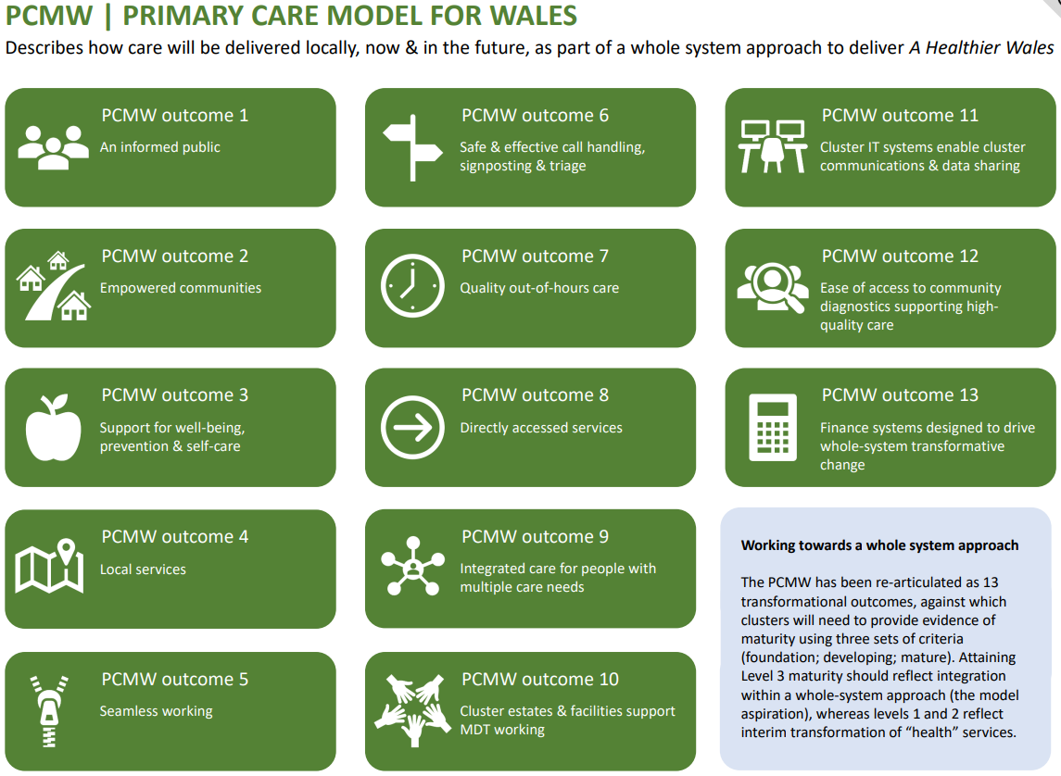

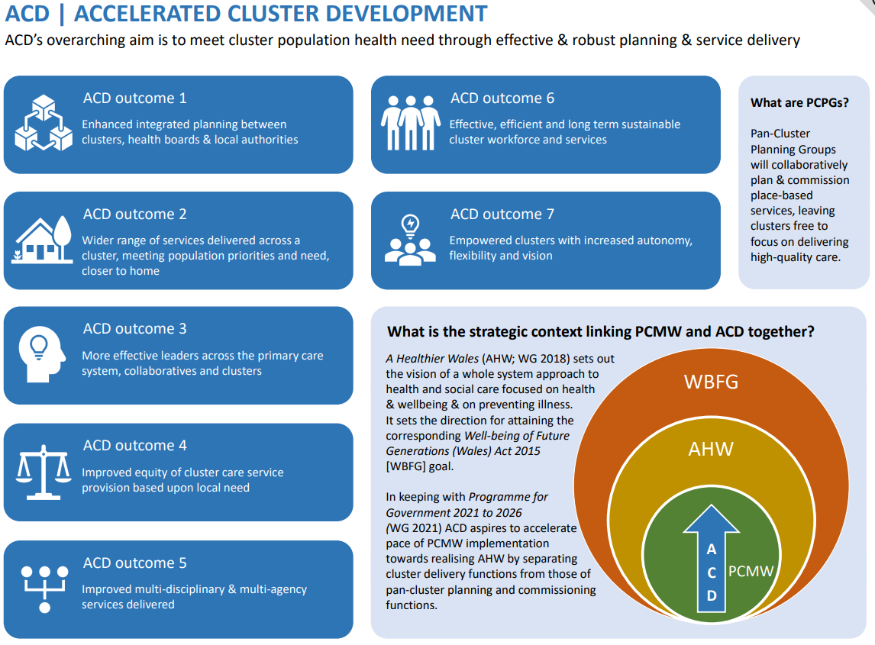

6.2 Appendix 2: Statements to measure maturity of cluster working towards the PCMW outcomes.

- Pre-Foundation - The cluster has not focused on / taken forward this area of work.
- Foundation - Cluster members have a common understanding of this area of work.
- Developing - The cluster are / have developed plans and processes and can demonstrate progress in this area of work.
- Mature - The cluster can demonstrate sustained good practice and innovation across the cluster and wider system in this area of work.

PCMW Outcome | Pre -foundation | Foundation | Developing | Mature
An Informed Public

Empowered communities

Support for well-being, prevention & self-care

Local Services

Seamless working

Safe & effective call handling, signposting & triage

Quality out-of-hours care

Directly accessed services

Integrated care for people with multiple care needs

Cluster estates & facilities support multi-professional working

Cluster IT systems enable cluster communications & data sharing

Ease of access to community diagnostics supporting high-quality care

Finance systems designed to drive whole-system transformative change

6.3 Appendix 3: Statements to measure maturity of cluster working towards the ACD outcomes.
- Pre-Foundation - The cluster are not aware that progress has been made.
- Foundation - The cluster and strategic partners have a common understanding of this element of ACD.
- Developing - The cluster and strategic partners are/ have developed plans and processes, and progress is being made.
- Mature - The cluster and strategic partners can demonstrate sustained good practice and innovation across the system.

ACD Outcome | Pre-foundation | Foundation | Developing | Mature
Enhanced integrated planning between clusters, health boards & local authorities

Wider range of services delivered across a cluster, meeting population priorities and need, closer to home

More effective leaders across the primary care system, collaboratives, and clusters

Improved equity of cluster care service provision based upon local need

Improved multi-professional & multi-agency services delivered

Effective, efficient, and long-term sustainable cluster workforce and services

Empowered clusters with increased autonomy, flexibility, and vision

6.4 Appendix 4: Participant information sheet

INTRODUCTION
We invite you to participate in a cluster self-reflection.
Before completing the cluster self-reflection, it is important for you to understand why it is being undertaken and what it will involve. Please take the time to read the cluster self-reflection process document. Details of which are summarised below.
WHAT IS THE PURPOSE OF CLUSTER SELF-REFLECTION?
Cluster self-reflection is one of three agreed methods for evaluating the progress (maturity) of cluster working towards the Primary Care Model for Wales (PCMW) and Accelerated Cluster Development (ACD). The self-reflection exercise aims to:
- Assess the maturity of cluster working across Wales.
- Identify and develop understanding of factors which are enabling or hindering cluster working.

WHO SHOULD COMPLETE CLUSTER SELF-REFLECTION?
It is proposed that the cluster self-reflection be undertaken as part of a facilitated discussion. Ideally, this discussion should include all cluster members or representation from the broad range of professionals within the cluster. However, if this is not possible the cluster lead or a nominated deputy can complete the cluster self-reflection on their own.
The findings from the self-reflection discussion should be submitted to the Primary Care Division, Public Health Wales, using the online survey.

ARE THERE ANY RISKS OR BENEFITS TO PARTICIPATING IN THE CLUSTER SELF-REFLECTION?
There are no known risks associated with participating in the cluster self-reflection. The cluster self-reflection is an opportunity for the cluster to consider their strengths, where work has progressed against the PCMW and ACD outcomes and to identify areas where further work is required.

WHAT WILL HAPPEN WITH MY INFROMATION AND HOW WILL IT BE HANDLED?
All information collected will be stored confidentially within the Primary Care Division, Public Health Wales. The information will be used solely for the purpose of the cluster self-reflection. All responses will be anonymised so that you and your cluster are not identifiable in any publications resulting from this work.
WHAT HAPPENS IF A CLUSTER DOES NOT COMPLETE THE SELF-REFLECTION?
If a cluster does not participate in the cluster self-reflection, they will be asked to provide feedback on the reasons why they declined to participate.

WHAT WILL HAPPEN TO THE RESULTS FROM THE CLUSTER SELF-REFLECTION?
Clusters can use their own self-reflection findings, to inform future priority areas and planning activities. Anonymised cluster self-reflection findings will be analysed at both an all Wales and health board region level and will describe the maturity of cluster working against the PCMW and ACD outcomes. Thereby identifying PCMW and ACD outcome areas where additional system support/ action is required to progress the maturity of cluster working.
The findings from the cluster self-reflection will also feed into the cluster peer review process.

CONSENT
By proceeding with the survey, you indicate that you have read this information sheet, understand the purpose of the cluster self-reflection, and consent to participate.

For any queries regarding Information Governance please contact: phw.informationgovernance@wales.nhs.uk.

For general queries on accessing the form please contact Sian.Hart2@wales.nhs.uk.
If you require further information on the cluster self-reflection, please contact: Rachel.Andrew@wales.nhs.uk

A nominated deputy must have sufficient knowledge of the cluster and authority within the cluster or health board to complete the cluster self-reflection.
Driscoll’s Model of Reflection Driscoll's Model of Reflection
A nominated deputy must have sufficient knowledge of the cluster and authority within the cluster or health board to complete the cluster self-reflection.

