

Add Partner Logos
(White versions preferred)
Main Title
Subtitle
Version 1.0

Cluster Self-Reflection Report 2024/25

Authors: Victoria Tice, Sarah MacAulay-Nolan, Harvey Carman and Rachel Andrew
Primary Care Division
Public Health Wales

Version: 1.0 July 2025

Contents
Executive Summary 4
Introduction 6
Methodology 6
Self-reflection questionnaire 6
Realist informed qualitative discussions 7
Sample and recruitment 7
Data collection instrument 8
Data analysis 8
Results 8
Overview of participants 8
Insights into Cluster purpose, Cluster role, system support and time 13
Thematic Analysis 15
Resource Deficiency 16
Strategic Alignment and Governance 17
Operational strain 18
Underdeveloped system working 19
Realist Informed Qualitative Discussions 20
Cluster Lead 21
People and relationships 21
Shared Goals 22
Discussion 22
Limitations 25
Conclusions 25
Lessons Learnt and Opportunities for Action 26
Acknowledgments 27
Appendices 28
Appendix 1: PCMW outcomes 28
Appendix 2: ACD outcomes 29
Appendix 3: Opportunities for action 2023/34 self-reflection 30
Appendix 4: Individual PCMW graphs and technical analysis 31
Appendix 5: Individual ACD graphs and technical analysis 38
Appendix 6: Number of qualitative responses 43
Appendix 7: Opportunities for action 2024/25 self-reflection 44
Appendix 8: Index of Abbreviations 44

Tables
Table 1: Summary of overarching themes and sub-themes 16
Figures
Figure 1: Percentage of Cluster responses by Health Board 9
Figure 2: Summed PCMW maturity levels by year 10
Figure 3 PCMW outcomes Maturity Levels 23/24 11
Figure 4: PCMW outcomes Maturity Levels 24/25 11
Figure 5: Summed ACD outcomes maturity by year 12
Figure 6: ACD outcomes Maturity levels 23/24 13
Figure 7: ACD outcome Maturity levels 24/25 13
Figure 8: Perceived progress of cluster working towards PCMW 14
Figure 9: Participant agreement on the defined role of clusters 14
Figure 10: Perceived system support for cluster working 15
Figure 11: Perceived access to Health Board support for cluster working 15
Figure 12: Comparison of current and desired cluster meeting frequency 16
Figure 13: Perceived achievability of the cluster’s contribution to the PCMW 16
Figure 14: Evidence supporting the overarching theme – Resource deficiency 18
Figure 15: Evidence supporting the overarching theme – Strategic alignment and governance 19
Figure 16: Evidence supporting the overarching theme - Operational strain 20
Figure 17: Evidence supporting the overarching theme – Underdeveloped system working 21
Figure 18: Average maturity of PCMW outcomes by year 32
Figure 19: PCMW outcome 1 (Informed Public) maturity by year 33
Figure 20: PCMW outcome 2 (Empowered communities) maturity by year 33
Figure 21: PCMW outcome 3 (Support for well-being, prevention and self-care) maturity by year 34
Figure 22: PCMW outcome 4 (Local services) maturity per year 34
Figure 23: PCMW outcome 5 (Seamless working) maturity by year 35
Figure 24: PCMW outcome 6 (Safe and effective call handling signposting and triage) maturity by year 35
Figure 25: PCMW outcome 7 (Safe and Quality out of hours care) maturity by year 36
Figure 26: PCMW outcome 8 (Directly accessed services) maturity by year 36
Figure 27: PCMW outcome 9 (Integrated care for people with multiple care needs) maturity by year 37
Figure 28: PCMW outcome 10 (Clusters estates and facilities support MDT working) maturity by year 37
Figure 29: PCMW outcome 11 (Cluster IT systems enable cluster communications and data sharing) maturity by year 38
Figure 30: PCMW outcome 12 (Ease of access to community diagnostics supporting high quality care) maturity by year 38
Figure 31: PCMW outcome 13 (Finance systems designed to drive whole-system transformative change) maturity by year 39
Figure 32: Average maturity of ACD outcomes by year 40
Figure 33: ACD outcome 1 (Enhanced integrated planning between clusters, health boards & local authorities) maturity by year 40
Figure 34: ACD outcome 2 (Wider range of services delivered across a cluster, meeting population priorities and need, closer to home) maturity by year 41
Figure 35: ACD Outcome 3 (More effective leaders across the primary care system, collaboratives and clusters) maturity by year 41
Figure 36: ACD outcome 4 (Improved equity of cluster care service provision based upon local need) maturity level by year 42
Figure 37: ACD outcome 5 (Improved multi-professional & multi-agency services delivered) maturity by year 42
Figure 38: ACD outcome 6 (Effective, efficient and long-term sustainable cluster workforce and services) maturity by year 43
Figure 39: ACD outcome 7 (Empowered clusters with increased autonomy, flexibility, and vision) maturity per year 43

Executive Summary
This report presents the key findings from a cross-sectional mixed methods study, designed to gain a deeper understanding of cluster working across Wales. The second cycle of cluster self-reflection (2024/25) was undertaken in April/ May 2025. Across Wales, the response rate was 88% (n=53).
Across both the 2023/24 and 2024/25 self-reflection periods, the data demonstrates that the predominant level of maturity for all Primary Care Model for Wales (PCMW) and Accelerated Cluster Development (ACD) outcomes was consistently either 'Foundation' or 'Developing'. When looking at individual outcomes, there was a shift away from a ‘Pre-foundation’ stage, for the majority of PCMW outcomes (62%, n=8) and for all ACD outcomes (100%, n=7). Suggesting an increasing level of maturity across clusters. In addition, clusters had a generally positive outlook on cluster progress towards the PCMW (81.8%, n=43).
For 2024/2025, findings of note include:
- PCMW outcomes 4 (Local services) had the highest proportion of clusters self-reflecting as being either ‘Developing’ (57%) or ‘Mature’ (25%) with only 2% reporting this as ‘Pre-foundation’.
- PCMW outcome 11 (Cluster IT systems enable cluster communication and data sharing) had the lowest proportion of clusters reporting this outcome as ‘Mature’ (6%), and the majority reported it as ‘Foundation’ (49%).
- ACD outcome 2 (Wider range of services delivered across a cluster, meeting population priorities and need, closer to home) had the highest proportion of clusters reporting it as ‘Mature’ (19%).
- ACD outcome 7 (Empowered clusters with increased autonomy, flexibility and vision) had the highest proportion of ‘Pre-foundation’ responses (19%).
- No significant relationship was found between deprivation and reported levels of maturity across clusters.
Clusters were asked to rate their understanding of the cluster role and purpose alongside perceived system support and time available for cluster working. Where clusters responded as disagree or strongly disagree, participants were asked to provide further detail. These responses were thematically analysed, and four themes emerged: Resource Deficiency, Strategic Alignment and Governance, Operational Strain and Underdeveloped System Working. However, it is important to note that the qualitative themes were informed by a small number of clusters who expressed disagreement.
There was a strong consensus that the role of clusters is to bring together local services to plan and deliver better coordinated care for individuals and communities (86.8%, n=46). However, there was evidence that levels of support for clusters, from both the primary and community care system and from Health Board teams e.g. planning, finance, etc. varied.
Lack of time was a strong recurring theme across the first and second cycle of self-reflection, demonstrating the importance of this issue. Data suggests there is an invisible workload (work undertaken by staff beyond their contracted hours), overstretched resources and misalignment between ambition and reality. Whilst more time to deliver cluster working is recognised by respondents as an opportunity, further consideration on how to overcome the perceived gap between the ambition of clusters, PCMW and ACD against what is possible based on current resources is needed.
Limitations in the methodology of the cluster self-reflection should be considered when reviewing this report, in particular the subjective nature of the self-reflection process. However these results will be triangulated with Cluster Peer review, the Realist qualitative discussions and the PCMW Key Indicators, to provide a more robust assessment of the progress of cluster working towards the PCMW and A Healthier Wales.
Conclusion on trends cannot be derived from two cycles of self-reflection. However, the findings do imply that most clusters are progressing their level of maturity and are establishing or building upon their foundational capabilities. This suggests that ongoing targeted support and capacity building across clusters are required.
Based on the self-reflection findings, a number of ‘Opportunities for Action’ have been developed to support ongoing cluster development, including:
- PHW investigate and address the specific challenges identified by the minority of respondents who showed declining participation in cluster self-reflection.
- Welsh Government, with relevant stakeholders, collaboratively review contracts/ service level agreements to ensure they accurately reflect all cluster and professional collaborative responsibilities and are equitable across professional groups, and across Wales.
- SPPC review and refresh role descriptions for all system partners and ensure the information is effectively shared at all levels within the system.
- SPPC and Health Boards, with relevant stakeholders, collaboratively evaluate time allocation for cluster leads and members to ensure that clusters have the necessary capacity to fulfil their responsibilities.
- PHW collaboratively work with partners to map the support provided to clusters, including Health Board ‘backroom functions’. Identifying where gaps exist and sharing examples of effective support mechanisms that have facilitated cluster working.
- PHW conduct further investigation into the contrasting experiences of clusters regarding autonomy and support, identifying specific factors that enable empowerment versus those that lead to disempowerment.
- PHW review the self-reflection survey and data to establish whether and what changes should be made to ensure future self-reflection surveys are robust and comparable.

Introduction
Cluster self-reflection is one of three measures for the monitoring and evaluation of the Primary Care Model for Wales (PCMW). This is the second cycle of cluster self-reflection. The first cycle was completed in 2023/24. This report summarises the All Wales findings from the second cycle of cluster self-reflection.
Cluster self-reflection took place in April/ May 2025 and aimed to enable cluster leads and cluster members to come together to reflect on experiences of cluster working in their geographical area. Following the same approach as the first cycle, clusters rated their maturity against the 13 PCMW outcomes (Appendix 1) and the 7 Accelerated Cluster Development (ACD) outcomes (Appendix 2). In addition clusters reflected on the purpose and role of clusters and the time required for the clusters to achieve these.
The second cycle of cluster self-reflection will build on the learning taken from the first cycle in 23/24 and will continue to build an understanding of the factors that inhibit or drive cluster working to deliver the PCMW and achieve A Healthier Wales.
An update on progress against the Opportunities for Action identified in the first cycle of self-reflection is provided in Appendix 3. This is a high level update and does not provide detail of the wealth of work happening in each cluster and Health Board area.

Methodology
This project used a cross-sectional mixed methods approach, combining a survey (quantitative and qualitative questions) and two focus groups. The integration of numerical data and narrative perspectives allowed for a deeper understanding of the data.

Self-reflection questionnaire
Sample and recruitment
At the time of data collection, there were 60 Clusters in Wales. All Clusters were invited to participate via email which included information on the project, instructions and the link to the self-reflection survey. The survey was open from 01st April 2025 until 31st May 2025.
Data collection instrument
An online survey was developed using Microsoft Forms which contained a mix of closed and open-ended questions to gather both quantitative and qualitative data. Data Protection Impact Assessment (DPIA) was completed by the Public Health Wales (PHW) Primary Care Division (PCD) Evaluation team (further described as the Evaluation team) and informed consent was gathered prior to completion of the survey.
Data analysis
The survey submissions were exported directly from Microsoft forms into Excel for analysis. Descriptive analysis at an all-Wales level was undertaken by the Evaluation team to understand frequency distribution of maturity levels and the mean maturity score for PCMW across the two years. The following scoring system was used:
Primary Care Model for Wales
Mature: The cluster can demonstrate sustained good practice and innovation across the cluster and wider system in this area of work
Developing: The cluster are /have developed plans and processes and can demonstrate progress in this area of work
Foundation: Cluster members have common understanding of this area of work
Pre-Foundation: The cluster has not focused on/ taken forward this are of work
Accelerated Cluster Development
Mature: The cluster and strategic partners can demonstrate sustained good practice and innovation across the system
Developing: The cluster and strategic partners are/ have developed plans and processes, and progress is being made
Foundation: The cluster and strategic partners have a common understanding of this element of ACD
Pre- Foundation: The cluster are not aware that progress has been made
Thematic analysis of qualitative data was also undertaken. Initial coding was completed by three members of the Evaluation team. Any debates in the themes and codes were discussed until a consensus was reached.

Realist informed qualitative discussions

Sample and recruitment
From the 2023/24 survey responses, clusters responses were analysed, and five potential clusters were identified for further exploration. Three clusters, were chosen based on maturity. One cluster subsequently withdrew, and two realist-informed discussions were held in April 2025. Participants included cluster leads, colleagues involved in cluster working from representative Health Boards and members of the Primary Care Division, PHW.

Data collection instrument
Realist evaluation aims to generate discussion based on assumptions and hypothesis developed in advance of the focus group. For these sessions the assumptions were informed by the 23/24 cluster self-reflection responses, supporting information taken from information on Primary Care One, and the Primary Care Clusters Dashboard.

Data analysis
The focus groups were recorded, the qualitative data extracted and thematically analysed by the focus group facilitator.

Results
This section presents an overview of participants and an analysis of maturity scores for both PCMW and ACD outcomes. Throughout this section, there is also a comparative analysis of findings from the 23/24 and 24/25 self-reflection surveys.

Overview of participants
Across all Health Boards, the overall response rate for Wales in 2024-2025 was 88% (n=53), a small improvement on the 2023-2024 survey (77%, n=46) (Figure 1). In 24/25, the data indicates generally high engagement for the cluster self-reflection survey across most Health Boards, with several achieving full participation from their clusters. Cardiff and Vale University Health Board had a lower response rate compared to other Health Boards. Aneurin Bevan University Health Board and Cardiff and Vale University Health Board, experienced a decline in participation from 2023/24.
Figure 1: Percentage of Cluster responses by Health Board

Primary Care Model for Wales Maturity Findings
Across all clusters, PCMW outcomes 4 (Local services) had the highest proportion of clusters self-reflecting as being either ‘Developing’ (57%) or ‘Mature’ (25%). With only 2% reporting this as ‘Pre-foundation’.
For 2024-2025, PCMW outcome 11 (Cluster IT systems enable cluster communication and data sharing) had the lowest proportion of clusters reporting this outcome as ‘Mature’ (6%). With the majority of clusters reporting it as ‘Foundation’ (49%). PCMW outcome 7 (Quality Out-of-Hours) was most frequently reported as ‘Mature’ (26%). This was higher than reported in the first cycle (16%), suggesting an improvement in the interface between in-hours and out-of-hours services. However, 25% of clusters reported this as ‘Pre-foundation’, showing the variation across clusters.
In order to compare the levels of maturity across the first and second cycle of cluster self-reflection, an overall summary of maturity levels has been provided (Figure 2) alongside the maturity levels for each of the PCMW outcomes for each year (Figures 3 and 4). For a detailed analysis of individual PCMW outcomes see Appendix 4.
Figure 2: Summed PCMW maturity levels by year

When submissions are summed, there was a decrease in the ‘Pre-foundation’ level (-9%) and an increase in the ‘Developing’ level (+6%) with the ‘Mature’ level remaining stable.
When comparing the proportion of responses for each level of maturity, between the cycle one and two, the main findings are:
- The predominant level of maturity for all PCMW outcomes was consistently either 'Foundation' or 'Developing' for both 23/24 (63%) and 24/25 (73%)
- 77% (n=10) of outcomes advanced maturity levels, between ‘Pre-foundation’ and ‘Developing’ (PCMW outcomes 1, 2, 5, 6, 7, 8, 9, 10, 12 and 13)
- 62% (n=8) of outcomes had a reduction in the number of clusters self-assessed as ‘Pre-foundation’ (PCMW outcomes 1, 2, 3, 5, 6, 7, 8, 9, 10, 12 and 13).
- Outcome 12 had the largest shift out of the ‘Pre-foundation’ level (-35%) followed by Outcome 7 (-25%)
- Four outcomes (4, 8, 10 and 11) saw a decline in clusters self-assessed as ‘Mature’.
- Outcome 10 had the largest decline out of the ‘Mature’ level (-11%)
- Two outcomes (5 and 7) saw an increase in clusters self-assessed as ‘Mature’.
- Outcome 7 had the largest shift to the ‘Mature’ level (+10%)
Figure 3 PCMW outcomes Maturity Levels 23/24

Figure 4: PCMW outcomes Maturity Levels 24/25

Accelerated Cluster Development Maturity Findings
In order to compare the levels of maturity across the first and second cycle of cluster self-reflection, an overall summary of maturity levels (Figure 5) has been developed plus a detailed examination of maturity levels for each of the ACD outcomes (Figures 6 and 7). For a detailed analysis of individual outcomes see Appendix 5.
For 2024-2025, ACD outcome 2 (Wider range of services delivered across a cluster, meeting population priorities and need, closer to home) had the highest proportion of clusters responding as ‘Mature’ (19%) and the highest proportion when ‘Developing’ (43%) and ‘Mature’ (19%) were combined. Closely followed by outcome 5 (Improved multi-disciplinary and multi-agency services delivered) with ‘Developing’ (47%) and ‘Mature’ (13%). ACD outcome 7 (Empowered clusters with increased autonomy, flexibility and vision) had the highest proportion of ‘Pre-foundation’ responses (19%). Outcome 3 (More effective leaders across the primary care system, collaboratives and cluster) had the lowest proportion of ‘Pre-foundation’ responses (2%).
When responses were summed and compared with the first cycle of self-reflection, the main findings were:
- There has been a fall in the proportion of clusters responding as ‘Pre-foundation’ (-11%)
- There has been an increase across ‘Foundation’ (+6%), ‘Developing’ (3%) and ‘Mature’ (2%) responses
- As in cycle one, the majority of clusters responses are for ‘Foundation’ and ‘Developing’
- The data largely reflects a positive change in self-assessed maturity scores for all ACD outcomes between cycle one and two
Figure 5: Summed ACD outcomes maturity by year

When comparing individual ACD outcome data, between cycle one and two, the main findings were:
- All outcomes saw a steady improvement, contributing to the overall increase in perceived maturity across ACD
- Five of the seven ACD outcomes have seen an increase in responses for ‘Mature’ (ACD outcomes 1, 3, 4, 6 and 7)
- Two outcomes (2 and 5) saw a small drop in the proportion responding as ‘Mature’. However for both of these outcomes, the proportion of clusters responding as either ‘Foundation’ or ‘Developing’ had increased
- All 7 ACD outcomes have seen a decrease in responses for ‘Pre-foundation’
- ‘Pre-foundation’ is the lowest reported stage of maturity across four of the ACD outcomes (2, 3, 4 and 5)
- In the first cycle of self-reflection ACD outcome 4 (Improved equity of cluster care service provision based upon local need) had the highest proportion of clusters responding as ‘Pre-foundation’ (48%), this has fallen to 8%
- In the second cycle of self-reflection ACD Outcome 7 (Empowered clusters with increased autonomy, flexibility and vision) had the highest proportion of clusters responding as ‘Pre-foundation’ (19%). However this had fallen from 31% in cycle one.
Figure 6: ACD outcomes Maturity levels 23/24

Figure 7: ACD outcome Maturity levels 24/25

Deprivation and Cluster Working
Cluster responses were aggregated by outcome and examined by deprivation level using visualisations and analysis of variance (ANOVA). No significant relationship was found between deprivation and maturity.

Insights into Cluster purpose, Cluster role, system support and time
This section presents the quantitative findings derived from key questions designed to ascertain participant understanding of the cluster role and purpose alongside perceived system support and time available for cluster working.
The majority of respondents believed their cluster had made progress towards achieving the PCMW (81.1%, n=43) (Figure 8).
Figure 8: Perceived progress of cluster working towards PCMW

The majority of respondents strongly agreed or agreed (86.8%, n=46) that the role of the cluster is to bring together all local services to plan and deliver better coordinated care that promotes the wellbeing of individuals and communities (Figure 9).
Figure 9: Participant agreement on the defined role of clusters

Just under half of respondents strongly agreed or agreed (45.3%, n=24) that the system provided adequate support. However, almost a third of respondents (34.0%, n=18) strongly disagreed or disagreed (Figure 10).
Figure 10: Perceived system support for cluster working

The majority of respondents (69.8%, n=37) felt they had adequate access to health board teams for support. However, 13.2% (n=7) said they disagreed or strongly disagreed they had access to support (Figure 11).

Figure 11: Perceived access to Health Board support for cluster working
Currently, four annual cluster meetings are the norm for the majority (67.9%, n=36). However, when considering ideal frequency, this preference decreases to 43.4% (n=23). Conversely, the desire for six meetings annually doubles, increasing from 3.1% (n=12) to 45.3% (n=24) (Figure 12).
Figure 12: Comparison of current and desired cluster meeting frequency

Just under half (47%, n=25) of respondents did not think enough time is allocated for cluster working to contribute to the PCMW (Figure 13).
Figure 13: Perceived achievability of the cluster’s contribution to the PCMW

Thematic Analysis
This section providing insights into why participants disagreed with statements concerning the cluster's role, purpose, system support, and available time for cluster working. The responses have been synthesised into four overarching themes, each with corresponding sub-themes.
It is important to note that the qualitative themes discussed below were informed by a small number of clusters who expressed disagreement to the statements above. Therefore, these findings represent specific perspectives and may not reflect the collective opinion of all clusters who participated in self-reflection. For an overview of response rates for each question see Appendix 6.

Table 1: Summary of overarching themes and sub-themes
Overarching themes | Sub-themes
Resource deficiency | Time constraints
Resource deficiency | Financial constraints
Resource deficiency | Lack of adequate support
Strategic alignment and governance | Aligning ambition with resources
Strategic alignment and governance | Funding challenges for successful projects
Strategic alignment and governance | Need for greater autonomy
Operational strain | Overstretched resources
Operational strain | Invisible workload
Operational strain | More time
Underdeveloped system working | Role ambiguity
Underdeveloped system working | Challenges in implementation and perceived effectiveness of Pan-Cluster Planning Groups (PCPG) and professional collaboratives
Underdeveloped system working | Inter-organisational disconnect

Resource Deficiency
Under this overarching theme, three sub-themes were identified: Lack of adequate support, Time constraints and financial constraints. Respondents recognised that without sufficient project support, specialist input, time and funding, cluster projects are going to be limited in their effectiveness to deliver on their objectives (Figure 14).
Time constraints
A recurring and significant challenge highlighted by participants was how the amount of time allocated for cluster working was not enough to deliver change. Respondents also recognised time given (for cluster meetings and cluster leads) was not sufficient and prevented clusters delivering the ambition of the PCMW.
Financial constraints
Participants emphasised funding as significantly impacting clusters’ ability to develop. Lack of funding, financial restrictions and difficulties in accessing alternative funding opportunities were all listed as issues for clusters, limiting their ability to continue successful projects and fund new projects.
Lack of adequate support
Respondents highlighted that access to support functions within Health Boards are essential to successful cluster working. Support with finance, Human Resources, Project management, planning and business support were recognised as key to successful cluster working and to enable efficiency. However, access to this support was not routinely available across Wales, limiting the clusters’ ability to have impact.
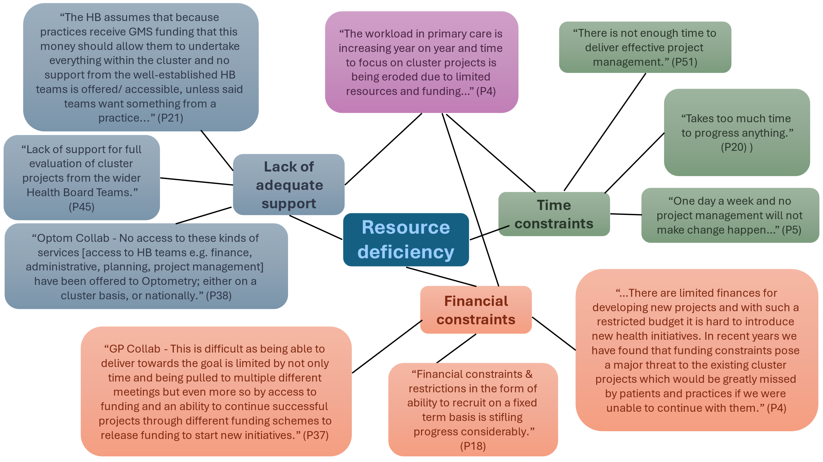
Figure 14: Evidence supporting the overarching theme – Resource deficiency

Strategic Alignment and Governance
Under this overarching theme, three sub-themes were identified: Need for greater autonomy, Aligning ambition with resources and Funding challenges for successful projects. The sub-themes suggest there is great ambition for cluster working in Wales. However, without adequate resources, clearly considered and communicated processes and autonomy in place for clusters, the ambition is unlikely to be realised. (Figure 15).
Need for greater autonomy
Participants expressed frustration at having limited authority and empowerment, making it challenging to get decisions approved and projects off the ground due to restrictive governance. Some respondents felt that the ‘top-down’ approach by the Health Board actively worked against the cluster concept where clusters are unable to adapt to change, proactively respond to needs or innovate.
Funding challenges for successful projects
Participants highlighted there was no clear strategies for funding and mainstreaming successful projects at a cluster level. Respondents articulated that without clear processes in place for spread and scale, and funding, it would remain difficult for clusters to release funds for innovation and new projects.
Aligning ambition with resources
A theme emerging from the feedback centred on the crucial need to align ambitions for clusters with the reality of available resources. Participants highlighted the ambition of PCMW, and the expectations of what clusters should be doing is unrealistic based on current resources. Responses emphasised that clusters want to do more and deliver the ambition of PCMW but recognise that without adequate resource (time, funding, skills, and people) this ambition would not be realised.
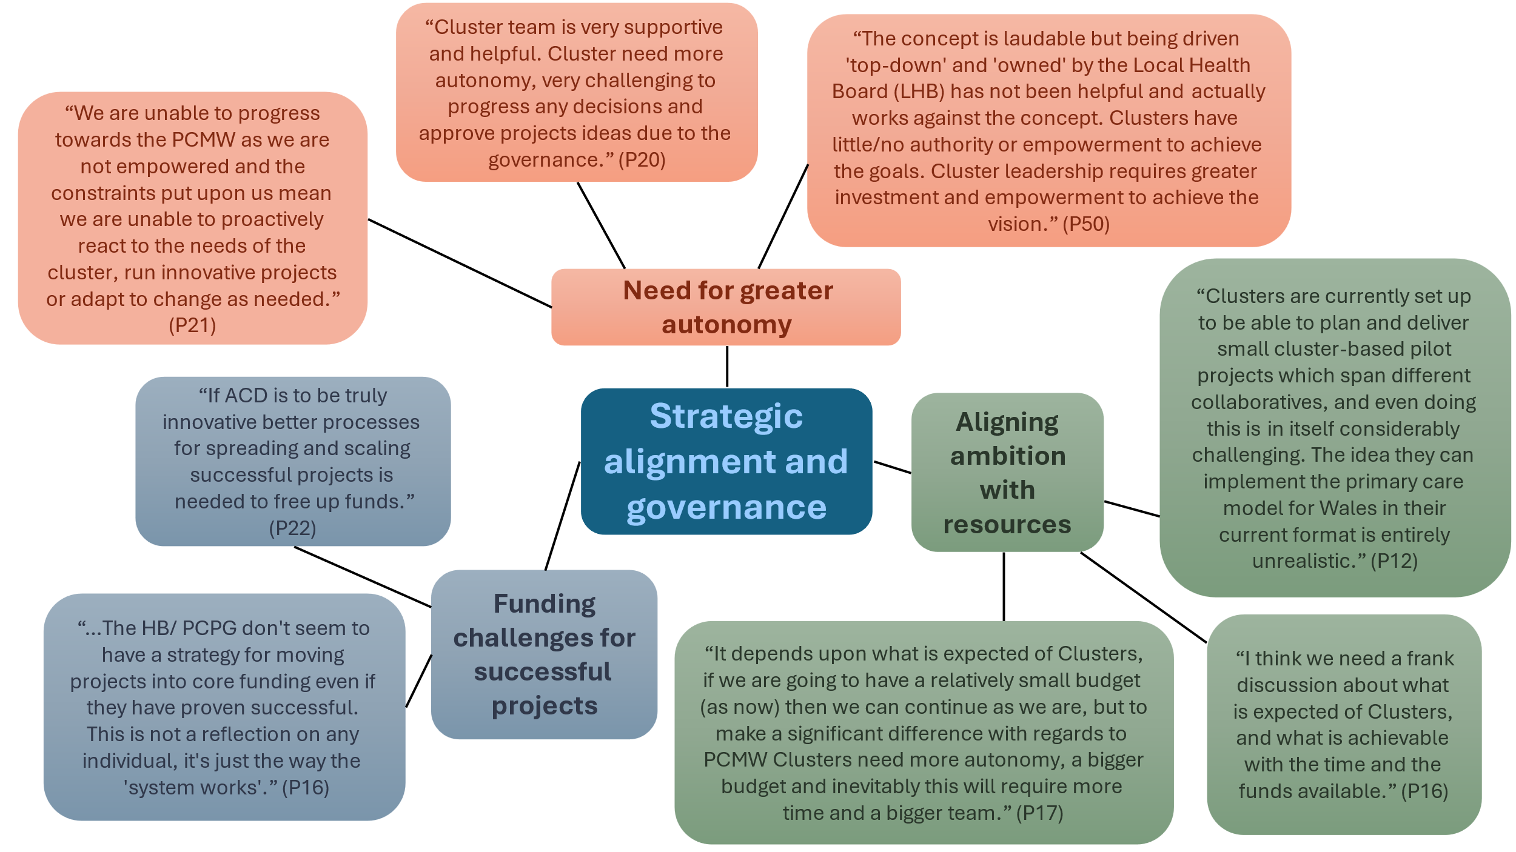
Figure 15: Evidence supporting the overarching theme – Strategic alignment and governance

Operational strain
Under this overarching theme, three sub-themes were identified: Overstretched resources, Invisible workload and More time. Together, these sub-themes all point to a system struggling under the weight of high demands and expectations (Figure 16).
Overstretched resources
Participants described how key personnel (cluster leads and cluster support managers) are overwhelmed by an ever-growing list of broad and demanding responsibilities, which directly impeded their ability to deliver on objectives and empower their teams.
Invisible workload
Participants stressed that cluster members are dedicating significant uncontracted time to ensure the functioning and progress of clusters and their projects. The quotes demonstrate that much of the progress and operation within some clusters are sustained by an unacknowledged and uncompensated 'invisible workload' carried out by dedicated individuals, rather than through adequately resourced and formally recognised time commitments.
More time
Participants emphasised that more time is needed to support effective collaboration, project delivery, innovation, engagement, and the essential 'backroom functions' required for clusters to thrive and have a meaningful impact.
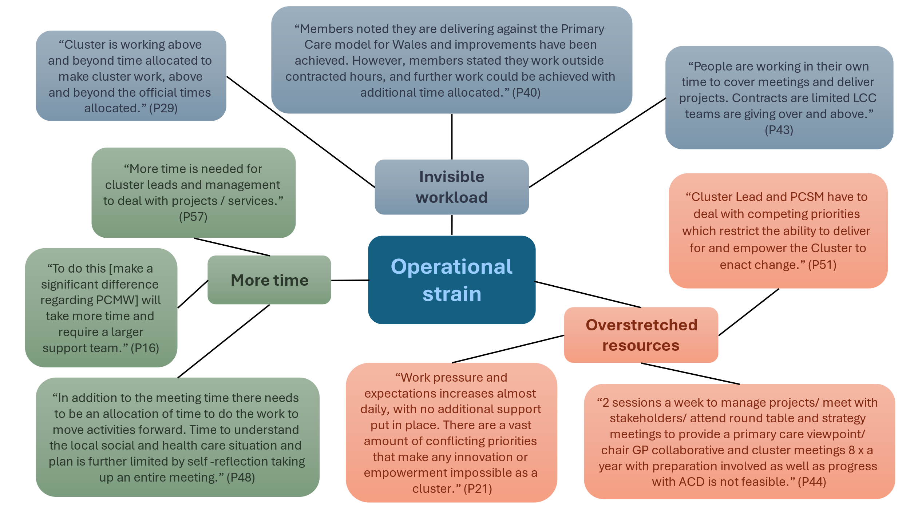
Figure 16: Evidence supporting the overarching theme - Operational strain

Underdeveloped system working
Under this overarching theme, three sub-themes were identified: Role ambiguity, Challenges in implementation and perceived effectiveness of PCPGs and professional collaboratives and Inter-organisational disconnect. These sub-themes highlight that the entire system (including roles, collaborative efforts, and inter-organisational relationships) are not working together smoothly (Figure 17).
Role ambiguity
The lack of clearly defined roles and decision-making processes within the system is a critical barrier, undermining effective collaboration and project advancement within the clusters.
Challenges in implementation and perceived effectiveness of PCPGs and professional collaboratives
PCPGs were consistently described by participants as being absent or ineffective, with some meetings rarely occurring. Others described their frustration with the lack of clear direction, and an absence of common objectives. Some highlighted that the development and maturity of professional collaboratives was also highly inconsistent across Wales, with some areas lacking them entirely and others experiencing a decline in engagement.
Inter-organisational disconnect
Participants expressed how there was poor or absent engagement from certain system partners (e.g. Local Authorities and professional collaboratives), possibly stemming from differing priorities, funding streams, and a lack of trust between partners (especially the Local Health Board dominated structure).
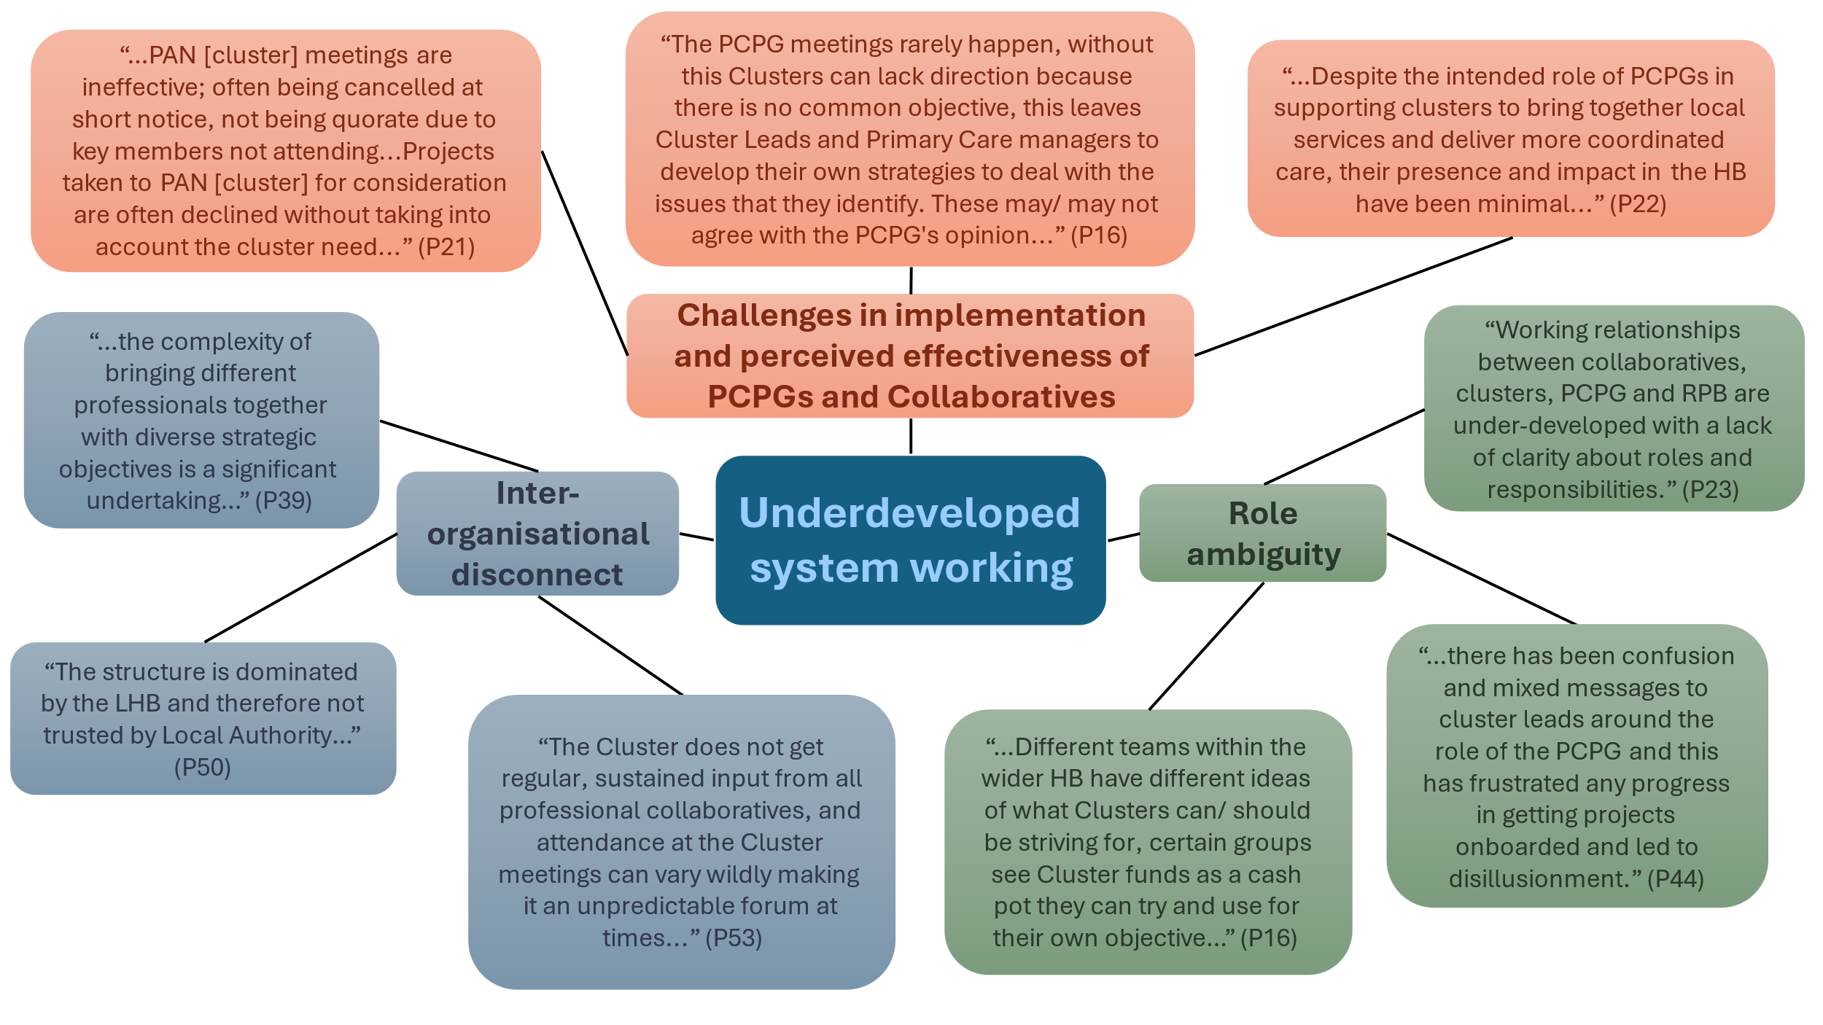
Figure 17: Evidence supporting the overarching theme – Underdeveloped system working

Realist Informed Qualitative Discussions
Two clusters in Wales took part in focus groups. The realist informed qualitative discussions sought to understand the context behind cluster 2023/24 self-reflection responses.
The discussions reinforced previously identified themes. Despite differences in demography, rurality, deprivation, and approaches to cluster working the factors identified as driving successful cluster maturity were similar. Including the Cluster Lead, People and relationships and Shared goals.
In addition, the qualitative discussions highlighted the subjective nature of cluster self-reflection. With some clusters responding as mature if they felt they had achieved all that they could with the limited resources available to them, rather than considering clusters maturity within the primary and community care system.

Cluster Lead
The cluster lead (CL) role was recognised as a key driver for successful cluster working. Compassionate leadership, experience and knowledge all reflected as effective characteristics for cluster leads.
Cluster A: The CL has extensive experience across different roles within primary care, resulting in knowledge of General Medical Contract (GMC), a unique understanding of what is possible within the cluster and effective leadership skills. Health Board colleagues reflected approaches to leadership, honest, two-way dialogue, shared decision making and strength-based approaches to planning and people resulted in the cluster team working collaboratively.
"Obviously they have got some really good partners there (within cluster) and they’ve already mentioned things like the dental collab lead and that's all really important. But I think their leadership is, really key to how the cluster is developed."
Cluster B: The CL has long standing experience in the CL role, has a vast knowledge of the cluster system, partners, the cluster locality and people. Taking a personal and pragmatic approach, relationships built over time, and their approach to cluster working has delivered a willingness for collaboration across the whole cluster system, wider locality and delivers continuity.
“If they do not know the person within the cluster, they know who will know”

People and relationships
The discussions highlighted the value of people and relationships. People and relationships are key enablers for cluster working, the make-up of a cluster can be a strength, driving forward progress towards PCMW outcomes that rely on collaborative working, joined up working and relationships particularly.
Cluster B: It was acknowledged, that this cluster benefited from a stable population and relatively stable workforce, both supported maintaining relationships across the cluster. Uniquely to this cluster it was also recognised how teams and organisations across health, social care and wider partners who work across the locality all work well together, organisational relationships are solution focused and supportive. Annual joint planning meetings and shared workplan priorities drives forward effective collaborative working.
“Long standing commitment to joint working, partnership working with the Third Sector, Local Authority and us (Health Board). That is demonstrated in our joint plan.”
Cluster A: Somewhat uniquely, benefit from having engaged and proactive professional collaboratives for all contractor professionals. People within these structures share enthusiasm and a proactive attitude to wanting to help their population. This cluster highlighted how the right people in the right role results in an openness for sharing best practice, and that successful collaboration across different structures within the cluster can move forward collective action.
“The obvious thing to do then is to tap into your strength, which is that you've got these people willing to work, wanting to talk about their problems and see how we can move it forward”

Shared Goals
Both clusters reflected that utilising the strengths and skills of the cluster team is an enabler towards delivering shared goals where opportunities arise.
Cluster A: Engagement and the relationships within the cluster team provides opportunities to share best practice, to work in partnership to support each other to overcome issues or work towards a specific outcome. An example of ‘point of care testing for diabetes’ was given, how together the idea was not stopped by hurdles to implementation but together, collaboratives and clusters members identified opportunities for training and work being done between dentist lead and nursing collaborative. Identifying shared goals and working together, this cluster is demonstrating maturity against PCMW actions they can influence, and where success requires effective collaborative working, relationships and partnership.
“The answer is forming the relationships and finding ways of working together”
Cluster B: Highlighted, that a well-established system which supports cluster working across the locality and focuses on shared priorities, can empower and strengthen cluster working. Collectively the system manage risks and takes shared ownership for progress. This discussion demonstrated the PCPG is essential for cluster working but requires engaged and passionate colleagues to deliver shared goals.
“I see the priority is us working together and understanding what the other person can do. What a pharmacist can do, what the nurses can do.”

Discussion
There was high engagement with cluster self-reflection (88%), and an overall upward trend in cluster participation across Wales (2023/24 engagement 77%). Suggesting a strong commitment to the self-reflection process from most Health Boards. The achievement of 100% participation by five Health Boards in 2024-2025 is particularly encouraging, indicating strong local leadership and support within these regions. Two Health Boards saw a decline in participation, which warrants further investigation to understand engagement barriers with cluster self-reflection.
Across both the 2023/24 and 2024/25 self-reflection periods, the data demonstrates that the predominant level of maturity for all PCMW and ACD outcomes was consistently either 'Foundation' or 'Developing'. These findings imply that most clusters are still establishing or building upon their foundational capabilities, and that there is an ongoing need for targeted support and capacity building across clusters.
While the overall picture remained stable, there were notable increases and decreases in maturity within individual PCMW and ACD outcomes. Whilst trends in the maturity of cluster working cannot be identified from two cycles of self-reflection, clusters had a generally positive outlook on cluster progress towards the PCMW (81.8%) and a strong consensus that the role of clusters is to bring together local services to plan and deliver better coordinated care for individuals and communities (86.8%). This indicates a clear and widely accepted understanding of the fundamental purpose and role of clusters across Wales, which is crucial for effective collaboration across the primary and community care system. Exploration of the underlying factors driving both positive shifts and declines in self-reported maturity, would enable more targeted support for cluster development.
However, for those who provided further comment, challenges in cluster working were evident. Nearly half (45.3%) of respondents perceived they had adequate support, while 34.0% felt unsupported, highlighting inconsistent experiences across clusters. Access to support from Health Board teams was largely positive (69.8%) but again, a notable proportion still faced challenges in this area. Self-reflection feedback highlighted system support, particularly from Health Boards, is essential for cluster success, yet some clusters perceive a lack of alignment, trust and stalled collaborative working. The data suggests there is an inequity in the availability of support functions to assist clusters and/or professional collaboratives across Wales. The realist conversations emphasised the value of established professional collaboratives and PCPGs, supportive partners, and strong professional relationships in successful cluster working. This mixed perception, suggests action across the primary and community care system is needed to communicate and promote what support should be routinely available to all clusters in Wales, to ensure clusters feel adequately resourced and enabled to perform their functions effectively.
Lack of time was a strong recurring theme for both the 2023/24 and 2024/25 self-reflection cycles and demonstrates the importance of this issue. Nearly half (47.0%) of respondents felt that the current time allocated did not support them to achieve the PCMW ambition, while 36.0% remained neutral. Alongside this, there is a desire for more frequent cluster meetings. While four annual meetings was the norm, there was a preference for six meetings a year, evidencing that more protected time for cluster working is needed. Clusters reflected that there was insufficient time to deliver the ambition of PCMW and ACD, and if the time allocation remained the same, only the current levels of cluster working could be delivered, effectively precluding efforts for innovation, project delivery, partnership working and meaningful collaboration. This challenge is compounded by the perceived lack of dedicated time and expertise to deliver crucial backroom functions such as project management and finance, ultimately impeding successful cluster transformation and project delivery.
The ongoing risk and consequence to a reported lack of time, is the prolonged and hidden workload shouldered by cluster members outside their contracted hours. Responses from 2023/24 self-refection observed “goodwill” as a key enabler, with 2024/25 responses strengthening the evidence that clusters still need more time to deliver their objectives, as members currently feel the need to work beyond contracted hours and undertake a wide variety of functions to advance cluster projects. Qualitative data points to an invisible workload, overstretched resources and misalignment between ambition and reality. Whilst more time to deliver cluster working is recognised by respondents as an opportunity, further consideration on how to overcome the perceived gap between the ambition of clusters, PCMW and ACD against what is possible based on current resources and funding is needed. Furthermore, if this gap between time, resource and delivery continues there is a potential risk to the stability of clusters in Wales, and the wellbeing and welfare of cluster members. This issue isn’t unique to clusters or Wales, as broader literature on system change and scaling up frequently cites insufficient time and resources as routine barriers to delivery.
A review of available evidence on service integration recognised adequate funding as fundamental for delivering systems that improve health outcomes. Funding was identified as the most reported barrier in 2023/24 qualitative findings, whilst financial constraints and funding challenges for successful projects were strong themes for 2024/25 responses. A lack of funding, current financial models, ambiguous funding processes and legacy projects were perceived to be limiting progress and opportunities for cluster development across Wales. Positively, respondents recognised clear processes and/ or funding strategies for primary and community care could be an opportunity to enable clusters. However, until suggested structures or funding policies are formalised, which support clusters in mainstreaming projects, identifying funding opportunities and undertaking successful bid processes, transformation, innovation and delivery of proactive services which are responsive to local needs are unlikely.
ACD outcome 7 (Empowered clusters with increased autonomy, flexibility and vision) saw a positive shift towards ‘Mature’. However, where clusters have provided further detail, a perceived lack of autonomy and disempowerment among cluster is perceived. For some, this was in relation to a lack of clear governance, whilst others cited a top-down approach by the Health Board which restricted clusters in progressing and developing. Further exploration of these contrasting experiences would be beneficial.
A review of systems leadership literature, recognises that paradoxes within a system can create friction and inconsistencies. Power imbalances, conflict and working within environments of uncertainty can limit the effectiveness of a system. Therefore, a common understanding of the purpose/ goal of a system, integrated perspectives and collaborative approaches are required to overcome the complexities of working within a multiprofessional, multi-organisational system, such as cluster working.

Limitations
Direct comparisons between clusters were not feasible due to varied approaches to self-reflection, non-mandated staff participation, and potential reporting and recall biases. As a consequence of this, the results were analysed at an All Wales level. While this approach may obscure regional nuances, it safeguards participant anonymity.
Differing interpretations of 'maturity' complicates the objective assessment of cluster development based solely on self-reflection data. A cluster's self-reported maturity may reflect internal capabilities and/or the effectiveness within the wider health and care system, thus failing to provide a consistent benchmark for progress across all clusters. To mitigate bias and subjectivity, the self-reflection findings will be triangulated using multiple data sources, including Realist qualitative discussions (deep dives), the Cluster Peer Review findings, and the PCMW Key Indicator data. This will ensure a more robust and accurate picture of cluster working in Wales (report due quarter four).
It is important to note that comparisons between the 2023/24 and 2024/25 survey data should be made with caution. Slight modifications were made to the surveys layout, including alterations to question presentation within the Microsoft Form. This potentially limits the direct comparability of responses across the two years.
The lack of information on who within the cluster completed the survey in 2024/25 limits the ability to assess potential biases or generalisability of the findings.
Finally, the qualitative data derived from Likert scale questions presents a partial view. For specific items, participants were only prompted to provide explanatory comments when selecting negative response options. Consequently, the qualitative insights lack balance, offering limited understanding of the rationale behind positive or neutral responses.

Conclusions
Clusters are making progress in establishing foundational capabilities and moving beyond the ‘Pre-foundation’ level for both PCMW and ACD outcomes, and this consistent shift is an achievement. Yet, the data also highlights a need for action across all actors within the primary and community care system, to enable effective cluster working, in order to reach, and consistently sustain higher levels of maturity for all PCMW and ACD outcomes.
While there is a strong and positive perception regarding the purpose and progress of cluster working towards the PCMW, challenges concerning how the primary and community care system is working with clusters, the financial processes in place and the time allocated to function and deliver cluster objectives and projects persist. Addressing these area of concern is of relevance to all working within and with clusters.
Analysis of the themes ‘Operational strain’ and ‘Resource deficiency’ reveals a potential imbalance, with a perceived mismatch between escalating demands and inadequate capacity, for those who provided qualitative responses. The issues of overstretched resources, an invisible workload, and a call for more time, considered alongside the responses from 2023/24 cluster self-refection suggests the system is operating beyond its sustainable limits. This potential imbalance is limiting the clusters ability to achieve strategic objectives (PCMW and ACD) while also posing a possible risk to staff wellbeing. Consistent and robust system support, increasing resource and time, and the communication of transparent funding processes are suggested priority areas which are central to overcoming perceived barriers to cluster working.
Lastly, findings suggest that a perceived lack of clarity regarding defined roles, decision making processes, coupled with the slow establishment of key structures (e.g. PCPGs) are barriers to effective cluster working. Realist conversations further emphasised that strong relationships are key for cluster functionality. Therefore, improving inter-organisational connectedness, alignment of priorities, and strengthening trust among partners, can support cohesive, impactful system-wide collaboration and the delivery of the PCMW and A Healthier Wales.

Lessons Learnt and Opportunities for Action
- Commitment to self-reflection: Understanding participation
  - Lesson: High participation demonstrates a strong commitment from Health Boards and clusters, highlighting the value placed on this process. However, to ensure universal engagement and maximise insights, it's crucial to identify and address the specific barriers faced by any group with declining or inconsistent participation.
  - Action: PHW investigate and address the specific challenges identified by the minority of respondents who showed declining participation in cluster self-reflection.
- A system under pressure
  - Lesson: Sustainable progress within a collaborative system is fundamentally dependent on adequate and formally recognised capacity. Relying on goodwill and "invisible workload" is not a viable long-term strategy to progress the PCMW or ACD and critically, it poses a risk to staff wellbeing.
  - Actions: Welsh Government, with relevant stakeholders, collaboratively review contracts/ service level agreements to ensure they accurately reflect all cluster and professional collaborative responsibilities and are equitable across professional groups and across Wales.
- Fragmented collaboration and unclear direction
  - Lesson: The prevalence of fragmented collaboration and unclear direction hinders the effectiveness of integrated efforts within the system, demonstrating that genuine progress on strategic objectives (such as PCMW and ACD) is unattainable without unified purpose, clear communication, and defined pathways decision-making and collaborative action.
  - Action: SPPC review and refresh role descriptions for all system partners and ensure the information is effectively shared at all levels within the system.
- Time allocation for cluster working
  - Lesson: The perceived time dedicated to cluster activities is insufficient, leading to concerns about the feasibility of delivering expected PCMW and ACD outcomes. This insufficiency poses a substantial barrier to the effective implementation and progress of the PCMW, suggesting a fundamental disconnect between aspirations for cluster output and the practical capacity provided to achieve it.
  - Action: SPPC and Health Boards, with relevant stakeholders, collaboratively evaluate time allocation for cluster leads and members to ensure that clusters have the necessary capacity to fulfil their responsibilities.
- Challenges in system support and access to Health Board teams
  - Lesson: Existing pathways for support are not universally effective or consistently utilised by all. This suggests that while resources may exist, their delivery and accessibility are not uniformly experienced across all clusters, and this will have a significant effect on a cluster’s ability to achieve the ambition of the PCMW.
  - Action: PHW collaboratively work with partners to map the support provided to clusters, including Health Board ‘backroom functions’. Identifying where gaps exist and sharing examples of effective support mechanisms that have facilitated cluster working.
- Addressing systemic barriers and fostering autonomy
  - Lesson: A perceived lack of autonomy and top-down approaches for some clusters hinder their development and empowerment, necessitating a deeper understanding of these varied experiences.
  - Action: PHW conduct further investigation into the contrasting experiences of clusters regarding autonomy and support, identifying specific factors that enable empowerment versus those that lead to disempowerment.
- Continuous improvement and learning for the Primary Care Division
  - Lesson: Several limitations for the self-reflection project and data were identified. Consistent and comparable data collection, clear definitions, comprehensive qualitative insights, understanding respondent demographics, and the triangulation of multiple data sources are crucial for robust and accurate assessment of the progress of cluster working towards the PCMW.
  - Action: PHW review the self-reflection survey and data to establish whether and what changes should be made to ensure future self-reflection surveys are robust and comparable.

Acknowledgments
Thank you to all colleagues who participated in the cluster self-reflection process.

Appendices

Appendix 1: PCMW outcomes
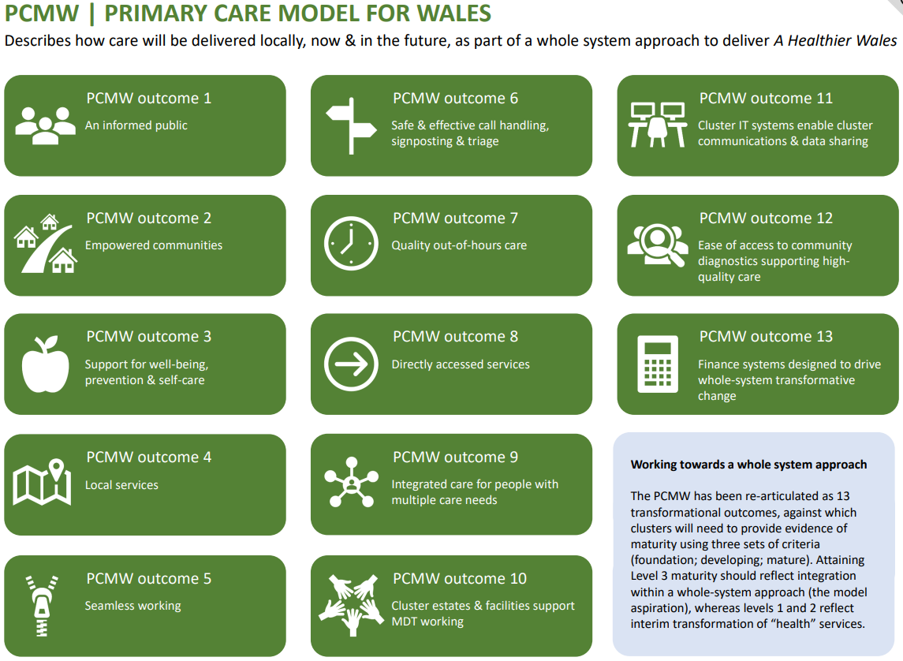

Appendix 2: ACD outcomes
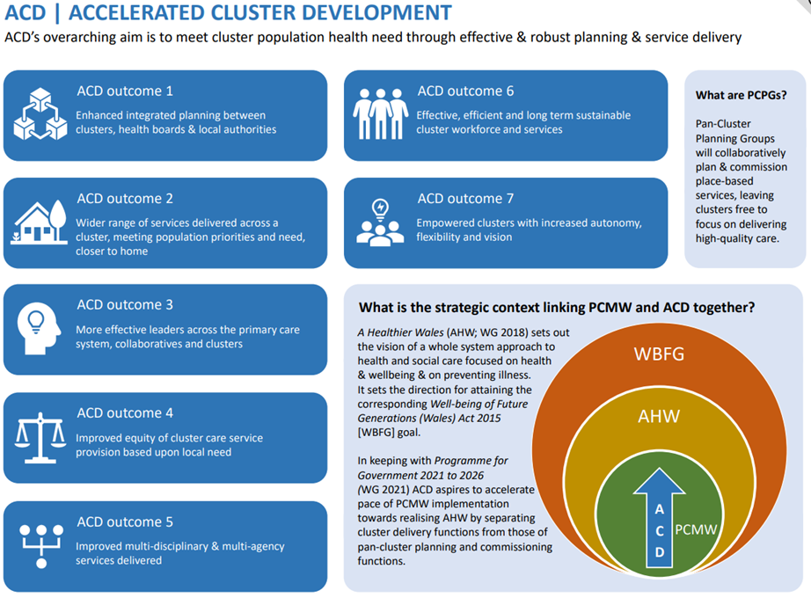

Appendix 3: Opportunities for action 2023/34 self-reflection
Opportunities for action | Lead organisation | Timescale | Update on progress
HB to facilitate, and support clusters in annual cycles of self-reflection to provide assurance of the progress of cluster working | HB | April 2025 | - Second cycle of cluster self-reflection facilitated by HBs
PHW and SPPC to further refine the PCMW and ACD maturity matrix, to better reflect multi-professional cluster working | PHW / SPPC | Dec 2025 | - In progress – scheduled for National Primary Care Board Nov 2025
HB and clusters to collectively consider the identified barriers, and explore potential solutions both local and where national engagement is required | HB/ Clusters | March 2025 | - HB Primary Care teams continue to work closely with clusters to identify local enablers and barriers  - AWCLG, ACD ALG and CDSON meetings provide peer to peer opportunities to explore issues / solutions
PHW, SPPC and HEIW to strengthen and communicate opportunities to share and promote examples of innovation and ongoing good practice clusters are delivering, including through the Primary Care One website and HEIW Primary and Community Care Compendium of Roles and Models website | PHW/ SPPC/ HEIW | Dec 2024 | - CDSON meeting agenda revised to facilitate ‘in depth peer to peer discussions’ to share success / issues  - SPPC collated a Cluster Year Book
HB and clusters to consider the organisational development needs of the cluster and the professional collaboratives, and putting in place mechanisms for individual and team development | HB/ Clusters | March 2025 | - Primary Care Academies in place and supporting organisational development needs
HB and clusters to consider ways to strengthen the working relationships and communications with strategic partners including within the health board and with PCPG, and RPB | HB/ Clusters | June 2025 | - WG and SPPC scoping PCPG summit  - ACD ALG sharing success/ issues of their local PCPGs
WG, HBs and SPPC to consider a review of the recommended time allocation for the cluster lead and professional collaborative lead roles, to determine if this adequate for the leads to fulfil their responsibilities | WG/ HB/ SPPC | 2025/26 | - Cluster meeting frequency and time allocation included in the second cycle of cluster self-reflection
SPPC and PHW to strengthen communication of the role and remit of clusters and professional collaboratives in Wales | SPPC/ PHW | Dec 2025 | - SPPC leading work to refresh lead role descriptors and role/ remit of PCPG
HB and clusters to explore ways of identifying and strengthening the local mechanisms that can enable clusters to become autonomous, empowered, and innovative entities | HB/ Clusters | March 2025 | - CDSON Procurement and Conflict of Interest session held October 2024
WG, HBs and SPPC to maintain a focus on strengthening cluster working and implementation of the PCMW across Wales | WG/ HB/ SPPC | 2025/26 | - PCMW Key Indictors domains agreed, and metrics being progressed
WG, HBs, SPPC and clusters to consider ways to mitigate against the current finance and funding barriers experienced by clusters | WG/ HB/ SPPC | 2025/26 | - SPPC and cluster leads working with finance colleagues to develop Finance FAQ
Clusters should engage with future self-reflection cycles, providing insight in ways to strengthen cluster working and to inform the evaluation of PCMW | Clusters | April 2025 | - Second cycle of cluster self-reflection completed by 53 clusters (88%)

Appendix 4: Individual PCMW graphs and technical analysis
Mean analysis
The data has been analysed to identify the mean maturity score for each PCMW outcome from 2023/24 and 2024/25 responses to provide an overview of any changes between the two years across Wales.
The average maturity score for all PCMW outcomes across Wales shows an increase from 2.52 in 2023/24 to 2.67 in 2024/25. Significant improvements were observed in several outcomes, with PCMW outcome 7 demonstrating the most substantial growth, increasing from an average score of 1.89 to 2.54. Strong progress was also evident in PCMW outcome 6 (from 2.48 to 3.00), PCMW outcome 2 (from 2.39 to 2.75), PCMW outcome 12 (from 1.89 to 2.23), and PCMW outcome 5 (from 2.70 to 2.79).
Figure 18: Average maturity of PCMW outcomes by year

Outcome 4 maintained a high maturity score across both years, although there was small decline seen (3.09 to 3.06), and outcome 3 and 8 maintained scores above 2.9. However, a few outcomes experienced decreases in maturity level, outcome 9 showing the largest decline from 3.04 to 2.88 and outcome 11 having a small reduction in maturity level (2.30 to 2.21).

Individual outcome analysis
In this section, each PCMW outcome is presented as a bar graph with the percentage distribution across the four maturity levels for the years 2023/24 and 2024/25.
PCMW outcome 1 remained relatively stable for the ‘Pre-foundation’ and ‘Mature’ levels. A small decrease in ‘Foundation’ (37% to 32%) and a corresponding increase in the ‘Developing’ level (46% to 51%).
Figure 19: PCMW outcome 1 (Informed Public) maturity by year

For PCMW outcome 2, both the ‘Pre-foundation’ level (13% to 0%) and ‘Foundation’ (46% to 34%) levels saw a large decrease with corresponding increase in the ‘Developing’ level (30% to 58%).
Figure 20: PCMW outcome 2 (Empowered communities) maturity by year

For PCMW outcome 3, the data shows a relatively stable maturity profile between 2023/24 and 2024/25.
Figure 21: PCMW outcome 3 (Support for well-being, prevention and self-care) maturity by year

For PCMW outcome 4, the ‘Pre-foundation’ and ‘Foundation’ levels remained stable. There was an increase in the ‘Developing’ level (50% to 57%) with a corresponding decrease in the ‘Mature’ level (30% to 25%).
Figure 22: PCMW outcome 4 (Local services) maturity per year

PCMW outcome 5 had a small decrease in the ‘Pre-foundation’ (9% to 4%) and ‘Developing’ (43% to 38%) levels with a small increase in the ‘Mature’ level (15% to 23%).
Figure 23: PCMW outcome 5 (Seamless working) maturity by year

For PCMW outcome 6 there were large decreases in the ‘Pre-foundation’ (20% to 4%) and ‘Foundation’ levels (30% to 19%). Conversely, there was a large increase in the ‘Developing’ level (28% to 53%).
Figure 24: PCMW outcome 6 (Safe and effective call handling signposting and triage) maturity by year

For PCMW outcome 7, the ‘Pre-foundation’ level reduced by half (51% to 25%). Conversely, there was an increase in the ‘Developing’ (11% to 23%) and ‘Mature’ (16% to 26%) levels.
Figure 25: PCMW outcome 7 (Safe and Quality out of hours care) maturity by year

For PCMW outcome 8, there were decreases in both the ‘Pre-foundation’ (-13%) and ‘Mature’ (-8%) levels while both the ‘Foundation’ (+12%) and ‘Developing’ (+10%) levels increased between 23/24 and 24/25.
Figure 26: PCMW outcome 8 (Directly accessed services) maturity by year

Four PCMW outcome 9, there was a decrease in the ‘Pre-foundation’ level (-9%) and an increase in the ‘Foundation’ level (+12%). Both ‘Developing’ and ‘Mature’ levels remained relatively stable.
Figure 27: PCMW outcome 9 (Integrated care for people with multiple care needs) maturity by year

For PCMW outcome 10, there was an increase in clusters stating their maturity level was at ‘Foundation’ (+12%) and reduction in the number indicating they were at a ‘Mature’ level (-11%). Both ‘Pre-foundation’ and ‘Developing’ levels remained relatively stable.
Figure 28: PCMW outcome 10 (Clusters estates and facilities support MDT working) maturity by year

For PCMW outcome 11. most levels remained relatively stable (Pre-foundation, Foundation and Developing) with a small decrease in clusters reporting to be at the ‘Mature’ level (-5%).
Figure 29: PCMW outcome 11 (Cluster IT systems enable cluster communications and data sharing) maturity by year

For PCMW outcome 12, the data shows a substantial decrease in clusters reporting at the ‘Pre-Foundation’ level (-35%) and increases for ‘Foundation’ (+31%) and ‘Developing’ (+6%).
Figure 30: PCMW outcome 12 (Ease of access to community diagnostics supporting high quality care) maturity by year

For PCMW outcome 12, there was a decrease in clusters reporting at the ‘Pre-foundation’ level (-8%) and an increase at the ‘Foundation’ level (+11%). Both the ‘Developing’ and ‘Mature’ levels remained relatively stable.
Figure 31: PCMW outcome 13 (Finance systems designed to drive whole-system transformative change) maturity by year

Appendix 5: Individual ACD graphs and technical analysis
Mean Analysis
The data has been analysed to identify the mean response for each ACD outcome from 2023/24 responses and 2024/25 responses. Overall the results provide an overview of any changes and track how clusters are progressing between the two years across Wales.
Improvements:
- No ACD outcomes have seen a decrease
- ACD outcome 4 has seen the biggest improvement from 2.1 to 2.6

Figure 32: Average maturity of ACD outcomes by year

Individual outcome analysis
For ACD outcome 1, ‘Pre-foundation’ decreased (-9%) and very small increases were spread across the other maturity levels (Foundation: +3%, Developing: +3% and Mature: 4%).
Figure 33: ACD outcome 1 (Enhanced integrated planning between clusters, health boards & local authorities) maturity by year

For ACD outcome 2, the ‘Pre-foundation’ (-5%), ‘Developing’ (-6%) and ‘Mature’ (-3%) levels decreased while the ‘Foundation’ level increased (+14%).

Figure 34: ACD outcome 2 (Wider range of services delivered across a cluster, meeting population priorities and need, closer to home) maturity by year

For ACD outcome 3, the ‘Pre-foundation’ level decreased (-7%) and conversely, the ‘Mature’ level increased (+9%). Both the ‘Foundation’ and ‘Developing’ levels remained relatively stable.
Figure 35: ACD Outcome 3 (More effective leaders across the primary care system, collaboratives and clusters) maturity by year

For ACD outcome 4, there was a decrease in the ‘Pre-foundation’ (-14%) and ‘Foundation’ (-12%) levels with a corresponding increase in the ‘Developing’ level (+23%).
Figure 36: ACD outcome 4 (Improved equity of cluster care service provision based upon local need) maturity level by year

For ACD outcome 5, there was a decrease in clusters indicating they were at the ‘Pre-foundation’ level (-9%) and an increase for the ‘Foundation’ level (+10%). Both the ‘Developing’ and ‘Mature’ levels remained relatively stable.
Figure 37: ACD outcome 5 (Improved multi-professional & multi-agency services delivered) maturity by year

For ACE outcome 6, there was a decrease in clusters reporting their maturity level as ‘Pre-Foundation’ (-15%) and ‘Developing’ (-10%) while the ‘Foundation’ level increased (+24%).
Figure 38: ACD outcome 6 (Effective, efficient and long-term sustainable cluster workforce and services) maturity by year

For ACD outcome 7, there was a decrease in clusters reporting their maturity level as ‘Pre-foundation’ (-19%) while increases were reported for ‘Foundation (+7%), ‘Developing’ (+7%) and ‘Mature’ (+4%).
Figure 39: ACD outcome 7 (Empowered clusters with increased autonomy, flexibility, and vision) maturity per year

Appendix 6: Number of qualitative responses
Self-reflection Survey Questions | Number of responses from those who disagreed or strongly disagreed
Do you feel that cluster working has made progress towards achieving the Primary Care Model for Wales? | 4
The role of a cluster is to bring together all local services to plan and deliver better co-ordinated care that promotes the wellbeing of individuals and communities? As a cluster, do you agree with this? | 2
In your area, do you feel that the primary and community care system (professional collaboratives, pan-cluster planning groups (PCPG), health board, local authority), supports the cluster to fulfil their role in bringing together all local services to plan and deliver better co-ordinated care that promotes the wellbeing of individuals and communities? | 18
As a cluster, do you currently have access to health board teams e.g. finance, administrative, planning, project management, that can support you in the delivery of cluster working towards the Primary Care Model for Wales? | 7
Within the time allocated to cluster working, is it achievable for the cluster to deliver their contribution towards the Primary Care Model for Wales? | 25

Appendix 7: Opportunities for action 2024/25 self-reflection
Opportunities for action | Lead organisation/s | Timescale
PHW investigate and address the specific challenges identified by the minority of respondents who showed declining participation in cluster self-reflection. | PHW | Oct 2025
Welsh Government, with relevant stakeholders, collaboratively review contracts/ service level agreements to ensure they accurately reflect all cluster and professional collaborative responsibilities and are equitable across professional groups and across Wales. | WG | TBC
SPPC review and refresh role descriptions for all system partners and ensure the information is effectively shared at all levels within the system. | SPPC | Nov 2025
SPPC and Health Boards, with relevant stakeholders, collaboratively evaluate time allocation for cluster leads and members to ensure that clusters have the necessary capacity to fulfil their responsibilities. | SPPC/ HB | TBC
PHW collaboratively work with partners to map the support provided to clusters, including Health Board ‘backroom functions’. Identifying where gaps exist and sharing examples of effective support mechanisms that have facilitated cluster working. | PHW | March 2026
PHW conduct further investigation into the contrasting experiences of clusters regarding autonomy and support, identifying specific factors that enable empowerment versus those that lead to disempowerment. | PHW | Oct 2025
PHW review the self-reflection survey and data to establish whether and what changes should be made to ensure future self-reflection surveys are robust and comparable. | PHW | March 2026

Appendix 8: Index of Abbreviations
ACD Accelerated Cluster Development
CDSON Cluster Development Support Officer Network
HB Health Board
HEIW Health Education and Improvement Wales
LA Local Authority
PCD Primary Care Division
PCMW Primary Care Model for Wales
PCPG Pan-Cluster Planning Group
PHW Public Health Wales
NHS Exec NHS Executive
RPB Regional Partnership Board
SPPC Strategic Programme for Primary Care
WG Welsh Government

Gweithio gyda'n gilydd
i greu Cymru iachach
Working together
for a healthier Wales

Primary Care Model for Wales
Welsh Government. A healthier Wales: long term plan for health and social care. 2018
Systems approach to scaling up: a systematic review and narrative synthesis of evidence for physical activity and other behavioural non-communicable disease risk factors
Theories, models and frameworks for health systems integration. A scoping review
Systems leadership in practice: thematic insights from three public health case studies
Further work is required to develop the detail of the opportunities for action including specific sub-actions, time frames and monitoring requirements.
To understand how clusters have matured across PCMW indicators, each stage of maturity has had a score applied: 1-Pre-foundation, 2-Foundation, 3-Developing and 4-Mature.

