THE PRIMARY CARE MODEL FOR WALES

Introduction

The population of Wales is living longer and with age comes an increased risk of health and wellbeing needs. This in turn creates an increase in demand on services. For services to be stable and resilient, they need to evolve to create more capacity and focus on proactive care that prevents and delays avoidable health and wellbeing needs and supports those living with multiple long term health conditions. That range of care includes advice on healthy lifestyles, supporting self-management, early detection of diseases, rehabilitation, ongoing monitoring and care. Primary Care, accounting for between 80 – 90% of NHS Wales activity, also signposts patients to the most appropriate part to the system on a daily basis through care navigation and every contact counts.

It has been a long-standing aim of the Welsh Government to increase the pace at which services are evolving. The Welsh Government’s 10-year plan for the evolution of health and social care services, A Healthier Wales was published in 2018 and put supporting what matters to people at the heart of services. The plan set out a vision for seamless services at or close to home. With people only going to a hospital when this is the right thing for their specific needs.

The Welsh Government endorsed the 2018 Primary Care Model for Wales as the agreed approach to the planning, organisation and delivery of community-based services in line with A Healthier Wales. In December 2024, the Welsh Government published the third and final set of actions to deliver the vision in A Healthier Wales. In response to those actions, the original Primary Care Model for Wales has been reviewed and refreshed.

The Primary Care Model for Wales

What is Primary Care?
The term ‘primary care’ is a shorthand term to refer to health and wellbeing services delivered at home or in the community. Whilst predominantly funded and delivered by the NHS, it can also be delivered in partnership with Local Authorities, Third and Independent Sector and communities.

What is the Primary Care Model for Wales?
The Primary Care Model for Wales (PCMW) describes a whole system approach to planning, organising and delivering sustainable and accessible local health and wellbeing care.

Why is the PCMW required?
To provide a model for the collective focus of health and care services on planning and delivering place-based, multi-professional working at or close to home.

Who delivers the PCMW?
The broad range of primary and community care workforce, strategic partners including Welsh Government, Health Board Executive teams, Local Authority Leaders.

What is the expected impact for the population of Wales?
Health and care services that are designed, planned and delivered to meet the local population need to improve population health and wellbeing in an equitable and sustainable way.

The model is demonstrated in the illustration below.

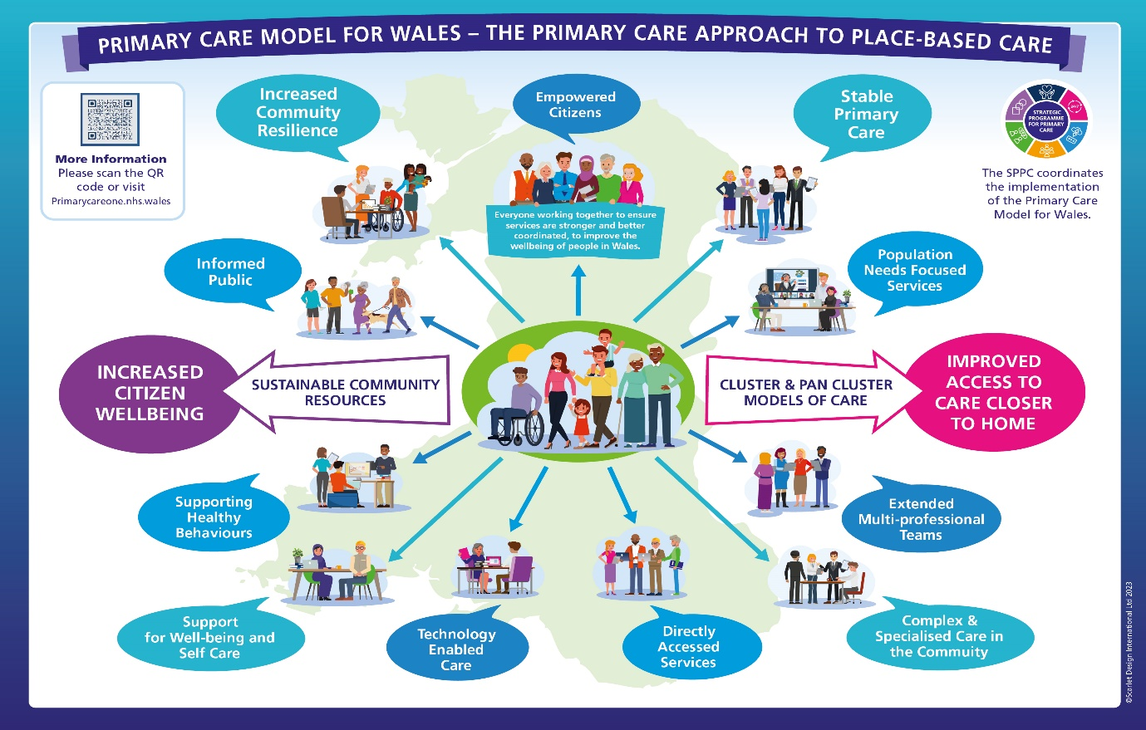

The Principles & Components

The Principles

Primary care services are planned, funded, organised and delivered so they:
- comply with nationally set quality statements, models and guidelines
- are accessed at home or in the community unless there is evidence they are required to delivered in a hospital for reasons of safety
- are accessed directly (or referred to by a professional to ensure continuity of care or person centred, coordinated care from several services)
- are proportionate to need, prioritising individuals, families and communities with the greatest need
- make effective use of the time, skills and expertise of the workforce and community assets and other resources
- are collaborative and coordinated for the benefit of the population they serve irrespective of organisational and professional boundaries
- safely and appropriately share data and information
- empower individuals, families and communities to take responsibility for their own health and wellbeing to do what matters to them
- are a mix of clinical and non-clinical, face to face, on the phone and online
- are proactive, anticipating the physical, mental and emotional needs of individuals and communities
- for urgent care needs are available 24/7, with priority given to those with the most urgent needs
The Components

3.1 An Informed Public

Services provide information to the public and describe actions that individuals can take to maintain health and wellbeing. They communicate and explain the potential benefits and limitations of the care that they offer to educate and empower the public to take ownership of their own health and wellbeing. Local public and professional communication strategies have a strong focus on explaining how services are evolving.
There are a variety of approaches to meet cultural and social differences to enable behaviour change. Services take every opportunity to provide information, advice and assistance to help people make positive lifestyle choices. When people are informed to understand the importance of self-responsibility, they are more likely to adopt habits that maximise their health and wellbeing and to access services appropriately.

3.2 Empowered Citizens & Communities

Building upon an informed public, individuals, families and communities are able to use a range of ways to influence the design of services and provide feedback on their experiences. Local champions share their experiences of services. All professionals act as advocates for the community they serve, using their experience and feedback from service users to guide local decision making.

3.3 Support for well-being, prevention and self-care

There are a range of local services and resources available to promote self-care and self-referral, and a range of technologies that can aid self-care and communication. For example, Educating Patient Programmes offer peer support to fully understand particular conditions and explore the most effective management strategies for each individual. Support for self-care will be balanced with targeted support for people at increased risk of health and wellbeing problems, where providing continuity of care with a professional has been shown to improve health and well-being outcomes.

3.4 Local Services

People access the majority of services at home or in the community delivered by a wide range of trained professionals and volunteers. Services are tailored to the specific needs and circumstances of those communities. There is a range of ways to contact or be contacted by services – by phone, text, email, apps and video calls.

People also access a variety of self -care services on the phone and online. For example, the national 111 phone line and website provides help and advice on health topics with a range of symptom checkers. 111 press 2 offers mental health and wellbeing support. Each Local Authority provides an Information, Advice and Assistance (IAA) telephone line. Information on opening hours and locations is available from 111, Health Board websites, service specific websites and Local Authority Information, Advice and Assistance telephone lines.

People use a suite of apps on their own smart phones. The NHS Wales App allows an individual to access a range information and services such as their own health record, book appointments and order repeat prescriptions. Increasingly technology enabled care can be used in the home for self and remote monitoring.

3.5 Population Needs Focused Services

The people who provide the broad range of local services are typically employed or contracted by the NHS and a local authority. Contracted services typically are those provided by GPs, dentists, community pharmacists, optometrists, local authority, third sector services and care homes. Health Boards provide a wide range of clinical services through community based multi professional teams which are tailored to the needs of local populations, including an increasing focus on prevention and self-management. In order to provide coordinated services and make the best use of funding, resources, time, skills and expertise, there are collaborative mechanisms at community, county and regional level.

At community level
Local services come together as Clusters to collaborate on both the planning and the delivery of services for communities of between 25,000 and 100,000 people. Cluster collaboration enables a real understanding of the needs of a community and where professionals can build relationships with their colleagues to improve communication and coordination. It also supports professional wellbeing and performance by creating opportunities to meet with colleagues to share experience, develop ideas and receive peer support.

Clusters are supported by professional networks. A Professional Collaborative is the name given to peer networks for each of the professional groups. Each Collaborative has a particular expertise and can provide the most informed analysis of the performance, risks and opportunities for their area of professional practice in each local area. The Collaboratives provide an opportunity for problem solving and sharing good practice. As many aspects of care require a multi professional approach, each Professional Collaborative provides a representative to the local Cluster, where the totality of care provision is discussed.

At county level
Cluster Leads represent their Clusters on Pan Cluster Planning Groups which are responsible for planning, funding, commissioning and contracting services for the county population.

At regional level
Regional Partnership Boards are responsible for producing formal 5 yearly Population Needs Assessments and Area Plans to meet that population need. This strategic planning process is informed by detailed information on population need and plans drawn up by Clusters and Pan Cluster Planning Groups, which in turn, feeds into the Health Board IMTP planning processes and population health strategies.

3.6 Safe & Effective Navigation Systems

Safe and effective navigation systems channel people to the most appropriate services. This may be through:
- The 111-phone service, GP practices. and the Information, Advice and Assistance service use telephone navigation systems to signpost or refer people to the best local service for their specific needs.
- Local services access care navigation systems to refer individuals on to home and community-based services such as district nursing, end of life and palliative care and enhanced community care.

Where appropriate, individuals access services offering personalised support to navigate and coordinate access to the right services for an individual’s specific needs.

3.7 Urgent Care 24/7

The national 111 service is available 24/7 to people who feel ill and are unsure what action to take. This service has access to individual’s clinical records which is essential to ensure continuity especially those with complex conditions and/or at the end of life. The 111 service is supported by a national virtual directory of services and also signposts people to local services and sources of help whilst providing symptom check advice and articles on a wide range of health issues.

3.8 Directly accessed services

People directly access (or self-refer) to a range of local services and professionals for help and advice about their health and wellbeing. These typically include:
- General Practice services for the prevention, diagnosis, treatment and management of long-term health conditions, episodes of urgent care
- Community pharmacies for advice and treatment for a range of common ailments and clinical services including immunisations
- Optometrists for advice and treatment of routine and urgent eye problems
- Dentistry for advice and treatment on oral health and dental decay
- Community Nursing, which provides a range of care, treatment and support to individuals
- Physiotherapy for musculoskeletal problems
- Audiology for hearing problems
- Podiatry for advice and care on foot health
- Occupational Therapy for help with mental health and independent living
- Dietetics for advice on eating healthily
- Speech and Language Therapy for those experiencing communication difficulties or difficulties with eating, drinking, and swallowing
- Social care for support with all forms of personal care and other practical assistance
- Third sector services for a range of support, such as mental and physical wellbeing

3.9 Integrated Community Care for Complex Needs

Individuals living multiple care needs are proactively identified and their health and wellbeing needs are addressed through a care plan that recognises their preferences. This is proactively monitored with each person accessing the care and support they need. This may include care at home, including in a care home. Where an individual is taken to or admitted to hospital for services that are only safely provided by specialists in a hospital, the hospital proactively works with local services, so the individual does not stay in hospital longer than needed and risk harm.

3.10 The Local Infrastructure

The local infrastructure enables coordination of services and collaboration between teams. Local health and wellbeing facilities and resources, telephone and digital systems together with data systems are flexible and responsive to future changes and the needs of a multi professional workforce. People’s homes are adapted to enable home based services and independent living.

3.11 Outcomes

The impact of funding, planning, organising and delivering health and wellbeing services in line with the Primary Care Model for Wales is measured through National Outcome Measures. Qualitative analysis, such as self-reflection and peer review is used to complement the National Outcome Measures.

