SBUHB Local Cluster Collaboratives

Integrated Medium Term Plan
(IMTP)

Annual Plan 2023 – 2024

Contents
1. STRATEGIC CONTEXT 1
Development of LCC Integrated Medium Term Plan 2
LCC wide programmes 5
2. LCC WORKFORCE PROFILES 6
3. ACTION PLAN 7
AFAN LOCAL CLUSTER COLLABORATIVE 9
Forward Look 9
Action Plan 11
LCC Financial Profile 15
BAY HEALTH LOCAL CLUSTER COLLABORATIVE 16
Forward look 16
Action plan 17
LCC Financial profile 23
CITY HEALTH LOCAL CLUSTER COLLABORATIVE 24
Forward Look 24
Action Plan 25
LCC Financial profile 30
CWMTAWE LOCAL CLUSTER COLLABORATIVE 31
Forward look 31
Action plan 32
LCC Financial profile 41
LLWCHWR LOCAL CLUSTER COLLABORATIVE 42
Forward Look 42
Action plan 43
LCC Financial profile 48
NEATH LOCAL CLUSTER COLLABORATIVE 49
Forward look 49
Action plan 51
LCC Financial profile 57
PENDERI LOCAL CLUSTER COLLABORATIVE 58
Forward look 58
Action plan 60
LCC Financial profile 66
UPPER VALLEYS LOCAL CLUSTER COLLABORATIVE 67
Forward look 67
Action plan 69
LCC Financial profile 76

1. STRATEGIC CONTEXT

A Healthier Wales (AHW) sets out the vision for a whole system approach to health and social care focusing on health and wellbeing and on preventing illness. It sets the direction for attaining the corresponding Wellbeing of Future Generations (Wales) Act 2015 (WBFG) goal.
The Primary Care Model for Wales (PCMW) supports the vision for AHW, putting what matters to people at the heart of service planning and delivery will make sure the right care is available at the right time from the right source, at home or nearby.
In keeping with Programme for Government 2021 to 2026 (WG 2021) Accelerated Cluster Development (ACD) aspires to accelerate pace of PCMW implementation towards realising AHW.
On the ground, ACD includes the introduction of Local Cluster Collaboratives (LCCs) (formerly Primary Care Clusters), Professional Collaboratives (PCs) and the Pan Cluster Planning Groups (PCPG) to broaden and strengthen clinical engagement and to increase the influence from the community through to the Health Board and Regional Partnership Boards, enabling better aligning of work to improve services and well-being.
The diagram below depicts the current model and the expansion of LCC membership during the ACD transitional year 2022-23. Previously, membership consisted predominantly of GPs and the Third Sector, however, this has now grown to include wider community contractors and health board services, these being community dentistry, optometry, pharmacy, general medical services, allied health professionals & health sciences, nursing and mental health services.

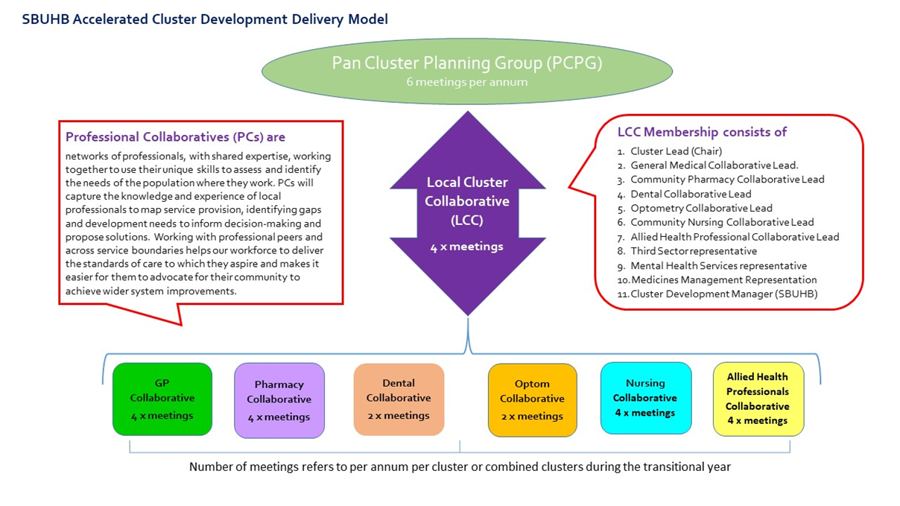

Development of LCC Integrated Medium Term Plan
Our LCCs are the delivery mechanism within ACD that allow the principles set out by the PCMW to be achieved (see Glossary of Terms). This is enacted through delivering our LCC IMTPs, which also help to inform Health Board and PCPG Planning.
During September and October 2022 our IMTPs were refreshed, maintaining the priority areas agreed in 2022-23 in line with the Health Board Recovery and Sustainability Plan and providing additional or amended actions where relevant.
The Action plans have been developed under the context of the Clinical Services Plan (CSP) 2019-2024 in order to keep people healthy, support them to avoid ill health and provide excellent healthcare when people need it. Cluster planning and delivery remains aligned to the four CSP principles, set out below:

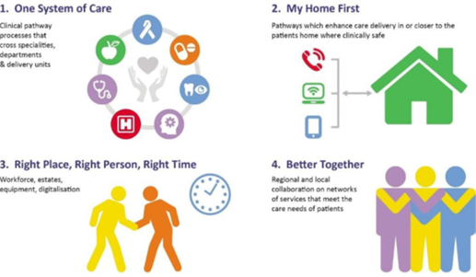
The LCC provided opportunity for input into the IMTP 2023-24 from the new Professional Collaboratives with engagement and contributions also received from partners in Medicines Management, Mental Health and Learning Disabilities, and the Third Sector, with a range of engagement exercises undertaken to identify key areas of work that could be undertaken and delivered through the newly formed LCCs.
During September and October 2022 proactive discussions were held with partners to seek responses to the RPB Needs Assessment, as well as to consider the health of their patient population. Further information has been considered via the Cluster-led Needs Assessment and Local Well-being Plans (Public Service Boards), combined with local knowledge and professional expertise.
Subsequently a comprehensive set of proposals have been received from the Professional Collaboratives and LCC members and these have been reflected in the LCC IMTPs where relevant as well as brought forward to the PCPG Plan currently under development.

LCC wide programmes

A range of pan-cluster programmes already agreed funding for, commissioned, or underway by SBUHB:
- Virtual Wards: Providing wraparound care closer to home where patients really want to be. Each Cluster has its own multidisciplinary team to target specific health and social care needs of the most vulnerable frail patients. Through the high quality care provided reduction of avoidable admissions is achieved along with facilitation of earlier safe discharges of patients from the acute sector.
- Primary Care Audiology: Service offering wax management and first contact hearing and tinnitus assessment and advice in the Community. Where onward management required patients are effectively directed to the relevant secondary care service, thus reducing their pathway time and complexity.
- Training and enhanced service for Domestic Abuse – IRIS i: IRIS is a general practice-based domestic Violence and Abuse (DVA) training support and referral programme. It is a collaboration between primary care and third sector organisations specialising in DVA. The programme includes training and education, clinical enquiry, care pathways and an opportunity to refer to a named advocate.
- All-Wales Diabetes Prevention Programme: The biggest modifiable risk factor to developing Type 2 Diabetes is being overweight or obese and reducing these risk factors through weight management interventions, is therefore a strategic priority
- Cancer Pre-habilitation: Programme aimed at optimisation prior to Cancer treatment, using time on the waiting list for positive intervention. This is offered to patients when they present to the GP with symptoms suggestive of cancer. If patient goes on to be diagnosed with cancer they are optimised prior to treatment, if not diagnosed they have received primary prevention through medication reviews/lifestyle changes

2. LCC WORKFORCE PROFILES
One of the most effective ways identified to deliver services to meet LCC priorities is through the employment of a multi-disciplinary team. This includes a range of professions and areas of expertise, with some working closely together to achieve the demands and capacity of the LCC needs.
During 2023/24, to ensure that workforce and services in each LCC meet the needs of the population and to deliver sustainable service, an assessment of contractor and cluster workforce will be completed across all 8 LCCs. This will allow for gaps to be identified informing future strategic workforce planning and commissioning.

Goal | Method | Outcome
To ensure that workforce and services in the Cluster meets the needs of the population and to deliver sustainable services | Complete an assessment of contractor and cluster workforce, initially GMS followed by other service areas/contractors, informed by respective demand and capacity analyses. | Clear understanding of workforce and service needs in the Cluster with gaps identified to inform future strategic workforce planning and commissioning through cluster, service areas, and PCPG

3. ACTION PLAN
Each LCC plan is set out by identifying a set of Goals, Methods and Outcomes against each programme of work under the six priority areas agreed by the eight LCC leads introduced in the over-arching PCPG plan:
- Unscheduled Care
- Planned Care
- Cancer and Palliative Care
- Prevention and Reducing Health Inequalities
- Children Young People and Maternity
- Mental Health and Learning Disabilities and the 7 goals
In addition, the Cluster has given consideration to:
The remaining HB Strategic Priority Areas:
- Responding to Covid (including addressing the four harms of Covid)
- Improving Patient Quality and the 5 Q&S goals
- Improving Planned Care
- Increasing Digital Capability
- Improving primary, community and therapy services
Ministerial Priorities 2023-24:
- Delayed transfers of care
- Primary care access to services (including GP & Community Services, Dental, Community Pharmacy, Optometry)
- Urgent & Emergency care including improved access and GMS sustainability via NHS 111
- Planned Care, Recovery, Diagnostics and Pathways of Care
- Cancer recovery
- Mental health and CAMHS

RPB Priority Areas
- Strengthening Communities
- Transforming Health and Care services at home
- Transforming Complex Care
- Transforming Mental Health Services

LCCs have also given consideration to the enablers and programmes in place which will support facilitation of the plan and wider priorities set out above and have set these out at the end of each LCC Action Plan in Table 7.
All of the actions contained within the 6 priority areas have been mapped against the above and the Primary Care Model for Wales ( PCMW) within the document and can be viewed in the embedded document at the end of each Action Plan
The GMO’s for each LCC lay out the overarching Goal, the method by which these will be achieved and the assumed outcomes of this. At time of printing current data for 22/23 is not yet available so quantifiable outcomes have not yet been agreed for all actions. LCC’s are currently working on developing their 23/24 progress monitoring tools to complement their GMO action plan and these will have quantifiable indicators agreed by the LCC for each action.
Delivery planning will commence in Quarter 4 of 22-23 and thereafter our IMTP will be underpinned by a robust progress monitoring tool tested throughout 22-23 and supported by the Cluster Business Manager and various LCC members.



AFAN LOCAL CLUSTER COLLABORATIVE

Forward Look
As the new Afan Local Cluster Collaborative (LCC) Chair since the summer of 2022, my first few months in the role have coincided with the introduction of the new Accelerated Cluster Development structure and a very different and strengthened way of working in partnership. This has brought with it many exciting new challenges and a renewed and reinvigorated multi-disciplinary membership for Afan Cluster, which our LCC members are committed to embracing for the benefit of our local population.
Afan LCC members hold a shared ambition to transform the way we provide primary care for the Afan population, enabling people to start well, live well and age well. We need to work not simply to build integrated services but to support resilient communities. I wish to ensure all members of our LCC have an equal opportunity to develop and coproduce projects. Collaboration is key to delivering healthcare for the people of Afan and this IMTP is therefore taking an increasingly whole system approach towards the very long term, sustainable and inter-generational approach to improving the wellbeing of the Afan population.
Our refreshed Integrated Medium Term Annual Delivery Plan for 2023-24 builds on our previous actions and aims to deliver excellent quality services to meet the needs of our population in a holistic way. We are committed to continuing our Afan Mental Health Model via a combination of practice based and third sector based Social Prescribers, with the dedicated sessional input of a practice based Mental Health Practitioner who works at an advanced level. This team of three very experienced and skilled staff have all been in post since the inception of the project in 2019 and work extremely well together and in partnership with other mental health and support staff. Going into 2023 our LCC is committed to evaluating the excellent work that has been achieved by these partnership working arrangements with a view to further strengthening our Mental Health Model of service delivery.

We have recently recruited a new Cluster Pharmacist who will commence employment in January 2023. This is a very welcome addition to the Cluster multi-disciplinary team (MDT) playing a crucial role in delivering our actions on anti-microbial prescribing reduction and also working in conjunction with GP practices and Community Pharmacists to ensure seamless services that best meet the needs of our population in relation to common ailments and care being provided in the right place at the right time.
We are also continuing with our attempts to recruit a Business Development & Implementation Manager to support the Cluster to scope and drive our existing projects and future aspirations going forward and achieve our vision for our population. This post is crucial for us to ensure robust project management of existing and new actions that the LCC has committed to.
Ultimately, this plan is about people, it is based on the health needs of our population, delivering quality services and ensuring equitable and timely access to primary care and community services across Afan. As we go into 2023 our Cluster will strengthen existing connections and partnerships in the communities it serves whilst also developing new ones; particularly ensuring that patients and carers in Afan are able to make direct and valuable contributions towards Cluster planning and activities.
Amran Hussain,
Afan LCC Lead

Action Plan

- PLANNED CARE
GOALS | METHODS | OUTCOMES
1.1 | Improving Patient Quality and Safety | - Continue to engage in prescribing management schemes  - Improve antimicrobial stewardship and build relationships with HB / Cluster pharmacy advisers | - Reduction in inappropriate antibiotic prescribing working towards HB targets
1.2 | Meeting Carers needs | - Increase awareness of Carers rights and needs across Cluster members by engaging with the Carers Service  - Individual Cluster member areas to have carers champions where possible  - Explore projects that will support Carers | - Improved staff training / skills / knowledge  - Increased identification and support of Carers
- CANCER & PALLIATIVE CARE
GOALS | METHODS | OUTCOMES
2.1 | Improve EOL for patients and patient’s family | - Plan, secure and deliver coordinated 24/7 palliative and end of life care in line with published standards  - All GP Practices engaging in regular in-house Palliative Care Meetings | - Better partnership working  - Better outcomes for patients and families
2.2 | Provide support to patients to quit smoking | - Promote Help me Quit to patients  - Liaise with Pharmacy colleagues to increase engagement in Level 3 service  - Ensure smoking status is up to date on patient records | - Increased referrals to Level 3 service against 2022/23 end of year uptake  - Reduction in smoking rates in cluster
2.3 | Increase early diagnosis and treatment of cancers | - Promote screening uptake  - Support early diagnostic centre | - Increased uptake to at least pre-COVID levels of  Bowel 61%  Cervical 72%
2.4 | Improve access to most appropriate care | - Accessing Dental advice and support through Consultant Connect for more rapid feedback regarding dental cancer / dental care uncertainty, and reduction in referrals where unnecessary | - Reduction in Dental referrals to oral health/ restorative dentistry consultants
- UNSCHEDULED CARE
GOALS | METHODS | OUTCOMES
3.1 | Reduce demand on outpatients and support improved referral to treatment times | - Increase the use of Consultant Connect by all clinical services who have access | - Improved communication between primary and secondary care  - Patients treated in primary and community settings when most appropriate
3.2 | Enable patients to access most appropriate care | - Maximise referrals and sign-posting to Community Pharmacy Common Ailments Scheme (CAS) by all relevant cluster members  - Understand the level of involvement for individual pharmacies and work to maximise use of service and a consistent approach across Community Pharmacies | - Increased referrals/sign posting  - Increased uptake of CAS in Community Pharmacy  - Reduced demand for Primary Care appointments
- MENTAL HEALTH & LEARNING DISABILITIES
GOALS | METHODS | OUTCOMES
4.1 | Develop services to improve mental health and wellbeing of patients | - Continue to fund a cluster mental health model and explore additional projects to address the mental health and wellbeing needs of the cluster population  - Ongoing monitoring and evaluation of the Cluster Mental Health Model to ensure that patient needs are being met  - Co-produce services with HB partners | - Increased MDT provision  - Better partnership working  - Better outcomes for patients
- CHILDREN, YOUNG PEOPLE & MATERNITY
GOALS | METHODS | OUTCOMES
5.1 | Improve outcomes for the most vulnerable families within the NPT clusters | - Continue to fund, support and work with the Specialist Health Visitor provision in NPT to ensure an integrated approach to assessments, thresholds and referrals | - Increase in appropriate referrals to Specialist Health Visitor  - Decrease in GP appointments
- PREVENTION AND REDUCING HEALTH INEQUALITIES
GOALS | METHODS | OUTCOMES
6.1 | Maximise engagement in Flu vaccination programme | - Review IVOR data for flu vaccination  - Develop and implement seasonal flu plan aimed at early administration of flu vaccine to eligible patients | - Increase in uptake in target group on 2022/23 figures working towards national targets.
6.2 | Maximise engagement in Childhood vaccinations | - Maintain performance in uptake of childhood immunisations where targets have been achieved and aim to achieve targets that have not yet been reached | - Increase in uptake in target group on 2022/23 figures working towards national targets.
6.3 | Patients are engaging in Public Health screening programmes | - Continue to promote and encourage patient engagement with all Public Health screening programmes | - Increase in uptake in target group working towards national targets
6.4 | Identify and support patients experiencing domestic violence | - Engage in the roll out of the primary care IRISi project  - Extend the roll out of the project to wider cluster members | - Increased identification of DVA  - Improved staff skills / knowledge

Return to Contents
7. ACTION PLAN ENABLERS
Technological | Workforce | Communication & Engagement | Finance
Blue stream E learning platform | Continued employment of Business Manager to provide the Cluster with the resources to achieve its goals | Primary and community communications officer delivering e-media, and press advertising campaigns | Emergency Planning Response and Resilience Plan
Ask My GP | Chronic conditions nurse |  | WG Funding
My Health Online | Cluster Pharmacist |  | Health Board funding for Virtual Ward/ IRIS I/ Primary Care Audiology
Vision 360 | Social Prescriber |  | Mental health and learning disabilities delivery group funding for social prescriber and for mental health triage post
Microsoft Teams | Local area co-ordinator
 | Virtual Ward staff
 | Primary Mental Health triage
 | Induction Pack for New Cluster staff
 | LCC Cluster Lead
 | LCC Cluster Members
 | Primary Care Cluster Development Team

Return to Contents

LCC Financial Profile
Statement of allocated LCC Spend decisions (As of January 2023)
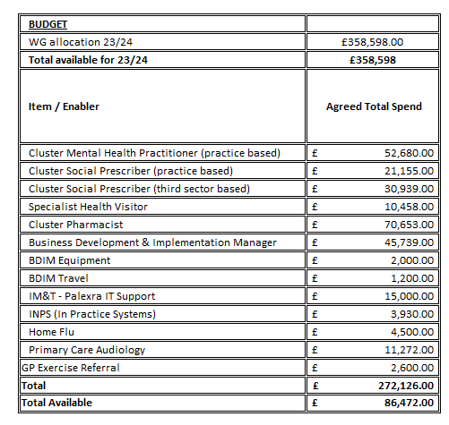

Return to Contents



BAY HEALTH LOCAL CLUSTER COLLABORATIVE

Forward look
Welcome to our Integrated Medium Term Plan for Bay Health Local Cluster Collaborative (LCC). We are in a time of change and re-development in the LCC. With the national advent of Advanced Cluster Development, we have all adapted to working in different ways and teams. We have established multiple Professional Collaborative teams, a Local Cluster Collaborative team and the Health Board Wide Pan Cluster Planning Group which brings in expertise from the Collaborative representatives as well as the local authority and the Third Sector. These groups are running in parallel to the cluster established IMTP in this transit period.
This year’s IMTP highlights the areas we are focussing on in Bay Health LCC including supporting and benefitting from the newly established Virtual Ward to help reduced unscheduled care, continuing to strengthen and develop our cluster MDT to optimise planned care for our harder-to-reach housebound population and improving cancer detection and prevention by promoting screening campaigns and the ‘Help me Quit’ service for smokers. We are also commissioning wellbeing and counselling services for both adults and children in our population who are struggling with their mental health and ensuring the cluster workforce is well trained in safeguarding those more vulnerable members of our community.


We are all looking forward to recovering from the pandemic and the exciting changes underway with the Advanced Cluster Development to continue to improve and support the health and wellbeing of all our cluster population.
Dr Nicola Jones, Bay LCC Lead 

Action plan

- PLANNED CARE
 | GOALS | METHODS | OUTCOMES
 | To reduce referral demand and face to face attendances where appropriate | Maximise use consultant connect to operate in all specialities to supplement e-advice (WCCG) | Reduce referrals  Reduce waiting lists  To increase patient contacts using consultant connect by 5%
 | Enable patients to access most appropriate care | Provision of a Primary care audiology service | Reduced contacts with GPS/Practice nurses for problematic wax, hearing and tinnitus concerns
 | Ensuring that all Heart failure patients are correctly coded – timely safe and secure. | Tidy Up Searches for all GP Patient registers to review Heart Failure coding categories and ensure correct coding prior to annual Heart Failure Review | Only the right patients invited for annual review ensuring timely and safe care, facilitating patients being commenced on the 4 pillars of Heart failure medications and receive self-care, treatment and advice
2. CANCER & PALLIATIVE CARE
 | GOALS | METHODS | OUTCOMES
2.1 | Reduce smoking rates | Help me quit – provide support to patient to quit smoking through advice and education, promotion through communications  Liaise with pharmacy colleagues to consider future action, increasing engagement with level 3 service | Increase patient contacts by a further 5% by the end of March 2024
2.2 | Improve Health of Cluster through increased uptake of screening projects | Promote screening uptake  Participate in non-responder projects for Bowel, cervical and Breast screening | Maintain High uptake of breast and cervical screening  Working towards target of 75%  Increasing uptake among non- responders
2.3 | Improve EOL for patients and patient’s family | Plan, secure and deliver well coordinated 24/7 palliative and end of life care in line with published standards, enhancing end of life care through the virtual ward and delivering advance care planning | Increased access to palliative care expertise  Increase in number of patients receiving end of life care in own home or hospice rather than hospital  Patients and their families experience better end of life care services.
- UNSCHEDULED CARE

 | GOALS | METHODS | OUTCOMES
3.1 | To reduce unnecessary impact on secondary care through accelerating pathways for  heart failure, respiratory and diabetes | Scoping exercise undertaken around 3rd sector support required.  Supporting and optimising housebound patients within their homes through Chronic Conditions Nurse | Practitioners accessing more 3rd sector pathways  Optimised care for difficult to access housebound patients, measured through Annual Reviews
3.2 | To increase uptake rates of the flu vaccine | Deliver a Cluster plan of action to address Flu to compliment individual practice plans including, promotion of self-care, vaccination clinics, communications, flu champions for 2023/24; practices to share ‘best practice’  Offer of Flu vaccine to carers at the same time as administering to housebound patients | Increased uptake in target groups from most recent data  65+ maintain 75%+  Under 65 at risk – 55%  2+3 yr. olds – 58%
3.3 | To provide more care in the community | To further develop the role of the CCNs | Database developed to monitor number of vulnerable patient’s supported in own home by CCN
3.4 | Enable Patients to access most appropriate care | Signposting of patients to Common Ailment Schemes  Working closely with individual community pharmacies to increase uptake into common ailment schemes | Increase in number of patients accessing the common ailments scheme by 5% releasing more GP time for those patients who require more input
3.5 | To improve access to independent prescriber course for pharmacists | Engage GP/Other mentors to support through GP/other mentorship/Supervision of Pharmacist | Increased number of pharmacists accessing independent prescriber course
3.6 | To improve balance, strength and prevent falls/deconditioning to the frail/elderly people on the virtual ward | Employ a physiotherapist to work with patients of the virtual ward | Improved Mobility  Improved Health Status  Improved Pain/discomfort  Improved ability to complete usual activity  Improved MH Status
4. MENTAL HEALTH & LEARNING DISABILITIES
 | GOALS | METHODS | OUTCOMES
4.1 | Improving outcomes for Carers (+ all other priority area) | Scope the opportunities for improving carers’ early identification, signposting and support across the key services areas of each cluster to supplement the work already undertaken through GMS | Cluster service areas confident to identify and support Carers
4.2 | Improve pathways for patients with low level mental Health | Develop a mental health cluster model by mapping and commissioning Cluster based Mental Health Services | Better reported patient experience/outcome measures  Rapid access to psychological therapies  Increase in referrals to social prescriber on 2022/23 figures
4.3 | Improve awareness of the needs of those living with dementia | Provide training for frontline staff across the LCC with the virtual dementia bus | Alterations are made to the physical environment to accommodate dementia patients’ needs  Alterations are made to the way that dementia patients are interacted with  36 frontline staff to access training
4.4 | Improve awareness of the needs of those with autism | Provide training for frontline staff across the LCC with the virtual autism bus | Alterations are made to the physical environment to accommodate autism patients’ needs  Alterations are made to the way that autism patients are interacted with.  24 frontline staff to access training
- CHILDREN, YOUNG PEOPLE & MATERNITY
 | GOALS | METHODS | OUTCOMES
5.1 | To protect the Health of Children in the Cluster | Promote Pre-school booster programme | Working towards achieving 95% preschool booster uptake  Maintaining high level of uptake in all other groups
5.2 | Mental Health Counselling | Please refer to Improving Mental Health 4.2
- PREVENTION & REDUCING HEALTH INEQUALITIES
 | GOALS | METHODS | OUTCOMES
6.1 | To ensure child and adult safeguarding is prioritised | Implement a plan across contractors to increase reporting, training and improvement of communications and pathways. | Staff up to date with all training
6.2 | To ensure Violence against women, Domestic Abuse and Sexual violence issues and processes are improved. | To explore expanding Ask ANI across all Health Professions in the Cluster | Increased awareness among staff  Increased access for individuals
6.3 | To improve antimicrobial stewardship | Implement work with Medicines Management through the prescribing leads group. | Reduction in overall Prescribing.  Reduction in 4C (Broad Spectrum) antibiotics prescribing in line with Health Board targets
6.4 | To improve transport access for the population of the Cluster | Project team to be established to explore current services and link in with partners to explore possible actions that may improve provision available | Population of the Cluster having better access of transport to access services available to them across the Cluster
6.5 | To improve access for client groups across the Cluster to services | To upskill staff on the use of induction loop systems | Better patient experience for the population of the Cluster

Return to Contents

7. ACTION PLAN ENABLERS
Technological | Workforce | Communication & Engagement | Finance
Blue stream E learning platform | Continued employment of Business Manager to provide the Cluster with the resources to achieve its goals | Primary and community communications officer delivering e-media, and press advertising campaigns | Emergency Planning Response and Resilience Plan
Ask My GP | Chronic conditions nurse |  | WG Funding
My Health Online | Cluster Pharmacist |  | Health Board funding for Virtual Ward, IRISi, Primary care audiology
Vision 360 | Social Prescriber |  | Mental health and learning disabilities delivery group funding for social prescriber and for mental health triage post
Microsoft Teams | Local area co-ordinator
 | Virtual Ward staff
 | Primary Mental Health triage
 | Induction Pack for New Cluster staff
 | LCC Lead
 | LCC Members
 | Primary Care Cluster Development Team
Return to Contents

LCC Financial profile
Statement of allocated LCC spend decisions (As of January 2023)
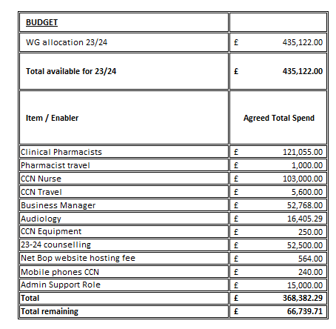

Return to Contents



CITY HEALTH LOCAL CLUSTER COLLABORATIVE

Forward Look
Welcome to the City Cluster Integrated Medium Term Plan (IMTP) 2023/24. The Plan highlights our Cluster vision and priorities and details how we will achieve these over the next year. The City Cluster covers an area of Swansea with high levels of deprivation, homelessness, and ethnic diversity. Our Cluster Plan has developed over the last few years to adapt and meet the changing needs of our diverse and growing population. We have fostered new and innovative ways of working that support practice sustainability and help ensure we have the right people in place to deliver safe and effective healthcare. This multidisciplinary approach has maximised the opportunities for cross-practice working and ensured better access for patients by working more closely with all primary care contractors across the Cluster. City Health Cluster continues to take seriously its role in developing and promoting net-zero health care. Our initial approach involved the leasing of an electric vehicle for use by the Cluster Paramedic. In 2023/24 work will concentrate on reducing the environmental impacts of inhaler use across the Cluster.
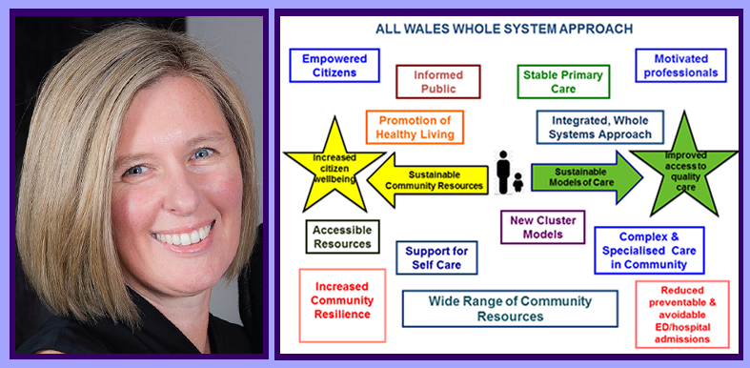
The last twelve months has seen the introduction of a range of new Cluster based initiatives including a Virtual Ward, Common Ailments Scheme and Vulnerable Adult Project all of which are instrumental in helping alleviate pressures on the wider NHS. The Cluster will continue to develop these locally based initiatives in 2023/24 as a means of providing advice and support to help people remain healthy. At the time of writing the Cluster Pharmacist and Paramedic are in the process of giving flu vaccinations to the housebound patients of all Practices. Many of these patients will also be receiving Covid Boosters at the same time.
The next twelve months will present the Cluster with a range of new opportunities and challenges. The City Health Cluster intends to develop methods of improving patient engagement, further strengthen our links with local schools and to work with partner agencies on a range of initiatives aimed at improving the health and wellbeing of its population. In addition, implementation of the Accelerated Cluster Development programme, which aims to align cluster work with regional priorities will be developed further. The IMTP underpins the work of the Cluster and will be the vehicle by which the Cluster will drive change and continue working towards meeting the Quadruple Aims outlined in the Welsh Government’s - A Healthier Wales.
Dr Ceri Todd, City LCC Lead

Action Plan
- PLANNED CARE
 | GOALS | METHODS | OUTCOMES
1.1 | To address long term waits for persistent pain service | To support the continued delivery of a Persistent pain Management service within the Cluster | Decrease in waiting list for first appointments
1.2 | To reduce referral demand and face to face attendances where appropriate | Maximise usage of Consultant Connect across service areas for City GP Practices | To increase Consultant Connect targets by 5%
1.3 | Ensuring that all Heart failure patients are correctly coded – timely safe and secure. | Tidy Up Searches for all GP Patient registers to review Heart Failure coding categories and ensure correct coding prior to annual Heart Failure Review | Only the right patients invited for annual review ensuring timely and safe care, facilitating patients being commenced on the 4 pillars of Heart failure medications and receive self-care, treatment and advice
- CANCER & PALLIATIVE CARE
 | GOALS | METHODS | OUTCOMES
2.1 | Improving early diagnosis of Cancer | - Improve uptake of screening through the promotion of uptake of screening  - Promote bowel, cervical and breast screening uptake  - Participate in research aimed at increasing early detection of colorectal cancer in Primary Care | Increase in levels of uptake from most recent baselines with the aim of achieving uptake of:  Cervical - 70%  Breast - 70%  Bowel - 55%
2.2 | Improving early diagnosis of Cancer | Increasing referrals into the RDC via the 2 new pathways for excluding colorectal cancer in the young and to provide rapid access and assessment for suspicious neck lumps | Increased referrals into service on 2022/23 figures  Rapid diagnosis/reassurance for those moving through the pathways
2.3 | Reduce Smoking rates | Help me quit – provide support patient to quit smoking through advice and education, promotion through communications  Liaise with pharmacy colleagues to consider future action, increasing engagement with level 3 service | Increase patient contacts by a further 5% by the end of March 2024.
2.4 | Improve EOL for patients and patient’s family | Plan, secure and deliver well-co-ordinated 24/7 palliative and end of life care in line with published standards | Patients and their families experience better end of life care services  All practices engaging in regular in house Palliative care meetings
- UNSCHEDULED CARE
 | GOALS | METHODS | OUTCOMES
3.1 | Increase uptake rates of the flu vaccine | Deliver cluster plan of action to address Flu to compliment individual practice plans including, promotion of self-care, vaccination clinics, communications, Healthy living hub, flu champions for 23/24, practices to share best practice, flu plan for 2023/24. | Increased uptake in target groups.to:  65+over - 75%  Under 65 at risk - 50%  2+3 year olds - 50%  Reduced variation in vaccination rates across cluster
3.2 | Enable Patients to access most appropriate care | Signposting of patients to Common Ailment Schemes  Working closely with individual community pharmacies to increase uptake into common ailment schemes | Increase in number of patients accessing the Common Ailment Scheme by 10%
- MENTAL HEALTH & LEARNING DISABILITIES
 | GOALS | METHODS | OUTCOMES
4.1 | To reduce gaps in Health Outcomes with those with Learning Disabilities | Annual Health Checks for those with learning disabilities. | All patients on Learning Disability Registers received the offer of an annual health check.
4.2 | Improve pathways for patients with low level mental health | Develop a mental health cluster model by mapping and commissioning Cluster based Mental Health Services | Better reported patient experience/outcome measures  Rapid access to psychological therapies  Increase in referrals to social prescriber on 2022/23 figures
4.3 | To increase knowledge and understanding of staff within the Cluster of the patients experience for patients with Dementia and Autism. | Provide Level 1 training to staff working across the Cluster. | Increased awareness of staff enabling them to support patients appropriately
5. CHILDREN, YOUNG PEOPLE & MATERNITY
 | GOALS | METHODS | OUTCOMES
5.1 | To promote Nutrition in schools | Support/fund a coordinated plan of action in response to the outcomes of the scoping exercise undertaken in 22/23 | Maximise the number of schools participating in the Healthy Eating Project
5.2 | To improve the Mental Health and Wellbeing of young people | To commission a project related to the mental health and wellbeing of younger people | Project commissioned to refer young people into
5.3 | Improve Health of pregnant women and their unborn child | Increase vaccination uptake in pregnant women | Increase uptake of flu vaccine in pregnant women by 10%
6.PREVENTION & REDUCING HEALTH INEQUALITITES
 | GOALS | METHODS | OUTCOMES
6.1 | To increase awareness of GP and Practice Nurse understanding of injecting drug users | Raise awareness through accredited e learning and education through local services | Attendance by all surgeries to training offered  Clear management plans in place
6.2 | To increase awareness of substance misuse services | Sharing knowledge across the cluster of services available  Explore possibility of dedicated cluster substance misuse support worker | Improved access to services available  Reduce deaths from overdose  Improve harm minimisation
6.3 | To improve antimicrobial stewardship | Implement work with Medicines Management through the prescribing leads group. | Reduction in overall Prescribing.  Reduction in 4C (Broad Spectrum) antibiotics prescribing in line with Health Board targets
6.4 | To consider inequalities to access of service for patients | Identification of issues around access  Scope out possibility of voluntary services that can support  Continue to work towards building relationships with all communities within the Cluster | Identification of possible options to improve access collated

Return to Contents
7. ACTION PLAN ENABLERS
Technological | Workforce | Communication & Engagement | Finance
Blue stream E learning platform | Continued employment of Business Manager to provide the Cluster with the resources to achieve its goals | Primary and community communications officer delivering e-media, and press advertising campaigns | Income generation by the Cluster
Ask My GP | Continued employment of Cluster Paramedic |  | WG funding for Virtual Ward, IRISi, Primary Care audiology
My Health Online | Cluster Pharmacist |  | Mental health and learning disability delivery group funding for social prescriber and for mental health triage post
First Practice Management | Social Prescriber |  | Emergency Planning Response and Resilience Plan
Vision 360 | Local area co Ordinator
 | Primary Mental Health triage
 | Induction Pack for New LCC staff
 | LCC Members
 | LCC Cluster Lead
 | Primary Care Cluster Development Team
Return to Contents

LCC Financial profile

Statement of allocated LCC Spend decisions (As of January 2023)
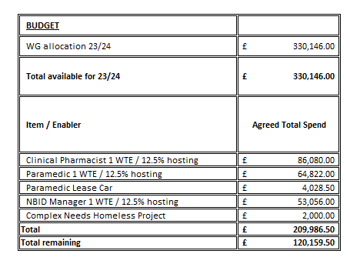

Return to Contents

CWMTAWE LOCAL CLUSTER COLLABORATIVE
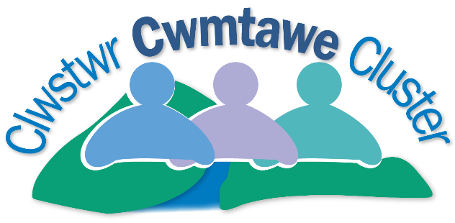

Forward look
The Cwmtawe LCC has managed added pressures and increasingly complex issues since the global pandemic yet I’m proud to say continues to be a vanguard in Wales for promoting and enabling a social model of health and wellbeing, ensuring patients receive the maximum support to access the services and mechanisms needed to live healthy and happy lives. We have listened to patient needs, developing a hub of services for the LCC population based on feedback from the community and key stakeholders. We have continued to deliver initiatives collaboratively with a social ethos ensuring real and tangible benefits for our patients and communities.
During my first year as LCC Lead I’m pleased to say we have been able to continue developing the services available in the mental health hub. It has expanded to include new roles providing targeted timely support close to home. These roles include: The LCC Mental health and Wellbeing Triage Worker which offers a first port of call to support low level mental health issues and prevent issues escalating. The LCC has also seen the introduction of the Cwmtawe Pathways Service, an exciting and innovative development which supports the needs of patients living with complex needs including domestic abuse, substance misuse and associated mental health issues, highlighting difficult safeguarding issues. This role has proven its worth with partners who are forecast to make substantial upstream savings and patients more able to manage the troubles that their life may bring.

With the advent of the new Accelerated Cluster Development Programme where members of the LCC are from all providers of primary care forming Local Cluster Collaborative, there is now a greater appetite for synergy between all facets of Primary Care, delivering preventative services, responding to patient needs, but able to look at those needs as a whole and not in isolation. I look forward to being able to build those relationship during the coming year, developing holistic services for the patients of Cwmtawe LCC. An additional element of the ACD programme is the regional focus of the new ‘Pan Cluster Planning Group’ where we are able to share good practice and initiatives with the wider SBUHB Local Cluster Collaboratives. ides a mechanism to mainstream successful projects. So moving forward we are well placed to continue to build and embed services patients need to maintain their health and wellbeing in the Cwmtawe community.
Mike Garner, Cwmtawe LCC Lead

Action plan

1. PLANNED CARE
 | GOALS | METHODS | OUTCOMES
1.1 | To achieve prescribing targets by reducing Antimicrobial Prescribing | Review patients currently prescribed antibiotics which have increased | Reduction in prescribing levels. Overall HB target for antibacterial prescribing: A quarterly reduction of 5% against baseline data from April 2019-March 2020. 4C Antimicrobials: HB Target: A quarterly reduction of 10% against baseline data from April 2019-March 2020. GP Practice Target: Maintain performance levels within lower quartile or show reduction towards quartile
1.2 | Reduce the environmental impacts of inhaler use in Swansea Bay University Health Board | Reduce the prescribing of MDIs containing HFA 134a in line with All Wales Medicines Strategy Group (AWMSG) recommendations across Primary & Acute Care.  -Provide education on the environmental impact of MDIs to all persons/LCC healthcare professionals to ensure the most appropriate choice of low GWP inhalers are prescribed | Education of LCC staff.  Target a shift to 80% of inhalers being low global warming potential (GWP) alternatives, to put Wales in line with the current European leaders in the field, but only where it is clear patients’ stabilisation will not be affected. Target date by 2025
1.3 | To improve patient experience for those patients on secondary care waiting lists | Implement the Get Ready for Surgery Project:  - Optimising patients for planned surgery/treatments enabling healthier lifestyle choices. | Novel project testing hypothesis  Improved patient outcomes while they wait for surgery  Enhance recovery following treatment/surgery. Improve the overall wellbeing of the patient  Reduce demand on health care  Improved patient experience whilst they wait for surgery
1.4 | Ensuring that all Heart failure patients are correctly coded – timely safe and secure. | Tidy Up Searches for all GP Patient registers to review Heart Failure coding categories and ensure correct coding prior to annual Heart Failure Review | Only the right patients invited for annual review ensuring timely and safe care, facilitating patients being commenced on the 4 pillars of Heart failure medications and receive self care, treatment and advice
2. CANCER & PALLIATIVE CARE
 | GOALS | METHODS | OUTCOMES
2.1 | Cancer prevention | To promote model developed for Bowel screening Wales (in partnership with PHW)  Promotion of Bowel Cancer during Awareness week by sending out letters to non responders  Training volunteers in screening services awareness  Promotion of Cervical screening via Woman’s Wellbeing Events and other methods | Support increase in bowel screening within the LCC working towards national targets  Social media hits and shares  Support Increase in the uptake of Cervical screening working towards national targets  Increase in number of volunteers trained and deployed
2.2 | To ensure that Palliative patients receive appropriate and dignified care | Develop consistent coding within the LCC to ensure identification of palliative patients.  Link with the Palliative care team to develop a gold standard for end of life and palliative care.  Link in with the 3rd Sector to develop to ensure patients link in with support services | Align service delivery with the Quality Statement for Palliative and end of Life Care
3. UNSCHEDULED CARE
 | GOALS | METHODS | OUTCOMES
3.1 | Development of integrated Community Care through provision of complex case management in order to maintain independence and prevent unnecessary hospital admissions. | Employment of a Frailty nurse (2-year contract).  -To act as a liaison between care/nursing home, undertaking reviews acting as the interface between GP practices and the homes.  - Supporting patients to manage their conditions in both care homes and housebound situations | To support care management of 175 patients  Improved partnership approaches to care  Support reduced hospital admissions
3.2 | Increase MDT with a focus on patients experiencing DV, substance misuse and poor mental health | Employment of a Complex needs worker (2 year contract)  Expand referrals to include those from other LCC members  Employment of a part-time case worker to support the complex needs worker | - Reduced demand on GP’s with an ambition of 30% evidenced via independent evaluation  - Better support for patients to take responsibility for their own health  - Improved access to other sources of support  - Identification and quantification of ‘hidden’ cause of poor physical and mental health issues. Initial assessments.  - Improved identification of safeguarding issues  - Proof of concept identified and supports concerns raised by partners via Safer Swansea Partnership  - Increased capacity in the number of cases being supported by the project on 22/23
3.3 | Development of integrated Community Care through provision of  a virtual ward within the LCC. | Development of a LCC virtual ward | 150 patients seen/supported within virtual wards per annum from the 2 practices participating.  83% of patients seen within VW have received improved access to diagnostic services  Evaluation to be undertaken by QI team
3.4 | To devise and forward leaflets to  local schools and creches for onward distribution to parents outlining the Common Ailments Scheme to ensure that parents are aware of how/when pharmacy can support | Leaflets to be produced tailored to CAS support for babies (creches) and children (schools) | Parents aware of scheme and conditions that can be supported. Increased referrals to Pharmacy on 2022/23 figures. Decreased demand on GP time.
3.5 | To ensure that Reception and Front Line staff are trained in the Common Ailments scheme to ensure that information can be shared with patients as appropriate | Pharmacy staff to deliver training to LCC Front Line staff as part of a PLTS session | Patients accessing Community Pharmacy as appropriate. Reduction in demand on GP time
3.6 | To have a dedicated phone line for the Common Ailments scheme within the LCC. Consultation can take place over the phone with a Pharmacy Tech/Pharmacist to ensure efficient am appropriate service for patients | Discussions to take place regarding staffing/cover and location of the phone line. Proposal to be written and costed | Strengthening of partnership working. Patients appropriately referred to CAS. Positive impact on GP time
3.7 | Improve early diagnosis of conditions helping to reduce unscheduled care | To work with the Health Board to increase availability of phlebotomy services within the community. | Reduced wait for blood test for patients allowing for early diagnosis and treatment reducing unnecessary waiting times improving patient experience. Assist with chronic disease management
4. MENTAL HEALTH & LEARNING DIFFICULTIES
 | GOALS | METHODS | OUTCOMES
4.1 | Improved access to low intensity and high intensity psychological therapies to improve access to Mental Health  Improve prevention and self-care | Commissioning of Psychological therapies | Support achievement of maximum wait for high intensity psychological therapies of 26 weeks and 56 day wait for other therapies  Rapid access to psychological therapies  81% of patients seen will have improved patient outcomes – articulated in year-end report
4.2 | Timely Access to Mental Health services within Primary Care | Employment of a LCC Mental Health Triage and Wellbeing Worker | Novel Project testing hypothesis  - Achievement of a LCC model for mental health services in primary care  - Patients with mental health needs, are referred for the right service at the right time. Case studies in quarterly reporting  - Patients already known to secondary mental health services receive a step up/ step down provision. Method of measurement to be determined  - Increased MDT and options for referral  - Reduction in demand for appointments with GP’s of patients with poor mental health
4.3 | Suicide prevention:  Improved patient outcomes for patients with suicidal ideation | To collate accurate data via a new practice coding template to inform service development  Development of front line Mental Health Champions within each practice | Testing hypothesis  Increased % of Staff feel equipped to interface with patients with suicidal ideation and have a specific point of reference for advice.  The LCC has accurate patient data for those at risk of suicide resulting in improved patient outcome
5. CHILDREN, YOUNG PEOPLE & MATERNITY
 | GOALS | METHODS | OUTCOMES
5.1 | Refer to mental health psychological therapies above 4.2
5.2 | Refer to suicide prevention work 4.3
5.3 | Refer to flu actions below 6.1
5.4 | Refer to plans to boost teenage 3 in 1 jab below 6.4
5.5 | Refer to childhood weight management below 6.9
6. PREVENTION & REDUCING HEALTH INEQUALITIES
 | GOALS | METHODS | OUTCOMES
6.1 | To Reduce Hospital admissions of patients with Flu | Deliver a LCC plan of action to address Flu to compliment individual practice plans including, promotion of self-care, vaccination clinics, communications, continued use of flu champions for to increase uptake of influenza vaccinations; practices to share ‘best practice’ | - Contact made with 75% of non-attenders  - Increased uptake from target groups by 4% from most recent data and to reduce gap in uptake amongst practices  - Support reduction in hospital admissions due to influenza
6.2 | Continue to increase work to reduce smoking | Promote “Help Me Quit” through Comms via Social Media, Facebook, Twitter  Deliver Help Me Quit training practice staff in providing support –Brief intervention training  Practices to cleanse their records in ensuring that patients have an up to date record of their smoking status and referred to “Help Me Quit” accordingly | - Support reduction in numbers of smokers  - Support reduction in respiratory illnesses  - Increase in referrals to the Help me quit project by 10%(Base line figure for 2021- 2022=297 Referrals)
6.3 | Improved uptake of the screening programmes particularly for  - Bowel screening  - Cervical Screening | Utilise volunteers to contact non responders working in partnership with Public Health Wales | Contact 60% of non- responders.  Testing hypothesis- Improved screening rates by 15% for bowel screening and 5% for cervical screening
6.4 | To improve uptake of the 3 in 1 teenage booster vaccination | Work with SNAPP Health Champions to promote the reasons for vaccination within schools –myth busting | Project funding pending-measures to be developed  Increase in uptake of childhood vaccinations working toward national targets
6.5 | Safeguarding:  Better management of patients with complex needs and Improved ability of professions to act with clear communication routes | LCC to develop clear protocols between all partners | Safeguarding protocols are in place between all partners
6.6 | Improving outcomes for Carers (+ all other priority areas) | Scope the opportunities for improving Carers' early identification; signposting; and support across the key services areas of each LCC to supplement the work already undertaken through GMS | LCC service areas confident to identify and support Carers
6.7 | Improve awareness of the needs of those living with dementia | Provide training for frontline staff across the LCC with the virtual dementia bus | Alterations are made to the physical environment to accommodate dementia patient’s needs.  Alterations are made to the way that dementia patients are interacted with.  36 Frontline staff trained
6.8 | Improve awareness of the needs of those living with autism | Provide training for frontline staff across the LCC with the virtual autism bus | Alterations are made to the physical environment to accommodate autistic patient’s needs.  Alterations are made to the way that autistic patients are interacted with.  24 frontline staff trained
6.9 | To support a LCC wide approach to children's healthy eating and weight management | Training to support sensitive and confident conversations around weight: using Motivational Interviewing | Parents accessing the Health Parenting programme  Children and young people and their families accessing drop in sessions and other group activities  Improved wellbeing using a validated wellbeing score  Improvement in diet quality, reduction in sedentary behaviours and increased physical activity
6.10 | Protecting the health of clinical staff through the provision of specialist equipment | The purchase two patient chairs specifically designed for wax removal to support the ongoing delivery of the service | Reduction in musculoskeletal injuries of staff.  Avoidance of complaints and reduction of risk of injury to the ear canal
6.11 | To ensure a joined up approach between Home First Pathway 0 and the LCC, in particular the GP practices | Ensure that information is communicated to the GP practices (with consent of patient) in relation to LCC patients that are referred and supported through Pathway 0 | - Improved patient outcomes  - Improved communication  - Improved awareness by GP Practices of services being provided to their patients by Pathway 0

Return to Contents

7. ACTION PLAN ENABLERS
Technological | Workforce | Communication & Engagement | Finance
The use of My Health | Continual employment of a LCC Commissioning & Development Manager to provide the LCC with the resources to achieve its goals | My Surgery App | Seek opportunities for both external and multi – agency funded projects to maximise LCC funds
Ask my GP | LCC Project & Admin support | Primary and community communications officer delivering e-media, and press advertising campaigns | Financial allocation is £260,040.00
E consult | Other workforce working within the LCC:  LMPHSS; Social prescriber: LACs, ONA, Complex Needs worker |  | Mental health delivery group for social prescriber and for mental health triage post
My Surgery App | Bluestream E learning platform |  | WG funding for Virtual Ward, IRISi, Primary Care audiology
Bluestream E learning platform | Induction pack for new LCC staff
 | LCC Lead
 | Primary Care Cluster Development Team
 | Emergency plan – resilience and response

Return to Contents

LCC Financial profile
Statement of allocated LCC spend decisions (As of January 2023)
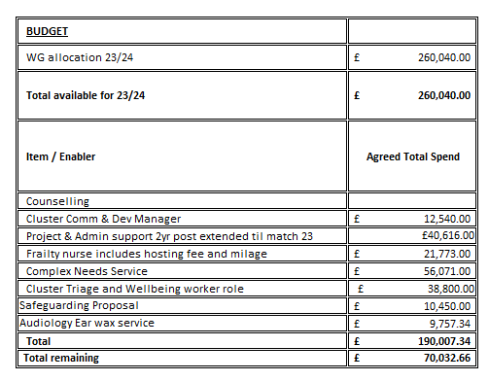
Return to Contents



LLWCHWR LOCAL CLUSTER COLLABORATIVE

Forward Look
Welcome to the Llwchwr LCC Plan 2023/24 which identifies key areas for improvement within the Local Cluster Collaborative and how these will be enhanced over the next 12 months. Over the last 12 months we have seen several changes starting with the implementation of Accelerated Cluster Development Programme a Welsh Government initiative. This has seen representatives from all the key strands of primary care coming together 4 times a year under the name of Local Cluster Collaborative in order to take a holistic approach to improving health and wellbeing across the Llwchwr area.
Bringing on board new partners has resulted in this being a transition year whilst we all get to learn each other’s strengths and identify the much broader health and wellbeing needs of our population. In spite of that we have managed to provide additional services to our patients for example counselling to both adults and children meeting unprecedented need as we come out of the pandemic.
In addition, we have been able to address emerging issues such as Safeguarding. These are complex and ultimately unique to every situation so hard for frontline staff to gain experience in every area. The project developed by Dr Satori to provide peer support to colleagues and share learning has gone from strength to strength and is recognised as an exemplar in good practice to ensure that difficult situations are properly managed. So much so the model is currently being adopted by other LCC’s across SBUHB.

We have also begun focused work to try and address the more difficult issue of obesity within Llwchwr area as it has a negative impact on so many chronic health condition. A working group has now been established to scope out what we really need and what works for patients, to provide the best way in which we can support them to manage their weight. We hope to be in a position to have services in place by April 2023.
Over the next 12 months, the LCC will continue to strengthen links with the local community. Exploring an array of methods to engage with patients to further develop a co-productive approach to health and social well-being by listening and adapting pathways where possible. We will have the benefit of building on work started this year, with all strands of primary care to achieve our priorities but also be able to look to roll out our more successful projects across the whole of SBUHB.
Dr James Kerrigan
Llwchwr LCC Lead

Action plan

1 | PLANNED CARE
 | GOALS | METHODS | OUTCOMES
1.1 | Planned Care to reduce referral demand and face to face attendances where appropriate | Maximise usage of Consultant Connect across service areas for Llwchwr GP practices to supplement e- advice | 15% Increase uptake of consultant connect
1.2 | To achieve prescribing targets by reducing Antimicrobial Prescribing | Review patients currently prescribed antibiotics which have increased | Reduction in prescribing levels. Overall HB target for antibacterial prescribing: A quarterly reduction of 5% against baseline data from April 2019-March 2020. 4C Antimicrobials: HB Target: A quarterly reduction of 10% against baseline data from April 2019-March 2020. GP Practice Target: Maintain performance levels within lower quartile or show reduction towards quartile
1.3 | Reduce the environmental impacts of inhaler use in Swansea Bay University Health Board | Reduce the prescribing of MDIs containing HFA 134a in line with All Wales Medicines Strategy Group (AWMSG) recommendations across Primary & Acute Care.  -Provide education on the environmental impact of MDIs to all persons/LCC healthcare professionals to ensure the most appropriate choice of low GWP inhalers are prescribed | Education of LCC staff.  Target a shift to 80% of inhalers being low global warming potential (GWP) alternatives, to put Wales in line with the current European leaders in the field, but only where it is clear patients’ stabilisation will not be affected. Target date by 2025
2 | CANCER & PALLIATIVE CARE
 | GOALS | METHODS | OUTCOMES
2.1 | Improve screening rate in line with targets for: Bowel Screening 60%  Cervical screening 80% | Targeted interventions to non-responders | - To contribute to year on year improved screening rates. Bowel screening by 10% and Cervical screening by 5%
3 | UNSCHEDULED CARE
 | GOALS | METHODS | OUTCOMES
3.1 | To Reduce Hospital admissions of patients with Flu | Deliver a LCC plan of action to address Flu to compliment individual practice plans including, promotion of self-care, vaccination clinics.  Continued use of flu champions for to increase uptake of influenza vaccinations; practices to share ‘best practice’ | - Increased uptake in target groups by 5%
3.2 | Development of integrated care particularly the care of frail elderly into LCC MDT, | Continued employment of a frailty nurse to develop a LCC wide approach to frailty  Frailty Nurse to use comprehensive geriatric assessment of those with high attendance at practice to identify needs | Novel project testing hypothesis  Identification of 30% of patients classified as frail.  Number of new referrals to the service  Number of patients where hospital admission has been avoided.  Improved partnership approaches to care.  Support reduced hospital admissions.
3.3 | To ensure a joined up approach between Home First Pathway 0 and the LCC, in particular the GP practices | Ensure that information is communicated to the GP practices (with consent of patient) in relation to LCC patients that are referred and supported through Pathway 0 | - Improved patient outcomes  - Improved communication  - Improved awareness by GP Practices of services being provided to their patients by Pathway 0
3.4 | Improve early diagnosis of conditions helping to reduce unscheduled care | To work with the Health Board to increase availability of phlebotomy services within the community. | - Reduced wait for blood test for patients allowing for early diagnosis and treatment reducing unnecessary waiting times improving patient experience. Assist with chronic disease management
4 | MENTAL HEALTH & LEARNING DISABILITIES
 | GOALS | METHODS | OUTCOMES
4.1 | Improved access to low intensity and high intensity psychological therapies to improve access to Mental Health  Improve prevention and self-care | Commissioning of Psychological therapies | - Support achievement of maximum wait for high intensity psychological therapies of 26 weeks and 56-day wait for other therapies.  - Rapid access to psychological therapies  - Reduction on GP demand  - Improved patient outcomes –Year-end report  - Reducing potential demand on secondary care services  - 81% of patients seen will have improved patient outcomes – articulated in year-end report
4.2 | Improve access to care for patients with learning difficulties | Delivery of annual health checks for patients with learning difficulties, including dental and optometry | Novel project – expected outcomes  - Increase in 10% of annual health check for those with learning difficulties
5 | CHILDREN, YOUNG PEOPLE & MATERNITY
 | GOALS | METHODS | OUTCOMES
5.1 | Refer to mental health psychological therapies above 4.1
5.2 | Refer to flu actions above 3.2
6 | PREVENTION & REDUCING HEALTH INEQUALITIES
 | GOALS | METHODS | OUTCOMES
6.1 | To improve the knowledge and skills of the LCC workforce regarding Safeguarding issues | To continue to develop a Safeguarding Single Point of Contact (SPOC) within the LCC. Expand that to create a peer support network across other LCCs to provide confidence regarding safeguarding issues. | - That ‘safeguarding of adults and children will be embedded into everyday routine  - 85% attendance of Safeguarding leads at peer support sessions  That clinical staff have confidence when dealing with safeguarding issues measured via year end questionnaire
6.2 | To provide a community-based educational programme to facilitate lifestyle change in patients with pre-diabetes, past history of gestational diabetes, obesity and/or non-alcoholic fatty liver disease. Reduced medication and risks of developing other chronic disease | Delivery of an Obesity project to address the goals of the LCC | Novel Project – under development  - Patients referred to the project are provided with Healthy Eating advice  - Develop Physical Fitness improvements  - Receive education on other lifestyle changes (eg sleep and stress)  - Medical supervision during their time involved in the project
6.3 | Improving outcomes for Carers (+ all other priority areas) | Scope the opportunities for improving Carers' early identification, signposting and support across the key services areas of each LCC to supplement the work already undertaken through GMS | - LCC service areas confident to identify and support Carers
6.4 | Continue to support patients by signposting to Help Me Quit | Promote “Help Me Quit” through communication channels via Social Media, Facebook, Twitter  Consider Help Me Quit training practice staff in providing support –Brief intervention training | - Increase in referrals to the Help me quit project by 7% on 2022/23 figures
6.5 | To improve health inequalities within the LCC | Explore provision to provide baseline health checks to LCC patients including a blood glucose and cholesterol monitor with tests strips | - Improve early diagnosis of health conditions and patients awareness of their health
6.6 | Increase the prescribing ability within the LCC | To provide backfill locum cover for optometry training to prevent reduction in clinics | - Provision of Optometry clinics with a prescribing optometrist.

Return to Contents
- ACTION PLAN ENABLERS
Technological | Workforce | Communication & Engagement | Finance
Blue stream E learning platform | Continued employment of Business Manager to provide the LCC with the resources to achieve its goals | Primary and community communications officer delivering e-media, and press advertising campaigns | Emergency Planning Response and Resilience Plan
Ask My GP | LCC Pharmacist |  | WG Funding
My Health Online | Social Prescriber |  | Health Board funding for Virtual Ward, IRISi, Primary Care audiology
Vision 360 | Local area co-ordinator |  | Mental health and learning disabilities delivery group funding for social prescriber and for mental health triage post
Microsoft Teams | Virtual Ward staff
 | Primary Mental Health triage
 | Induction Pack for New LCC staff
 | LCC Lead
 | LCC Members
 | Primary Care Cluster Development Team
 | Frailty Nurse
 | Audiology

Return to Contents

LCC Financial profile
Statement of allocated LCC spend decisions (As of January 2023)
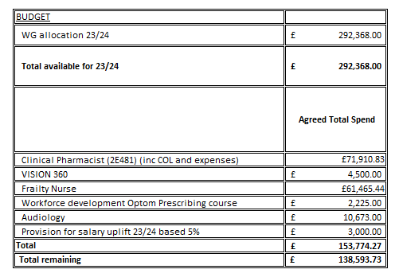

Return to Contents

NEATH LOCAL CLUSTER COLLABORATIVE


Forward look
Welcome to Neath Cluster’s IMTP Annual Delivery Plan for 2023-24. It reviews progress made in the third year of the IMTP 2020-2023 and sets out the Cluster’s delivery plan for 2023-2024.
Neath Cluster has continued to work collaboratively towards a common vision moving us away from the traditional model of care and developing a Multidisciplinary Cluster Team (MDT). The MDT is currently made up of a Business Implementation and Development Manager, 2 Pharmacists, a Pharmacy Technician, Physiotherapists, audiology, Mental Health Workers and Admin Support Worker. We are continuing to review and expand this as able. The Cluster continued to work closely with all partners and has welcomed the representation, support, new ideas and projects put forward from Dentistry, Optometry and Community Pharmacy. We are proud the cluster has had a further year of enhanced cohesive collaborative working.
This year has seen us meet the challenges of moving out of the Global covid-19 pandemic and partners have supported the cluster through this. 2022/23 has however continued to be very trying at times for the cluster practices and partners. Navigating a new way of working to maintain reduced risk whist trying to go back to ‘normal’ has not been easy. As always, without the continued support and dedication of all our partners we would not be in such a progressive position as we now find ourselves.
This year has also brought big change and prospects with it in the form of the national Advanced Cluster Development (ACD) programme. This year has been a transition year with the new model being set up and embedded. We now have a larger number of individual professional collaborative’s feeding in to the new Local Cluster Collaborative and although many of these members have been part of the old model we look forward to working more closely and effectively together moving forward. Working more closely with other partners at the pan cluster level will hopefully allow for much greater opportunity in future and I look forward to it being a driver for development over the coming year.
In developing this annual delivery plan, the cluster has: -
- Reflected on their collective experiences moving out of the Covid-19 pandemic, which may have informed new / revised ways of working within the cluster and new cluster priorities going forward. Considered which elements of the cluster Covid-19 response will need to be stepped down / reactivated though 2023/24 in response to any future waves/outbreaks.
- Reviewed their current 3 year Cluster IMTP plans 2020/23 and considered, in light of ACD and coming out of the pandemic, elements of the plan that are now redundant, or can be updated/enhanced, and which elements of the plans will continue to be delivered or perhaps accelerated delivery as a beneficial consequence of ACD. MDT working remains high on our list of priorities having recently appointed a new Business Implementation and Development Manager and currently looking to recruit a cluster community clinician. Additionally, we aim to improve mental health provision for both adults and children as this is a major area for review and improvement having been impacted upon by Covid-19 and we are working closely with partners to do so.
- Identified a set of cluster priorities and SMART actions for 2023/24 outlining how the cluster arrived at these priorities (rationale) and how the cluster will address/deliver/monitor the actions and the associated workforce and financial implications going forward. Moving forward, we should consider having fewer but more impactful actions whilst considering future cluster priorities. For example, we hope to have a new cluster community clinician in post soon, an enhanced model from the previous cluster paramedic (to improve patient care and experience); further develop the role and function that Virtual Wards have (with improved care, prevention of admission and coordinate discharged of patients) via the enhanced funding being provided; and continue to work closely to tackle identified public health priorities such as Flu, Covid-19, screening etc.
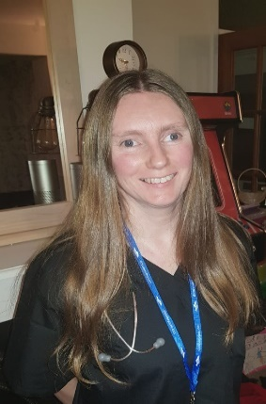
2023/24 will see the cluster pressing forward at pace as ACD settles in to our strategic planning structures. We feel we are in a stronger position to deal with any further waves of the Pandemic. However, we need to be mindful of the ongoing impact following Covid-19 with increased patient demand, subsequent impact it has on our staff and moral.
Going forward, the future direction for Clusters including the implementation of Accelerated Cluster Development is changing how we operate significantly. We need to be mindful of this as we progress through the year of full implementation and be ready to face any impact it may have and make the most of any opportunities it may provide.
Dr Deborah Burge-Jones, Neath LCC Lead

Action plan

- PLANNED CARE
 | GOALS | METHODS | OUTCOMES
1.1 | Engage in prescribing management schemes & further improve antimicrobial stewardship and pain management | - Engage in the Prescribing Management Scheme (PMS) for 2023-24  - Ensure prescribing of antibiotics is in line with SBU HB recommendations where appropriate  - Review prescribing data (which will be provided by Medicines Management to Clusters / GP Practices) on a regular basis to monitor progress  - Continue to utilise CRP POC for the management of LRTI  - Utilise supportive packages for QI work around UTI management / prophylaxis and 4Cs where appropriate  - Ensure that analgesic agents are only prescribed where the benefits outweigh the risks and that patients are appropriately monitored and reviewed | - Increased assurance that antibiotics are being prescribed appropriately  - Maintenance of current low prescribing with aim of further reduction in prescribing of Co-amoxiclav, cephalosporin, fluoroquinolone and clindamycin items prescribed per 1,000 patients and a reduction in overall antibiotic prescribing  - A reduction in the prevalence of healthcare associated infection (HCAI), including Clostridioides difficile infection and Staphylococcus aureus bacteraemia  - Management of patient expectation in relation to antibiotic prescribing and pain management  - Increased assurance that patients are prescribed analgesic therapy where the benefits outweigh the risks and that they are appropriately reviewed and monitored  - Reduction in the prescribing of gabapentin, pregabalin, tramadol and other opioids.
1.2 | Reduce the environmental impacts of inhaler use in Swansea Bay University Health Board | - Reduce the prescribing of MDIs containing HFA 134a in line with All Wales Medicines Strategy Group (AWMSG) recommendations across Primary & Acute Care  - Provide education on the environmental impact of MDIs to all persons/cluster healthcare professionals to ensure the most appropriate choice of low GWP inhalers are prescribed.  - Promote the recycling of inhalers prescribed in SBUHB via approved schemes or to use appropriate disposal routes | - Reduction in greenhouse gases.  - SBUHB achieve WG targets of reducing carbon footprint.
2. CANCER & PALLIATIVE CARE
 | GOALS | METHODS | OUTCOMES
2.1 | Develop a consistent approach to reduce smoking prevalence | - Develop and implement sustainable processes/initiatives that lead to increased referrals to the Me Quit local smoking cessation services.  - Increase engagement with the local Pharmacies Level 3 service. | - Increased referrals to “Help Me Quit” on 2022/23 figures  - Reduced local prevalence of smoking.  - Reported numbers of Quitters (CO tested)
3. UNSCHEDULED CARE
 | GOALS | METHODS | OUTCOMES
3.1 | Provide more care within the community setting and keeping people at home for longer | - Expand the Virtual Ward (Home First approach and reduce risk of readmission)  - Promote the role that VW’s play within the primary care setting  - Engage in and with the VW MDT to offer advice and support about patients to prevent admission. | - Reduced unnecessary admissions  - Early facilitated discharges from hospital  - Most vulnerable people within our communities provided the right service, at the right time by the right discipline.
3.2 | To reduce the demand on Primary Care services by managing their urgent care and home based services.  To ensure patients care needs are provided with the most appropriate response to their needs. | - Support the recruitment of Community Clinician Band 7.  - Providing a timely responsive Home visiting service delivered by a cluster based paramedic/Specialist Nurse | - Reduced hospital admissions;  - Increased GP time saved and capacity;  - Timely patient care;  - Increased numbers of clinical assessments and diagnosis as close to home as possible.  - Improvement in chronic disease management.
4. MENTAL HEALTH & LEARNING DISABILITIES
 | GOALS | METHODS | OUTCOMES
4.1 | Support services to improve mental health and wellbeing of patients. | - Continue to support and further enhance the SP and MH Well being service  - Continue to support the roll out of the LPMHSS link worker to facilitate more streamlined access.  - Support the roll out of a new pilot CAMHS link services to facilitate more streamlined access to appropriate forms of care for CYP. | - Reduction in demand on GP services, medicines.  - Reduction in impact on Mental Health Services, Social Care.  - Improved patient reported outcome measures.  - Patients linked to more appropriate services based on their needs.
4.2 | Identify and support patients experiencing domestic violence. | - Engage in the primary care IRIS project  - Offer GP partners training IRIS opportunities  - Encourage referral from Primary Care settings into service | - Patients experiencing domestic abuse are supported and kept safe.  - Clinicians who attended the training to be confident enough to ask the question.  - Clinicians who attended the training to be confident to make referrals.  - Patients physical and mental health improves  - Patients are better able to manage addiction  - Patients have independence and control of their lives.  - Patients have positive and healthy relationships with the people in their lives
4.3 | Improve patient access to information around mental health and well-being – Mental Health Website. | - Develop marketing campaign to expand reach of the Website as a single point of access for information relating to MH and wellbeing.  - Review and update the MH Hub website | - Improved access to mental health resources for patients  - Increase awareness of what low level mental health services are  - Freed up time from MH services and GP’s patients who are enabled to access information directly  - Improved awareness for clinicians on what locally relevant resources are for their patients
4.4 | To improve the Awareness Raising and Training for staff across NCN around Autism / Dementia  VR Bus | - Commission and Roll out level 1 Virtual reality training awareness associated with Autism / Dementia | - Staff and professionals working within the Cluster will give patients with Autism / Dementia and their Carers a positive experience of services by having first-hand experience of what autism feels like.
5. CHILDREN, YOUNG PEOPLE & MATERNITY
 | GOALS | METHODS | OUTCOMES
5.1 | Children 0 – 18 are protected from abuse, harm and neglect , preventing harm to children’s health , well-being and development  Neath, Upper Valleys and Afan clusters | - Provide specialist Health Visiting advice and service to the Child and Family Team across the age span  - Undertake triage activity regarding referrals to SS applying quality assurance.  - Facilitate effective and safe info sharing  - Coordinate multiagency working in best interests of child. | - Integrated approach to assessments, thresholds and referrals.  - Improved outcomes for the most vulnerable families.  - Improved communication between health, social services and third-party agencies.  - Improved education for health partners.  - Effective and efficient referral pathway for health partners.  - Improved safeguarding of children and Young people.
6.PREVENTION & REDUCING HEALTH INEQUALITIES
 | GOALS | METHODS | OUTCOMES
6.1 | Deliver Enhanced Flu Vaccination Programme | - Regularly review IVOR data for flu vaccination  - Develop and implement a seasonal flu plan aimed at early administration of the flu vaccine to eligible patients and increasing uptake in particular to those unable to access main stream provision | - Increased uptake of influenza vaccine in target groups on 2022/23 figures, working towards national targets.  - Reduced morbidity / mortality / hospital admissions due to influenza.
6.2 | Encourage uptake of public health screening programmes. | - Encourage patients to engage with screening programmes as offered by PHW  - Promote screening via cluster social media platforms.  - Encourage increased screening in Cervical Screening.  - Consider other screening programmes of activity. | - Increased screening uptake on 2022/23 figures working towards national targets.  - Reduced Cancer Rates.  - Narrowed gap between Neath and national average with screening programmes.
6.3 | Identify and manage patients who have pre diabetes/diabetes | - Continue delivering the pre-diabetes project. | - Reduced or Delayed risk of onset of Type 2 diabetes.  - Identification and management of patients at risk developing diabetes

Return to Contents

7.ACTION PLAN ENABLERS
Technological | Workforce | Communication & Engagement | Finance
Vision 360 Support (INPS) | Business Development & Implementation Manager |  | Emergency Planning Response and Resilience Plan
V360 Support EMIS integration | Vision Admin Support |  | WG Funding
 | Pharmacists x 2 |  | Health Board funding for Virtual Ward, IRISi training, Primary care audiology
 | Pharmacy Technician
 | Community Clinician
 | Social Prescriber
 | Virtual Ward staff
 | Primary Mental Health Link worker
 | Induction Pack for New Cluster staff
 | Cluster Lead
 | Cluster Members
 | Primary Care Cluster Development Team

Return to Contents

LCC Financial profile
Statement of allocated LCC spend decisions (As of January 2023)
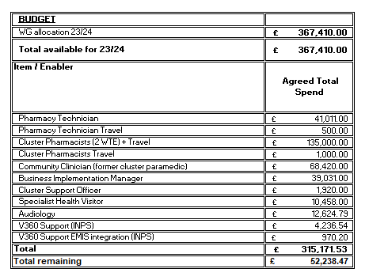

Return to Contents

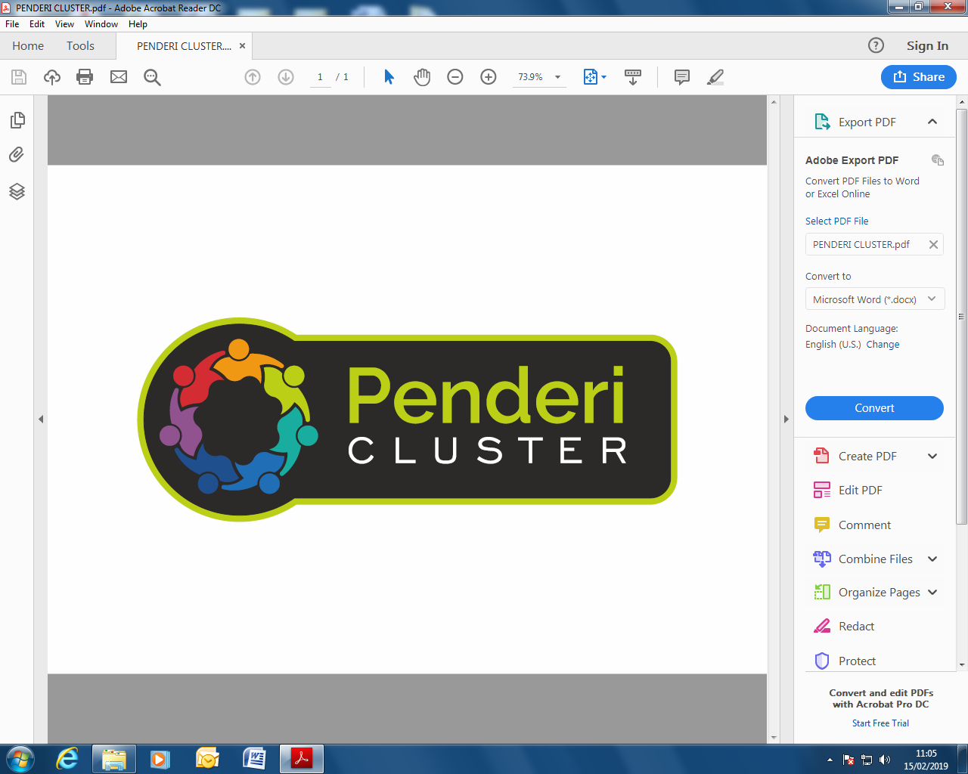

PENDERI LOCAL CLUSTER COLLABORATIVE

Forward look

Welcome to the Penderi Cluster Plan 2023-2024 which highlights the Cluster vision and priorities and how we will achieve them over the next year.

The Cluster has come a long way over the past year. We continued our preventative approach to supporting children and families by developing new a model of working in partnership with the Local Authority through the ‘Primary Care Child and Family Wellbeing Service’. This took a holistic approach to supporting children and families experiencing mental health issues and developmental delay in the family home. This ‘upstream’ approach demonstrated improved wellbeing outcomes for children and their families. Our Women’s Refuge Service is another successful project which has been supporting women and children who are affected by Domestic Abuse within our Cluster.

Other innovative projects that have been supported within the Cluster include:
- Implementation of a Spirometry project in 2022-23 to clear the backlog of COPD diagnosis, so that they will be managed appropriately in the community and avoid unnecessary hospital admissions.
- Implementation of backlog projects in 2022-23 to clear some of our chronic condition review backlogs, so that all these patients get treatment optimisation and a care plan, thereby reducing urgent care and hospital admissions.
- The Penderi Young People’s Project that supports 11-25 year olds with their emotional and mental health.
- Carers Helpdesks have been introduced working collaboratively with Swansea Carers Centre.
- Developing strong links with Community Pharmacists and working on improving uptake of the Community Pharmacy Common Ailment Scheme by our cluster population.
- A Social Prescribing Co-ordinator to take a holistic approach to patients’ needs, connecting people to community groups and statutory services for practical and emotional support.

Further innovative projects due to commence through 2023-24 include:-
- Expanding our MDT by employing a Mental Health Counsellor, to provide CBT counselling to the mental health patients within our cluster. This is an evidence based intervention to prevent mental health crisis.
- We are due to start a Diabetes Prevention Programme aimed at preventing Diabetes in Pre-Diabetic patients.
- Working in collaboration with SCVS to improve Bowel Screening uptake. This is aimed at encouraging non-responders to participate in Bowel Screening testing. This work is to be expanded to all other screening areas during the latter part of 2023-24.


Over the next 3 years, we will continue to strengthen our links with the local community and explore alternative methods of engagement to further develop a co-productive approach to health and wellbeing. We will work towards embracing the Accelerated Cluster Development model and work in collaboration with all professional collaboratives, to improve the suite of mechanism and infrastructure within the Cluster.

We will continue to enhance our Multi-Disciplinary Team and ensure care is better co-ordinated to promote the health and wellbeing of individuals and communities. We will adopt a preventative, holistic approach through partnership, collaboration, use of local assets and co-production. We look forward to developing new innovative projects and ways of working that will support the local community and enhance patient wellbeing across the Cluster.
Dr Sowndarya Shivaraj,
Penderi LCC Lead,
www.facebook.com/PenderiCluster/www.pendericluster.co.uk

Action plan

1.PLANNED CARE
GOALS |  | METHODS | OUTCOMES
1.1 | Accelerate Pathways | - Increase uptake of community COPD service/clinic  - Increase uptake of Pre Diabetes project  - Uptake of community Audiology in primary care settings  - Increase uptake of Young Person Wellbeing service | - Increased patient contacts on 2022/23  - Optimised COPD treatment  - Prevention of COPD admissions  - Prevention of Diabetes  - Reduction in audiology waiting lists  - Improved wellbeing of young adults  - Reduction in CAMHS referrals
1.2 | Liaison Advice and Guidance to reduce referral demand and face to face attendances where appropriate | - Access structured advice, guidance and triage service offered in the top 10 high demand specialties (use of email advice line for various specialities)  - Increase uptake of Consultant Connect in all specialties to supplement e-advice (WCCG)  - Use of WCCG advice line in all specialities  - Mental Health Triage Nurse appointments in practices | - Reduction in referrals (ENT, Secondary Care, LPMHSS)  - Reduction in waiting lists  - Increase in timely treatment for patients at the right place
1.3 | Maximise access to diagnostic services | - Increase appropriate uptake of services provided by Rapid Diagnostic Centre (RDC)  - Increase use of RDC neck lump and colorectal service  - Use of community Spirometry service provided in Estuary medical practice | - Contribution to Reduction in >8wk waits  - Early diagnosis of COPD/Asthma
1.4 | Carers needs and services | - Continue Raising awareness of Carers rights and needs  - Signposting of newly identified Carers to appropriate services  - Consider needs of Carers when developing services  - Identify Carer support champions who can deliver above | - Improved staff training / skills / knowledge  - Increased identification and support of Carers
2.CANCER & PALLIATIVE CARE
GOALS |  | METHODS | OUTCOMES
2.1 | Help Me Quit – provide support to patients to quit smoking | - Liaise with Pharmacy colleagues to increase engagement in Level 3 service  - Promote “Help Me Quit” via Communications/Social Media  - Ensure smoking status is up to date on patient records | - Increased referrals to Level 3 service on 2022/23 figures  - Improved staff skills / knowledge  - Reduction in smoking rates  - Contribution to Reduction in morbidity / mortality
2.2 | Increase early diagnosis and treatment of cancer | - Promote screening uptake  - Continue collaborative work with SCVS and help bowel screening non responders to increase uptake  - Use of FIT testing for Bowel cancer screening resources | - Increased uptake to at least pre-COVID levels of  Bowel 61%  Cervical 72%  - Early detection of cancer
2.3 | Improve access to most appropriate care | - Accessing Dental advice and support through Consultant Connect for more rapid feedback regarding dental cancer / dental care uncertainty, and reduction in referrals where unnecessary  - Use of Community Audiology service  - Use of Community COPD and Heart failure service | - Reduction in Dental referrals to oral health/ restorative dentistry consultants  - Reduction in ENT referrals  - Reduction in COPD admissions
3. UNSCHEDULED CARE
GOALS |  | METHODS | OUTCOMES
3.1 | Reducing admissions by effective planning for the winter season across the cluster to ensure continual increase in uptake of flu vaccinations and advanced promotion of self-care | - Increase uptake of Flu vaccination via Cluster Flu Plan  - Vaccination clinics, Social Media, Flu champions to contact patients and collate information on declined appointments  - Improve 2-3 years old vaccination uptake  - Evaluate 2022-23 uptake and learn from what went well  - Utilise software (ACCURX / MHOL etc) and support from PHW to enhance patient experience and encourage uptake | - Increased uptake in target groups on 2022/23 figures working towards national targets  - Improvement in effective planning for winter season  - Contribution to Reduction in morbidity/mortality and hospital admissions due to influenza
3.2 | Enable patients to access most appropriate care | - Maximise referrals/sign posting to Common Ailments Scheme  - Maximise use of Childhood obesity reduction service  - Appropriate use of Physio Direct self-referrals | - Increased uptake of CAS in Community Pharmacy on 2022/23 figures  - Reduced demand for GP appointments
4. MENTAL HEALTH & LEARNING DISABILITIES
GOALS |  | METHODS | OUTCOMES
4.1 | Early Years Mental Health Support | - Fund and engage with Penderi Young Persons Project  - Maximise use of Engage CBT service for young people’s mental health counselling  - Link with Health Visitors to identify early years mental health problems and offer support and early intervention  - Consider implementation of the HENRY Early Years Project | - Increase in referrals to the Young Persons Project  - Reduction in appointments with GPs
4.2 | Improving support for Mental Health | - Continue to work with LPMHSS and maximise use of cluster specific services with the aim of having more streamlined access (Mental Health Triage nurse)  - Continue to work with HB funded Social Prescriber  - Consider commissioning of Low Level Mental Health Support Services from the 3rd Sector  - Consider funding for Cognitive Behaviour Therapy Service  - Consider funding for Complex Needs Worker | - Reduction in demands on GP services, medicines  - Reduction in impact on Mental Health Services, Social Care  - Improved patient reported outcome measures
5.CHILDREN, YOUNG PEOPLE & MATERNITY
GOALS |  | METHODS | OUTCOMES
5.1 | To ensure child safeguarding is prioritised | - Liaise with Flying Start where domestic abuse is identified  - Adverse Childhood Events / Child Safeguarding training  - Identify and promote best practice between professionals such as Health visitors and Social Services | - Improved staff skills / knowledge  - Improved joined up working between professionals
6.PREVENTION AND REDUCING HEALTH INEQUALITIES
GOALS |  | METHODS | OUTCOMES
6.1 | Ensure Adult safeguarding issues and processes are improved | - Engage with IRISi and maximise use of the service  - Continue to fund the Penderi Women’s Refuge Service  - All Practices and Cluster partners to have safeguarding leads and up to date policies in place | - Increased identification of DVA  - Improved staff skills / knowledge
6.2 | Ensure high immunisation levels are maintained | - Maintain performance in the uptake of childhood immunisations in areas where targets have been achieved  - Increase MMR uptake in liaison with Health Visitors  - Educate parents and encourage vaccination uptake  - Reflect on 2022/23 uptake and see what went well | - Increased uptake of childhood immunisations on 2022/23 figures, working towards national targets  - Improved child health and wellbeing  - Reduced morbidity & mortality  - Reduced variation across cluster, Health Board and all Wales Position
6.3 | Encourage uptake of Public Health screening programmes | - Provide opportunities to attend cervical screening in GP practices or sexual health clinics  - Encourage patients to engage with screening programmes opportunistically  - Work with SCVS to encourage non responders to engage  - Consider Cluster funding for public awareness events  - Review data as it becomes available | - Increased screening uptake working towards national targets  - Reduced cancer rates
6.4 | Promote uptake of COVID -19 vaccination within the Cluster alongside regional and local vaccination centres | - Educating patients to take up the offer of the vaccine  - Monitor future guidance on vaccination within primary care  - Keep an accurate, centralised digital record of those who have been vaccinated  - Keep records of significant side effects noted by patients | - Maximise uptake among target groups  - Reduction in transmission of Covid-19 and its effects  - Reduction of infection and mortality due to Covid-19

Return to Contents
7. ACTION PLAN ENABLERS
Technological | Workforce | Communication & Engagement | Finance
Blue stream E learning platform | Continued employment of Business Manager to provide the Cluster with the resources to achieve its goals | Primary and community communications officer delivering e-media, and press advertising campaigns | Emergency Planning Response and Resilience Plan
Ask My GP | Chronic conditions nurse |  | WG Funding
My Health Online | Cluster Pharmacist |  | Health Board funding for Virtual Ward, IRISi, Primary care audiology
Vision 360 | Social Prescriber |  | Mental health and learning disabilities delivery group funding for social prescriber and for mental health triage post
Microsoft Teams | Local area co-ordinator
 | Virtual Ward staff
 | Primary Mental Health triage
 | Induction Pack for New Cluster staff
 | LCC Lead
 | LCC Members
 | Primary Care Cluster Development Team
Return to Contents

LCC Financial profile
Statement of allocated LCC spend decisions (As of January 2023)
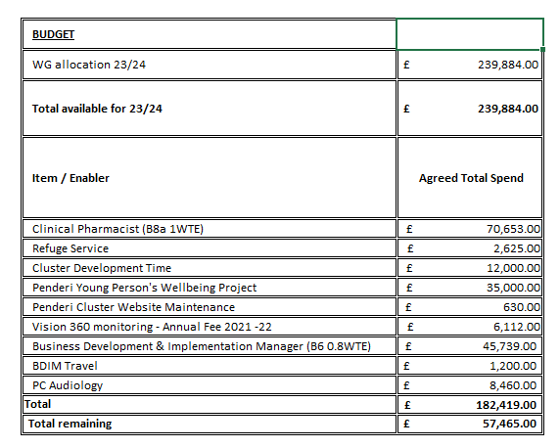

Return to Contents


UPPER VALLEYS LOCAL CLUSTER COLLABORATIVE

Forward look

Welcome to the Upper Valley’s IMTP Annual Delivery Plan for 2023-24. In this plan we aim to build upon the excellent work carried out in 2022-23. In the last few years there has been a massive strain on Primary Care services but it has been a pleasure to see all members of the cluster group evolving their working practice to meet the current demands. I appreciate that pressures and challenges remain within the health service, however I know we are all committed to continuing improving services and health outcomes for all patients in the cluster
In previous years we have focused on maintaining essential services to enable the local population to access healthcare professionals in their time of need, and now we need to move to business as usual.
Community Pharmacy and cluster GP practices have worked hard to support the mass vaccination centres (MVC) to ensure timely delivery of the COVID autumn booster campaign to patients, including those unable to travel to the MVC. The vaccination campaigns have undoubtedly helped to prevent hospitalisation and saved lives, we need to continue to be vigilant in maintaining the message that COVID vaccines are the still the safest and best option in the battle against the virus.
This year we have seen the introduction of the national Accelerated Cluster Development (ACD) programme. I am pleased to advise that all the new members have settled into their new roles and have already had an impact on decision making. It is a pleasure working with the professional collaborative leads who are all highly skilled and knowledgeable. I firmly believe no one profession holds all the expertise in primary care and it has been a pleasure listening and sharing views to resolve common problems to the benefit of the cluster population.
There is no doubt that COVID 19 has exacerbated problems with mental health and wellbeing, the cluster is prioritising a rapid review of provision of services for those with mental health needs in the cluster, with a view to commissioning appropriate services to bridge any gaps. The cluster is working with a social prescriber to work with citizens in a holistic way to address their non-medical needs and help them take greater control of their health and well-being. We have also identified the need for individual counselling and group therapy, commissioning MIND to undertake this work and will review the progress throughout this year.
We have been keen to develop cluster wide Multi-Disciplinary Teams (MDT) to ensure citizens see the most appropriate health care professional the first time. The cluster has effective first contact physiotherapy, a community occupational therapist, specialist health visitor and supports first contact audiology service. The intention is to strengthen this way of working. The Cluster has been keen to advertise the excellent work our community pharmacies are providing. We are keen to increase public awareness of the common ailment scheme and the new independent prescribing services being offered within our pharmacies.
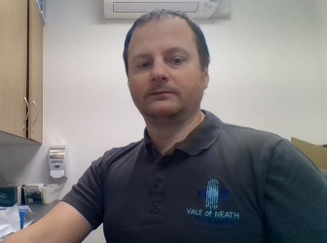
Finally, I would like to say how proud I am that the cluster is leading in an inhaler recycling pilot, which is the first of its kind in Wales. Working with Swansea Bay University Health Board and the Welsh Government we have secured funding for a 12 month pilot. The result of this pilot will shape future development so we hope it will be a success.
Nikki Watts, Upper Valleys LCC lead

Action plan

1. PLANNED CARE
 | GOALS | METHODS | OUTCOMES
 | Provide more care in the community | - Implement the trial without Catheter (TWOC) project to manage patients in their own homes | - Better patient care.  - Patient satisfaction  - % of successful TWOCs  - Length of time between referral and TWOC
 | Improve diagnosis and management of Hypertension | - Support patients to self-monitor their BP when necessary  - Management of diagnosed hypertensive patients in community pharmacy | - Early diagnosis of Hypertension  - Management of blood pressure in patients with hypertension  - No of patients’ blood pressure in target range  - No of patients started/changed medication as a result of the monitoring
 | Engage in prescribing management schemes & further improve antimicrobial stewardship and pain management | - Engage in the Prescribing Management Scheme (PMS) for 2023-24  - Ensure prescribing of antibiotics is in line with SBUHB recommendations where appropriate  - Review prescribing data (which will be provided by Medicines Management to LCC / Practices) on a regular basis to monitor progress  - Continue to utilise CRP POC for the management of LRTI  - Utilise supportive packages for QI work around UTI management / prophylaxis and 4Cs where appropriate  - Ensure that analgesic agents are only prescribed where the benefits outweigh the risks and that patients are appropriately monitored and reviewed | - Increased assurance that antibiotics are being prescribed appropriately  - Maintenance of current low prescribing with aim of further reduction in prescribing of Co-amoxiclav, cephalosporin, fluoroquinolone and clindamycin items prescribed per 1,000 patients and a reduction in overall antibiotic prescribing  - Aim for a reduction in the prevalence of healthcare associated infection (HCAI), including Clostridioides difficile infection and Staphylococcus aureus bacteraemia  - Management of patient expectation in relation to antibiotic prescribing and pain management  - Increased assurance that patients are prescribed analgesic therapy where the benefits outweigh the risks and that they are appropriately reviewed and monitored  - Reduction in the prescribing of gabapentin, pregabalin, tramadol and other opioids.
 | Improved management of patients with diabetes | - Encourage uptake of diabetes education programme for patients newly diagnosed with diabetes | - Increased attendance at Diabetes education Programmes  - To improve patient awareness and self-management of Type 2 diabetes within the Cluster population
 | Reduce demand on outpatients and support improved referral to treatment times. | - Increase the use of Consultant Connect.  - Increase the use of GPTR  - Participate in the Extended Minor Surgery Service for transfer of low risk Basal Cell Carcinoma excisions from secondary care dermatology to the Cluster | - % of GP practices with bypass numbers on Consultant  - Improved communication between primary and secondary care  - Patients can be treated in primary and community care  - Increased admission avoidance.

 | CANCER & PALLIATIVE CARE
 | GOALS | METHODS | OUTCOMES
 | Improve EOL for patients and patient’s family | - Engage with Compassionate Communities Programme.  - Support Dying Matters weeks.  - GP practices, nursing and community pharmacy engage in routine palliative care meetings. | - Patients and their families experience better end of life care services.  - Fewer people dying in hospital  - Improved management and access to EOL medication
 | Support patients with USC referrals to make lifestyle changes | - Explore engaging in the Cancer pre-habilitation project | - Patients with suspected upper and lower GI cancer benefit at the time of referral to USC from lifestyle support and interventions to maximise outcomes of treatment

- UNSCHEDULED CARE
 | GOALS | METHODS | OUTCOMES
 | Provide more care in the community | - Support the expansion of the Virtual Ward (Home First approach and reduce risk of readmission)  - Promote community pharmacies to engage in out of hours IP service  - Raise public awareness of the out of hours IP service in community pharmacy  - Community pharmacy engagement in the Discharge Medicines review enhanced service | - Reduced unnecessary admissions, Support discharge from hospital  - Vulnerable patients supported.  - Improved accuracy in medication prescribing resulting in decrease in hospital readmission  - Reduced demand on 111, WAST and A&E units
 | Ensure the provision of signposting, information and assistance for all | - Raise awareness of ‘Choose Pharmacy’ and the common ailments service (CAS)  - Engagement in the Care Navigation training programme | - Information, advice or assistance to signpost people who want – or need - urgent support or treatment to the right place, first time.  - Appropriate treatment for minor ailments in a timely manner from the community pharmacy, preventing the need for presentation at GP practices

- MENTAL HEALTH & LEARNING DISABILITIES
 | GOALS | METHODS | OUTCOMES
 | Develop and provide services to improve mental health and wellbeing of patients. | - Continue to commission Low Level Mental Health Support Services from the 3rd Sector  - Continue to work with LPMHSS to develop an LCC specific service with the aim of having more streamlined access.  - Continue to support Social prescriber and LCC Mental Health Practitioner roles.  - Improve methods for capturing patient reported outcomes. | - Reduction in demand on GP services, medicines.  - Reduction in impact on Mental Health Services, Social Care.  - Patients reporting improvement in mental health and wellbeing.
 | Identify and support patients experiencing domestic violence | - Engage in the primary care IRISi project  - Engagement in the AskAni code word scheme | - Patients experiencing domestic abuse are supported and kept safe

- CHILDREN, YOUNG PEOPLE & MATERNITY
 | GOALS | METHODS | OUTCOMES
 | Improve outcomes for the most vulnerable families within the NPT clusters | - Quarterly review of the Specialist Health Visitor Service.  - Support the extension of the Specialist Health Visitor role  - Provide specialist health visiting advice and service to the child and family team across the age span. | - Integrated approach to assessments, thresholds and referrals.  - Improved outcomes for the most vulnerable families  - Improved communication between health, social services and third-party agencies  - Improved education for health partners  - Effective and efficient referral pathway for health partners  - Improved safeguarding of children and Young people

- PREVENTION & REDUCING HEALTH INEQUALITIES
 | GOALS | METHODS | OUTCOMES
 | Improve uptake of childhood vaccinations | - Continue to maintain performance in the uptake of childhood immunisations in areas where targets have been achieved.  - Build on existing working relationships with Health Visitors  - Continue to educate parents and encourage vaccination uptake. | - Improved uptake of childhood immunisations on 22/23 figures  - Improved health and wellbeing of children.  - Reduced morbidity & mortality  - Reduced variation across cluster, Health Board and all Wales position
 | Encourage uptake of Public Health screening programmes | - Provide opportunities to attend cervical screening in GP practices or sexual health clinics  - Encourage patients to engage with screening programmes opportunistically  - Review data as it becomes available | - Increased screening uptake, working towards national target  - Reduced cancer rates
 | Deliver an enhanced Flu vaccination Programme | - Regularly review IVOR data for flu vaccination when available  - Develop and implement a seasonal flu plan aimed at early administration of the flu vaccine to eligible at risk patients and increasing uptake | - Increased uptake of influenza vaccine in target groups  - Reduced mortality / hospital admissions due to influenza.
 | Develop a consistent approach to reduce smoking prevalence | - Develop and implement sustainable processes/initiatives that lead to increased referrals to the Help Me Quit local smoking cessation services  - Increase engagement with the local Pharmacies Level 3 service. | - Increased referrals to “Help Me Quit”  - Increased uptake in use of Level 3 service  - Reduced local prevalence of smoking – reduced morbidity / mortality
 | Support patients to manage their weight | - Support GP Practices and Community Pharmacy with dietary education marketing  - Participate in the HB wide ‘Henry’ programme when/ if becomes available (going to PCPG) | - Patients are supported to manage their weight.
 | To improve patient awareness and self-management of Type 2 diabetes within the Cluster population, Identify and manage patients who have pre diabetes | - Delivery of the two year All Wales Diabetes Prevention Programme (AWDPP). | - National evaluation based on a core set of patient clinical outcomes to be finalised.
 | Develop strategies which contribute to the decarbonisation of the environment to help with the current climate emergency | - Pharmacists and prescribers to build upon and support existing efforts to encourage responsible disposal of inhalers through discussions with patients, information leaflets, posters and media  - Engagement by 8/10 community pharmacies in the LCC Inhaler Scheme  - Encourage remaining 2 pharmacies to engage in the scheme | - An increase in carbon friendly disposal of inhalers
 | To support individuals who are frail, socially isolated or at risk of falls and empower individuals with long term health conditions with a timely and responsive service | - Supporting the extension of funding an OT to support LCC patients  - A timely responsive Occupational Health review | - Reduction in Patient and carer distress  - Improved participation in activities and stabilisation of health and wellbeing  - Positive patient feedback

Return to Contents

- ACTION PLAN ENABLERS
Technological | Workforce | Communication & Engagement | Finance
Vision 360 | Business Development & Implementation Manager | HB social media pages | Emergency Planning Response and Resilience Plan
 | Social Prescriber |  | WG Funding
 | Occupational Therapist |  | Health Board funding for Virtual Ward, IRISi, Primary care audiology
 | First Contact Physiotherapist
 | Primary Mental Health Link Worker
 | Virtual Ward staff
 | Induction Pack for New Cluster staff
 | LCC Lead
 | LCC Members
 | Primary Care Cluster Development Team

Return to Contents

LCC Financial profile
Statement of allocated LCC spend decisions (As of January 2023)
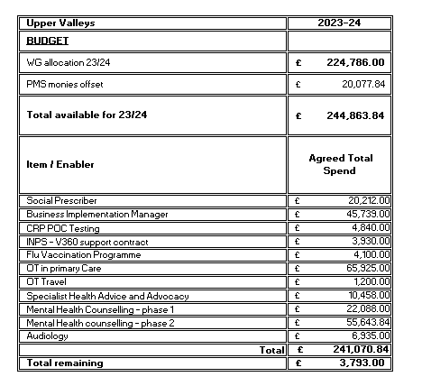

Return to Contents

GLOSSARY OF TERMS
Term | Acronym | Working Definition
ACCURX | ACCURX | Software - lets healthcare teams and patients seamlessly connect with each other
A Healthier Wales | AHW | Welsh Government long term plan for health and social care
All Wales Medicine Strategy Group | AWMSG | Advises Welsh Government about the use, management and prescribing of medicines
Child and Adolescent Mental Health Service | CAMHS | NHS Services that assess and treat young people with emotional, behavioural, or mental difficulties.
Common Ailment Scheme | CAS | offers patients a free NHS consultation and free medication for 27 common ailments that cannot be managed by self-care alone
Cognitive behavioural Therapy | CBT | talking therapy that can help you manage your problems by changing the way you think and behave
Chronic Conditions Nurse | CCN | Registered Nurse responsible for providing domiciliary and practice-based care for the management and monitoring of the care of patients with long term chronic illness (for example heart disease, COPD, and diabetes)
Chronic obstructive pulmonary disease | COPD | A group of lung conditions that cause breathing difficulties
C-reactive protein | CRP | Test identifies sign of inflammation
Children Young People | CYP | Children refers to younger children who do not have the maturity and understanding to make important decisions for themselves. The term young people refers to older or more experienced children who are more likely to be able to make these decisions for themselves.
Domestic Violence | DV | Domestic violence and abuse is any incident or pattern of incidents of controlling, coercive or threatening behaviour, violence, or abuse between those aged 16 or over who are or have been intimate partners or family members regardless of gender or sexuality.
Domestic Violence and Abuse | DVA
Ear nose and Throat | ENT | Refers to the department/specialist that deals with diseases affecting the ear, nose, and throat.
End of Life | EOL | The term end of life usually refers to the last year of life, although for some people this will be significantly shorter. The term palliative care is often used interchangeably with end-of-life care. However, palliative care largely relates to symptom management, rather than actual end of life care.
Faecal immunochemical test | FIT testing | Bowel cancer test
Global Warming Potential | GWP | An indicator aimed at including in a single value the added effect of all the substances contributing to the greenhouse effect.
Health Board | HB | a local government agency that supervises public health.
Health Care Associated Infection | HCAI | Infections acquired by patients during their stay in a hospital or another healthcare setting
Identification& referral to improved safety interventions | IRISi | Training and support product for practices in respect of patients disclosing domestic violence
Influenza Vaccination Online Reporting | IVOR | Monthly information on the number of flu vaccines administered
Local Cluster Collaborative | LCC | These are the mechanisms by which representatives of the individual Professional Collaboratives come together to assess the wider health and wellbeing needs of their population and respond to RPB and PSB assessment of population health and needs to produce a prioritised annual cluster plan. This plan also sets out how any funding allocated for decision at cluster level should be invested. This more multi professional, multi sector membership enables clusters to address many of the more complex and challenging issues which require a collaborative response. Interprofessional/sector dialogue also enables more efficient service delivery. By strengthening arrangements between Clusters and RPBs there is further opportunity to ‘draw down’ resources to support delivery of cluster level plans that complement RPB strategic priorities.
Local Primary Mental Health Support Service | LPMHSS | The LPMHSS provide goal focused mental health assessments and treatment by way of short-term psychological interventions which can be delivered individually or in group settings.
Lower Respiratory Tract Infection | LRTI | Broad terminology which includes acute bronchitis, pneumonia, acute exacerbations of chronic obstructive pulmonary disease/ chronic bronchitis and acute exacerbation of bronchiectasis
Metered dose inhaler | MDI | A metered dose inhaler is a device that delivers a specific amount of medication to the lungs, in the form of a short burst of aerosolized medicine that is usually self-administered by the patient via inhalation.
My Health online | MHOL | Allows patients to book GP appointments and request repeat prescriptions online using mobile, tablet or computer.
Measles Mumps and Rubella Vaccine | MMR | The MMR vaccine is a vaccine against measles, mumps, and rubella (German Measles).
Neath Port Talbot | NPT | Relates to the areas of the Health Board that fall within Neath Port Talbot Council
Occupational Therapy | OT | Occupational Therapists help people with physical disabilities and long-term conditions to get the most out of life, THe focus is on finding an optimal level, whatever the barrier.
Point of Care | POC | Point of care testing is a form of testing is defined as diagnostic testing that is performed at or near to the site of the patient with the result leading to a potential change in the care of that patient.
Regional Partnership Board | RPB | Regional Partnership Boards bring together health boards, local authorities and the third sector to meet the care and support needs of people in their area.
Public Services Board | PSB | Public Services Boards improve joint working across all public services in each local authority area in Wales. Each Board must carry out a well-being assessment and publish an annual well-being plan. The plan sets out how they will meet their responsibilities under the well-being of Future Generations (Wales) Act.
Primary Care Model for Wales | PCMW | The transformational model for community based services, which is a place based approach to sustainable and accessible local health and wellbeing care.  The model focuses on:  • Service developments based on demand; planning and transformation is led through coordinated local care teams.  • The promotion of healthy living by making well-being less of a medicalised term  • Service planning and delivery across local communities  • A more preventative, pro-active, and coordinated care system which includes general practice and a range of services for communities  • A whole system approach that integrates health, local authority, and voluntary sector services, and is facilitated by collaboration and consultation  • Care for people that incorporates physical, mental, and emotional well-being, which is linked to healthy lifestyle choices  • Integrated and effective care on a 24/7 basis, with priority for the sickest people during the out-of-hours period.  • Creating stronger communities by empowering people and giving them access to a range of assets, ranging from access to debt and housing advice, to social prescriptions for gardening clubs and the leisure centre.  • Advice and support to help people remain healthy, with easy access to local services for care when it is needed  • Strong and professional leadership across sectors and agencies to drive quality improvement  · Technological solutions to improve access to information, advice, and care, and to support self-care.
Public Health Wales | PHW | Public Health Wales is the national public health agency in Wales and exists to protect and improve health and wellbeing and reduce health inequalities for people in Wales.
Protected Learning Time | PLTS | Allows GP Practices time to carry out staff training for the whole practice at a time.
Prescribing Management Scheme | PMS | The focus of the scheme is on quality improvement in key clinical areas such as respiratory medicine through development of therapeutic pathways with both acute and primary care working together. In addition, it provides the potential to reinvest into the development of patient centred services in the community to bring care closer to home.
Quality Improvement | QI | The term quality improvement refers to the systematic use of methods and tools to try to continuously improve quality of care and outcomes for patients.
Rapid Diagnostic Centre | RDC | The Rapid Diagnostic Centre based at Neath Port Talbot Hospital is for patients with vague but concerning symptoms that do not fit into any of the existing referral pathways. At the RDC, patients will have an individualised assessment with the aim of achieving a diagnosis and initiating a treatment plan or gain the reassurance that nothing concerning has been found.
Urgent suspected cancer | USC | When a patient goes to their GP with suspected cancer symptoms, they can be referred for further tests under an urgent suspicion of cancer pathway to investigate the symptoms further. The aim is either to confirm or rule out cancer
Urinary Tract Infection | UTI | A urinary tract infection (UTI) is an infection in any part of your urinary system – your kidneys, ureters, bladder, and urethra.
Welsh Ambulance Service Trust | WAST | The Welsh Ambulance service trust is the national ambulance service for Wales.
Welsh Clinical Communications Gateway | WCCG | A national system in Wales for the electronic exchange of clinical information, such as referrals, that integrates primary and secondary care systems using familiar yet highly secure internet technology.
Swansea Bay University Health Board | SBUHB | SBUHB covers a population of around 390,000 in the Neath Port Talbot and Swansea areas.
Swansea Council for Voluntary Services | SCVS | Not for profit organisation that supports the Third Sector within Swansea
Social Prescriber | SP | Takes a holistic approach to patients’ needs, connecting people to community groups and statutory services for practical and emotional support
Virtual Ward | VW | A virtual ward is a technology-enabled way to provide support to patients without them needing to stay in hospital. Vulnerable patients, often with complex needs, receive care in their homes –0 either after discharge, as a way to avoid hospital admission or to monitor their condition.

Return to Contents

