Lead: Alan Lawrie, National Programme Advisor
Author: Raylene Roper, Senior Programme Manager, Strategic Programme for Primary Care
Karen Gully, National Advisor, Accelerated Cluster Development
Date: 15th July 2022
Purpose: Paper to summarise the Health Board returns and position against the national actions for the Accelerated Cluster Development (ACD) Readiness Checklist as at 31st May 2022.
Strategic Programme for Primary Care

Update Summary ACD Readiness Checklist
Position reported as at 31 May 2022
Paper date: 15th July 2022

Timeline
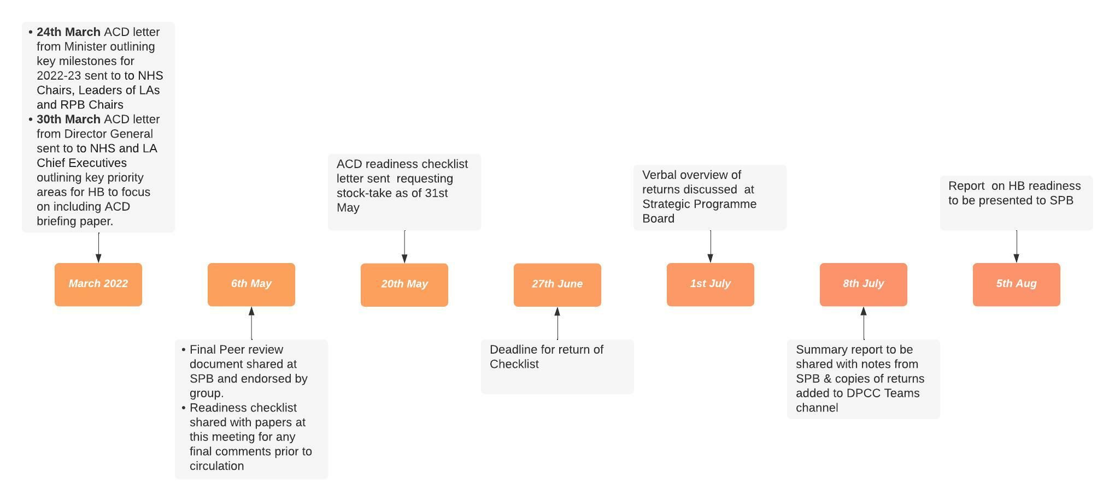
Returns
Returns received from all health boards, by 1 July 2022.

Overview
Section 1 of the Readiness Checklist contains thirty actions for Health Boards with their Local Authority / Regional Partnership Board partners to deliver between April 2022 and April 2023. Twenty of the thirty actions have timelines for delivery between April-September 2022.

Section 2 of the Readiness Checklist contains seventeen actions to be progressed at a national level by the Strategic Programme for Primary Care (SPPC) team with national partners.

An early ‘check in’ on progress with delivery as at 31st May 2022 was captured from health boards across Wales and is summarised in Table 1 below. Feedback received from this exercise has been positive, with health boards noting it has been a useful exercise to see progress and to identify areas to continue to address and progress.

An update on progress against the seventeen national actions as at 31st May 2022 is summarised in Table 2 below.

Common themes/areas to note:

Health Board actions:
The majority of the actions contained in Table 1 are lifted from the letter from the Minister for Health and Social Services to NHS Chairs, Leaders of Local Authorities and RPB Chairs (dated 24 March) and from the NHS Wales Chief Executive to NHS and Local Authority Chief Executives (dated 30 March).

Whilst some of the action milestone dates for completion have slipped by a month or so it is recognised that good progress is being made by all health boards and their partners across Wales to progress implementation of ACD during this transition year. There are no ‘early warning’ concerns raised that need further escalation; a further progress check in with Directors of Primary Care will be undertaken at the August and at the October Strategic Programme Board meetings to check in and share learning across Wales.

To note:
- All health boards are still progressing / finalising the governance route, assurance and adopting/adapting the model terms of reference for the pan cluster planning groups (links to action #4, 5, 6 and 9).

- All health boards are progressing the development of action plans for, recruitment to, and supporting the leadership and OD requirements for the various professional collaboratives in their health board area, linked to ongoing contract reform discussions and national leadership programme work led by HEIW/SPPC (links to action #7, 8, 9, 12, 13, 14, 15 and 17).

- Identifying the cluster to take part in the peer review (action #16) is one area which stands out as work in progress. Reasons include lack or understanding of the process. A briefing pack to support the peer review process has been finalised and is being translated ready for uploading on SPPC website and sharing with health boards and RPBs in early July. It is anticipated this will enable completion of this action with minimal delay.

- Recruitment into posts is varied (action #10) with some health boards are reporting they are unable to recruit / failing to recruit. Query to be noted as possible risk to delivery.

National Actions:
Good progress has been made on the national actions by the SPPC team. The ACD toolkit, cluster planning support portal, action learning group, peer review process and the ‘Once for Wales’ Contract and Community Interest Company have all been completed / launched / confirmed.

Work is progressing on the ACD leadership and development offer for Wales (in collaboration with HEIW) and the establishment of the regional hack days. Further work is required on the refresh of the Cluster Handbooks and to augment the all Wales communications plan and materials.

Work is also progressing with Welsh Government partners on the development of the 2023/24+ planning guidance and the alignment of the ACD/PCPG and RPB planning/partnership interface and revised codes of practice/guidance.

The ‘check in’ with Health Boards / national team will be repeated in October and the table will be extended to include the remaining ten ACD Programme health board (with their partners) actions for delivery over the October 2022-March 2023 period to compliment the update on the actions listed in table 1&2 below.

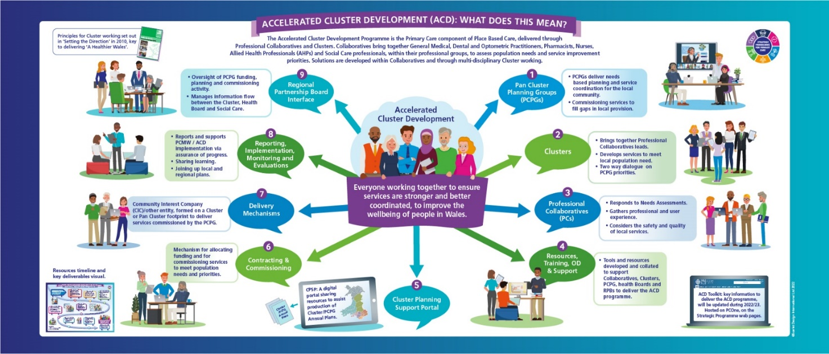

Table 1: ACD Programme Actions (to be delivered by September 2022) early check in – Health Board actions

# | Timescale | Action | Lead / Owner | Status | Commentary | Why is this important?
1 | April | 2022/2023 Cluster Annual Plans published on Health Board websites (option to hyperlink from PCOne); Health Boards support delivery of the Cluster Plans over the next 12m as required | DPCCs and HB teams | Must do | Completed by all Health Boards  Showing as completed by 7 out of 7 health boards (HBs). One HB note - Cluster IMTPs (not annual plans) are updated and published  One HB - plan to publish after 30th June | Plans have been in place for 10 years and should play a central role in informing the Health Board of critical local issues and priorities  Plans assist local coordination between teams and services to ensure seamless care and the most efficient use of resources  The clarity of existing plans is critical for briefing and engaging the new Professional Collaboratives and Pan Cluster Planning Groups:  - To understand where the focus of current effort is placed  - To contribute to effective solutions for current challenges
2 | April | 2022/2023 Cluster Funding proposals / initiatives commence; local monitoring in place | DPCCs, PC Teams, Clusters | Must do | Showing as completed by 5 out of 7 HBs  2 HBs – show this as ongoing / work in progress; robust monitoring in place  SPPC Action: Assurance provided. Does not require follow up | Transparency and governance of the use of public money is essential. Spending plans have been in place for seven years but to inform new discussions there needs to be clarity of resource available to support new initiatives  The aim of cluster working is to encourage and support collaboration of services around a local community and to test new solutions. This requires clear pathways to test, evaluate and mainstream where projects are successful, releasing resource for further innovation
3 | April | Confirm the geographical boundary to inform the development of the map of Pan Cluster Planning Groups (PCPG) and associated Clusters for the Health Board / Regional Partnership Board region | DPCC, DoP with RPB Partners | *Must do | Completed by all Health Boards | This provides clarity of planning and operational footprints. Leads need to understand the organisational architecture and local decision making systems
4 | April | Agree the governance route within the health board for the Pan Cluster Planning Group | DPCC with DoPs and BS | *Must do | Showing as completed by 4 out of 7 HBs  3 HBs – show this as ongoing /work in progress: further discussions scheduled with Partners in June/July to finalise arrangements  SPPC Action: Assurance required from 3/7. Progress check in with DPCCs at August Strategic Programme Board (SPB) | This ensures clarity of connection from the RPB to the Cluster footprint and is a key requirement to ensure the effectiveness of the partnership agenda between health boards, local authorities and third sector providers
5 | April  (through Q1) | Health Boards and their Local Authority partners establish Pan Cluster Planning Groups, Terms of Reference are adapted / adopted (added to but not downgraded) and PCPG governance is embedded into the local architecture | DPCC, DoP, DSS and RPBs | *Must do | All 7 HBs show this as ongoing/work in progress  SPPC Action: Action through Q1. Progress check in with DPCCs at August Strategic Programme Board (SPB) | The aim of the PCPG is to deliver the principles of the Social Services & Well-being Act 2014 (the Act), The Wellbeing of Future Generations Act (2015) and A Healthier Wales  The PCPG will:  - Lead the development of an integrated plan which addresses the health, care and wellbeing needs of the whole population of [County]  - Support the implementation at local level of the joint partnership agenda, including (but not limited to)  - Cluster plans  - Integrated [County] plan  - Priorities determined by the RPB and the [County] Partnership Board (PSB)  - Requirements of the individual organisational plans which involve partnership working  - Bring together senior leaders from the NHS, Local Authority (to agree which departments) and key partners in the Third Sector  The Cluster Survey highlighted the need for greater influence from Clusters into the wider health and social care system  PCPGs also highlight opportunities from time limited to funding streams (such as winter pressures etc)
6 | April-June | PCPG Assurance is part of the Health Boards existing Board Governance structure | BS, DPCC, DoP | Must do | Showing as completed by 3 out of 7 HBs  Four HBs show this as ongoing /work in progress  SPPC Action: Action through Q1. Progress check in with DPCCs at August Strategic Programme Board (SPB) | This ensures that Health Boards are supporting and enabling the business of the Board through the agreed local footprints, informed by the knowledge and experience of the workforce  Effective governance structures and processes ensure that HBs understand the maturity of local partnership arrangements and that they put in place appropriate organisational development support  PCPGs will be highlighting risks and opportunities from primary and community care services so that HB Governance systems are complete- taking a whole system view that reflects patient, public and workforce experience
7 | April | Set out a project plan to begin establishing the Professional Collaboratives for the contractor professions: GMS, Optometric, Pharmacy, Dental | DPCC, DWOD, Prof Advisors | *Must do | One HB showing as completed  6 HBs showing as ongoing /work in progress  SPPC Action: Recognised work in progress linked to national Contract Reform. Progress check in with DPCCs at August Strategic Programme Board (SPB) | Clusters were established to support a collaborative approach between ALL local health and social care services serving a defined population  The Cluster Survey highlighted that whilst GP practices were established at the core of this approach, the engagement of other contractor services, nursing, AHP, social services and third sector is variable  Professional Collaboratives are being introduced to increase workforce engagement. The GP collaborative supports GP practices to address issues specific to General Practice (including sustainability concerns) and similar arrangements apply for the other contractor professions, nursing and AHP  Local authorities will consider how similar arrangements might support social care teams.  This allows the Cluster to achieve the original aim of a multi-disciplinary forum for holistic needs assessment, collaborative discussions and innovative projects
8 | May | Set out a project plan to begin establishing the comparable arrangements for establishing Professional Collaboratives for other professions such as nursing, allied health professionals, and potentially social services | DPCC, DWOD with DoN, DoTh and DSS | *Must do | All 7 HB show on track /work in progress linked to national workshops and national guidance through June-August  SPPC Action: Recognised work in progress linked to SPPC national/local AHP/Nursing workshops. Progress check in with DPCCs at August Strategic Programme Board (SPB) | As above
9 | April-June | Any changes that are needed to the Health Board Scheme of Delegation / SFIs to allow PCPGs to have delegated authority to act are actioned | BS, DPCC, DoP, DoF | Must do | 6 out of 7 HB show on track /work in progress of which one HB notes some risks are being managed  One HB notes this work as not yet started  SPPC Action: Recognised work in progress linked to actions 4-6 above. Progress check in with DPCCs at August Strategic Programme Board (SPB) | Ensuring that form follows function – ie that systems support and enable the shared purpose  PCs and PCPGs will only be successful if they are able to deliver change - they need to be able to respond to local challenges and make the most of local opportunities  The decision making process should be transparent, rapid and easy to follow  The Cluster Survey highlighted concerns about slow and opaque systems which limit innovation and discourage clinical engagement
10 | April-June | Progress delivery of and appointments to any posts funded from the Strategic Programme for Primary Care Fund 2022 (SPPC Fund) ACD investment plans | DPCCs / HOPC | *Must do | All 7 HB show on track /work in progress – some posts have been recruited to - others unable to recruit suitable applicants so back out to advert  SPPC Action: Assurance provided. Does not require follow up; further assurance via SPPC Fund monitoring | The ACD programme is necessarily ambitious - system backlog, increasing demand and public frustration require an active response  Clinical leads need to focus on the clarity of needs assessment, prioritisation, colleague engagement and delivery of solutions  They require managerial and technical expertise to deliver this programme of work
11 | April-June | Consider the current Cluster arrangements, membership and governance to ensure it aligns with the model Cluster Terms of Reference for the ACD programme.  Review transition year Cluster Lead / Chair arrangements / future Professional Collaborative leads representation on the PCPG | DPCCs, PCPG, and Cluster partners | To Consider | All 7 HB show ongoing / work in progress  SPPC Action: Recognised work in progress linked to actions 4-6&9 above. Progress check in with DPCCs at August Strategic Programme Board (SPB) | The Transition Year provides an opportunity to implement and test the ACD actions building on established arrangements and further strengthening the integrated, collaborative approach  The ACD Action Learning Group supports this work and provides a forum, with the SPPC, to ensure that there is shared learning, rapid problem solving and effective implementation
12 | May-June | Consider leadership and professional development needs of the various Professional Collaborative Leads and Cluster Leads | DWOD with DPCC, DoN, DoTh and DSS | To Consider | 5 out of 7 HB show on track /work in progress  One HB note action as completed  One HB adjusted timescale for achievement - aim to have 1st meeting by September  SPPC Action: Recognised work in progress. Progress check in with DPCCs at August Strategic Programme Board (SPB) | Clinical Leadership is a critical factor in system change but leads require a clear understanding of the organisational structures and systems and agreed SMART objectives  Health Boards must have a clear understanding of their expectations for PCPGs, Clusters and PCs which are articulated to their clinical and managerial leadership  HEIW is providing a comprehensive programme of leadership development which can support this work
13 | May-June | Consider the Organisational Development needs to optimise Pan Cluster Planning Group working | DWOD, DoP, DPCC, RPBs and PCPGs | To Consider | All 7 HB show on track /work in progress  SPPC Action: Recognised work in progress. Progress check in with DPCCs at August Strategic Programme Board (SPB) | As above
14 | May-June | Engage with the SPPC commissioned PCC Leadership engagement exploratory workshops for Professional Collaboratives, Pharmacy, Dental, Optometry, Nursing and AHPs | Primary Care Teams including Nursing and Therapy Leads | To Consider | 6 out of 7 HB show on track / work in progress  1 HB shows as completed  SPPC Action: Recognised work in progress. Progress check in with DPCCs at August Strategic Programme Board (SPB) | As above
15 | June onwards | Engage with the Strategic Programme for Primary Care on the leadership and OD programmes for Cluster Leads, Professional Collaboratives & Leads PCPG members | DWOD, DoP, DPCC, RPBs and PCPGs, Cluster / Colab Leads | *Must Do | 6 out of 7 HB show on track /work in progress – 3 HB note engagement will begin when national programme confirmed and delivered  1 HB notes it will review this action in Q3  SPPC Action: Work with HEIW to finalise Leadership & OD offer. Progress check in with DPCCs at October Strategic Programme Board (SPB) | As above
16 | June | Confirm and prepare one Cluster footprint per Health Board to be part of the Cluster peer review process being drawn up for 2022-2023 | DPCCs / DoPs / RPBs | *Must Do | 2 HBs have agreed their Cluster  5 out of 7 HB this is ongoing/under discussion  SPPC Action: Finalise the Peer Review briefing pack (July) which outlines more detail and clear expectations of the process and roles will help to support health boards in achieving this requirement. | Peer Review provides an opportunity to reflect on the experience of delivering the Cluster approach. This will highlight successes but also clarify challenges and barriers that wider systems can and should address  The Transition Year Peer Review cycle will inform the development of an annual process to ensure that this adds value
17 | April-Sept  (March ‘23) | Supported by Health Boards, individual Professional Collaboratives are established in each Cluster footprint for General Practice, Pharmacy, Optometry, Nursing, Allied Health Professionals (AHPs) and potentially social services and these are represented on the Cluster / PCPG  Subject to contract reform, Dental Professional Collaboratives are expected to be established by March 23 | DPCC, DoPs, WoD, DoTHs, DoNs, and PCPGs, Cluster / Collaborative Leads | *Must Do | 6 out of 7 HB show on track /work in progress  1 HB notes it will review this action in Q3  SPPC Action: Recognised work in progress. Progress check in with DPCCs at October Programme Board (SPB) following Nursing/AHP health board workshops in the summer | As above
18 | April-Sept | Update skills and knowledge on the ‘Once for Wales’ contract for PCPGs to use with Community Interest Companies (CiCs) if formed | RPBs, PCPGs, HB Exec Teams | *Must Do | 5 out of 7 HB note this is work which requires input from national team / work not yet started  1 HB notes it will review this action in Q3  SPPC Action: Publish CIC chapter on ACD toolkit (July) and confirm dates for August CIC workshops with Health Boards. | One of the challenges highlighted in the Cluster Survey was the ability to employ staff at Cluster level. CICs offer a solution and allow access to a wider range of funding sources
19 | April-Sept | Develop proposals to ensure that there is good and effective stakeholder, public and patient engagement in Clusters and PCPGs | RPBs, PCPGs, HB Exec Teams | To Consider | 4 out of 6 HB note this as on track/ongoing  3 HBs note as not yet started  SPPC Action: Recognised work in progress. Progress check in with DPCCs at October Programme Board (SPB) | Clusters are the local footprint for health and social care services. Stakeholder, public and patient engagement should be a core aspect of all service development approaches. This is particularly important to ensure that proposed solutions are deliverable within the local context
20 | July-Sept | Professional Collaboratives (where established) begin to respond to published population needs assessments (such as RPNAs published in April 2022) and identify their service gaps and developments in response to Welsh Government planning guidance | Professional Collaboratives | *Must Do | 3 out of 6 HB note this as on track /ongoing  4 HB notes this as not yet commence  SPPC Action: Recognised work in progress. Progress check in with DPCCs at October Programme Board (SPB) | Professional Collaborative members bring a wealth of knowledge about the experience of their patients and their carers as well as experience of the effectiveness of local health and care systems. Professional teams also gather intelligence about the local population through clinical audit and quality improvement activities. This rich information informs the understanding of population need. RPBs should also ensure that the RPNA and other relevant sources of information are accessible for Clusters to ensure that needs assessments and plans at every level are comprehensive

Table 2: SPPC response to the national actions in the ACD Readiness Checklist as at 31 May 2022

# | Timescale | Action | Lead / Owner | Status | Commentary | Why is this important?
A | April | ACD Toolkit and Cluster Planning Support Portal launched | SPPC Team & PC Hub | Must Do | Complete  Toolkit and Portal launched. | The Toolkit provides a practical guide for all aspects of the ACD programme – easily accessible in a single portal  Step by step guidance for those new to roles and more detailed content to support the business of Cluster working  Provides a range of resources to avoid duplication of effort and support consistency
B | 2022/2023 | ACD Toolkit and Cluster Planning Support Portal periodically updated | SPPC Team & PC Hub | Must Do | Ongoing  Further information updated within the toolkit as the material is developed.  Cluster Planning Support Portal views currently being sought to aid refinement of the portal in late summer. | The toolkit is updated to reflect real experience, adapting resources where needed and sharing examples of good practice.  As the resources support the delivery of the programme it is vital that they cover current issues
C | April  2022/2023 | ACD Action Learning Group established – monthly sharing and learning across Wales | SPPC Team | Must Do | Complete  Monthly meetings being held to share and learn across Wales. | The peer network is driving forward a challenging and important agenda. The transition year has a focus on implementation and learning from the introduction of new structures that emerged as recommendations from the Cluster Survey. This leadership group is leading the change within health boards and working at the national level to share experience and ideas This work is supported by the SPPC and a range of partners including HEIW to ensure that the enabling national programmes are fully aligned with the needs of the service
D | 2022/2023 | Cluster Development Support Officer Network continues to meet quarterly for peer engagement and shared learning across Wales | PC Hub | Must Do | Ongoing  Next meeting scheduled July to received ACD update/Readiness checklist feedback and discuss ACD/Cluster/PCPG Planning arrangements for 2023 onwards | Cluster Support Officers work closely with Cluster Leads in the day-to-day implementation of the Cluster agenda. The readiness checklist provides a useful summary and timeline for actions. Each Cluster area is unique and the Network provides the opportunity to share experience, check out concerns and propose ideas. The SPPC works closely with the group and identifies issues that can be actioned on a ‘Once for Wales’ basis
E | May-June | PCMW / Cluster transition year Peer Review process published | SPPC Team & PC Hub | Must Do | Complete  PCMW/ACD Monitoring and Evaluation Plan and the Cluster Peer Review process published. Peer Review briefing packs to be sent out to health boards early July. | Peer review allows those who best understand local systems, and the current pressures, to identify barriers and enablers and to share good practise.  Peer review has benefits to clusters, regional partnership boards (Health Boards and Local Authorities) (RPBs) and the Strategic Programme for Primary Care (SPPC), highlighting structures and systems that are working effectively and identifying risks that remain unaddressed.  Cluster peer review during the transition year is an opportunity to test out a new process and provide intelligence to inform a regular peer review process.
F | April-June | The Strategic Programme for Primary Care [SPPC] establishes a Leadership and OD Programme to support the Professional Collaboratives and Cluster Leads. | SPPC Team and HEIW | *Must Do | Ongoing  Working with HEIW the scope and content of the programme has been agreed; universal offer for each professional collaborative to be hosted on separate Gwella Platforms (paper to WOD 5th July) and a bespoke development course and action learning set for the Pan Cluster Planning Groups Cluster Leads to be commissioned to commence Autumn 2022. | Leaders at all levels face the challenge of supporting current approaches and developing new ways of working to meet the needs of the population and improve the experience of the workforce more effectively. The Leadership Programme will offer core skills and more advanced learning opportunities with support for individuals to build their career path.
G | April -September | Work with WG, Senior NHS Executives, LA partners as required to revise codes of practice, guidance/authority of the RPBs. The revised RPB governance, accountability, along with improved integrated planning arrangements will make clear reference to the role of PCPGs and Clusters | SPPC Team, NHS Executives, WG Colleagues and LA partners | Must Do | Ongoing  Linked to the Welsh Government Rebalancing Care and Support Strengthening Regional Partnership Boards programme of work | A shared sense of purpose across the whole health and care system is essential to achieve the aims of A Healthier Wales. A ‘line of sight’ between strategic planning and delivery within real communities ensures that all of our efforts are directed towards those shared aims.
H | April -September | ‘Once for Wales’ Contract and Community Interest Company briefing sessions held for Health Boards and RPB partners | SPPC Team; NHSWSSP, PCC | Must Do | Ongoing  CiC chapter published in the ACD Toolkit (chapter 5) Health Board awareness and information workshops to be held in August/September | New delivery models offer solutions to practical challenges such as the employment of staff at Cluster level. A small number of Community Interest Companies have been established and offer Health Boards the opportunity to commission specific services to meet local needs. This approach also allows a greater degree of autonomy for the local participants which can allow more rapid problem solving and a greater sense of local ownership.
I | April -September | Augment the all Wales communications plan and materials for local use | SPPC Team and WG colleagues | *Must Do | Further work required to progress and align this action | The Transition Year has an extremely busy programme of work which requires an active communications strategy to keep all stakeholders informed and engaged.
J | June – March | ACD Regional Hacks commence | SPPC Team | Must Do | Scoping for regional hacks underway; engagement via ACD Action Learning Group | Hack Days have a positive track record for rapidly developing digital solutions to practical challenges. This dynamic problem-solving approach could be supported for a wider range of issues if members of the Action Learning Group determine that this will add value.
K | April -December | Embed the requirements for Regional Partnership Boards to work with PCPGs (though updated planning and funding guidance) | SPPC Team and WG colleagues | *Must Do | Linked to G above: Linked to the Welsh Government Rebalancing Care and Support Strengthening Regional Partnership Boards programme of work | A shared sense of purpose across the whole health and care system is essential to achieve the aims of A Healthier Wales. A ‘line of sight’ between strategic planning and delivery within real communities ensures that all of our efforts are directed towards those shared aims.
L | June | Cluster Handbooks are refreshed and uploaded onto PCOne | PH Hub | Must Do | Delayed  Handbook refresh work commenced; handbook 1 complete and sent for translation; work ongoing on handbook 2 and 3. To be completed by August. | The handbooks provide practice advice, ideas and tips to help working with clusters.
M | July | Cluster / Pan Cluster Planning Group Planning Guidance for 2023/24 published | SPPC Team WG colleagues | Must Do | Ongoing to be reported in Q2 | The links between different levels within the system need to be clear to ensure that each part is contributing to the shared aim of more effectively meeting the needs of communities and making it easier for the workforce to deliver the high standards of care to which they aspire.
N | September | Solutions to Information Governance issues published |  | Must Do | Ongoing to be reported in Q2 | Clarity in the management of Information Governance is an example of a Once for Wales solution that ensures consistency and the best systems to support care.
O | Sept – March 2023 | PCMW / Cluster transition year Peer review commences; reflective report and future peer review guidance produced | SPPC Team, Clusters, RPBs | Must Do | Ongoing to be reported in Q3 | The Peer Review cycle in 2022/23 will inform the evaluation of Cluster working and provide recommendations for an established programme of Peer Review from 2023 onwards
P | December | Learning from the SPPC commissioned Professional Collaborative Optometry pilot shared across Wales | SPPC Team | Must Do | Ongoing to be reported in Q3 | Professional Collaboratives provide an opportunity for strengthened peer support, local collaboration and increased influence for professional groups.  The pilot project allows us to test this approach, to learn from that experience and adapt as needed.
Q | December | Strategic Programme for Primary Care Fund 2022 ACD investment interim report produced | SPPC Team | Must Do | Ongoing to be reported in Q4 | The Interim Report will summarise how investment has been used, highlight what has worked well and share that knowledge across the system to inform local approaches.  This learning will also inform the national understanding of the skills and capacity required to support the programme of change needed to deliver A Healthier Wales.

