Item | Presenters
Welcome & Scene Setting | Darren Hughes (Chair)  Director, Welsh NHS Confederation
Overview of the Session | Sue Morgan, National Director and Strategic Programme Lead for Primary Care  Sarah McCarty, Director of Improvement and Development, Social Care Wales
Brief overview of the Primary Care Model for Wales (PCMW) and the Accelerated Cluster Development Programme (ACD) | Dr Karen Gully, National Professional Advisor on Accelerated Cluster Development
Cluster Working in Action | Will Beer, Assistant Divisional Director, Primary & Community Care, Aneurin Bevan University Health Board
Placed based care from an Allied Health Professions and Nursing Perspective | Kerrie Phipps, National AHP lead for Primary and Community Care  Chiquita Cusens, National Lead Nurse for Primary and Community Care
Summary | Sue Morgan National Director and Strategic Programme Lead for Primary Care
Interactive panel discussion chaired by Darren Hughes | Alan Lawrie National Programme Advisor for Primary Care  Dr Karen Gully, National Professional Advisor  Kerrie Phipps National AHP lead for Primary and Community Care  Sarah McCarty, Director of Improvement and Development, Social Care Wales  Sue Morgan National Director and Strategic Programme Lead for Primary Care  Will Beer Assistant Divisional Director, Primary & Community Care, Aneurin Bevan University Health Board
NHS Confederation Webinar
‘Placed based care’ in action in Wales
7 July 2022
13:30-15:00

‘Place Based Care’ in action in Wales

This session will provide a brief strategic overview of place based care before undertaking a deep dive into ‘place based care’ in action in Wales. We will hear from a range of stakeholders working together at cluster level pre-pandemic as well as a reflection on where they are now. This session will provide an insight into how place based care is working in a part of Wales and, linking it to the aspirations of ‘A Healthier Wales’ and the Programme for Government, explore what can be achieved by working together to deliver the aspirations of the Primary Care Model for Wales.
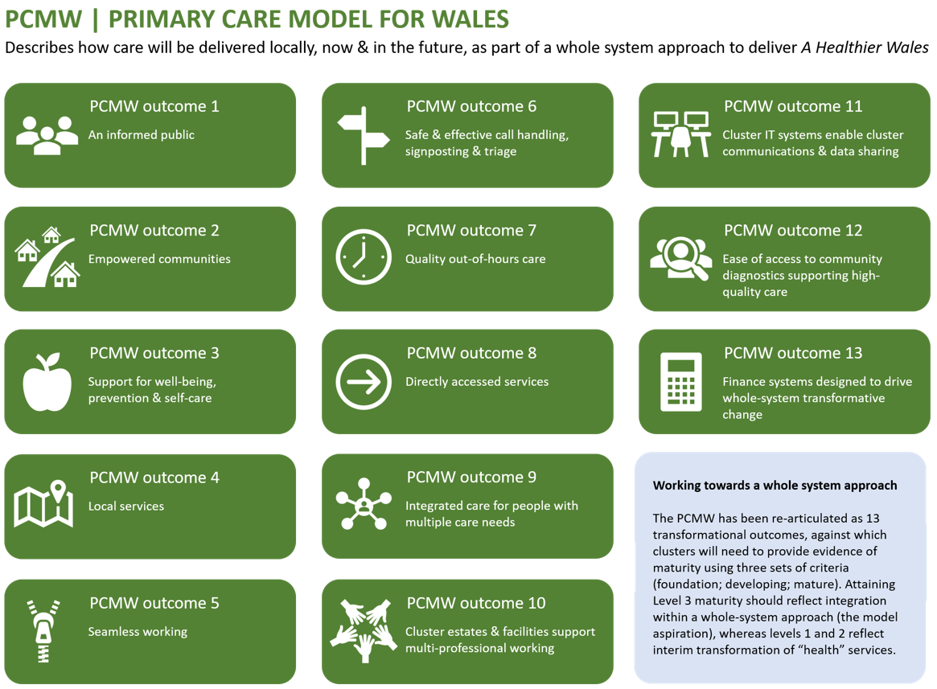

NHS Confederation Briefing Session
‘Placed based care’ in action in Wales
7th July 2022
13:30-14:30
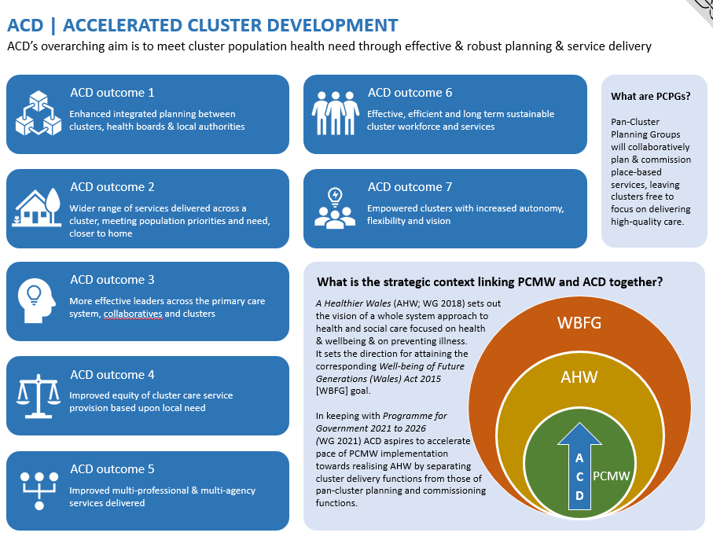

Biographies

Alan Lawrie, National Programme Advisor for Primary Care
Alan Lawrie is National Programme Advisor for Primary Care working with the Strategic Programme for Primary Care. Alan was previously a Chief Operating Officer in Cwm Taf Morgannwg and has over 25 years’ experience as an Executive Director in the NHS across the UK. Alan’s passion is the primary and community care agenda and cluster development is a key part of this moving forward in Wales.

Chiquita Cusens, National Lead Nurse for Primary and Community Care
Chiquita is the National Nursing Lead for Primary & Community Care working with the Strategic Programme for Primary Care. She has extensive clinical and operational experience within community health and social care, identifying new ways of working, developing and transforming services. Chiquita is passionate about the role Nurses have in leading and enabling care for individuals to stay at or close to home, at both an individual, neighbourhood and system level. Chiquita has a special interest in end of life care, previously leading and supporting community services to achieve outstanding (CQC) for end of life care.

Dr Karen Gully, National Professional Advisor
Karen qualified from Bristol University and was a GP partner in a practice in Hereford. She gained membership of the Faculty of Public Health before joining Caerphilly Teaching Health Board as Medical Director. In 2008 Karen joined Welsh Government as a Senior Medical Officer providing professional advice in relation General Practice and Primary Care. This included the development of the policy to establish collaborative primary and community care services through Cluster networks. She was Medical Director in Powys Teaching Health Board before joining ABUHB to lead the further development of Neighbourhood Care Networks and subsequently to coordinate the primary and community care response to the COVID 19 Pandemic. Karen has joined the SPPC as a National Professional Advisor and she continues to provide professional advice to the Post COVID Recovery Programme in ABUHB.

Kerrie Phipps, National AHP lead for Primary and Community Care
Kerrie provides professional leadership and expert strategic advice, on a national basis, relating to the role of AHPs working across Primary and Community Care, in line with the vision of A Healthier Wales, the Strategic Programme for Primary Care and the AHP Framework in Wales – ‘Looking Forward Together.

Her role focuses on optimising the AHPs offer and accessibility across Primary and Community Care, in order to support a preventative, pro-active whole system pathway approach to recovery and rehabilitation provision, which prioritises services at or close to home and enables citizens throughout Wales to live as independently as possible for as long as possible.
Kerrie has over 30 years of experience working across health and social care and is passionate about AHPs utilising their unique skillset to support presenting needs, delivering person-centred support within a place-based care model of care. She is a leader committed to creating a culture of compassionate care, inspiring greater collaboration to bring positive, inclusive and productive transformation.

Sarah McCarty, Director of Improvement and Development
Sarah began her career as a youth worker in Wales. She worked in a variety of statutory and voluntary settings in particular with vulnerable young people, and in supporting young people’s participation. She was a founding member of the then Children and Young People’s Welsh Assembly and went on to hold positions in local authorities in youth work and wider business planning, and service improvement, supported by a Masters in Strategic Management.

Sarah went on to become Executive Director of Skills for Care and Development where she worked for the UK wide partnership from 2005. She became Director in 2008 and expanding the work of the Sector Skills Council to address a wide range of workforce challenges faced by the sector. During this time she also volunteered as a Chair of a Charity supporting young people as well as being an independent visitor.

Sarah joined Social Care Wales as Director in April 2016. She is keen to bring her experience and expertise in partnership working, supporting improvement and workforce development. Sarah has become a Welsh language learner and is looking forward to putting this learning into practice.

Sue Morgan, National Director & Strategic Programme Lead for Primary & Community Care
The role of National Director & Strategic Programme Lead for Primary & Community Care in Wales works as a bridge between Welsh Government and the NHS. The focus of the role is to drive the implementation of the Primary Care Model for Wales through the development and implementation of the Strategic Programme for Primary Care.

Sue has 25 years of NHS management experience that includes operational management, service planning, commissioning and programme management across a number of different NHS organisations in Wales. Before moving to her current role, Sue was Director of Operations for Primary and Community Care Services in Cardiff & Vale University Health Board, which saw the challenges of GMS sustainability alongside the drive to transform whole system care to be delivered as close of home as possible. Prior to that Sue headed up Women and Children Services which, in addition to general management of those services, also included the planning and commissioning of the Children’s Hospital for Wales. Both roles involved working across organisations at a regional and national level and with other partners such as professional bodies, Local Authorities, the Independent Sector and the Third Sector. Sue’s early career was in operational management in secondary care and NHS service planning.

Will Beer, Assistant Divisional Director, Primary & Community Care, Aneurin Bevan University Health Board
Will is a Consultant in Public Health within Aneurin Bevan University Health Board having held various posts in South Wales since 1998. He completed a Master’s in Public Health at the University of the West of England and became a Member of the Faculty of Public Health in 2016. Will is leading on Integrated Well-being Networks as part of the Transformation programme in ABUHB funded by Welsh Government. He is passionate about community orientated approaches to health improvement and the role of primary care clusters in working collaboratively to plan and deliver services locally. Will was the Cluster Lead for Newport East Neighbourhood Care Network until 2021. In Spring 2022 Will took up a new post of Assistant Divisional Director, Primary & Community Care, Aneurin Bevan University Health Board and is leading the delivery of the Accelerated Cluster Development Programme across Aneurin Bevan University Health Board.

