

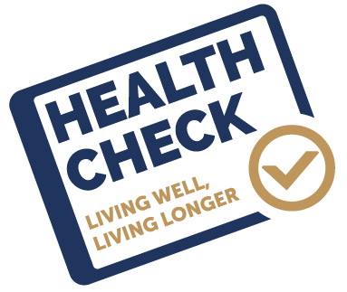

Inverse Care Law Programme
Update Report

Dr Alice Puchades & Sara Thomas
Published June 2022

Executive Summary
This report has been prepared on behalf of the Prevention and Well-being Workstream of the Primary Care Strategic Programme. It provides a review of the Inverse Care Law (ICL) Programme in Wales which was previously overseen by the Inverse Care Law Programme Development Board and the National Inverse Care Law Programme Board. It is an update to a 2019 companion report which is available here: https://primarycareone.nhs.wales/files/sharing-practice/icl-prog-final-report-v12-sept-2019-pdf/.
- The ICL Programme aims to improve the prevention and management of chronic conditions and reduce premature mortality by offering a cardiovascular disease risk assessments (CVRA) also referred to as a “heath check” to eligible people, targeting more deprived communities with highest risk of cardiovascular disease (CVD).

- The Inverse Care Law (ICL) Programme of cardiovascular disease risk assessments (CVRA) commenced in Aneurin Bevan (AB) and Cwm Taf (CT) University Health Boards (UHBs) in 2015. Whilst having a shared objective of reducing health inequalities, the models in AB and CT differed with regard their eligibility criteria, method of selection, CVRA software and venue of CVRA delivery - local community venues in AB and patients’ general practice in the CT model. Please see table 1 pages 29-32 of the 2019 companion report (linked above) for full information on the different models used in AB and CT.

- As part of a national programme roll-out, pilot CVRA projects were also established in Hywel Dda (HD) and Abertawe Bro Morgannwg (ABM) UHBs from 2016-2018, based on the AB community venue model. The ABM pilot in Bridgend North cluster was paused and restarted as a general practice delivery model when UHB boundaries changed and the cluster transferred to the newly created Cwm Taf Morgannwg (CTM) UHB in April 2019.

- Eligible General Practitioner (GP) registered patients (aged 40-74 in CT and 40-64 in AB), not otherwise known to have CVD were invited to attend a CVRA with a trained Health Care Support Worker (HCSW). During the face to face consultation, a 10-year risk of a cardiovascular event (QRisk2 score) was calculated from measurements taken (BMI, BP, HbA1c, pulse, Lipids and Cholesterol) and information provided by the individual (family history, smoking status, physical activity, alcohol consumption); the results were discussed with the patient together with advice given on how to reduce the risk and any support available to achieve this.

- Whilst the main focus of the CVRA was lifestyle risk reduction, the Health Care Support Worker also undertook measurements for clinical risk factors, which triggered clinical referral to Primary Care if indicated.

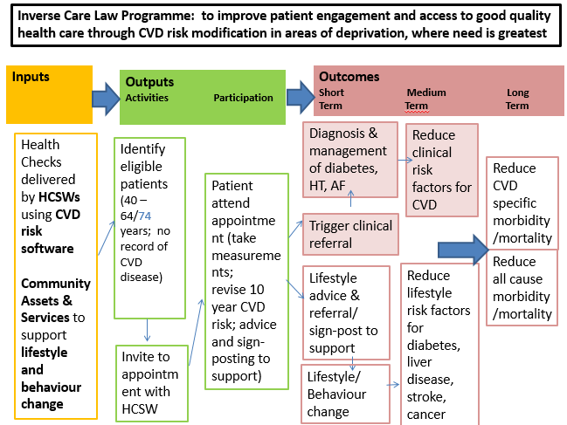
Figure 1: Logic Model of ICL CVRA Programme

- The COVID-19 pandemic paused both the ICL CVRA programme patient-facing activity, and also the work on the ICL programme update report including the review of the published evidence and SAIL data analysis in March 2020. Work on the ICL Programme update report was restarted in Autumn 2020 following this delay, and CVRA health checks restarted in CTM in August 2021.

- A previous report on the ICL Programme for the period 2013-2018 was produced for Welsh Government in 2019 and contained three recommendations, which form the basis of this update report. The recommendations were:

  - Recommendation1:
Establish a detailed next phase of the national Inverse Care Law Programme in Wales that consolidates the model based on the valuable learning to date; the re-focused programme will inform the Primary Care Strategic Programme and contribute to the realisation of the prevention vision set out in a Healthier Wales.

  - Recommendation 2:
Explore the challenges posed by the evaluation of the programme with particular focus on addressing the weaknesses in the data architecture underpinning the programme.

  - Recommendation 3:
Explore opportunities for health economic evaluation of the programme and longitudinal research drawing on the strength of the SAIL Databank.

This update report includes:
  - A review of the published international evidence for CVD health check programmes.
  - Analysis of programme data from 2013-2019 held in the SAIL Databank where available for AB, CT and Bridgend.
  - Reflections on the ICL Programme from both AB and CTM UHBs.
  - Key learning points and Conclusions.

Evidence Review
- The evidence review was mainly based on studies which examined the NHS Health Check (NHSHC) Programme in England, as they made up the majority of the published evidence. The NHS England model differs in that it is a universal health check programme and is not targeted to reduce health inequalities in deprived communities.

- The review found that the evidence is not clear on the impacts or optimum model for CVD health check programmes:
  - It is not clear if CVD health check programmes have health benefits to people that attend them, with mixed results on their clinical benefits including diagnosis of CVD risk factors, treatment of CVD risk factors, diagnosis of CVD and mortality.
  - However, it is worth noting that whist there is no evidence for the health benefits of CVD health check programmes themselves, the clinical and lifestyle interventions which occur following a CVD health check are evidence-based and informed by NICE guidance.
  - Modelling studies found that it is unclear if CVD health check programmes have a positive health economic impact, although it is likely that programmes that target higher risk or more deprived groups are more cost-effective. However, these modelling studies found that CVD health check programmes still may not be cost-effective when considering the opportunity cost of running a CVD health check programme at the expense of other medical or social care activities.
  - There was no evidence which specifically examined whether CVD health check programmes could address health inequalities.
  - Most studies show that women and older people have a higher uptake of CVD health check programmes, with some evidence that people who attend NHS England health checks are healthier than people who are invited but do not to attend.

- There is debate around the eligibility criteria, with some studies stating that CVD screening programmes should not solely target older people as age is not a modifiable risk factor, with others demonstrating that programmes with a higher age threshold, or which have eligibility criteria to include people with pre-existing conditions such as hypertension, have the greatest population health gains due to increased identification and treatment of risk factors and clinical conditions.

- There is no conclusive evidence on the venue for health checks or the preferred CVD risk calculation tool.

- There needs to be consistent clinical and lifestyle follow-up after a CVD health check in order to improve the health impacts of CVD health check programme. This includes medical follow up of clinical risk factors to start medication as appropriate, and consistent and adequately funded lifestyle management programmes. However, even with appropriate clinical and lifestyle follow-up, there is no conclusive evidence on the population health benefits and economic impact of CVD health check programmes.

- Further research is needed into different CVD health check models to assess their health and economic impacts.

SAIL Data Analysis
- The Secure Anonymised Information Linkage (SAIL) Databank project and data analysis presented in this update report was designed in consultation between Public Health, Primary Care, and Swansea University SAIL teams, building on previous analyses undertaken on this programme’s data and an enhanced understanding of data flows. New cascades outlining the stages for moving through the CVRA to lifestyle/ clinical follow-up were created, and used in a revised protocol for the SAIL analysis which was completed in January 2020.

- There were some issues with the data flows and completeness of the primary care data within the SAIL Databank, particularly for AB and Bridgend (BRID) which necessitated additional steps and/ or impacted on the analyses that could be undertaken:

  - Data extracted from primary care records into SAIL for CVRA and subsequent clinical activity data in CT was used in the analyses as it was deemed sufficiently complete when compared to programme data collected locally. This was not the case in AB where invitation and attendance data had to be separately imported from the commercial software system employed in the community CVRAs. It was not possible due to staff redeployment to COVID-19 response to undertake the additional work required to also obtain the necessary clinical activity data from primary care records to complete the clinical and lifestyle cascade analyses extraction for AB.

  - There were inconsistencies in BRID data, particularly around invites and uptake data. There was no means of retrospectively correcting this for the analyses.

- This means that the SAIL analyses presented in this report uses:
  - Data from AB, CT and BRID for attendance at CVRA.
  - Data from AB and CT for uptake, but not BRID.
  - Data on the clinical and lifestyle cascades for CT only.

Eligible, invited, attended and uptake
- 10.5% of people in AB, CT and BRID who would have been eligible for a CVRA based on their age and GP registered location were ineligible due to pre-existing cardiovascular related conditions.

- Ineligibility due to pre-existing cardiovascular related conditions was statistically significantly higher in BRID and CT at 13% (95% CI 12.5-13.5%) and 11% (95% CI 10.8-11.2%) respectively, compared to AB which had 9.4% (95% CI 9.2-9.6%) of people ineligible due to pre-existing conditions. This is likely to be partly due to the different eligibility criteria, with people up until 74 being eligible in CT compared to 64 in AB.

- The reach of the ICL programme was defined as:
The number of people who attended an ICL Health Check /
The number of people who were eligible for an ICL Health Check

- The reach of the CVRA in AB and CT programmes combined was 13.6%.

- The uptake of the ICL programme was defined as:
The number of people who attended an ICL Health Check /
The number of people who were invited to an ICL Health Check

- The uptake of the CVRA in the AB and CT programmes combined was 49.2%.

- The uptake was statistically significantly higher in AB at 50.7% (95% CI 50.1-51.3) compared to 47.7% (95% CI 47.0-48.3) uptake in CT. There could be many reasons for this, but this could be potentially due to their different delivery models.

- 74.9% who attended CVRA across AB, CT and BRID lived in quintiles 1 (most deprived) and 2 (next most deprived). This is in line with the aim of the ICL programme, to target deprived areas as a means of reducing health inequalities.

- Uptake for eligible people living in the three most deprived quintiles (Q1, 2 and 3) was over 45% in AB and CT. Uptake in AB, which specifically targets people living in Q1 and Q2, was highest in Q1 and Q2. Uptake in CT, which did not specifically target people living in the most deprived quintiles, but reflected deprivation in its pre-CVRA QRISK2 estimate approach was highest in Q3 and 4.

- Uptake for CT and AB combined increased with age, from a 43.9% uptake in 40-44 year olds to a 71.2% uptake in 70-74 year olds, which is consistent with findings from other studies.

- However, the number of people who attended a CVRA was highest in the 45-49-year-old age groups. 4,332 people aged 45-49 in AB and CT attended a CVRA out of 9,273 people who were invited, and uptake of 46.7%. This is because many more people were invited and attended in this age group, even though the uptake was lower.

- Uptake was statistically significantly higher in women at 52% than men at 46.7% for AB and CT combined.
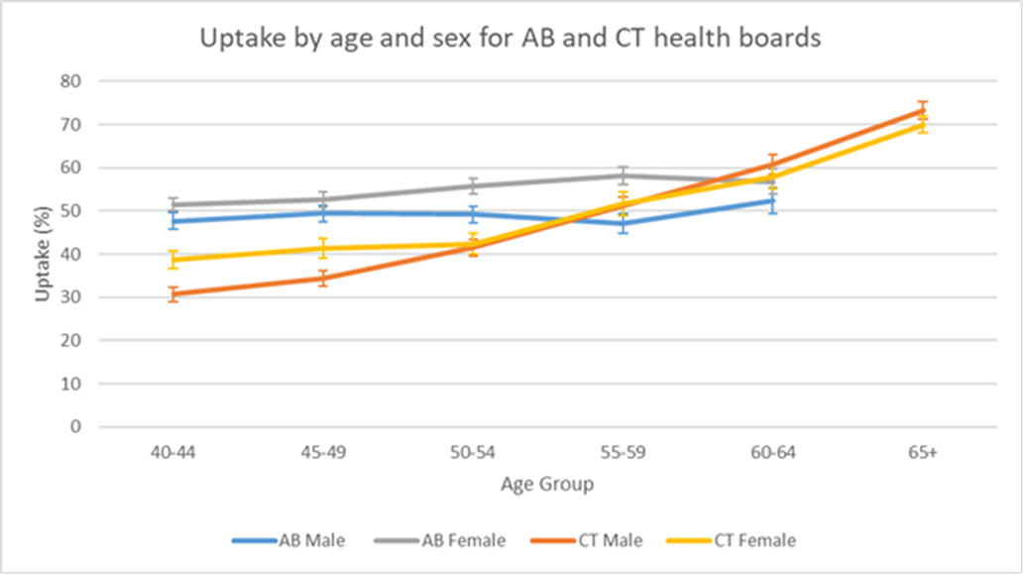
Figure 2: Uptake by age and sex for AB and CT

- Both AB and CT health boards show a general pattern of increasing uptake with age for both men and women. This is less marked in AB than CT. The uptake was higher in younger people in AB.

Clinical cascades
The SAIL data analysis included examinations of cascades for the identification and management of both clinical and lifestyle risk factors. Data available for CT only.
There were five clinical cascades:
- Management of high QRISK2 score.
- Management of raised HbA1c / raised blood sugar and pre-diabetes.
- Management of raised blood pressure / hypertension.
- Management of elevated cholesterol / hypercholesterolaemia.
- Management of irregular pulse / atrial fibrillation.
 |  | Attended Health Check | QRISK2 10-20% | QRISK2 >20% | HbA1c 42-47 | HbA1c >=48 | Raised blood pressure | Total cholesterol >7.5 | Cholesterol HDL ratio >6 | Irregular pulse
CT | n | 11,414 | 4,488 | 1,702 | 1,087 | 246 | 3,759 | 93 | 987 | 249
CT | % | N/A | 39.3 (38.4-40.2) | 14.9 (14.3-15.6) | 9.5 (9.0-10.1) | 2.2 (1.9-2.4) | 32.9 (32.1-33.8) | 0.8 (0.7-1.0) | 8.6 (8.2-9.2) | 2.2 (1.9-2.5)
Table 1: Summary of number and percentage of clinical risk factors identified at ICL Health Check in CT
- 39.3% of people who attended a CVRA in CT had a QRISK2 score (risk of cardiovascular event in next 10 years) of 10-20% and 14.9% had a QRISK2 >20%. This means that over half (54.2%) had an elevated QRISK2 of either 10-20% or >20% which demonstrates that the majority of people attending for CVRA have an elevated risk of CVD and substantial potential to benefit from intervention.

- The most common individual clinical risk factors identified at health check in CT was raised blood pressure (32.9%).

- The least common clinical risk factors identified at health check in CT were total cholesterol >7.5 (0.8%), HbA1c >=48 (2.2%) and irregular pulse (2.2%).

 |  | Attended Health Check | QRISK2 10-20% and started statin 12 months | QRISK2 >20% and started statin 12 months | HbA1c >=48 and diagnosed diabetes 12 months | Raised blood pressure and started anti-HTN 12 months | Total cholesterol >7.5 and diagnosed FH 12 months | Cholesterol HDL ratio >6 or total cholesterol >7.5 and started statin 12 months | Irregular pulse and diagnosed AF 3 months
CT | n | 11,414 | 611 | 383 | 130 | 416 | <5 | 240 | 14
CT | % | N/A | 5.4 (5.0-5.8) | 3.4 (3.0-3.7) | 1.1 (1.0-1.4) | 3.6 (3.3-4.0) | N/A | 2.1 (1.9-2.4) | 0.1 (0.1-0.2)
Table 2: Summary of number and percentage of clinical outcomes identified following an ICL health check in CT

- The most common clinical outcomes identified following a health check were elevated QRISK2 10-20% and started on statin (5.4%) and raised blood pressure and started on anti-hypertensive medication (anti-HTN) (3.6%).

- The least common clinical outcomes identified following a health check were raised total cholesterol >7.5 and diagnosed with familial hypercholesterolemia (FH) (N/A due to <5 people having clinical outcome) irregular pulse and diagnosed with AF within 3 months (0.1%).

- This indicates that some clinical risk factors that are identified at the CVRA are more likely to lead to a clinical diagnosis or medication than other risk factors. This could be because these risk factors are more accurate clinical markers for their relevant condition, these risk factors or conditions are more likely to require medication, or because of informed patient choice to accept medication for these conditions.

Lifestyle cascades
There were four lifestyle cascades:
- Smoking and smoking cessation.
- Overweight or obese and weight management.
- Physical inactivity and exercise referral.
- Excess alcohol consumption and alcohol services.

 |  | Attended Health Check | Current Smoker | BMI 25-30 | BMI >30 | Low physical activity | High alcohol Audit >=8 | Very high alcohol Audit >=16
CT | n | 11,414 | 2,323 | 5,085 | 3,782 | 7,855 | 1,987 | 96
CT | % | N/A | 20.4 (19.6-21.1) | 44.6 (43.6-45.5) | 33.1 (32.3-34.0) | 68.8 (68.0-69.7) | 17.4 (16.7-18.1) | 0.8 (0.7-1.0)
Table 3: Summary of lifestyle risk factors identified by Health Checks in CT
- The most common lifestyle risk factors identified were low physical activity (68.8%), BMI 25-30 (44.6%), and BMI >30 (33.1%). 77.7% of people were either overweight or obese.

- 20.4% of people were identified as current smokers. 17.4% were identified as having high alcohol intake (Audit C score >=8) and 0.8% were identified as having a very high alcohol risk Audit C score >=16.

 |  | Attended Health Check | Smoker and given smoking cessation advice | Overweight or obese and given weight management advice | Low physical activity and given physical activity advice | Alcohol audit >=8 and given alcohol advice
CT | n | 11,414 | 2,278 | 7,658 | 7,217 | 1,786
CT | % | N/A | 20.0 (19.2-20.7) | 67.1 (66.2-68.0) | 63.2 (62.3-64.1) | 15.6 (15.0-16.3)
Table 4: Summary of lifestyle advice given following Health Checks by Health Board
- The most common lifestyle advice identified were overweight or obese and given weight management advice (67.1%) and low physical activity and given physical activity advice (63.2%).

- The least common lifestyle advice identified were smoker and given smoking cessation advice (20.0%) and high alcohol (audit >=8) and given alcohol advice (15.6%).

 |  | Attended Health Check | Smoker and smoking cessation referral | Overweight or obese and referred to weight management service | Low physical activity and referred to NERS | Low physical activity and completed NERS* | Alcohol Audit >=16 and referred to alcohol service
CT | n | 11,414 | 1,101 | 947 | 1,678 | 245 | 33
CT | % | N/A | 9.6 (9.1-10.2) | 8.3 (7.8-8.8) | 14.7 (14.1-15.4) | 2.1 (1.9-2.4) | 0.3 (0.2-0.4)
Table 5: Summary of lifestyle programme referral and completion following Health Checks in CT* Data for completing NERS is from NERS dataset which was linked with the ICL dataset in SAIL
- The most common lifestyle programmes referred to were low physical activity and referred to exercise referral programme (14.7%), smoker and referred to smoking cessation (9.6%), and overweight or obese and referred to weight management (8.3%).

- Data from the National Exercise Referral Scheme (NERS) was linked to ICL data in SAIL. This showed that 7.4% of people were referred to NERS, whilst 2.1% completed NERS within 12 months.

- There are multiple reasons why many people who were identified as having a lifestyle risk factor at the CVRA were not recorded as being referred to lifestyle programmes. Only some of the people with the lifestyle risk factor were eligible for lifestyle programme referral, for example there are different referral criteria for specific NERS programmes, based on low levels of physical activity and whether this is combined with other risk factors for chronic disease. There were also limited availability of lifestyle programmes for some risk factors, such as weight management services. People were also able to decline referral to a lifestyle service.

Effect of age, sex and deprivation on clinical and lifestyle cascades

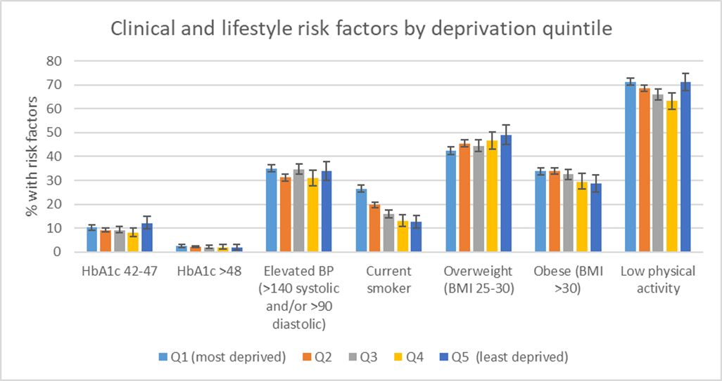
Figure 3: Clinical and lifestyle risk factors by deprivation quintile for CT
- There is a clear relationship between smoking and deprivation quintile, with smoking being statistically significantly higher in people in the most deprived quintiles (Q1 and Q2) compared to the least deprived quintiles (Q4 and Q5). 26.5% of people in Q1 were current smokers compared to 12.5% of people in Q5.

- The proportion of people who were overweight was lowest in Q1 (most deprived) and highest in Q5 (least deprived), whilst the proportion of people who were obese was lowest in Q5 (least deprived) and highest in Q1 (most deprived). However, the difference is only statistically significant between Q1 and Q5 for overweight people, and not statistically significantly different between the different quintiles for obese people.

- There is no clear pattern for the clinical risk factors of elevated HbA1c 42-47 or >48 or elevated BP (>140 systolic and/or >90 diastolic).

- Low physical activity showed a similar relationship of higher levels of physical inactivity in Q1 (most deprived) which slowly decreased to Q4 (second least deprived). However, the highest levels of physical inactivity were in Q5 (least deprived).
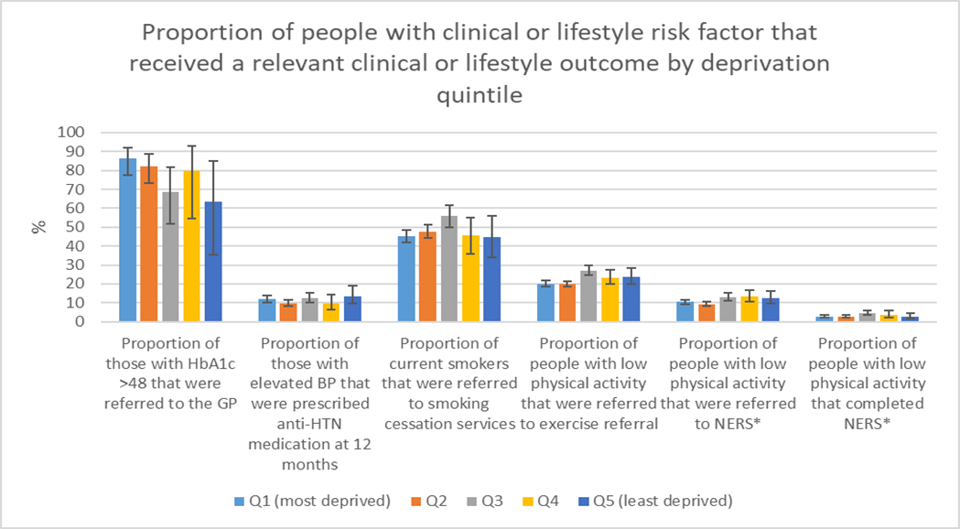
Figure 4: Proportion of people with clinical or lifestyle risk factor that received a relevant clinical or lifestyle outcome by deprivation quintile in CTM
- There is no clear relationship between deprivation quintiles and the proportion of people with any of the clinical or lifestyle risk factors investigated and the relevant clinical or lifestyle outcomes. This highlights, that whilst there are differences in clinical and lifestyle risk factors by deprivation quintile, there is no evidence of an Inverse Care Law for outcomes following the identification of these risk factors.

Key Learning Points
There are a number of Key Learning Points from the “Inverse Care Law Programme Update Report 2021”. Many of these (1-10) were first documented in the 2019 programme update report.
The programme has demonstrated:

- The feasibility and value of utilising an affordable, and readily available and appropriately-trained primary care-based workforce resource to enhance the identification of previously unrecognised CVD risk and signpost into existing lifestyle and/or clinical interventions aiming to modify such risk.

- That many preventive activities that were traditionally performed by registered primary care staff can be successfully taken on by HCSWs (or other similar roles) working within a prudent, robust framework of governance, training and management. The success of this approach has possible application to many other areas of primary care transformation through the primary care strategic programme.

- Successful development and delivery of a social model of CVRA delivered by appropriately trained HCSWs was achieved, providing capability and capacity to GP practices to implement national guidance (NICE CG181) with pace and at scale.

- The ability to link into Clinical Pathways with appropriate clinical governance arrangements.

- Feedback from individuals who attended a CVRA, as reported in previous 2019 report, found that they like the experience, although 50.8% of those invited do not take up the offer, which remains a key area for further exploration.

- The feasibility of undertaking CVRA with full use of software in GP practice premises, other health care settings and community venues with minimal difference in uptake, but sufficient to warrant further exploration.

- That models developed in one health board can be adapted and implemented successfully in other health boards. However, the imperative to roll out the programme before a full evaluation had been conducted meant that opportunities were missed to strengthen the programme at its foundation and in its linkages with services/initiatives aimed at changing disease risk.

- Development of a range of products:
  - Training programmes and operational manuals for Health Care Support Workers undertaking CVRA in conjunction with the British Heart Foundation (BHF).
  - CVRA Software tailored for Wales – for use in both Practice and Community settings
  - Publicity and patient materials

- Primary care and public health working together with wider partners with shared objective of improving population health; providing opportunity for practices to make contact with patients who otherwise wouldn’t attend the surgery or take interest in their health and wellbeing; providing additional capacity to practices enabled them to take an active interest in CVD prevention and social referral.

- The availability of services to support lifestyle change is key – lack of low level weight management support service is a serious concern. This will hopefully improve moving forward due to the significant national investment in the All Wales Weight Management Pathway and the All Wales Diabetes Prevention Pathway.

Evaluation

The literature review, which was predominantly based on studies of the NHSHC in England, showed that:

- Overall the published evidence is not clear on the impacts or optimum model for CVD health check programmes.

- It is not clear if CVD health check programmes have health benefits to people that attend them, with mixed results on their clinical benefits including diagnosis of CVD risk factors, treatment of CVD risk factors, diagnosis of CVD and mortality.

- It is also unclear if they have a positive health economic impact, although it is likely that programmes that target higher risk or more deprived groups are more cost-effective. However, they still may not be cost-effective when considering the opportunity cost of running a CVD screening programme at the expense of other medical or social care activities.

- The literature review did not find any evidence on the effect of CVD health check programmes on health inequalities.

- There is also mixed evidence around an optimum model for CVD screening programme, including the eligible population, location, clinical and lifestyle follow-up.

- There is debate around the eligibility criteria, with some studies stating that screening programmes should not solely target older people as age is not a modifiable risk factor, with others demonstrating that programmes with a higher age threshold, or which have eligibility criteria to include people with pre-existing conditions such as hypertension, have the greatest population health gains due to increased identification and treatment of risk factors and clinical conditions.

- Studies into clinical and lifestyle follow up highlight the need for consistent follow-up after a CVD health check in order to improve the health impacts of CVD health check programme. This includes medical follow up of clinical risk factors to start medication as appropriate, and consistent and adequately funded lifestyle management programmes. However, even with appropriate clinical and lifestyle follow-up there is no conclusive evidence on the population health benefits and economic impact of CVD health check programmes.

- Further research is needed into different CVD screening models to assess their health and economic impacts.

The ICL programme SAIL Analyses:

- Provided a unique experience of using SAIL to evaluate a complex intervention where:
  - Parallel local monitoring of data provided comparison between SAIL and local data.
  - Data governance agreement with practices and data transmission posed challenges, which were exacerbated by staff being redeployed during the COVID pandemic.
  - The operation of the ICL health check programme varied between health boards and developed over time, adding to the complexity of evaluating the programme.
  - The evaluation was led by the Public Health and Swansea University SAIL team, with input from GPs and the ICL health check teams. This has allowed for greater insight into what happens during and following a health check, and has made for a better informed data extraction and analyses. However, it is acknowledged that the SAIL analyses could have further benefited from Clinical Informatics input throughout its duration.

- The ICL programme delivered in excess of 23,000 cardiovascular risk assessments between February 2015 and December 2019.

- The ICL programme successfully targeted inverse care by reaching more deprived populations, 74.9% patients attending CVRA across AB, CT and BRID lived in quintiles 1 (most deprived) and 2 (next most deprived).

- Uptake was statistically significantly higher for people aged 45-54 in AB, which uses community venues with extended opening hours for CVRA, compared to CT which uses GP venues. This may suggest that community venues with more flexible appointments may be preferable to people in younger age groups.

- Over half the people that attended a CVRA had increased risk of CVD as measured by their QRISK2 score. This indicates that the ICL Programme is targeting a higher risk population for CVD risk, and the importance of ensuring that appropriate and up-to-date data is held to accurately assess CVD risk in the population.

- The ICL CVRA identified lifestyle and clinical risk factors and the Health Care Support Worker provided lifestyle advice, directing patients to further clinical or lifestyle follow-up accordingly. However, the SAIL analyses highlighted inconsistency in the follow-up of lifestyle and clinical risk factors, and the implementation decay of the ICL Programme. The majority of people who were identified as having a lifestyle risk factor as determined by the risk assessment tools used in the CVRA were not documented as being referred to a lifestyle service at the time of the CVRA. There could be many reasons for this:
- the risk factor or referral not being appropriately recorded during the CVRA
- the person declining referral to the lifestyle service.
- the person not being eligible for lifestyle services (i.e. not meeting referral criteria). Also there could be inadequate lifestyle support provision available, which was found to be the case for weight management support during the study period.

- At this current time, we are not able to capture the results /risk modification outcomes from lifestyle referrals and activity in SAIL including;
- Weight loss following referral to and participation in a weight management programme
- Number of people who have quit smoking following referral to Help Me Quit or other programmes including Community Pharmacy and self-help
- Whilst data from the NERS database was able to report engagement with and completion of NERS programme we were not able to capture increased physical activity/weight loss following referral and participation in the NERS programme or other local programme.
The data linkage to these data sources held by PHW were hampered by governance issues which could not be resolved in the necessary timeframe for data analysis.

- Ultimately the evaluation did not have sufficient longitudinal data to demonstrate whether the ICL programme successfully modified risk or impacted health inequalities that arise from CVD mortality at a population level. There is a case for the continuation of the ICL programme with extended evaluation. Longitudinal outcome data at individual patient level (using SAIL) and population level (using routinely published data) would be required to be examined to establish whether the programme has successfully modified risk of CVD and led to reduced CVD (and all cause) morbidity and mortality.

Conclusions
Health Inequalities and Programme design

- All Lifestyle and clinical intervention programmes should consider their impact on health inequalities.
- In designing and developing an equitable intervention delivery model this would include consideration of:
  - Targeting the intervention to those with greater need rather than universal offer;
  - Making the intervention more accessible to the target groups by addressing barriers to uptake e.g. by offering flexible appointments in suitable venues that enable extended hours of operation, identifying and meeting specific needs of local populations

- The CVRA in its current form provides a tested case-finding model for a range of cardiovascular conditions and their risk factors. There should be a full exploration of how the CVRA model developed in the ICL programme could provide an integrated and co-ordinated approach to case-finding for programmes targeting diabetes prevention (AWDPP) and stroke prevention (through identification and management of atrial fibrillation and hypertension).
- The application of the model could be extended to a wider basket of chronic conditions and their risk factors. This warrants further exploration.
- Where programmes continue to use the CVRA model or similar case-finding approach, the learning should be captured and shared.
- When designing lifestyle and clinical interventions, attention should be given to the availability of services to support the identified needs of individuals

Cardiovascular Risk Assessment
- To deliver the CVRA model as a method of case finding, at scale across Wales, due regard should be given to the learning from this programme and ongoing best evidence from other models. This must include the following system considerations:
  - Availability of lifestyle and clinical support for individuals identified with cardiovascular risk at CVRA. Essential to undertake early mapping of the available lifestyle risk modification services post CVRA and address any critical gaps in provision, particularly weight management
  - Clear pathways for accessing non-medical support and connecting to communities through social prescribing
  - A comprehensive financial framework to support the delivery of the programme in various settings including primary care
  - Design, functionality and availability of CVRA Software that can interact fully/ be integrated with the patient record held in Primary Care Clinical Systems
  - Training of HCSW staff
  - Robust monitoring of outcomes and evaluation
  - Scope to reflect in the model additional population health challenges post-COVID-19 including capacity in primary care

Programme Evaluation
- Evaluations of complex interventions should have a clear programme level oversight structure to ensure fidelity to the original plan and allow for consistent communication and feedback loops between teams leading on programme delivery and evaluation
- Plans for programme evaluation should be clearly defined at the outset giving due consideration to the outcomes to be measured, data required and complexity of model. Particular attention must be given to complex interventions, where multiple models are being evaluated or where the model is likely to change over time.
- There should be robust and consistent engagement with stakeholders to secure their input into the design, delivery, monitoring and evaluation of such programme.

Acronyms
AB: Aneurin Bevan University Health Board
ABM: Abertawe Bro Morgannwg University Health Board
AF: Atrial Fibrillation
BMI: Body Mass Index
BP: Blood Pressure
BRID: Bridgend
CCG: Clinical Commissioning Group
CT: Cwm Taf University Health Board
CTM: Cwm Taf Morgannwg University Health Board
CVD: Cardiovascular Disease
CVRA: Cardiovascular Risk Assessment
FH: Familial Hypercholesterolaemia
GP: General Practitioner
HCSW: Healthcare Support Worker
HD: Hywel Dda University Health Board
HDL: High-Density Lipoprotein
HTN: Hypertension
ICER: Incremental Cost-Effectiveness Ratio
ICL: Inverse Care Law
IMD: Indices of Multiple Deprivation
MI: Myocardial Infarction
NERS: National Exercise Referral Service
NHSHC: NHS Health Check
NRT: Nicotine Replacement Therapy
PREMS: Patient Reported Experience Measure
QALY: Quality Adjusted Life Year
SAIL: Secure Anonymised Information Linkage
TIA: Transient Ischaemic Attack
UHB: University Health Board
WIMD: Welsh Index Multiple Deprivation
Contents

Executive Summary 2
Chapter 1: Introduction 21
Chapter 2: Update on the ICL Programme and the Impact of COVID-19 23
Chapter 3: Evidence Review of Cardiovascular Disease Health Checks 29
Chapter 4: SAIL Databank analysis (2013-2019) 44
Data analysis headlines 47
Uptake and reach of the programme 54
Clinical cascades and lifestyle cascades 72
Chapter 5: Reflections on the ICL Programme 107
Chapter 6: Key Learning Points 117
Chapter 7: Conclusions 121
References 124

Chapter 1: Introduction

This report is an update on the “Inverse Care Law Programme 2013-2018 Update Report”, which was submitted to Welsh Government in September 2019.
The “Inverse Care Law Programme 2013-2018 Update Report” included background information on the rationale, design and implementation of the Inverse Care Law (ICL) Programme of Cardiovascular Disease (CVD) Health Checks pioneered in Aneurin Bevan (AB), Cwm Taf (CT) University Health Boards, and further pilot sites in Abertawe Bro Morgannwg (ABM) and Hywel Dda (HD) University Health Boards. It included an examination of the internal ICL Programme data and Secure Anonymised Information Linkage (SAIL) Databank on the uptake and outcomes of the programme from 2015- May 2018, and highlighted limitations and challenges presented by the data flows. There was also information on the qualitative evaluation work that has been undertaken for the ICL Programme. Please refer to the “Inverse Care Law Programme 2013-2018 Update Report” for this background and contextual information Insert hyperlink here

The ICL Update Report 2013-2018 made three recommendations:
Recommendation1:
Establish a detailed next phase of the national Inverse Care Law Programme in Wales that consolidates the model based on the valuable learning to date; the re-focused programme will inform the Primary Care Strategic Programme and contribute to the realisation of the prevention vision set out in a Healthier Wales.

Recommendation 2:
Explore the challenges posed by the evaluation of the programme with particular focus on addressing the weaknesses in the data architecture underpinning the programme.

Recommendation 3:
Explore opportunities for health economic evaluation of the programme and longitudinal research drawing on the strength of the SAIL Databank.

This report provides an update of the ICL Programme with reference to the recommendations of the previous “Inverse Care Law Programme 2013-2018 Update Report”. It includes the findings from and analysis of programme data (to December 2019) within the SAIL Databank, an evidence review of the published literature and the impact of COVID on the delivery and evaluation of the ICL Programme. It gathers learning and draws conclusions from the programme.

Structure of the Report
The report will follow the structure outlined below:
Chapter 1: Introduction.
Chapter 2: Update on the ICL Programme and impact of COVID-19.
Chapter 3: Evidence Review of Cardiovascular Health Check Programmes.
Chapter 4: SAIL data analysis (2013-2019).
Chapter 5: Reflections on the ICL Programme.
Chapter 6: Key Learning Points.
Chapter 7: Conclusions.

Chapter 2: Update on the ICL Programme and the Impact of COVID-19
Update on the ICL Programme
ICL Programme 2013-2018
There have been significant changes to the ICL Programme since its design in 2013 and introduction in 2015. The previous report (https://primarycareone.nhs.wales/files/sharing-practice/icl-prog-final-report-v12-sept-2019-pdf/) outlined the initial rationale and model for the ICL programme, as well as summarising the learning from the ICL Programme up until 2018. This included a timeline for the ICL Programme from 2013-2018, which has been included as a summary below.
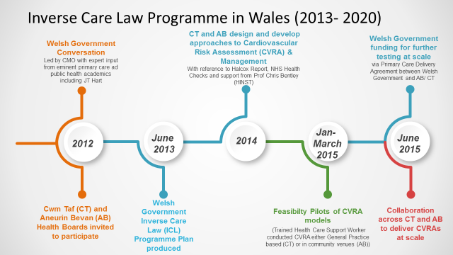
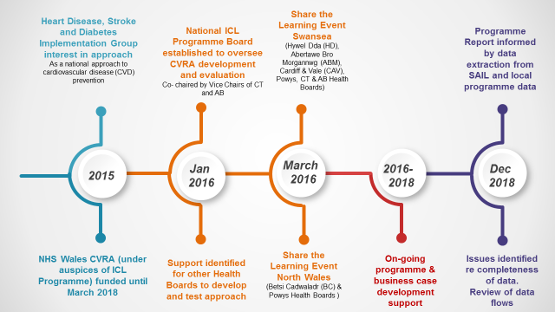
Figure 5: Timeline of ICL Programme 2013-2018
ICL Programme 2019- 2020
The progress of the programme since 2018 is summarised below.
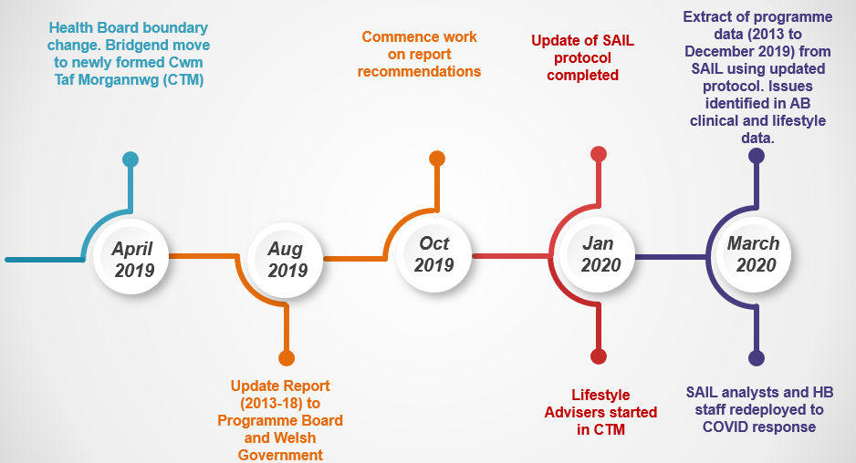
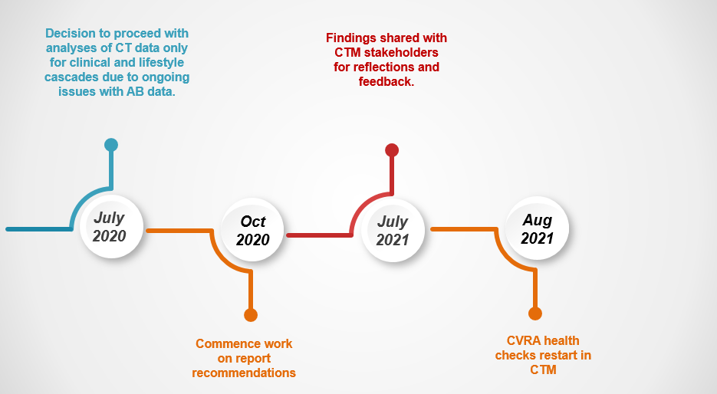
Figure 6: Timeline of ICL Programme 2019-2020

Update in Aneurin Bevan 2018 – March 2020
The ICL Programme continued to operate in AB, using the branding of Living Well Living Longer (LWLL) Programme until the COVID-19 pandemic in March 2020.

Update in Cwm Taf Morgannwg 2018-March 2020
As noted in the timeline, on 1st April 2019 there were changes to the health board boundaries. In advance of this boundary change, the CVD Health checks in Bridgend North Cluster, which had previously been running as a community model (based on the AB approach and using Health Diagnostics software), changed to the CT Primary Care based model using Informatica software.
To complete the coverage of CT, the latter stages of the programme was rolled out to the Taf Ely Cluster which covers predominantly more affluent areas of CT with pockets of deprivation. In order to continue with the ICL Programme’s key aim of reducing health inequalities, the cluster agreed to prioritise resource and target patients with elevated pre-estimated QRISK2 score living in the most deprived quintiles (Q1 and Q2).
A rapid internal review of the Cwm Taf Health check service was undertaken in November 2018 with a follow up in 2019. This identified that there were areas of concern with the lifestyle and clinical follow up after an individual had attended a CVRA. Some individuals who were identified as having clinical risk factors were not following up with the GP as advised. It is not known why individuals were not being followed up by GPs, but is possible that some GP surgeries and individuals were not pursuing active follow-up. Some individuals who were identified as having lifestyle risk factors which needed addressing were not attending lifestyle management services that were available on referral, and it was not known whether they were undertaking independent lifestyle changes.
Following this review, a new lifestyle adviser service was created, which aimed to support individuals who were identified as having lifestyle risk factors for a period of 6 months to work towards managing their risk and improving their health goals. There were plans to evaluate the service over the 6-month period to measure consistent, long-term outcomes for the individuals undertaking the programme.
The lifestyle adviser service was introduced in January 2020 following a period of training. 54 individuals were referred to the service before March 2020 when the ICL Programme was paused due to COVID. The individuals who were referred to the lifestyle adviser service were offered virtual support but lifestyle referral services in the community were limited. Early indication of outcomes of the lifestyle advisor service were promising showing increase in physical activity scores, weight loss and wellbeing. However, due to COVID the planned 6-month intervention and evaluation were not possible.

Update on pilot programmes (2016-18)
Pilots of the ICL Programme were started in ABM and HD UHBs. The funding that had supported the pilots in these health boards ceased in 2018. No further activity was reported in HD, and the ABM pilot site in Bridgend North cluster adopted the CTM primary care delivery model when Bridgend joined the newly formed CTM University Health Board on 1st April 2019.

Impact of COVID-19 on the ICL Programme
The COVID-19 pandemic has had significant impacts on the ICL Programme. Social distancing and stay-at-home national guidance meant that face-to-face health checks were stopped in both AB and CTM in March 2020. The staff who deliver and oversee the ICL Programme in both AB and CTM were redeployed to undertake urgent COVID-19 related work in the Health Boards.

Update in Aneurin Bevan March 2020 onwards
The majority of staff who were working on the ICL Programme in AB have been redeployed to the acute COVID response. AB are currently not operating the ICL Programme but are aiming to restart from April 2022, and are working with the Planning Department to include the plan to restart a re-designed programme in the Annual Plan/IMTP.
AB are exploring the eligibility criteria for the ICL programme, looking at the potential to extend to socially vulnerable groups, and communities disproportionately affected by the pandemic or who have become deconditioned during lockdown such as those who have been shielding or have become increasingly frail and at risk of falls.
They are exploring the potential to develop the pre-diabetes pathway through the Well-being Advisor Service based on the learning from the Afan Valley cluster and national pilot. There will also be new referral routes into community weight management services following investment in the All Wales Obesity Pathway.

Update in Cwm Taf Morgannwg March 2020 onwards
The ICL Programme of CVD Health Checks and Lifestyle Adviser service was paused in March 2020. Both services restarted and have been delivering full face-to-face health checks since August 2021.
The ICL CVD Health Check Programme staff have been involved in delivering a pre-diabetes pilot project in the South Cynon Cluster. This pilot involves offering patients with pre-diabetes a brief lifestyle intervention with a healthcare support worker to offer them clinical and lifestyle risk factor support. The ICL CVD Health Check team have delivered this brief intervention (face to face and virtual) and have seen approximately 600 people for their first pre-diabetes appointment whilst being further redeployed to help with the COVID response. Uptake of this intervention has been higher than anticipated in the circumstances. Early patient outcomes are promising and the evaluation of this pilot is expected to be completed by November 2022.
As a response to there being little activity in communities, at the time, to support behaviour change for this group the team worked closely with a number of private and third sector partners to offer them goal setting and support to make sustained change. The HCSW and Lifestyle Adviser roles were pivotal in supporting patients to understand their condition and patient satisfaction ratings are extremely favourable.
Phase 2 of the South Cynon pre-diabetes pilot involves seeking to identify individuals at increased risk of developing type 2 diabetes that are unaware of this increased risk, and offer them an appointment to assess their risk of developing diabetes plus a HbA1c POCT if appropriate. This is planned to commence in early 2022 and the ICL team has been funded to expand their capacity to deliver these diabetes risk appointments. A key element of this work has been ensuring practice staff are upskilled to undertake the interventions and have had additional training and shadowing opportunities.
The team resumed CVRAs in August 2021 alongside supporting the pre-diabetes pilot and are currently looking to develop the programme in line with the new weight management service, Wellness Improvement Service and Mental Health support.
Future work on the ICL Programme is exploring the strategic vision of the ICL Programme in CTM, including examining how it can align with wider work being undertaken in the HB such as the pre-diabetes programme and a proposed lung health checks. There are plans to review the membership and terms of reference for the ICL Steering Group in CTM, and restart regular meetings to ensure that there is a clear process for implementing future changes to the strategic vision and operation of the programme.

Impact of COVID-19 on the ICL Update Report
The work on the latest ICL update report was started in October 2019 based around the recommendations of the August 2019 report for Welsh Government. It focussed on consolidating learning from the AB and CTM programmes to inform the revised model (Recommendation 1), and improving the use of SAIL data to evaluate the ICL Programme (Recommendations 2 and 3). In March 2020 the work on this report was paused due to acute COVID-19 pressures, with the staff involved in the evaluation from AB and CTM University Health Boards, Public Health Teams and Swansea University SAIL team being redeployed to acute COVID-19 related work.
Work on the SAIL data analyses restarted in Autumn 2020. However, the CVD Health Checks had not resumed in person due to ongoing social distancing measures. Most of the health board and public health staff who operated and oversaw the ICL Programme were still redeployed to COVID-19 related roles or still primarily involved in the acute COVID-19 response. This meant that there were some necessary changes to the planned evaluation beyond the initial delay, such as only using CT data for SAIL lifestyle and clinical cascades due to lack of resources in AB to verify the SAIL output with the internal programme outcome data.

Economic Evaluation
The health economic evaluation work was initially progressed in 2019 following the publication of the “Inverse Care Law Programme 2013-2018 Update Report”. The Health Economics Department of Swansea University were approached to discuss the possibility of a health economic evaluation, including the data required, timescale and cost of undertaking a health economic evaluation. This initial discussion was happening alongside the work with SAIL to redesign the data extraction and analyses protocol for the programme. It was decided that the SAIL evaluation data was required before an economic evaluation could be planned and conducted, as it was necessary to understand exactly what data on the output and outcomes of the ICL Programme was available before being able to plan how this could be incorporated into an economic analysis. The ICL programme and evaluation then paused in March 2020 due to COVID-19 when staff were redeployed to COVID-19 related work.
The ICL evaluation restarted in autumn 2020 following the initial acute COVID-19 response. The initial focus of the ICL evaluation was on completing the final SAIL data extract, and understanding the available data on the uptake, outputs and outcomes of the ICL Programme which is described in detail in Chapter 4. Work was also undertaken to review the evidence base around CVD Health Check Programmes, including the economic evaluation of health check programmes, as part of the Evidence Review outlined in Chapter 3.
Following the completion of the SAIL data report and the evidence review of CVD Health Check Programmes discussions were conducted with a range of stakeholders involved in the ICL Programme and Evaluation about undertaking a potential economic evaluation of the ICL Programme. However, after examining the available data on the output and outcomes of the ICL Programme and comparing to economic evaluations of other CVD Health Check Programmes it was decided that it would not be possible to conduct a robust economic evaluation of the ICL Programme with the data that is currently available. The ICL Programme has also adapted since its creation in 2013, including changes to Health Board boundaries, invitation processes, tests undertaken, and follow up of people with identified risk factors. These changes were implemented at different times in the Health Boards, making it difficult to accurately assess the costs associated with ICL Programme over time. It was felt that any attempt at an economic evaluation using the data that is currently available would be unreliable, and would likely underestimate or overestimate the economic impact of the ICL Programme.
Summary
The ICL Programme in both AB and CTM UHBs have continued to evolve since 2018. Changes include redrawing of health board boundaries and the introduction of new lifestyle adviser services, and disease specific focus on diabetes. The COVID-19 pandemic has also impacted on both the ICL Programme delivery and SAIL analyses since March 2020, with both the programme and evaluation being paused. The ICL programme SAIL analyses restarted in autumn 2020, with changes made to the planned work, based on limitations with data and staff availability. The CVRAs restarted in CTM in August 2021.

Chapter 3: Evidence Review of Cardiovascular Disease Health Checks
Evidence Review
A rapid and light touch review of the published evidence around cardiovascular disease (CVD) health checks was undertaken, and a full report including a detailed methodology and results section was produced. This complete evidence review is included as a supplementary report “Evidence Review of Cardiovascular Disease Health Checks”.
Aim
The aim of the evidence review was to examine the evidence base around CVD health checks, to inform the ICL Programme CVRA /Health Check Model moving forward. This included looking at the evidence around a number of issues including:
- Clinical impact of CVD health check programmes.
- Health economic impact of CVD health check programmes.
- Best features of CVD health check programmes including eligibility criteria, CVD risk assessment tools, clinical follow up and lifestyle follow up.
- Evaluation of CVD health check programmes.
Methodology
The search strategy built on the systematic review conducted by the University of Cambridge Primary Care Unit submitted to Public Health England on 14th January 2017.
The search was limited to free full text only and English language only. The search time frame was from November 2016 to December 2020 to follow on from the previous systematic review. The search was conducted on three search engines:
- Ovid Medline.
- PubMed.
- HDAS PsycInfo.
A range of search terms were used in the search including health check, cardiovascular screen and population screen.
There was no published data for the ICL CVD health check programmes in Wales. Therefore, the review has drawn much of the evidence from the NHS Health Check (NHSHC) programme in England with some additional studies from the US and EU. Health is a devolved issue and there are cultural and population disparities between England and Wales. There are also key differences in the commissioning, eligibility, organisation, and follow-up of clinical and lifestyle risk factors of the NHSHC in England and the CVD Health Check (under auspices of the ICL Programme) in Wales, with the ICL Programme in Wales aiming to provide an integrated model of CVD risk assessment and management within the Welsh context. However, the NHSHC Programme in England remains the most meaningful and beneficial comparator with published studies for the ICL programme in Wales.

Results
The Evidence Review identified 14 studies. Out of these studies:
- 10 contained information on the NHSHC Programme in England.
- 4 did not contain information on the NHSHC Programme in England.

Summary of evidence
This rapid evidence review found mixed evidence on the health impacts, economic impacts, optimum model for a CVD health check programme and evaluation of CVD health check programmes. None of these studies specifically examined the ICL Programme in Wales as there is no published literature on the ICL Programme.
Overall Summary
Overall the evidence is not clear on the impacts or optimum model for CVD health check programmes. It is not clear if CVD health check programmes have health benefits to people that attend them, with mixed results on their clinical benefits including diagnosis of CVD risk factors, treatment of CVD risk factors, diagnosis of CVD and mortality. However, it is worth noting that whist there is no evidence for the health benefits of CVD health check programmes themselves, the clinical and lifestyle interventions which occur following a CVD health check are evidence-based and informed by NICE guidance.
It is also unclear if they have a positive health economic impact, although it is likely that programmes that target higher risk or more deprived groups are more cost-effective. However, they still may not be cost-effective when considering the opportunity cost of running a CVD screening programme at the expense of other medical or social care activities. The evidence review did not find any evidence on the effect of CVD health check programmes on health inequalities.
There is also mixed evidence around an optimum model for CVD screening programme, including the eligible population, location, clinical and lifestyle follow-up. Most studies show that women and older people have a higher uptake of CVD health check programmes, with some evidence that people who attend health checks are healthier than people who are invited but do not to attend. There is debate around the eligibility criteria, with some studies stating that screening programmes should not solely target older people as age is not a modifiable risk factor, with others demonstrating that programmes with a higher age threshold, or which have eligibility criteria to include people with pre-existing conditions such as hypertension, have the greatest population health gains due to increased identification and treatment of risk factors and clinical conditions.
There is no conclusive evidence on the venue for health checks or the CVD risk screening tool. Studies into clinical and lifestyle follow up highlight the need for consistent follow-up after a CVD health check in order to improve the health impacts of CVD health check programme. This includes medical follow up of clinical risk factors to start medication as appropriate, and consistent and adequately funded lifestyle management programmes. However, even with appropriate clinical and lifestyle follow-up there is no conclusive evidence on the population health benefits and economic impact of CVD health check programmes. Further research is needed into different CVD screening models to assess their health and economic impacts.

Health impacts
Six of the studies looked at the health impacts of the CVD health check programmes. These included studies reviewing the NHSHC, other CVD health check programmes and a systematic review of multiple studies. The studies showed mixed evidence of the health impacts of CVD health check programmes. Some studies did not demonstrate a relationship between CVD health check programmes and clinical outcomes including diagnosis of CVD risk factors, CVD, or other disease such as diabetes; management of CVD risk factors; and all-cause mortality. Other studies did demonstrate that people who had attended a CVD health check programme had a higher prevalence of diagnosis of some specific CVD risk factors, CVD or other diseases such as diabetes, or management of CVD risk factors. However, even in these studies the results were often mixed, with statistically significant results for only some risk factors and diseases. Many of the health professionals who were involved in the NHSHC Programme in England had positive opinions about the programme and its benefits to patients, whilst a minority did not feel the programme was beneficial.
Overall, the evidence base shows mixed results for the clinical impacts of CVD health check programmes, including the NHSHC Programme in England. There isn’t a consensus on whether CVD health check programmes do have clinical benefits to patients such as identifying CVD risk factors and diseases, managing risk factors or impacting on all-cause mortality. However, it is worth noting that whist there is no evidence for the health benefits of CVD health check programmes themselves, the clinical and lifestyle interventions which occur following a CVD health check are evidence-based and informed by NICE guidance (NICE 2020).

Economic impacts
Two studies modelled the economic impacts of the NHSHC programme in England against other CVD health check scenarios. They found mixed evidence on the economic impacts of CVD health checks. It is unlikely that the current universal NHSHC programme in England is cost-effective or equitable based on their analyses, but CVD health check programmes which target the most deprived areas are more likely to be cost-effective. However, if you consider the opportunity cost of operating CVD health check programmes, especially if this includes additional support for people in deprived areas on top of universal health checks, it is unlikely that the programmes will be cost-effective. This is because they may involve greater costs, which would otherwise have been spent on other health and social care activity which has a greater return on investment. Overall, it is unclear whether CVD health checks, either universal or targeted to areas of deprivation, are cost effective.

CVD screening programme model
Eligible population
Seven studies looked at the eligible population for CVD health check programmes. The results on uptake of CVD health checks by age, sex, ethnicity and deprivation were mixed. Some studies found uptake was higher in people from more deprived backgrounds whilst other studies found uptake was higher in people from less deprived backgrounds, and there was no clear pattern between studies about ethnicity and uptake of CVD health checks. The most consistent evidence was that uptake was higher in older individuals compared to younger individuals, and women compared to men, although not all of these findings were statistically significant.
There is some evidence that people who attend universal health checks may already be healthier than people who don’t attend. One study found that people who attended CVD health checks had lower prevalence of some CVD risk factors compared to those that were invited but did not attend. This correlates with the opinions of some healthcare providers who felt that those who are most likely to benefit from CVD health checks are least likely to attend.
Two of the studies also looked at the health impacts of inviting different populations for CVD health checks. One found that a targeted approach to invitation, inviting those at higher risk, may be more efficient at identifying CVD risk factors than non-targeted invitation. Another found that the benefits of the NHS Health Check Programme could be improved if the eligibility criteria included people up until the age of 79 or those that already had a diagnosis of hypertension. They also found that increasing attendance in people with the greatest CVD risk or who have declined previous health checks may yield relatively large gains in population health for fewer additional health check appointments. Also increasing attendance in people from deprived backgrounds improved inequalities, although it is associated with relatively small gains in measures of average population health.

Setting
One study looked at the NHSHC setting and found that when community settings were used as venues for health checks there were some benefits, such as better resources and support for ongoing lifestyle? management. However, there were also concerns about poor access to venues, privacy difficulties, internet connection difficulties and some resistance from GPs to accept clinical? referrals.

Risk Assessment Tool
One systematic review compared multiple CVD risk assessment tools. It found that there is international guidance that recommends the evaluation of CVD risk in all persons with a family history of premature cardiovascular disease, those with major risk factors, and those with significant comorbidities, with a maximum periodicity of 5 years. However, in the remaining population, asymptomatic and without known risk factors, risk assessment from the age of 40 in men and 50 years in women could be offered, although the evidence is less robust.
It also found that most CVD risk scores underestimate risk in younger individuals and overestimate risk in older individuals. This can make it challenging to manage CVD risk across the population as it is difficult to establish cut-off points for different interventions across age groups. It is important to remember that all interventions that take place following a health check to reduce CVD risk, including health counselling and lifestyle management, can be unnecessary and have unintended impacts by medicalising individuals.

Clinical Follow Up
Two studies looked at the clinical follow-up after an NHSHC. One study found that specific patient groups including those with the highest CVD risk, younger women, and those living in the most deprived areas were more likely to be prescribed medication following a CVD health check. Another study looked at the impact of clinical follow-up after a CVD health check and found that increasing the likelihood of starting treatment amongst those eligible was associated with relatively large improvement in indices of population health compared to increases in attendance or changes in eligibility criteria. Increasing treatment rates following the NHSHC is associated with compression of morbidity (the increase in QALYs is greater than the increase in survival). As the gain in time lived in full health is greater than the increase in survival, the programme is adding more good quality life years than it is adding years to life. The greatest benefit to population health is getting eligible people to start statins.

Lifestyle Follow up
Four studies looked at the lifestyle follow-up after a CVD health check. One study found that the patients who were most likely to receive lifestyle service referrals were those with the highest CVD risk, younger women, and those in the most deprived areas. The evidence on the impact of lifestyle interventions is varied, with one study finding that people who attended a CVD health check were more likely to receive weight management advice or smoking cessation interventions. However, another study found mixed evidence on whether people who attended a health check had a statistically significant lower smoking prevalence following their health check. Healthcare professionals also expressed concern over the long-term cost and resource pressure needed to sustain the NHS Health Check programme and stated that the wider support services in the community are inconsistent and lack long-term financial and resource security.

Evaluation
One study looked at the optimum method for conducting an economic evaluation of a CVD health check programme. It recommended that any economic evaluation should take a broad view of the health costs of the programme, and a long term view of the programme outcomes, including both hard and soft CVD outcomes. It stated that economic evaluations should be cautious about comparing screening strategies based on risk scoring systems that include age as a risk factor for CVD, as age is a non-modifiable risk factor and therefore a strategy to treat patients above a fixed threshold of absolute risk will predominantly select older people. It also advised that when assessing population level CVD health check programmes cost-effectiveness as measured using cost-per-QALY may not be appropriate due to the substantial budget impact. Financing these programmes could successively cut into more essential health services elsewhere, and so the opportunity cost of offering a CVD health check programme.

Summary of evidence by topic area
Some studies appear more than once in the “Summary of evidence of CVD health check by topic area” table below as they contain evidence on multiple topic areas.
Topic area | Study | Summary of findings of the study
Health impact of CVD Screening Programmes | Views of commissioners, managers and healthcare professionals on the NHS Health Check programme: a systematic review  (Mills et al 2017) | - Opinions on the health impact for the England NHSHC programme were mixed, with some similarities and differences across the professions interviewed. Different studies found that many health professionals approached the programme positively and thought it was beneficial to patients. However, a minority of health professionals did not have buy-in to the programme with a small minority considering it a waste of time.
Health impact of CVD Screening Programmes | NHS Health Check comorbidity and management: an observational matched study in primary care  (Robson et al 2016) | - The matched analysis found that newly-diagnosed comorbidity was more likely in attendees to the NHSHC than non-attendees. New diagnoses of diabetes were 30% more likely in attendees than non-attendees, whilst hypertension was 50% more likely, and chronic kidney disease (CKD) 80% more likely.
Health impact of CVD Screening Programmes | Delivery and impact of the NHS Health Check in the first 8 years: a systematic review  (Martin et al 2018) | - The systematic review found very mixed evidence for whether NHSHC impacted on disease detection.  - A range of studies looked at the diagnoses of a range of CVD including:  - Hypertension  - Hypercholesterolaemia  - Type 2 Diabetes  - Atrial Fibrillation (AF)  - Coronary artery disease  - Peripheral vascular disease  - Some studies found statistically significant increased diagnoses of some of these CVD. However, this varied between studies, with other studies not finding statistically significant differences. There was no consensus as to whether diagnoses of specific CVD did increase following the NHSHC.
Health impact of CVD Screening Programmes | Evaluating the effectiveness of the NHS Health Check programme in South England: a quasi-randomised controlled trial  (Kennedy et al 2019) | - Multivariate analysis found that people who attended health checks had statistically significantly higher detection of:  - CVD risk  - Elevated total cholesterol  - Hypertension  - Diabetes  - People taking statins for CVD risk  - People with hypertension taking antihypertensives.  - Multivariate analysis found no statistically significant detection of:  - AF  - CKD  - People on antiglycaemic medication  - People on nicotine replacement therapy (NRT) to quit smoking
Health impact of CVD Screening Programmes | A Randomised Trial Examining Cardiovascular Morbidity and All-Cause Mortality 24 years Following General Health Checks: the Ebeltoft Health Promotion Project (EHPP)  (Bernstorff et al 2019) | - A randomised control trial conducted in Denmark in 1992 provided invitees aged 30-49 with a general health check and referral to their GP for any abnormal results.  - This study found that general health checks offered to the general population aged 30–49 did not result in statistically significant decreases in CVD or all-cause mortality.
Health impact of CVD Screening Programmes | Health checks and cardiovascular risk factor values over six years’ follow-up: Matched cohort study using electronic health records in England  (Alageel and Gulliford 2019) | - The matched cohort study found that there were reductions in risk factors for the population up to six years after they attended an NHSHC compared to people who did not attend. There were reductions in:  - BMI  - Systolic Blood Pressure (BP)  - Smoking rates  - However, it is worth noting that this same study found that NHSHC participants already had lower BMI, systolic BP and smoking rates before attending an NHS Health Check, compared to people who did not attend an NHS Health Check.  - There was a slightly greater reduction in BP in women compared to men following the NHSHC.
Economic impact of CVD Health Check Programmes | Future cost-effectiveness and equity of the NHS Health Check cardiovascular disease prevention programme: Microsimulation modelling using data from Liverpool, UK  (Krypidemos et al 2018) | - The study looked at the economic impact of multiple scenarios, and compared these to the current NHSHC model used in England.  - Universal screening was the least effective strategy in reducing health inequalities, whereas a combination of population-wide intervention and targeted screening (for the most deprived areas) was the most effective.  - They found that the current NHSHC model had an Incremental Cost Effectiveness Ratio (ICER) of 11,000, with a very wide 95% uncertainty interval of −270,000 to 320,000. This means that the current NHSHC model is unlikely to become cost-effective or equitable  - In contrast models which are both targeted to the most deprived, and occur alongside structural change such as stricter tobacco and dietary salt laws, are more likely to be cost-effective and equitable.
Economic impact of CVD Health Check Programmes | Universal or targeted cardiovascular screening? Modelling study using a sector-specific distributional cost effectiveness analysis  (Collins et al 2020) | - This study modelled the economic impacts of four different CVD screening scenarios:  - no CVD screening,  - ‘current’ basic universal CVD screening as currently implemented by NHSHC  - enhanced universal CVD screening with ‘increased’ population-wide delivery  - ‘universal plus targeted’ with top-up delivery to the most deprived fifth  - It found that compared with a ‘no Health Checks’ scenario over a time horizon of 30 years from 2011 to 2040, the ICER of the current Health Checks scenario was approximately £11,000 per QALY, £7400 per QALY for the ‘increased’ scenario, and £1500 per QALY for the ‘universal plus targeted’ scenario.  - Reducing the time horizon to 20 years increased these ICERs to around £21,000 per QALY for the current scenario, £13000 per QALY for the ‘increased’ scenario, and £14,000 per QALY for the ‘universal plus targeted’ scenario  - Using the sector-specific hybrid health production cost of £2000 for public health spend and £13000 for medical spend means that all net health benefit values are negative, meaning that cardiovascular screening would be reducing total population health because the CVD-related health benefits and cost savings would be less than the value of investing in something else.  - Looking at the costs foregone due to spending for the CVD screening programme not being spent on other health or social care activity means that ‘increased’ and ‘universal plus targeted’ would be assessed as inferior to the ‘current’ or indeed to a ‘no health checks’ scenario because the ‘increased’ and ‘universal plus targeted’ involve more total public health spend producing a negative return on investment, and therefore the potential health loss is greater
Eligible population | Views of commissioners, managers and healthcare professionals on the NHS Health Check programme: a systematic review  (Mills et al 2017) | - In the England NHSHC programme there were concerns around the programme attracting the worried well. Some professionals felt that those who access the service not necessarily those who the programme would be targeted at or would benefit from, whilst those who would most likely benefit were the ones who were less likely to attend.
Eligible population | NHS Health Check comorbidity and management: an observational matched study in primary care  (Robson et al 2017) | - The England NHSHC invitation process varied between Clinical Commissioning Groups (CCGs).  - Overall, the study found that attendees at the NHS Health Check were older than non-attendees, and more likely to be from more deprived quintiles or from South Asian ethnic groups.  - For the England NHSHC there is evidence that a targeted approach to invitation, inviting those at higher risk, may be more efficient than non-targeted invitation. There was more new diabetes, hypertension, and CKD diagnosed in the CCGs using a targeted approach. In Tower Hamlets, which used targeted invitation most extensively, 8.8% were identified at high CVD risk over 5 years, compared with 6.4% in Newham using unselective invites: a 38% increase in those identified at high CVD risk.
Eligible population | Delivery and impact of the NHS Health Check in the first 8 years: a systematic review  (Martin et al 2018) | - The systematic review looked at whether coverage and uptake varied by a range of factors including:  - Age  - Gender  - Deprivation  - Ethnicity  - Generally, coverage and uptake were higher in older age groups, although not all studies found a statistically significant difference.  - The majority of studies found coverage and uptake were higher in women compared to men, although again not all studies found a statistically significant difference in uptake by gender. One study found uptake was higher in men.  - Studies varied on whether deprivation impacted coverage and uptake. Some studies found higher coverage in more deprived areas, whilst other studies found no statistically significant difference, and others found higher coverage uptake in the least deprived areas.  - Studies were varied as to whether ethnicity impacted coverage and uptake. Some found higher coverage and uptake in people from South Asian and Black ethnic backgrounds. However, other studies found no difference in coverage and uptake by ethnicity, and some studies found that uptake was lower in people from black ethnic backgrounds.
Eligible population | Evaluating the effectiveness of the NHS Health Check programme in South England: a quasi-randomised controlled trial  (Kennedy et al 2019) | - Attendees to the NHSHC in Hampshire were found to be older, from less deprived backgrounds and more likely to be female than those who were invited but chose not to attend.
Eligible population | The current and potential health benefits of the National Health Service Health Check cardiovascular disease prevention programme in England: A microsimulation study  (Mytton et al 2018) | - Modelling showed that the population health benefits of the NHSHC Programme improve if:  - The upper age limit was increased to 79  - People who had a diagnosis of hypertension were eligible  - This is because more people with risk factors or clinical conditions would be identified and treated.  - Modelling showed that the population health benefits of the NHSHC Programme would decrease if:  - The starting age for eligibility was increased from 40 to 50.  - This is because fewer people with risk factors or clinical conditions would be identified and treated.  - Modelling also showed that raising the starting age and raising the upper age cut-off, was associated with an improvement in population health. This is because the population health loss from increasing the starting age is offset by the population health gain from increasing the upper age cut-off.  - Modelling showed that health gains could be made by increasing attendance in different groups:  - Increasing attendance in all people had the largest population health gains  - Increasing attendance in people with the greatest CVD risk or who have declined previous health checks may yield relatively large gains in population health for fewer additional health check appointment  - Increasing attendance in people from deprived backgrounds improved inequalities, although it is associated with relatively small gains in measures of average population health.
Eligible population | NHS health checks: a cross- sectional observational study on equity of uptake and outcomes  (Coghill et al 2018) | - The study of NHSHC programme in Bristol found statistically significant higher uptake of screening in older people aged over 50, and in women.  - The uptake in people from the least economically deprived backgrounds was also higher, although this was not statistically significant.
Eligible population | Health checks and cardiovascular risk factor values over six years’ follow-up: Matched cohort study using electronic health records in England  (Alageel and Gulliford 2019) | - A matched cohort study found that people who attended the NHSHC were significantly different than people who did not attend. People who attended the health check had:  - Lower BMI  - Systolic blood pressure  - Smoking rates  - There was no difference between people who attended the NHS health check and people who did not attend for:  - Total and HDL cholesterol
Setting for Health Check | Views of commissioners, managers and healthcare professionals on the NHS Health Check programme: a systematic review  (Mills et al 2017) | - In the England NHSHC programme when community settings were used as venues for health checks there were some benefits, such as better resources and support for ongoing management. However there were also concerns about poor access to venues, privacy difficulties, internet connection difficulties and some resistance from GPs to accept referrals.
Risk Assessment Tool | The Role of Cardiovascular Risk Assessment in Preventive Medicine: A Perspective from Portugal Primary Health-Care Cardiovascular Risk Assessment  (Santos 2020) | - Risk modelling is crucial for preventive management, aiming to avoid the CVD event, but with the concern of not causing harm and respecting the autonomy of the patient.  - There are many algorithms to objectify the risk of cardiovascular diseases, but none is sufficiently reliable to get a universal recommendation.  - Algorithms considered in this paper include:  - RISK score  - Globorisk  - Pooled Cohort ASCVD Risk Equations  - Reynolds estimator  - PROCAM calculator  - QRISK2  - JBS3 risk calculator  - ASSIGN-SCORE  - CUORE Project  - Systematic COronary Risk Evaluation (SCORE)  - Most CVD risk scores underestimate risk in younger individuals and overestimate risk in older individuals.  - This can make it challenging to manage CVD risk across the population as it is difficult to establish cut-off points for different interventions across age groups.  - It is important to remember that all interventions that take place following a health check to reduce CVD risk, including health counselling and lifestyle management, can be unnecessary and potentially harmful.  - The European Society of Cardiology recommends the evaluation of CVD risk in all persons with a family history of premature cardiovascular disease, those with major risk factors, and those with significant comorbidities, with a maximum periodicity of 5 years. In the remaining population, asymptomatic and without known risk factors, risk assessment from the age of 40 in men and 50 years in women could be offered, although the evidence is less robust.
Clinical Follow up | The current and potential health benefits of the National Health Service Health Check cardiovascular disease prevention programme in England: A microsimulation study  (Mytton et al 2018) | - Modelling showed that for the NHSHC Programme increasing the likelihood of starting treatment amongst those eligible was associated with relatively large improvement in indices of population health compared to increases in attendance or changes in eligibility criteria  - Increasing treatment rates following the NHSHC is associated with compression of morbidity (the increase in QALYs is greater than the increase in survival). As the gain in time lived in full health is greater than the increase in survival, the programme is adding more good quality life years than it is adding years to life.  - Increasing the likelihood of starting all treatment amongst those eligible 2.5-fold increases the health benefits of the programme 2- to 3-fold.  - The largest gains are seen for a 2.5-fold increase in statin treatment
Clinical Follow up | NHS health checks: a cross- sectional observational study on equity of uptake and outcomes  (Coghill et al 2018) | - A study of the NHSHC in Bristol found that after controlling for age, gender, IMD quintile, ethnicity and QRISK score, compared to men, women were most likely to be prescribed a cardiovascular drug, as were patients aged ≥  70 years compared to aged ≤ 70 years. Those classified as being at high risk of CVD were most likely to be prescribed cardiovascular medication  .  - It is not clear if this is due to a higher prevalence of clinical conditions in these groups.  - There was no evidence of any association between prescribing of CVD drugs and socioeconomic status or ethnicity.
Lifestyle Follow up | Views of commissioners, managers and healthcare professionals on the NHS Health Check programme: a systematic review  (Mills et al 2017) | - Healthcare professionals involved in the England NHS Health Check programme raised concerns around the long-term cost and resource pressure needed to sustain the programme and the wider support services in the community which are inconsistent and lack long-term financial and resource security.
Lifestyle Follow up | Delivery and impact of the NHS Health Check in the first 8 years: a systematic review  (Martin et al 2018) | - The systematic review found mixed evidence as to whether Health Checks impacted smoking prevalence of people who attended health checks. Some studies found no evidence of change in smoking prevalence, some found a non-statistically significant decrease in smoking prevalence, whilst others found a statistically significant decrease in smoking prevalence.
Lifestyle Follow up | NHS health checks: a cross- sectional observational study on equity of uptake and outcomes  (Coghill et al 2018) | - The groups who were most likely to be referred  to lifestyle services were younger women, those in the most deprived indices of multiple deprivation (IMD) quintile and those who were at highest risk of CVD.  - It is not clear if this is due to a higher prevalence of lifestyle risk factors in these groups.
Lifestyle Follow up | Health checks and cardiovascular risk factor values over six years’ follow-up: Matched cohort study using electronic health records in England  (Alageel and Gulliford 2019) | - The matched cohort study found that people who attended an NHSHC were more likely to receive specific lifestyle advice than people who did not attend. In particular people who attended NHSHC were more likely to:  - Receive weight management advice  - Receive smoking cessation interventions
Evaluation of Health Check programmes | Modelling the costs and long-term health benefits of screening the general population for risks of cardiovascular disease: a review of methods used in the literature  (Epstein et al 2015) | - When assessing population level CVD health check programmes cost-effectiveness as measured using cost-per-QALY may not be appropriate due to the substantial budget impact. Financing these programmes could successively cut into more essential health services elsewhere. Alternative approaches might assume a fixed overall budget, or assume a fixed number of persons will be treated.  - Economic evaluations should consider all health care costs (direct cost). This includes screening costs (inviting, testing and communication of results to the target population), acute clinical CVD events (hospitalization, interventions, procedures, medication), long-term health and social care maintenance incurred in the years after the first CVD event (which may include average costs of subsequent CVD events), and monitoring costs associated with primary care follow-up of those patients identified as high risk for CVD.  - Given the substantial impact of CVD on the wider economy taking a societal perspective in an economic evaluation may be justified. But in this case an evaluation should also take account of the productivity that will be lost by displaced health programmes.  - Ideally an economic evaluation model should predict events over the full lifetime of the cohort of patients and facilitate extrapolation, synthesis and sensitivity analysis. They should also include both hard and soft CVD outcomes. Hard outcomes include confirmed myocardial infarction (MI) and stroke, whilst soft outcomes include unconfirmed MI, Transient Ischaemic Attack (TIA) and angina.  - Economic evaluations should be cautious about comparing screening strategies based on risk scoring systems that include age as a risk factor for CVD, as age is a non-modifiable risk factor and therefore a strategy to treat patients above a fixed threshold of absolute risk will predominantly select older people.
Table 6: Summary of evidence of CVD health check by topic area

Chapter 4: SAIL Databank analysis (2013-2019)

Recommendation 2 of the Inverse Care Law 2013-2018 Update Report stated:
“Explore the challenges posed by the evaluation of the programme with particular focus on addressing the weaknesses in the data architecture underpinning the programme.”
SAIL data flow
Data was captured in different ways for the CT and AB programmes due to the different health check models and software systems used. In CT, the CVRA and clinical activity data was entered directly into the primary care record using the Informatica module on the Audit + platform. Data extracted locally provided a useful cross-reference and means of validation of the SAIL data. Whilst there were differences in the numbers, suggesting that the primary care data entering SAIL was not 100% complete, compared to the locally collected data, it was deemed to be sufficiently complete to use.
The CVRA activity in AB was captured in the stand-alone Health Diagnostics software and communicated to GP practices via electronic link. Issues identified with data flow into the Primary Care data available to SAIL in earlier report required that supplementary data for the AB programme from the Health Diagnostics database had to be input separately. The diagram below shows the different data flow from the AB and CT health check programmes into SAIL. This is explained in more detail in the Inverse Care Law 2013-2018 Update Report (hyperlink)
Figure 7: Data flow of AB and CT health check programmes into SAIL

SAIL data analysis process
Following the Inverse Care Law 2013-2018 Update Report, work was started in 2019 to improve the data architecture to allow for a more accurate and detailed analyses of the ICL Programme using primary care data in the SAIL databank. This work involved staff from a variety of organisations, including Public Health, Primary Care, and the Swansea University SAIL team. Work was undertaken initially to understand the patient and data flow through the ICL programme through discussions with staff involved in running the health check programmes and GPs to advise on appropriate follow up and READ codes used. This led to a pathway through the ICL programme to be created, with relevant READ codes which was used to write a protocol alongside the Swansea University SAIL Team, to outline the data extraction and analysis that was to be undertaken.

Pathway through the CVD Health Check of the ICL programme
The protocol specified the pathway that an individual participating in the programme may follow. This was split into three main sections
Lifestyle cascades. This includes SAIL data from the CT programme only.

Clinical cascades. This includes SAIL data from CT programme only.

Eligibility, invited and attended the ICL Programme. This includes data from the SAIL Databank from CT, BRID and AB. However, as described below, programme data captured in SAIL from Bridgend was evidently unreliable and there was no immediate means of rectifying this and so only CT and AB programmes are included for uptake data.

Please note:
- The Bridgend North Cluster pilot (BRID) was originally a part of ABM and based on the Community model of AB and used the Health Diagnostics software. As a result of health board boundary changes on 1st April 2019 Bridgend became part of the newly formed CTM. This is why BRID and CT data is separate in this analysis, despite BRID now being part of CTM.
- There were issues with the flow of data from the AB programmes into SAIL which required a separate data input. Whilst this was addressed for the invitation and attendance data, it remained unresolved for the clinical and lifestyle cascade data for AB and required manual verification of the data extracted to ensure its completeness. Due to COVID-19 response pressures on the Public Health and ICL teams within AB, they did not have capacity to undertake the data verification process, and a pragmatic decision was made with the leads for the ICL programmes in AB and CTM, that the AB data would not be included in the clinical and lifestyle cascade analyses.
- When the analyses of clinical and lifestyle cascades for BRID was reviewed by the Public Health and Primary Care teams from CTM it was felt to be misleading, and so the decision was made to not include it in the final report. The Bridgend lifestyle and clinical cascade data for BRID with its caveats is available on request to the CTM Local Public Health Team.


Figure 8: Overview of the pathway and data process flow through the ICL programme.
*Data for completing NERS is from NERS dataset which was linked with the ICL dataset in SAIL

Data analysis headlines
Eligible, invited, attended and uptake
- 10.5% of people in AB, CT and BRID who would have been eligible for a CVRA based on their age and GP registered location were ineligible due to pre-existing cardiovascular related conditions.

- Ineligibility due to pre-existing cardiovascular related conditions was statistically significantly higher in BRID and CT at 13% (95% CI 12.5-13.5%) and 11% (95% CI 10.8-11.2%) respectively, compared to AB which had 9.4% (95% CI 9.2-9.6%) of people ineligible due to pre-existing conditions. This is likely to be partly due to the different eligibility criteria, with people up until 74 being eligible in CT compared to 64 in AB.

- The reach of the CVRA in AB and CT programmes combined was 13.6%.

- The uptake of the CVRA in the AB and CT programmes combined was 49.2%.

- The uptake was statistically significantly higher in AB at 50.7% (95% CI 50.1-51.3) compared to 47.7% (95% CI 47.0-48.3) uptake in CT. There could be many reasons for this, but this could be potentially due to their different delivery models.

- 74.9% who attended CVRA across AB, CT and BRID lived in quintiles 1 (most deprived) and 2 (next most deprived). This is in line with the aim of the ICL programme, to target deprived areas as a means of reducing health inequalities.

- Uptake for eligible people living in the three most deprived quintiles (Q1, 2 and 3) was over 45% in AB and CT. Uptake in AB, which specifically targets people living in Q1 and Q2, was highest in Q1 and Q2. Uptake in CT, which did not specifically target people living in the most deprived quintiles, but reflected deprivation in its pre-CVRA QRISK2 estimate approach was highest in Q3 and 4.

- Uptake for CT and AB combined increased with age, from a 43.9% uptake in 40-44 year olds to a 71.2% uptake in 70-74 year olds, which is consistent with findings from other studies.

- However, the number of people who attended a CVRA was highest in the 45-49-year-old age groups. 4,332 people aged 45-49 in AB and CT attended a CVRA out of 9,273 people who were invited, and uptake of 46.7%. This is because many more people were invited and attended in this age group, even though the uptake was lower.

- Uptake was statistically significantly higher in women at 52% than men at 46.7% for AB and CT combined.

- Both AB and CT health boards show a general pattern of increasing uptake with age for both men and women. This is less marked in AB than CT. The uptake was higher throughout age ranges in AB than CT.

Clinical cascades
There were five clinical cascades:
- Management of high QRISK2 score.
- Management of raised HbA1c / raised blood sugar and pre-diabetes.
- Management of raised blood pressure / hypertension.
- Management of elevated cholesterol / hypercholesterolaemia.
- Management of irregular pulse / atrial fibrillation.
- 39.3% of people who attended a CVRA in CT had a QRISK2 score (risk of cardiovascular event in next 10 years) of 10-20% and 14.9% had a QRISK2 >20%. This means that over half (54.2%) had an elevated QRISK2 of either 10-20% or >20% which demonstrates that the majority of people attending for CVRA have an elevated risk of CVD and substantial potential to benefit from intervention.

- The most common individual clinical risk factors identified at health check in CT was raised blood pressure (32.9%).

- The least common clinical risk factors identified at health check in CT were total cholesterol >7.5 (0.8%), HbA1c >=48 (2.2%) and irregular pulse (2.2%).

- The most common clinical outcomes identified following a health check were elevated QRISK2 10-20% and started on statin (5.4%) and raised blood pressure and started on anti-HTN (3.6%).

- The least common clinical outcomes identified following a health check were raised total cholesterol >7.5 and diagnosed with familial hypercholesterolemia (FH) (N/A due to <5 people having clinical outcome) and irregular pulse and diagnosed with AF within 3 months (0.1%).

- This indicates that some clinical risk factors that are identified at the CVRA are more likely to lead to a clinical diagnosis or medication than other risk factors. This could be because these risk factors are more accurate clinical markers for their relevant condition, these risk factors or conditions are more likely to require medication, or because of informed patient choice to medication for these conditions.

Lifestyle cascades
There were four lifestyle cascades:
- Smoking and smoking cessation.
- Overweight or obese and weight management.
- Physical inactivity and exercise referral.
- Excess alcohol consumption and alcohol services.
- The most common lifestyle risk factors identified were low physical activity (68.8%), BMI 25-30 (44.6%), and BMI >30 (33.1%). 77.7% of people were either overweight or obese.

- 20.4% of people were identified as current smokers. 17.4% were identified as having high alcohol intake (Audit C score >=8) and 0.8% were identified as having a very high alcohol risk Audit C score >=16.

- The most common lifestyle advice identified were overweight or obese and given weight management advice (67.1%) and low physical activity and given physical activity advice (63.2%).

- The least common lifestyle advice identified were smoker and given smoking cessation advice (20.0%) and high alcohol (audit >=8) and given alcohol advice (15.6%).

- The most common lifestyle programmes referred to were low physical activity and referred to exercise referral programme (14.7%), smoker and referred to smoking cessation (9.6%), and overweight or obese and referred to weight management (8.3%).

- Data from the National Exercise Referral Scheme (NERS) was linked to ICL data in SAIL. This showed that 7.4% of people were referred to NERS, whilst 2.1% completed NERS within 12 months.

- There are multiple reasons why many people who were identified as having a lifestyle risk factor at the CVRA were not recorded as being referred to lifestyle programmes. Only some of the people with the lifestyle risk factor were eligible for lifestyle programme referral, for example there are different referral criteria for specific NERS programmes, based on low levels of physical activity and whether this is combined with other risk factors for chronic disease. There were also limited lifestyle programmes for some risk factors, such as weight management services. Also People were also able to decline referral to a lifestyle service if they did not want to be referred.

Effect of age, sex and deprivation on clinical and lifestyle cascades
- There is a clear relationship between smoking and deprivation quintile, with smoking being statistically significantly higher in people in the most deprived quintiles (Q1 and Q2) compared to the least deprived quintiles (Q4 and Q5). 26.5% of people in Q1 were current smokers compared to 12.5% of people in Q5.

- The proportion of people who were overweight was lowest in Q1 (most deprived) and highest in Q5 (least deprived), whilst the proportion of people who were obese was lowest in Q5 (least deprived) and highest in Q1 (most deprived). However, the difference is only statistically significant between Q1 and Q5 for overweight people, and not statistically significantly different between the different quintiles for obese people.

- There is no clear pattern for the clinical risk factors of elevated HbA1c 42-47 or >48 or elevated BP (>140 systolic and/or >90 diastolic).

- Low physical activity showed a similar relationship of higher levels of physical inactivity in Q1 (most deprived) which slowly decreased to Q4 (second least deprived). However, the highest levels of physical inactivity were in Q5 (least deprived).

- There is no clear relationship between deprivation quintiles and the proportion of people with any of the clinical or lifestyle risk factors investigated and the relevant clinical or lifestyle outcomes. This highlights, that whilst there are differences in clinical and lifestyle risk factors by deprivation quintile, there is no evidence of an Inverse Care Law for outcomes following the identification of these risk factors.

Eligible, invited and attended
This section includes SAIL data from AB, BRID and CT.
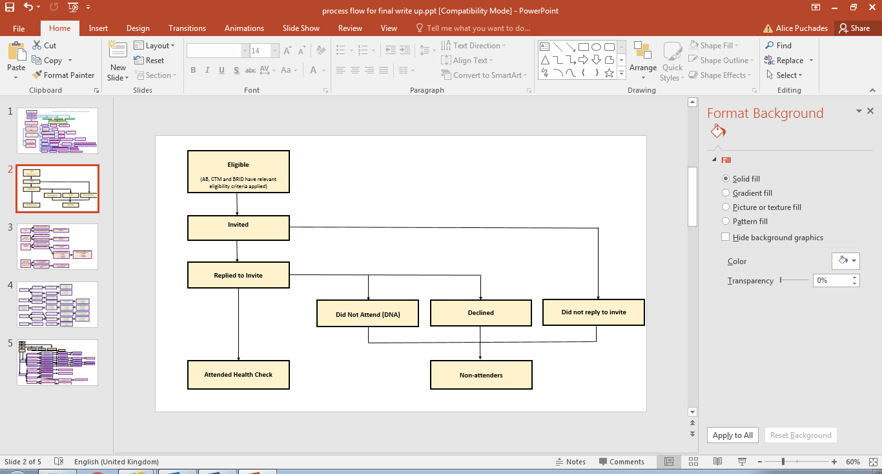
Figure 9: Process flow diagram of eligible, invited and attended.

Data were gathered on the number of people who were:
- Eligible for a Health Check from the ICL programme. As previously discussed the eligibility criteria varied between the two health boards. The relevant eligibility criteria were applied to each health board.
- Invited to a Health Check.
- Attended a Health Check.
- Did not attend a Health Check.

As you can see from Figure 5 there are a number of reasons why someone was classified as a non-attender. This included:
- People who did not reply to the invite.
- People who replied to the invite and declined to attend a Health Check.
- People who replied to the invite, booked a Health Check, but did not attend.

Eligibility criteria
The eligible population in AB is defined as patients age 40-64 years, not on a CVD register and lived in the two most deprived quintiles (Q1 and 2).
The eligible population in CT is defined as patients aged 40-74 years, not on a Cardio Vascular Disease (CVD) register who had an initial estimated 10-year CVD risk which was high (>20%); Medium (10-20%) or low (<10%) with missing data.

When BRID was part of the ICL pilot scheme whilst it was still in ABM, the pilot scheme was operating using the AB model, including using AB eligibility criteria. However, when BRID moved to the newly formed CTM University Health Board, it changed its operating model to align with the CTM model, including for eligibility criteria. For the purposes of the SAIL data analysis we are applying the CTM eligibility criteria in BRID.
There were also some differences in the eligibility criteria used in Taf Ely area of CTM. This was the final area of CTM to roll out the ICL programme, and due to its relative low levels of deprivation it was decided that the health checks would be targeted at only people living in the most deprived quintiles (Q1 and Q2). Again for the purposes of the SAIL data analysis we are applying the CTM eligibility criteria to all of CTM.
People were not eligible for the ICL programme if they were on a chronic disease register for a pre-existing condition or were prescribed medication which is used to treat CVD. A full list of the pre-existing conditions and medications was reviewed by Public Health Specialists and experienced GPs. and included in the SAIL protocol, to enable eligible people to be identified within the SAIL Databank. Pre-existing conditions that made people ineligible for the programme included diabetes, chronic kidney disease and late stage terminal illness. Prescribed medications that made people ineligible for the programme included statins, antihypertensive medication, anti-arrhythmia medication and diuretics.
Analysis was undertaken to examine the proportion of people (patients registered with participating GP practices), who were eligible based on the relevant eligibility criteria for age and residence, but ineligible due to having one of the specified pre-existing conditions or prescriptions for specific medications associated with these conditions.
Health Board | Eligible based on age and residence | Eligible based on age, residence with no pre-existing conditions/ prescriptions | Number ineligible due to pre-existing conditions/ prescriptions | Percentage ineligible due to pre-existing conditions/ prescriptions  (%)
AB | 90,741 | 82,233 | 8,508 | 9.4 (9.2-9.6)
BRID | 17,619 | 15,332 | 2,287 | 13.0 (12.5-13.5)
CT | 103,936 | 92,497 | 11,439 | 11.0 (10.8-11.2)
Total | 212,296 | 190,062 | 22,234 | 10.5 (10.3-10.6)
Table 7: Eligibility criteria based on age and residence, including and excluding pre-existing conditions and prescribed medications.

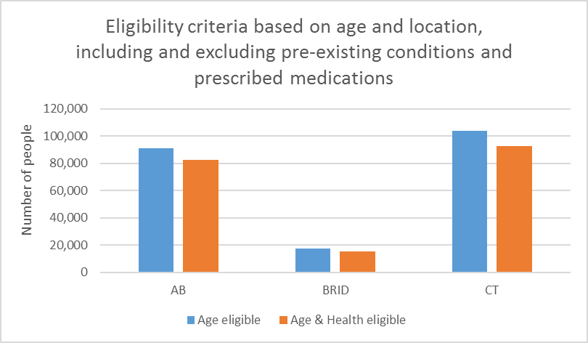
Figure 10: Eligibility criteria based on age and location, including and excluding pre-existing conditions and prescribed medications.
- Overall 10.5% (95% CI 10.3-10.6) of people who would have been eligible for the programme based on their age and location were ineligible due to pre-existing conditions.

- This was statistically significantly higher in BRID and CT at 13% (95% CI 12.5-13.5%) and 11% (95% CI 10.8-11.2%) respectively, compared to AB which had 9.4% (95% CI 9.2-9.6%) of people ineligible due to pre-existing conditions.

- This result is not surprising due to the different age ranges for eligibility. In CT the programme targets people up until age 74, whilst the upper age range in AB is 64. As older people aged 65-74 are more likely to have pre-existing conditions this would make a higher proportion of the people in BRID and CT ineligible for the ICL programme.

- Other factors which could impact the percentage of people ineligible for the programme include different levels of pre-existing conditions in the population of the different health boards, or different proportions of people with pre-existing conditions being diagnosed due to differences within the healthcare systems.

- Quality and Outcome Framework (QOF) data shows that there are small differences in the proportion of the population with diagnoses of some of the pre-existing conditions which would have excluded them from the ICL Programme between AB and CT UHBs. In 2019 the proportion of patients diagnosed with hypertension was 16.2% in AB and 16.9% in CTM, whilst the proportion of patients with chronic obstructive pulmonary disease (COPD) was 2.3% in AB and 2.8% in CTM. However, the proportion of patients diagnosed with other CVD conditions was consistent across HBs, such as coronary heart disease diagnosed in 3.6% of patients in AB and CTM and diabetes diagnosed in 6.5% of patients in AB and CTM (QOF database 2019).

Uptake and reach of the programme
Reach
Reach is simplified to:
Reach = Attended / Eligible

In the ICL programme the reach is therefore defined as:
Reach = the number of people who attended an ICL Health Check / the number of people who were eligible for an ICL Health Check
The reach of a programme is defined as:
Reach = the number of people served by a programme / the potential number of people who were eligible to have been served

Uptake
Uptake is simplified to:
Uptake = Attended / Invited

In the ICL programme the uptake is therefore defined as:
Uptake = the number of people who attended an ICL Health Check / the number of people invited to an ICL Health Check

The uptake of a programme is defined as:
Uptake = the number of people served by a programme / the number of people invited to the programme

Uptake and Reach data

 | Eligible | Invited | Attended | Reach  (Attended / Eligible)  (%) | Uptake  (Attended / Invited)  (%)
AB | 82,233 | 24,478 | 12,409 | 15.1 (14.9-15.3) | 50.7 (50.1-51.3)
CT | 92,497 | 23,953 | 11,414 | 12.3 (12.1-12.6) | 47.7 (47.0-48.3)
BRID* | 15,332 | 1,710 | 2,157 | 14.1 (--) | 126.1 (--)
AB and CT combined | 174,730 | 48,431 | 23,823 | 13.6 (13.5-13.8) | 49.2 (48.7-49.6)
Table 8: Eligible, invited, attended, reach and uptake of the ICL health check programme by Health Board. * BRID data for invited inaccurate so 95% CI not calculated. See comments below.

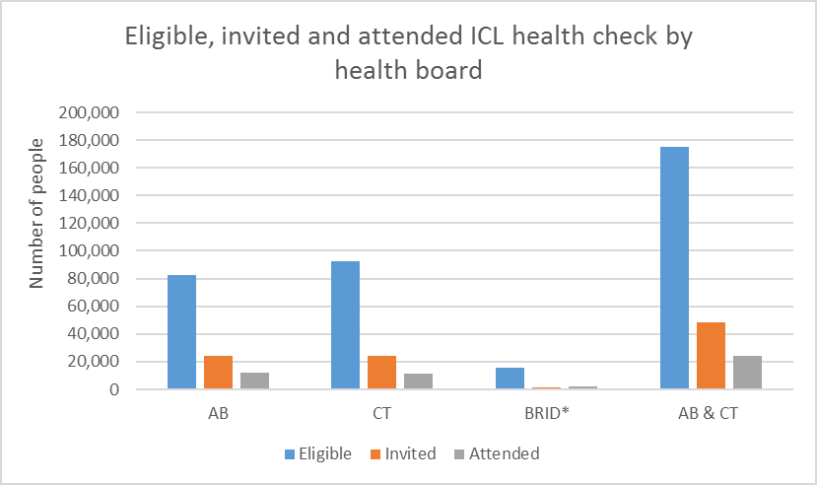
Figure 11: Eligible, invited and attended the ICL health check programme by health board. * BRID data for invited inaccurate.

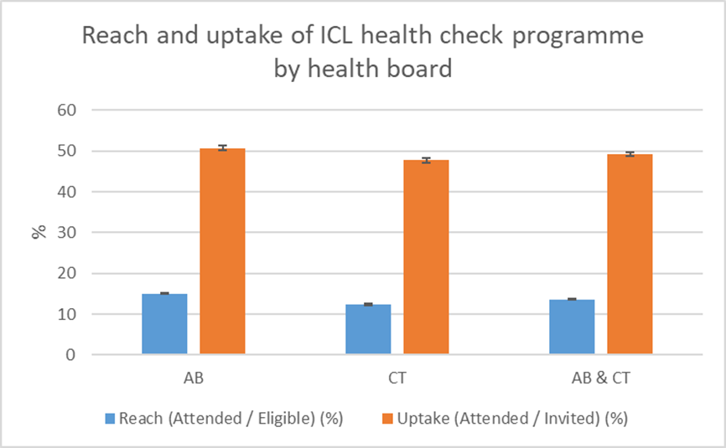
Figure 12: Uptake and reach of the ICL health check programme by health board.

- The uptake in BRID was calculated at 126.1%. This is because more people were recorded as having attended a health check than were invited to a health check. This is likely to be due to inaccuracies with the invitation process and coding of invites in the Bridgend programme. Because BRID data for invites were inaccurate 95% CI were not calculated for BRID result, and a separate total for just AB and CT combined was also calculated which did not include BRID data.
- The reach of the overall ICL programme was 13.7% and was very similar for just AB and CT combined at 13.6% (95% CI 13.5-13.8).

- The reach was statistically significantly higher in AB at 15.1% (95% CI 14.9-15.3) and lower in CT at 12.3% (95% CI 12.1-12.6).

- The uptake of AB and CT programmes combined was 49.2% (95% CI 48.7 – 49.6).

- The uptake of the AB and CT programmes was similar but statistically significantly different at 50.7% (95% CI 50.1-51.3) and 47.7% (95% CI 47.0-48.3) respectively.

- The reason for the large discrepancy between the reach (attended/eligible) and uptake (invited/attended) is the difference between the number of people who were found to be eligible for the ICL programme in the SAIL data, and the number of people who were invited for a health check. Of the people who were found to be eligible in SAIL data, only 29.7% in AB and 25.9% in CT were invited for a health check during the study period.

- This is slightly lower than for the NHS Health Check in England, where at the end of 2016, 31.8% of the people eligible to receive a health check in the five-year period from 2013- 2018 have received one (Usher-Smith et al 2017). However, it is worth noting that the NHS Health Check is a universal programme, and so will have a different target population than the ICL programme, making it challenging to directly compare the two programmes.

- The invitation process between AB and CT differed as did the booking process: In AB the health check was delivered within specific Primary Care Cluster (Neighbourhood Network) areas and universally invited people resident in most and next most deprived WIMD quintiles (Q1 and Q2). There was a central booking line run by a dedicated team from the programme office base in Abertillery. In CT the Health Check was offered to all practices across the health board and delivered over a 5-year period, targeting patients with highest pre-CVRA estimated QRisk2 Score, for the majority of the programme. The one exception in CT was in the Taf Ely cluster, which is a more affluent area in CT, which targeted people with elevated pre-estimates risk living in Q1 and Q2. Invitation letters and appointment booking were managed via individual general practices.

- Some of the discrepancy in numbers may be due to changes in General Practices, or people moving during the study period.

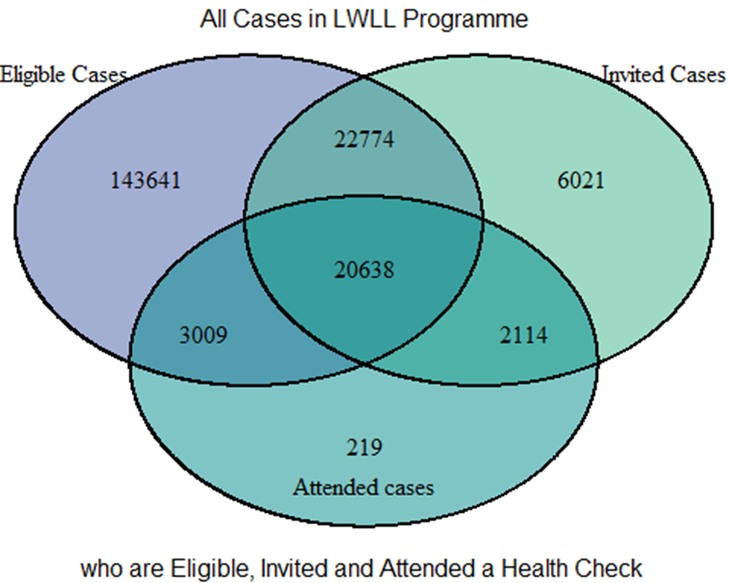
Figure 13: Venn diagram of Eligible, Invited and Attended cases for AB, CT and BRID health boards.

This Venn diagram demonstrates the number of people who are eligible, invited and attended. It shows that there are differences between the groups of eligible, invited and attended.
- By far the largest group is the 143,641 people who were found to be eligible in SAIL data but were not invited or attended a Health Check. This could be for many reasons including:
  - People were invited to health checks in different areas at different times. If someone became eligible for a health check, for example by turning 40 or moving into the area, then they may not have been invited if people within that area were not being invited at the time.
  - People who moved between health boards could be double counted, so some of these people may have been invited at multiple practices/health boards and then go on to attend a single health check or not attended a health check at their current practice/health board.

- 3,228 people attended a health check without being invited. As people needed to be invited in order to have a health check appointment this is likely to be due to issues with recording of invites completed in practices / secondary ICL recording systems and resulting coding of health check invite data.

Demographics of invited and attended
The demographics of the invited and attended groups was explored to see if there were any differences in the uptake by deprivation quintile, age and sex.

Deprivation quintiles
The ICL Programme aimed to address health inequalities by targeting people in greatest need who lived in areas of deprivation. The AB programme was delivered in the areas of the health board only where deprivation was high whereas as in CT, all areas of the health board were covered given the widespread deprivation with a more targeted approach in Taf Ely cluster. Also, the eligibility criteria varied between AB and CT: In AB, only people who lived in quintile 1 (Q1) (most deprived) and quintile 2 (Q2) (next most deprived) were eligible for a health check. In CT, a pre-health check estimated QRISK2 score was derived from existing data in the practice, and people who were classified as high, medium or “low with missing data” were invited. This means that people from all deprivation quintiles could be eligible to be invited to the CTM programme. However, postcode is included in a QRISK2 score, so that people who lived in more deprived areas are likely to have higher QRISK2 scores. As previously mentioned, the one exception to this was in the Taf Ely cluster, which is a more affluent area in CT, where people from Q1 and Q2 only were invited for CVRA.

Invited by deprivation quintiles
 |  | AB |  |  | CT |  |  | BRID* |  | AB and CT combined |  |  |  | TOTAL*
 | Number invited to health check  (n) |  | Proportion of those invited to health check  (%) | Number invited to health check  (n) |  | Proportion of those invited to health check  (%) | Number invited to health check  (n) |  | Proportion of those invited to health check  (%) |  | Number invited to health check  (n) | Proportion of those invited to health check  (%) | Number invited to health check  (n) |  | Proportion of those invited to health check  (%)
Q1 (most deprived) | 10,512 |  | 42.9 | 7,897 |  | 33.0 | 855 |  | 51.5 |  | 18,409 | 38.0 | 19,264 |  | 38.4
Q2 | 8,821 |  | 36.0 | 9,118 |  | 38.1 | 319 |  | 19.2 |  | 17,939 | 37.0 | 18,258 |  | 36.4
Q3 | **2,848 |  | 11.6 | 3,411 |  | 14.2 | 323 |  | 19.5 |  | 6,259 | 12.9 | 6,582 |  | 13.1
Q4 | **795 |  | 3.2 | 1,487 |  | 6.2 | 155 |  | 9.3 |  | 2,282 | 4.7 | 2,437 |  | 4.9
Q5 (least deprived) | **416 |  | 1.7 | 1,164 |  | 4.9 | 8 |  | 0.5 |  | 1,580 | 3.3 | 1,588 |  | 3.2
N/A | 1,086 |  | 4.4 | 876 |  | 3.7 | 50 |  | 3.0 |  | 1,962 | 4.1 | 2,012 |  | 4.0
Total | 24,478 |  | n/a | 23,953 |  | n/a | 1,660 |  | n/a |  | 48,431 | n/a | 50,141 |  | n/a
Table 9: Invited to ICL health check by deprivation quintile and health board. * BRID data for invited inaccurate. **not eligible for health check based on health board’s eligibility criteria
- The invitation data shows that the majority of people who were invited were in Q1 and Q2. However, in all health boards people were invited who were listed in SAIL data as having a Lower-layer Super Output Area (LSOA) of residence in all five deprivation quintiles. A higher proportion of people were invited from Q1 and Q2 in AB (78.9%) compared to CT (71.1%) and BRID (70.7%), which is not surprising given the differences in eligibility criteria in AB compared to CT and BRID.

- As described above the BRID invitation data is likely to be inaccurate due to the fact that invite data from Bridgend was not verified. Therefore, a separate column for AB and CT data combined, but excluding BRID data, was included in this table.

- There were people in all health boards who were classified as N/A, who have not declared an address or of insufficient quality to be matched to an LSOA and therefore not able to be classified into any of the five deprivation quintiles.

Attended by deprivation quintiles
 |  | AB |  |  | CT |  |  | BRID |  |  | AB and CT combined |  |  | TOTAL
 | Number attended health check  (n) |  | Proportion of those that attended health check  (%) | Number attended health check  (n) |  | Proportion of those that attended health check  (%) | Number attended health check  (n) |  | Proportion of those that attended health check  (%) | Number attended health check  (n) |  | Proportion of those that attended health check  (%) | Number attended health check  (n) |  | Proportion of those that attended health check  (%)
Q1 (most deprived) | 5,426 |  | 43.7 | 3,571 |  | 31.3 | 715 |  | 33.1 | 8,997 |  | 37.8 | 9,712 |  | 37.4
Q2 | 4,894 |  | 39.4 | 4,353 |  | 38.1 | 488 |  | 22.6 | 9,247 |  | 38.8 | 9,735 |  | 37.5
Q3 | 1,092 |  | 8.8 | 1,744 |  | 15.3 | 807 |  | 37.4 | 2,836 |  | 11.9 | 3,643 |  | 14.0
Q4 | 398 |  | 3.2 | 763 |  | 6.7 | 56 |  | 2.6 | 1,161 |  | 4.9 | 1,217 |  | 4.7
Q5 (least deprived) | 107 |  | 0.9 | 591 |  | 5.2 | 7 |  | 0.3 | 698 |  | 2.9 | 705 |  | 2.7
N/A | 492 |  | 4.0 | 392 |  | 3.4 | 84 |  | 3.9 | 884 |  | 3.7 | 968 |  | 3.7
Total | 12,409 |  | n/a | 11,414 |  | n/a | 2,157 |  | n/a | 23823 |  | n/a | 25,980 |  | n/a
Table 10: Attendance at ICL health check by deprivation quintile and health board.

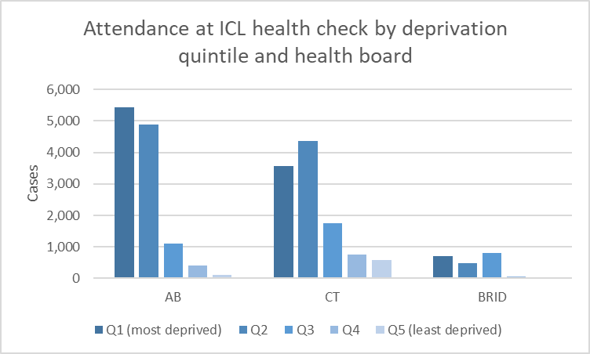
Figure 14: Attendance at ICL health checks by deprivation quintile and health board

- 74.9% of people who attended a health check in the ICL programme in all of the health boards were in either Q1 or Q2 (37.4% and 37.5% respectively).

- In AB only 12.9% of people who attended were from Q3 – Q5. In CT 27.2% of people were from Q3 – Q5, although the majority of these (15.3%) were in Q3. This is not surprising as AB’s eligibility criteria was people living in Q1 and Q2 only, whilst CT used QRISK2 score to stratify people into risk categories. This means that CT did not explicitly exclude people from Q3 - Q5. The results for BRID are more complex to interpret as they initially followed the AB model, before changing to the CT model due to health board boundary changes.

Uptake by deprivation quintiles
Uptake (Attended / Invited)
(%)
 | AB | CT | AB and CT combined
Q1 (most deprived) | 51.6 (50.7-52.6) | 45.2 (44.1-46.3) | 48.9 (48.2-49.6)
Q2 | 55.5 (54.4-56.5) | 47.7 (46.7-48.8) | 51.5 (50.8-52.3)
Q3 | 38.3 (36.6-40.1) | 51.1 (49.5-52.8) | 45.3 (44.1-46.6)
Q4 | 50.1 (46.6-53.5) | 51.3 (48.8-53.8) | 50.9 (48.8-52.9)
Q5 (least deprived) | 25.7 (21.8-30.1) | 50.8 (47.9-53.6) | 44.2 (41.8-46.6)
Table 11: Uptake of ICL health check by deprivation quintile and health board

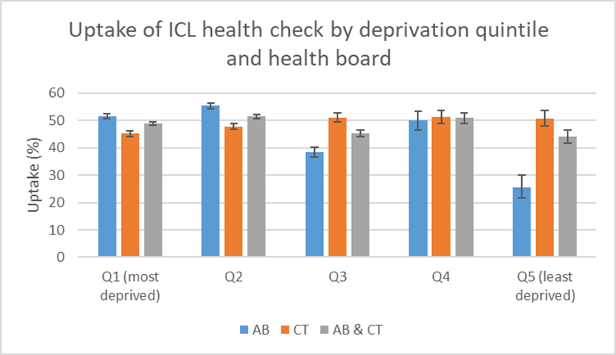
Figure 15: Uptake of ICL health check by deprivation quintile and health board

- As the BRID uptake data was unreliable BRID data were not included in this analysis of uptake by deprivation quintile.

- The uptake varied by deprivation quintile for AB and CT combined. The uptake was highest in the second most deprived quintile (Q2) at 51.5% (95% CI 50.8 – 52.3). The uptake was lowest in the least deprived quintile (Q5) at 44.2% (95% CI 41.8-46.6). Uptake in all of the quintiles had overlapping 95% CI with uptake in another quintile.

- Uptake in the three most deprived quintiles for AB and CT (Q1,2 and 3) were all above 45%.

- The uptake by deprivation quintile varied between the different health boards. Uptake in AB was highest in Q1 and 2 at 51.6% (95% CI 50.7-52.6) and 55.5% (95% CI 54.4 – 56.5) respectively, although only the uptake in Q2 was statistically significantly higher than other quintiles. Only people who live in Q1 and Q2 are eligible for the ICL programme in AB, so this shows the highest uptake in the groups specifically targeted by the ICL programme.

- Uptake in CT was highest in Q3 and Q4 at 51.1% (95% CI 49.5-52.8) and 51.3% (95% CI 48.8-53.8) respectively. These are statistically significantly higher than the uptake in Q1 and Q2.

- The lack of a consistent pattern of uptake by deprivation across the ICL programme is similar to the findings for uptake by deprivation of the NHS Health Check (NHSHC) programme in England. There is no consistent relationship between deprivation and uptake of the NHSHC programme, with some studies showing higher uptake in more deprived communities, whilst other studies showing higher uptake in less deprived communities. It is worth noting that the NHSHC programme offers universal health checks to people aged 40-74 in England, and is not aiming to target areas of deprivation like the ICL programme.

Age Group
Invited by Age Group
 | AB | Percentage of those that were invited to health check  (%) | CT | Percentage of those that were invited to health check  (%) | BRID* | Percentage of those that were invited to health check  (%) | AB and CT combined | Percentage of those that were invited to health check  (%) | TOTAL* | Percentage of those that were invited to health check  (%)
30-39 | **3,727 | 15.2 | **1,203 | 5.0 | *81 | 4.7 | 4930 | 10.1 | **5,011 | 11.1
40-44 | 4,810 | 19.7 | 4,352 | 18.1 | 371 | 21.6 | 9162 | 18.9 | 9,533 | 21.1
45-49 | 4,934 | 20.2 | 4,339 | 18.1 | 318 | 18.5 | 9273 | 19.2 | 9,591 | 21.3
50-54 | 4,902 | 20.0 | 3,846 | 16.0 | 277 | 16.1 | 8748 | 18.1 | 9,025 | 20
55-59 | 3,824 | 15.6 | 3,215 | 13.4 | 230 | 13.4 | 7039 | 14.5 | 7,269 | 16.1
60-64 | 2,233 | 9.1 | 2,886 | 12.0 | 175 | 10.2 | 5119 | 10.6 | 5,294 | 11.7
65-69 | **32 | 0.1 | 2,626 | 10.9 | 147 | 8.5 | 2658 | 5.5 | 2,805 | 6.2
70-74 | **0 | n/a | 1,470 | 6.1 | 111 | 6.4 | 1470 | 3.0 | 1,581 | 3.5
75 + | **0 | n/a | **9 | 0.0 | **0 | n/a | 9 | 0.0 | **9 | 0
N/A | **14 | 0.1 | **5 | 0.0 | **0 | n.a | 19 | 0.0 | **29 | 0.1
Table 12: Number invited to ICL health check by age group and health board. * BRID data for invited inaccurate. ** not eligible for health check based on health board’s eligibility criteria

- In AB, 40-64 year olds were eligible for the ICL programme, whilst in CT 40-74 year olds were eligible for the ICL programme. BRID initially followed AB criteria 40-64, before changing to CT criteria of 40-74.

- A number of people were invited from other age groups. The majority of these (5,011) were in the 30-39 age group, so just below the lower age limit for inclusion in the ICL programme. This was explored with both the ICL programme leads in AB and CT and the SAIL Team who undertook the analysis. The ICL programme in both AB and CT had internal data from their respective Health Check systems, which did not show that large numbers of people were invited aged 30-39 in either programme. It is not known definitively why this discrepancy exists between SAIL and internal ICL Programme data for invitation by age group, but one potential explanation is different timings of data extracts identifying people who were due to turn 40 in the same year.

- Very few people were invited who were over the upper age limit for the programme (32 people aged 65-69 in AB, and 9 people aged 75+ in CT) or did not fit into one of these age categories (29 people classed as N/A).

Attended by Age Group
 |  | AB |  |  | CT |  |  | BRID |  |  | AB and CT combined |  |  | TOTAL
 | Number attended health check  (n) |  | Proportion of those that attended health check  (%) | Number attended health check  (n) |  | Proportion of those that attended health check  (%) | Number attended health check  (n) |  | Proportion of those that attended health check  (%) | Number attended health check  (n) |  | Proportion of those that attended health check  (%) | Number attended health check  (n) |  | Proportion of those that attended health check  (%)
30-39 | *1,021 |  | 8.2 | *369 |  | 3.2 | *21 |  | 1.0 | *1390 |  | 6 | *1,411 |  | 5.4
40-44 | 2,533 |  | 20.4 | 1,487 |  | 13.0 | 381 |  | 17.7 | 4020 |  | 17.3 | 4,401 |  | 16.9
45-49 | 2,712 |  | 21.9 | 1,620 |  | 14.2 | 434 |  | 20.1 | 4332 |  | 18.6 | 4,766 |  | 18.3
50-54 | 2,735 |  | 22.0 | 1,609 |  | 14.1 | 463 |  | 21.5 | 4344 |  | 16.2 | 4,807 |  | 18.5
55-59 | 2,113 |  | 17.0 | 1,650 |  | 14.5 | 388 |  | 18.0 | 3763 |  | 18.2 | 4,151 |  | 16
60-64 | 1,276 |  | 10.3 | 1,720 |  | 15.1 | 290 |  | 13.4 | 2996 |  | 12.6 | 3,286 |  | 12.7
65-69 | *9 |  | 0.1 | 1,883 |  | 16.5 | 99 |  | 4.6 | 1892 |  | 7.9 | 1,991 |  | 7.7
70-74 | 0 |  | 0 | 1,047 |  | 9.2 | 72 |  | 3.3 | 1047 |  | 4.4 | 1,119 |  | 4.3
75+ | 0 |  | 0 | *5 |  | <0.1 | *6 |  | 0.23 | *5 |  | <0.1 | *11 |  | <0.1
N/A | *7 |  | 0.1 | *24 |  | 0.2 | 0 |  | 0 | *31 |  | 0.1 | *31 |  | 0.1
Table 13: Number attended health check by age group and health board. *not eligible for health check based on health board’s eligibility criteria
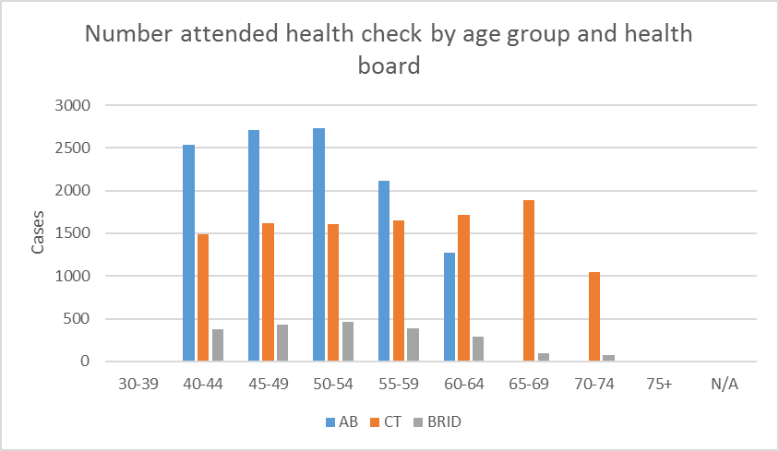
Figure 16: Number attended health check by age group and health board.
*data only shown for people who were eligible for the ICL Programme in the respective HBs

- The highest proportion of people attending health checks were in 45-49 (18.3%) and 50-54 (18.5%) age groups. The proportion attending for the 65-69 (7.7%) and 70-74 (4.35) age groups was lower as only people aged 65-74 in CT and BRID were eligible for health checks, as AB had an upper age limit of 64.

- Some people who attended a health check were outside the eligible age group. Again, the majority of these people were aged 30-39 (1411 people, 5.4% of those who attended). Very few people attended who were over the upper age limit for the programme or were not able to be categorised (42 people in total making up just over 0.1% of all those who attended).

- There were differences in attendance between the health boards. In AB the age categories which had the highest attendance was 45-49 and 50-54 at 21.9% and 22.0% respectively. In CT the number of people attending increased slightly through the age categories, peaking at 16.5% of attendees in 65-69 year olds.

Uptake by Age Group
Uptake (Attended / Invited)
(%)
 | AB | CT | AB and CT combined
40-44 | 52.7 (51.3-54.1) | 34.2 (32.8-35.6) | 43.9 (42.9-44.9)
45-49 | 55 (53.6-56.4) | 37.3 (35.9-38.8) | 46.7 (45.7-47.7)
50-54 | 55.8 (54.4-57.2) | 41.8 (40.3-43.4) | 49.7 (48.6-50.7)
55-59 | 55.3 (53.7-56.8) | 51.3 (49.6-53.1) | 53.5 (52.3-54.6)
60-64 | 57.1 (55.1-59.2) | 59.6 (57.8-61.4) | 58.5 (57.2-59.9)
65-69 | n/a | 71.7 (70.0-73.4) | 71.2 (69.4-72.9)
70-74 | n/a | 71.2 (68.9-73.5) | 71.2 (68.9-73.5)
Table 14: Uptake of health check by age group
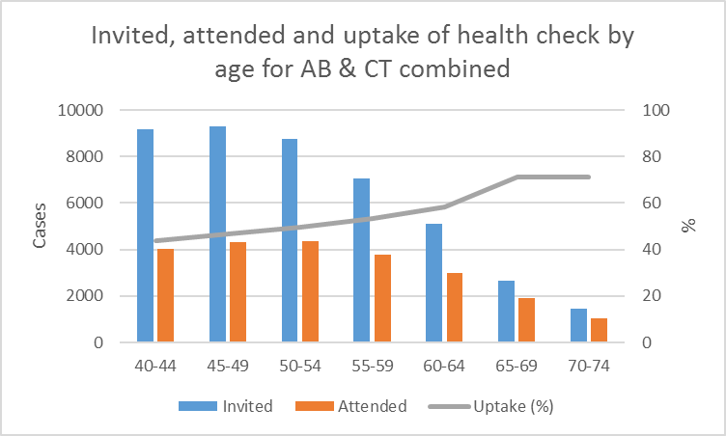
Figure 17: Invited, attended and uptake of health check by age group for AB and CTM health boards.

- The uptake by age group in BRID was not included as it is unreliable, due to issues with the invite data outlined above.

- Uptake for CT and AB combined increased with age, from a 43.9% (95% CI 42.9-44.9) uptake in 40-44 year olds to a 71.2% (95% CI 68.9-73.1) uptake in 70-74 year olds.

- This is consistent with findings from the NHSHC and other health check programmes which shows that uptake of health checks increases with age.

- However, it is worth noting that the number of people who attended health checks was highest in the 45-54-year-old age groups.

- The uptake varied between the different health boards. Uptake in AB did increase with age but was reasonably consistent throughout the age groups from 52.7% (95% CI 51.3-54.4) uptake in 40-44 year olds to 57.1% (95% CI 55.1-59.2) uptake in 60-64 year olds.

- Uptake in CT also increased with age, and this was a more marked increase from a 34.2% (95% CI 32.8 – 35.6) uptake in 40-44 year olds and a 71.2% (95% CI 68.9 – 73.5) uptake in 70-74 year olds.

- Uptake was statistically significantly higher in AB than CT for people aged 40-59. Uptake was slightly higher in CT than AB for people aged 60-64, but this was not statistically significant. The reasons for these differences in uptake are not known, however it has been theorised that the model in AB, where people had health checks in community venues, may have encouraged higher uptake in the younger age groups. Also the AB programme offered more flexible times for CVRA e.g. evening appointments that would have improved access for working age adults.

Sex
Invited by sex
 |  | AB |  |  | CT |  |  | BRID* |  |  | AB and CT combined |  |  | TOTAL*
 | Number attended health check  (n) |  | Proportion of those that attended health check  (%) | Number attended health check  (n) |  | Proportion of those that attended health check  (%) | Number attended health check  (n) |  | Proportion of those that attended health check  (%) | Number attended health check  (n) |  | Proportion of those that attended health check  (%) | Number attended health check  (n) |  | Proportion of those that attended health check  (%)
Male | 11,904 |  | 48.6 | 13,641 |  | 56.9 | 931 |  | 54.4 | 25545 |  | 52.7 | 26,476 |  | 52.8
Female | 12,574 |  | 51.4 | 10,310 |  | 43.0 | 779 |  | 45.6 | 22884 |  | 47.3 | 23,663 |  | 47.2
Table 15: Invited to ICL health check by sex and health board. * BRID data for invited inaccurate.
- In AB and CT combined, slightly more men than women were invited to a health check (52.7% male vs. 47.3% female).

- The proportion of males and females invited to health checks varied between health boards.

- In AB slightly more women were invited (48.6% male vs. 51.4% female), whilst in CT slightly more men were invited (56.9% male vs. 43.0% female).

Attendance by sex
 |  | AB |  |  | CT |  |  | BRID |  |  | AB and CT combined |  |  | TOTAL
 | Number attended health check  (n) |  | Proportion of those that attended health check  (%) | Number attended health check  (n) |  | Proportion of those that attended health check  (%) | Number attended health check  (n) |  | Proportion of those that attended health check  (%) | Number attended health check  (n) |  | Proportion of those that attended health check  (%) | Number attended health check  (n) |  | Proportion of those that attended health check  (%)
Male | 5,644 |  | 45.5 | 6,278 |  | 55.0 | 1,051 |  | 48.7 | 11922 |  | 50.1 | 12,973 |  | 49.9
Female | 6,762 |  | 54.5 | 5,136 |  | 45.0 | 1,106 |  | 51.3 | 11898 |  | 49.9 | 13,004 |  | 50.1
Table 16: Attendance at ICL health check by sex and health board.
- The attendance by sex was evenly split for AB and CT combined at 50.1% male and 49.9% female.

- The attendance by sex of the individual programmes varied. In AB slightly more people who attended were female rather than male (54.5% female vs 45.5% male), whilst in CT slightly more people who attended were male rather than female (45% female vs. 55% male).

- This follows roughly the same pattern as invites, with more women being invited in AB and more men being invited in CT.

Uptake by sex
 | AB | CT | AB and CT combined
Male | 47.4 (46.5-48.3) | 46.0 (45.2-46.9) | 46.7 (46.1-47.3)
Female | 53.8 (52.9-54.7) | 49.8 (48.9-50.8) | 52.0 (51.3-52.6)
Table 17: Uptake by sex and health board.
- The uptake by sex in BRID was not included as it was unreliable, due to issues with the invite data outlined above.

- Overall the uptake was slightly higher in women than men at 52% (95% CI 51.3 – 52.6) in women and 46.7% (46.1-47.3) in men. This difference is statistically significant.

- The uptake in both AB and CT was higher in women than men. This aligns with findings for other health check programmes, including the NHSHC in England, where the majority of studies have found higher uptake in women.

- There are no statistically significant differences in uptake for males between AB and CT. However, AB does have statistically significantly higher uptake in women at 53.8% (95% CI 52.9 – 54.7) compared to CT at 49.8% (95% CI 48.9- 50.8).

Uptake by age and sex
The invited and attended data was analysed for a combination of age and sex for AB and CT. This analysis was not carried out for BRID due to the small numbers of people who attended health checks in BRID, and the unreliable invite and uptake data.
 |  | AB |  |  | CT
Age Group | Sex | Invited  (n) | Attended  (n) | Uptake  (Attended/Invited)  (%) | Invited  (n) | Attended  (n) | Uptake  (Attended/Invited)  (%)
40-44 | Male | 2,623 | 1,252 | 47.7 (45.8-49.6) | 2,486 | 764 | 30.7 (29.0-32.6)
45-49 | Male | 2,567 | 1,268 | 49.4 (47.5-51.3) | 2,504 | 861 | 34.4 (32.5-36.3)
50-54 | Male | 2,437 | 1,200 | 49.2 (47.3-51.2) | 2,267 | 940 | 41.5 (39.5-43.5)
55-59 | Male | 1,861 | 877 | 47.1 (44.9-49.4) | 2,016 | 1,030 | 51.1 (48.9-53.3)
60-64 | Male | 1,068 | 559 | 52.3 (49.3-55.3) | 1,699 | 1,033 | 60.8 (58.5-63.1)
65+ | Male | N/A | N/A | N/A (--) | 1,971 | 1,443 | 73.2 (71.2-75.1)
40-44 | Female | 2,486 | 1,281 | 51.5 (50.0-53.5) | 1,866 | 723 | 38.7 (36.6-40.1)
45-49 | Female | 2,739 | 1,444 | 52.7 (50.9-54.6) | 1,835 | 759 | 41.4 (39.1-43.6)
50-54 | Female | 2,754 | 1,535 | 55.7 (53.9-57.6) | 1,579 | 669 | 42.4 (40.0-44.8)
55-59 | Female | 2,125 | 1,236 | 58.2 (56.1-60.2) | 1,199 | 620 | 51.7 (48.9-54.5)
60-64 | Female | 1,263 | 717 | 56.8 (54.0-59.5) | 1,187 | 687 | 57.9 (55.1-60.7)
65+ | Female | N/A | N/A | N/A (--) | 2,135 | 1,495 | 70 (68.0-71.9)
Table 18: Uptake of ICL health check by age and sex for AB and CT.

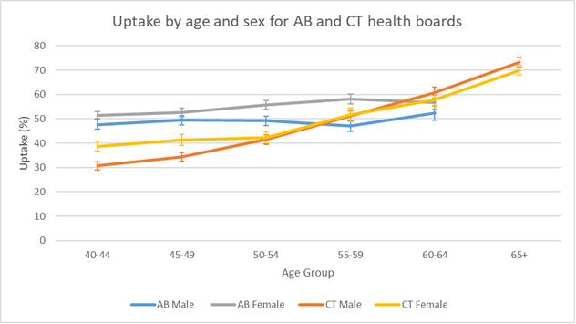
Figure 18: Uptake by age and sex for AB and CT

- Both AB and CT health boards show a general pattern of increasing uptake with age for both men and women.

- The uptake in AB for both men and women is statistically significantly higher than men and women in CT for ages 40-54. However, for ages 55-64 this pattern of statistically significantly higher results for both men and women in AB is not seen.

- This is less marked in AB than CT. In AB the uptake in women is higher than men in all age groups, although this difference is not statistically significant in all age groups. The difference in uptake between men and women is greatest in ages 50-59.

- In CT the uptake of women is higher in women aged 40-54 and the uptake in men is higher aged 55-65+. This difference was only statistically significant in ages 40-49.

- The AB model with community venues and flexibility of appointment times may have been more accessible for younger, working age men and women.

Clinical cascades and lifestyle cascades
At the CVRA, a range of physical measurements are taken and information about lifestyle behaviours captured. These may trigger immediate advice, sign-posting/ referral to a lifestyle service or follow-up by a clinician.
The clinical and lifestyle cascades that follow were developed to inform the SAIL data analysis protocol. They reflect the management that should occur after a CVRA for clinical or lifestyle risk factors that are identified. The clinical and lifestyle cascades were created in collaboration between clinicians (GPs, Nurses, Pharmacists) and Public Health specialists associated with the AB and CT ICL programmes, NWIS and the Swansea University SAIL teams.
The clinical and lifestyle cascade analyses were undertaken for CT programme only, due to incompleteness or irregularities in the AB and BRID data described at the beginning of this chapter. There were issues with the flow of data from the AB programmes into SAIL which required a separate data input. Whilst this was addressed for the invitation and attendance data, it remained unresolved for the clinical and lifestyle cascade data for AB and required manual verification of the data extracted to ensure its completeness. Due to COVID-19 response pressures on the Public Health and ICL teams within AB, they did not have capacity to undertake the data verification process, and a pragmatic decision was made with the leads for the ICL programmes in AB and CTM, that the AB data would not be included in the clinical and lifestyle cascade analyses.
When the analyses of clinical and lifestyle cascades for BRID was reviewed by the Public Health and Primary Care teams from CTM it was felt to be misleading, and so the decision was made to not include it in the final report. The Bridgend lifestyle and clinical cascade data for BRID with its caveats is available on request to the CTM Local Public Health Team.
Post data extraction and analyses, it was established that an incomplete set of READ codes had been used to identify a new diagnosis of hypertension in the patient primary care record. Therefore, data on new hypertension diagnoses from the SAIL analyses is known to be incomplete and an underestimate of the true number. The data recording n prescription of anti-hypertensive medication was therefore used as a proxy measurement for identifying patients with a new diagnosis of hypertension.

Clinical cascades
As shown in the table below there were five clinical cascades:
- Management of high QRISK2 score.
- Management of raised HbA1c / raised blood sugar and pre-diabetes.
- Management of raised blood pressure / hypertension.
- Management of elevated cholesterol / hypercholesterolaemia.
- Management of irregular pulse / atrial fibrillation.

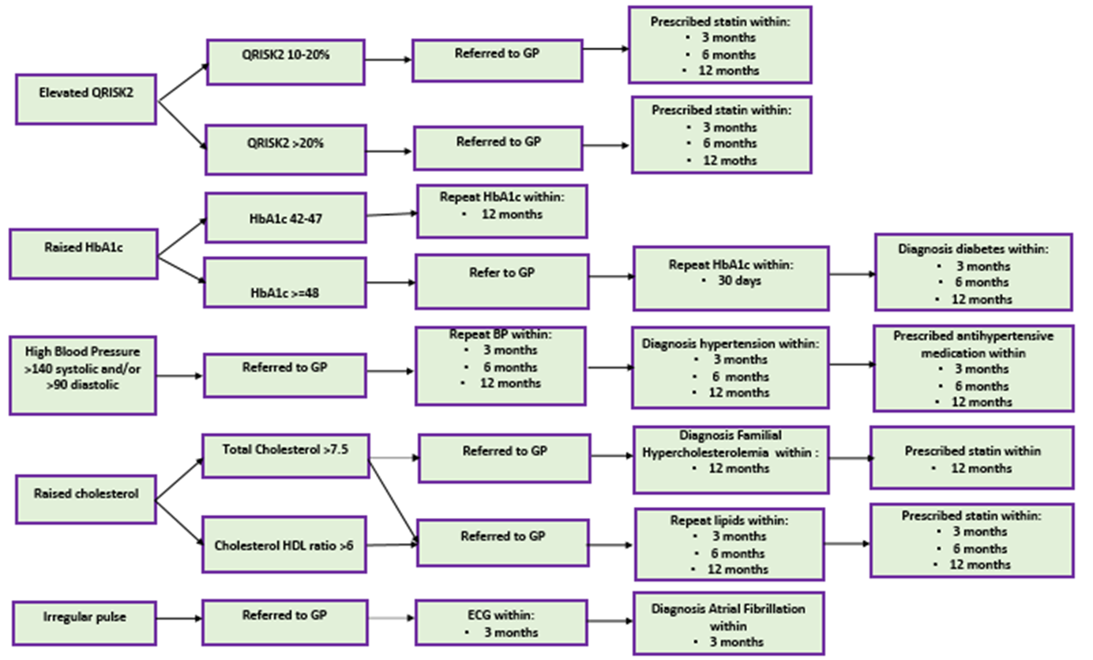
Figure 19: Process flow diagram of the clinical cascades

Clinical Risk Factors
There are five clinical risk factors of interest that were identified during a CVRA. Some of these risk factors are split into multiple results (e.g. QRISK2 10-20% and QRISK2 >20%) giving a total of eight risk factor findings. These risk factors are:
- Elevated QRISK2 score. This was split into:
  - QRISK2 10-20%.
  - QRISK2 >20%.
- Raised HbA1c. This was split into:
  - HbA1c 42-47
  - HbA1c >=48.
- Raised blood pressure (either systolic >140 and/or diastolic >90 mmHg).
- High cholesterol. This was split into:
  - Total cholesterol >7.5.
  - Cholesterol: HDL ratio >6.
- Irregular pulse.

The risk factors were not mutually exclusive, so an individual could be identified as having elevated QRISK2, raised HbA1c, raised blood pressure, high cholesterol and irregular pulse. However, some of the categories within the risk factors were mutually exclusive. An individual could either be identified as having QRISK2 10-20% or QRISK2 >20%, or HbA1c 42-47 or HbA1c >=48, but could not have both of these risk factors identified.

 |  | Attended Health Check | QRISK2 10-20% | QRISK2 >20% | HbA1c 42-47 | HbA1c >=48 | Raised blood pressure | Total cholesterol >7.5 | Cholesterol HDL ratio >6 | Irregular pulse
CT | n | 11,414 | 4,488 | 1,702 | 1,087 | 246 | 3,759 | 93 | 987 | 249
CT | % | N/A | 39.3 (38.4-40.2) | 14.9 (14.3-15.6) | 9.5 (9.0-10.1) | 2.2 (1.9-2.4) | 32.9 (32.1-33.8) | 0.8 (0.7-1.0) | 8.6 (8.2-9.2) | 2.2 (1.9-2.5)
Table 19: Summary of number and percentage of clinical risk factors identified at ICL Health Check (CT University Health Board)
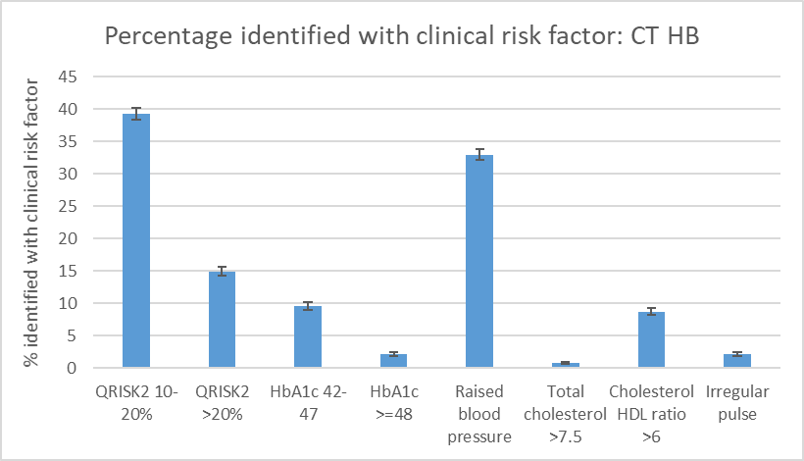
Figure 20: Percentage of those that attended ICL health check that were identified with clinical risk factors (CT University Health Board.)

- 39.3% of people had a raised QRISK2 10-20% and 14.9% of people had a raised QRISK2 of >20%. As QRISK2 is mutually exclusive this means that 54.2% of people who attended a health check in CT had an elevated QRISK2 score of either 10-20% or >20%. This is not surprising as the health check in CT was targeted at people with higher QRISK2 scores (estimated by data already in GP record), but does demonstrate that over half the people that attended a health check had increased risk of CVD as measured by their QRISK2 score.

- The most common individual clinical risk factor that was found at the health check was raised blood pressure which was found in 32.9% of people.

- The least common individual clinical risk factors were total cholesterol >7.5 (0.8%), HbA1c >=48 (2.2%) and irregular pulse (2.2%).

- As HbA1c 42-47 and HbA1c >=48 are mutually exclusive findings it is possible to combine the number of people with HbA1c 42-47 and >=48 to calculate the number and proportion with a raised HbA1c. In total 10.3% of people (1,333) had a raised HbA1c of either 42-47 or >=48.

Clinical outcomes
The outcomes of the clinical cascades were either a diagnosis of a condition or the initiation of treatment. Some clinical cascades had more than one end outcome (for example diagnosed with hypertension and started antihypertensive medication).
In the clinical cascades some of these outcomes also had various time limits (for example started on a statin at 3 months, 6 months and 12 months after the CVRA). This was based on advice from clinicians about the time periods which could be expected for follow up of different clinical risk factors. In this report we include the data at 12 months after the CVRA to show the maximum number of people who had each of the clinical outcomes. The one exception is for “irregular pulse” and “diagnosed with AF”, which is within a 3-month time period, based on clinician advice that this would be the expected time period for follow-up of a finding of irregular pulse.
The outcomes of the clinical cascades are:
- Elevated QRISK2 score:
  - QRISK2 10-20% started on statin within12 months.
  - QRISK2 >20% started on a statin within 12 months.
- Raised HbA1c >=48 and diagnosed with diabetes within 12 months.
- Raised Blood pressure:
  - Raised blood pressure and diagnosed with hypertension (HTN) within 12 months
  - Raised blood pressure and started on anti-hypertensive medication (anti-HTN) within 12 months.
- Raised cholesterol:
  - Raised total cholesterol >7.5 and diagnosed with familial hypercholesterolemia (FH) within 12 months.
  - Raised total cholesterol >7.5 or raised cholesterol / HDL ratio >6 and started on statin within 12 months.
- Irregular pulse and diagnosed with atrial fibrillation (AF) within 3 months.

The clinical outcomes were not mutually exclusive, so an individual could have had an elevated QRISK2 and been started on a statin, have a raised HbA1c and be diagnosed with diabetes, have raised blood pressure and be diagnosed with HTN and started anti-HTN medication, have raised cholesterol and started on a statin, and have an irregular pulse and be diagnosed with AF. However, some of the categories within the clinical outcomes were mutually exclusive. An individual could either be identified as starting a statin following a QRISK2 10-20% or QRISK2 >20% but could not have both of these clinical outcomes.

The clinical outcome data extracted from patient clinical records does not capture detail of all possible intermediary steps or narrative to identify whether people received the optimum medical treatment following their ICL CVRA. For example, a person who was identified as having a QRISK2 10-20% may have had appropriate follow up but not been started on a statin for a variety of reasons (e.g. contraindications to statins) or a person who was identified as having an irregular pulse at the health check may have received appropriate follow up and investigations, but ultimately not be found to have AF. Also the data captured relies on accurate and consistent use of READ coding in the patient primary care clinical record.

The analyses of clinical outcomes were undertaken in two ways using the following as denominators:
- the total ICL CVRA attendees
- the number of people identified as having the relevant clinical risk factor at CVRA

Clinical outcomes of people who attended an ICL CVRA

The clinical outcomes were firstly examined for all the people who attended a CVRA in CT. The percentages were calculated by dividing the number of people with the clinical outcome by 11,414 (the total number of people who attended a CVRA in CT).

 |  | Attended Health Check | QRISK2 10-20% and started statin 12 months | QRISK2 >20% and started statin 12 months | HbA1c >=48 and diagnosed diabetes 12 months | Raised blood pressure and started anti-HTN 12 months | Total cholesterol >7.5 and diagnosed FH 12 months | Cholesterol HDL ratio >6 or total cholesterol >7.5 and started statin 12 months | Irregular pulse and diagnosed AF 3 months
CT | n | 11,414 | 611 | 383 | 130 | 416 | <5 | 240 | 14
CT | % | N/A | 5.4 (5.0-5.8) | 3.4 (3.0-3.7) | 1.1 (1.0-1.4) | 3.6 (3.3-4.0) | N/A | 2.1 (1.9-2.4) | 0.1 (0.1-0.2)
Table 20: Summary of number and percentage of clinical outcomes identified following an ICL health check (CT University Health Board)

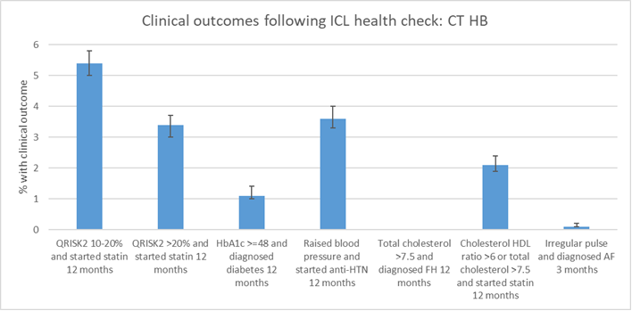
Figure 21: Percentage of those that attended ICL health check that had clinical outcomes following a health check (CT University Health Board)

- The clinical outcome data shows that the most common clinical outcomes identified were:
  - elevated QRISK2 10-20% and started on statin (5.4%).
  - elevated QRISK2>20% and started on statins (3.4%).
  - raised blood pressure and started on anti- HTN medication (3.6%).

- The least common clinical outcomes identified were:
  - raised total cholesterol >7.5 and diagnosed with FH within 12 months (N/A due to <5 people having clinical outcome).
  - irregular pulse and diagnosed with AF within 3 months (0.1%).

Clinical outcomes of people identified as having a clinical risk factor at ICL CVRA
The clinical outcomes were also examined by the number of people who were identified as having the clinical risk factor. The percentages were calculated by dividing the number of people who had a specific clinical outcome by the number of people identified with that risk factor at the health check.
For example, 4,488 people were identified as having a QRISK2 10-20% at a health check. 611 people were identified as having a QRISK2 10-20% and being started on a statin within 12 months. By dividing 611/4,488 it was calculated that 13.6% of people who were found to have a QRISK2 score of 10-20% at the health check were prescribed a statin within 12 months.
 | Proportion of people with QRISK2 10-20% and prescribed statin 12 months | Proportion of people with QRISK2 20% who were prescribed statin at 12 months | Proportion with HbA1c >=48 and diagnosis diabetes 12 months | Proportion with high BP and started anti-HTN in 12 months | Proportion with elevated total cholesterol or cholesterol: HDL ratio and started statin 12 months | Proportion with irregular pulse and diagnosed AF in 3 months
CT | 13.6 (12.6-14.6) | 22.5 (20.6-24.5) | 52.8 (46.6-59.0) | 11.1 (10.1-12.1) | 22.2 (19.8-24.8) | 5.6 (3.4-9.2)
Table 21: Summary of number and percentage of clinical outcomes identified following identification of a clinical risk factor in an ICL health check (CT University Health Board)
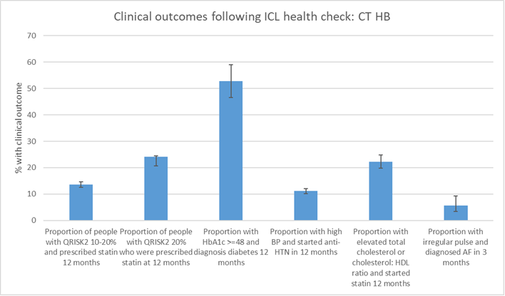
Figure 22: Summary of number and percentage of clinical outcomes identified following identification of a clinical risk factor in an ICL Cardiovascular Risk Assessment (CVRA) (CT University Health Board)

- The most common clinical outcomes for people who were identified as having a clinical risk factor at the health check were:
  - Proportion with HbA1c >=48 at the health check and subsequently diagnosed with diabetes within 12 months (52.8%).
  - Proportion of people with QRISK2 20% at the health check who were subsequently prescribed statin at 12 months (22.5%).
  - Proportion with elevated total cholesterol or cholesterol: HDL ratio at the health check and subsequently started statin at 12 months (22.2%).

- The least common clinical outcomes for people who were identified as having a clinical risk factor at the health check were:
  - Proportion with irregular pulse at the health check and subsequently diagnosed AF in 3 months (5.6%).

- This indicates that some clinical risk factors that are identified at the CVRA are more likely to lead to a clinical diagnosis or medication than other risk factors. This could be because these risk factors are more accurate clinical markers for their relevant condition, or because these risk factors or conditions are more likely to require medication.

Individual Clinical Cascades
The individual clinical cascades are explored more thoroughly individually below. There are five individual cascades for the different risk factors and follow-up pathways:
- Management of high QRISK2 score.
- Management of raised HbA1c / diabetes.
- Management of raised blood pressure / hypertension
- Management of elevated cholesterol / hypercholesterolemia.
- Management of irregular pulse / atrial fibrillation.
Some of these pathways have multiple risk factors (such as raised QRISK2 10-20% and QRISK2 >20%). These will have tables for each risk factor.
Each individual cascade for the different risk factors contains two types of tables:
- Table of the number and proportion of people identified with the clinical risk factor and each of the stages of follow-up for that clinical risk factor.
For example, 4,488 people were identified as having a QRISK2 10-20%, which is 39.3% of the 11,414 people who attended a health check in CT.

- Table of the different clinical outcomes by the number of people with the clinical risk factor. The percentages were calculated by dividing the number of people who had a specific clinical outcome by the number of people identified with that risk factor at the health check.
For example, 4,488 people were identified as having a QRISK2 10-20% at a health check. 4,463 people were identified as having a QRISK2 10-20% and referred back to GP. By dividing 4,463/4,488 it was calculated that 99.4% of people who were found to have a QRISK2 score of 10-20% at the health check were referred back to their GP.

1. Raised QRISK2
 |  | Attended Health Check | QRISK2 10-20% | QRISK2 10-20% and referred back to GP | QRISK2 10-20% and prescribed statin 3 months | QRISK2 10-20% and prescribed statin 6 months | QRISK2 10-20% and prescribed statin 12 months
CT | n | 11,414 | 4,488 | 4,463 | 521 | 560 | 611
CT | % | N/A | 39.3 | 39.1 | 4.6 | 4.9 | 5.4
Table 22: Number and percentage of people with clinical risk factor QRISK2 10-20% and the stages of clinical follow-up (CT University Health Board)

 | QRISK2 10-20% | Proportion of people with QRISK2 10-20% who were referred back to GP  (%) | Proportion of people with QRISK2 10-20% and prescribed statin 3 months  (%) | Proportion of people with QRISK2 10-20% and prescribed statin 6 months  (%) | Proportion of people with QRISK2 10-20% and prescribed statin 12 months  (%)
CT | 4,488 | 99.4 | 11.6 | 12.5 | 13.6
Table 23: Proportion of people with clinical follow-up following identification of clinical risk factor QRISK2 10-20% (CT University Health Board)

 |  | Attended Health Check | QRISK2 >20% | QRISK2 >20% and referred back to GP | QRISK2 >20% and prescribed statin 3 months | QRISK2 >20% and prescribed statin 6 months | QRISK2 20% and prescribed statin 12 months
CT | n | 11,414 | 1,702 | 1,515 | 383 | 399 | 411
CT | % | N/A | 14.9 | 13.3 | 3.4 | 3.5 | 3.6
Table 24: Number and percentage of people with clinical risk factor QRISK2 >20% and the stages of clinical follow-up (CT University Health Board)

 | QRISK2 >20% | Proportion of people with QRISK2 >20% who were referred back to GP  (%) | Proportion of people with QRISK2 >20% who were prescribed statin at 3 months  (%) | Proportion of people with QRISK2 >20% who were prescribed statin at 6 months  (%) | Proportion of people with QRISK2 20% who were prescribed statin at 12 months  (%)
CT | 1,702 | 89.0 | 22.5 | 23.4 | 24.1
Table 25: Proportion of people with clinical follow-up following identification of clinical risk factor QRISK2 >20% (CT University Health Board)

2. Raised HbA1c
 |  | Attended Health Check | HbA1c 42-47 | HbA1c 42-47 and repeat HbA1c in 12 months
CT | n | 11,414 | 1,087 | 1,087
CT | % | N/A | 9.5 | 9.5
Table 26: Number and percentage of people with clinical risk factor HbAa1c 42-47 and the stages of clinical follow-up (CT University Health Board)

 | HbA1c 42-47 | Proportion with HbA1c 42-47 and repeat HbA1c in 12 months  (%)
CT | 1,087 | 100
Table 27: Proportion of people with clinical follow-up following identification of clinical risk factor HbA1c 42-47 (CT University Health Board)

 |  | Attended Health Check | HbA1c >=48 | HbA1c >=48 and referred back to GP in 30 days | HbA1c >=48 and repeat HbA1c in 30 days | HbA1c >=48 and diagnosis diabetes 3 months | HbA1c >=48 and diagnosis diabetes 6 months | HbA1c >=48 and diagnosis diabetes 12 months
CT | n | 11,414 | 246 | 199 | 246 | 116 | 122 | 130
CT | % | N/A | 2.2 | 1.7 | 2.2 | 1.0 | 1.0 | 1.1
Table 28: Number and percentage of people with clinical risk factor HbAa1c >=48 and the stages of clinical follow-up (CT University Health Board)

 | HbA1c >=48 | Proportion with HbA1c >=48 and referred back to GP in 30 days  (%) | Proportion with HbA1c >=48 and repeat HbA1c in 30 days  (%) | Proportion with HbA1c >=48 and diagnosis diabetes 3 months  (%) | Proportion with HbA1c >=48 and diagnosis diabetes 6 months  (%) | Proportion with HbA1c >=48 and diagnosis diabetes 12 months  (%)
CT | 246 | 80.1 | 100 | 47.2 | 49.6 | 52.8
Table 29: Proportion of people with clinical follow-up following identification of clinical risk factor HbA1c >=48 (CT University Health Board)

3. Raised blood pressure
 |  | Attended Health Check | High BP >140 systolic and/or >90 diastolic | High BP and referred back to GP | High BP and repeat BP in 3 months | High BP and repeat BP in 6 months | High BP and repeat BP in 12 months | High BP and started anti-HTN in 3 months | High BP and started anti-HTN in 6 months | High BP and started anti-HTN in 12 months
CT | n | 11,414 | 3,759 | 1,500 | 2,162 | 2,162 | 2,162 | 347 | 379 | 416
CT | % | N/A | 32.9 | 13.1 | 18.9 | 18.9 | 18.9 | 3.0 | 3.3 | 3.6
Table 30: Number and percentage of people with clinical risk factor BP >140 systolic and/or >90 diastolic and the stages of clinical follow-up (CT University Health Board)

 | High BP >140 systolic and/or >90 diastolic | Proportion with high BP and referred back to GP  (%) | Proportion with high BP and repeat BP in 3 months  (%) | Proportion with high BP and repeat BP in 6 months  (%) | Proportion with high BP and repeat BP in 12 months  (%) | Proportion with high BP and started anti-HTN in 3 months  (%) | Proportion with high BP and started anti-HTN in 6 months  (%) | Proportion with high BP and started anti-HTN in 12 months  (%)
CT | 3,759 | 39.9 | 57.5 | 57.5 | 57.5 | 9.2 | 10.1 | 11.1
Table 31: Proportion of people with clinical follow-up following identification of clinical risk factor BP >140 systolic and/or >90 diastolic (CT University Health Board)

4. Raised cholesterol
 |  | Attended Health Check | Total cholesterol >7.5 | Cholesterol :HDL ratio >6 | Elevated total cholesterol or cholesterol: HDL ratio and repeat cholesterol 3 months | Elevated total cholesterol or cholesterol: HDL ratio and repeat cholesterol 6 months | Elevated total cholesterol or cholesterol: HDL ratio and repeat cholesterol 12 months | Elevated total cholesterol or cholesterol: HDL ratio and started statin 3 months | Elevated total cholesterol or cholesterol: HDL ratio and started statin 6 months | Elevated total cholesterol or cholesterol: HDL ratio and started statin 12 months
CT | n | 11,414 | 93 | 987 | 644 | 683 | 727 | 201 | 220 | 240
CT | % | N/A | 0.8 | 8.6 | 5.6 | 6.0 | 6.4 | 1.8 | 1.9 | 2.1
Table 32: Number and percentage of people with clinical risk factors total cholesterol >7.5 or cholesterol: HDL ratio >6 and the stages of clinical follow-up (CT University Health Board)

 | Total cholesterol >7.5 or cholesterol :HDL ratio >6 | Proportion with elevated total cholesterol or cholesterol: HDL ratio and repeat cholesterol 3 months  (%) | Proportion with elevated total cholesterol or cholesterol: HDL ratio and repeat cholesterol 6 months  (%) | Proportion with elevated total cholesterol or cholesterol: HDL ratio and repeat cholesterol 12 months  (%) | Proportion with elevated total cholesterol or cholesterol: HDL ratio and started statin 3 months  (%) | Proportion with elevated total cholesterol or cholesterol: HDL ratio and started statin 6 months  (%) | Proportion with elevated total cholesterol or cholesterol: HDL ratio and started statin 12 months  (%)
CT | 1,080 | 59.6 | 63.2 | 67.3 | 18.6 | 20.4 | 22.2
Table 33: Proportion of people with clinical follow-up following identification of clinical risk factors total cholesterol >7.5 or cholesterol: HDL ratio >6 (CT University Health Board)

 |  | Attended Health Check | Total cholesterol >7.5 | Total cholesterol >7.5 and diagnosed FH | Total cholesterol >7.5, diagnosed FH and started statin
CT | n | 11,414 | 93 | <5 | <5
CT | % | N/A | 0.8 | <5 | <5
Table 34: Number and percentage of people with clinical risk factor total cholesterol >7.5 and the stages of clinical follow-up for the FH pathway (CT University Health Board)

5. Irregular pulse
 |  | Attended Health Check | Irregular pulse | Irregular pulse and referred to GP | Irregular pulse and ECG in 3 months | Irregular pulse and diagnosed AF in 3 months
CT | n | 11,414 | 249 | 232 | 167 | 14
CT | % | N/A | 2.2 | 2.0 | 1.5 | 0.1
Table 35: Number and percentage of people with clinical risk factor irregular pulse and the stages of clinical follow-up (CT University Health Board)

 | Irregular pulse | Proportion with irregular pulse and referred to GP  (%) | Proportion with irregular pulse and ECG in 3 months  (%) | Proportion with irregular pulse and diagnosed AF in 3 months  (%)
CT | 249 | 93.2 | 67.1 | 5.6
Table 36: Proportion of people with clinical follow-up following identification of clinical risk factor irregular pulse (CT University Health Board)
- The individual cascades demonstrate that the proportion of people coded as being referred back to the GP following identification of clinical risk factors varied from 39.9% of those with elevated BP being referred back to GP to 99.4% of people with QRISK2 10-20%. This code was identified to be inconsistently used at the point of CVRA of the ICL programme and so little can be inferred from this.

- The individual cascades show that most follow up occurs within first 3 months with small increase in follow-up activity over time for many of the clinical cascades. For example, the proportion of people with raised HbA1c that went on to be diagnosed with diabetes was 47.2% at 3 months, 49.6% at 6 months, and 52.8% at 12 months after the health check.
Lifestyle cascades


Figure 23: Process flow diagram of the Lifestyle Cascades
*Data for completing NERS is from NERS dataset which was linked with the ICL dataset in SAIL

As shown in Figure 23 there were four lifestyle cascades:
- Smoking and smoking cessation.
- Overweight or obese and weight management.
- Physical inactivity and exercise referral.
- Excess alcohol consumption and alcohol services.

Lifestyle Risk Factors
There are four lifestyle risk factors of interest that were identified during the CVRA/health check. Some of these risk factors are split into multiple results (e.g. BMI 25-30 and BMI >30) giving a total six risk factor findings. These risk factors are:
- Current smoker.
- Overweight or obese:
  - BMI 25-30 (overweight).
  - BMI >30 (obese).
- Physical activity levels classified as inactive, moderately inactive or moderately active.
- High alcohol or very high alcohol intake:
  - Audit score >=8 (high alcohol intake).
  - Audit score >=16 (very high alcohol intake).

The lifestyle risk factors were not mutually exclusive, so an individual could have been a current smoker, been overweight, had low physical activity and had high alcohol intake. However, some of the categories within the lifestyle risk factors were mutually exclusive. An individual could either be identified as being overweight (BMI 25-30) or obese (BMI >30) but could not have both of these lifestyle risk factors.
All of these lifestyle risk factors, apart from BMI, are self-reported, which may mean that they under-estimate the true proportion of people with these lifestyle risk factors. Research has shown that self-reported studies routinely under-estimate the proportion of people with potentially harmful lifestyle behaviours such as high levels of alcohol consumption or low levels of physical activity (Livingston and Callinan 2015; Prince et al 2020). This can be due to multiple reasons, such as respondents not recognising or accurately remembering their actions, or the social desirability bias.

 |  | Attended Health Check | Current Smoker | BMI 25-30 | BMI >30 | Low physical activity | High alcohol Audit >=8 | Very high alcohol Audit >=16
CT | n | 11,414 | 2,323 | 5,085 | 3,782 | 7,855 | 1,987 | 96
CT | % | N/A | 20.4 (19.6-21.1) | 44.6 (43.6-45.5) | 33.1 (32.3-34.0) | 68.8 (68.0-69.7) | 17.4 (16.7-18.1) | 0.8 (0.7-1.0)
Table 37: Summary of lifestyle risk factors identified by Health Checks (CT University Health Board)

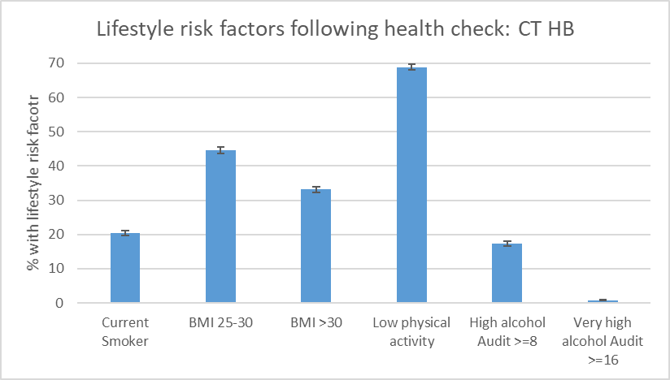
Figure 24: Summary of lifestyle risk factors identified during CVRA (CT University Health Board)
- The most common lifestyle risk factors identified were:
  - low physical activity (61.5%).
  - BMI 25-30 (44.0%).
  - BMI >30 (33.7%).

- The least common lifestyle risk factor identified was very high alcohol Audit >=16 (0.8%).

- Examining the risk factors which are mutually exclusive you can see that 77.7% of people were either overweight (BMI 25-30) or obese (BMI >30).

Lifestyle outcomes
The outcomes of the lifestyle cascades were “to be given lifestyle advice” or “to be referred to a lifestyle programme” or both. Everyone who was identified as having the lifestyle risk factor was eligible for lifestyle advice, however only some of the people with the lifestyle risk factor were eligible for lifestyle programme referral. For example, everyone with Audit >=8 was eligible for alcohol advice, but only those with Audit >=16 were eligible for alcohol service referral. Also there are different referral criteria for specific NERS programmes, based on low levels of physical activity and whether this is combined with other risk factors for chronic disease. People were also able to decline referral to a lifestyle service if they did not want to be referred.
Unlike the clinical outcome, most of the lifestyle outcomes would have happened at the time of the CVRA, including providing lifestyle advice or referring to lifestyle programme. However, some of these lifestyle outcomes also had various time limits. For example, referred to NERS at 3 months, 6 months or 12 months and completed NERS at 6 months and 12 months after the health check. (As NERS is a 16-week course we did not look at completed NERS within 3 months of a health check, as this would not have been possible given the length of the course). For this table we have taken the data for 12 months to show the maximum number of people who had each of the lifestyle outcomes.
The outcomes of the lifestyle cascades are:
- Current smoker:
  - Smoker and given smoking cessation advice.
  - Smoker and referred to smoking cessation service.

- Overweight (BMI 25-30) or obese (BMI >30):
  - Overweight or obese and given weight management advice.
  - Overweight or obese and referred to weight management service.

- Low physical activity:
  - Low physical activity and given physical activity advice.
  - Low physical activity and referred to the National Exercise Referral Scheme (NERS).
  - Low physical activity and completed NERS*.

- High (Audit>=8) or very high (Audit >=16) alcohol intake:
  - High alcohol (Audit >=8) and given alcohol advice.
  - Very high alcohol (Audit >=16) and referred to alcohol service.

*The data on completion of NERS came from the NERS programme data which was linked to the ICL dataset in SAIL. This was the only lifestyle programme which we were able to link in SAIL, and therefore get data on the outcome of the lifestyle programme referral.
The lifestyle outcomes were not mutually exclusive, so an individual could be a current smoker and be given lifestyle advice and referred to a smoking cessation service, be overweight or obese and given weight management advice and referred to a weight management service, have low physical activity and be given physical activity advice and be referred to NERS, and have very high alcohol intake and be given alcohol advice and been referred to alcohol services.
Lifestyle advice
The lifestyle advice outcomes were firstly examined for all the people who attended a CVRA in CT. The percentages were calculated by dividing the number of people with the clinical outcome by 11,414 (the total number of people who attended a health check in CT).
 |  | Attended Health Check | Smoker and given smoking cessation advice | Overweight or obese and given weight management advice | Low physical activity and given physical activity advice | Alcohol audit >=8 and given alcohol advice
CT | n | 11,414 | 2,278 | 7,658 | 7,217 | 1,786
CT | % | N/A | 20.0 (19.2-20.7) | 67.1 (66.2-68.0) | 63.2 (62.3-64.1) | 15.6 (15.0-16.3)
Table 38: Summary of lifestyle advice given following Health Checks (CT University Health Board)
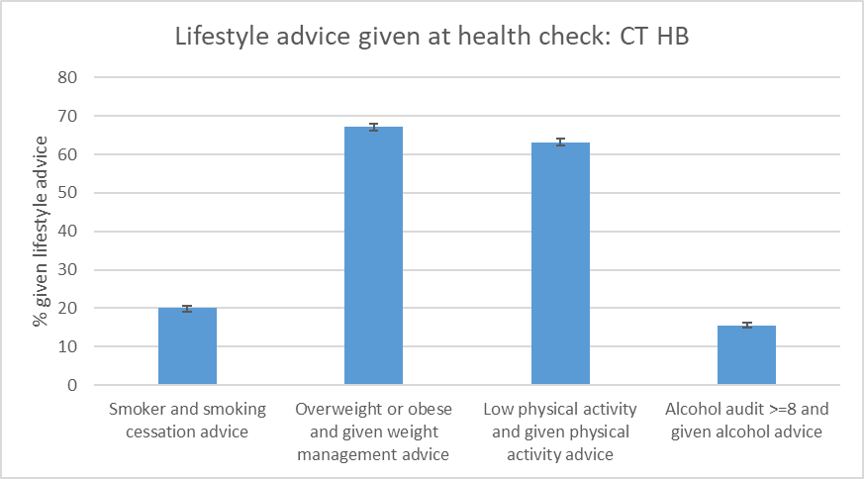
Figure 25: Summary of lifestyle advice given following Health Checks (CT University Health Board)
- The data shows that the most common lifestyle advice identified were:
  - overweight or obese and given weight management advice (67.1%).
  - low physical activity and given physical activity advice (63.2%).
- The least common lifestyle advice identified were:
  - Smoker and given smoking cessation advice (20.0%).
  - High alcohol (audit >=8) and given alcohol advice (15.6%).
- This follows the same pattern as lifestyle risk factors identified, with the more prevalent lifestyle risk factors having a higher percentage of people given lifestyle advice.

It is worth noting that it is not possible for the SAIL analysis to assess the effectiveness of providing lifestyle advice at the CVRA on lifestyle risk factors for people who smoke, are overweight or obese, have low physical activity or high alcohol intake. The SAIL analysis is able to identify READ codes that capture that lifestyle advice was provided to people that attended the health check, but due to the lack of subsequent consistent follow-up it was not possible to use SAIL to assess if this impacted on smoking status, BMI, physical activity or alcohol intake.

Lifestyle programme referral
The lifestyle programme referral outcomes were firstly examined for all the people who attended the an ICL health check in CT. The percentages were calculated by dividing the number of people with the clinical outcome by 11,414 (the total number of people who attended a health check in CT).
 |  | Attended Health Check | Smoker and smoking cessation referral | Overweight or obese and referred to weight management service | Low physical activity and referred to NERS | Low physical activity and completed NERS* | Alcohol Audit >=16 and referred to alcohol service
CT | n | 11,414 | 1,101 | 947 | 1,678 | 245 | 33
CT | % | N/A | 9.6 (9.1-10.2) | 8.3 (7.8-8.8) | 14.7 (14.1-15.4) | 2.1 (1.9-2.4) | 0.3 (0.2-0.4)
Table 39: Summary of lifestyle programme referral and completion following Health Checks (CT University Health Board) * Data for completing NERS is from NERS dataset which was linked with the ICL dataset in SAIL
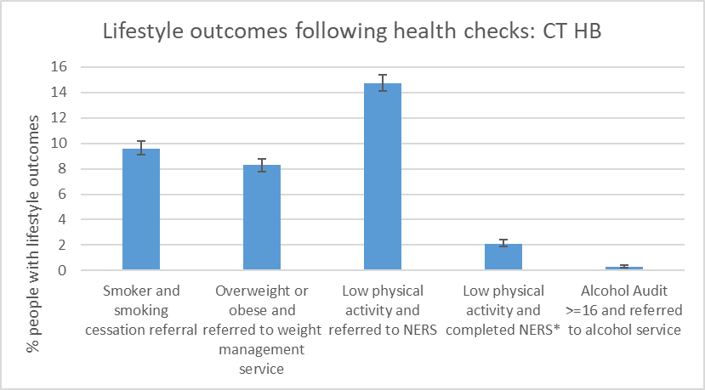
Figure 26: Summary of lifestyle programme referral and completion following CVRA (CT University Health Board) *Data for completing NERS is from NERS dataset which was linked with the ICL dataset in SAIL
- The data shows that the most common lifestyle programmes referred to were:
  - low physical activity and referred to NERS (14.7%).
  - Smoker and referred to smoking cessation (9.6%).
  - Overweight or obese and referred to weight management (8.3%).
- The least common lifestyle programme referred to was:
  - Very high alcohol (audit >=16) and referred to alcohol service (0.3%).
- This follows a similar pattern as lifestyle risk factors identified, with the more prevalent lifestyle risk factors having a higher percentage of people referred to lifestyle services. However, a far lower proportion identified with lifestyle risk factors were referred to lifestyle services compared to those that received lifestyle advice. This could be for multiple reasons, including people declining referral to lifestyle services, or people not meeting the threshold for referral to a lifestyle service.
- Data from the NERS programme was linked to the ICL data in SAIL, which was able to show that 2.1% (95% CI 1.9-2.4) or people in CT who attended a health check were identified as having low physical activity, were referred to NERS, and subsequently completed the NERS programme within 12 months of the health check.

Lifestyle outcomes of people identified as having a lifestyle risk factor at ICL health check
Lifestyle advice
The lifestyle advice outcomes were also examined by the number of people who were identified as having the lifestyle risk factor. The percentages were calculated by dividing the number of people who had a specific lifestyle outcome by the number of people identified with that risk factor at the health check.
For example, 2,323 people were identified as being current smokers at CVRA. 2,278 people were identified as being current smokers and given smoking cessation advice. By dividing 2,278/2,323 it was calculated that 98.1% of people who were found to be current smokers were given smoking cessation advice.
 | Proportion of smokers given smoking cessation advice  (%) | Proportion of overweight or obese given weight management advice  (%) | Proportion with low physical activity given exercise advice  (%) | AUDIT-C >=8 and given alcohol advice  (%)
CT | 98.1 (97.4-98.6) | 86.4 (85.6-87.1) | 91.9 (91.3-92.5) | 89.9 (88.5-91.1)
Table 40: Proportion of people with lifestyle risk factor given lifestyle advice (CT University Health Board)

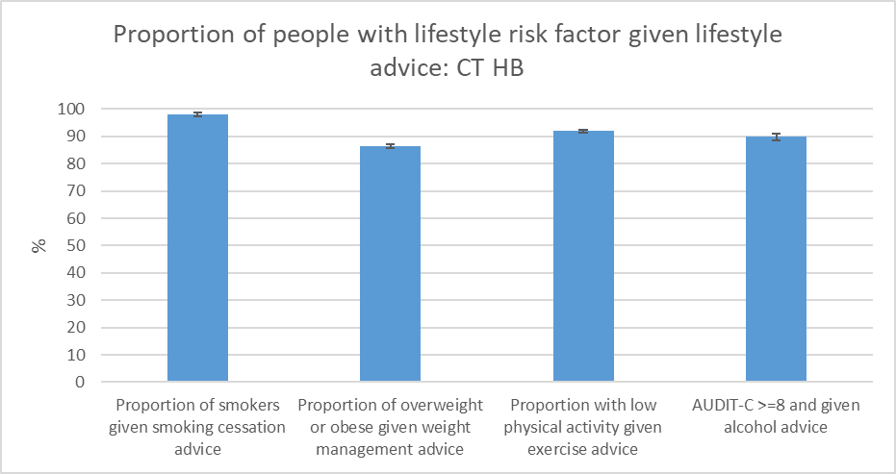
Figure 27: Proportion of people with lifestyle risk factor given lifestyle advice (CT University Health Board)
- For all lifestyle risk factors there was a very high proportion of people identified with that risk factor who were given lifestyle advice. For all lifestyle risk factors over 85% of people identified with that risk factor were given lifestyle advice. This indicates that the vast majority of people who are identified as having a lifestyle risk factor are given lifestyle advice at the health check.

- There could be many reasons why someone who has been identified as having a lifestyle risk factor is not recorded as being given lifestyle advice such as either the risk factor or lifestyle advice not being appropriately recorded during the CVRA, or the person declining to receive lifestyle advice on a specific lifestyle risk factor.

Lifestyle service referral or completion
The lifestyle service referral outcomes were also examined by the number of people who were identified as having the lifestyle risk factor. The percentages were calculated by dividing the number of people who had a specific lifestyle outcome by the number of people identified with that risk factor at the health check.
For example, 2,323 people were identified as being current smokers a health check. 1,101 people were identified as being current smokers and referred to smoking cessation referral services. By dividing 1,101/2,323 it was calculated that 47.4% of people who were found to be current smokers were given smoking cessation referral.
 | Proportion of smokers given smoking cessation referral  (%) | Proportion of overweight or obese given weight management referral  (%) | Proportion with low physical activity and exercise referral  (%) | Proportion with low physical activity and NERS referral 12 months*  (%) | Proportion with low physical activity and completed NERS 12 months*  (%) | Proportion with AUDIT-C >=16 and referred to alcohol services  (%)
CT | 47.4 (45.4-49.4) | 10.7 (10.1-11.3) | 21.4 (20.5-22.3) | 10.7 (10.0-11.4) | 3.1 (2.8-3.5) | 34.4 (25.6-44.3)
Table 41: Proportion of people with lifestyle risk factor with lifestyle service referrals or completion (CT University Health Board)
* Data for completing NERS is from NERS dataset which was linked with the ICL dataset in SAIL

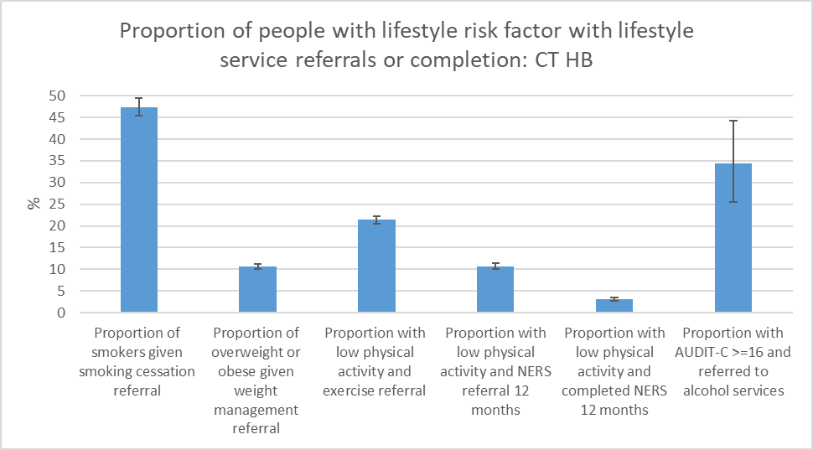
Figure 28: Proportion of people with lifestyle risk factor with lifestyle service referrals or completion (CT University Health Board). * Data for completing NERS is from NERS dataset which was linked with the ICL dataset in SAIL

- The proportion of people with lifestyle risk factors who were given lifestyle service referrals varied a lot between different risk factors.

- The most common lifestyle service referral for people with lifestyle risk factors were:
  - Current smokers identified at health check and given smoking cessation referral (47.4%)
  - People identified as AUDIT-C >=16 at health check and referred to alcohol services (34.4%)

- The least common lifestyle service referral for people with lifestyle risk factors were:
  - Overweight or obese identified at health check and given weight management referral (10.7%)

- This indicates that the majority of people in both CT who are identified as having a lifestyle risk factor were not referred to lifestyle service. There could be many reasons why someone who has been identified as having a lifestyle risk factor is not recorded as being referred to lifestyle service such as either the risk factor or lifestyle advice not being appropriately recorded during the CVRA, the person not being eligible for lifestyle services (i.e. not meeting referral criteria) or the person declining referral to the lifestyle service. Also there could be inadequate lifestyle support provision available, which was found to be the case for weight management support during the study period

- In CT there is linked NERS data which shows the outcome for people referred to NERS due to low physical activity. This shows that 10.7% (95% CI 10.0-11.4) of people who have low physical activity during CVRA were referred to NERS, whilst 3.1% (95% CI 2.8-3.5) who have low physical activity complete NERS. This indicates that just under 1 in 3 people who were referred to NERS (10.7% referred) ended up completing NERS (3.1% completed).

- We do not have direct data comparing these results with the wider NERS programme. However, we do know that normally around 25% of people who start the NERS programme reach the 16-week completion.

- We don’t have linked data for the outcomes of other lifestyle programmes, but this indicates that it is possible that a significant proportion of people who are referred to lifestyle services may not complete the lifestyle programme.

Individual lifestyle cascades
The individual lifestyle cascades are explored more thoroughly individually below. There are four individual cascades for the different risk factors and follow-up pathways:
- Smoking and smoking cessation
- Overweight or obese and weight management
- Physical inactivity and exercise referral
- Excess alcohol consumption and alcohol services

Some of these pathways have multiple risk factors (such as alcohol consumption: AUDIT-C >=8 and AUDIT-C>=16) These will have tables for each risk factor.
Each individual cascade for the different risk factors contains two types of tables:
- Table of the number and proportion of people identified with the lifestyle risk factor and each of the stages of follow-up for that lifestyle risk factor.
For example, 2,323 people were identified as being a current smoker which is 20.4% of the 11,414 people who attended a health check in CT.
- Table of the different clinical outcomes by the number of people with the clinical risk factor. The percentages were calculated by dividing the number of people who had a specific clinical outcome by the number of people identified with that risk factor at the health check.
For example, 2,323 people were identified as being a current smoker at a health check. 2,278 people were identified as being smokers and given smoking cessation advice. By dividing 2,278/2,323 it was calculated that 98.1% of people who were current smokers were given smoking cessation advice.

1. Smoking
 |  | Attended Health Check | Current smoker | Smoker and smoking cessation advice | Smoker and smoking cessation referral | Smoker and smoking cessation referral declined
CT | n | 11,414 | 2,323 | 2,278 | 1,101 | 914
CT | % | N/A | 20.4 | 20.0 | 9.6 | 8.0
Table 42: Number and percentage of people with lifestyle risk factor current smoker and the stages of lifestyle follow-up (CT University Health Board)

 | Current smoker | Proportion of smokers given smoking cessation advice  (%) | Proportion of smokers given smoking cessation referral  (%) | Proportion of smokers and smoking cessation referral declined  (%)
CT | 2,323 | 98.1 | 47.4 | 39.3
Table 43: Proportion of people with lifestyle follow-up following identification of lifestyle risk factor current smoker (CT University Health Board)

2. Overweight and obese
 |  | Attended Health Check | Overweight (BMI 25-30) | Obese  (BMI >30) | Overweight or obese | Overweight or obese and weight management advice | Overweight or obese and weight management referral | Overweight or obese and weight management referral declined
CT | n | 11,414 | 5,085 | 3,782 | 8,867 | 7,658 | 947 | 295
CT | % | N/A | 44.6 | 33.1 | 77.7 | 67.1 | 8.3 | 2.6
Table 44: Number and percentage of people with lifestyle risk factors overweight or obese and the stages of lifestyle follow-up (CT University Health Board)

 | Overweight or obese | Proportion of overweight or obese given weight management advice  (%) | Proportion of overweight or obese given weight management referral  (%) | Proportion of overweight or obese and weight management referral declined  (%)
CT | 8,867 | 86.4 | 10.7 | 3.3
Table 45: Proportion of people with lifestyle follow-up following identification of lifestyle risk factors overweight or obese (CT University Health Board)

3. Low physical activity
 |  | Attended Health Check | Low physical activity | Low physical activity and exercise advice | Low physical activity and exercise referral | Low physical activity and exercise referral declined
CT | n | 11414 | 7855 | 7217 | 1678 | 3377
CT | % | N/A | 68.8 | 63.2 | 14.7 | 29.6
Table 46: Number and percentage of people with lifestyle risk factor low physical activity and the stages of lifestyle follow-up (CT University Health Board)

 | Low physical activity | Proportion with low physical activity given exercise advice  (%) | Proportion with low physical activity and exercise referral  (%) | Proportion with low physical activity and exercise referral declined  (%)
CT | 7855 | 91.9 | 21.4 | 43.0
Table 47: Proportion of people with lifestyle follow-up following identification of lifestyle risk factor low physical activity (CT University Health Board)

 |  | Attended Health Check | Low physical activity and NERS referral 3 months* | Low physical activity and NERS referral 6 months* | Low physical activity and NERS referral 12 months* | Low physical activity and completed NERS 6 months* | Low physical activity and completed NERS 12 months*
CT | n | 11414 | 785 | 817 | 839 | 233 | 245
CT | % | N/A | 6.9 | 7.2 | 7.4 | 2.0 | 2.1
Table 48: Number and percentage of people with lifestyle risk factor low physical activity and the stages of lifestyle follow-up (CT University Health Board) * Data for NERS is from NERS dataset which was linked with the ICL dataset in SAIL

 | Low physical activity | Proportion with low physical activity and NERS referral 3 months  (%) | Proportion with low physical activity and NERS referral 6 months  (%) | Proportion with low physical activity and NERS referral 12 months  (%) | Proportion with low physical activity and completed NERS 6 months  (%) | Proportion with low physical activity and completed NERS 12 months  (%)
CT | 7855 | 10.0 | 10.4 | 10.7 | 3.0 | 3.1
Table 49: Proportion of people with lifestyle follow-up following identification of lifestyle risk factor low physical activity (CT University Health Board) * Data for NERS is from NERS dataset which was linked with the ICL dataset in SAIL

4. High alcohol intake
 |  | Attended Health Check | High alcohol AUDIT-C >=8 | AUDIT-C >=8 and given alcohol advice
CT | n | 11414 | 1987 | 1786
CT | % | N/A | 17.4 | 15.6
Table 50: Number and percentage of people with lifestyle risk factor high alcohol AUDIT-C >=8 and the stages of lifestyle follow-up (CT University Health Board)

 | High alcohol AUDIT-C >=8 | AUDIT-C >=8 and given alcohol advice
CT | 1987 | 89.9
Table 51: Proportion of people with lifestyle follow-up following identification of lifestyle risk factor high alcohol AUDIT-C >=8 (CT University Health Board)

 |  | Attended Health Check | Very high alcohol AUDIT-C >=16 | AUDIT-C >=16 and referred to alcohol services | AUDIT-C >=16 and declined referral to alcohol services
CT | n | 11414 | 96 | 33 | 33
CT | % | N/A | 0.8 | 0.3 | 0.3
Table 52: Number and percentage of people with lifestyle risk factor very high alcohol AUDIT-C >=16 and the stages of lifestyle follow-up (CT University Health Board)

 | Very high alcohol AUDIT-C >=16 | Proportion with AUDIT-C >=16 and referred to alcohol services  (%) | Proportion with AUDIT-C >=16 and declined referral to alcohol services  (%)
CT | 96 | 34.4 | 34.4
Table 53: Proportion of people with lifestyle follow-up following identification of lifestyle risk factor very high alcohol AUDIT-C >=16 (CT University Health Board)

- The individual lifestyle cascades show that a high proportion of people who are identified with lifestyle risk factors are provided with lifestyle advice compared to the proportion referred to lifestyle services. For example, 98.1% of smokers are given smoking advice whilst only 47.4% of smokers are referred to smoking cessation services. However, as mentioned above some people who were identified with some lifestyle risk factors would not have been eligible (met referral criteria) for referral to specific lifestyle services within CT. It also does not capture the reasons that people declined referrals, for example if they were identified with multiple risk factors and chose to accept referral to one lifestyle service.

- CTM changed to an opt out-system from the previous opt-in system of referrals for HMQ smoking cessation services, which led to an increase in HMQ referrals. However, due to this change in HMQ referral in CTM happening partway through the SAIL data analysis period, this is not captured in the SAIL data.

- The individual cascades also recorded the number of people who declined referral to services, for example 39.3% of smokers declined smoking cessation service referral. However, for most cascades this still left some people who were identified with the risk factor who were not recorded as either the referred to services or declined referral. For example, out of 2,032 smokers 1,101 were referred to smoking cessation services and 914 declined a referral to smoking cessation services. This leaves 308 smokers who are not recorded as either being referred or declining referral. This may be due to inaccurate recording or referrals or referrals being declined, or due to differences in eligibility criteria for some lifestyle risk factors. In early 2019, referral to smoking cessation support changed from an opt-in to an opt-out decision which increased referral rates.

Effect of age, sex and deprivation on clinical and lifestyle cascades
Clinical and lifestyle risk factors by deprivation
The prevalence of key clinical and lifestyle risk factors and management was examined by deprivation quintiles. These were chosen as risk factors with a higher prevalence in the CT population in order to allow for further analysis by deprivation quintile. This analysis was undertaken for CT only. The attended figures are the people who attended a health check from CT.
 |  | Attended health check | HbA1c 42-47 | HbA1c >48 | Elevated BP (>140 systolic and/or >90 diastolic) | Current smoker | Overweight (BMI 25-30) | Obese (BMI >30) | Low physical activity
Q1 (most deprived) | n | 3571 | 363 | 87 | 1,251 | 945 | 1,517 | 1,209 | 2,549
Q1 (most deprived) | % | N/A | 10.2 (9.2-11.2) | 2.4 (2.0-3.0) | 35.0 (33.5-36.6) | 26.5 (25.0-27.9) | 42.5 (40.9-44.1) | 33.9 (32.3-35.4) | 71.4 (69.9-72.8)
Q2 | n | 4353 | 402 | 91 | 1,357 | 859 | 1,981 | 1,479 | 2,994
Q2 | % | N/A | 9.2 (8.4-10.1) | 2.1 (1.7-2.6) | 31.2 (29.8-32.6) | 19.7 (18.6-20.9) | 45.5 (44.0-47.0) | 34.0 (32.6-35.4) | 68.8 (67.4-70.1)
Q3 | n | 1744 | 161 | 35 | 605 | 278 | 777 | 566 | 1,151
 | % | N/A | 9.2 (8.0-10.7) | 2.0 (1.5-2.8) | 34.7 (32.5-37.0) | 15.9 (14.3-17.7) | 44.5 (42.2-46.9) | 32.5 (30.3-34.7) | 66.0 (63.7-68.2)
Q4 | n | 763 | 61 | 15 | 236 | 99 | 356 | 225 | 483
 | % | N/A | 8.0 (6.3-10.1) | 2.0 (1.2-3.2) | 30.9 (27.8-34.3) | 13.0 (10.8-15.6) | 46.7 (43.2-50.2) | 29.5 (26.4-32.8) | 63.3 (59.8-66.7)
Q5 (least deprived) | n | 591 | 71 | 11 | 200 | 74 | 290 | 169 | 422
 | % | N/A | 12.0 (9.6-14.9) | 1.9 (1.0-3.3) | 33.8 (30.1-37.8) | 12.5 (10.1-15.4) | 49.1 (45.1-53.1) | 28.6 (25.1-32.4) | 71.4 (67.6-74.9)
Table 54: Clinical and lifestyle risk factors by deprivation quintile (CT University Health Board)

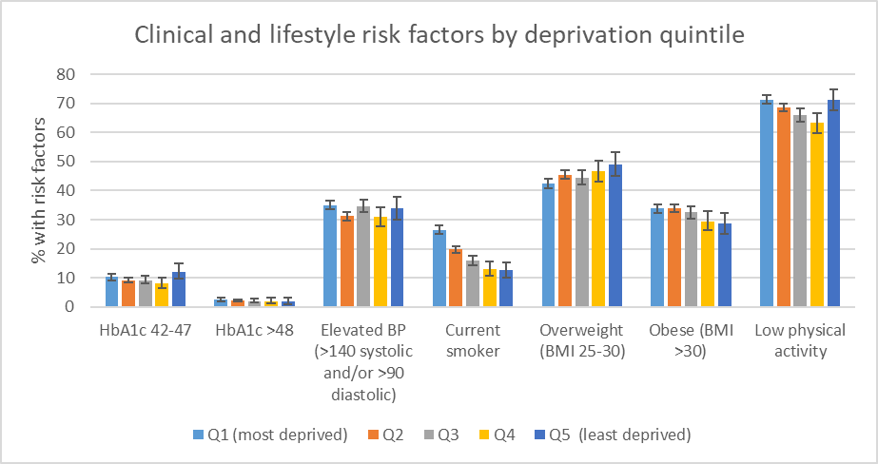
Figure 29: Clinical and lifestyle risk factors by deprivation quintile (CT University Health Board)

- There is no clear pattern for the clinical risk factors of elevated HbA1c 42-47 or >48 or elevated BP (>140 systolic and/or >90 diastolic).

- There is a clearer pattern for lifestyle risk factors, particularly smoking. 26.5% (95% CI 25.0-27.9) of people in Q1 (most deprived) were current smokers, whilst only 12.5% (95% CI 10.1-15.4) of people in Q5 (least deprived) smoked. This shows a clear relationship between deprivation levels and prevalence of smoking.

- Low physical activity showed a similar relationship of higher levels of physical inactivity in Q1 which slowly decreased to Q4. However, the highest levels of physical inactivity were in Q5.

- The overweight and obese findings were also interesting as they showed the opposite patterns. The proportion of people who were overweight was lowest in Q1 and highest in Q5, whilst the proportion of people who were obese was lowest in Q5 and highest in Q1. However, the difference is only statistically significant between Q1 and Q5 for overweight people, and not statistically significantly different between the different quintiles for obese people.

Clinical and lifestyle management by deprivation
The clinical and lifestyle management by deprivation contains two types of tables:
- Table of the number and proportion of people identified with the clinical or lifestyle risk factor and each of the stages of follow-up for that clinical or lifestyle risk factor by deprivation quintile.
For example, 75 people in Q1 (most deprived) were identified as having an HbA1c of >48 and were referred to the GP which is 2.1% of the 3,571 people in Q1 who attended a health check in CT.

- Table of the different clinical or lifestyle outcomes by the number of people with the clinical or lifestyle risk factor by deprivation quintile. The percentages were calculated by dividing the number of people who had a specific clinical or lifestyle outcome by the number of people identified with that clinical or lifestyle risk factor at the health check.
For example, 86.2% of people in Q1 (most deprived) who were identified as having a HbA1c of >48 were subsequently referred to a GP.

 |  | Attended health check | HbA1c >48 and referred to GP | Elevated BP and on anti-HTN medication at 12 months | Smoker and referred to smoking cessation | Low physical activity and exercise referral | Low physical activity and NERS referral* | Low physical activity and completed NERS*
Q1 (most deprived) | n | 3571 | 75 | 149 | 428 | 512 | 264 | 71
 | % | N/A | 2.1 (1.7-2.6) | 4.2 (3.6-4.9) | 12.0 (11.0-13.1) | 14.3 (13.2-15.5) | 7.4 (6.6-8.3) | 2.0 (1.6-2.5)
Q2 | n | 4353 | 75 | 134 | 411 | 599 | 282 | 85
 | % | N/A | 1.7 (1.4-2.2) | 3.1 (2.6-3.6) | 9.4 (8.6-10.3) | 13.8 (12.8-14.8) | 6.5 (5.8-7.3) | 2.0 (1.6-2.4)
Q3 | n | 1744 | 24 | 75 | 155 | 310 | 151 | 53
 | % | N/A | 1.4 (0.9-2.0) | 4.3 (3.4-5.4) | 8.9 (7.6-10.3) | 17.8 (16.1-19.6) | 8.7 (7.4-10.1) | 3.0 (2.3-4.0)
Q4 | n | 763 | 12 | 23 | 45 | 113 | 65 | 18
 | % | N/A | 1.6 (1.0-2.7) | 3.0 (2.0-4.5) | 5.9 (4.4-7.8) | 14.8 (12.5-17.5) | 8.5 (6.7-10.7) | 2.4 (1.5-3.7)
Q5 (least deprived) | n | 591 | 7 | 27 | 33 | 101 | 53 | 11
 | % | N/A | 1.2 (0.6-2.4) | 4.6 (3.2-6.6) | 5.6 (4.0-7.7) | 17.1 (14.3-20.3) | 9.0 (6.9-11.6) | 1.9 (1.0-3.3)
Table 55: Clinical and lifestyle management by deprivation quintile (CT University Health Board) * Data from the NERS dataset which was linked to ICL dataset in NERS.

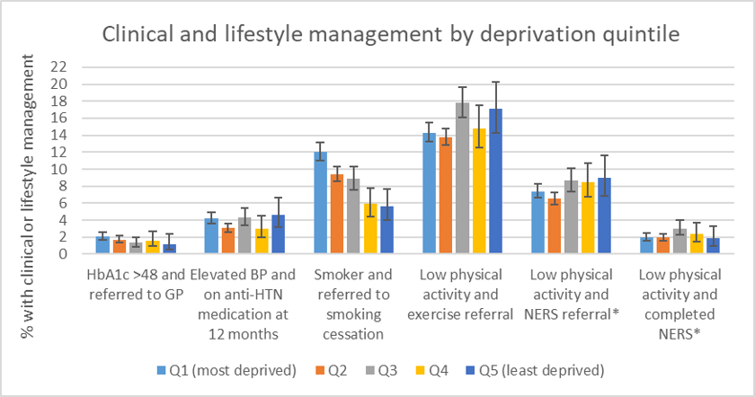
Figure 30: Clinical and lifestyle management by deprivation quintile (CT University Health Board)

- There is no clear relationship between quintile of deprivation and most areas of clinical and lifestyle management by deprivation quintile.

- This is likely to be due to the fact that there wasn’t a clear correlation between many of the clinical and lifestyle risk factors and deprivation, so there is no relationship of the management of these conditions.

- The only exception is for smoking, which shows the highest referral to smoking cessation in the most deprived (Q1) and the lowest in the least deprived (Q5). There is a statistically significant difference in smoking cessation referral between the most deprived quintiles (Q1 and Q2) and the least deprived quintiles (Q4 and Q5), which is not seen for any other clinical or lifestyle risk factor. This is likely to reflect that a much higher proportion of people in Q1 are current smokers compared to Q5.

 | Proportion of those with HbA1c >48 that were referred to the GP  (%) | Proportion of those with elevated BP that were prescribed anti-HTN medication at 12 months  (%) | Proportion of current smokers that were referred to smoking cessation services  (%) | Proportion of people with low physical activity that were referred to exercise referral  (%) | Proportion of people with low physical activity that were referred to NERS*  (%) | Proportion of people with low physical activity that completed NERS*  (%)
Q1 (most deprived) | 86.2 (77.4-91.9) | 11.9 (10.2-13.8) | 45.3 (42.1-48.5) | 20.1 (18.6-21.7) | 10.4 (9.2-11.6) | 2.8 (2.2-3.5)
Q2 | 82.4 (73.3-88.9) | 9.9 (8.4-11.6) | 47.8 (44.5-51.2) | 20.0 (18.6-21.5) | 9.4 (8.4-10.5) | 2.8 (2.3-3.5)
Q3 | 68.6 (52.0-81.5) | 12.4 (10.0-15.3) | 55.8 (49.9-61.5) | 26.9 (24.5-29.6) | 13.1 (11.3-15.2) | 4.6 (3.5-6.0)
Q4 | 80.0 (54.8-93.0) | 9.7 (6.6-14.2) | 45.5 (36.0-55.2) | 23.4 (19.8-27.4) | 13.5 (10.7-16.8) | 3.7 (2.4-5.8)
Q5 (least deprived) | 63.6 (35.4-84.8) | 13.5 (9.5-18.9) | 44.6 (33.8-55.9) | 23.9 (20.1-28.2) | 12.6 (9.7-16.1) | 2.6 (1.5-4.6)
Table 56: Proportion of people with clinical or lifestyle risk factor that received a relevant clinical or lifestyle outcome by deprivation quintile (CT University Health Board) *Data from the NERS dataset which was linked to ICL dataset in SAIL

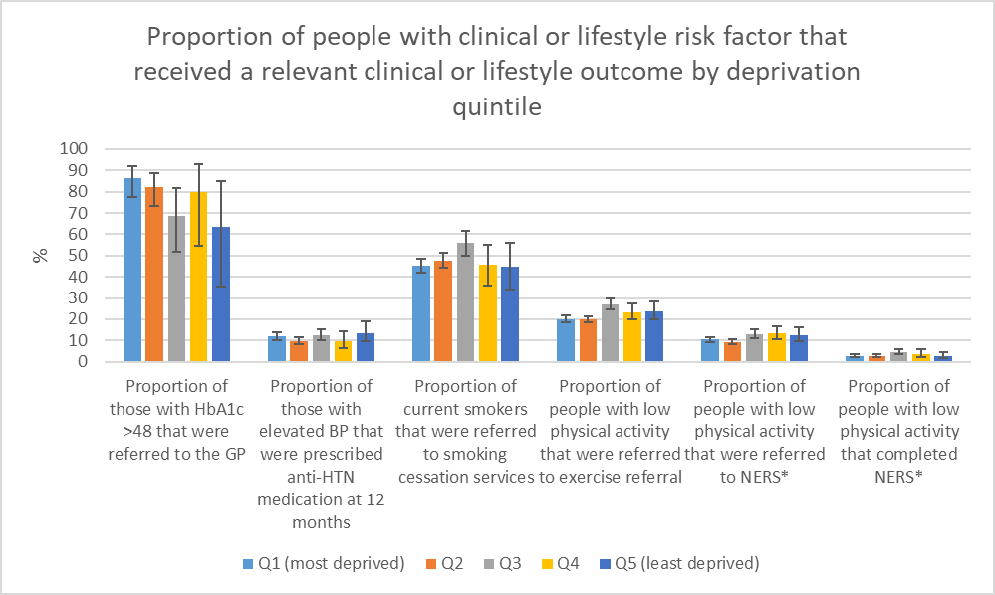
Figure 31: Proportion of people with clinical or lifestyle risk factor that received a relevant clinical or lifestyle outcome by deprivation quintile (CT University Health Board)

- There is no clear relationship between deprivation quintiles and the proportion of people with any of the clinical or lifestyle risk factors investigated and the relevant clinical or lifestyle outcomes. None of the results are statistically significantly different from one quintile to another for the same clinical or lifestyle risk factor.

- This indicates that people from different quintiles of deprivation did not receive markedly different healthcare or lifestyle management or outcomes following their health checks. This shows that whilst there is evidence that lifestyle risk factors such as smoking and obesity show a strong link with deprivation quintiles, there is no evidence of Inverse Care Law for management of these risk factors once they had been identified.

Chapter 5: Reflections on the ICL Programme
During 2021, reflections on the ICL Programme were collated from a range of Public Health and Primary Care staff who were overseeing or working on the ICL Programme. These reflections aimed to collate the experiences of the programmes so far, including what had worked well with the CVRA health checks, what areas may require improvement or change, and thoughts on the future of the ICL Programme.
These reflections have been divided into two sections.
- Reflections for the ICL Programme in CTM aims to capture reflections on the experiences of the staff who have been overseeing or working within the ICL programme in CT and more recently Bridgend. The aim of these reflections is to guide the future of the ICL Programme in CTM specifically.
- Reflections for the ICL Programme across Wales aims to capture more broad reflections on the ICL Programme. The aim of these reflections is to guide the future of the ICL Programme across the whole of Wales.

Area of the ICL Programme | Evidence from the Evidence Review and SAIL data | Reflections for the ICL Programme in CTM | Reflections for the ICL Programme across Wales
Aim of the ICL Programme | The ICL Programme aims to address the Inverse Care Law, which states that medical care tends to vary inversely with the needs of the population served. It aims to improve the prevention and management of chronic conditions and reduce premature mortality by offering CVRAs to eligible people living in AB and CTM, to reduce health inequalities.  The literature review indicates that CVD Health Check programmes which target more deprived populations may be able to improve health inequalities, and may be more cost-effective than whole population level screening. However, this evidence is not conclusive.  The SAIL data shows that a large proportion of people who attend a health check in CT and AB are from the three most deprived quintiles. This is more marked in AB, which only targets people from the most deprived quintiles.  The data also shows that people who attend health checks from all quintiles of deprivation have clinical and lifestyle risk factors for CVD, which are common to other chronic conditions. Some risk factors are strongly linked to deprivation (e.g. smoking, obesity), but many risk factors have a similar prevalence across the deprivation quintiles. | The ICL Programme in CTM should continue to focus on addressing the Inverse Care Law, by aiming to improve the prevention and management of “chronic conditions”.  Currently the focus is on offering CVRAs to eligible people, focusing on CVD risk. This should continue, but consideration should also be given for how to maximise the value of the consultation/ interaction to both patient and healthcare system. This may involve extending to include other conditions e.g. lung cancer, pre-diabetes, COPD. | The ICL Programme provides a model of CVRA that could be scaled up across Wales. It should continue to target more deprived populations with the aim of improving population health, and reducing health inequalities. It should continue to aim to create a more integrated model of CVD risk assessment and management.  Consider how to maximise the value of the consultation/ interaction to both patient and healthcare system. This may involve extending to include other conditions e.g. lung cancer, pre-diabetes COPD.  Consider the local priorities for the ICL Programme given the impact of COVID-19 on different populations, as described in “Build Back Fairer: The COVID-19 Marmot Review” (Marmot et al 2020).
ICL Programme Brand | The evidence review did not have any evidence around the ICL Programme Brand. | Programme was branded as “Cwm Taf Health Checks” and “Living Well, Living Longer” in ABUHB  There were no strong opinions or reflections on the branding with CTM. However, it was felt that branding should be consistent across the work being undertaken to tackle multiple chronic conditions and risk factors.  Therefore, the branding should be reviewed to ensure consistency depending on the future direction of the ICL Programme, and how it interacts with other programmes of work. | This is more an issue in the future if an All Wales ICL Programme with public facing intervention e.g. health check is established. In this case would recommend a single, recognisable brand  In absence of national programme, the local area should decide on their branding.  There is a need to consider whether the CVRA is part of a wider wellbeing service that would use the same or a related brand
Governance and strategic direction | The evidence review did not have any evidence around the governance and strategic direction. | Previous arrangements: Steering Group reporting to Primary Care Population Heath and Partnerships Committee.  There are plans to review the terms of reference and membership for the Steering Group, and to restart meetings to ensure that there is oversight for any changes to the strategic direction or operational delivery of the programme. | The ICL programme should be considered a partnership between primary care and public health, with primary care cluster buy-in to the programme to allow it to be successful. The governance structure should link into existing primary care networks.  Strategic Programme for Primary Care (Prevention and Wellbeing work stream) would be most appropriate means of national overview
Patient Eligibility Criteria | The literature review found mixed evidence over the age criteria for CVD health checks. Programmes which include older adults may have greater, shorter term population health benefits and health economic benefits, as they are have a higher prevalence of clinical risk factors which can be clinically treated to reduce CVD risk. However, the evidence also states that age is not a modifiable risk factor, and that health checks should not solely identify older people who are not able to modify their CVD risk.  The SAIL data shows that uptake of the ICL Programme is higher in older age groups, which is consistent with findings from other studies. It also shows that uptake was higher in women than men, which again is consistent with findings from other studies.  Uptake was highest in Q1 and Q2 in AB, whilst higher in Q3-5 in CT. This suggests that a targeted programme can successfully reach people living in the most deprived quintiles, but this may not benefit all people who are impacted by the inverse care law. | CTM eligibility criteria previously:  Age 40-74 years (64 in AB)  Estimated QRisk2 >20%, 10-20% and <10% with missing data  The current eligibility criteria need to be reviewed depending on the strategic direction and vision for the ICL Programme. | The exact group that you are targeting may need to vary by HB due to differences in population, geography and resources.  With that in mind we recommend that the programme:  • Targets people aged 40-74, but targets as a priority those aged 40-64 if resources are limited.  • Target more deprived areas. Should look at local geography and deprivation quintiles when making decisions on which geographic areas you want to take part. Should also be aware that there are drivers of health inequalities that are beyond socioeconomic deprivation. Limiting eligibility to deprivation excludes identification of risk that’s not captured in the composite index but which may be relevant to inequalities in health  • Takes into consideration pre-existing QRISK2 scores.  o Include those with QRISK2 scores of >20%, 10-20% or with missing data.  o Prioritise those with QRISK2 >20% or those with missing data.  o Think prudently about including people with a QRISK2 of 10-20% if they are over 50. Consider whether they have a modifiable risk factor.
Tests offered in Health Checks | The evidence review did not look at evidence of tests offered in health checks. Minimum data set required for calculation of QRISK 2.  The SAIL data did not look specifically at the tests offered at health check, but did find that the most common risk factors identified were raised BMI and raised BP, indicating that height, weight and BP should all be measured as a priority.  The SAIL data also identified that a similar proportion of people were identified as having raised HbA1c and raised cholesterol (around 9-10% of people who attended the health check).  The SAIL data found that only 2.3% of people were found to have an irregular pulse, and only 0.1% were subsequently diagnosed with AF. However, measuring a pulse is quick and free, and AF is potentially serious condition. | CT: Originally programme undertook POC HbA1c on all patients. This was revised in 2019 to test only those identified by Diabetes UK (Leicester Practice Risk Score) tool, following recommendation and evidence review by the local public health team  The current tests for CVD risk offered, which are required for QRISK2 calculation, should remain in place.  It will be beneficial to explore the literature to identify whether there are any other additional tests which may be easy to implement, and fit with the strategic vision of the programme if it expands to include other chronic conditions e.g. spirometry for COPD, or risk factor for lung cancer prompting a referral for scan | Minimum data set of tests is required for calculation of QRISK 2. Tests required include: BMI, cholesterol, blood pressure, pulse, alongside demographic information, medical and family history.  HbA1c testing will depend on local situation and venue. If in a healthcare venue which can do venous sampling, then consider this as first line test based on stratified risk. If not able to do venous sampling, then consider point of care testing.
Software and dashboards | The evidence review did not have any evidence around the software and dashboards.  Anecdotally, patients responded well to the bus queue and “Heart Age” vs “chronological age” illustration.  The experience of extracting primary care data from SAIL data identified incomplete data for AB, requiring a data fix via separate import of data. Important consideration for updating single patient record in primary care | CTM currently use Informatica software for their health checks. This is a module that sits on the Audit+ platform within GP clinical systems. It is therefore fully integrated within the primary care clinical system and provides ability to record all activity directly back to the patient record. Informatica can extract the same data available to SAIL, but currently without the ability to link with other data sets at individual level.  Confirm the ability of Informatica software to operate in non- healthcare settings e.g. community venues | When looking for software and dashboards need to consider:  • Functions  • Specifications  • Contract length and cost  - Mechanism for writing to clinical record  The software used will ideally operate across both NHS venues and in the community).
Preferred CVD risk tool | Currently the ICL Programme uses QRISK2 scores (i.e. risk of cardiovascular event in next 10 years), as recommended by NICE for identification of CVD risk.  The evidence review did not recommend any specific CVD risk tool. It did state that many risk tools mainly identify only participants, and that as age is not a modifiable risk factor, this should be considered when choosing a CVD risk tool. | The QRISK2 is currently used alongside lifetime risk in CTM  The limitations of QRISK2 in identifying modifiable risk factors in a younger population were noted, but as QRISK2 is used in NICE guidance it was considered appropriate to continue to use in the CVRA. | In the future we should consider ways to look at estimates of lifetime risk (rather than 10-year risk) or heart age as they may be better for identifying risk and engaging younger people with addressing modifiable risk factors.  However, we are keeping QRISK2 estimates currently as they are used by NICE guidelines, which are then used to determine the management of modifiable risk factors.
Venue | The evidence review found when community settings were used as venues for health checks there were some benefits, such as better resources and support for ongoing management. However, there were also concerns about poor access to venues, privacy difficulties, internet connection difficulties and some resistance from GPs to accept referrals from an “outside” source.  The SAIL data examination was limited in AB due to lack of data on clinical and lifestyle cascades, partly due to the difficulty of transferring health check data to GP patient clinical record when CVRA are undertaken in community venues. This was not a problem in CT where CVRA activity and outcomes recorded directly to patient record in practice.  The uptake of the ICL Programme was higher in AB, especially in the younger age groups. There is no evidence as to why AB uptake is higher, but this may be due to the fact that AB uses community venues which may be closer to home / not medicalising people / more options for flexible evening or weekend appointments that would suit people of working age. | Currently in CTM GP surgeries are used for health checks. This has some benefits, particularly around practice awareness, integrated software, data recording and ease of planned clinical follow-up. However, it may also be a contributing factor to the lower uptake amongst working age adults compared to the AB model, which uses community venues alongside offering more flexible appointments.  The venue of the health checks will be reviewed in CTM, when reviewing the strategic direction and vision for the ICL Programme. This could involve continuing to use primary care, whilst exploring the option for community locations and workplaces as additional venues i.e. a mixed model | Venues will vary depending on what is available in different locations. Ideally would want to integrate as much as possible with primary care, as this makes data extraction and provision easier and increases the likelihood of patients following up with primary care if required. If possible to have clinics in GP surgeries or primary care / wellbeing hubs, then these would be ideal. If not, then consider NHS venues outside of primary care and then consider other community venues and workplaces.
Workforce competencies | The evidence review and SAIL data did not identify any evidence around workforce competencies. | Previously: HCSW Training programme and competencies developed; nurse supervision; tasks undertaken by band 3 HCSW in practice with practice admin support for appointments etc.  Band 4 HCSW employed to deliver lifestyle adviser service.  There were no CTM specific reflections on the workforce competencies. | Demonstrated that CVRA can be performed by healthcare support workers who have received training on key competencies. Need to have these competencies and training defined (achieved for programme).  The programme will require some clinical input and leadership from nurses.  Need to consider the admin support required to run the programme, including identifying and inviting patients, managing appointments and data collection. Depending on the governance structure and location of the health checks this could be admin support from GP surgeries or external. Has potential to be delivered as Wales-wide training programme
Lifestyle follow-up | The evidence review found that healthcare professionals working on the NHSHC in England had stated that the wider support services in the community are inconsistent and lack long-term financial and resource security.  The SAIL data found that a minority of people who were identified as having a lifestyle risk factor were referred for lifestyle follow-up. This could be due to many reasons, but potentially may be due to lack of lifestyle services or high thresholds for referral. This difference between prevalence of lifestyle risk factor and proportion referred to lifestyle service was particularly large for weight management services. | CT identified lack of ongoing lifestyle support availability in the communities as an issue, particularly level 1weight management and broader physical activity opportunities.  Smoking referral opt out rather than opt-in (Jan 2019)  Lifestyle support Adviser role identified commenced Jan 2020.  Future programme must work with stakeholders to address this gap in lifestyle support post CVRA to optimise intervention potential | There need to be lifestyle support services in place which can support people with identified modifiable risk factors. These should include services for:  • Smoking cessation  • Drug and alcohol  • Weight management  • Exercise referral  There needs to be clear referral criteria for each of these services and they need to have enough capacity to support the referrals into them from the Health Check programme.  There needs to be the consideration of lifestyle follow up support from a wellbeing service which can support higher risk patients make lifestyle changes.  The referral criteria and structure of these additional support services needs to be defined.  HCSW should continue to explore shared-decision making with patients, to enable patients to take an active role in their lifestyle support.
Clinical follow-up | The evidence review highlighted the importance of clinical follow-up after a health check, stating that it would have a large impact on the effectiveness of the health check programme by improving clinical follow-up. |  | There need to be robust guidelines and procedures to ensure that patients who meet the criteria for clinical/ GP follow up receive it.
Other initiatives to align with/ dependencies | The evidence review and SAIL data did not contain any information about other initiatives which the ICL Programme should align with, or how they should align. | The ICL Programme should align with wider programmes in CTM- including prediabetes checks and the proposed lung health check.  There should be a focus on the patient experience, to ensure that there is alignment with these other programmes, and that patients are able to easily navigate health checks and follow-up without duplication of efforts.  Consider use of Patient Reported Experience Measures (PREMS). | The ICL Programme should align with other lifestyle and clinical management programmes being undertaken by a HB.
Evaluation | The evidence review had recommendations on economic evaluation including that it should take a broad view of the health costs of the programme, and a long term view of the programme outcomes, including both hard and soft CVD outcomes.  The SAIL data showed the limitations of the evaluation, cross-referencing internal programme data with GP data in SAIL. The SAIL data was as thorough an evaluation as possible of historic data, but there are still limitations with the data that made it not possible to conduct a full economic evaluation currently.  The issues with use of inaccurate READ codes for HTN used in the SAIL analysis highlights the need for ongoing involvement of primary care and clinical informatics throughout the evaluation.  The SAIL data highlighted the implementation decay of the ICL Programme. | The local CTM ICL programme has undergone multiple changes since its introduction in 2015, including changes to GP surgery and UHB boundaries, model used within different areas, and follow-up programmes. This has made the SAIL evaluation challenging, and impacted on the accuracy of the evaluation.  The SAIL evaluation has demonstrated the lack of consistency in coding of activity between different health check programmes and GP practices undertaking follow-up. This has meant that significant work was needed to create an accurate protocol for the evaluation, which is still likely to have some inaccuracies.  Collaboration between Swansea University SAIL Team, Public Health, General Practice and ICL Programme staff were important for enabling the latest SAIL evaluation. However, there needed to be more consistent involvement of primary care and clinical informatics throughout the evaluation process.  The software systems used by the ICL programme in CTM, which sits on the Audit + platform of the GP clinical system has enabled the SAIL database to be used for evaluation. This has avoided the need to import external data sets as in AB.  Future analyses could explore the capabilities of Informatica to capture necessary information to evaluate the ICL Programme. Informatica will be able to capture primary care data, but not external data. If further analysis of external data is required then there is the potential to explore further involvement in SAIL | The National ICL programme has been fragmented with different models of operation and evolution of service with time making robust evaluation very difficult.  Robust communication between the teams overseeing the ICL programme and those undertaking the evaluation is needed for such a complex longitudinal intervention.  Other HBs undertaking this work should align their evaluations to the established evaluation methods used in the ICL programmes. They should expect to sign up to SAIL.  There should be benchmarking to other HBs.  The dataflow for evaluation should be considered when deciding which computer system to choose for a health check programme.
Table 57: Reflections on the ICL CVD health check programme

Chapter 6: Key Learning Points

There are a number of Key Learning Points from the “Inverse Care Law Programme Update Report 2021”. Many of these (1-10) were first documented in the 2019 programme update report.
The programme has demonstrated:

- The feasibility and value of utilising an affordable, and readily available and appropriately-trained primary care-based workforce resource to enhance the identification of previously unrecognised CVD risk and signpost into existing lifestyle and/or clinical interventions aiming to modify such risk.

- That many preventive activities that were traditionally performed by registered primary care staff can be successfully taken on by HCSWs (or other similar roles) working within a prudent, robust framework of governance, training and management. The success of this approach has possible application to many other areas of primary care transformation through the primary care strategic programme.

- Successful development and delivery of a social model of CVRA delivered by appropriately trained HCSWs was achieved, providing capability and capacity to GP practices to implement national guidance (NICE CG181) with pace and at scale.

- The ability to link into Clinical Pathways with appropriate clinical governance arrangements.

- Feedback from individuals who attended a CVRA, as reported in previous 2019 report, found that they like the experience, although 50.8% of those invited do not take up the offer, which remains a key area for further exploration.

- The feasibility of undertaking CVRA with full use of software in GP practice premises, other health care settings and community venues with minimal difference in uptake, but sufficient to warrant further exploration.

- That models developed in one health board can be adapted and implemented successfully in other health boards. However, the imperative to roll out the programme before a full evaluation had been conducted meant that opportunities were missed to strengthen the programme at its foundation and in its linkages with services/initiatives aimed at changing disease risk.

- Development of a range of products:
  - Training programmes and operational manuals for Health Care Support Workers undertaking CVRA in conjunction with the British Heart Foundation (BHF).
  - CVRA Software tailored for Wales – for use in both Practice and Community settings
  - Publicity and patient materials

- Primary care and public health working together with wider partners with shared objective of improving population health; providing opportunity for practices to make contact with patients who otherwise wouldn’t attend the surgery or take interest in their health and wellbeing; providing additional capacity to practices enabled them to take an active interest in CVD prevention and social referral.

- The availability of services to support lifestyle change is key – lack of low level weight management support service is a serious concern. This will hopefully improve moving forward due to the significant national investment in the All Wales Weight Management Pathway and the All Wales Diabetes Prevention Pathway.

Evaluation

The literature review, which was predominantly based on studies of the NHSHC in England, showed that:

- Overall the published evidence is not clear on the impacts or optimum model for CVD health check programmes.

- It is not clear if CVD health check programmes have health benefits to people that attend them, with mixed results on their clinical benefits including diagnosis of CVD risk factors, treatment of CVD risk factors, diagnosis of CVD and mortality.

- It is also unclear if they have a positive health economic impact, although it is likely that programmes that target higher risk or more deprived groups are more cost-effective. However, they still may not be cost-effective when considering the opportunity cost of running a CVD screening programme at the expense of other medical or social care activities.

- The literature review did not find any evidence on the effect of CVD health check programmes on health inequalities.

- There is also mixed evidence around an optimum model for CVD screening programme, including the eligible population, location, clinical and lifestyle follow-up.

- There is debate around the eligibility criteria, with some studies stating that screening programmes should not solely target older people as age is not a modifiable risk factor, with others demonstrating that programmes with a higher age threshold, or which have eligibility criteria to include people with pre-existing conditions such as hypertension, have the greatest population health gains due to increased identification and treatment of risk factors and clinical conditions.

- Studies into clinical and lifestyle follow up highlight the need for consistent follow-up after a CVD health check in order to improve the health impacts of CVD health check programme. This includes medical follow up of clinical risk factors to start medication as appropriate, and consistent and adequately funded lifestyle management programmes. However, even with appropriate clinical and lifestyle follow-up there is no conclusive evidence on the population health benefits and economic impact of CVD health check programmes.

- Further research is needed into different CVD screening models to assess their health and economic impacts.

The ICL programme SAIL Analyses:

- Provided a unique experience of using SAIL to evaluate a complex intervention where:
  - Parallel local monitoring of data provided comparison between SAIL and local data.
  - Data governance agreement with practices and data transmission posed challenges, which were exacerbated by staff being redeployed during the COVID pandemic.
  - The operation of the ICL health check programme varied between health boards and developed over time, adding to the complexity of evaluating the programme.
  - The evaluation was led by the Public Health and Swansea University SAIL team, with input from GPs and the ICL health check teams. This has allowed for greater insight into what is happens during and following a health check, and has made for a better informed data extraction and analyses However, it is acknowledged that the SAIL analyses could have further benefited from Clinical Informatics input throughout its duration.

- The ICL programme delivered in excess of 23,000 cardiovascular risk assessments between February 2015 and December 2019.

- The ICL programme successfully targeted inverse care by reaching more deprived populations, 74.9% patients attending CVRA across AB, CT and BRID lived in quintiles 1 (most deprived) and 2 (next most deprived).

- Uptake was statistically significantly higher for people aged 45-54 in AB, which uses community venues with extended opening hours for CVRA, compared to CT which uses GP venues. This indicates that community venues with more flexible appointments may be preferable to people in younger age groups.

- Over half the people that attended a CVRA had increased risk of CVD as measured by their QRISK2 score. This indicates that the ICL Programme is targeting a higher risk population for CVD risk, and the importance of ensuring that appropriate and up-to-date data is held to accurately assess CVD risk in the population.

- The ICL CVRA identified lifestyle and clinical risk factors and the Health Care Support Worker provided lifestyle advice, directing patients to further clinical or lifestyle follow-up accordingly. However, the SAIL analyses highlighted inconsistency in the follow-up of lifestyle and clinical risk-factors, and the implementation decay of the ICL Programme. The majority of people who were identified as having a lifestyle risk factor as determined by the risk assessment tools used in the CVRA were not documented as being referred to a lifestyle service at the time of the CVRA. There could be many reasons for this:
- the risk factor or referral not being appropriately recorded during the CVRA
- the person declining referral to the lifestyle service.
- the person not being eligible for lifestyle services (i.e. not meeting referral criteria). Also there could be inadequate lifestyle support provision available, which was found to be the case for weight management support during the study period.

- At this current time, we are not able to capture the results /risk modification outcomes from lifestyle referrals and activity in SAIL including;
- Weight loss following referral to and participation in a weight management programme
- Number of people who have quit smoking following referral to Help Me Quit or other programmes including Community Pharmacy and self-help
- Whilst data from the NERS database was able to report engagement with and completion of NERS programme we were not able to capture increased physical activity/weight loss following referral and participation in the NERS programme or other local programme.
The data linkage to these data sources held by PHW were hampered by governance issues which could not be resolved in the necessary timeframe for data analysis.

- Ultimately the evaluation did not have sufficient longitudinal data to demonstrate whether the ICL programme successfully modified risk or impacted health inequalities that arise from CVD mortality at a population level. There is a case for the continuation of the ICL programme with extended evaluation. Longitudinal outcome data at individual patient and population level would be required to be examined using SAIL and routinely published data to establish whether the programme has successfully modified risk of CVD and led to reduced CVD (and all cause) morbidity and mortality.

Chapter 7: Conclusions
Addressing previous recommendations
The previous (2019) programme update report found that:
“valuable learning has been gained from undertaking the programme to date. It has demonstrated an ability to reach more deprived populations, in an effort to mitigate the effects of poverty on health and close the inequality gap. Despite good uptake and promising early outputs, there is more work to be done to encourage wider population engagement with this programme. In addition, greater focus is needed on the availability and sustainability of support services as well as refining the method of evaluating the impact of this approach over time.”
It made three recommendations that have been the focus of the programme and which are addressed in this report.
Establish a next phase of national Inverse Care Law Programme in Wales (Recommendation 1):
Progress on this has been adversely affected by the redeployment of programme teams to support the COVID-19 pandemic response. However, the evidence presented in this report drawn from a review of published literature on health checks and analyses of programme data in the SAIL databank were presented to a panel of primary care and public health experts who subsequently made recommendations for CTM and Wales.
Explore the challenges posed by the evaluation of the programme with particular focus on addressing the weaknesses in the data architecture underpinning the programme (Recommendation 2):
A SAIL evaluation project management group was established to better understand data flows and rewrite the SAIL evaluation protocol. This provided more robust data for evaluation. There were also reflections on the possibility of using programme software for formative evaluation and local monitoring of the ICL Programme moving forward.
Opportunities for health economic evaluation of the programme and longitudinal research drawing on the strength of the SAIL database (Recommendation 3):
The opportunities were explored and paused until outcome data was validated.

Health Inequalities and Programme design

- All Lifestyle and clinical intervention programmes should consider their impact on health inequalities.
- In designing and developing an equitable intervention delivery model this would include consideration of:
  - Targeting the intervention to those with greater need rather than universal offer;
  - Making the intervention more accessible to the target groups by addressing barriers to uptake e.g. by offering flexible appointments in suitable venues that enable extended hours of operation, identifying and meeting specific needs of local populations

- The CVRA in its current form provides a tested case-finding model for a range of cardiovascular conditions and their risk factors. There should be a full exploration of how the CVRA model developed in the ICL programme could provide an integrated and co-ordinated approach to case-finding for programmes targeting diabetes prevention (AWDPP) and stroke prevention (through identification and management of atrial fibrillation and hypertension).
- The application of the model could be extended to a wider basket of chronic conditions and their risk factors. This warrants further exploration.
- Where programmes continue to use the CVRA model or similar case-finding approach, the learning should be captured and shared.
- When designing lifestyle and clinical interventions, attention should be given to the availability of services to support the identified needs of individuals

Cardiovascular Risk Assessment
- To deliver the CVRA model as a method of case finding, at scale across Wales, due regard should be given to the learning from this programme and ongoing best evidence from other models. This must include the following system considerations:
  - Availability of lifestyle and clinical support for individuals identified with cardiovascular risk at CVRA. Essential to undertake early mapping of the available lifestyle risk modification services post CVRA and address any critical gaps in provision, particularly weight management
  - Clear pathways for accessing non-medical support and connecting to communities through social prescribing
  - A comprehensive financial framework to support the delivery of the programme in various settings including primary care
  - Design, functionality and availability of CVRA Software that can interact fully/ be integrated with the patient record held in Primary Care Clinical Systems
  - Training of HCSW staff
  - Robust monitoring of outcomes and evaluation
  - Scope to reflect in the model additional population health challenges post-COVID-19 including capacity in primary care

Programme Evaluation
- Evaluations of complex interventions should have a clear programme level oversight structure to ensure fidelity to the original plan and allow for consistent communication and feedback loops between teams leading on programme delivery and evaluation
- Plans for programme evaluation should be clearly defined at the outset giving due consideration to the outcomes to be measured, data required and complexity of model. Particular attention must be given to complex interventions, where multiple models are being evaluated or where the model is likely to change over time.
- There should be robust and consistent engagement with stakeholders to secure their input into the design, delivery, monitoring and evaluation of such programme.

References

Alageel and Gulliford. 2019. Health checks and cardiovascular risk factor values over six years’ follow-up: Matched cohort study using electronic health records in England. PLoS Medicine.

Bernstorff et al. 2019. Health checks and cardiovascular risk factor values over six years’ follow-up: Matched cohort study using electronic health records in England. BMJ Open.

Coghill et al. 2018. NHS health checks: a cross- sectional observational study on equity of uptake and outcomes. BMC Health Services Research.

Collins et al. 2020. Universal or targeted cardiovascular screening? Modelling study using a sector-specific distributional cost effectiveness analysis. Preventative Medicine.

Epstein et al. 2015. Modelling the costs and long-term health benefits of screening the general population for risks of cardiovascular disease: a review of methods used in the literature. The European Journal of Health Economics.

Kennedy et al. 2019. Evaluating the effectiveness of the NHS Health Check programme in South England: a quasi-randomised controlled trial. BMJ Open.

Krypidemos et al. 2018. Future cost-effectiveness and equity of the NHS Health Check cardiovascular disease prevention programme: Microsimulation modelling using data from Liverpool, UK. PLoS Medicine.

Livingston and Callinan. 2015. Underreporting in alcohol surveys: whose drinking is underestimated? The Journal of Studies on Alcohol and Drugs.

Marmot et al. 2020. Build Back Fairer: The COVID-19 Marmot Review. Available at: https://www.instituteofhealthequity.org/resources-reports/build-back-fairer-the-covid-19-marmot-review

Martin et al. 2018. Delivery and impact of the NHS Health Check in the first 8 years: a systematic review. The British Journal of General Practice.

Mills et al. 2017. Views of commissioners, managers and healthcare professionals on the NHS Health Check programme: a systematic review. BMJ Open.

Mytton et al 2018. The current and potential health benefits of the National Health Service Health Check cardiovascular disease prevention programme in England: A microsimulation study. PLoS Medicine.

NICE. 2020. CVD risk assessment and management. Available at: https://cks.nice.org.uk/topics/cvd-risk-assessment-management/

Prince et al. 2020. A comparison of self-reported and device measured sedentary behaviour in adults: a systematic review and meta-analysis. International Journal of Behavioral Nutrition and Physical Activity.

QOF database. 2019. Wales 2019 QOF data. Available at: https://www.gpcontract.co.uk/browse/WAL/19

Robson et al. 2016. NHS Health Check comorbidity and management: an observational matched study in primary care. The British Journal of General Practice.

Santos. 2020. The Role of Cardiovascular Risk Assessment in Preventive Medicine: A Perspective from Portugal Primary Health-Care Cardiovascular Risk Assessment. Journal of Environmental and Public Health.

Usher-Smith et al. 2017. NHS Health Check Programme rapid evidence synthesis. The Primary Care Unit, University of Cambridge and RAND Europe.

95% confidence intervals (95% CI) were calculated for a range of ICL Programme data from SAIL. 95% confidence intervals can be interpreted as we are 95% confident that the true result lies between the upper and lower confidence intervals. Results are statistically significantly different when the 95% confidence intervals do not overlap.
The data on referral to NERS is different to the data on referral to exercise referral schemes, as the exercise referral scheme data is taken from primary care record of activity following the health check, whilst the NERS data is taken directly from the NERS dataset
Please see “Chapter 3: Evidence Review of cardiovascular disease health checks” for further information and references for the NHSHC programme.
Please see “Chapter 3: Evidence Review of cardiovascular disease health checks” for further information and references for the NHSHC programme.
Please see “Chapter 3: Evidence Review of cardiovascular disease health checks” for further information and references for the NHSHC programme
Initially all patients who attended a CVRA with the ICL Programme received an HbA1c test. The Diabetes UK (Leicester Practice Risk Score) tool was introduced in CTM in 2019, following an evidence review by the Local Public Health Team. This was used to identify people who were at higher risk of diabetes, meaning that only people who were identified as having a higher risk of diabetes were offered an HbA1c test.
Data on new hypertension diagnoses from the SAIL analyses is known to be incomplete and an underestimate of the true number. The data recording prescription of anti-hypertensive medication was therefore used as a proxy measurement for identifying patients with a new diagnosis of hypertension. .
Initially all patients who attended a CVRA with the ICL Programme received an HbA1c test. The Diabetes UK (Leicester Practice Risk Score) tool was introduced in CTM in 2019, following an evidence review by the Local Public Health Team. This was used to identify people who were at higher risk of diabetes, meaning that only people who were identified as having a higher risk of diabetes were offered an HbA1c test.
There were known to be inaccuracies in the READ codes used in the SAIL protocol to identify a new diagnosis of hypertension following a raised blood pressure reading at the CVRA. Therefore, data on new hypertension diagnoses is known to be inaccurate, and prescription of anti-hypertensive medication is a better proxy measurement for identifying patients with a new diagnosis of hypertension.

