
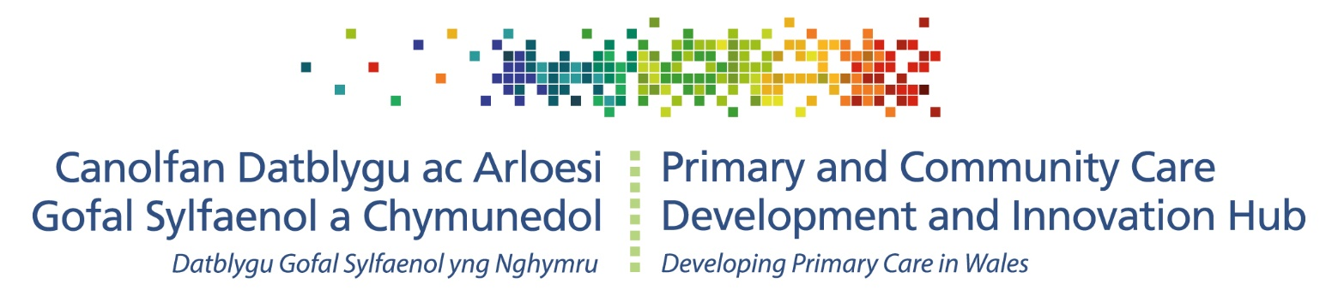
primarycareone.nhs.wales/topics1/strategic-programme/
Cluster peer review:
ACD transition year

24/7
STRATEGIC PROGRAMME FOR PRIMARY CARE

Foreword

The Primary Care Model for Wales and, specifically cluster working, has been a consistent policy and strategic aim in Wales for over ten years. First introduced in the Welsh Government document Setting the Direction in 2010, cluster working brings together local services involved in health and care across a geographic area. The transformational model for primary and community care, which is a place-based approach to sustainable and accessible local health and well-being care, supports the vision set out in A Healthier Wales (Welsh Government, 2018).

In response to the Welsh Government strategy A Healthier Wales, the Strategic Programme for Primary Care was developed to accelerate development of the cluster approach. A fundamental component of the approach of the Strategic Programme for Primary Care is to constantly listen and learn from services to guide future plans. Following successful programmes of peer review for regional partnership boards and primary care out-of-hours services, the Strategic Programme for Primary Care has committed to develop a similar cycle of reflection for cluster achievements.

The 2022-2023 transition year for Accelerated Cluster Development will see the introduction of strengthened planning and delivery arrangements in the community, including the introduction of professional collaboratives and pan-cluster planning groups. During this year, we will support the peer review of a small number of clusters to gather the early learning. This provides the opportunity for the hard work of clusters and their successes to be recognised, and to identify any barriers to service improvement. This, in turn, will identify any supportive actions required at a national and/ or local level.

I would like to take this opportunity to thank you for your work and commitment to the development of cluster working to date and during this transition year.

Sue Morgan
National Director & Strategic Programme Lead for Primary & Community Care

Contents
Executive summary 4
Cluster peer review: Transition year 4
Rationale for peer review 5
What is peer review? 5
What is the place of peer review in Wales? 5
How will peer review benefit primary care in Wales? 6
Monitoring and evaluation context 7
Cluster peer review: Transition year context & aim 7
Current context 7
Aim and objectives 7
Cluster peer review: Transition year process 7
Outline of arrangements 7
Meeting format 8
Next steps 8
Funding 8
Index of abbreviations 8
Appendices 10
Appendix 1: PCMW and ACD outcomes for allocation (3 per LHB) 10
Appendix 2: Proposed core reflective question schedule 12

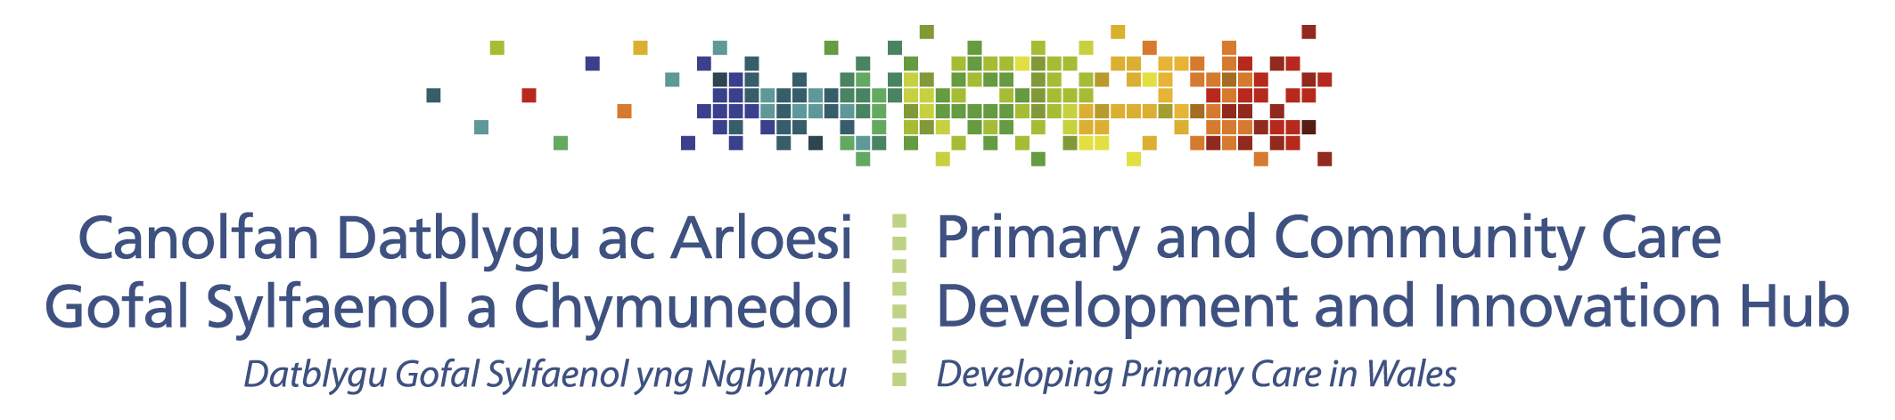

Executive summary

Cluster peer review: Transition year

- Peer review allows those who best understand local systems and the current pressures to identify barriers and enablers and to share good practise.
- NHS Wales approved a peer review framework in 2017 to support improvement in priority areas.
- Peer review highlights structures and systems that are working effectively and identifies risks that remain unaddressed.
- Cluster peer review during the ACD transition year (2022/23) is an opportunity to test out a new process and will provide intelligence to inform a regular peer review process.
- The process for cluster peer review during the transition year is described to ensure consistency in the recruitment of one volunteer cluster per region to participate.

Figure 1. Cluster peer review: Transition year process in summary
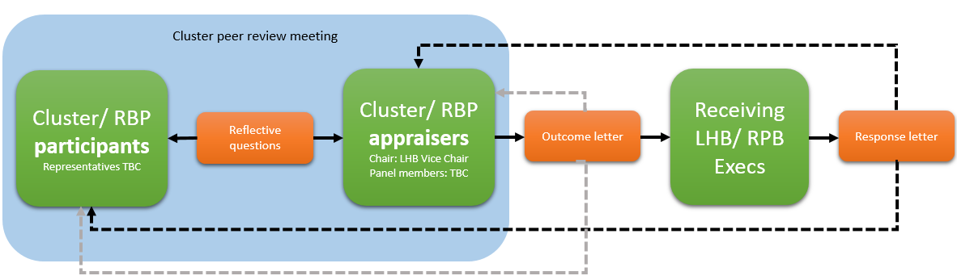

- The transition year process will involve participant cluster and RPB agreed representatives in dialogue with peer cluster and RPB representatives from another region. This interaction will be structured around a set of reflective questions that explore three allocated PCMW/ ACD outcomes.
- An outcome letter summarising the discussion and agreed actions will be sent to the host health board, copied to the RPB and SPPC. The receiving Execs will be asked to respond to the letter, confirming receipt of this feedback and support for any actions indicated.

Rationale for peer review

What is peer review?

- Peer review is a process to drive continuous quality improvement involving self-assessment, enquiry and learning between teams of equivalent specialisation and knowledge.
- Self-reflection and reporting concerns alone is not sufficient to make the changes necessary for improvements to occur.
- Peer review between those delivering services and those managing the system can enable those with ideas for change to be heard by those with the ability to make them happen.
- Change may be indicated at the frontline and/ or at managerial levels following a peer review.
- Accountability is essential for effective peer review, moving it from a reflective exercise to a worthwhile event that creates tangible improvements.
- Peer review facilitates action planning around what works and identifies how to sustain this, along with the improvements to be made and how to implement them.

What is the place of peer review in Wales?

- Peer review is recommended by the Organisation for Economic Co-operation and Development (OECD), who in 2016 commented positively on peer review in Wales and recommended more widespread use of peer review and finding ways of integrating the lessons learned into standard clinical practice.¹
- NHS Wales adopted a peer review framework in 2017, which proclaims that “NHS Wales will own, agree and oversee an annual programme of peer reviews, akin to the existing programme of clinical audit to support improvement in priority areas.”¹
- The elements of peer review are in keeping with the proposed whole system values, as set out in A Healthier Wales:
  - Co-ordinating health and social care services seamlessly, wrapped around the needs and preferences of the individual, so that it makes no difference who is providing individual services;
  - Measuring the health and well-being outcomes which matter to people, and using that information to support improvement and better collaborative decision making;
  - Proactively supporting people throughout the whole of their lives, and through the whole of Wales, making an extra effort to reach those most in need to help reduce the health and well-being inequalities that exist;
  - Driving transformative change through strong leadership and clear decision making, adopting good practice and new models nationally, more open and confident engagement with external partners;
  - Promoting the distinctive values and culture of the Welsh whole system approach with pride, making the case for how different choices are delivering more equitable outcomes and making Wales a better place in which to live and work.
- The Welsh Government Quality and Safety Framework describes a universal duty of “quality management” to ensure that care meets the six domains of quality (care that is safe, effective, patient-centred, timely, efficient and equitable). Data collected from peer review processes can help to continuously connect quality assurance, planning and improvement.

How will peer review benefit primary care in Wales?

Cluster benefits:
- Opportunity to advocate for solutions that are working well and merit wider adoption;
- Responding to concerns around visibility and ability to influence change as highlighted in the Cluster Survey 2020, the peer review informs wider system understanding of frontline service issues and conveys that there are clear mechanisms to facilitate system-wide responses;
- Opportunity to understand the links between community and wider health and social care services, and how they can work in partnership more effectively;
- Opportunity to recognise what changes are needed to deliver the Primary Care Model for Wales (PCMW) and Accelerated Cluster Development (ACD) outcomes;
- A forum to reflect on achievements under the QAIF quality improvement and patient safety domains and sharing of good practise.

Health board benefits:
- Opportunity to understand how the connectivity between the cluster, pan-cluster planning groups and the health board is working, and to explore whether this can be improved.

Regional partnership board (RPB) benefits:
- Opportunity to advocate for what is working well and sustaining it;
- Opportunity to understand the structural barriers to the implementation of area plans;
- Opportunity to understand the links between community and wider health and social care services, and how they can work in partnership more effectively;
- Reinforce the importance of local and regional contributions to the shared ambition of improving health and well-being for all citizens, with a bias towards partnership actions that result in disproportionate improvements for people with greater needs (this includes keeping people well, not just managing illness).

Strategic Programme for Primary Care (SPPC) benefits:
- Understanding of progress towards attaining the PCMW and ACD outcomes and how they are being delivered in Wales, along with key barriers and enablers.
- Intelligence to inform SPPC evaluation and shaping of national support priorities and actions.

Monitoring and evaluation context
- The peer review process described here is one of several tools proposed as part of a unified approach to monitoring and evaluating PCMW and ACD implementation progress (for details, see the ACD Toolkit).
- The subsequent format and framing of peer review will be informed by the experience gained via the cluster peer review transition year process.

Cluster peer review: Transition year context & aim

Current context
- Continuing pressures from the COVID-19 pandemic require a flexible and proportionate approach to peer review.
- Learning during the transition year process will shape an agreed process for subsequent years.
- The transition year will see the establishment of professional collaboratives and pan-cluster planning groups (PCPGs). During this period of structural change, a developmental approach to the peer review process will be appropriate.

Aim and objectives
The aim of the transition year process is to test a mechanism for cluster peer review and to learn from experience in each health board area.

Objectives of the transition year process are to:
- Develop and test a process during 2022-23, learning from the experience of clusters and RPBs to shape future peer reviews;
- Identify the key components/ drivers that enable successful cluster working and any barriers to change;
- Compile examples of good practice driving successful cluster working;
- Provide written recommendations for action to accountable organisations;
- Inform the priorities of the SPPC.

Cluster peer review: Transition year process

Outline of arrangements
- For 2022-23 the SPPC are calling for a single cluster from each health board to engage in peer review as (a) participants and (b) as appraisers for a cluster in a different region, in each case working alongside respective RPB representatives.
- Participants should be, to the extent possible, able to represent their cluster/ health board/ RPB and have sufficient authority to ensure that actions are delivered on behalf of their organisations.
- Clusters, health boards and RPBs will have the freedom to decide on how they are best represented in peer review meetings; these proposals and feedback will inform guidance around optimal representation for future cycles.
- Peer review panels will have strong links at Board level and ensure emphasis of the partnership agenda. Proposed membership of the panel will be provided as part of supplementary guidance to this document as well as the support offered from the SPCC.
- Additional membership of peer review panels will be for local determination. Local experience will inform guidance for future cycles.
- A series of questions to frame the peer review discussion is provided (see Appendix 2).
- To inform the subsequent cycle of peer reviews (including documentation and training requirements), reviews should be completed by December 2022.

Meeting format
- The SPPC will identify three unique PCMW and ACD outcomes for each region to focus on (see Appendix 1); this is to ensure full coverage and capture of any outcome-specific challenges.
- Reflective questions will similarly be made available in advance of the meeting (see Appendix 2).
- In addition to the allocated outcomes/ reflective question set, panels will have discretion to raise questions with a local/ regional focus, in keeping with the constraints of the meeting agenda.
- Clusters, health boards and RPBs will consider the allocated questions in advance as preparation. No written submissions will be required in the transition year.
- The Chair will guide participants through the questions in a semi-structured way, and will conclude with a verbal summary of the discussion, a note of any examples of good practise to highlight for sharing, and of the recommended actions (what, who and when) for agreement by all parties.

Next steps
- A formal outcome letter will be shared with participants, panel members, receiving health board, and RPB.
- A copy of the outcome letter will be shared with the SPPC.
- The receiving executives should provide formal acknowledgement via a response letter, confirming how key points will be actioned.
- Following completion of each regional process, the SPPC will coordinate feedback of those involved to reflect on the experience. This will inform the process for subsequent peer review cycles and address any requirements for training and development that are identified.

Funding
- The NHS Wales peer review framework indicates that direct and opportunity costs of peer review are to be met by the organisation(s) being reviewed; this includes staff time, travel and subsistence costs and accommodation and refreshments for meetings held on site.

Index of abbreviations

ACD Accelerated Cluster Development
DPCMH Director of Primary, Community and Mental Health
LHB Local Health Board
PCMW Primary Care Model for Wales
PCPGs Pan-cluster planning groups
RPBs Regional partnership boards
SPPC Strategic Programme for Primary Care

Appendices

Appendix 1: PCMW and ACD outcomes for allocation (3 per LHB)

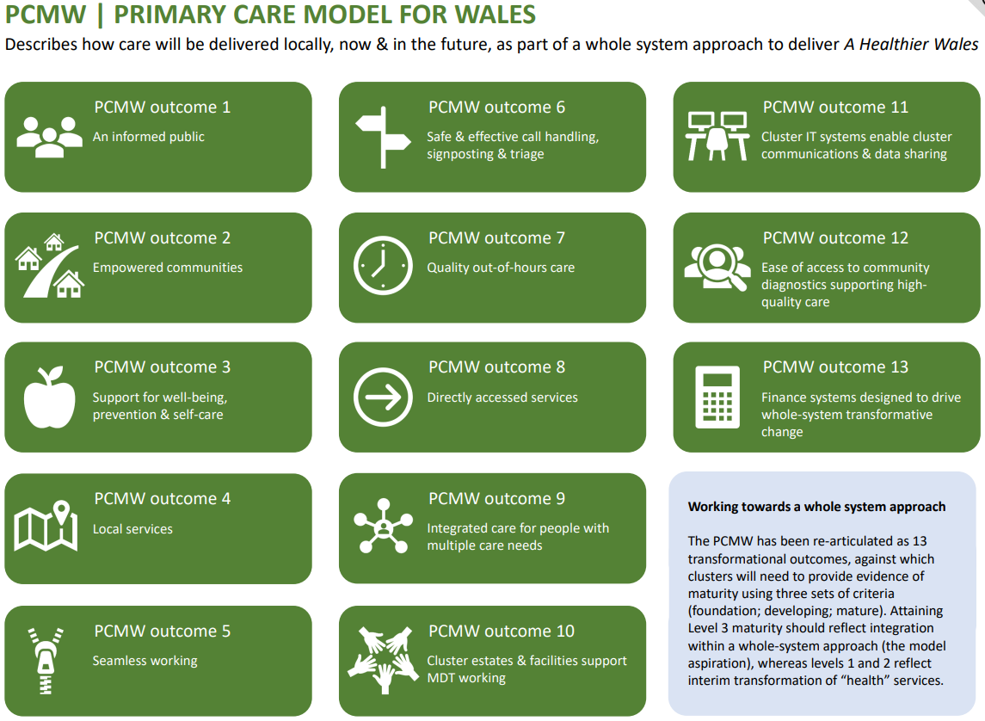

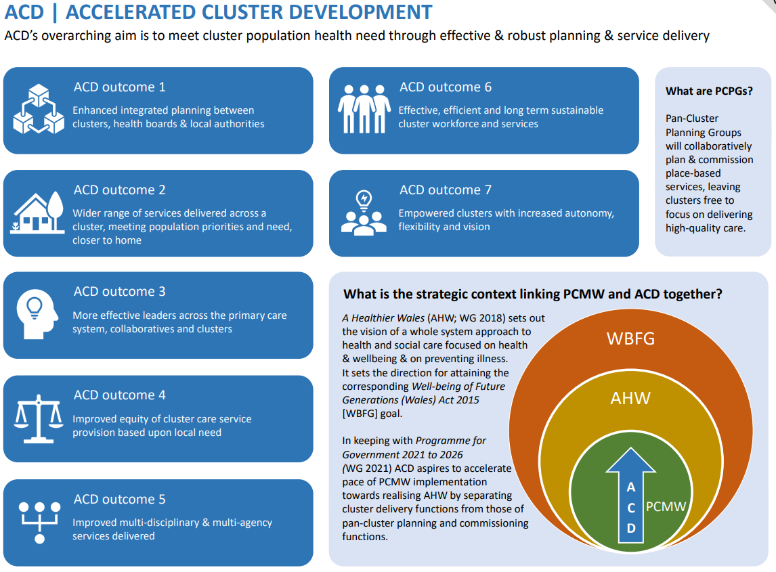

Appendix 2: Proposed core reflective question schedule
The following questions promote reflection and are flexible enough to support constructive discussion around each outcome of interest. Participants can share these questions with peers/ stakeholders ahead of the meeting to ensure a wider range of reflections are captured and taken forward into the discussion. Similarly, appraisers/ panel members are encouraged to do likewise to facilitate a meaningful exchange of experience and sharing of successful practice.

- Are the outcome measures recognised locally?
- How has this measure been approached?
- Has there been dialogue between the cluster and the RPB around this?
- What has gone well?
- What has gone less well?
- What more could be done to achieve this purpose?

NHS Wales Peer Review Framework: July 2017. Accessed at: http://www.wales.nhs.uk/sitesplus/documents/1064/NHS%20Wales%20Peer%20Review%20Framework%20%28July%202017%29.pdf
Welsh Government (2019) A Healthier Wales. Accessed at: https://gov.wales/sites/default/files/publications/2019-10/a-healthier-wales-action-plan.pdf
Welsh Government. Quality and Safety Framework: Learning and Improving. Accessed here: https://gov.wales/sites/default/files/publications/2021-09/quality-and-safety-framework-learning-and-improving_0.pdf
NHS Wales Peer Review Framework: July 2017. Accessed at: http://www.wales.nhs.uk/sitesplus/documents/1064/NHS%20Wales%20Peer%20Review%20Framework%20%28July%202017%29.pdf

