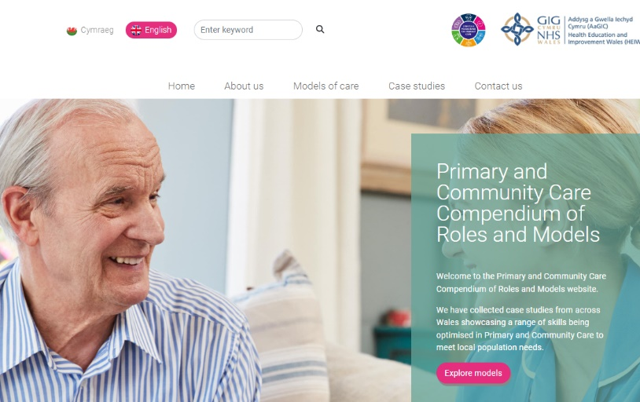
The Primary and Community Care Compendium of Roles and Models website has been produced on behalf of the Workforce and Organisational Development workstream of the Strategic Programme for Primary Care (SPPC) in collaboration with Health Education and Improvement Wales (HEIW).

The website builds on the original concept of the Compendium of Emerging Roles and Models in Primary Care which was launched by WEDS (Workforce Education and Development Services, now part of HEIW) in 2018.

Primary and Community Care roles and service models continue to evolve and we have revised the content and functionality, bringing you a re-designed, up to date resource which will expand going forward.

The website address is Home | Primary Community Care Compendium (heiw.wales).

The Primary and Community Care Compendium includes:
- Four models of care: Urgent/ Same-Day Emergency Care; Direct access to the right professional at the right time; Supporting people with complex needs; and Planning, prevention and promotion
- Case studies of people with lived experience of working at the top of their licence, in new or innovative ways, to meet the health and wellbeing needs of the local population. The case studies highlight the skills and dedication of the postholders, with links on each page to related resources, such as regulatory bodies and careers information.
- Case studies currently ‘live’ in Wales which showcase examples of integrated multi-professional working to provide person centred care closer to home.

What next?
Phase two will be initiated to expand the website content with additional case studies across all four models of care and develop a toolkit to enable innovators in primary and community care services in Wales to upload their own stories, in the same content format.

Feedback from the soft launch is welcomed either via the Contact Us page or via a Survey Monkey which will be circulated to stakeholders in the next six weeks. The feedback will inform any future iterations to the website.

Alternatively, any comments or queries can be directed to SPPC@wales.nhs.uk using the subject title ‘PCC Compendium’’.

Soft launch stakeholder distribution list  - Case study participants  - Workforce and OD Workstream, SPPC  - Heads of Primary Care  - Directors of Primary Care and Community Services  - Strategic Programme Board  - Directors of Therapies and Health Sciences  - Executive Directors of Nursing | - National 111 /OOH Board  - Community Pharmacy HB Leads  - Primary Care Clinical Ref Group

