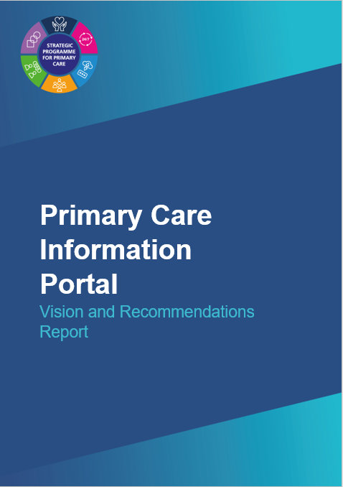
The Primary Care Information Portal Vision and Recommendations Report (2022) has been produced on behalf of the Data and Digital Technology workstream of the Strategic Programme for Primary Care (SPPC).

This report is the end result of an engagement exercise in April 2022 asking stakeholders for their comments and feedback in relation to the display of primary and community care information. The feedback pertained specifically to:

1. How data and information in the Primary Care Information Portal could be presented in a more meaningful way.

2. The governance and access rights in place for existing data fields and what data and information users can view, analyse, and extract.

The recommendations were endorsed by the Strategic Programme Board on 7th October and work will progress over Q3/Q4 2022/23 and beyond to consider, and where appropriate, implement the recommendations.

Seven key areas were identified in the recommendations:

- A new primary care information portal, built on the strengths of the existing platform but reflecting the requirements of the wider audience of primary and community services.
- Purpose – to support quality assurance, and improvement, and quality in planning and control.
- Audience – to create a user group to feedback regularly on the requirements of the multiple audiences. The resource would continue to be non-patient facing.
- Content – to consider in my detail the data sources, data standards and information governance of the resource.
- Displays – provision for standard templates with access sorted by provider, commissioner, and the individual user.
- Analysis – the application of nationally agreed analytical methods including baseline data and trend/trigger identification.
- Process – how feedback is acted upon, automated data collection where able, and the ease of downloading data if the menu of analytics is not suitable for the user needs.

Any comments or queries should be directed to SPPC@wales.nhs.uk using the subject title ‘PCIP Vision Report’.

