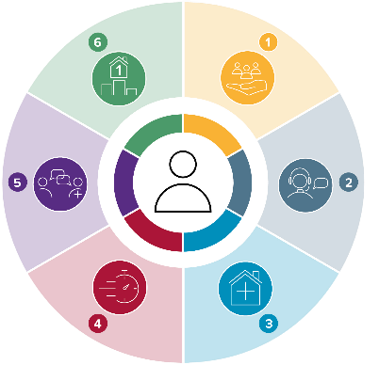
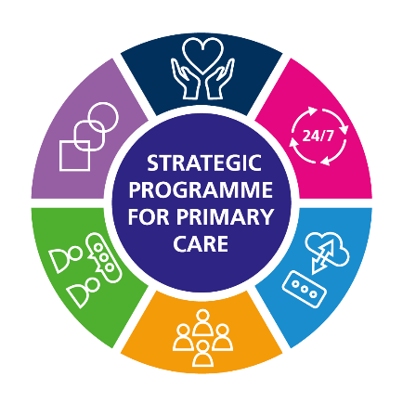
Urgent Primary Care Centre Programme (UPCC) seeks to design and deliver a new model of urgent care for the population of Wales that have an urgent primary care need providing a service for people within eight hours of contacting their local Health Board. The aim is to provide seamless care, delivered at a local level consistently regardless of organisational boundaries.
Strategic Programme for
Primary Care
Release note: National Framework for Urgent Primary Care Centres Visual
Release date: 30 May 2023
Author: Bethan Gregory

The National UPCC Framework is underpinned by six principles and components:
- Communication – being responsive, open and straightforward
- Strong clinical leadership – Supporting our people, promoting an inclusive culture and support everyone to fulfil their potential
- Right workforce for the service – work together to do the right thing for the person
- 7 days a week service – right person, right place, right time
- Positive experience for the service user – people at the heart of everything we do
- Supporting primary care as a partnership – recognising we are part of a bigger team, improving the safety and wellbeing of the communities we serve
The UPCC National Framework for Urgent Primary Care Centres visual can be accessed here: Urgent Primary Care Centres - Primary Care One (nhs.wales)
Any comments or queries should be directed to SPPC@wales.nhs.uk and please title the email ‘UPCC National Framework for Urgent Primary Care Centres visual’.
