This paper by the Strategic Programme for Primary Care is an introduction to why immunisations provided by Nursing Home nurses should be promoted and enabled. The paper encompasses what needs to be considered when developing a nursing home immunisation model for residents and a peer-to-peer model for staff. The paper outlines learning from work undertaken as part of the Community Infrastructure program, recommendations and next steps.
Strategic Programme for
Primary Care
Release note: Developing a Nursing Home Immunisation Model: Recommendations
Release date: 30 May 2023
Author: Emily Wilson

Prior to the Covid-19 pandemic, yearly vaccinations such as Flu (influenza) - have been provided to nursing home residents via the GMS contract either by GP’s, general practice nurses or by other healthcare professionals such as district nurses on behalf of the practice. Historically, while there are some examples of nursing home registered nurses vaccinating their own residents, this is not widespread practice. In addition, there are no systems in place, where nursing homes with registered nurses are able to vaccinate their own staff.

The ‘Developing a Nursing Home Immunisation Model: Recommendations’ paper can be found here: Community Infrastructure (CI) Programme - Primary Care One (nhs.wales)
Any comments or queries should be directed to SPPC@wales.nhs.uk and please title the email ‘Developing a Nursing Home Immunisation Model’.
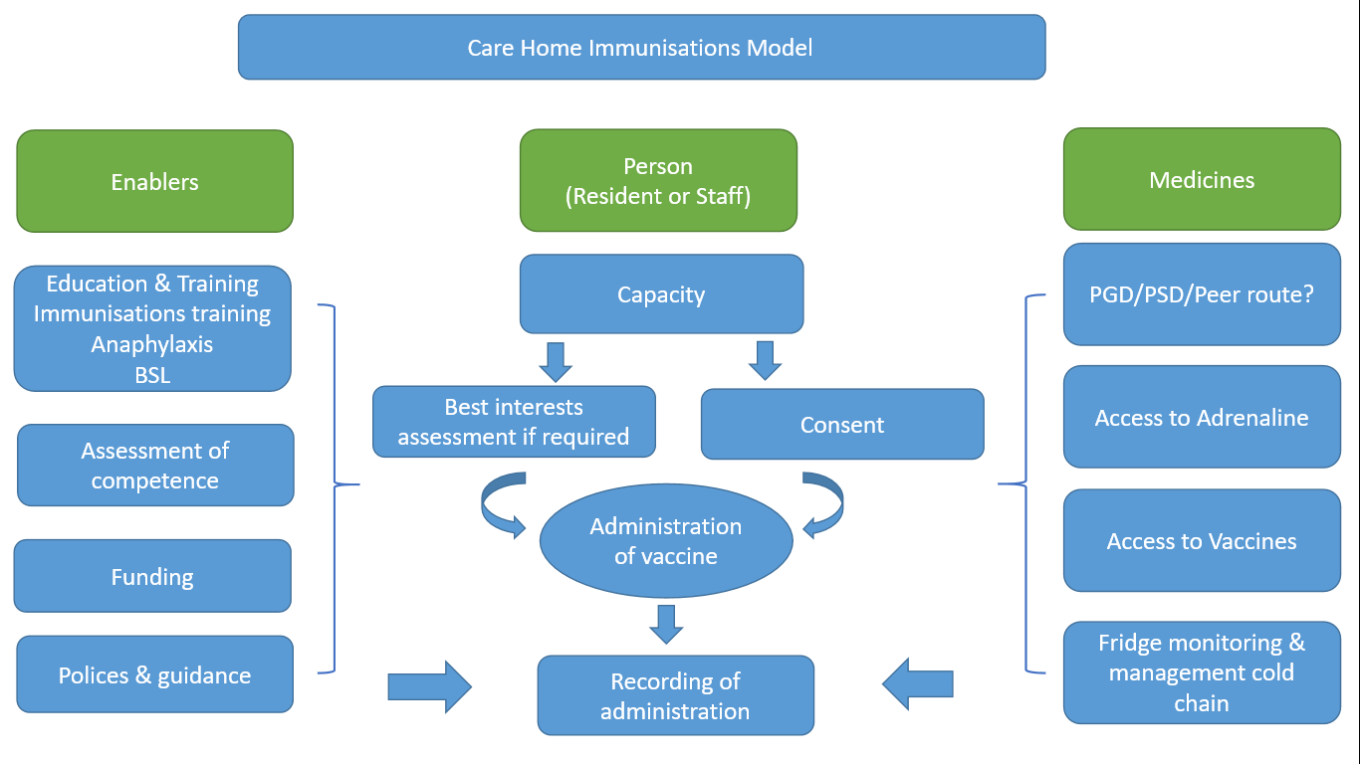
Nursing Home Immunisation Model

