
Community Infrastructure (CI) Programme
Enhanced Community Care
‘Virtual Wards’

Nationally agreed definition, standards, and underpinning quality statements for model of care & support

May 2023

Community Infrastructure (CI) Programme

Purpose

This paper presents a Once for Wales agreed definition, core standards and underpinning quality statements, of an Enhanced Community Care model of care and support.

These provide a base from which community based services can deliver - high-quality evidence-based care to people and populations requiring enhanced community care. They seek to decrease both local and national variation currently in the delivery of this model of care and support.

Table of Contents

Purpose 2
1. Introduction 3
2. Background 3
3. Assessment 4
4. Once for Wales Enhanced Community Care; standards and underpinning quality statements 5
Fig 1 Population – who is the intervention aimed at? 7
Fig 2 Team around the person – based on the person’s health, social care and wellbeing needs 8
Fig 3 Standards and underpinning quality statements 9
5. Summary 10
6. Next Steps: Evaluation; measurements of success demonstrating value and impact 10
Annex 1 10
Annex 2 10

Introduction

The principles of place-based care underpin all National Programmes and Programme for Government. Key to this is collaborative multi-professional working, which delivers more effective, seamless local care, essential to realising the future ambition of community-based health, care, and well-being in Wales.
The Community Infrastructure (CI) Programme seeks to define the fundamental infrastructure required to deliver a place-based 24/7 integrated, multi-professional community model. Building on the principles outlined in the Primary Care model for Wales, it focusses on how Primary and Community Care services work collaboratively together, to provide seamless care, delivered at a local level.
Multi-professional working is central to the Community Infrastructure programme and underpins the ambition of the Primary Care Model for Wales:
- Multi-professional teams working at cluster level
- Safe & effective systems to direct people to the right care in the right place and at the right time.
- Integrated team working ensuring a holistic approach to care
- Seamless 24/7 services
‘Virtual wards’ are identified as a model of multi-professional working and suitable for a range of conditions that can be safely and effectively managed and monitored at home, or at a person’s usual place of residence. Many local areas have developed or are developing virtual wards for a range of conditions, including for people with respiratory problems and COVID-19, heart failure or acute exacerbations of a frailty-related condition.
Extensive stakeholder engagement revealed both local and national variation currently in the definition and delivery of this model of care and support. Due to the increasing focus on virtual wards and the role they play in supporting care closer to home, it was agreed by the Community Infrastructure programme and its stakeholder group, that a focus on virtual wards was required.
This paper by the Strategic Programme for Primary Care is the culmination of many months of engagement and significant discussion with all stakeholders, and provides the Once for Wales agreed definition, core standards and underpinning quality statements, of an Enhanced Community Care (formerly virtual ward) model of care and support.
These provide a base from which community based services can deliver the high-quality evidence-based care to people and populations requiring enhanced community care. They seek to decrease both local and national variation currently in the delivery of this model of care and support.

Background

The Community Infrastructure programme is currently developing an All Wales Multi-Professional Framework for Integrated Working; underpinned by a literature scoping review, group concept mapping and an evaluation tool providing a ‘roadmap’ towards effective and evidence-based forms of Multi-Professional practice. Working with Professor Carolyn Wallace and Professor Mark Llewellyn, alongside Sophie Randall of the Welsh Institute for Health and Social Care and PRIME Centre Wales based at the University of South Wales, the Community Infrastructure Key Stakeholder Group, the Multi-professional/Virtual Wards Task and finish group, and national workshops.
The aim of the Multi-Professional Framework is to support organisations to deliver joined up, outcome focused, evidence-based community services, through a place-based multi-professional working model of care which;
- Creates collaborative working across community professions
- Focuses on consistency, reducing variation and building on good practice
- Utilises data to demonstrate value and impact to focus attention and resource
Collaboration through place-based systems of care offers the best opportunity to meet the holistic needs of individuals and of the local population. This will challenge some of the traditional boundaries between professions and between services.
The evaluation tool component of the Multi-Professional Framework aims to support collaborative multi professional working by:
- Illustrating what ‘good’ looks like, with steps to suggest and/or demonstrate development, and
- Providing a way for stakeholders – whether leaders, managers, practitioners or others, to discuss amongst and for themselves how they perceive their current circumstances and agree on the next steps to be taken.
In conjunction with the discussions on what a Multi-Professional Framework may look like, the Community Infrastructure Programme has been focused on building a strong foundation to enable innovation and adaptability to improve care, so people are seen in the right place at the right time as close to home as possible.
This work identified the following areas as needing further discussion:
- Whether a virtual ward is a multi-professional team by another name, or whether this is a specific model of multi-professional care, that has required standards, underpinning quality statements and evaluation framework.
- That a shared definition and understanding of what a virtual ward is, is required
- Recognition that the term virtual ward does not adequately capture the health, social and wellbeing needs, that people who require this level of intervention may need.
- Demonstrating the value and effectiveness of virtual wards is not happening in a consistent way across Wales at the moment

Assessment
An initial comparison of examples of multi-professional working and virtual wards was carried out to try and understand these questions.
Extensive engagement and significant discussion with all stakeholders has determined that virtual wards is:
- A specific model of multi-professional care
- Which requires a consistent and inclusive definition, standards, underpinning quality statements, and a way of evaluating its value and impact.
- Requiring national uniformity but with local flexibility, to deliver this model of care and support.
- Providing a base from which community based services can deliver high-quality evidence based care to people and populations.
Notably, a key point of discussion across stakeholder engagement has been the name ‘virtual wards’, with consensus that this language needs to change as it’s confusing and not reflective of all partners involved in delivering this model of care and support.
The outcome was that ‘Enhanced Community Care’ was chosen as the preferred name for this model of care and support, with the following simple and expanded definitions agreed:

Simple definition of Enhanced Community Care

An integrated health and social care approach with an identified population group, delivering a multi-professional response, avoiding crisis and acute interventions where feasible.

Expanded definition of Enhanced Community Care

An integrated health and social care approach with an identified population group, delivering a multi-professional and/or cross sector response avoiding crisis and escalation of health and care needs where feasible.​ This may include step up support to prevent hospital admission or step-down support to enable people to leave hospital early, while still receiving the treatment, care and support the person requires.

Supporting people to be cared for in their own homes or usual place of residence, with focus on what matters to the individual and those people important to them, and the actions required to support this.​

Using a mixture of technology and face-to-face support, remote consultation, and possibly remote monitoring and/or remote intervention.

Once for Wales Enhanced Community Care; standards and underpinning quality statements

The Six Standards of the All Wales Enhanced Community Care model of working, were developed in partnership with key stakeholders and based upon the six domains of quality: Safety, Timeliness, Effectiveness, Efficiency, Equity, and Person-centered.
Each of the Six Standards have underpinning quality statements which set out what is required to deliver this model care and support and should be used as a benchmarking tool to deliver high-quality evidence-based care to people and populations.
Additionally, through the work of the Community Infrastructure Programme, two complimentary visuals have been developed to identify how this Enhanced Community Care model aligns across multi-professional working from:
Fig. 1 A population-based focus: who the intervention aimed at

Fig 2 A ‘Team around the person’ focus: based on the person’s health, social care and wellbeing needs

Fig 3 Standards and underpinning quality statements

The Six Standards and Underpinning Quality Statements can be applied to both a population and ‘team around the person’ based focus.
Services delivering this model of Enhanced Community Care are encouraged to use these Six Standards and Underpinning Quality Statements to identify opportunities to test and scale up improvements at a local level.

The Six Standards of Enhanced Community Care are:
Safe | Recognising we are part of a bigger team – improving safely the health and wellbeing of the communities we serve
Effective | Work together to do the right thing for the person
Person-centered | People at the heart of everything we do
Timely | Right skillset, right place, right time
Efficient | We are responsive, open and straightforward
Equitable | Supporting our people – promoting an inclusive culture that supports everyone to fulfil their potential

Fig 1 Population – who is the intervention aimed at?

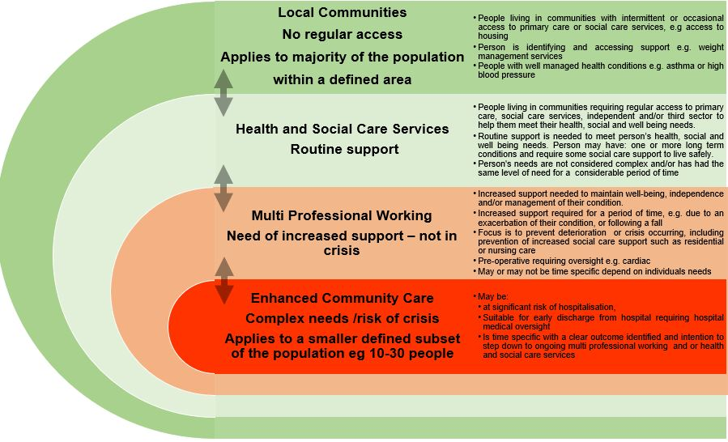

Fig 2 Team around the person – based on the person’s health, social care and wellbeing needs

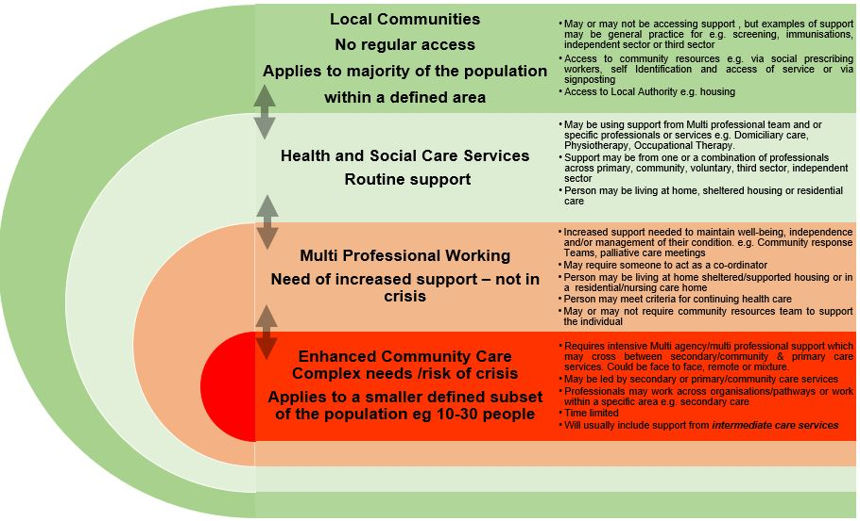

Fig 3 Standards and underpinning quality statements
Standards
Safe    Recognising we are part of a bigger team – improving safely the health and wellbeing of the communities we serve | Effective    Work together to do the right thing for the person | Person-Centered    People at the heart of everything we do | Timely    Right skillset, right place, right time | Efficient    We are responsive, open and straightforward | Equitable    Supporting our people – promoting an inclusive culture that supports everyone to fulfil their potential
Underpinning Quality Statements
Clear definition of population group, model is flexible to respond to requirement of needs with agreed inclusion and exclusion criterion  Common IT interface for standardised and systematic reporting, supported with data sharing agreements and digital solutions  Resources working with the right skill mix, at the right level and at the right capacity  A learning system, tested and evidenced based  Quality & Safety at the core; clear risk management, governance and escalation processes  Development of trusted relationships & agreed communication links between services | Continuous monitoring, measurement and evaluation; utilising the Multi-professional Framework for Integrated Working’s Development Matrix (an evaluation tool for multi-professional integrated working)  Wide ranging multi-professional team working with the person and their goals, central to support  Support new workforce models & wider workforce training & education opportunities  Working to maximum level of competency | Continual co production of care with the person being supported  Anticipatory and holistic care planning with the person being supported  Involvement of the wider support network of the person (kinship carers)  Measures and goals based on the persons’, not the system.  ‘What matters to me’ conversations  Clear communication between professionals and the person/family being supported - team around the person  Person centered approach based on needs | Clear point of access  Clear timescales for response and duration of support  Access to information at the right time to enable informed decisions  Triage once, triage well -with maximum focus on supporting and signposting well at first contact  Resourced to the right capacity to ensure response times can be met, 24/7  Appropriate use of technology to support virtual triage, telehealth devices &/or F2F consultations | Compliments & aligns with other service offers  Shared access to information and appropriate use of technology  Reduced duplication through prudent working and streamlined collection of data  The right level of interaction for the needs of the person – no more no less  Value demonstrated through evidence-based outcomes and cost effectiveness  Clear governance for audit and assurance | Fair & equitable access offer to whole population regardless of geography  Person is at the core of support provided, with person related experience and outcome measures integral to delivery  Equitable outcomes regardless of characteristics, such as age, gender, ethnicity, morbidities and socioeconomic status.  Equitable service and assessment process regardless of profession and means of assessment, with consideration of local demographics and identified care needs.

Summary

This Once for Wales approach sets out an agreed definition, core standards and underpinning quality statements, of an Enhanced Community Care model of care and support.
These provide a base from which community based services can deliver the high-quality evidence-based care to people and populations, requiring enhanced community care. They seek to decrease both local and national variation currently in the delivery of this model of care and support.
The Six Standards and underpinning quality statements provide a lens through which to identify what good enhanced community care looks like for the population who the intervention is aimed at, and the team around the person’ focus: based on the person’s health, social care and wellbeing needs.

Next Steps: Evaluation; measurements of success demonstrating value and impact

Moving forward, the focus by the Community Infrastructure programme is on a Once for Wales approach to demonstrating the value and effectiveness of Enhanced Community Care.
Currently, an assessment of intelligence generated from all stakeholder engagement to date and associated ‘Data Deep Dives’ is in progress, which will inform the development of an outcome measure / evaluation framework component with associated data standards. This work forms the next phase of delivery 2 of the Enhanced Community Care work and will include
- Outcome measures based on the Health and Care Quality Standards; 6 domains of quality and 6 quality enablers in line with the Duty of Quality statutory guidance 2023.
- Data standards to support evaluation aligned to the Health and Care Quality Standards to achieve maximum impact
The Plan on a page outlines work carried out in each phase.

Annex 1

Development Matrix for Multi-Professional Working

Annex 2

Health and Care Quality Standards

H

P9

