Introduction
Enhanced Community Care
Formerly ‘Virtual Wards’

Summary paper

This is a summary of the paper Enhanced Community Care (ECC) presented to National Primary Care Board (NPCB) in May 2023 and subsequently updated in August 2023 to include Phase 2 Evaluation framework.

Purpose

The paper by the Strategic Programme for Primary Care provides the Once for Wales agreed definition, core standards and underpinning quality statements, of an Enhanced Community Care (formerly virtual ward) model of care and support. Providing a base from which community based services can deliver high-quality evidence-based care to people and populations requiring enhanced community care.

This updated paper outlines the ECC Evaluation Framework which includes a set of measures and outcomes. This enables services to demonstrate the value and effectiveness of their ECC model of care and support in a consistent way across Wales. Ensuring people receive safe person-centred care regardless of the population the ECC focuses on, and an opportunity to share learning from this way of working in a consistent way across Wales.

Simple definition of Enhanced Community Care

An integrated health and social care approach with an identified population group, delivering a multi-professional response, avoiding crisis and acute interventions where feasible.
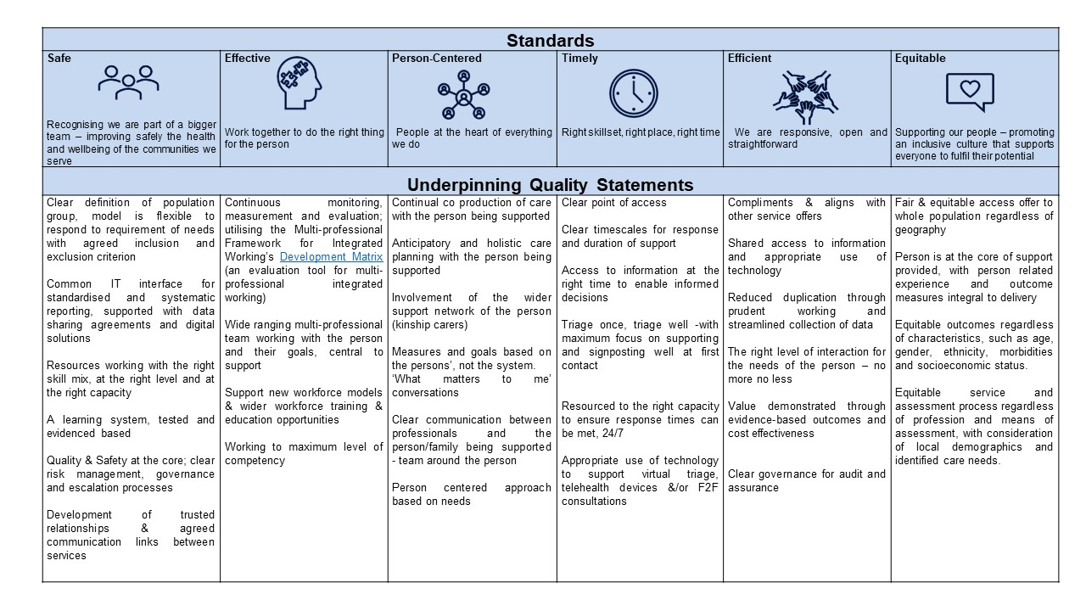

Once for Wales Enhanced Community Care; standards and underpinning quality statements

Each of the Six Standards have underpinning quality statements which set out what is required to deliver this model of care and support and should be used as a benchmarking tool to deliver high-quality evidence-based care to people and populations.

Evaluation; measurements of success demonstrating value and impact

This addition to the May ’23 paper sets out the ECC Evaluation Framework, including the set of proposed measures and outcomes. Providing a tool for ECC models of care and support to use to evaluate their own service, enabling them to understand what good quality looks like in their individual areas through a person-centred perspective. The measures and outcomes are key important metrics that all models of care and support should monitor at a minimum, providing evidence based intelligence to inform where a service is doing well, and where it is not doing so well, enabling a focused approach to improvements.
It is recognised that the framework will also have a wider application across multi-professional services as the measures and outcomes are transferrable to several settings.

It is imperative to note that ECC models of care will require significant digital support to enable them to collect and report the proposed measures and outcomes, therefore further work is to be done to formalise the proposed measures, associated data standards and the collection of PROMs and PREMs, requiring phase 3 of this project. In the interim, we propose that the following measures are the minimum that all Enhanced Community Care services should be able to report on, whilst work is progressed on phase 3:

- Total number of referrals to ECC
- Total number of referrals by source
- Total number of referrals by referral outcome
- Total number of discharges from ECC
- Total number of discharges by outcome
- Average length of stay in ECC

There are also some additional measures that multiple ECC models of care, but not all, are currently able to report
- Total number of referrals by type/reason
- Total number of referrals by urgency of referral
- % of admissions avoided
- % of emergency admissions within 28 days post discharge from ECC
- Total number of bed days saved

Recommendations / Actions

- The measures and outcomes set out in the ECC Framework are agreed as high level core metrics for the ECC model.

- Approval is given to proceed with phase 3 of ECC, which requires SPPC – CI to work collaboratively with:
  - Welsh Value in Health; and
  - DHCW,
to ensure organisations are provided with clear guidance to collect the required data in a consistent and efficient manner.

Full paper for further reading

Linked work
Short read

Multi-professional Framework for Integrated Working; once for Wales agreed definition, core standards with underpinning quality statements, and evaluation tool, to support organisations to deliver joined up, person-centred, outcome focused community services.

To visit the Community Infrastructure toolkit please click here.

