
Primary Care Division
Work Plan 2022/2023

End of Year Report
Narrative




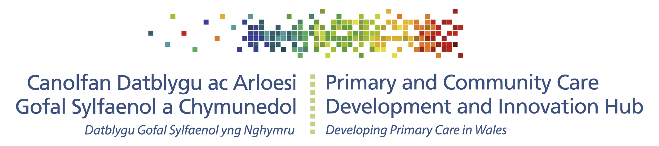

End of Year Review

The Primary Care Division work alongside key partners to influence improvement in population health through primary care settings. The Division is organised into two teams: The Primary Care Development and Innovation Hub (the PC Hub), and the Dental Public Health Team. The PC Hub has two overarching remits of (1) Supporting our partners in the delivery of national plans for the transformation of primary and community care in Wales and (2) developing a coordinated approach to prevention in primary and community care to reduce the avoidable burden of disease and improving population health. The Dental Public Health Team focus on supporting and leading oral health and dental improvement and epidemiology programmes and supporting dental services development in Wales.

The Primary Care Division developed an ambitious programme of work for 2022/23. Our transformation work has been varied and changes year on year to meet the needs and demands of the wider system. During 2022/23 it has focussed around providing the building blocks for cluster working and maturity under the direction of the Accelerated Cluster Development programme (ACD), providing specialist public health advice, input and support into the Strategic Programme for Primary Care (SPPC) workstreams, advocating population health approaches, focussing on prevention and evaluation as primary care starts to recover from the pandemic and work progresses to deliver the Primary Care Model for Wales. A notable programme of work that has gained significant traction across the system during 2022 is the Greener Primary Care Framework and Award Scheme.

The prevention portfolio has developed in response to emerging priority areas highlighted by the pandemic, in particular the need to address obesity prevention and to support wellbeing through primary and community care. Our work has focussed on core public health deliverables in addition to supporting and providing public health system leadership into the work of the SPPC and contract reform with a focus on leading an All-Wales Diabetes Prevention Programme (AWDPP); primary care obesity prevention; and contributing to development of a social prescribing framework.

During 2022/23, the Dental Public Health team focussed on re-engagement with the relevant stakeholders to lead, plan and co-ordinate recovery of Designed to Smile and Dental Epidemiology Programmes which were severely affected by the COVID19 pandemic. We also worked with the Welsh Government, Health Boards, Health Education and Improvement Wales and other stakeholders to restart the GDS Reform Programme with key objectives of integrating risk and needs assessment, prevention and evidence based treatments in dental service delivery. Learning from the reform programme should be valuable for Welsh Government, Health Boards and the dental service providers not only in co-designing and implementing a new dental contract but also in setting up a monitoring and improvement system for improved quality, safety and patient outcomes.

Headline achievements at the end of the 2022/2023 financial year include:

- Launching the Obesity Prevention Action Plan and influencing height/weight BMI measurement in the GMS QI QAIF and Community Nursing Specification
- All Wales Diabetes Prevention Programme moving to implementation phase – at the end of March 2023 1,664 interventions were completed across the participating clusters
- Social Prescribing Interfaces paper published
- Cluster Planning Support Portal live and continuous improvement to the Primary Care One website that also hosts the SPPC web pages; 65,000 page views since November 2022
- Monitoring and Evaluation Framework for the Primary Care Model for Wales (PCMW) / ACD Programme released, Cluster Development Framework and Cluster Peer Review methodology
- Greener Primary Care Wales Framework and Award Scheme - 16 bronze, 11 silver and 8 gold awards given
- End of Pacesetter Programme 2020/22 report published; and work completed to articulate the outputs and expected outcomes for the SPPC Fund 2022 projects – supporting the system to development monitoring and evaluation processes.
- Introduction of a new monitoring process for the Designed to Smile programme across Wales
- Commenced work to deliver the dental health survey of year 1 children – survey protocol reviewed, training and Calibration event and field trip held and data collection underway
- Dental public health team provided its expertise to the restart of the Dental Reform Programme across Wales. We also hosted the bi-annual GDS Quality and Safety Forum which brought together all stakeholders to discuss various aspects of quality and safety in dentistry and share learning.
You can read more about this work in the following pages.

Primary Care Prevention
Developing a coordinated approach to prevention in primary & community care to reduce the avoidable burden of disease and improving population health

Obesity Prevention
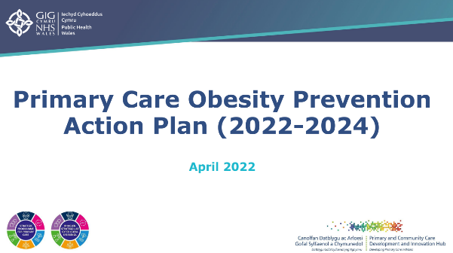
The Primary Care Obesity Prevention (PCOP) Action Plan 2022-24 was published in early 2022/23 and a programme management approach was implemented to support its delivery. A new chairperson, the Interim Director of the Health & Wellbeing Directorate, Public Health Wales (PHW), was invited to chair the PCOP Steering Group to help drive forward the delivery of the Action Plan.
Key developments aligned to the PCOP Action Plan include: establishment of an ‘SPPC Obesity Prevention Peer Network’ for SPPC Fund projects; development of a grant collaboration with the FUSE academic collaborative to understand the effectiveness and implementation of non-specialist interventions for weight management up to 5-years after birth; input into the development of the MSK framework to support incorporation of the All Wales Weight Management Pathway (AWWMP), as well as broader early intervention and prevention interventions; production of a PCOP Communication and Engagement Plan; collaboration with PHW Behavioural Science Unit; presentation to the Four Nations Weight Management meeting to showcase Wales’ Primary Care Obesity Prevention Action Plan; and contribution to the development of a minimum data set for the AWWMP and ‘MECC Healthy Weight Conversations’ eLearning modules.

Following our input into contract negotiations, the GMS contract agreement 2022-23 includes a Quality Improvement project focused on specific unhealthy behaviours in newly registered patients as well as patients with certain long-term or chronic conditions. The QI project will include supporting identification of patients aged 16 and over who have a high BMI, signposting/referring patients who are identified as at risk to relevant support and ensuring HbA1C measurements are taken, and referrals made into the All Wales Diabetes Prevention Programme where appropriate. Also following our feedback, the National Community Nursing Specification includes ‘height and weight’ within the list of ‘Practice & Skills for All Registered Community Nurses and Health Care Support Workers’, as well as requirements for knowledge/skills related to wider determinants, Making Every Contact Count (MECC), person centred approaches, and motivational interviewing.

Diabetes Prevention

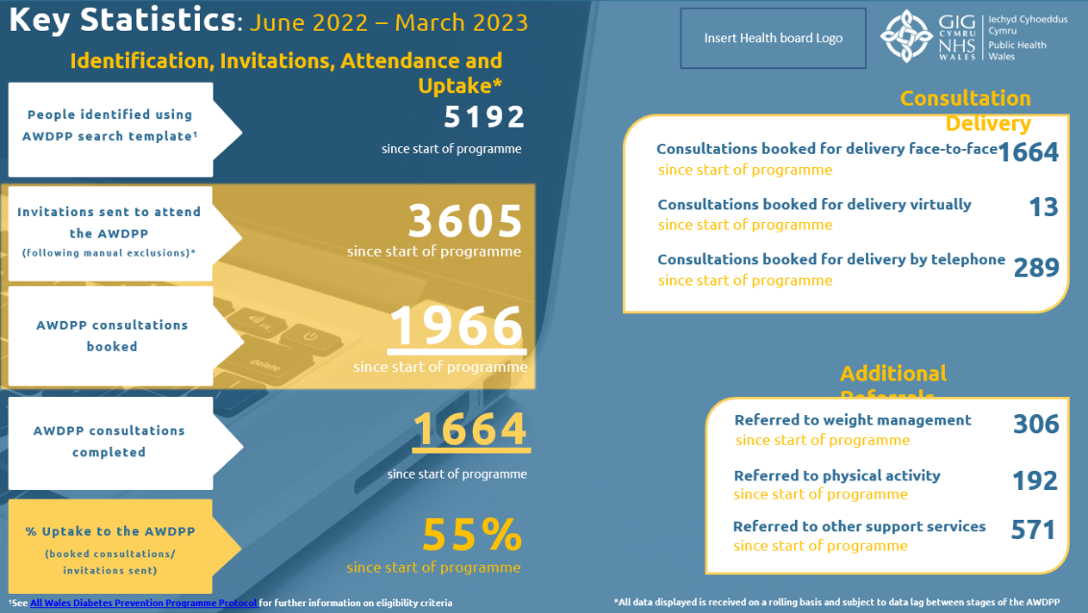
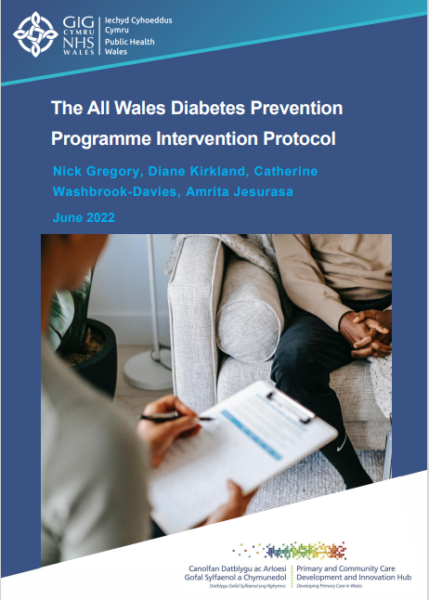
Led by the Primary Care Hub, the All Wales Diabetes Prevention Programme (AWDPP) formally launched in June 2022 during ‘Diabetes Awareness Week’. The launch event was held in Swansea Bay and attended by the Deputy Minister for Mental Health and Wellbeing with coverage on mainstream and social media. Within the first 9 months of implementing the AWDPP, 12 out of 14 primary care clusters receiving WG funding have commenced delivery of the programme, with 26 healthcare support workers and 7 dietetic leads recruited and actively delivering the AWDPP across Wales. Several health boards have also identified alternative funding sources to extend the delivery of the AWDPP to additional clusters, and five primary care clusters (in addition to the 14 funded by Welsh Government) have commenced AWDPP activity through these alternative sources of funding. PHW have commissioned a process evaluation of the initial stages of AWDPP implementation, and the draft evaluation report is due in May 2023. A modified stepped wedge design outcome evaluation has also commenced, and this is due to conclude by the end of 2024/25. In addition to publishing the AWDPP Intervention Protocol , the AWDPP central team has developed a compendium of resources to enable delivery of the AWDPP, including a Training, Supervision and Quality Assurance Framework, a Consultation Manual, and public-facing resources including letters and an information leaflet. The AWDPP central team have provided ongoing programme management and support to health boards, managed the grant funding, developed templates on EMIS and Vision systems, and coordinated training and access to resources. In addition, we have led the development of a ‘once-for-Wales’ Data Protection Information Agreement (DPIA) and Joint Controller Agreement (JCA) and produced the first AWDPP Activity Report for the initial 6 months of operations.

Social Prescribing

In 2022/23, key publications by the PC Hub to support the development of social prescribing in Wales, included: a ‘minute briefing’ and post event summary report on the ‘Social Prescribing in Primary Care in Wales’ engagement event held in March 2022; and a Social Prescribing Interfaces report, published September 2022, with recommendations to inform strategic direction and policy development in relation to social prescribing.
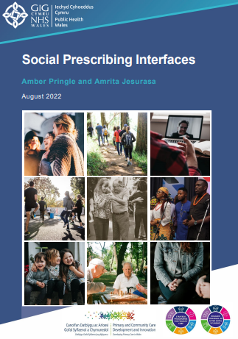
The PC Hub has continued to lead the cross-sector Social Prescribing Coordinating Group, which coordinates the Connected Communities Strategy social prescribing deliverables and supports Welsh Government with development of a national framework for social prescribing.
Furthermore through a social prescribing lens, the PC Hub has: inputted into the development of the National Review of Primary Care Mental Health Demand & Activity; established a grant collaboration between the University of South Wales and PHW to develop an evidence-based glossary of terms; commissioned the development of descriptive case studies; supported development of a ‘Core capabilities framework’, led by Health Education and Improvement Wales (HEIW); contributed to the PHW ‘Cost of living crisis in Wales: A public health lens’ report; and submitted responses to the Welsh Government consultation on a national framework for social prescribing; Health & Social Care Committee questions in relation to social prescribing; and an inquiry into community assets.
In recognition of the emerging evidence base in relation to social prescribing, the PC Hub has also had a key role in supporting sharing of learning and information exchange through representation at the EurohealthNet Social Prescribing Country Exchange; presentation on ‘Understanding Social Prescribing in Wales: A Mixed Methods Study’ at the PHW Research and Evaluation Conference; and providing contributions to both a ‘Cross-country comparison on social prescribing’ led by Germany/ WHO Collaborating Centre for Health Systems Research and Management; and to a WHO Deep dive on the well-being economy showcase for Wales.

Primary Care Transformation
Supporting our partners in the delivery of national plans for the transformation of primary and community care in Wales

Primary Care Model for Wales (PCMW)

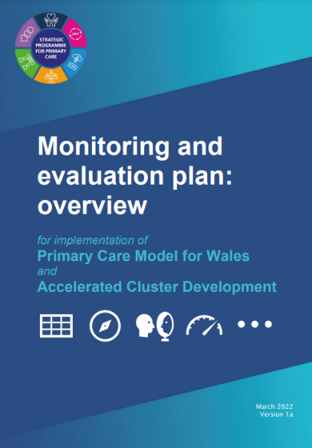
A PCMW / Accelerated Cluster Development (ACD) monitoring and evaluation plan was developed during 2022 which was supported by a Cluster Development Framework (CDF). This defines the anticipated outcomes and describes implementation maturity descriptors for PCMW and success criteria for ACD. The Cluster peer review process for the transition year was designed, and pilot reviews implemented Proposals have been made to Strategic Programme for Primary Care for a self-reflection tool and key indicator dashboard to further support and monitor implementation progress during post-transition year.

Accelerated Cluster Development (ACD)

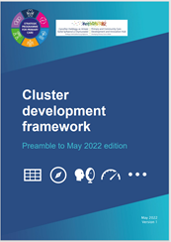
The Division have worked closely with SPPC and health boards to support the implementation of the ACD transition year. Support was provided to an Optometry Professional Collaborative pilot in one area of Cwm Taf which will include evaluation and reporting during 2023. A series of facilitated workshops were commissioned, delivered and reported for community pharmacy, optometry, nursing and Allied Health Professionals. A Learning and development opportunities for new and existing cluster leads discussion paper informed the development of a leadership programme being provided by HEIW and available in Spring 2023. The ACD Toolkit was launched on PC One. The Cluster Planning Support Portal (CPSP) was developed and published to support the cluster planning cycle. The online Population Health Information by Topic (PHIT) index was updated as a resource to guide professional collaborative advice on health improvement priorities. The Primary Care One website has been enhanced with a new Tools section and other content in support of the SPPC, PC Hub, ACD and wider transformation activities.


Greener Primary Care Wales

Designed and led by the Primary Care Division, Public Health Wales, the Scheme was launched nationally in June 2022 with the support of the Minister for Health and Social Services, Minister for Climate Change and the Future Generations Commissioner. The first year saw over 100 practices, across all 4 contractor settings and all health board areas in Wales complete approximately 650 climate change actions with 16 bronze, 11 silver and 8 gold awards given. The relaunch of year 2 was marked with a webinar on 20 March 2023 which was endorsed for the second year with a Ministerial written statement. An animation designed and developed to promote the Scheme was developed and a Yearbook of case studies from year 1 published with funding from the Welsh Government Health and Social Care Climate Emergency National Programme. Successful completion of the 2022-2023 Bevan Exemplar programme where the Scheme was commended at the Bevan Showcase event in January 2023.

Other climate change activity

The Primary Care Division has been integral to the establishment of a PHW Climate Change Board and the inclusion of a chapter in the PHW Long Term Strategy dedicated to climate change, highlighting the role primary care. At the request of Welsh Government a national Task and Finish group was established to provide a coordinated approach, national oversight, input and support to address inhaler use and disposal in Wales aligned to the relevant initiatives in the NHS Wales Decarbonisation Strategic Delivery Plan (2021). The group is chaired by PCD. The inaugural was held meeting in January 2023 and a Decarbonisation – Inhaler Prescribing, Use and Disposal, 2023–2030. A national strategy for Wales, has been drafted in partnership with All Wales Therapeutics and Toxicology Centre which will be consulted on during 2023. The Division have undertaken a rapid review of the evidence of inhaler use and disposal and commissioned a behavioural insights piece of work about enablers and barriers to patients returning inhalers to the community pharmacy for safe disposal with Cardiff Metropolitan University to support the inhaler Task and Finish workplan. The Division continues to attend, participate and provide ongoing public health advice offered to the Approaches to Healthcare project of the Climate Emergency National Programme Board.

Eye Health Care

Ongoing provision of general public health advice and input into strategic development of primary care eye health care service developments. This includes specialist public health advice into the Optometry Contract Reform Implementation Board and relevant sub-groups. During 2022 the PC Hub provided advice and guidance to an HEIW Optometric Fellow producing an All Wales Eye Health Needs Assessment.

Pacesetter Programme 2020/2022 and SPPC Fund 2022

The team led on the production of the Pacesetter Programme 2020-2022 End of programme report that was published in August 2022 which provides a summary of activity and learning for national consideration and brings to a close the Pacesetter Programme across Wales.
The team also produced a number of papers to support the introduction and monitoring of the new Strategic Programme for Primary Care Fund (SPPC Fund) – benefits and Outcomes papers for the Obesity and ACD projects 2022/23 SPPC Fund 2022-23 OP Projects - Benefits and Outcomes Paper. and SPPC Fund 2022-23 ACD Projects – Benefits and Outcomes Paper. and produced a mid-year SPPC Fund monitoring and performance report for National Primary Care Board in November 2022. The team are currently working on the SPPC Fund End of Year 1 report for National Primary Care Board in the summer to capture expenditure, outputs/outcomes, reflections and learning and to help to inform future investment prioritisation.

All Wales Practice Manager Network (Gwella)

All Wales Practice Manager Network established on HEIW Gwella platform and launched at All Wales Practice Manager Conference in November 2022. Demonstrations made to Practice Managers with ongoing activity to promote the network.

Cluster Development Support Officer Network (CDSON)
The Division coordinates and Chairs the Cluster Development Support Officer Network; an informal community of interest to bring together health board staff from across Wales who work in and around clusters to share learning and engage with the ACD programme.
Primary Care Public Health Networks
The Division coordinates the Primary Care Interests Group (PCIG) and Primary care Leads Network (PCLN) that bring together Local Public Health team primary care leads and PHW Directorates to synergise and harness the capacity of the public health system, sharing learning and receive briefings on programmes of work to strengthen population health impact of primary care in Wales. The network discussion topics / presentations have included ACD delivery, the emerging Strategic Workforce Plan for Primary Care in Wales; Community Infrastructure programme, Population Health approaches across Wales, Inverse Care Law Programme, the refresh of the Cluster Profiles (2014), developing the Public Health System (MOU2)
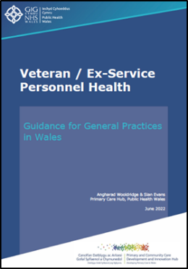
Veterans and Ex-Service Personnel Health

The Ex Service / Veterans Health – Guidance for General Practices, 2022 provides detail of the duty on all general practices in Wales to provide care, signpost to and/or refer to relevant services where appropriate any veteran or veteran family member registered with the practice.

. 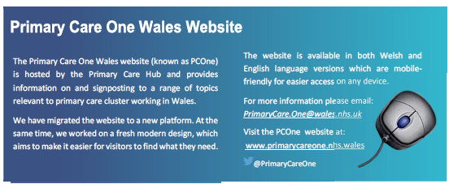

Dental Public Health
Supporting and leading oral health and dental services improvement in Wales

Oral Health Improvement

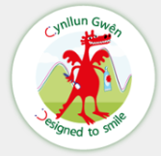
Designed to Smile, the national oral health improvement programme for children (www.designedtosmile.org) continued to work towards regaining coverage that was suspended during the pandemic. A new monitoring process was implemented, and the 2021/22 annual report was published in September 2022.
In 2022, the dental public health team became more closely involved in Gwen Am Byth, the national oral health improvement programme for dependent older adults Gwên am byth - Public Health Wales (nhs.wales), chairing the national advisory group, and taking responsibility for annual reporting to Welsh Government.

Oral Health Intelligence (including dental epidemiology)
Dental Public Health team is responsible for the design, conduct and delivery of the Dental Epidemiology Programme for Wales, working alongside the Welsh Oral Health Information Unit (WOHIU) within the Cardiff University School of Dentistry and Community Dental Services (CDSs) in Health Boards. This programme had to be paused during the pandemic.
The recovery of the programme started in 2022 with engagement with relevant stakeholders and teams and planning for the dental health survey of year 1 children. The survey protocol was reviewed and improved. Training and Calibration (T&C) event for the dental epidemiology field teams was held on 5-7th of October 2022 in Gwent. Dental examination and data collection from Year 1 children is almost complete. We plan to carry out analyses and publish a survey report in Q4 2023/24.
During the second half of the 2022/23, we also started planning for the dental health survey of Year 7 children in Wales. Training and Calibration event for the dental epidemiology field teams will be held on 27-29th of September in North Wales.

General Dental Service (GDS) Reform Programme
The GDS reform programme was hosted by Public Health Wales prior to the COVID19 pandemic with an increasing number of dental practices applying to join the programme every year since the programme started in September 2017. The programme had several objectives including re-orientation of the General Dental Services so that offer of the dental care was based on ‘need and risks’ and delivery of care was prevention and outcome focussed with broader aim of reducing inequity in dental service use. The programme was paused during the pandemic and restarted on 1st of April 2022 as agreed with the Welsh Government. Working with the Welsh Government, we transferred the hosting and governance of the reform programme to the Welsh Government with development of new programme structure and workstreams.
Dental public health team provided its expertise to the GDS Reform Programme during 2022/23. We provided dental public health input through the overarching Dental Strategic Oversight Group, chaired two out of the three workstreams, programme co-ordination group and provided dental public health input into the remaining workstream and other work associated with the dental reform. We organised several workshops and engagement events providing platforms for all stakeholders to communicate, provide feedback and share each other's perspective and ideas. We provided programme management support to the whole of the programme throughout the year.

Details of the GDS Reform Programme can be found at: https://primarycareone.nhs.wales/topics1/dental-public-health/general-dental-services-gds-reform-programme-for-wales/

Dental Public Health Advice and Support
Dental Public Health team also provided independent advice and support to several external stakeholders especially Welsh Government, Health Boards, Health Education and Improvement Wales (HEIW), NHS Business Services Authority, Welsh Dental Committee, Strategic Advisory Forums for dental specialities and others.
We reviewed, improved and co-ordinated once for Wales annual Quality Assurance self-assessment process. 99.7% of NHS dental practices in Wales participated and submitted their self-assessments to their Health Boards. We also hosted bi-annual GDS Quality and Safety Forum which brought together all stakeholders to discuss various aspects of quality and safety in dentistry and share learning.

Further information on the work of the Primary Care Hub and the wider Primary Care Division can be seen on PCONE, on the Primary Care Division and Dental Public Health page of the PHW website.

