Strategic Programme for Primary Care
World Organization of National Colleges, Academies and Academic Associations (WONCA)
Europe Conference 2023 (summary)
Report date: August 2023
Author: Kelly King

The Strategic Programme for Primary Care (SPPC) supported a small working group from across NHS Wales to attend the WONCA Europe Conference in Brussels in June 2023.

WONCA is the World Organization of National Colleges, Academies and Academic Associations of General Practitioners/Family Physicians, a not-for-profit organisation which promotes the highest standards of care in family medicine. The organisation provides a forum for exchange of knowledge and information between practitioners and member organisations.

The aim of the delegate group to attend was to assess the progress towards a multi professional model of care across European countries, to understand the shared challenges and to identify learning for the delivery of the Primary Care Model for Wales.
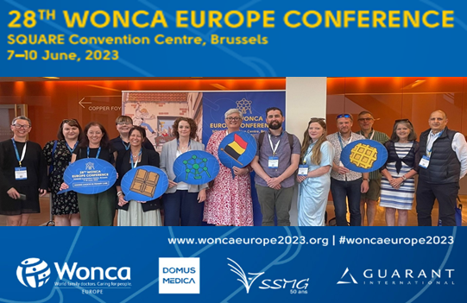
Delegates attended plenary sessions, workshops and short paper presentations, contributing questions and providing examples of the Welsh model. The group shared feedback from a wide number of session and explored how this might be relevant for the Welsh context.

Working as group also provided participants to learn from their peers about emerging models and the development of enhanced practice across the Welsh system. The conference highlighted many shared challenges across primary care internationally, including escalating demand and backlogs of care arising from the Pandemic, workforce deficits, staff burn-out/mental health concerns, over-medicalisation and the impact of social issues on health care utilisation.

The delegate group produced a summary report reflecting on the experiences of the group and plans to disseminate the learning across NHS Wales.

Any comments, queries, or requests for further information, should be directed to SPPC@wales.nhs.uk with the title ‘WONCA 2023 Conference Report’.

