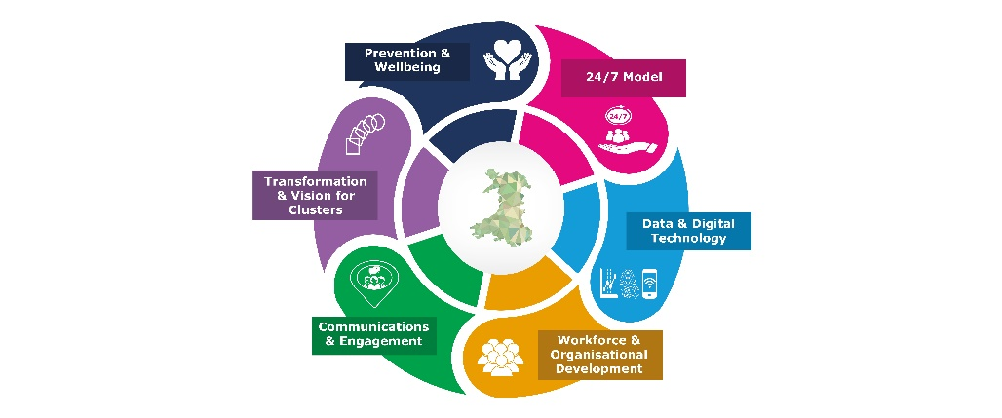
Strategic Programme for Primary Care

COVID-19 Toolkit for Community Pharmacy Contractors

Updated: October 2020

This document is updated (October 2020) and supersedes the April 2020 edition.

The environment in which services are now delivered, looks very different compared to April 2020 (when the first edition was published). Refreshed content includes:
- A reflection of the learning from COVID-19
- The changes and supporting resources made available throughout COVID-19
- Updating of hyperlinks.

Updates have been made by:
Cardiff & Vale University Health Board – Louise Allen, Community Pharmacy Advisor.
Welsh Government – Lloyd Hambridge, Clinical Fellow.
Strategic Programme for Primary Care – Stacey Forde, Senior Programme Manager and Iris Wilmshurst, Senior Project Manager.

Contents
Executive summary 4
Introduction 5
Practical checklist for community pharmacies 7
1. To protect the health and wellbeing of all pharmacy staff 10
1.1 If a staff member displays COVID-like symptoms 11
1.2 Infection Prevention and Control including Personal protective equipment (PPE) 12
1.3 Waste handling and cleaning 14
1.4 Security issues and community safety 14
1.5 Helping you and your family 14
1.6 Test, Trace and Protect (TTP) 15
1.7 Face Coverings 16
1.8 Further information 17
2. To ensure community pharmacies continue to be available to dispense and supply repeat and acute prescriptions, with if necessary a reduction in hours pharmacies are open to the public 18
2.1 Opening times / working behind closed doors 18
2.2 Temporary closure guidance 20
2.3 Course of action if closure is required 21
2.4 Situation reporting (SITREP) 22
2.5 Business continuity plans 22
3. To support a move away from demand-led to more planned ways of working particularly in respect of repeat prescriptions 22
3.1 Repeat prescriptions 22
3.2 Changes to service provision 23
3.3 Substance misuse services 24
4. To reduce footfall in community pharmacies both to support social-distancing and reduce pressure on pharmacy teams 27
4.1 Working with the patient and volunteers 27
4.2 Medication collection and delivery 27
4.3 Medication supply from community pharmacy within the wider primary care continuity plans 28
5. To support the public to self-care, through improved access to online information or through telephone advice and medicines from their community pharmacist 31
5.1 Communication channels in community pharmacy 31
5.2 Promote Self-Care and change your service provision 32
Links to further information: 32
Conclusion 34
Appendices 35
Appendix 1: Pharmacy staff with COVID-like symptoms guidance 35
Appendix 2: Template - Notification of closure forms 37
Appendix 3: Template - Closure notices English and Welsh 39
Appendix 4: Public information posters 42
Appendix 5: Key worker letter for community pharmacy 46
Appendix 6: List of Health Board Contacts 47
Appendix 7: GP Messaging - Repeat Prescriptions COVID-19 48
Appendix 8: Poster – Information for volunteers collecting medication 49
Appendix 9: Delivering Medicines Safely COVID-19: Guidance 50
Appendix 10: Guidance on: Use of NHS Wales email between GMPs and Community Pharmacies 52

Executive summary
To support the retention of safe, efficient, and accessible pharmaceutical services, the Welsh Government (WG) have outlined a set of five key objectives:
- To protect the health and wellbeing of all pharmacy staff;
- To ensure community pharmacies continue to be available to dispense and supply repeat and acute prescriptions, with if necessary a reduction in hours pharmacies are open to the public;
- To support a move away from demand-led to more planned ways of working particularly in respect of repeat prescriptions;
- To reduce footfall in community pharmacies both to support social-distancing and reduce pressure on pharmacy teams; and
- To support the public to self-care, through improved access to online information or through telephone advice and medicines from their community pharmacist
Note: the order of the objectives has been changed to reflect the flow of this document
Work has been underway with partners across Government, Health Boards (HB), Community Pharmacy Wales, the Royal Pharmaceutical Society, along with other key stakeholders to develop a range of measures to support meeting these objectives.
There is an expectation on community pharmacies, practices and clusters to work collaboratively in establishing the best patient and prescription journey, especially for symptomatic and COVID-19 positive patients and those requiring urgent palliative care medicines.
This toolkit compiles information that has so far been released in relation to each of these objectives. It also offers guidance and supporting information to enable the continuity of services by community pharmacies at this unprecedented time of pressure. Practical tips and templates have been included to help contractors navigate their way through the process.
It should be noted that the situation is very fast-moving, and plans are evolving at pace, so this document provides only a snapshot of the current situation (as of 1st October 2020).
Whilst we hope that this toolkit will be useful in providing guidance, it is important to acknowledge that this should not be taken as a blueprint for the continuity of services for every pharmacy. This information should be used in conjunction with each pharmacy’s business continuity plan and should be seen as offering complementary or supplementary guidance only.

Introduction
During the COVID-19 outbreak the community pharmacy sector in Wales has risen to the challenges it has faced. Community Pharmacy has seen an unprecedented increase in prescription volume and footfall and the dedication and efforts of all community pharmacy teams across Wales has been astounding and very much appreciated by the NHS in Wales.
The Health Boards (HB) in Wales continue to offer their support and guidance to community pharmacy to enable them to adjust their daily practice in line with the Welsh Government (WG) and Public Health Wales guidance and advice. It is hoped that the measures implemented so far will have reduced the pressures faced by the community pharmacy network.
WG and HBs will continue to work together to ensure the safety and wellbeing of this key NHS frontline pharmacy workforce.
To support the retention of safe, efficient, and accessible pharmaceutical services, WG have outlined a set of five key objectives, with all measures aligned to one or more of those objectives.
The objectives were:
- To protect the health and wellbeing of all pharmacy staff;
- To ensure community pharmacies continue to be available to dispense and supply repeat and acute prescriptions, with if necessary a reduction in hours pharmacies are open to the public;
- To support a move away from demand-led to more planned ways of working particularly in respect of repeat prescriptions;
- To reduce footfall in community pharmacies both to support social-distancing and reduce pressure on pharmacy teams; and
- To support the public to self-care, through improved access to online information or through telephone advice and medicines from their community pharmacist
Note: the order of the objectives has been changed to reflect the flow of this document
Work has been underway with partners across Government, HBs, Community Pharmacy Wales, the Royal Pharmaceutical Society and with other stakeholders to develop a range of measures to support meeting these objectives.
Our ability to provide care as the number of patients infected with COVID-19 rises depends on a whole system approach to management.
There is an expectation on community pharmacies, practices and clusters to work collaboratively in establishing the best patient and prescription journey, especially for symptomatic and COVID-19 positive patients and those requiring urgent palliative care medicines.
This toolkit has been developed as part of the work to support all community pharmacy contractors to as they rise to the challenge of providing quality services during unprecedented pressures in a consistent and co-ordinated approach to COVID-19. Practical tips and templates have been included to help contractors navigate their way through the process.
The protection and wellbeing of all pharmacy staff is paramount and this toolkit sets out some basic principles. These should be considered in addition to contractors Business Continuity Plans and seek to compliment guidance published by professional bodies.
It should be noted that the information contained in this document is correct at time of publication (October 2020). Further updates are available on the Community Pharmacy Wales website: http://www.cpwales.org.uk/The-Health-Landscape/Coronavirus-Information-Updates.aspx
As an aid for community pharmacies in preparing for COVID-19, a checklist of practical advice has been produced by the Welsh Government and is available in Welsh and English. Links are provided below and copies are provided in the next section.
- COVID-19 - Practical Checklist for Community Pharmacies:
http://www.cpwales.org.uk/getattachment/The-Health-Landscape/Coronavirus-Information-Updates/Guidance-on-managing-the-pharmacy/COVID-19-Practical-Checklist-for-Community-Pharmacies-final.pdf.aspx?lang=en-GB
- COVID-19 - Rhestr Wirio Ymarferol i Fferyllfeydd Cymunedol:
http://www.cpwales.org.uk/getattachment/The-Health-Landscape/Coronavirus-Information-Updates/Guidance-on-managing-the-pharmacy/COVID-19-Practical-Checklist-for-Community-Pharmacies-Welsh-PDF.pdf.aspx?lang=en-GB

Practical checklist for community pharmacies
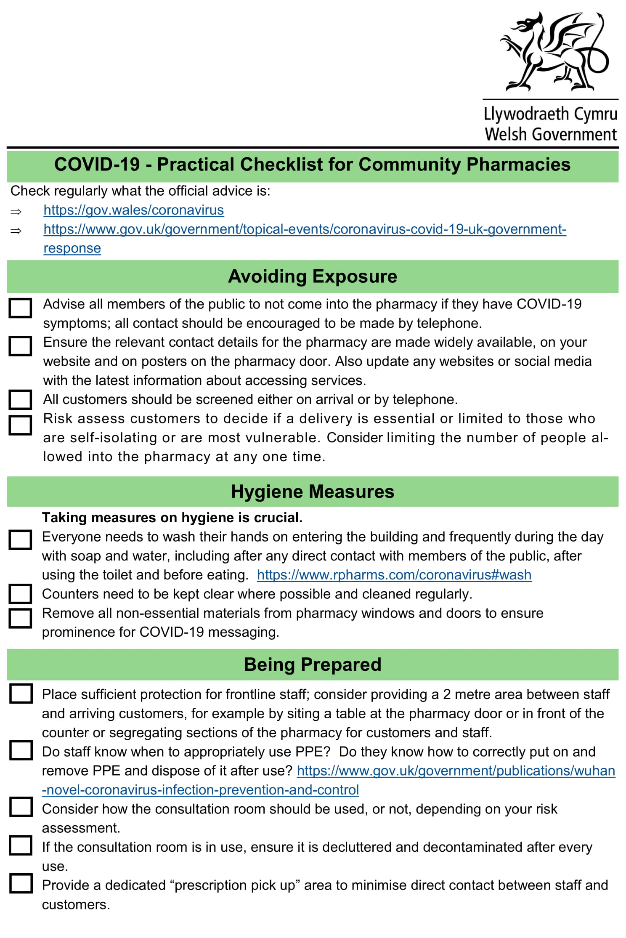
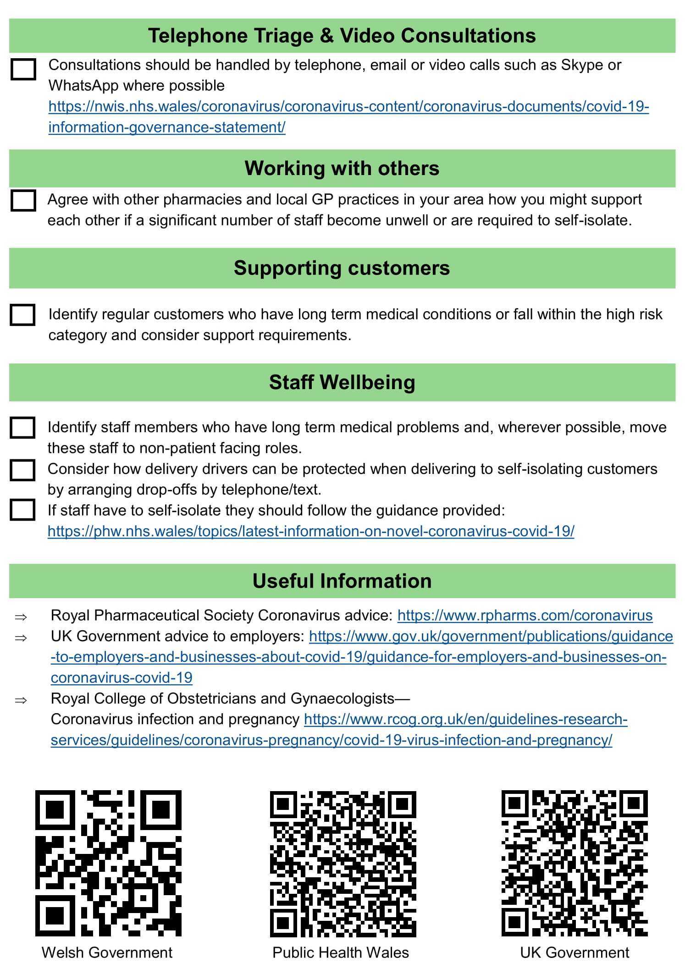
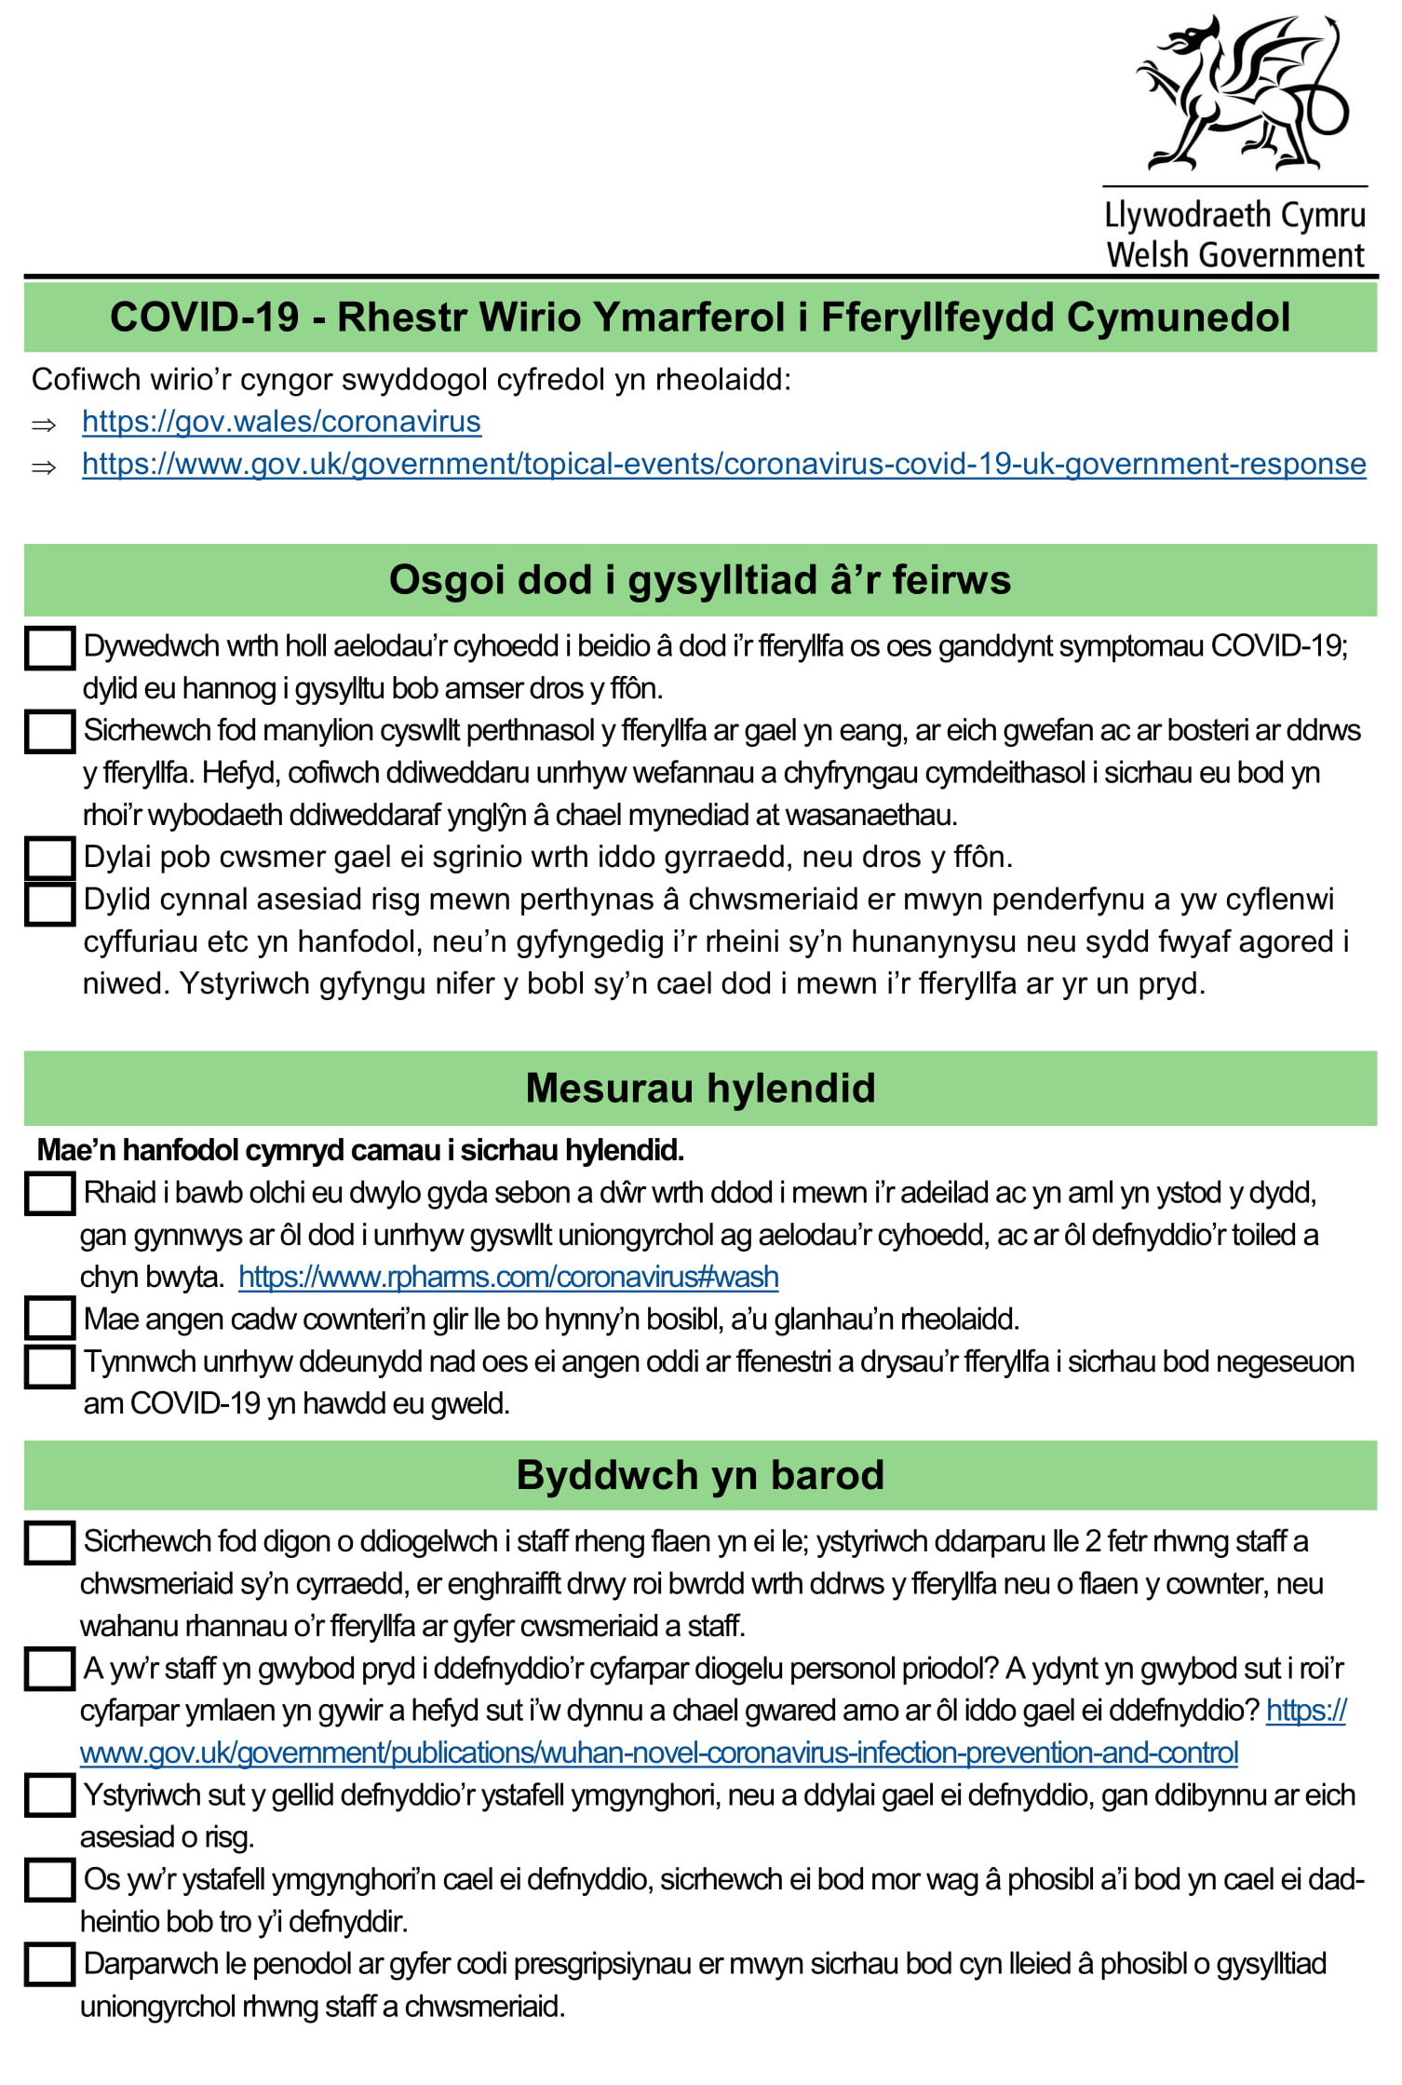
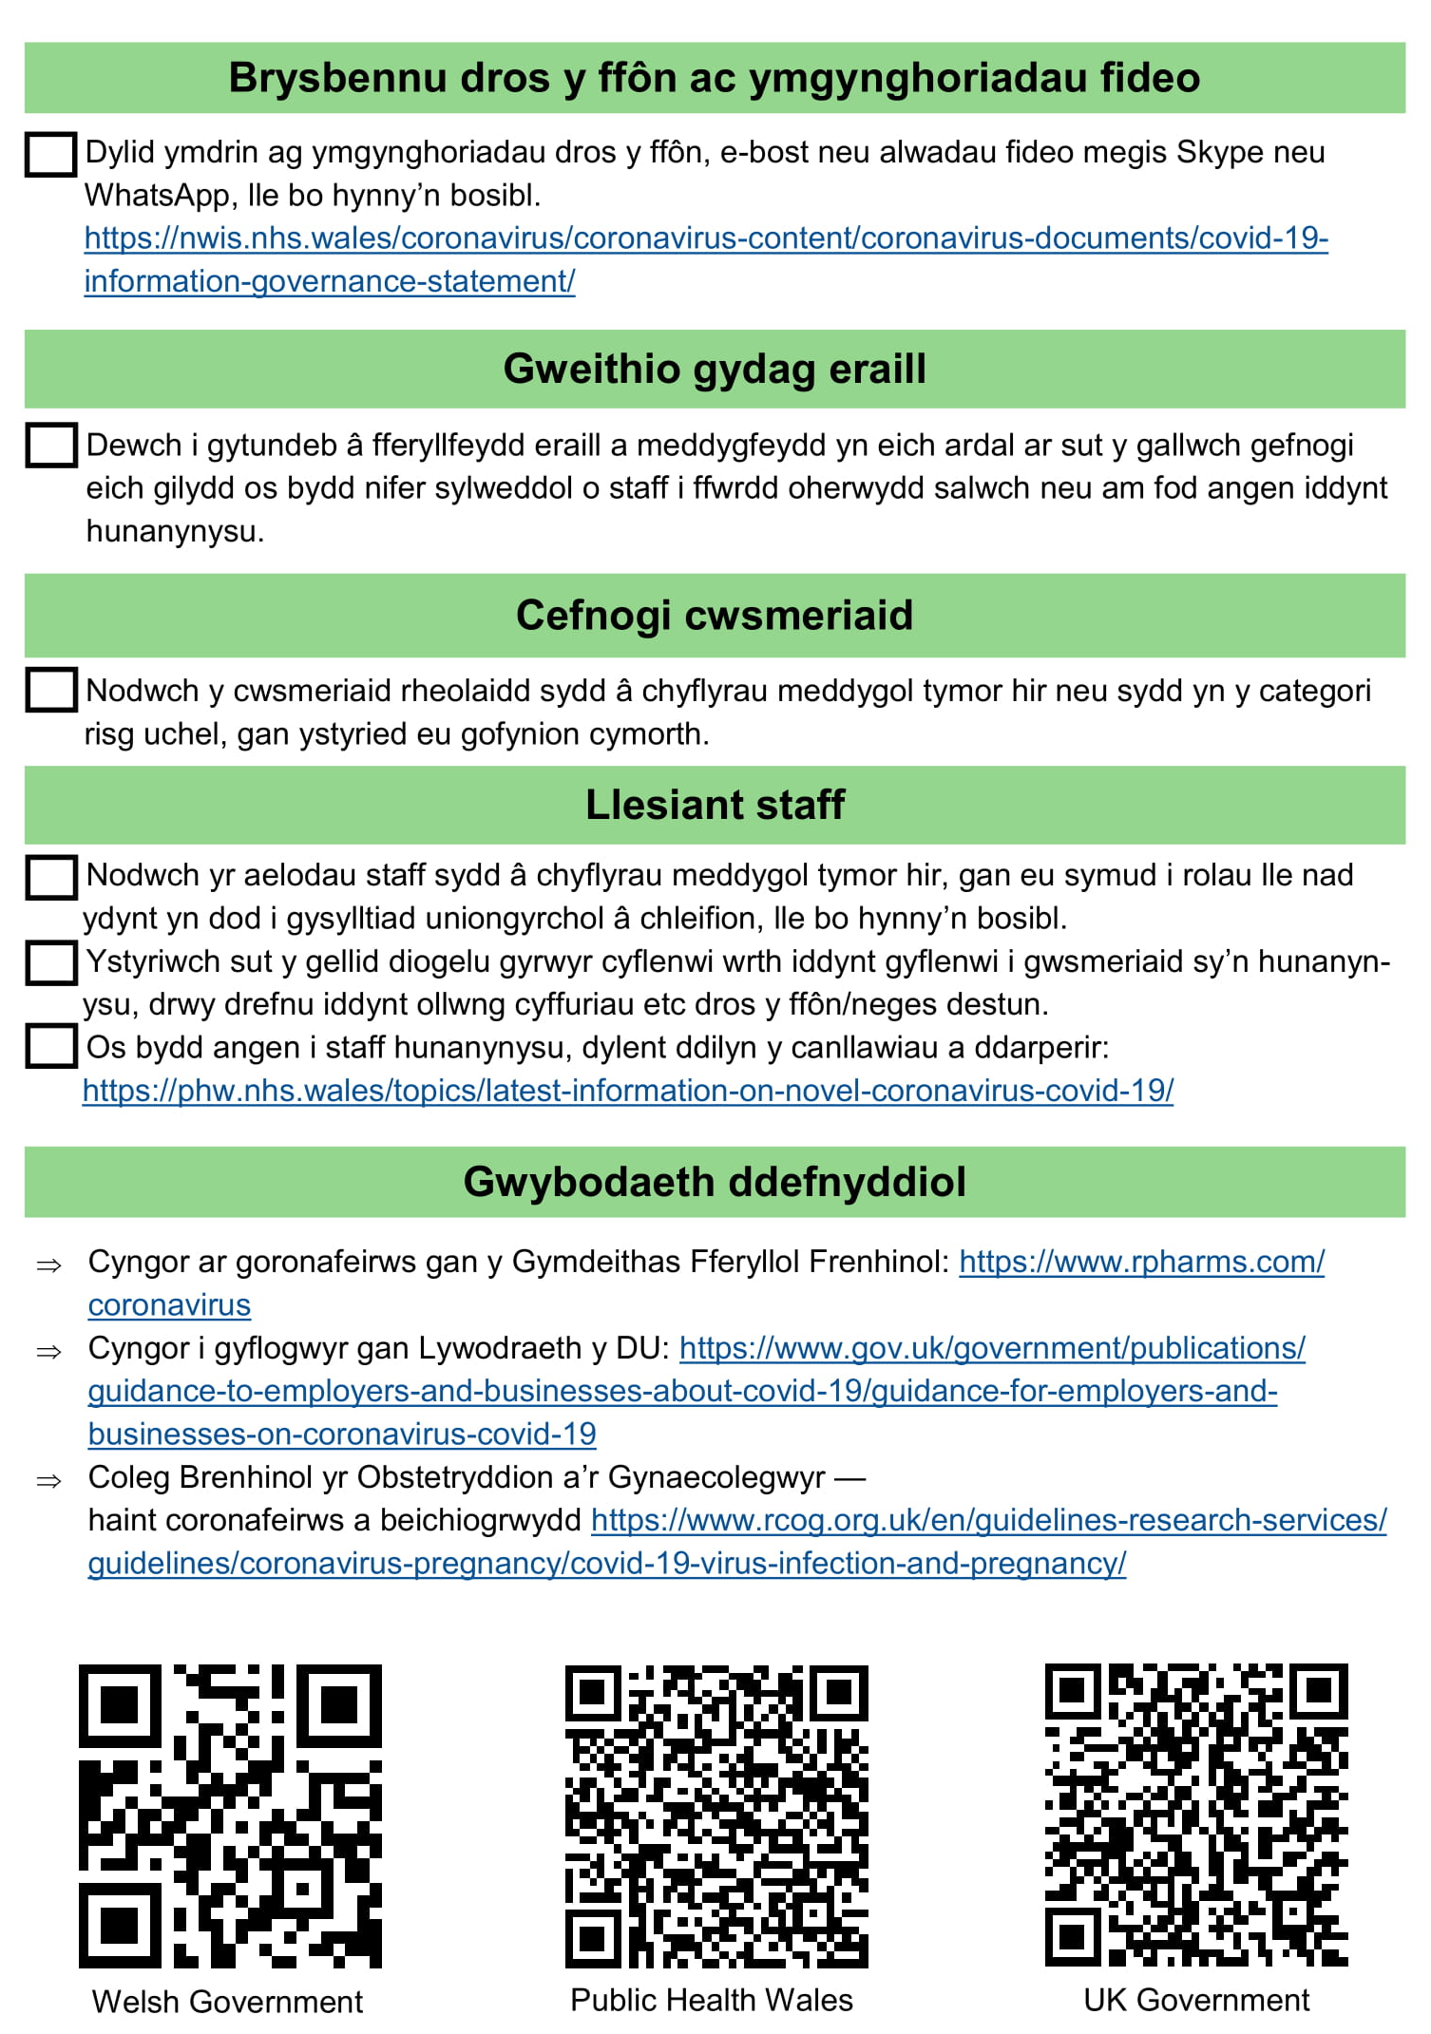

1. To protect the health and wellbeing of all pharmacy staff
Support yourself and your teams to protect their health and wellbeing
- It is understandable pharmacy staff are concerned about the risk of contracting COVID-19, HBs and WG continue to review the guidance and offer the appropriate advice in line with Public Health Wales.
- WG guidance encourages all staff to take a break every day; stop all non-essential activities; create a rota to make sure your team are not customer facing all day.
- Keep an eye on the health of your team and send anyone home immediately if they feel unwell for any reason.
- No member of staff should be coerced or pressurised to come to work if they should be self-isolating.
- Statutory sick pay can now be claimed from the first day of sickness. A self-isolation note can be accessed by: https://111.nhs.uk/isolation-note

1.1 If a staff member displays COVID-like symptoms
Guidance of what to do if a staff member displays COVID-like symptoms is available in Appendix 1 and can be displayed in the dispensary area. This advice should also be followed if a pharmacist or staff member is required to self-isolate due to symptomatic household contact.
If the pharmacist in charge displays symptoms
- Unless another pharmacist is on the premises and able to act as the responsible pharmacist, the pharmacy must close.
- The pharmacist with symptoms must go home and self-isolate in line with government guidance (https://www.gov.uk/government/publications/covid-19-stay-at-home-guidance/stay-at-home-guidance-for-households-with-possible-coronavirus-covid-19-infection).
- The pharmacy should immediately implement the relevant sections of its business continuity plan.
- The pharmacy team should notify the HB of the closure using the temporary closure notice (Appendix 2) and notify the local GP practice, other local pharmacies, local drug and alcohol Teams and patients due to collect urgent dispensed medication.
- Relevant information should be displayed for the public (e.g. nearest pharmacy, how to access medication, useful contact numbers. Appendix 3 is a template).
- The pharmacy should try to find suitable pharmacy cover for the remainder of the day where possible, and for the period during which the usual pharmacist may be in self-isolation.
- Where same day locum cover cannot be secured, the pharmacy should make arrangements for the collection of urgent dispensed prescriptions.
- This may include:
- transferring prescriptions or dispensed medication to a nearby pharmacy for the patient to collect; or
- where no other option is available, allowing staff to supply dispensed medication in the absence of a pharmacist for a short period of time, as per GPhC advice
https://www.pharmacyregulation.org/news/regulatory-approach-challenging-circumstances-gphc-and-psni-joint-statement.
- The pharmacy should undertake a thorough clean of the areas and equipment used by the symptomatic member of staff. Even where a pharmacist is available to allow normal operation of the pharmacy, it would be appropriate to close temporarily in order to clean thoroughly.
- The pharmacist should arrange to be tested in line with the guidance issued by your HB if the result is negative, the pharmacist can return to work if well enough. If the result is positive, the pharmacist must continue to self-isolate in line with guidelines.
- The pharmacy must keep the HB regularly updated as to their opening status until the situation stabilises. Where the pharmacy is unable to open the following day (e.g. in the absence of locum cover), this must be raised with the HB as a matter of urgency.

If a non-member of pharmacist staff displays symptoms
- In line with government advice, it is not necessary to close the pharmacy if a member of staff become symptomatic (https://www.gov.uk/government/publications/guidance-to-employers-and-businesses-about-covid-19/guidance-for-employers-and-businesses-on-coronavirus-covid-19#what-to-do-if-someone-develops-symptoms-of-coronavirus-covid-19-on-site).
- The first step would be to send the affected member of staff home to self-isolate in line with government guidelines.
- The pharmacy should undertake a thorough clean of the areas and equipment used by the symptomatic member of staff (this may require a brief closure of the premises).
- You should then arrange for the symptomatic member of staff to be tested in line with the HB guidance.
- Other staff can continue to work, following appropriate infection prevention measures.
- Other staff do not need to self-isolate unless they too begin to display symptoms, when self-isolation and testing would be appropriate.

1.2 Infection Prevention and Control including Personal protective equipment (PPE)

- Community pharmacies remain low risk environments for COVID-19 transmission.
- There are a number of standard IPC measures, which pharmacy teams should undertake, to minimise the risk of transmission amongst staff and users of the pharmacy further still.
- The most important steps pharmacy teams should follow to protect themselves and others from the transmission of COVID-19 include:
- Physical distancing;
- Hand hygiene;
- Environmental decontamination;
- Appropriate use of Personal Protective Equipment (PPE).

- Please review the attached WG guidance recommending the appropriate the use of Personal Protective Equipment (PPE) in community pharmacy:
Infection prevention and control (including PPE) guidance:

PPE should be used for all contacts with patients, and when working alongside colleagues, where social distancing cannot be maintained (within 2 metres).
Staff should be trained and follow the appropriate methods for donning and doffing PPE in addition to following the advice detailed in the above document on what PPE should be used for the service or activity undertaken.

- Any individual who is suspected or confirmed to have COVID-19 should not be in work and should be self-isolating under current government guidance.
- Community pharmacies should implement measures to ensure that no-one with suspected or confirmed COVID-19 should enter their pharmacy. Appendix 4 includes a template for public information.
- Staff and patients should not mix/share the same space within the pharmacy except where strictly necessary; staff should follow good hand hygiene principals, and ensure a 2m social distance is maintained between staff and patients in all usual circumstances.
- If a possible or confirmed case presents at the pharmacy and is deemed too unwell to return home, they should be asked to move to an area in the pharmacy where they can be isolated (e.g. a consultation room), away from other patients and pharmacy staff. Emergency services should be called. In an emergency, where entry to the area in which someone is isolated is unavoidable, PPE (comprising disposable gloves, apron, fluid resistant surgical mask and eye/face protection) should be worn by the person entering the area in order to provide direct care. In all cases exposure should be kept to a minimum.
- Used PPE and cleaning materials should be disposed of as clinical waste.
- Remember: PPE must ONLY be used in line with WG guidance.
- For further government guidance on PPE, see: https://www.gov.uk/government/publications/wuhan-novel-coronavirus-infection-prevention-and-control/covid-19-personal-protective-equipment-ppe
- Guidance on social distancing for businesses available at: https://gov.wales/taking-all-reasonable-measures-maintain-physical-distancing-workplace
- Guidance on operating a safe workplace as far as practically possible available at: https://gov.wales/workplace-guidance-employers-and-employees-covid19
- Guidance on COVID-19: infection prevention and control (IPC) available at: https://www.gov.uk/government/publications/wuhan-novel-coronavirus-infection-prevention-and-control

1.3 Waste handling and cleaning
- Waste such as PPE, tissues, disposable cleaning cloths should be disposed of in disposable rubbish bags and then placed in another bag and kept separate from other waste. This should be kept aside for at least 72 hours before putting into usual external waste bin.
- For decontaminating/disinfecting surfaces, national infection prevention guidance recommends that disposable cloths/paper towels and a fresh solution of general-purpose detergent and water be used.

Cleaning guidance from the government
- COVID-19- cleaning in non-healthcare settings:
https://www.gov.uk/government/publications/covid-19-decontamination-in-non-healthcare-settings
- Reducing the risk of transmission of COVID-19 in the hospital setting – Environmental Decontamination:
https://www.gov.uk/government/publications/wuhan-novel-coronavirus-infection-prevention-and-control/reducing-the-risk-of-transmission-of-covid-19-in-the-hospital-setting#environmental-decontamination

1.4 Security issues and community safety
- Reports of abuse, and violence, against community pharmacy staff, are not acceptable Police Officers and Community Support Officers will be increasing visible patrol activity in all areas of Wales to reduce potential community tensions and encouraging people to conform with Government advice on social distancing.
- As part of the overall strategy there will be a natural focus on retail areas, town centres and high streets where many of our pharmacies are located.
- Please be aware if there is an urgent concern for safety or there is a need to report an incident community pharmacy staff should be encouraged to use the 101 or 999 (in an emergency) reporting routes. This will not only afford appropriate protection but also inform any emerging intelligence picture in support of policing operations to manage any emerging community tensions.

1.5 Helping you and your family
- All HBs have issued an NHS approved key worker letter template for community Pharmacy teams. This represents the value HBs place on community pharmacy teams as key member of the NHS frontline defence against COVID (See Appendix 5).
- All HBs are testing community pharmacy team members, and staff are advised to contact their HB’s community pharmacy leads for further information as set out in Appendix 6.
- In some HBs testing can be provided for family members of community pharmacy teams where a non-symptomatic community pharmacy team member is having to self-isolate due to a symptomatic family member, this ensures community pharmacy teams are operating with a maximum workforce wherever possible.

1.6 Test, Trace and Protect (TTP)
- If you or a team member test POSITIVE, in line with the Welsh Government’s Test, Trace, Protect Strategy you will be contacted by a member of the TTP team to help identify any individuals you have been in close contact with - beginning up to two days before you started having symptoms and asking them to take precautions and self-isolate (for 14 days).

- You will be asked to share details of contacts you may or may not live with, and with whom you have been in close proximity on any occasion during a period beginning up to 2 days before you started experiencing symptoms,

- Contact criteria
A contact is a person who, in the period 48 hours prior to and 7 days after the case’s symptom onset or specimen collection date (if case was asymptomatic), had at least one of the following types of contact with the case:
- A household contact is somebody who lives in the same household as a case.
- A direct contact is a person who has:
- Been within 1 metre of the index case and has been coughed on, had a face-to-face conversation, had skin-to-skin physical contact, or has been in other forms of contact within 1 metre for 1 minute or longer.
- A proximity contact is a person who has:
- Been within 2 metres of the index case for more than 15 minutes. This can be cumulative – added from a few encounters, not necessarily all at once;
- Travelled in a car with – or in a plane near- the case.
- This contact needs to have occurred during the period of time the case was considered to be most infectious (48 hours before the case started to have symptoms until 7 days after the case started to have symptoms/ or from the date a swab was taken, if asymptomatic).
People working in professional roles who have correctly used personal protective equipment (PPE) or work behind an appropriate screen or partition (e.g. a Perspex screen) are not regarded as a contact for those purposes.

If, however, they have not worn appropriate PPE, they are considered as a non-household contact (direct or proximity contact).

- What are the implications of TTP for Community Pharmacy?

- There is a potential risk for TTP to significantly disrupt business continuity in community pharmacy

- The risk can be mitigated by strict adherence to guidance for:
- PPE
- Physical distancing in and outside of clinical environments
- Rostering staff to work within teams
- Particular attention must be paid to maintaining physical distance during break and lunch times. More information can be found at:
- https://gov.wales/test-trace-protect-html
- https://gov.wales/test-trace-protect-your-questions#section-42186

1.7 Face Coverings

- Face coverings are now required in all indoor public places in Wales, for both customers and staff working in indoor public areas as detailed by Welsh government, further information can be found here

- http://www.cpwales.org.uk/getattachment/The-Health-Landscape/Coronavirus-Information-Updates/Welsh-Government-Comms/20200914-Mandatory-wearing-of-face-covering-in-Primary-Care.pdf.aspx?lang=en-GB

- CPW and RPS Wales have produced a helpful bilingual poster that can be displayed in pharmacies:

- http://www.cpwales.org.uk/getattachment/The-Health-Landscape/Coronavirus-Information-Updates/Guidance-on-managing-the-pharmacy/Safety-and-Infection-Control-in-the-Pharmacy/00259-001b-2007-Face-Covering-Poster-WELSH-PRINT-2.pdf.aspx?lang=en-GB

For more information see links below:

- https://gov.wales/face-coverings-guidance-measures-be-taken-employers-and-managers-premises
- https://gov.wales/face-coverings-guidance-public

1.8 Further information
- Guidance for food businesses on coronavirus (COVID-19) – Information for retailers that reads across to pharmacies:
https://www.gov.uk/government/publications/covid-19-guidance-for-food-businesses/guidance-for-food-businesses-on-coronavirus-covid-19

https://gov.wales/taking-all-reasonable-measures-minimise-risk-exposure-coronavirus-workplaces-and-premises-open

2. To ensure community pharmacies continue to be available to dispense and supply repeat and acute prescriptions, with if necessary a reduction in hours pharmacies are open to the public
Use a flexible and sustainable approach to ensure your community pharmacy continues to operate
This will allow you to continue to dispense and supply repeat and acute prescriptions and your services to your patients.
Managing demand, reducing footfall, and maintaining social distancing
- You may want to consider how you may need vary the workflow in your pharmacy that will enable social distancing amongst staff.
- As advised by CPW contractors should carry out a risk assessment and look at what reasonable measures could be taken to support social distancing within their premises.
- Consider the following (but not limited to):
- Workflow within the pharmacy
- Shift patterns of staff members
- Work space / work stations
- If you have not already done so, you may want to consider implementing a notification system to inform patients when their prescriptions are ready, supported with clear information that they should not call the pharmacy and should wait until they hear from you. For example, this might involve them giving a mobile phone number and being sent a text when the item is ready for collection.
- It may also be valuable to ask patients to write the number of days treatment that they have remaining on their prescription, so that you can gauge the urgency of the items and better prioritise workflow through the pharmacy.

2.1 Opening times / working behind closed doors
The following steps will help ensure that the public and other health organisations retain the confidence of community pharmacies during this difficult time and that we are able to effectively plan our response, including how community pharmacy contributes.

Contracted hours
- Please ensure that your pharmacy is open for the full contracted hours as listed on the NHS Direct website. If there is not a responsible pharmacist for the full period of your contracted hours, you must complete the temporary closure notification (Appendix 2) and email this as soon as possible to your HB.
- Please ensure that the “Pharmacy Closure During Contracted Opening Hours” form (Appendix 2) is submitted to NWSSP when the pharmacy is closed if HB requests.
- The mechanism to formally change your contracted hours is to submit an HN1 form (available from shared services), giving at least 90 days’ notice of the intended change. In the case of Core Hour changes, the HB may refuse the change.

Flexible working/Operating behind closed doors
- As you will be aware, you are permitted if required, to open behind closed doors for the first hour of each day, and for up to 1 hour during the working day without notifying the HB.
- In order to maintain public confidence in community pharmacy, it is important that the following are adhered to in order for these closures to be permitted.
- During periods of closed door working, staff should be catching up on the pharmacy’s workload or taking rest breaks, but sufficient staff should remain on the premises to enable the pharmacy to be reopened in response to an urgent need e.g. urgent prescriptions.
- The pharmacy must notify all local healthcare providers of their closed door working periods (and OOHs if the affected times are after 18:30hrs on a week day or any time on a weekend).
- A notice must be displayed in the pharmacy window (at all times) that outlines the working pattern for the pharmacy and include, as a minimum:
  - Times when the pharmacy will be accessible to the public (i.e. the times in between the closed door working periods)
  - Times when the pharmacy will be open, but working behind closed doors (making clear that the staff will be working hard during this period to serve their patients)
  - Mechanism(s) for patients and other healthcare professionals to access the pharmacy team during closed door working periods for urgent access to medicines
  - A system to enable patients to drop prescriptions off for later dispensing, without them having to queue to do so (including information that you want them to write on the prescription, such as a contact number)
- Healthcare professionals should be able to access the pharmacy team during the whole working day (including periods of closed door working) to discuss urgent queries.
- Pharmacy teams should take all reasonable steps to open communication channels with local healthcare providers (and OOH if appropriate) in addition to the advertised pharmacy phone number (which is frequently engaged). This may include messaging services such as a mobile phone number, Hospify or other mechanisms that are agreed locally.

Urgent Queries
- The HBs would consider the following situations as ‘urgent’ and requiring access to the pharmacy during closed door working periods (this list is not exhaustive):
  - A new prescription for End of Life Care (Palliative) medicines (to minimise suffering and allow a dignified and comfortable death).
  - A healthcare professional collecting medicines for their patient (to minimise wasting precious healthcare professional time).
  - An acute prescription issued by the GP Out of Hours service (the OOH service only issue a prescription where the treatment is needed urgently).
  - An acute prescription issued where a delivery service cannot be offered (patients with suspected or confirmed COVID-19 should be able to go home as soon as possible to minimise the risk of virus transmission).
  - A patient needing to collect repeat medicines where they need to take a dose before the pharmacy will next be accessible.
  - Allowing a collection of waste medicines by SRCL.

2.2 Temporary closure guidance
General Pharmaceutical Council (GPhC) guidance on closures
- The GPhC has recently produced regulatory guidance around COVID-19: https://www.pharmacyregulation.org/news/regulatory-approach-challenging-circumstances-gphc-and-psni-joint-statement
- Patients and treatment agency should be informed of this transfer where possible.
- Pharmacies routinely dispensing WP10MDAs are encouraged to reflect this information in their business continuity plans.
- Pharmacies should consider the GPhC guidance above and wherever possible work with local pharmacy colleagues to maintain provision where pharmacies will be closed for more than the current day and supervisions are due. Suggested actions include:
- Contacting local pharmacy colleagues to agree a plan for transfer of prescriptions in the event of a pharmacy closure in advance. These should be included in your business continuity plans.
- Prescribing agencies have agreed that where replacement prescriptions are needed to cover the original pharmacy, these will be provided in due course.
- Ensure prescription forms are clearly endorsed with the pharmacy details to ensure pharmacies receive the correct levels of reimbursement and remuneration.
- Consider making a copy of the prescription before transfer.

Things to consider if closure is necessary
- Where a pharmacy is unable to open or needs to close due to unforeseen circumstances, pharmacy staff must ensure the following:
- The pharmacy must notify the local HB at the point of closure using the Temporary Closure Notification form (Appendix 2). Ideally, use the mitigating actions box to inform the HB what has been done with WP10 (MDA) prescriptions.
- If possible, the names of any urgent care patients who have not collected medication on that day should be sent to HB (see HB contact list Appendix 6)
- All patients must be advised of contingency plans for collecting subsequent doses if the pharmacy will be unable to open when the next dose is due (see below).
- Where a pharmacist is on the premises, pharmacists should consider the following:
If possible, pharmacists should contact prescribers to confirm that they are happy for patients on daily/twice weekly prescriptions to have subsequent doses provided in advance as take home. These patients should be contacted and asked to return to the pharmacy (if they have already collected today’s dose).

2.3 Course of action if closure is required
In the event that pharmacies are unable to provide pharmaceutical services for their contracted hours, either because:
- they are unable to open or
- because they need to close early,
The priority must be for the pharmacy to make appropriate provision for their patients to receive their medication or services and to communicate their closure as outlined below.
- The responsible pharmacist should refer to the pharmacy’s Business Continuity Plan when making decisions as to whether to temporarily close the pharmacy.
- The pharmacy must use all reasonable endeavours to resume provision of pharmaceutical services as soon as practicable.
- This procedure applies to temporary closures due to COVID-19, adverse weather or other unexpected circumstances beyond the control of the pharmacist.
- Changes to contracted opening hours for other reasons (e.g. where pharmacists are aware of the need to temporarily close the pharmacy prior to the day of closure) must be discussed and agreed with the LHB prior to the day of the closure.
Informing NHS Wales
- Please ensure that the “Pharmacy Closure During Contracted Opening Hours” form (Appendix 2) is submitted following HB process for reporting closure.
- This information will be shared and cascaded to NHS Direct, Out of Hours Services and HBs to ensure patients can access up to date information in relation to accessing services.

Contractor Actions
- Multiples to contact regional/head office for information and advice
- Complete the notification of closure form (Appendix 2) and follow the HB process for reporting closure:
- Via Email in the first instance
- In the event you cannot access email, please telephone your HB community pharmacy lead or team.
Please DO NOT contact LHB Switchboards or pharmacy departments.
- Phone local GP Practices to advise them of the closure and inform them of expected time and date of re-opening.
- Phone other local pharmacies to inform them of closure and check if they are remaining open.
- Identify which enhanced services cannot be provided and, if appropriate, notify the prescriber and clients and support making alternative arrangements. This is especially relevant to supervised administration clients who attend pharmacies on a daily basis. See contingency guidance.
- Attempt to deal with urgently required medication that is awaiting collection by patients in line with pharmacy Responsible Pharmacist Standard Operating Procedures.
- Place notice in window advising patients of the closure and reason and detail locations of other pharmacies in the locality. Include NHS Direct number (0845 4647).
- If the pharmacy is contracted to provide any additional hours (rota) service, or provides services on Saturdays and Sundays, contact the local OOH service to inform them of closure.

2.4 Situation reporting (SITREP)
- As of 1 June 2020, all community pharmacies are asked to complete (and maintain) their pressure level, workforce and (as an optional feature) PPE information. Following an initial submission, reporting is only required to reflect a change (e.g. pressure level information will roll-over until changed). Pharmacies can access the tool via the NECAF system and detailed user guidance has been issued and can be found here: http://www.cpwales.org.uk/getattachment/The-Health-Landscape/Coronavirus-Information-Updates/Guidance-on-managing-the-pharmacy/Guidance-on-Pharmacy-Services-(Essential-Advanced/Community-Pharmacy-Escalation-Tool/NECAF-Community-Pharmacy-Escalation-Tool-User-Guide-v1-0-20200529.pdf.aspx?lang=en-GB.
- It is the opportunity for you to flag your situation to the HB and inform them of your staffing levels.
- This helps HBs to understand the pressure that you are under, allows them to respond and direct and signpost your patients.

2.5 Business continuity plans
- All pharmacies will have their own business continuity and all contractors have been asked to undertake a review of their business continuity plans with a specific focus on COVID-19 preparedness before the end of April, as agreed with WG:
- An outline collaborative approach to continuity of pharmacy service has been developed by CCA and NPA and this document considers how the sectors will work together: https://thecca.org.uk/wp-content/uploads/2020/09/Continuity-of-Pharmacy-Service-Wales.pdf

3. To support a move away from demand-led to more planned ways of working particularly in respect of repeat prescriptions
Changing the way your community pharmacy works to support the move away from demand-led to more planned ways of working particularly in respect of repeat prescriptions

3.1 Repeat prescriptions
- WG has advised practices to switch all appropriate patients to repeat dispensing (batch prescribing). If repeat dispensing is not possible, they have requested post-dated prescriptions are issued where appropriate. This will support continuity of supply of medication during COVID-19 epidemic and minimise social contacts.
- Health prescribing teams continue to support and advise practices to follow the WG guidance. http://www.cpwales.org.uk/The-Health-Landscape/Coronavirus-Information-Updates/Welsh-Government-Comms.aspx
- The information sent to GPs can be found in Appendix 7.

3.2 Changes to service provision
Telephone consultations
- Commissioned services where applicable can be provided over the phone, where it is safe and appropriate to do so.
- Offering enhanced services (e.g. EC, CAS, EMS) via telephone where feasible and appropriate to support patients to self-isolate will help to reduce the footfall in your community pharmacy.

Advanced and Enhanced service
- HBs and WG have reviewed the Advanced and Enhanced services that can still be provided in community pharmacy this is summarised below as at 1st April 2020* and may be subject to change. (*reviewed September 2020)
ADVANCED SERVICES:
- MUR – Suspended as of 1 April 2020 (including telephone MURs) until April 2021
- DMR – ACTIVE - (HIGH PRIORITY) – Consider remote/telephone consultations*
ENHANCED SERVICES:
National Services:
N.B. Usual commissioning procedures apply
- Care Homes Support – Suspended (N.B. SBUHB are looking at telephone consultations)
- Common Ailments Service – ACTIVE – (HIGH PRIORITY) – telephone consultations*
- Emergency Contraception – ACTIVE – (HIGH PRIORITY) - Consider remote/telephone consultations*
- Emergency Medicines Supply – ACTIVE – (HIGH PRIORITY) - Consider remote/telephone consultations*
- Needle & Syringe Service – ACTIVE
- Rota – ACTIVE (HIGH PRIORITY) –for urgent prescriptions
- Sore Throat Test & treat – Suspended and revised service to be piloted.
- Smoking Cessation Level 2 – ACTIVE – Supply up to 4 weeks NRT on each occasion (professional discretion)
- Smoking Cessation Level 3 – ACTIVE (Existing clients) – Consider remote/telephone consultations* can increase the supply of NRT up to 4 weeks (professional discretion). No CO monitoring required
New Clients –As above if pharmacy has the capacity to provide No CO monitoring required, if no capacity refer to HMQ
- Supervised Administration – ACTIVE – extended to pharmacy technicians, no requirement to use consultation room (appropriate location in pharmacy to be used instead)

Locally Commissioned (in relevant HBs)
N.B. Usual commissioning procedures apply
- BBV Testing - Suspended
- Inhaler Review Service – Suspended
- Independent Prescribing – Discuss with Relevant LHB Community pharmacy lead (dependent on service commissioned/ experience of IP/ PPE etc.)
- MAR Chart – ACTIVE
- Palliative Care Services – (Stock and/or Just In Case Packs) – ACTIVE – High priority
- Patient Sharps Service – ACTIVE
- Respiratory Rescue packs - ACTIVE
- Triage and Treat Service – Contractors have been given the option to either suspend or continue (where they believe it is safe to do so)
- Waste Reduction Service - ACTIVE
*Only provide Face to face consultations where social distancing can be maintained and or appropriate PPE is in place.
Patients attending the pharmacy for any consultations/ collect medication following a telephone consultation should be screened appropriately and asked to send a representative if they should be in self-isolation.

3.3 Substance misuse services
Guidance for community pharmacies
- The following guidance has been prepared in discussion with substance misuse services and outlines the principles which would support continuation of service during the COVID-19 pandemic.
- WG has published guidance for substance misuse services, all agencies should refer to this document for further information:
https://gov.wales/coronavirus-covid-19-guidance-for-substance-misuse-and-homelessness-services-html
- Please note that due to rapidly changing circumstances, this guidance is subject to change. For the most up to date situation on COVID-19 go to: Coronavirus (COVID-19) on GOV.WALES and Public Health Wales
- Prescribers and pharmacists should make best interest decisions jointly and whilst some principles will be applied routinely others must be considered on a case-by-case basis with joint discussions.
- Patients receiving opioid substitution therapy may be at risk of complications of COVID-19 and so any variation to supervision agreement needs to be considered by prescribers.

General advice for pharmacies
- Obtain up to date telephone contact details for all substance misuse patients.
- Encourage patients to nominate a representative who they would authorise to collect prescriptions on their behalf in emergency situations, ideally with agreement from prescribers.
- Prescribing agencies are actively reviewing patients to see if it is clinically appropriate to move patients to take home doses or reduce frequency of supervisions.

Non-collection of prescriptions
- Under normal circumstances pharmacists should contact the prescriber if 3 consecutive doses are missed or, if a weekly prescription, the patient is more than 3 days late in collecting. This allows time for the prescriber to contact the patient and discuss continuing treatment but confirm with the local DAT teams the process they wish to follow.

Principles to consider when supervising the administration of Methadone and Buprenorphine doses
- Weekly prescriptions should ideally be supervised on the day of pick-up.
- If the prescription contains the words Supervised Consumption the pharmacist may, at their discretion, supply without supervision if they feel the benefits outweigh the risks. The pharmacist may wish to document the details on the Patient Medication Record.
- As always, medication should not be supplied to patients who appear to be inebriated.
- If supervision of weekly or other interval prescriptions is necessary, the following may apply:
- Supervised consumption may take place in any appropriate area of the pharmacy, not just the consultation room (please confirm with patients that they are happy to proceed).
- Registered technicians can now supervise.
- Some Prescribers have agreed that buprenorphine may be crushed before giving to the patient to reduce supervision time. This is at the professional discretion of the pharmacist (off-licence use). If pharmacists do not wish to crush tablets then supervision must be for the appropriate time. Please refer to the local HB guidance for further information.
- Prescribers are looking at alternative preparations to sublingual buprenorphine for some patients. Suitable patients may be switched to injectable buprenorphine preparations in the coming weeks. Prescribers will advise pharmacies of any changes to medication.

For patients self-isolating/those with symptoms of COVID-19 infection
- Patients should be told that they must inform prescribers if they need to self-isolate.
- If a patient with a daily/twice weekly prescription contacts the pharmacy to advise that they are unable to attend the pharmacy for supervision, pharmacists should attempt to contact the prescribing agency to discuss appropriateness of the dose being supplied as a take home.
- In cases where the patient has a weekly prescription the pharmacist should contact the prescriber to discuss the quantity that may be dispensed.
- If unable to contact the prescriber for patients with weekly prescriptions, then arrangements should be made to supply to a representative or delivery could be considered.
- The above scenarios should include a discussion of plans for further doses if the patient is self-isolating for longer than 14 days, in addition to allowing nominated representatives to collect on the patient’s behalf.
- Prescribers have been requested to inform pharmacies if there are individuals who should not be allowed to represent patients.
- If the patient contacting the pharmacy does not have a representative to help them consider delivery to the patient if possible.

4. To reduce footfall in community pharmacies both to support social-distancing and reduce pressure on pharmacy teams
Support your team to reduce footfall in community pharmacies, reducing pressure on pharmacy teams

4.1 Working with the patient and volunteers
Working with patients
- Social distancing is crucial for preventing the spread of contagious illnesses such as COVID-19 which can spread through coughing, sneezing and close contact. By minimising the amount of close contact with others, chances of catching and spreading the virus to others is reduced.
- Put clear signage on the door advising people NOT to enter the pharmacy if they have symptoms of COVID-19 (Appendix 4).
- Screen patients BEFORE they enter the pharmacy and limit the number of people allowed in at any one time to ensure social distancing.
- Provide a 2m area between staff and customers, by siting a table at the pharmacy door, chairs in front of the counter or by segregating sections of the pharmacy for customers and staff. Use tape to mark floors or physical barriers to encourage this. If you have a dispensing hatch or screen use it. Provide a dedicated “prescription pick up” area so medicines are not handed directly to customers.
- If possible, telephone patients when their prescription is ready for collection to avoid waiting within the pharmacy.
- If a patient is suspected of having COVID-19 and has already entered the pharmacy they should be isolated in line with guidance and Personal Protective Equipment should be worn by pharmacy staff providing care.
- Follow good infection control procedures. Surfaces must be cleaned regularly; for decontaminating/disinfecting surfaces national infection prevention guidance recommends that disposable cloths/paper towels and a fresh solution of general purpose detergent and water be used. Staff should wash their hands frequently with soap and hot water. Provide hand sanitiser for staff and customers.

Working with volunteers
- Pharmacies have experienced a significant increase in the number of people seeking to support through volunteering.
- Pharmacies approached with offers of support, including medication delivery, should refer all volunteers to the Volunteering Wales website: https://volunteering-wales.net/
- Pharmacies requiring volunteer support can also contact their local county voluntary council (CVC) a list can be found at: https://www.gvs.wales/about-us/wcva-county-voluntary-councils-cvcs-and-volunteer-centres-vcs

4.2 Medication collection and delivery
Medication collection
- Social distancing guidelines should be followed for all medication collections.
- Unless previously known to staff, pharmacies should request to see identification from any volunteer presenting to collect medication on behalf of a patient.
- Most volunteers who work regularly with organisations associated with the local CVC will have ID available.
- A poster has been provided that can be placed in the pharmacy to provide information for volunteers collecting medication (Appendix 8).
- For all other organisations or individuals, pharmacies are encouraged to confirm with the patient before supplying the volunteer with medication. Particular caution is required where controlled drugs are involved.
- Patient confirmation for an organisation or individual to collect their medication may be recorded on the PMR system.
- Pharmacies should consider the potential consequences of providing medication to unknown persons without patient consent.
- Any messages or counselling for the patient should be undertaken by phone before medication is supplied.
- Cold chain storage requirements should be highlighted to the volunteer.
- Pharmacies should consider recording the identity of volunteers collecting medication on behalf of patients. The back of the patient’s prescription form may be used for this purpose.

Delivery solution for Wales
The National Volunteer Prescription Delivery Scheme and Royal Mail Track 24 Click and Drop Scheme have been in place to support community pharmacies in ensuring that shielding patients, or those who are self-isolating, continue to receive their medicines during COVID-19.
Following the announcement from the Chief Medical Officer that shielding was to be paused from 16 August the Chief Pharmaceutical Officer wrote to community pharmacies on 20 July to outline a transition period for medicines delivery support. During this time pharmacies were asked to reprioritise their pre-existing prescription delivery services; priority should be given to those people who genuinely cannot collect prescriptions from the pharmacy or practice and who do not have anyone who can collect the prescription on their behalf.
Although both the National Volunteer Prescription Delivery Scheme and Royal Mail Track 24 Click and Drop Scheme will come to an end 30 September, the Welsh Government has provided assurance that Ministers are in support of rapid remobilisation of both schemes, if needed, in response to local or national lockdown measures, as a result of COVID-19.

4.3 Medication supply from community pharmacy within the wider primary care continuity plans
- WG established a national Planning and Response Group to oversee the response to COVID-19 and ensure that a whole system response is in place to respond to the challenges of COVID-19.
- Each Cluster has considered and agreed with their HB the model that best suits their local context and arrangements depending on demographics and local resources available. It might be necessary to change and/or flex the chosen model depending on changes in demand and workforce capacity/availability.
- Clusters need HBs to support the coordination of the primary care response across practices including community pharmacy contractors linking to system-wide planning and resilience testing.
- Our ability to provide care as the number of patients infected with COVID-19 rises depends on a whole system approach to management.
- There is an expectation on community pharmacies, practices and clusters to work collaboratively in establishing the best patient and prescription journey, especially for symptomatic and COVID-19 positive patients and those requiring urgent palliative care medicines.
- Alternative ways of communicating prescription requirements will need to be utilised such as the email solution suggested by NWIS (Appendix 10) and this will need collaboration from all parties to ensure it is successful.
- More information and guidance on delivering medicines safely including preparation, transit and delivery is available in Appendix 9.
Key reminders: Patient confidentiality
It is a legal requirement of anyone working within the healthcare profession to respect and protect people’s dignity and privacy. It is your responsibility to ensure:
- All written patient information is kept out of sight of the public.
- No confidential information is overheard.
- Requests for patient information are always referred to the pharmacist.
Key reminders: Infection control
- Wash your hands with soap and water, when entering a pharmacy/surgery, frequently throughout the day, including after direct contact with members of the public, after using the toilet and before eating.
- Counselling and messages must be provided by pharmacy team over the phone and not face to face with driver.
- Only deliver to the patient’s home not their neighbour.
- Do not pick up returned medicines.
- Avoid using doorbells/knockers as much as possible – use your phone.
- If touching doorbells/knockers be mindful to wash/clean hands using soap or hand sanitiser afterwards.
- Clean equipment used during deliveries e.g. wiping electronic devices, pens etc.
- Maintain good vehicle hygiene e.g. wiping steering wheel, hand brake, door handles.
- Always avoid touching your face.
The diagram below summarises how medication may be supplied from community pharmacies (please refer to local HB guidance in your area as these may differ):

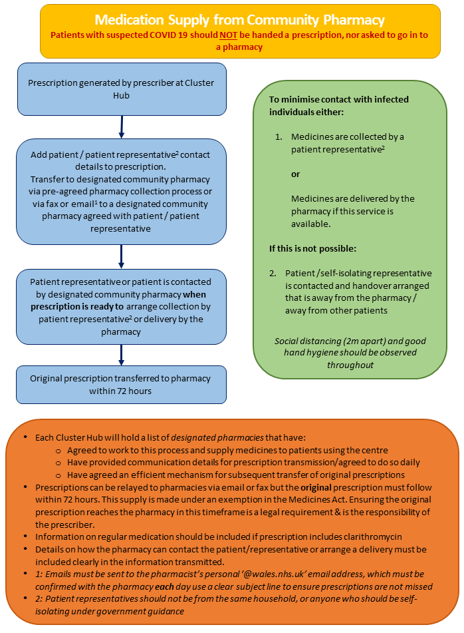

5. To support the public to self-care, through improved access to online information or through telephone advice and medicines from their community pharmacist
Communication is key to support community pharmacy other healthcare professionals and the public in understanding the new ways of working
- By communicating effectively you will help the public to continue to self-care, by receiving telephone advice and improving access to medicines from community pharmacy.
- During this period of the COVID-19 outbreak, Community Pharmacies and GP practices are facing significant pressures it is accepted that it could be more harmful to not share health information than to share it.
- Where clinical need demands it, we may need to work in different ways from usual with our focus being on what information we need to share and who we share it with, rather than how we share it.

5.1 Communication channels in community pharmacy
- Collaborative and open channels of communication are key to helping community pharmacy teams and the wider primary care network deliver the patient care they want to.
- Community pharmacies should consider having in place a system that will allow communication:
- During ALL contracted hours (included when working behind closed doors).
- For urgent use by healthcare professionals that will not be shared with patients.
- To avoid unnecessary congestion of the pharmacy patient phone line.
- To provide timely and appropriate access to Palliative Care teams, Carers and District Nurses.
- These are to be seen as supportive measure and not as additional tasks for pharmacies.
- Pharmacy teams may wish to use any of the following to build local communication channels with practices and other pharmacies.
- These could be useful options to communicate changes to opening times if agreed at a local level and could be used to discuss and liaise with practices around queries and stock shortages.
- These could also be used to alert Palliative Care team, Carers and District Nurses when to access the pharmacy or if stock is available if requested by HBs.
- We do appreciate that not all pharmacies and surgeries will have the ability to have a dedicated phone line but hope some of the options below will offer some useful alternatives.

Use of NHS Email
- Pharmacists can currently use their Choose Pharmacy NHS emails to discuss queries and liaise with practices.
- Email can also be used for urgent prescriptions under Emergency request by prescriber regulation. (Appendix 10)

Dedicated Phone lines
- Where possible using an additional phone line in a pharmacy for only Healthcare professionals to use.
- Where possible using a dedicated phone line in a surgery/GP practice for only Pharmacies to ring in on.
- This phone line could be used for Emergency request by prescriber for urgent prescription (this should be by the prescriber and not as an administrative task.)
- Some HBs may provide dedicated HB Pharmacy mobile phone’s where appropriate.

Hospify
- Hospify is a secure app for use in messaging/communication between healthcare professionals.
- The app is compliant with GDPR, NHS IG toolkit, ISO 27001 and the NICE evidence standard framework, and would be an option for pharmacy teams to build local communication channels with practices and other pharmacies.
- This could be a useful option to communicate queries and changes to opening times if agreed at a local level.
- It could also be used to transmit patient identifiable data where no other options are workable.
- But this is not recommended as a routine solution for the sending of prescriptions for dispensing, use of the email process as above where possible.
- For more information:
  - https://nwis.nhs.wales/coronavirus/digital-support-updates-for-healthcare-professionals/information-governance/
  - https://www.nhs.uk/apps-library/hospify/
  - https://www.hospify.com/

5.2 Promote Self-Care and change your service provision
- Promoting self-care should continue to be a focus for community pharmacy.
- Pharmacy teams can support patients in doing this by offering their advice and services in a variety of different ways.
- Provide services and consultations over the phone, where it is safe and appropriate to do so.
- Use your Pharmacy social media pages to promote key messages from WG.

Links to further information:
- Welsh Government – COVID-19 - Practical Checklist for Community Pharmacies:
http://www.cpwales.org.uk/getattachment/The-Health-Landscape/Coronavirus-Information-Updates/Guidance-on-managing-the-pharmacy/COVID-19-Practical-Checklist-for-Community-Pharmacies-final.pdf.aspx?lang=en-GB

- Llywodraeth Cymru – COVID-19 - Rhestr Wirio Ymarferol i Fferyllfeydd Cymunedol:
http://www.cpwales.org.uk/getattachment/The-Health-Landscape/Coronavirus-Information-Updates/Guidance-on-managing-the-pharmacy/COVID-19-Practical-Checklist-for-Community-Pharmacies-Welsh-PDF.pdf.aspx?lang=en-GB

- General Pharmaceutical Council – Coronavirus latest updates:
https://www.pharmacyregulation.org/contact-us/coronavirus-latest-updates

- Royal Pharmaceutical Society – Coronavirus updates and information:
https://www.rpharms.com/coronavirus/

- Royal Pharmaceutical Society – Coronavirus Q&A
https://www.pharmacyregulation.org/standards/guidance/questions-and-answers-coronavirus

- Community Pharmacy Wales – Coronavirus information and updates:
http://www.cpwales.org.uk/The-Health-Landscape/Coronavirus-Information-Updates

- Community Pharmacy Wales – Guidance on managing the pharmacy:
http://www.cpwales.org.uk/The-Health-Landscape/Coronavirus-Information-Updates/Guidance-on-managing-the-pharmacy.aspx

- Community Pharmacy Wales – COVID-19 Frequently Asked Questions:
http://www.cpwales.org.uk/getattachment/The-Health-Landscape/Coronavirus-Information-Updates/COVID19-FAQ.pdf.aspx?lang=en-

- GOV.UK – Stay at home: guidance for households with possible coronavirus (COVID-19) infection:
https://www.gov.uk/government/publications/covid-19-stay-at-home-guidance/stay-at-home-guidance-for-households-with-possible-coronavirus-covid-19-infection

- GOV.UK – Guidance for employers and businesses on coronavirus (COVID-19):
https://www.gov.uk/government/publications/guidance-to-employers-and-businesses-about-covid-19/guidance-for-employers-and-businesses-on-coronavirus-covid-19

Conclusion
Community pharmacy contractors are faced with an unprecedented challenge to provide services in a fast-changing environment.
To support the retention of safe, efficient, and accessible pharmaceutical services, the Welsh Government have outlined a set of five key objectives.
Work has been underway with partners across Government, HBs, Community Pharmacy Wales, the Royal Pharmaceutical Society, along with other key stakeholders to develop a range of measures to support meeting these objectives.
There is an expectation on community pharmacies, practices and clusters to work collaboratively in establishing the best patient and prescription journey, especially for symptomatic and COVID-19 positive patients and those requiring urgent palliative care medicines.
This toolkit compiles information that has so far been released in relation to each of these objectives. It also offers guidance and supporting information to enable the continuity of services by community pharmacies at this unprecedented time of pressure. Practical tips and templates have been included to help contractors navigate their way through the process.
It should be noted that the situation is very fast-moving, and plans are evolving at pace, so this document provides only a snapshot of the current situation (Updated 22nd September 2020).

Appendices

Appendix 1: Pharmacy staff with COVID-like symptoms guidance
ATTENTION: Coronavirus
PHARMACY STAFF WITH COVID-LIKE SYMPTOMS
PHARMACIST WITH SYMPTOMS (no other pharmacist immediately available)
- Close the pharmacy.
- The pharmacist should return home and self-isolate in line with government guidance. Arrange for the pharmacist to access COVID-19 testing as per LHB guidance.
- Action the relevant sections of the pharmacy’s business continuity plan.
- Secure a replacement pharmacist for the remainder of the day if possible, and for the duration of the potential self-isolation period.
- Notify the LHB of the pharmacy closure. Inform nearby GP practices and pharmacies, local drug & alcohol teams and patients due to collect urgent dispensed prescriptions.
- Plan how patients can collect urgent dispensed prescriptions. This may require the transfer of prescriptions and/or dispensed medication to a nearby pharmacy. Where no other option is available, pharmacy staff may hand out previously dispensed prescriptions for a short period of time, in the absence of a pharmacist.
- Prominently display information for the public on how to access urgent medication and other pharmacy services. Include contact details for nearby pharmacies.
- Undertake a thorough clean of the pharmacy, focussing on surfaces and equipment that the pharmacist is likely to have been in contact with.
- Reopen the pharmacy as soon as a replacement pharmacist is available. If the pharmacy may not be able to open the next working day, this must be raised with the LHB as a matter of urgency.

NON-PHARMACIST STAFF WITH SYMPTOMS
- In line with government advice, it is not necessary to close the pharmacy.
- The staff member should return home and self-isolate in line with government guidance. Arrange for them to access COVID-19 testing as per LHB guidance.
- Action the relevant sections of the pharmacy’s business continuity plan.
- Where necessary, secure additional support for the remainder of the day and for the duration of the potential self-isolation period.
- If specific roles such as care homes services are likely to be disrupted, inform service users of the potential delay and any action required.
- Undertake a thorough clean of the pharmacy, focussing on surfaces and equipment that the member of staff is likely to have been in contact with. This may require a temporary closure of the pharmacy.
- Other members of the team should follow appropriate infection prevention measures and can continue to work within the pharmacy. Staff that are not displaying COVID-like symptoms are not required to self-isolate.

Appendix 2: Template - Notification of closure forms
This form can be attached to an email or pasted into email body:
Send to the community pharmacy lead of your local health board via email or telephone to inform them (See appendix 6).

Pharmacy Name:
Pharmacy Address:

Name of person completing this information:
Job Title:
Date of Closure:
Time of Closure:
Reason for Closure: | Anticipated date of re-opening:
Actions taken to enable patients to access medication | Repeat prescriptions:  Supervised administration prescriptions:


PHARMACY CLOSURE DURING CONTRACTED OPENING HOURS
Pharmacy Name: |  | Pharmacy Account Number:
Pharmacy Address:

Date and Time of Closure (Instances to be reported as soon as practical. To include the length of time the pharmacy will be closed, if known):

Reason for Closure:

Alternative Arrangements made for Patients (e.g. Collection and Delivery of Prescriptions etc.):

Name of Responsible Local Health Board:
Date and Time of Notification:
Name of Person reporting Closure:
Designation of Person reporting Closure:

This form should be completed on EVERY OCCASION that a pharmacy has to close or is unable to provide pharmaceutical services during contracted opening hours. Where reasonably practicable please display a notice informing patients of alternative arrangements, etc.
Completed forms should be sent as follows:
- Email to the NHS Wales Shared Services Partnership on nwssp-primarycareservices@wales.nhs.uk
- Notify your Head Office where appropriate.
- Should you have any queries please contact Paula Curry on
01792 860410 for further information.

Appendix 3: Template - Closure notices English and Welsh
SORRY WE ARE
CURRENTLY
CLOSED DUE TO

……………………………………

WE EXPECT TO
REOPEN:-

……………………………………
Your nearest pharmacy is:-

…………………………………..
Sorry for any inconvenience
caused.


MAE’N DDRWG
GENNYM EIN BOD
AR GAU NAWR, OHERWYDD

…………………….…………………………..
RYDYM YN DISGWYL
AIL-AGOR:-

…………………………………………………..
Eich fferyllfa agosaf yw:-

…………………………………..
Ymddiheurwn am unrhyw anghyfleuster mae hyn yn ei achosi.

Welsh Translations for Closure Notice:
English | Welsh
Lack of Staff | Prinder Staff
Unforeseen Circumstances | Amgylchiadau Annisgwyl

Appendix 4: Public information posters
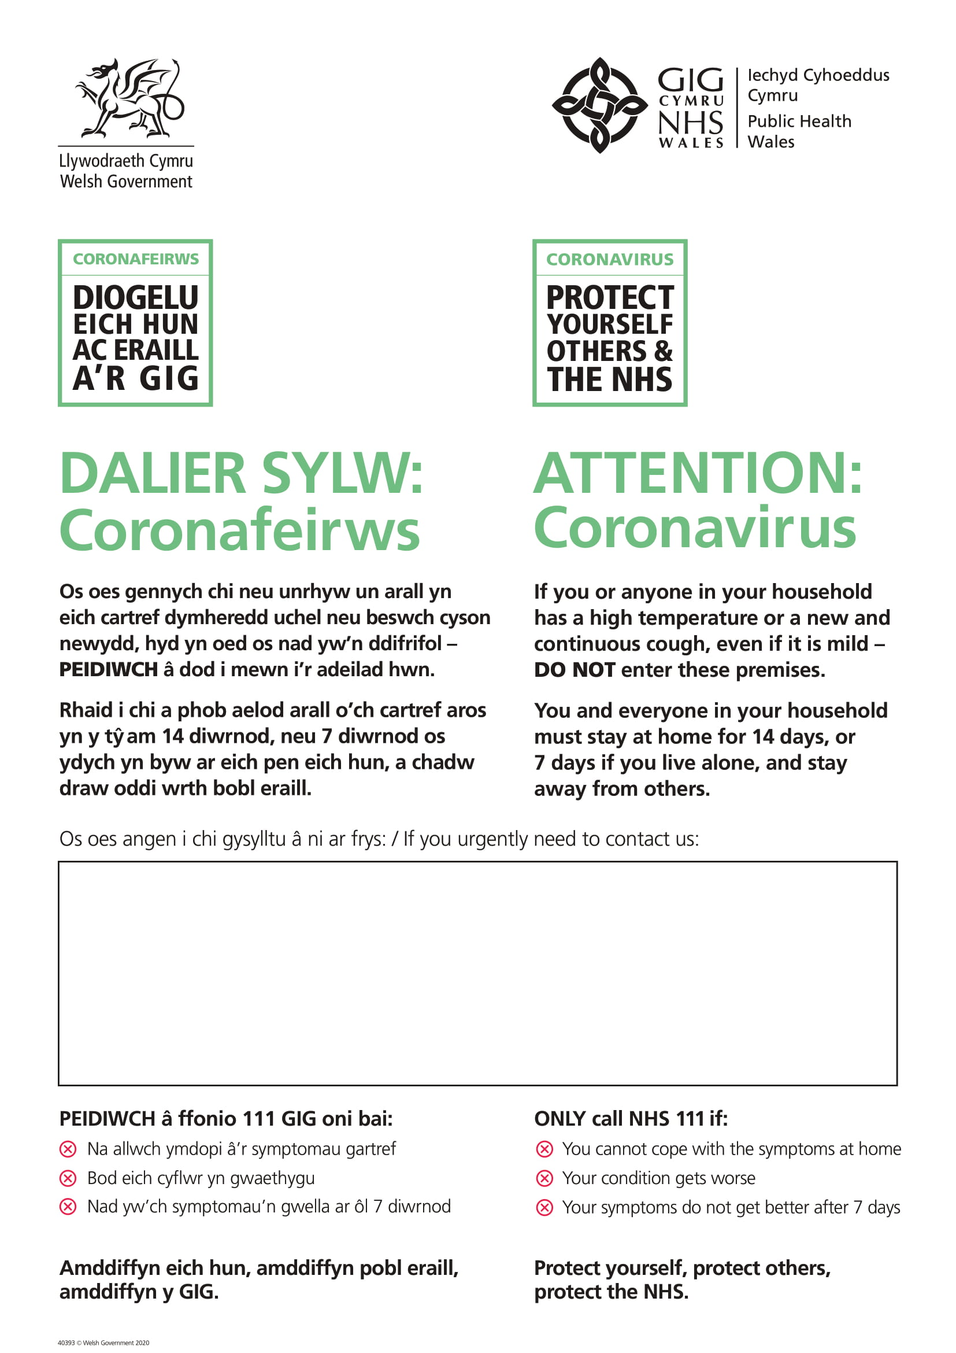
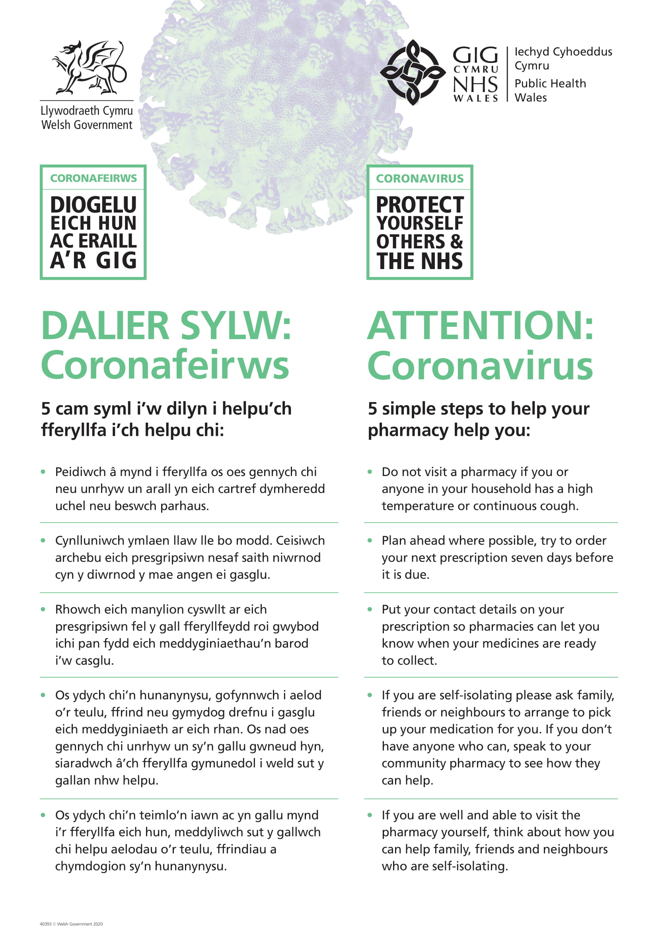
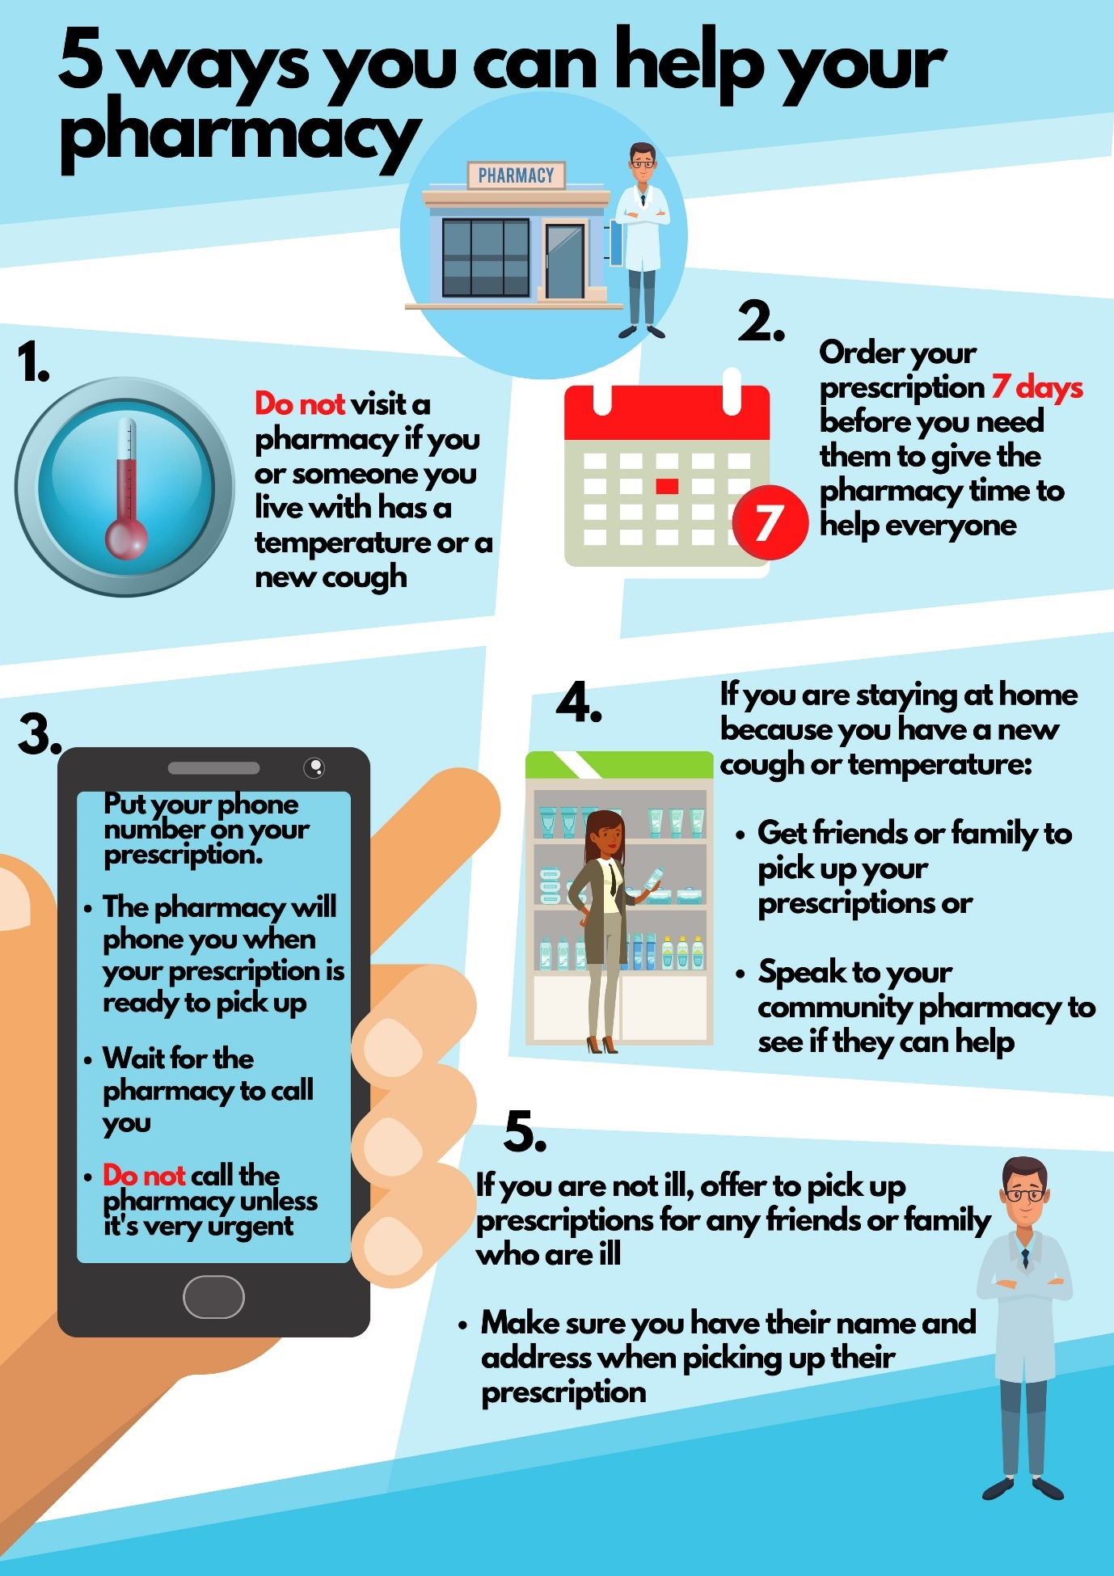
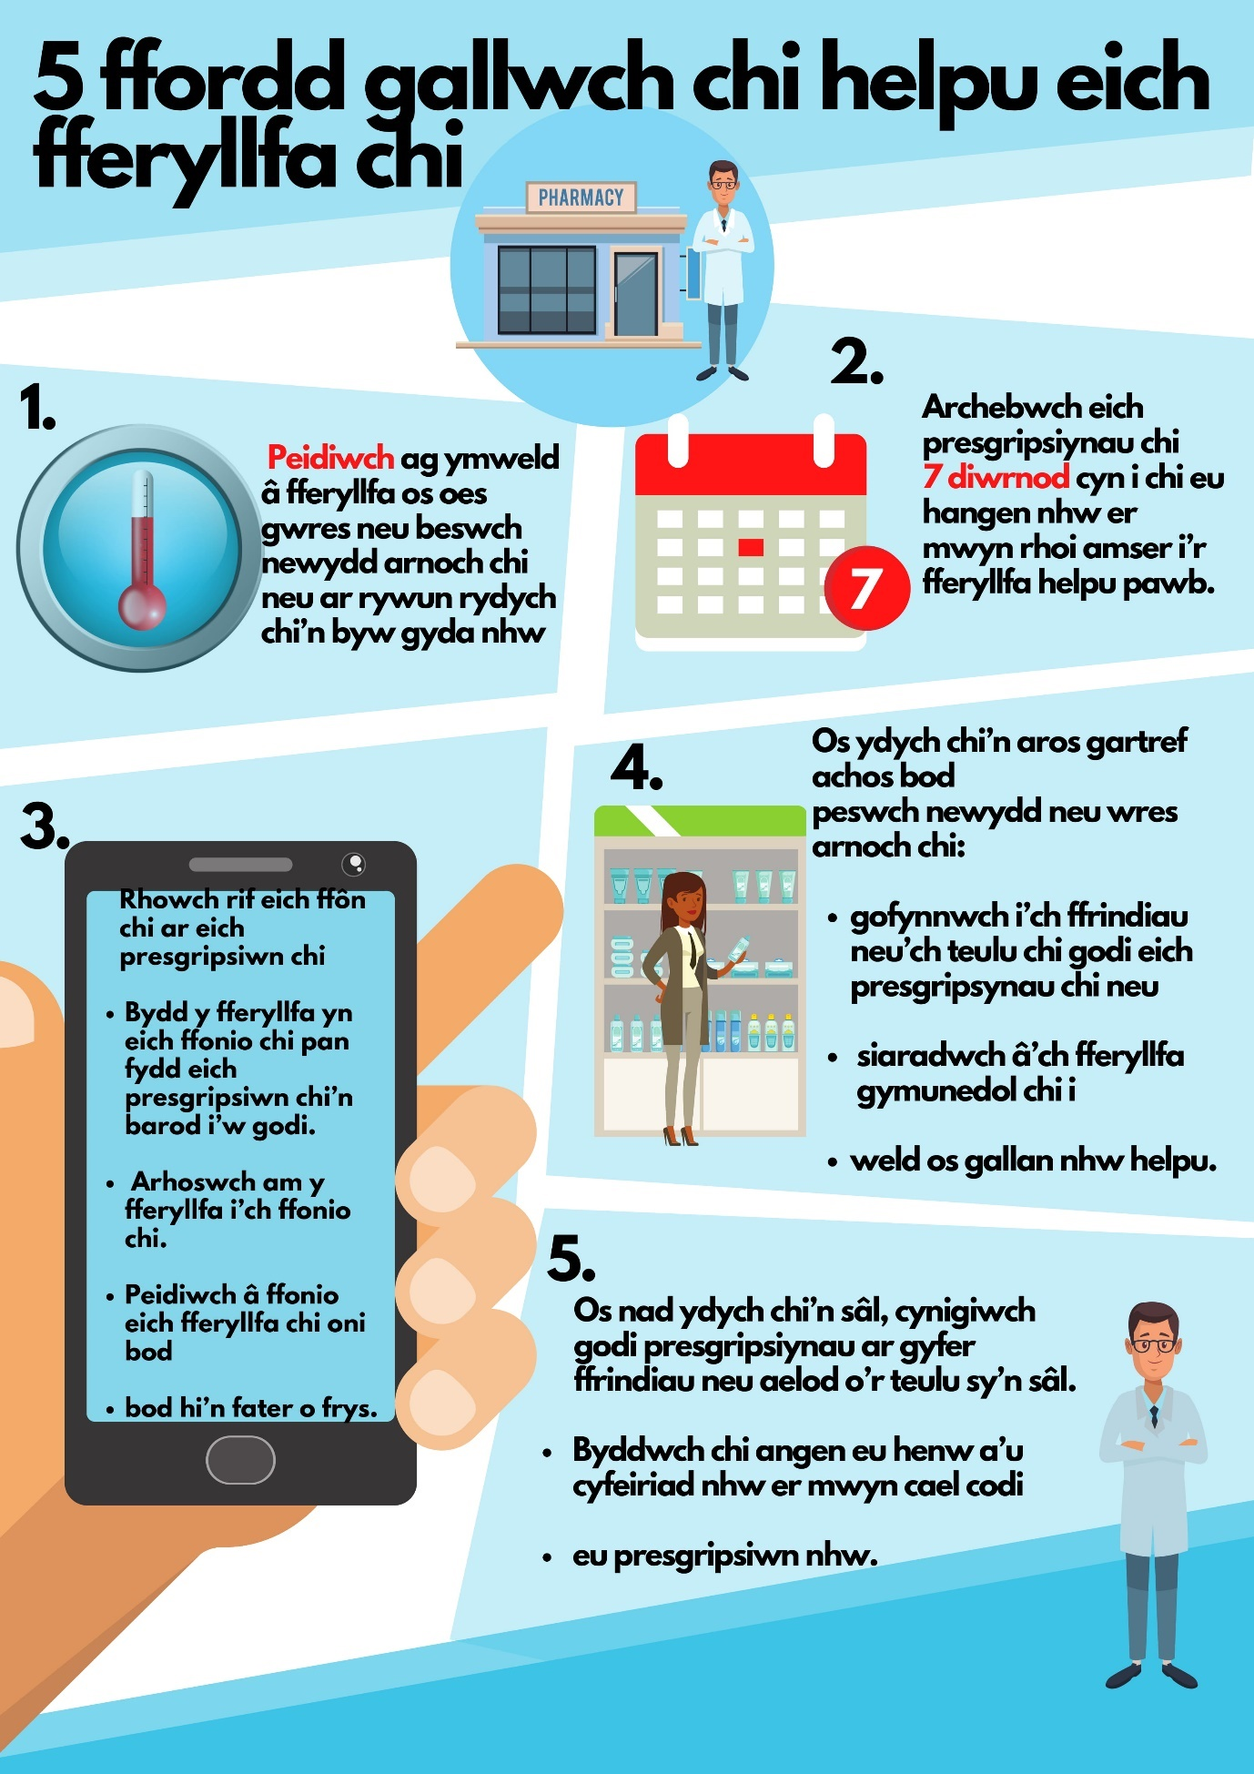

Appendix 5: Key worker letter for community pharmacy

To whom it may concern,
RE: COVID-19 pandemic and key worker status
The Welsh Government has identified the following key workers in health and social care:
"This includes but is not limited to doctors, nurses, midwives, paramedics, social workers, care workers, and other frontline health and social care staff including volunteers; the support and specialist staff required to maintain the UK’s health and social care sector; those working as part of the health and social care supply chain, including producers and distributors of medicines and medical and personal protective equipment."
Pharmacists, Pharmacy Technicians and support staff involved in the medicines supply chain are critical to the Government’s COVID-19 response and are key workers in the National Health Service.
Please accept this letter as confirmation that the below-named member of the team is a key frontline health worker for the purposes of the support available during the COVID-19 pandemic.

Yours sincerely,

[NAME]
[JOB TITLE]

Name of Individual: …………………………………………………

Place of Work: …………………………………………………

Appendix 6: List of Health Board Contacts

Health Board | Community Pharmacy Lead | Email | Tel
Aneurin Bevan UHB | Richard Evans | Richard.Evans8@wales.nhs.uk | 01495 241284
Betsi Cadwallader UHB | Adam Mackridge | Adam.Mackridge@wales.nhs.uk | 07769 934 852 (Mobile)
Cardiff and Vale UHB | Louise Allen | Louise.Allen2@wales.nhs.uk | 02921 836156
Cwm Taf Morgannwg UHB | Emma Williams | Emma.Williams34@wales.nhs.uk | 01443 443443 ext 74095
Hywel Dda Health Board | Angela Evans | angela.evans10@wales.nhs.uk | 01554 783083
Powys Teaching Health Board | Jason Carroll | Jason.Carroll@wales.nhs.uk | 01874 712654
Swansea Bay UHB | Amy David | Amy.David2@wales.nhs.uk | 01639 684557

Appendix 7: GP Messaging - Repeat Prescriptions COVID-19
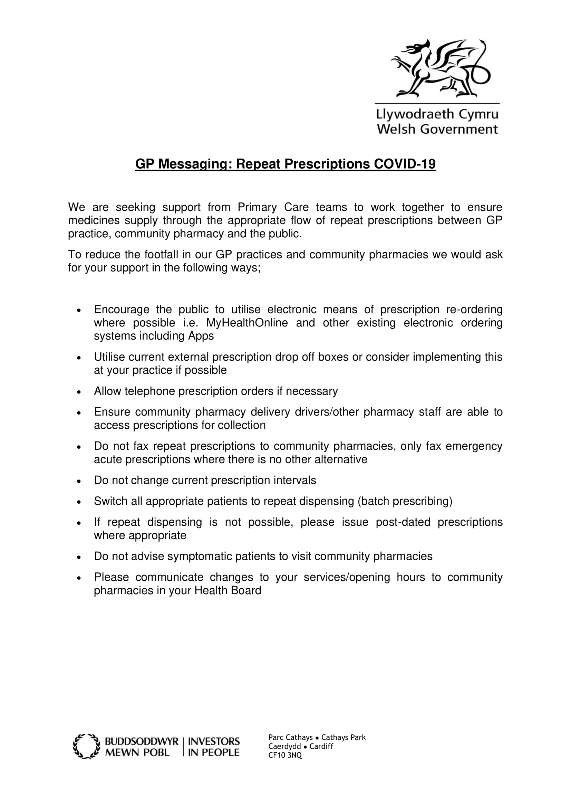

Appendix 8: Poster – Information for volunteers collecting medication

ATTENTION: Coronavirus
Volunteers Collecting Medication
Important Notice.

Appendix 9: Delivering Medicines Safely COVID-19: Guidance
Delivering Medicines Safely - COVID-19: Guidance
- Preparation:
To satisfy basic legal requirements whilst delivering medicines you must:
- Hold a valid driving license.
- Be covered by appropriate insurance.
- Follow the Highway Code.
- Ensure vehicle is roadworthy and has a valid MOT
(see https://www.gov.uk/guidance/coronavirus-covid-19-mots-for-cars-vans-and-motorcycles-due-from-30-march-2020 for current guidance).
- Ensure you are fit to drive and not be under the influence of alcohol or drugs.
- Never use a mobile phone whilst driving.
- Process:
Following the guidelines below will ensure each patient safely receives the correct medication. Failure to adhere consistently can have serious consequences for yourself and the patients.

At the pharmacy:
- CDs are more liable to misuse and are kept in a locked cabinet in the pharmacy. You will be required to sign the back of CD prescriptions when they are handed over to you. The details of each CD delivered, along with your name, will be recorded in the CD register.
- Ensure you have a contact phone number for the pharmacy in case queries arise.
- Ensure you have patient phone numbers – on bag labels if possible.

In transit:
- Whenever the vehicle is left unattended whilst delivering medicines, all windows must be closed, and doors must be locked, and the ignition key removed. Medicines must not be left in vehicles overnight.
- Transport medicines in the rear/boot where they cannot be seen by members of the public to protect patient confidentiality and minimise the risk of theft.
- Your role will involve manual handling processes and it is important you follow instructions provided. https://www.hse.gov.uk/msd/manual-handling/training.htm.

At the patient’s door/care home door:
- Phone the patient from 2m from the door to let them know you have arrived or knock on the door and step back 2m.
- Avoid using doorbells and knockers without gloves.
- Use hand sanitiser.
- Ask the patient or representative to confirm their name and address. Check this against the bag label.
- Ask the patient to confirm where the bag should be placed for immediate retrieval.
- Ask patient to stay indoors while you place the bag in the agreed location.
- Withdraw 2m from the bag and watch the patient pick up the bag. Ask them to check the details on bag label are correct.
- Explain all queries are to be phoned through to the pharmacy to maintain patient confidentiality.
- If no reply medicines must be returned to sending pharmacy.
- Driver to sign the electronic/paper audit trail noting date and time of delivery or failed delivery.
- Do not receive any returned medication.
- Do not post medication through letter box.
- Do not leave medication in porch or outbuilding.
- Do not leave medication at a different address (risk of cross infection).
- Do not enter the patient’s house – all issues to be resolved with pharmacy team over the phone.
- If possible, use hand sanitiser after every delivery.
- Wipe down the hand-held device, van door handles, steering wheel, hand brake, gear stick and ignition keys on a regular basis.
- Wash your hands with soap on entering next pharmacy.
- Key Patient confidentiality Reminders:
It is a legal requirement of anyone working within the healthcare profession to respect and protect people’s dignity and privacy. It is your responsibility to ensure:
- All written patient information is kept out of sight of the public.
- No confidential information is overheard.
- Requests for patient information are always referred to the pharmacist.
- Key Infection Control Reminders:
- Wash your hands with soap and water, when entering a pharmacy/surgery, frequently throughout the day, including after direct contact with members of the public, after using the toilet and before eating.
- Counselling and messages must be provided by pharmacy team over the phone and not face to face with driver.
- Only deliver to the patient’s home not their neighbour.
- Do not pick up returned medicines.
- Avoid using doorbells/knockers as much as possible – use your phone.
- If touching doorbells/knockers wear gloves and use hand sanitiser.
- Clean equipment used during deliveries e.g. wiping electronic devices, pens etc.
- Maintain good vehicle hygiene e.g. wiping steering wheel, hand brake, door handles.
- Always avoid touching your face.

Appendix 10: Guidance on: Use of NHS Wales email between GMPs and Community Pharmacies

Primary Care Support Service – Guidance on…
Current use of NHS Wales email between GMPs and Community Pharmacies

This guidance is to support the use of NHS Wales email between General Medical Practitioners (GMPs) and Community Pharmacists, however, it can also be referred to for emailing between any NHS Wales email account, excluding NHS Wales generic pharmacy accounts that must only be used for accessing NHS ENAS alerts.
The NHS Wales email network is considered secure for the transfer of any information, including personal data, within NHS Wales. This applies to email addresses that end in “@wales.nhs.uk”. Users must always evaluate whether the email platform is the most appropriate method to communicate such data.
During this period of COVID -19 GMPs and Community Pharmacies may be facing significant pressures it is accepted that it could be more harmful to not share health information than to share it. Where clinical need demands it, we may need to work in different ways from usual with our focus being on what information we need to share and who we share it with, rather than how we share it.
Reducing risks of using email
All transfer of information systems can pose various risks; however, these can be reduced by following the below guidance:
- GMPs and Pharmacists should only use the NHS Wales email system when emailing patient identifiable information to other healthcare professionals in Wales;
- Although the email system is considered safe, as a mitigating factor to avoid any inadvertent misdirection, additional pre-cautions such as encrypting attachments may also be considered when sending special category information (sensitive);
- Only email personal information between the Practice and Pharmacist if both parties have a legitimate reason to send and receive it, and only do so if it is strictly necessary;
- GMPs should not send emails to the generic NHS Wales Pharmacy account as it may be viewed by any member of staff;
- GMPs MUST contact the Pharmacy prior to sending an email to confirm which Pharmacist is on site that day and confirm the specific Pharmacist’s NHS Wales email address;
- There is always a risk of misdirection when sending emails. Users must double check that the communication is being directed to the intended recipient. All users should use the NHS Wales address book to check that the correct email address has been selected;
- Monitor your Outlook application to ensure that the email was sent appropriately, for example, no bounce back emails or ‘out of office’ reply’s. It is the responsibility of the sender to ensure the email was received by the recipient, DO NOT assume it has been received;
- Requesting a read receipt or confirmation email by return may help ensure the GMP or Pharmacist has received the email, particularly in emergency situations and in light of the above point;
- Emailing to other NHS email addresses are not currently considered secure, for example, @nhs.net
- A pragmatic approach to emailing should always be taken.

Use of Web Mail for Community Pharmacies
The Choose Pharmacy application enables Pharmacists to email directly through the NHS Wales email system, however, this does not always enable them to attach documentation.
An alternative route for Pharmacists to login to the NHS Wales email system is through the following link https://email.cymru.nhs.uk/owa/auth/logon.aspx?. Using Outlook Web Mail through this route allows the user to attach and send documents and is considered secure.
Use of NHS email for communicating urgent prescriptions
- NHS Wales email must not be used for routine prescription requests;
- NHS Wales email must only be used where it is not immediately possible to provide the pharmacy with an original WP10 or other valid NHS prescription;
- Prescribers must discuss transmission via email with the pharmacist on duty before sending prescription information;
- Prescribers will need to provide the pharmacy with the original copy of the prescription within 72 hours.

Policies for Emailing Person Identifiable Information
An All Wales Email Use Policy is in place, although not specifically for Primary Care, it sets out the responsibilities of all users when accessing the NHS Wales email service. Each organisation should have their own Email Policy, which supports the All Wales Policy when accessing the All Wales email system.

