

10th June 2022
Primary Care Division
Welcome to the first edition of the
Greener Primary Care Wales Newsletter
Greener Primary Care Wales | Transformation | Prevention




| What is Greener Primary Care
The Primary Care Hub, Public Health Wales, is delighted to announce that the Greener Primary Care Wales Framework and Award Scheme is now LIVE! To register your team and start taking action, please click here.
The Framework was officially launched by the Minister for Health and Social Services, Eluned Morgan MS, on 8 June 2022, and has also been recognised and endorsed by the Minister for Climate Change, Julie James MS, as well as The Future Generations Commissioner for Wales, Sophie Howe. Click here to see their full videos.
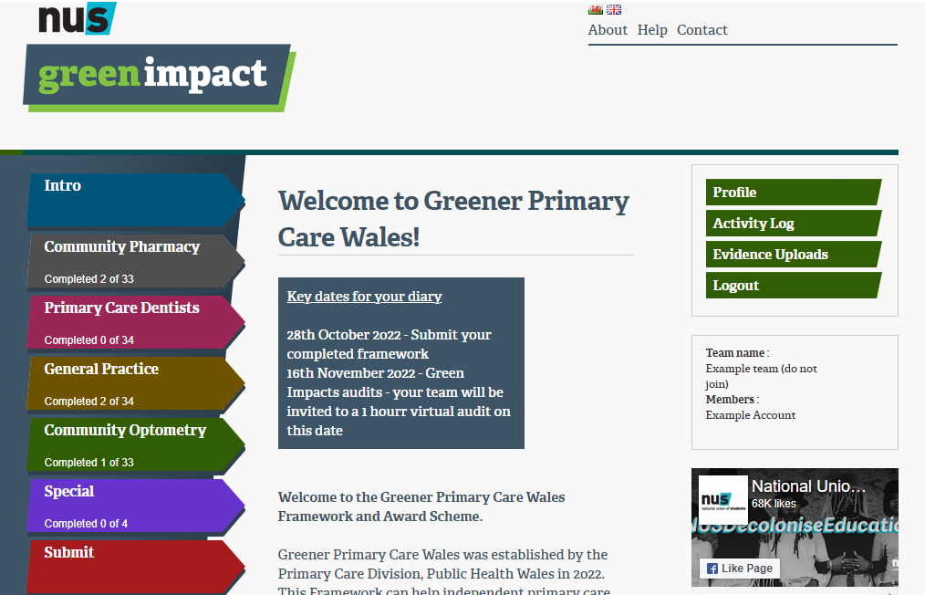


The Greener Primary Care Wales Framework and Award Scheme is a voluntary environmental sustainability framework designed for the four primary care contractors (General Practice, Community Pharmacy, Optometry and Dental).

Developed by the Primary Care Hub, and in collaboration with professional and contractor bodies, Welsh Government and clinicians, it consists of over 50 actions across a broad range of categories such as waste, healthy behaviours and procurement. These actions are aimed at helping primary care contractors to decarbonise and improve the environmental sustainability of their day to day practice.
Once registered with the scheme, practices can choose the most relevant actions and complete them in any order. Each completed action equates to 1 point, and as the number of points increases, so does the level of award achieved. At the end of each annual cycle, practices will be recognised with successive award levels dependent on the number of points achieved.

Where possible, the actions within the Framework have been aligned to several key Welsh policies, legislation and international criteria, including:
- NHS Wales Decarbonisation Strategic Delivery Plan
- The Wellbeing of Future Generations (Wales) Act 2015
- Prudent Healthcare Principles
- UN Sustainable Development Goals
The Framework is endorsed by the Royal College of General Practitioners, the British Dental Association, the Royal Pharmaceutical Society, Optometry Wales, and Community Pharmacy Wales.

This free online resource is an excellent place for practices to begin their sustainability journey and take steps towards creating a healthier planet.

Key Dates
- Week commencing 6 June: The Greener Primary Care Framework is LIVE!
- 8th June: National Launch; click here to see a recording of the launch webinar
- 28th October: Evidence submission deadline, framework temporarily closes
- 16th November: Audits and awarding
- 2023 (date TBC): Framework re-opens for Year 2

| Carbon Footprinting

The health sector in Wales is responsible for the most significant carbon emissions in the public sector. GP practices, community pharmacies, dental practices and optometric practices, therefore, have an essential role in reducing health sector emissions. The Welsh Government has set a target for Health and Social Care to reduce emissions by 16% by 2025 and 34% by 2030. One key step primary care settings can take is to calculate their current carbon footprint to help identify ways to reduce their energy use. A recent review published by the Primary Care Hub identified some carbon footprint calculators suitable for use by small and medium-sized businesses/small organisations that may be most relevant for use by individual primary care practices. The findings of the paper describe that no one, free of charge, carbon calculator exists which takes into account all the factors necessary for use across all four primary care contractor settings. However, each offer at least partial suitability for use in primary care settings. The top 4 most suitable calculators are listed below:
- See Sustainability GP Carbon Footprint Calculator
- The Carbon Trust Footprint Calculator
- The National Energy Foundation
- The Climate Hero Carbon Footprint Calculator

| Case Studies

Twelve practices across Wales were invited to participate in a piloting phase at the start of 2022. Each practice was asked to trial a selection of actions from the Framework and provide feedback to the Primary Care Hub. Two of the case studies collected as part of the pilot are summarised below.

Carbon Footprinting in a GP surgery

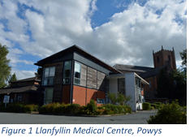
Both Llanfyllin Group Practice in Powys and JDS Evans independent pharmacy in Newport felt that they needed to act to reduce the effects of climate change. Finding time to calculate a carbon footprint was a challenge for Juliet, practice manager at Llanfyllin, especially as she had no idea how long it would take. The summary report created by the Primary Care Hub on carbon footprint calculators (above) helped by recommending which calculator to use; ‘See Sustainability’. It took 90 minutes for one practice building and gave a value of almost 250 tons of carbon each year. The result encompasses non-clinical emissions only, and therefore excludes a few areas of emissions such as moving medications, collection of blood, etc. As all practices are different, it isn’t easy to know how the practice compares to others, however, it is a valuable benchmark to compare against in the future once some of the actions from the Framework have been implemented. It has certainly acted as a catalyst for change in Llanfyllin. Juliet and the team are considering potential vending machines for medications to save patient travel; this may not reduce the carbon footprint calculation but would reduce carbon emissions from unnecessary travel. The team in Llanfyllin Group Practice are now more aware of their environmental impact and taking steps to reduce their carbon emissions after completing the calculation. It will be interesting to see what impact the changes will make on future carbon footprint calculations.

Inhaler Review and Switching


Andy at JDS Evans Pharmacy in Newport had aimed to take 50 of his customers through an inhaler review and, if appropriate, recommend they switch to more environmentally friendly versions. Switching 1 inhaler can save the equivalent of 180 miles in the average car, around 27kgs of carbon emissions. The ‘greener’ Dry Powder Inhalers (DPIs) are more expensive per inhaler, but for those who can use them are more clinically effective, so this higher cost may be saved if there is less need to use them. Two months later, Andy had spoken to more than 60 patients, and half of these were due to be switched, saving over 12,000kgs of carbon emissions. Quite an achievement. While speaking to patients, Andy was also ‘Making Every Contact Count’ as he offered flu vaccinations and stop smoking advice. As a pharmacist, Andy is reliant on local general practices to make the change to prescriptions. Through meetings with his local general practice, Andy built a relationship and was able to get feedback on how the inhaler switches were going. The capacity of general practices to make the switch is the critical enabler or barrier to this action, along with the problem of finding the time to spend with customers. Hopefully, funding through the reintroduction of enhanced services for inhaler reviews will make it feasible to continue. Andy aspires to reach more than 200 customers who could have their inhalers reviewed and save even more carbon emissions.



Pilot Sites’ Top Tips

The pilot sites signed up to The Greener Primary Care Wales Framework and have shared some of their top tips for starting the process.

- Read the framework first; some of these actions may have already been started or even completed
- Get your practice team involved and engaged early on in the process
- Create a project team and invite anyone in the practice who is interested in taking part
- Create smaller working groups to take forward individual actions and link actions to participating staff based on job roles or personal interests
- Build communication and morale within the team by ensuring everyone in your team is included in the project, including those who are not actively involved
- Include sustainability and climate action as standing agendas for practice and MDT meetings
- Choose one or two actions to start with; start small, and momentum will build
- If there is a direct impact on your patient, explain why you are making changes and bring them along on the sustainability journey
- Use the Further Information tab on the online framework; this will give you hints and tips on how to complete each action
- Set Ecosia as your default web browser
- Reach out to colleagues and other practices, share your experiences and approaches to tackling the framework
- Share your success with your staff, patients and the wider community

| Quick Wins

Getting Started
Thinking about registering but not sure where to start? The Greener Primary Care Wales Framework contains many actions which are easy to adopt, require few resources and are therefore a great starting point when thinking about making sustainable changes.

Below are some of the potential “quick wins” included in the Framework which can all help to kick-start your journey towards environmental sustainability;

Building and Estates
The practice has replaced, wherever possible, existing lighting with more energy-efficient options.

Carbon Management
The practice communicates and promotes (to staff and the public) the practice's participation in the Greener Primary Care Framework and Award Scheme.

Procurement
All tea and coffee purchased by the practice for staff and the wider MDT are Fairtrade certified. N.B. This only refers to tea or coffee bought with practice money, not products bought by staff. However, staff and the wider MDT are encouraged to purchase Fairtrade refreshments.

Transport and Smart Working
The practice encourages and promotes more environmentally friendly/sustainable modes of transport for practice staff, the wider MDT and patients.

Waste
The practice minimises the number of paper letters sent out by, or on behalf of, the practice. Where posting letters is necessary, the practice avoids using envelopes that contain plastic windows by using alternatives, such as purely paper-based envelopes or biodegradable options. •
Innovation and Co-Production
The practice actively involves and seeks feedback from the local community on any changes to adopt a more environmentally sustainable practice.

| Website & Key Contacts

Greener Primary Care Wales Website
The Greener Primary Care Wales webpages are part of the Primary Care One website. Our pages continue to develop and currently provide information on:

• Background on Greener Primary Care and the Framework and Award Scheme
• Relevance to Primary Care
• News and Updates
• Key Documents and Resources
• Contact Information

Please keep a lookout on our website for further updates.

Scan the QR code using your smartphone to visit the Greener Primary Care Wales website.



Key Contacts
For further information and queries, or to give us feedback, please get in touch with us on the following:

Greener Primary Care Mailbox
greenerprimarycare@wales.nhs.uk

Twitter @PrimaryCareOne

If you have previously signed up to the RCGP Green Impact for Health Toolkit, please contact Celine.Clark@sos-uk.org to register a new account with the Greener Primary Care Wales Framework and Award Scheme.

FAQ’s
Click here to view our FAQ’s covering all aspects of the Greener Primary Care Framework.

