
ANNUAL
REPORT
2022/23
All Wales
General Dental Services (GDS)
Reform Programme


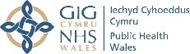
Table of Contents
1. Introduction 3
Figure 1: GDS Reform Programme Journey 4
2. Participation in contract reform 2022/23 5
Table 1: Total General Dental Services (GDS) contract value (2022/23) and expenditure 5
Table 2: Number and value of primary care dental contracts handbacks and recommissioned during 2022/23 6
3. What are the key indicators showing? 8
Figure 2: Percentage of population from each deprivation quintile who accessed general dental services in Wales during 24 months (2021/22 and 2022/23) 9
Figure 3: Number of patients living in different areas of deprivation who received urgent dental care in 2022/23 10
Figure 4: Reasons for urgent dental care appointments in Wales in 2022/23 11
Figure 5: Percentage of patients who visited general dental practices during 2022/23 and had dental treatment need 12
Figure 6: Percentage of adults with treatment need for different dental conditions 13
Figure 7: Percentage of children with treatment need for different dental conditions 13
Figure 8: Number of treatment types provided under Band II courses of treatment in 2022/23 14
Figure 9: Number of treatment types provider under Band III course of treatment in 2022/23 14
Table 3: Intended recall period on FP17Ws submitted during 2022/23 15
Figure 10: Percentage of children and adults with tooth decay (Red) or risks of tooth decay (Amber) that received 2 applications of fluoride varnish within 2022/23 16
4. Programme activities during 2022/23 17
Figure 11: Engagement Activities timeline 2022/23 19
Table 4: WG action/response to stakeholders’ concerns 21
5. Workforce planning and challenges 24
6. Next Steps 25

1. Introduction
A Healthier Wales: our plan for health and social care and a number of laws such as the Wellbeing of Future Generations Act and Socio-economic Duty provides Welsh Government’s (WG) long term vision for health and social care in Wales. They also provide guidance for dental system reform including General Dental Services (GDS) reform in Wales.
The oral health and dental services response to a Healthier Wales provided short to medium term priorities in oral health programmes and dental services:
- timely access to prevention focussed NHS dental care;
- sustained and whole system change underpinned by contract reform;
- teams that are trained, supported and delivering value-based quality care;
- oral health intelligence and evidence driving improvement; and
- improved population oral health.

The start of the GDS Reform Programme in Wales in September 2017 was the beginning of a journey towards aligning NHS dental services with the vision outlined in the above strategic documents and legal frameworks.
The annual report published before the pandemic provided a snapshot of the preliminary phases of the reform programme. Early phases focussed on integrating oral health risk and needs assessment using a standardised toolkit (ACORN) and delivery of prevention within the Units of Dental Activities (UDA) system. The GDS Reform Programme was paused during 2020/21 and 2021/22 due to the COVID19 pandemic.
In order to focus on controlling COVID19 transmission through the dental clinical settings, UDA targets were temporarily suspended, and NHS dental services were asked to prioritise the dental care of those with the highest need first. In addition, they were specifically required to maintain delivery of the preventive model of dental care, ensuring both continuity and expansion in the number of practices using ACORN to prioritise prevention in primary care.
The GDS Reform Programme restarted on 1 April 2022 (Figure 1) with a message from the Minister from Health and Social Care, Baroness Eluned Morgan (see below), a new governance structure and an offer to all dental practices to sign a contract variation which essentially tested new key performance indicators within the constraints of the existing UDA system dental regulations. In terms of volume or access indicators, practices were asked to see a certain number of patients for their given Annual Contract Value (ACV).

Figure 1: GDS Reform Programme Journey
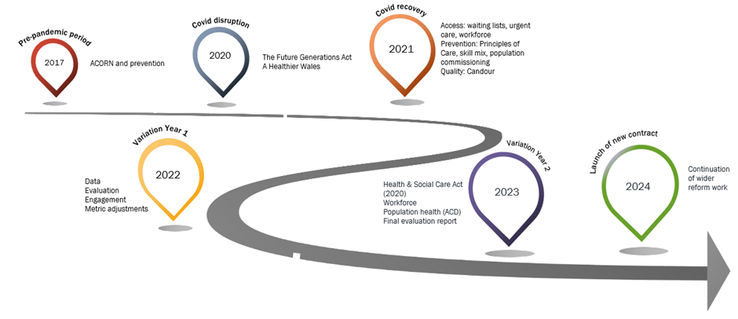
The purpose of this annual report is to provide an overview of programme activities during 2022/23 and analysis of the GDS data to understand performance against early key indicators. During this period the Assembly Health & Social Care committee held an inquiry into dental services, which helped to focus on some of the pressing issues already within scope of the GDS reform programme.
Message from Eluned Morgan, Minister for Health and Social Services in Wales (shared at the March 2022 GDS Reform Programme engagement event).

Reflections from the Chief Dental Officer for Wales:
The key reform principles have been embedded within the interim variation year 2022/23. Access, prevention and quality outcomes are integral to the reform programme. Issues that have been progressed are:
- Access:
  - Opening of the North Wales Dental Academy in Bangor
  - Wales Enhanced Recruitment Offer (WERO) with
  - Direct access for Therapists
  - Expansion of undergraduate Therapy programmes from September 2023, with additional increase in 2024
  - Work with GDC on registration routes for international graduates

- Prevention:
  - Therapy-led, secondary schools-based, programme

- Quality:
  - Duty of Candour and reporting through the Datix system

2. Participation in contract reform 2022/23

Table 1: Total General Dental Services (GDS) contract value (2022/23) and expenditure
Health Board | Total contract value (£) | Total value (£) of contracts that chose contract variation (%) | Total value (£) of contracts that chose UDA model (%)
Aneurin Bevan UHB | £30.7m | £24.5m (80%) | £6.2m (20%)
Betsi Cadwaladr UHB | £27.9m *  *Core contracts only (UDA or CR model – excludes Access and Ortho) | £26.8m (96%) | 1.1m (4%)
Cardiff and Vale UHB | £24.3m | £21.3m (87.7%) | £3m (12.3%)
Cwm Taf Morgannwg UHB | £23.6m | £20.8m (88%) | £2.8m (12%)
Hywel Dda UHB | £18m | £16.6m (92%) | £1.4m (8%)
Powys THB | £6.1m | £5.2m (84.1%) | £977k (15.9%)
Swansea Bay UHB | £20m | £19.8m (99%) | £212k (1%)

Table 2: Number and value of primary care dental contracts handbacks and recommissioned during 2022/23
Health Board | Number of contracts handed back during 2022/23 | Total value (£) of contracts handed back and reduction in contract size | Total value (£) reinvested (including any additional) within 2022/23
Aneurin Bevan UHB | - 1 contract handed back  - 1 contract reduced | £1.3m including:  - 1 contract closed = £954k / 33800 UDAs  - 1 contract reduction = £393k / 14274 UDAs | £1.5m including:  - £1.3m recurrent in GDS access  - £150k non recurrent in Orthodontics  - £18k non recurrent to increase GDS UDC access over the BH periods  Contract closure was tendered and reinvested fully to award a new NHS GDS contract in Ebbw Vale – practice officially opened on 19/07/23. Recurrent.  Contract reduction was reinvested as ‘top ups’ to existing GDS practices that expressed an interest in additional activity. Recurrent  Ortho and UDC funded via the GDS budget non-recurrently.
Betsi Cadwaladr UHB | 3 including:  - 1 contract handed back 31/07/23  - 2 contracts handed back 31/03/23  *does not include terminated contracts | - £1m hand back  - £1.4 non recurrent reductions  - £0 Recurrent reductions | - £320k non recurrent  - Procurement for GDS live until 14/07/23  Recommissioning exercise in process. 7 proposals received and being reviewed. Several are standard access requests, so are for a more innovative way of working to not only deliver activity but also to work towards addressing recruitment, retention and upskilling of staff locally.
Cardiff and Vale UHB | - 1 contract reduced  - 2 contracts handed back including:  - 1 x dental reform  - 1 x UDA | £621k | - Additional investment - £60k  - Reinvestment in contracts handed back / reduced will commence in 2023/24  One additional dental practice was sold and the transfer of the NHS contract was agreed with the new owner.
Cwm Taf Morgannwg UHB | 2 contracts handed back | £897k | In 2022/23: £317k.  In addition to this a new practice was commissioned in 2022/23 and is due to open in October 2023 [£567k ACV].  A second practice is due to open in Jan 2024 [£567k ACV]
Hywel Dda UHB | - 6 contracts handed back:  - 1 x contract ended 31 July 2022  - 2 x contracts ended 22 November 2022  - 3 x contracts ended 31 March 2023 | Total value of contracts for which resignation notices were received and terminated during 22/23 £1.2m | £487k reinvested during 22/23 to establish new contract in Ammanford  Other contracts inviting expressions of interest.
Powys THB | 2 contracts handed back | £227k – contracts returned due to retirement and being unable to sell/find successor | £370k  New contract started 1st May 2023. Funding transferred to the community dental service to employ salaried therapist and dentist to focus on reducing the waiting list.
Swansea Bay UHB | 0 contracts handed back | £0.00 | £0.00

3. What are the Key Indicators showing?
One of the success stories of the GDS Reform Programme is the improvement of the GDS database within NHSBSA. In addition to clinical data, GDS dental database now also includes ‘risks and need’ data of the patient population and useful patient experience information which provides additional indicators of quality of dental care in Wales.
The reform programme workstream 2 agreed on key domains (inequity in dental access, prevention, recall, re-attendance, risk and need) that would provide a high level national picture of the GDS in Wales. Analysis for this chapter were provided by the NHSBSA. The high level analyses are intended to provide a brief overview of the current GDS system in Wales. These analyses should trigger the discussion between dental stakeholders in Wales so that key performance indicators chosen for the dental system and dental services are in line with the strategic objectives and dental information system provides useful information for improvements in policy and plans. Detailed data analyses of the GDS data are available for Health Boards, dental practices and performers within the e-Den database.
Data collected have revealed the following:
Dental Access
COVID19 pandemic had a severe impact on dental services in Wales. Although GDS access is continuing to recover, it is still well below the dental access level prior to the pandemic. 1,061,691 patients were seen by the GDS during 2022/23.
Inequity in access to dental care is unfair and avoidable. Hence, it is important not only to understand the level of dental access but also level of inequities in dental access and improvement being made in reducing such inequities. In the 24 months spanning 2021/22 and 2022/23, a significantly higher proportion (64.5%) of children living in the least deprived population were able to access dental care from GDS compared to children living in the most deprived population (51.2%). This finding indicates that any dental capitation system without higher weighting for deprivation and/or ‘risk and need’ is likely to disadvantage children living in the most deprived areas in Wales. We have an opportunity in Wales to address inequities in dental access through transformation of primary dental care especially through the new dental contract.

Figure 2: Percentage of population from each deprivation quintile who accessed general dental services in Wales during 24 months (2021/22 and 2022/23)

Patient satisfaction with the GDS is quite high. 94% of patients who participated in the General Dental Service (Wales) Patient Survey administered by the NHSBSA during 2022/23 reported that they were satisfied with the overall dental experience. Overall 86% reported that that they were able to book an appointment at a convenient time that suited them. 91% of participants reported being involved in decisions made about their dental care as much as they wanted to be and the same percentage reported being satisfied with their travel distance to their dental practice.
Urgent Dental Care
The majority (64%) of the patients who accessed urgent dental care were from the three most deprived quintiles. This is not surprising considering higher level of tooth decay in deprived areas in Wales.

Figure 3: Number of patients living in different areas of deprivation who received urgent dental care in 2022/23

In 2022/23 the most common reasons for attending for urgent dental care were toothache and broken filling. Figure 4 provides breakdown of reasons for urgent dental care appointments in Wales.

Figure 4: Reasons for urgent dental care appointments in Wales in 2022/23

79% of patients who received urgent dental care stated that their urgent dental care problem was resolved after their urgent dental care appointment and 86% reported that they were satisfied with the quality of urgent dental care they received. Further findings from the survey of urgent dental care patients can be found here: Urgent dental patient survey Wales report
Risks and Treatment Need (ACORN)
ACORN is a standardised oral health risks and needs assessment toolkit used in General Dental Practices in Wales. While its primary objective is to enable integration of prevention and preventive dental care in the GDS through informed clinical discussions with patients, ACORN dataset within the NHSBSA also provides useful information on level of prevention and treatment need amongst patient populations and how that changes over time.
99% of GDS patients reported being provided with information in a way that they could understand. Overall 79% of patients reported discussing any risks or areas for improvement in their dental health. 96% of patients reported being provided with advice on how to improve or manage identified dental issues.
Overall 42% of patients who attended GDS in Wales had treatment need (one or more Red on ACORN). There was higher treatment need amongst the adult population (50%) compared to children (23%). There was also some variation between Health Boards (see Figure 5).

Figure 5: Percentage of patients who visited general dental practices during 2022/23 and had dental treatment need
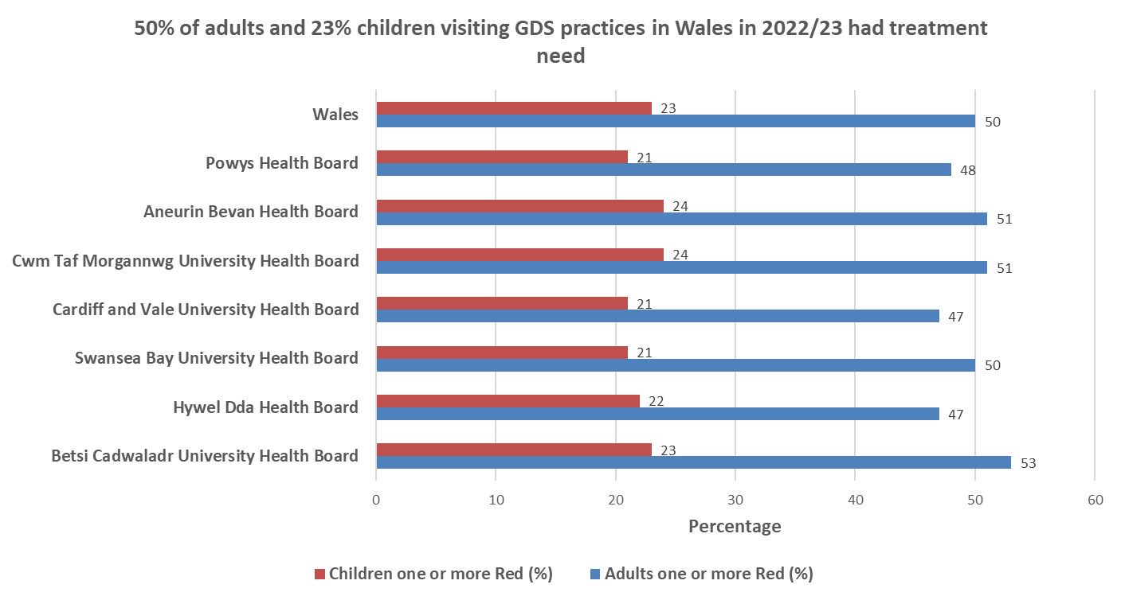

Level of treatment need in adults and children by dental disease category has been presented on Figures 6 and 7.

Figure 6: Percentage of adults with treatment need for different dental conditions

Figure 7: Percentage of children with treatment need for different dental conditions

Figures 8 and 9 provide types of treatment provided under Band II and Band III courses of treatment. Most courses of treatment provided under Band II had one type of treatment with average types of treatment being 1.1 (e.g. extraction= 1 type, extraction and fillings = 2 types). Amongst the Band III courses of treatment provided to adults during 2022/23, average type of treatment types was 1.8.

Figure 8: Number of treatment types provided under Band II courses of treatment in 2022/23
Figure 9: Number of treatment types provider under Band III course of treatment in 2022/23

Intended Recall on FP17W forms
Intended recall recorded on FP17Ws submitted during 2022/23 shows a move away from the traditional 6-monthly recall for most patients and impact of metrics for contract variation practices with 79.8% of adults with healthy mouth (Green for all 3 conditions on ACORN) assigned recall period of 10 months or longer. Table 3 also shows that 15.9% of children with treatment need (at least one Red on ACORN) and 39.8% of children with healthy teeth/mouth (Green for all 3 conditions on ACORN) were assigned recall period of 10 months or longer.

Table 3: Intended recall period on FP17Ws submitted during 2022/23
Intended recall period (months) | Adult at least one Red % | Child at least one Red % | Adult 3 Green % | Children 3 Green%
1 to 3 | 12.6 | 17.0 | 0.7 | 1.2
4 to 6 | 42.4 | 55.1 | 13.0 | 50.7
7 to 9 | 8.0 | 5.2 | 3.2 | 3.3
10 to 12 | 27.6 | 13.7 | 74.4 | 38.4
13 to 24 | 3.7 | 2.2 | 5.4 | 1.4

Reattendance
35% of adults with healthy mouth (Green for all conditions on ACORN) seen in 2022/23 had not been seen for more than 24 months
26.3% of children with healthy mouth (Green for all conditions on ACORN) seen in 2022/23 had not been seen for more than 24 months. This figure rises to 49.5% if we consider children with healthy mouth not being seen for more than 12 months.
45.5% of children with treatment need (Red on ACORN) had not been seen for more than 12 months.
29.6% of adults with at least one Red on ACORN in 2022/23 had not been seen for more than 24 months. This figure rises to 48.8% if we consider adults with treatment need not being seen previously for more than 12 months.

Fluoride Varnish (FV) applications
Lower than anticipated proportions of adults and children had received two FV applications in 12m, despite being classified as red or amber on ACORN (15.6% and 17.3% respectively). FV is effective in preventing tooth decay if it is applied at least twice a year and a key preventive strategy within system reform.

Figure 10: Percentage of children and adults with tooth decay (Red) or risks of tooth decay (Amber) that received 2 applications of fluoride varnish within 2022/23

4. Programme Activities during 2022/23
Public/patient view
In January 2022 PHW commissioned a piece of work gathering people’s stories to inform public communication and the work of the GDS Reform Programme. To facilitate the restart of the Programme in April 2022, this commissioned piece of work aimed to gather information to help with understanding the current situation of oral health in Wales, including the impact of the COVID19 pandemic on individual experiences of oral health, attitudes towards accessing dental services and people’s ability to access such services. People’s stories provide valuable insight to understand experiences of health and healthcare. The objectives of this project were to collect people’s stories on:
- ▪ How participants kept their mouth healthy before and during the pandemic
- ▪ How participants access information on oral health
- ▪ Experience of dental care needed during the pandemic.

The final report can be found via the following link: Gathering people’s stories to inform communication and the General Dental Services, April 2022
Key findings from the public interview included within the Bangor Evaluation of the GDS Reform Programme were as follows: Evaluation of GDS Reform
2022/23 was a transition year for Community Health Councils (CHCs), the body representing patients and wider public in the NHS system in Wales. A new independent body called Llais has been set up to give the people of Wales much more say in the planning and delivery of their health and social care services – locally, regionally and nationally.
The following link will take you to the evidence that the Board of Community Health Councils and the 7 CHCs in Wales submitted to the Senedd Inquiry into Dentistry in Wales: CHC Evidence to the Senedd Inquiry into Dentistry in Wales
Communications and engagement
As noted in the 2019 Annual Report, solutions to problems are likely to be sustained if those affected by them have been involved in their creation.

Continuing to recognise the importance of communication and engagement in a change process, the GDS Reform Programme has progressed over 2022-23 with the use of a variety of communication tools and engagement activities. These have included:
- quarterly programme updates
- information shared on the Primary Care One website
- virtual engagement events (March, July, September and January)
- post-event feedback reports
- FAQ documents
- modelling workshops
- work stream meetings, including various relevant stakeholders in the membership
- WG social media campaigns
- Continuing pilots of the Principles of Care through HEIW
- PrimaryCareOne website - General Dental Services (GDS) Reform Programme for Wales - Primary Care One (nhs.wales)

GDS reform has continued to be a key area of discussion in meetings between Welsh Government (Chief Dental Officer and Head of Dental Policy) and Health Boards. Locally, many Health Boards have also organised engagement sessions with contracted practices in their regions.

Figure 11: Engagement Activities timeline 2022/23
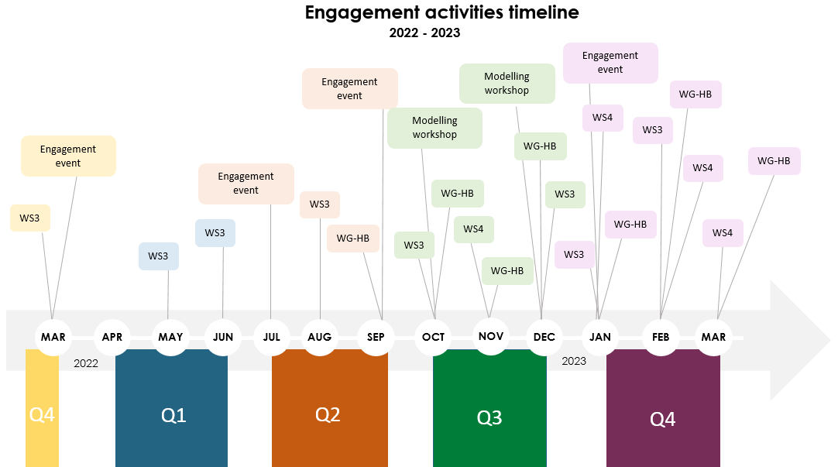
- 02 March 2022 Work stream 3: stakeholder engagement meeting
- 09 March 2022 engagement event: Open to all stakeholders. Restart of the GDS Reform programme
- 03 May 2022 Work stream 3: stakeholder engagement meeting
- 08 June 2022 Work stream 3: stakeholder engagement meeting
- 11, 13 & 14 July 2022 engagement event
  - Aimed at DCPs, performers/associates and contract owners.
  - Same event held on 3 dates to allow for maximum attendance.
  - Opportunity for attendees to provide honest feedback on their experiences so far (since start of contract variation on 1 April 2022)
- 18 August 2022 Work stream 3: stakeholder engagement meeting
- 26, 27 & 28 September 2022 engagement event
  - Open to all stakeholders.
  - Same event held on 3 dates to allow for maximum attendance.
  - Information provided on the ongoing work of the programme.
  - Further opportunity for delegates to contribute open and honest feedback on experience from the last 6 months
- September monthly Welsh Government meeting with Health Boards

- 13 October 2022 Work stream 3: stakeholder engagement meeting
- October monthly Welsh Government meeting with Health Boards
- 27 October & 12 December 2022 modelling workshops
  - Demonstrated modelling principles and application to the current dental reform programme.
- 22 November 2022 Work stream 4: profession engagement meeting
- November monthly Welsh Government meeting with Health Boards
- 05 December 2022 Work stream 3: stakeholder engagement meeting
- December monthly Welsh Government meeting with Health Boards

- 09 January 2023 Work stream 3: stakeholder engagement meeting
- 10 January 2023 Work stream 4: profession engagement meeting
- 24 & 25 January 2023 engagement event
  - Open to all stakeholders.
  - Same event held on 2 dates to allow for maximum attendance.
  - Provided an update on the data and feedback that is informing the progress of the programme and current innovation.
- January monthly Welsh Government meeting with Health Boards
- 07 February 2023 Work stream 4: profession engagement meeting
- 8 February 2023 Work stream 3: stakeholder engagement meeting
- February monthly Welsh Government meeting with Health Boards
- 14 March 2022 Work stream 4: profession engagement meeting
- March monthly Welsh Government meeting with Health Boards

In line with our Action Learning Approach, we will continue to regularly reflect on our methods of communication and engagement to capture insights and inform our future work.

Key themes from engagement events
There were some key themes that have come out of the engagement events over the last 12 months that delegates felt needed to be considered in the new dental contract and any primary care dental service provision. WG action and responses to these concerns can be seen at Table 4 below.

Table 4: WG action/response to stakeholders’ concerns
Theme | Action/response or comment
High demand for both routine and urgent dental care | Demand for NHS dental care has been high before the pandemic. COVID19 pandemic measures to control transmission had severe impact on delivery of dental care during 2020/21 and 2021/22. Hence, high demand for the NHS dental care (both routine and urgent) was understandable. Some HBs created a local central waiting list to understand the nature of the demand and increased capacity to see more urgent dental care patients.  Health Boards were provided with additional £2m recurrent to secure additional dental care.
Additional work for primary care teams in HBs from contract handbacks and recommissioning of services | - Acknowledged that primary care teams within HBs are working hard to understand and implement changes.  - Contract handback and reduction cause disruption including for patients affected. However, it also provides an opportunity for HBs to be innovative including re-orientation of resources to population with high dental care need and high demand.  - Most HBs have reported that they have been able to recommission or provide dental services using the money available from contract reduction or handback or are in the process of doing so.
New metrics were introduced in a rush with little time for planning for both HBs and dental practices. | - Work on new metrics and legal advice on metrics and the whole contract variation agreement took longer than expected.  - 2022/23 measures amended for 2023/24, based on feedback from HBs and dental teams.  - 2023/24 measures published in December 2022 to provide more time for health boards and dental practices to prepare for implementation.  - Learning will be used in introducing new NHS dental contract
High number of failed appointments is a major challenge for practices in terms of meeting volume metrics | - Worked with NHSBSA to start tracking DNA rates.  - Practices to reduce DNAs e.g. reminder emails/texts/phone calls, use of Attend Anywhere etc.  - Recognised that additional ongoing public communication is needed
How to structure payment to associates is a challenge for practice owners. | Payment structures and mechanisms to dental team members are business decisions for the individual practices. We encourage practices to share with each other payments and other incentives being used to retain and recruit associates and other team members.
Practices have clawback concerns as some practices will not be able to meet the volume metrics which was often highlighted as unfair during the period of change | Volume/access targets are needed to ensure value for public expenditure. Lack of volume measures can lead to significant reduced access. Unlike the UDA system, only a % of ACV is attached to the volume metric reducing the level of risk associated with the clawback for underperformance against the volume metrics.  There could be multiple and varied reasons why a particular practice is not able to meet their volume target. HBs have set up end of year contract review processes to understand why some practices have met volume metrics and others have not; and used local flexibility to support practices where they can. Practices and their HBs can agree to reduce the size of contract during the year if they know that they won’t be able to deliver the contract so that the money can be reinvested within the year to ensure dental access.
There are administrative burdens for practices to implement changes | It is acknowledged that changes in any system adds new and/or additional management burden on practices. NHSBSA provides support in relation to understanding the e-Den and other data related issues. Practices need to share learning with each other e.g. different types of contracts for associates, dental therapists, hygienists, dental nurses and other members of the team.
Both new and historic patients have higher treatment need requiring many appointments. | WG statistics team have been analysing the data to understand treatment need of patients seen during 2022/23. Practices should prioritise and see patients based on their treatment and prevention need. We need to create a system where new patients who do not go to a practice on a regular basis but need urgent dental care and/or occasional courses of treatment can also receive NHS dental care.
Each practice area has a different patient demographic with differing level of dental treatment need and risks and volume metrics in contract variation did not take account of this. | End of Year contract guidance issued to the Health Boards took account of mitigation factor for practices that are seeing high treatment need patients. HBs have used local flexibility to take account of other additional local factors so that practices prioritising dental care for their local population are not financially penalised. New dental contract negotiations and ongoing dental system reform beyond contract negotiations will aim to address inequity in NHS dental access.
Public expectations on dental access are high and practices are dealing with a lot of irate patients. | Communications being created to inform and educate public and patients
Workforce challenges are significant (including recruitment, retention and career progression) | - Health Education and Improvement Wales (HEIW) is making progress on work around workforce challenges: attraction, recruitment and retention.
There are multiple barriers in increasing use of skill-mix in the GDS | - Use of ‘skill mix’ in practices encouraged, where possible.  - HEIW has a range of tools on offer in support of skill mix and encouraging practices to utilise this more effectively.
HBs have been asked to make progress on Dental Collaborative which is a challenge especially without any incentives for dental practices | Accelerated Cluster Development (ACD) to be considered as part of the new dental contract.
Increased communication received by Health Boards and Welsh Government from Members of Senedd, patients and others which had resource implications in terms of responding to the queries, concerns and complaints. | Communications for public and patients being created to improve information provided and ease of accessing it.

5. Workforce planning and challenges
Challenges and solutions
Workforce has been a key area of concern identified through engagement on the programme. Specific concerns highlighted have included:
- Staffing – attraction, recruitment and retention of dentists and DCPs
- Pensions for DCPs
- Data
- Skill mix

There is a lot to be done around workforce and there are no easy fixes, but system reform will not be possible without addressing the existing workforce issues.
The following link will take you to the Development of the Dental Workforce Plan, 2023 document on the HEIW website: https://heiw.pagetiger.com/dental-workforce-plan-a

Attraction, recruitment and retention

Significant work has been undertaken around attraction to dental roles and innovative solutions are taking place to tackle the workforce challenges.

DCPs are a key part of the workforce in system reforms and HEIW is working with partners to increase and improve the offer.
- Widening of access for recruitment of hygienists to Higher Education Institutions (Bangor University)
- Development of a new placement agreement and tariff to support both Bangor and Cardiff Universities in placing hygiene and therapy students in outreach training placements
- Increasing provision of Dental Foundation Dental Therapy places in dental practices by 100%
- Established accredited Dental Nurse training programme to run in South East Wales where there is a critical workforce shortage

Skill mix
The following link will take you to a page of case studies relating to skill mix on the PCOne website: Workforce - Primary Care One (nhs.wales). During 2022/23 we were able to modify the NHS Rules & Regulations regarding direct access for dental therapists, which will allow new patients the opportunity to see another member of the team. Further modifications will be introduced and communicated to the dental teams during 2023/24.
HEIW has a range of tools on offer in support of skill mix and encouraging practices to utilise this more effectively. An example of this is the Skills Optimiser Self Evaluation Tool (SOSET), which can be found via the following link: Health Education and Improvement Wales launch tool to help dental teams optimise their skills - HEIW (nhs.wales)

6. Next Steps
Planning for Implementation of new dental contract
An amended contract variation agreement is in place for reform practices in 2023/24 and a new dental contract is in negotiation (expected to be introduced in 2024).
System reform: beyond the new dental contract
Alongside the agreement and introduction of the new dental contract in 2024, planning is also underway for the work of the wider reform programme. There are various areas to be included in this, such as: increased dental involvement in Accelerated Cluster Development (ACD), workforce expansion, specialist services in primary care, and continued focus on the prevention message for public and patients.
Accelerated Cluster Development
The roots of cluster and locality working were embedded in Setting the Direction, 2010. The following link will take you to the Setting the Direction document on the PHW website: https://phw.nhs.wales/services-and-teams/observatory/data-and-analysis/publication-documents/gp-clusters-2013/setting-the-direction-pdf/
Cluster working is now well established across Wales, focusing on the principle of a community oriented, needs based approach, using all local services and resources. To achieve this, professionals work together to understand local needs and to develop solutions that are effective in the local context. One of the ministerial priorities in Wales is focusing on out of hospital care and prevention. Clusters have a large role to play in this.
ACD is an important element for the continuing reform of dentistry in Wales as it facilitates better engagement across the primary care professions.

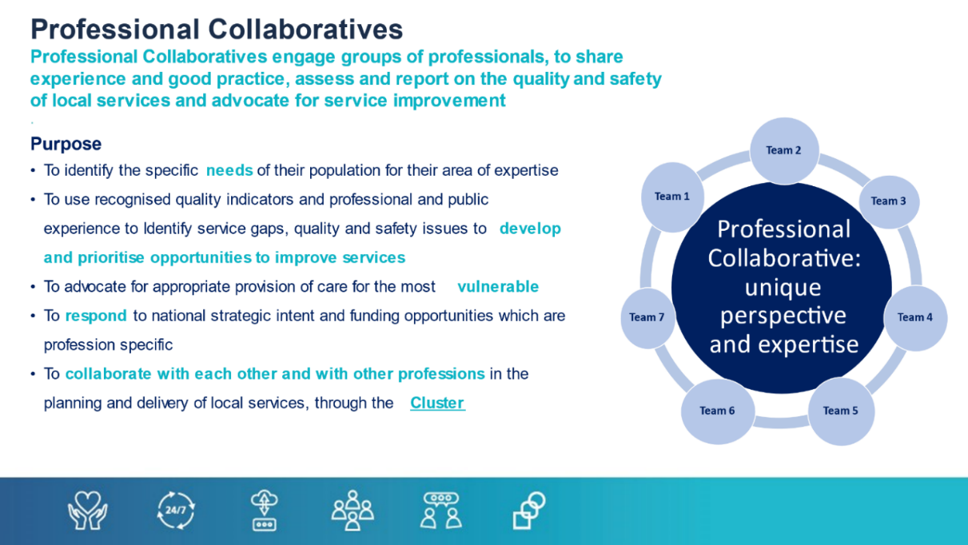
Further information on the recent ACD Programme and the ACD toolkit can be found via the following links.
- ACD overview - Primary Care One (nhs.wales)
- ACD toolkit

Dental Care professionals account for 6 of the 7 GDC registered professional groups (dental therapists, dental hygienists, dental nurses, clinical dental technicians, orthodontic therapists, dental technicians)

