

February 2024 Version 1.0
primarycareone.nhs.wales
Cluster Self-Reflection Process document

24/7
STRATEGIC PROGRAMME FOR PRIMARY CARE
Contents
Executive summary 3
1. Rationale for cluster self-reflection 4
1.1 Cluster self-reflection aims 4
1.2 What is self-reflection? 4
2. Cluster self-reflection development 4
3. How will self-reflection benefit primary and community care in Wales? 5
3.1 Cluster benefits 5
3.2 Health Board, Local Authority and Regional Partnership Board benefits 5
3.3 Strategic Programme for Primary Care (SPPC) benefits 5
4. Cluster self-reflection process 5
4.1 Outline of arrangements 5
4.2 Approaches to self-reflection 6
4.3 Cluster self-reflection steps 6
4.4 Time frame 8
5. Monitoring and evaluation 8
6. Index of abbreviations 8
7. Appendices 9
Appendix 1: PCMW and ACD outcomes 9
Appendix 2: Statements to measure maturity of cluster working towards the PCMW outcomes 11
Appendix 3: Statements to measure maturity of cluster working towards the ACD outcomes 12
Appendix 4: Driscoll’s What Model for self-reflection 13
Appendix 5: Tuckman’s stages of team development 14
Appendix 6: Participant information sheet 15



Executive summary
- Cluster self-reflection is one of three agreed methods to evaluate cluster working towards the Primary Care Model for Wales (PCMW) and Accelerated Cluster Development (ACD), alongside cluster peer review and the PCMW key indicators (under development).
- Cluster self-reflection aims to:
  - Understand the maturity of cluster working across Wales.
  - Identify system level barriers or enablers which affect cluster working.
- The cluster self-reflection process focuses on four areas:
  - Self-reflection on the progress of cluster working against the PCMW outcomes.
  - Self-reflection on the progress of cluster working against the ACD outcomes.
  - Reflection on the system facilitators and barriers, that impact on cluster working.
  - Consideration of where your cluster is, according to Tuckman's Team Development Model (forming, storming, norming or performing).
- Cluster self-reflection is not a performance measure of clusters but will provide an overview of the maturity of cluster working and highlight system enablers and barriers at both an all Wales and health board region level.
- All clusters in Wales are expected to complete the annual cluster self-reflection process.
- Ideally the cluster self-reflection will be undertaken as part of a facilitated discussion, including all cluster members or representation from the broad range of professionals within the cluster.
- Clusters will receive the cluster self-reflection process document, the cluster development framework (that contains the PCMW and ACD maturity matrix) and a link to the online survey in readiness for the survey opening on 1st April 2024.
- Clusters will have eight weeks to complete their self-reflection discussions and to submit their findings into the online survey. The survey will close on 31/05/2024.
- Submissions will be collated, anonymised, and analysed by the Primary Care Division, Public Health Wales.
- Cluster self-reflection findings will support the annual cluster peer-review process as well as cluster and strategic partnership planning processes.

Rationale for cluster self-reflection
Cluster self-reflection is one of three agreed methods to evaluate cluster working towards the Primary Care Model for Wales (PCMW) and Accelerated Cluster Development (ACD), alongside cluster peer review and the PCMW key indicators (under development).

1.1 Cluster self-reflection aims
- Understand the progress (maturity) of cluster working across Wales.
- Identify system level barriers or enablers which affect cluster working.

1.2 What is self-reflection?
Self-reflection or reflective practice enables individuals to gain insight into professional practice, the insights gathered, and lessons learnt can be applied to practice, professional development and improvement.
Self-reflection is commonly used across all health care professions, it is an approach to reviewing and thinking analytically about our own actions, and the practice is supported across regulators codes of practice.
There are several models and approaches to self-reflection. All models provide the tools to critically review individual or collective actions, outputs and provides opportunities to discover new and effective ways of working.

Cluster self-reflection development
Cluster self-reflection has been developed by the Primary Care Division in Public Health Wales, alongside colleagues working in /or with clusters, who volunteered to support this work. The process has been developed to capture the progress of cluster working towards the PCMW and ACD and not as a performance measure of clusters.
There have been several changes within the primary and community care system in recent years, which can impact on the maturity of cluster working. This self-reflection process has been designed to capture the maturity of clusters within this system, and not to capture the maturity of all aspects of the system e.g., Professional Collaboratives or Pan Cluster Planning Groups (PCPG). However, clusters will have the opportunity to reflect on their interactions with strategic partners and to highlight the system factors, that have facilitated or hindered their work.
We acknowledge that some of the PCMW/ ACD outcomes (appendix one) are not solely within the gift of a cluster to action. However, as leaders within the primary and community care system, the cluster will have various routes to influence progress towards the PCMW and ACD. Either through direct actions within their cluster plans/ PCPG plans or through advocating with strategic partners for action and through awareness raising.
As this is the first year of cluster self-reflection, the process will be reviewed and updated annually to ensure it meets the ongoing needs of clusters.

How will self-reflection benefit primary and community care in Wales?

3.1 Cluster benefits
- Strengthen the focus on cluster working and place-based care.
- Support cluster planning.
- Opportunity to advocate for system enablers and to identify system barriers that impact on cluster working.
- Opportunity to recognise what changes are needed to deliver the PCMW and ACD outcomes.
- Identify organisational development needs of the cluster.

3.2 Health Board, Local Authority and Regional Partnership Board benefits
- Opportunity to understand the progress of cluster working towards the PCMW and ACD outcomes across a health board region.
- Opportunity to understand what is working well and how that can be sustained.
- Opportunity to recognise what system wide changes are needed to progress towards the PCMW and ACD.
- Opportunity to reflect on the contribution of the whole system towards delivering health and care that is seamless, place-based and focused on prevention.
- Opportunity to inform strategic partnership planning.

3.3 Strategic Programme for Primary Care (SPPC) benefits
- Understanding of progress towards attaining the PCMW and ACD outcomes and how they are being delivered in Wales, along with key barriers and enablers.
- Intelligence to inform evaluation of the PCMW and ACD and to shape national support priorities and actions.

Cluster self-reflection process

4.1 Outline of arrangements
All clusters in Wales are expected to complete the annual cluster self-reflection process. It is proposed that the cluster self-reflection be undertaken as part of a facilitated discussion. Ideally, this discussion should include all cluster members or representation from the broad range of professionals within the cluster. However, it is appreciated several factors would affect the levels of engagement available. Therefore, if this is not possible the cluster lead or a nominated deputy* should complete the cluster self-reflection.
The findings from the self-reflection discussion should be submitted to the Primary Care Division, Public Health Wales, using the online survey. Only one online submission is required per cluster. Evidence of how the self-reflection process was carried out is not required.
The cluster self-reflection process document, the Cluster Development Framework (which contains the maturity matrix) and the link to the online survey will be available on the Primary Care One website, within the Primary Care Model for Wales page.
*A nominated deputy must have sufficient knowledge of the cluster and authority within the cluster or health board to complete the cluster self-reflection.

4.2 Approaches to self-reflection
Clusters and health boards can agree the method they wish to use to undertake the cluster self-reflection discussion. Suggested approaches include:
  - Facilitated discussion: A facilitated discussion utilises an external person who will support a group of people in their thinking, planning and decision-making processes. For some clusters it may be beneficial to have health board support to facilitate the cluster self-reflection discussion. Ideally the facilitated discussion will include all members or representation from a broad range of professionals within the cluster.
  - Collective discussion: Where facilitator support is not available, the cluster lead may choose to chair the cluster through a self-reflection discussion. Ideally the discussion will include all members or representation from a broad range of professionals within the cluster.
  - One to one / small group discussion: Where collective discussion is not possible, a one to one or small group approach to cluster self-reflection may be of benefit. Cluster leads may want to work with the health board or a small number of cluster members to complete cluster self-reflection process.
  - Single nominated person: Where all forms of collaborative cluster self-reflection are not available to the cluster, the cluster lead, or a nominated deputy* will complete the cluster self-reflection process on their own. Requesting input and opinions from colleagues, in advance of undertaking the process, may be of benefit.
*A nominated deputy must have sufficient knowledge of the cluster and authority within the cluster or health board to complete the cluster self-reflection.

4.3 Cluster self-reflection steps
Clusters will receive the cluster self-reflection process document, the cluster development framework (that contains the PCMW and ACD maturity matrix) and a link to the online survey in readiness for the survey opening on 1st April 2024. Clusters will have eight weeks to complete their self-reflection discussions and to submit their findings into the online survey. The survey will close on 31/05/2024.
Note: The PCMW and ACD maturity matrix are being reviewed and refreshed to better reflect cluster working in 2024. However, for this first year of self-reflection the revised criteria are not being introduced, as they remain in development.
The cluster self-reflection discussions will focus on four areas:
- Self-reflection on the progress of cluster working against the PCMW outcomes
The PCMW maturity matrix (page 14 of cluster development framework) contains criteria for each PCMW outcome (appendix one). The criteria describe activities/ actions which are considered as either foundation, developing or mature. These criteria will help clusters to reflect on which level of maturity their work aligns to.
Four statements have been developed to capture these levels of maturity. Clusters should tick one of the four statements, that best reflects the level of maturity their cluster is working at. This will be repeated for all of the 13 PCMW outcomes (appendix two). For example:
The first statement ‘The cluster has not focused on / taken forward this area of work’ should be ticked if the cluster is not progressing work against the PCMW outcome.
The second statement ‘Cluster members have a common understanding of this area of work’ should be ticked if the cluster feel they are meeting some or all foundation criteria within the maturity matrix.
The third statement ‘The cluster are / have developed plans and processes and can demonstrate progress in this area of work’ should be ticked if the cluster feel they are meeting some or all developing criteria within the maturity matrix.
The fourth statement ‘The cluster can demonstrate sustained good practice and innovation across the cluster and wider system in this area of work’ should be ticked if the cluster feel they are meeting some or all mature criteria within the maturity matrix.
A cluster does not have to have met all the criteria in one level of maturity before progressing to the next level of maturity.
- Self-reflection on the progress of cluster working against the ACD outcomes
The 7 ACD outcomes and associated criteria (cluster development framework page 32 onwards) describe how clusters and strategic partners should be working within the primary and community care system. Therefore, the four statements in this section have been amended to reflect this (appendix three). For example:
The first statement ‘The cluster are not aware that progress has been made’ should be ticked if clusters are not engaged with strategic partners for that outcome.
The second statement ‘The cluster and strategic partners have a common understanding of this element of ACD’ should be ticked if clusters are in dialogue with strategic partners and have a shared understanding of the outcome.
The third statement ‘The cluster and strategic partners are/ have developed plans and processes, and progress is being made’ should be ticked if the cluster is working with strategic partners for the outcome.
The fourth statement ‘The cluster and strategic partners can demonstrate sustained good practice and innovation across the system’ should be ticked if the cluster and strategic partner are aligned and collaborating closely with each other.
- Reflection on the system facilitators and barriers, that impact on cluster working
This section provides an opportunity for the cluster to share their insight on what system factors enable or hinder cluster working. Based on Driscoll's What model of self-reflection (appendix four), clusters will be asked to reflect on:
  - What? - are the system factors that enable or hinder cluster working?
  - So What? - has the cluster done to respond to these system enablers or barriers?
  - Now what? - has the cluster identified further support / action that is needed to progress the maturity of cluster working?
Free text boxes are provided within the online survey, to capture insight.
Identifiable data should not be included within this section.
- Consideration of where your cluster is, according to Tuckman's Team Development Model (forming, storming, norming or performing).
The changes within the primary and community care system can impact on cluster working and the development of the cluster as a team. This section provides clusters with an opportunity to reflect on themselves as a team and to consider which of Tuckman’s four stages of team development best reflects them: forming, storming, norming or performing.
Descriptors of each stage and how a cluster may function at each stage is outlined in appendix five.
Further detail on Tuckman’s model including the formal questionnaire to determine a team’s stage of development is available from the Primary Care Division, Public Health Wales, should the cluster wish to explore their team’s development further PCD.Business.Support@wales.nhs.uk.

4.4 Time frame
Cluster self-reflection discussions should be undertaken during April and May 2024. The findings from the discussions should be submitted through the online survey, which is open between 1st April and 31st May 2024.
Findings will be shared in August 2024.

Monitoring and evaluation
Clusters can use their own self-reflection findings, to inform their priority setting and planning activities.
Cluster self-reflection submissions will be collated, anonymised, and analysed by the Primary Care Division, Public Health Wales. The findings will be analysed at an all Wales and health board region level and will be used to provide an overview of the maturity of cluster working towards the PCMW and ACD. In addition, the findings will inform the cluster peer review process and will highlight system level enablers and barriers that require consideration by all strategic partners.
Following cluster self-reflection, clusters will be asked for feedback on how they found the process and whether / how they used their self-reflection findings. This will provide insight to improve the process going forward.

Index of abbreviations
ACD Accelerated Cluster Development
PCMW Primary Care Model for Wales
PCPG Pan-cluster planning groups
RPB Regional Partnership Board
SPPC Strategic Programme for Primary Care

- Appendices

Appendix 1: PCMW and ACD outcomes
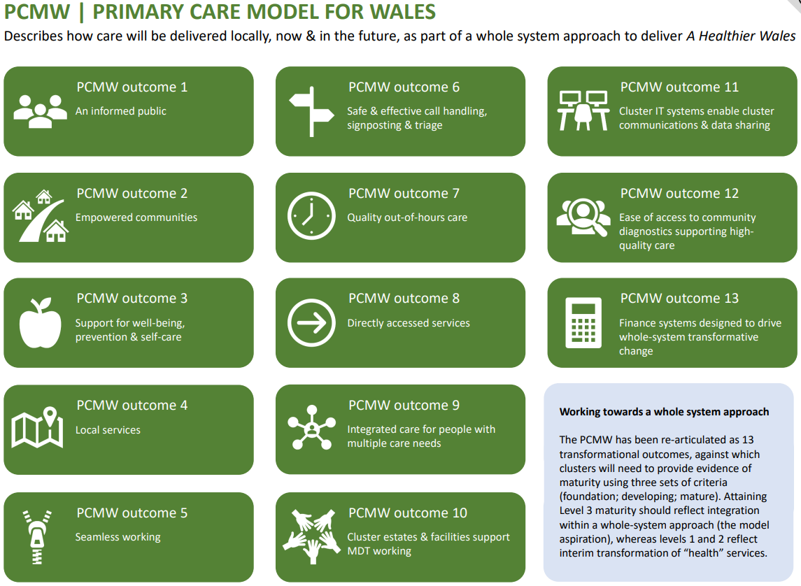

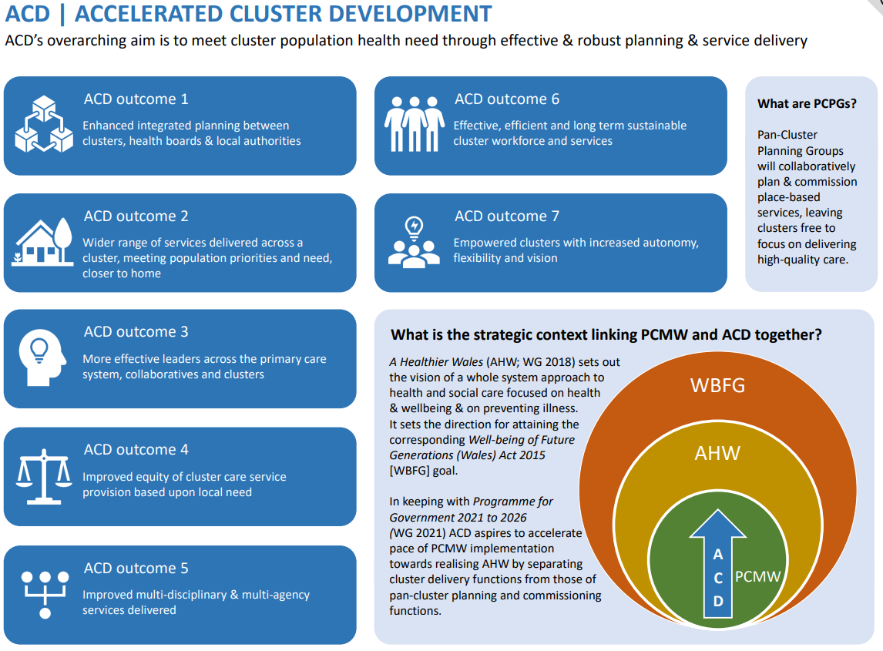

Appendix 2: Statements to measure maturity of cluster working towards the PCMW outcomes
 | The cluster has not focused on / taken forward this area of work. | Cluster members have a common understanding of this area of work. | The cluster are / have developed plans and processes and can demonstrate progress in this area of work. | The cluster can demonstrate sustained good practice and innovation across the cluster and wider system in this area of work.
An Informed Public
Empowered communities
Support for well-being, prevention & self-care
Local Services
Seamless working
Safe & effective call handling, signposting & triage
Quality out-of-hours care
Directly accessed services
Integrated care for people with multiple care needs
Cluster estates & facilities support multi-professional working
Cluster IT systems enable cluster communications & data sharing
Ease of access to community diagnostics supporting high-quality care
Finance systems designed to drive whole-system transformative change

Appendix 3: Statements to measure maturity of cluster working towards the ACD outcomes
 | The cluster are not aware that progress has been made. | The cluster and strategic partners have a common understanding of this element of ACD. | The cluster and strategic partners are/ have developed plans and processes, and progress is being made. | The cluster and strategic partners can demonstrate sustained good practice and innovation across the system.
Enhanced integrated planning between clusters, health boards & local authorities
Wider range of services delivered across a cluster, meeting population priorities and need, closer to home
More effective leaders across the primary care system, collaboratives, and clusters
Improved equity of cluster care service provision based upon local need
Improved multi-professional & multi-agency services delivered
Effective, efficient, and long term sustainable cluster workforce and services
Empowered clusters with increased autonomy, flexibility, and vision

Appendix 4: Driscoll’s What Model for self-reflection

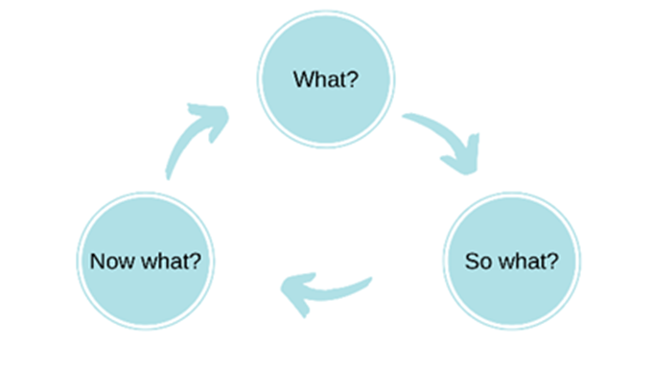

Appendix 5: Tuckman’s stages of team development
Tuckman’s stages | Definition | Examples within a cluster
Forming | During this stage, team members establish interpersonal relationships, become familiar with the assigned task, and create ground rules. | - Membership of the cluster has changed and there is a mix of new and old members, or the cluster remains predominantly GMS focused.  - Some cluster roles remain vacant, or attendance is inconsistent.  - Working relationships are in the early stages of development.  - Members do not understand their role in cluster planning and delivery and/or the cluster purpose is not clearly understood.
Storming | This stage marks a time of intragroup conflict due to a lack of group unity. Team members still see themselves as individuals rather than as part of a team and they may resist the formation of a group structure in favour of expressing their individuality. | - Cluster members feel there is a lack of equal engagement and influence between members.  - Members attendance and active engagement at cluster meetings is variable.  - Members feel frustrated, and some are disengaging from the cluster.
Norming | This stage is characterised by the emergence of group harmony where group members begin to openly express ideas and opinions. Members begin to accept each other for who they are, and task-related conflicts are avoided to preserve harmony. | - Cluster meetings are well attended, and members are actively engaged.  - Cluster members understand their role and that of others in the cluster.  - Cluster members feel respected and trusted by others.  - All cluster members share their knowledge and expertise into priority setting and planning.  - New and innovative ways of working are emerging within the cluster.
Performing | This stage reflects a period of productive collaboration in which members demonstrate support for each other and assume roles that will enhance task activities. Constructive attempts are made to resolve any issues related to the completion of project tasks. | - All cluster members share a common vision and purpose for their cluster.  - All cluster members consistently contribute to and collectively deliver the agreed clusters plans.  - Members recognise the valued contribution that each of them brings to the cluster.  - Cluster members understand their role in the primary and community care system and actively engage with strategic partners.

Appendix 6: Participant information sheet
INTRODUCTION
We invite you to participate in a cluster self-reflection, which has been co-developed by the Primary Care Division, Public Health Wales and colleagues working with/ in clusters who volunteered to support this work.
Before completing the cluster self-reflection, it is important for you to understand why it is being undertaken and what it will involve. Please take the time to read the cluster self-reflection process document. Details of which are summarised below.
WHAT IS THE PURPOSE OF CLUSTER SELF-REFLECTION?
Cluster self-reflection is one of three agreed methods for evaluating the progress (maturity) of cluster working towards the Primary Care Model for Wales (PCMW) and Accelerated Cluster Development (ACD). The self-reflection exercise aims to:
- Assess the maturity of cluster working across Wales.
- Identify system factors that enable or hinder cluster working.

WHO SHOULD COMPLETE CLUSTER SELF-REFLECTION?
It is proposed that the cluster self-reflection be undertaken as part of a facilitated discussion. Ideally, this discussion should include all cluster members or representation from the broad range of professionals within the cluster. However, if this is not possible the cluster lead or a nominated deputy* can complete the cluster self-reflection on their own.
The findings from the self-reflection discussion should be submitted to the Primary Care Division, Public Health Wales, using the online survey.
*A nominated deputy must have sufficient knowledge of the cluster and authority within the cluster or health board to complete the cluster self-reflection.
WHAT DOES THE CLUSTER SELF-REFLECTION INVOLVE?
The cluster self-reflection includes four sections. The first two sections, provide clusters with an opportunity to self-reflect on the progress of their work against the PCMW and ACD outcomes. Four statements have been developed to reflect the maturity of cluster working against the foundation, developing and mature criteria within the PCMW and ACD maturity matrix. One of the four statement should be chosen that best reflects cluster working for that outcome. This will be repeated for each outcome.
The second section of the cluster self-reflection is an opportunity for the cluster to share their insight on the system enablers and barriers, that impact on cluster working, and to consider how these have been harnessed/ overcome or where further support is required. Free text boxes are used within the survey to capture this insight. Identifiable data should not be included within this section. If identifiable data is submitted, it will be deleted and not included in the analysis.
The third section asks participants to consider which stage of Tuckman’s model of team development they see their cluster at (forming, storming, norming or performing). Descriptors of each stage and how a cluster may function at each stage is outlined in appendix four.
ARE THERE ANY RISKS OR BENEFITS TO PARTICIPATING IN THE CLUSTER SELF-REFLECTION?
There are no known risks associated with participating in the cluster self-reflection.
The cluster self-reflection is an opportunity for the cluster to consider their strengths, where work has progressed against the PCMW and ACD outcomes and to identify areas where further work is required.
WHAT WILL HAPPEN WITH MY INFROMATION AND HOW WILL IT BE HANDLED?
All information collected will be stored confidentially within the Primary Care Division, Public Health Wales. The information will be used solely for the purpose of the cluster self-reflection. All responses will be anonymised so that you and your cluster are not identifiable in any publications resulting from this work.
WHAT HAPPENS IF A CLUSTER DOES NOT COMPLETE THE SELF-REFLECTION?
If a cluster does not participate in the cluster self-reflection, they will be asked to provide feedback on the reasons why they declined to participate.
WHAT WILL HAPPEN TO THE RESULTS FROM THE CLUSTER SELF-REFLECTION?
Clusters can use their own self-reflection findings, to inform future priority areas and planning activities. Anonymised cluster self-reflection findings will be analysed at both an all Wales and health board region level and will describe the maturity of cluster working against the PCMW and ACD outcomes. Thereby identifying PCMW and ACD outcome areas where additional system support/ action is required to progress the maturity of cluster working. In addition, qualitative analysis of the system enablers and barriers will be undertaken, identifying themes for action at all levels of the primary and community care system (as required).
The findings from the cluster self-reflection will also feed into the cluster peer review process.
CONSENT
By proceeding with the survey, you indicate that you have read this information sheet, understand the purpose of the cluster self-reflection, and consent to participate.

For any queries regarding Information Governance please contact: phw.informationgovernance@wales.nhs.uk.
For general queries on accessing the form please contact Sian.jones104@wales.nhs.uk.
If you require further information on the cluster self-reflection please contact: Rachel.Andrew@wales.nhs.uk

https://www.bmj.com/content/347/sbmj.f6387
https://www.nmc.org.uk/globalassets/sitedocuments/other-publications/benefits-of-becoming-a-reflective-practitioner---joint-statement-2019.pdf
https://www.pcrs-uk.org/sites/default/files/Guide%20to%20Reflective%20Practice_FINAL_0.pdf
https://www.researchgate.net/publication/233648174_Reflection_in_healthcare_practice_Why_is_it_useful_and_how_might_it_be_done
Driscoll, J., 1994. Reflective practice for practise. Senior Nurse, 14(1), pp.47-50.
https://view.officeapps.live.com/op/view.aspx?src=https%3A%2F%2Fwww.etctoolkit.org.uk%2Fmedia%2F1127%2Fdriscoll.doc&wdOrigin=BROWSELINK
https://nursinganswers.net/reflective-guides/driscoll-model-of-reflection.php

