NHS Wales Planning Framework 2023/2026

Accelerated Cluster Development Programme Planning Guidance 2023/2024

Frequently Asked Questions

This Frequently Asked Questions sheet (FAQ) has been produced for Health Board Officers, Regional Partnership Board Coordinators, Pan Cluster Planning Groups, Clusters, Professional Collaboratives and other stakeholders across Wales to help answer some of the questions relating to the development of the Pan Cluster Planning Group three year Strategic Plans 2023/26 and Cluster Plans for 2023/24 and beyond during this transition planning year.
2022/2023 is the transition year for the ACD programme as the system in Wales transitions from the current (March 2022) cluster configuration into a revised planning and delivery configuration (March 2023) with Professional Collaboratives, Clusters and Pan Cluster Planning Groups (PCPGs) more closely aligned with the Regional Partnership Board planning infrastructure; integrated within health board governance arrangements.

The planning cycle to produce the RPB area plans 2023/2028; the Health Board IMTP Plans 2023/26, the Pan Cluster Planning Group three year Strategic Plans 2023/26 and the associated Cluster Delivery Plans 2023/24 are not quite fully aligned this year and therefore the planning cycle that will progress through autumn/winter 2022/23 to produce the strategic and delivery plans that will come into operation from April 2023 will be pragmatic in its design.

Work is currently progressing across Wales to fully align and integrate future (April 2024 onwards) RPB, IMTP and PCPG/Cluster planning arrangements so that the cycle of planning activity that will take place in autumn/winter 2023/24 to inform the new HB IMTP and PCPG/Cluster plans from April 2024 will (continue to) be developed in unison; and in future years will align with the refresh of the RPB area plans and PNAs.

Glossary of Terms:

ACD Accelerated Cluster Development
IMTP Integrated Medium Term Plan
PC Professional Collaborative
PCPG Pan Cluster Planning Group
RPB Regional Partnership Board
PNA Population Needs Assessment

During the ACD transition year what are the planning expectations for the Clusters and Pan

Cluster Planning Groups to inform service delivery from April 2023 and beyond?

2022/2023 is the transition year for the ACD programme as the system in Wales transitions from the current (March 2022) cluster configuration into a revised planning and delivery configuration (March 2023) with Professional Collaboratives (PCs), Clusters and Pan Cluster Planning Groups (PCPGs) more closely aligned with the Regional Partnership Board (RPB) planning infrastructure and planning cycle and the NHS IMTP planning cycle.
There is a clear expectation that through the newly created / emergent planning arrangements and, in particular the Pan Cluster Planning Groups (PCPGs) and their associated clusters, that PCPGs plans assimilate into the IMTP and complement the RPB Area Plans and that clusters are able to provide an operational plan for the coming year that is central to that of the PCPG.

RPBs across Wales were required to develop and publish a Regional Population Needs Assessment (PNA) by 1 April 2022 to inform the development of their five year RPB Area Plans, to be published by 1 April 2023. Health Boards are required to produce and publish a three year IMTP by April 2023.

Given the fact that the RPB Area Plans are not yet published; a light touch approach will be taken for the refresh of the current cluster plans and the development of PCPG plans for 2023/26 over the September 2022-March 2023 period. Clusters and PCPGs will be expected to have conversations over this period to refresh and agree cluster plans for 2023/24 that aggregate into PCPG level plans that will be refined over the coming financial year following the publication of the RPB Area Plans by 1st April 2023.

In her letter of 24 March 2022, the Minister for Health and Social Services laid out her expectations for the development of Cluster and PCPG plans:
Extract from Letter from the Minister for Health and Social Services; 24 March 2022; Accelerated Cluster Development
April 2022 - RPBs publish their Regional Population Needs Assessments [RPNA] which will inform Professional Collaborative, Cluster and PCPG level planning.
April to September 2022 - Supported by Health Boards, individual Professional Collaboratives are established in each cluster footprint for GMS, Community Pharmacy, Optometry, Community Nursing, Allied Health Professionals (AHPs) and potentially social services and these are represented on the cluster / PCPG. Subject to contract reform, Dental Professional Collaboratives are expected to be established by March 2023.
July to September 2022 - Professional Collaboratives (where established) begin to respond to published population needs assessments (such as RPNAs due to be published in April 2022) and identify their service gaps and developments in response to Welsh Government planning guidance.
September 2022 to November 2022 - Clusters begin to use the Professional Collaboratives’ responses to produce a cluster level response to address identified needs assessments and service gaps.
December 2022 - Pan Cluster Planning Groups use the cluster responses to produce a prioritised county wide response to the RPNA and a 3 year plan for 2023-26. These plans also identify those services which are most effectively delivered on a cluster footprint.
January 2023 - Health Boards use Pan Cluster Planning Group response to Regional Population Needs Assessments and 3 year plans to inform their 2023-26 IMTPs.
January to March 2023 - RPBs use Pan Cluster Planning Group responses to the RPNAs and 3 year plans to inform their next Area Plans assessments and plans.
April 2023 - RPBs publish their 5 year Joint Area Plan which should be informed by pan cluster responses.

Do clusters need to produce a plan for 2023/2024?

Yes. Under the Accelerated Cluster Development Programme clusters will be required to produce a cluster level response (cluster plan) for the 2023/2024 operating period to address identified needs and service gaps from local intelligence flowing up from the establishing Professional Collaboratives and to respond to the needs and priorities contained in the RPB PNAs that will inform the development of the RPB area plans and the PCPG strategic plans.
Given the timing of the development and publication of the refreshed RPB area plans and the new PCPG strategic plans; it is proposed that the ‘light touch’ approach to 2022/23 cluster level planning is extended to inform the production of the 2023/2024 cluster plans utilising similar guidance templates to those circulated in autumn 2021 to support the development of the 2022/23 cluster annual plans.
In effect, the cluster plans for 2023/24 could simply be a refresh of the current 2022/23 plans, supplement by any strategic direction emerging from the PCPG plans and the RPB area plans.
The cluster plans should be produced in draft by the end of November 2022 to inform the development of the emergent PCPG strategic plans (Ministerial letter, March 2022).

Is a template being issued to capture/direct the content of the cluster plan for 2023/24?

Yes. To support the ‘light touch’ approach a simple guidance template to indicate the suggested minimum requirements for cluster plans will be included in the data set health boards will be required to submit to Welsh Government as part of their IMTP submission. The template will guide the construction of the cluster plans, aligned to the emergent PCPG strategic three year plan submitted by the Health Board as part of their IMTP.
Health Boards and clusters are free to add additional information to the template to reflect their own local planning arrangements.

Pan Cluster Planning Groups are forming, what plans, if any, do they need to develop for 2023 and beyond?

Pan Cluster Planning Groups (PCPGs) provide the local footprint for the tactical delivery of RPB priorities contained within the emergent RPB Area Plans. The PCPGs will coordinate the use of all available resources to meet local needs, provide the strategic direction to inform the development of their respective cluster plans, and, in time, commission services and develop agreements to support partnership working.
PCPGs will use the RPB Population Needs Assessment, supplemented with local service intelligence flowing from the Professional Collaboratives and Clusters to lead the development of the PCPG strategic plan which will outline what services are needed, making prudent use of all funding, workforce, and other resources and which address the health, care and wellbeing needs of the local population.
Recognising the variation of establishment and formation of PCPGs across Wales, full local flexibility will be given to health boards and their partners to determine the structure and presentation of the PCPG plans for 2023/26 whilst the RPB area plans are under development. The PCPG strategic plans must give sufficient strategic direction to the clusters to enable them to develop their cluster plans for 2023/2024 in line with PCPG/RPB vision. It is expected that once the RPB area plans are published in April 2023 the PCPGs will work with the RPB and wider stakeholders to update and refine their three year strategic plans over the course of 2023/24, maturing their workforce and financial intelligence to inform future annual cluster plans.

PCPGs are expected to produce their (draft) plans by December 2022 (Ministerial letter, March 2022).

Is there a need to refresh the local cluster needs assessment or for the PCPGs to produce a needs assessment this year?

No. There is no requirement for clusters to refresh their cluster needs assessment in 2022 to inform their 2023/24 plans, however clusters may choose to do this to help shape and inform local priorities.
There is no need for PCPGs to produce a stand-alone needs assessment to inform the development of the PCPG strategic plan 2023/26.
PCPGs will use the RPB Population Needs Assessment, published on the RPB website in spring 2022, supplemented with local service intelligence flowing from the Professional Collaboratives and Clusters and other local data sources and intelligence to support the development of the PCPG strategic plan for 2023/26. Further information of key health intelligence data sources to support needs assessments can be obtained in the Cluster Planning Support Portal.

How does the ACD planning arrangements link to the development of the health board IMTP?

There is a clear expectation that ACD planning will be integrated with health board planning arrangements. There is a clear expectation that through the newly created ACD planning arrangements and, in particular the PCPGs and their associated clusters, that PCPGs develop three year strategic plans that assimilate into the HB IMTP and complement the RPB Area Plans. ACD plans should visibly inform (and be informed by) health board IMTPs, providing a solid foundation to providing care closer to home for the majority of the population. Refer to the NHS Planning Framework 2023/26 once published in Q3 2022/23 which will up uploaded into the ‘Accessing Planning Guide Support and Training’ section of the Cluster Planning Support Portal.

The Ministerial letter (24 March 2022) milestones included: January 2023 -Health Boards use Pan Cluster Planning Group response to Regional Population Needs Assessments and 3 year plans to inform their 2023-26 IMTPs.
Health Boards need to demonstrate that they are adopting cluster planning and delivery to ensure patients receive rapid access to appropriate advice and support, adopting effective pathways, signposting patients at the start of their journey on how to get help.

How does the ACD planning arrangements link to the development of the RPB Area Plans?

There is a clear expectation that through the newly created ACD planning arrangements and, in particular the PCPGs and their associated clusters, that PCPGs develop three year strategic plans that are informed by and complement the RPB Area Plans. Further information can be obtained from the Regional Partnership Board Area Plans – Supplementary Advice for Regional Partnership Boards (June 2022).

The Ministerial letter (24 March 2022) milestones included: January to March 2023 - RPBs use Pan Cluster Planning Group responses to the RPNAs and 3 year plans to inform their next Area Plans assessments and plans

When does the PCPG strategic plans and the associated cluster plan need to be completed?

In March 2022 the Minister for Health and Social Services set out her expectations for the development of the PCPG plan and the cluster plan to inform the development of the health board IMTP and RPB area plans. Health Board teams may set internal deadlines before the official date to allow sufficient time for the plans to be considered within the health board and RPB planning and governance processes. It is suggested that you also check with the Primary Care / Cluster / Locality managers in the health board as to your local timescales. The Ministerial milestones are:
September 2022 to November 2022 - Clusters begin to use the Professional Collaboratives’ responses to produce a cluster level response to address identified needs assessments and service gaps.
December 2022 - Pan Cluster Planning Groups use the cluster responses to produce a prioritised county wide response to the RPNA and a 3 year plan for 2023-26. These plans also identify those services which are most effectively delivered on a cluster footprint

Where does the PCPG strategic plans and the associated cluster plan need to be published?

One year cluster plans and three year PCPG strategic plans should be published on the Health Board website in 2023 alongside the Health Board IMTP 2023/2026. Good practice would also expect a link from the RPB website to the Health Board website to signpost stakeholders to the cluster/PCPG plans.

Will there be any form of monitoring of the Pan Cluster and cluster plans in 2023/24?

Yes. PCPGs and Clusters will be expected to monitor progress on the delivery of their plans through the course of 2023/24 reporting into their existing RPB and health board performance monitoring arrangements including reporting through to Welsh Government through health board IMTP scrutiny processes. In addition, as the Pan Cluster Planning Groups are established across Wales, local arrangements will be put into place for clusters to report their activity into the Pan Cluster Planning Group and the RPB.

What will happen to the cluster budget from April 2023?

Cluster budgets are determined by Welsh Government and delegated via Health Boards. The Health Board will delegate these budgets to the Clusters via the Pan Cluster Planning Groups. The Health Board and its partners may delegate additional resources to PCPGs and Clusters to achieve agreed outcomes. All financial decisions will be made in line with agreed NHS Standing Financial Instructions.
Health Board and RPB officers will put appropriate and proportionate arrangements in the place for the future allocation and monitoring of the cluster budget through the PCPG/Cluster planning arrangements. Use of the cluster funding will be aligned to the delivery of the strategic priorities contained in the PCPG plans and the cluster plans.
Further information to support the ACD planning cycle can be obtained from:
ACD Toolkit Cluster Planning Support Portal Population Health Information by Topic
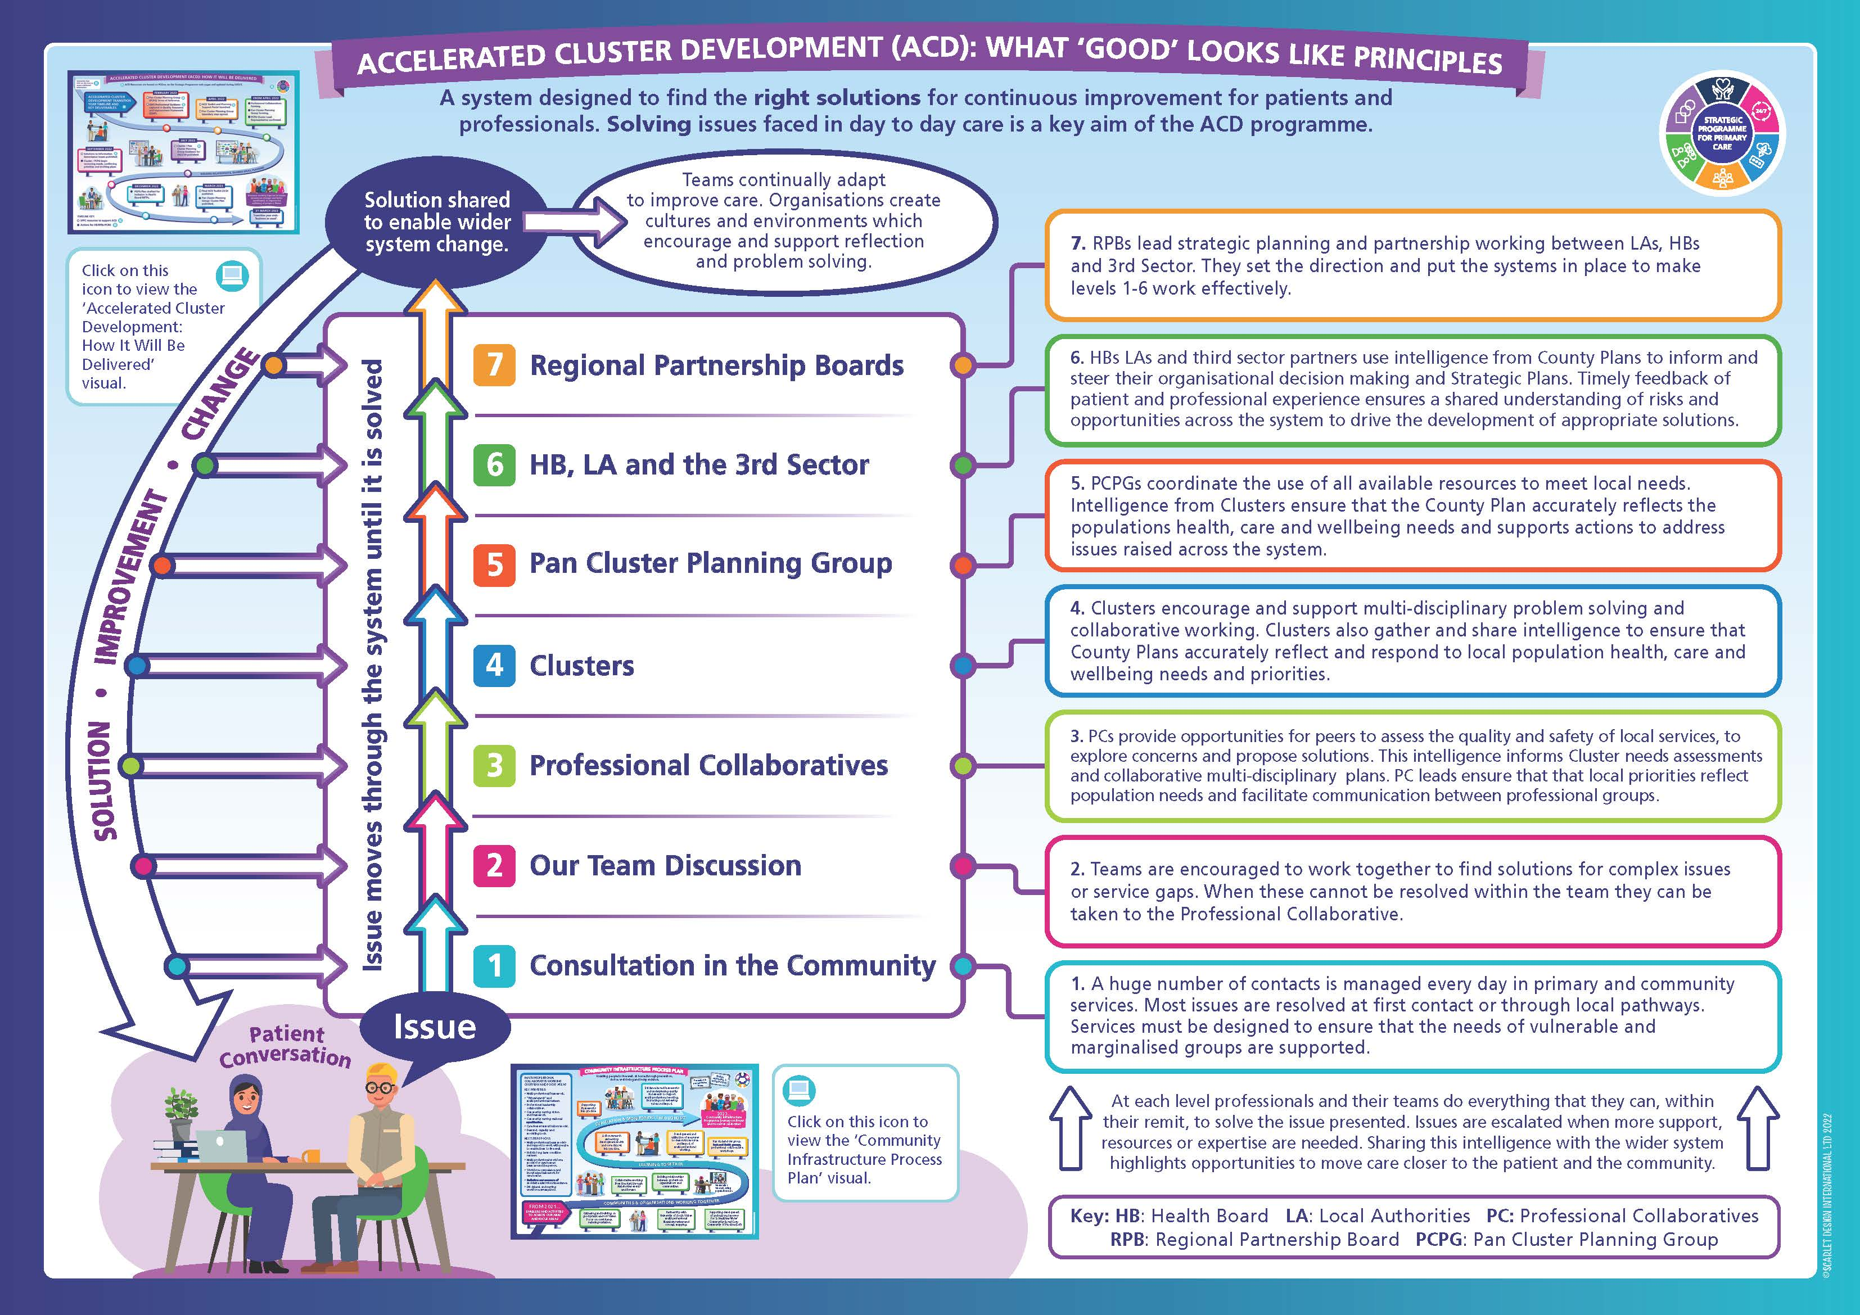

If you have questions that are not addressed in the FAQ, please contact: SPPC@wales.nhs.uk

