
CLUSTER WORKING IN
WALES

Tools, techniques and tips to help you as a leader

A set of handbooks for Cluster Leads, Professional Collaborative Leads and other staff working in or with clusters

Updated September 2023



Contents

Section A: General information about clusters 4
What are clusters? 4
What is Accelerated Cluster Development (ACD)? 5
How much funding is available to clusters? 6
Cluster meetings 7
Cluster governance 8

Section B: How you work 9
What is the Primary Care Model for Wales? 9
Population need and local priorities 10
Prioritising need and cluster planning 12

Section C: Tools and techniques to help you as a leader 13
Agenda setting 13
Chairing meetings 14
A record of the meetings 15
Developing yourself as a leader 16
Principles of team working 17
Managing change 19
Nolan principles 20
Business cases 21
Project Management 23
Measuring success and evaluation 24
Quality improvement 26

Section D: Who you work with 28
Health board who’s who 28
Regional Partnership Board 30
Public Service Board 30
Pan Cluster Planning Groups 30
What are professional collaboratives? 31
Local service providers 32
Cluster based staff 33
Information governance 35
Cluster Maturity 36

Introduction

This is the Tools, techniques and tips to help you as a leader handbook of a collection of CLUSTER WORKING IN WALES Handbooks produced by the Primary and Community Care Development and Innovation Hub, Public Health Wales.

This handbook provides information and a collection of tools, techniques and tips to help you develop your cluster or professional collaborative. It also provides signposting to resources to help you develop your leadership skills. It consist of four sections:

- Section A: General information about clusters
- Section B: How you work
- Section C: Tools and techniques to help you as a leader
- Section D: Who you work with

The handbooks as a set of resources

The handbooks provide practical advice for use by anyone new to a cluster or professional collaborative leadership role or anyone who wants to include cluster working as part of their work. The ideas and advice provided outlines a foundation for your cluster work and will give you the basic tools and techniques for working in or with clusters.

These handbooks provide an initial ‘go to’ resource and complement any other resources that may be produced locally or nationally.

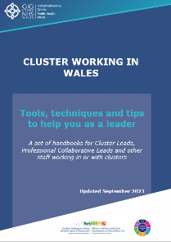
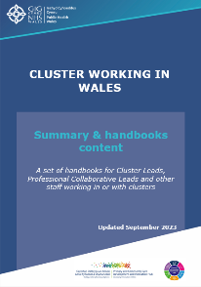
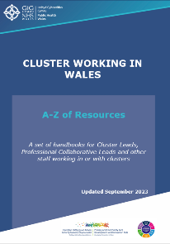
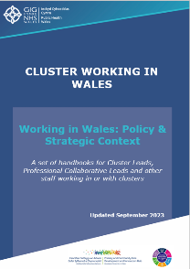
Although presented as separate handbooks, they are designed to be complementary to each other and will be most effective if used collectively. All handbooks contain hyperlinks which signposts you to further information and resources. To download the handbooks go to Primary Care One.

Section A: General information about clusters

What are clusters?

The concept of primary care clusters where primary care services are co-ordinated on a geographical locality basis in Wales was first introduced in 2010 in response to the Welsh Government’s Primary & Community Services Strategic Delivery Programme, Setting the Direction.

A cluster is defined as:

A cluster brings together all local services involved in health and care across a geographical area, typically serving a population between 25,000 and 100,000.

Working as a cluster ensures care is better co-ordinated to promote the wellbeing of individuals and communities.

Source: The Strategic Programme for Primary Care, 2018

Clusters were originally introduced as GP clusters where formal arrangements were put in place via the General Medical Services contract in April 2014 to enable GP practices to work collaboratively as clusters to develop services in their locality. The refreshed model for clusters we see today arose as a result of the Health, Social Care and Sport Committee Inquiry into Primary Care Clusters in October 2017.

Clusters bring together a wide range of stakeholders including include healthcare professionals, senior leads from health boards, local authorities and third sector.
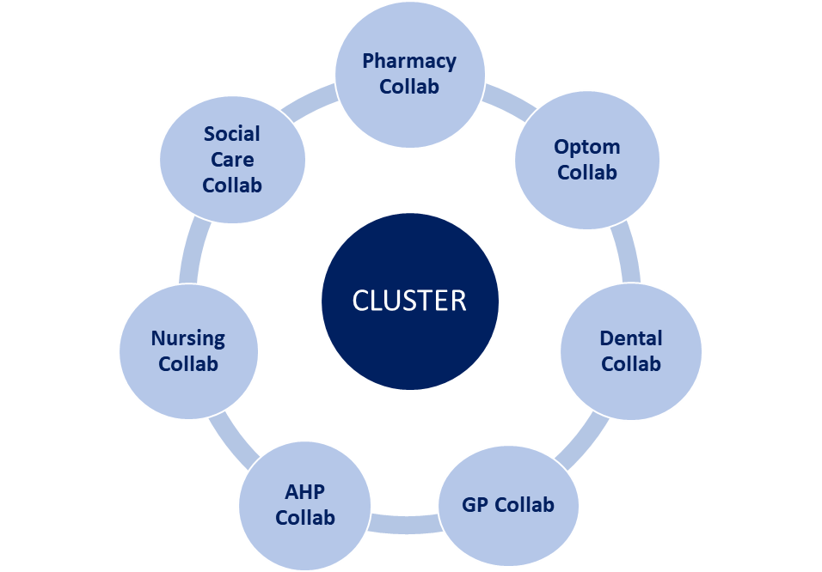
Clusters should encourage stakeholders to work together to find operational solutions that work in the local context and ensure seamless and efficient service provision to their local populations.

There are 60 clusters in Wales. Their geographical area and size of population are determined by the individual health board.

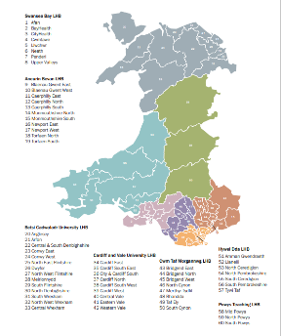
To view the map of all clusters in Wales, click here.

Specific detail about individual clusters by health board is available via Find a cluster - Primary Care One.

A cluster is the most local level of service planning and coordination and is responsible for:

- Planning of services best delivered at the cluster level.
- Integrating primary and community based services between health, social and voluntary sectors, physical and mental health services, with partners.
- Providing innovative and effective alternative to traditional outpatients or inpatients models of care.
- Understanding and responding to the full spectrum of health and social care needs of the population served by the Cluster with a particular focus on the needs of vulnerable groups.
- Focus on preventing ill health, and promoting wellbeing, enabling people to self-manage where appropriate.
Further information about the structure and background to cluster in the context of local delivery vehicles is covered in the Working in Wales: Policy & Strategic Context handbook

What is Accelerated Cluster Development (ACD)?
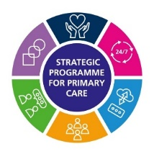

In 2021/22, the Strategic Programme for Primary Care introduced an Accelerated Cluster Development (ACD) Programme to ensure more rapid implementation of the Primary Care Model for Wales. The programme was time defined with 2023/24 being the transition year for implementation of the new structures.

The programme introduced the concept of Professional Collaboratives and Pan Cluster Planning Groups (PCPGs) to align planning and delivery functions. The aim is to broaden and strengthen clinical engagement and facilitate the relationship between local front-line health and care services through to the Regional Partnership Board (RPB). This will support an understanding of the needs of the local population to inform strategic priorities at an RPB / county and cluster level.

Information about professional collaboratives and Pan Cluster Planning Groups (PCPG) can be found in Section D: Who you work with.

To support the implementation of the Accelerated Cluster Development Programme, a Glossary of Terms provides a brief list of definitions to key terms used as part of the programme.

Further products to enable ACD implementation are as follows:
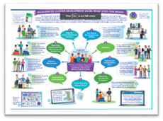
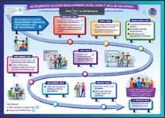
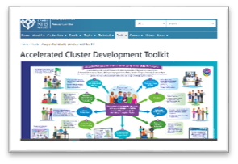
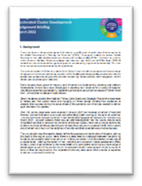

Accelerated Cluster Development Background | Accelerated Cluster Development Toolkit | Accelerated Cluster Development What does it means for me? | Accelerated Cluster Development Timeline

How much funding is available to clusters?

Every year clusters in Wales are given a total of £10 million recurrent funding to improve the care and well-being of the communities they serve.
Cluster budgets are delegated to clusters through Welsh Government allocation to health boards via the Pan Cluster Planning Groups. The health board and its partners may delegate additional resources to clusters from additional transformational funds against the delivery of specific delivery criteria.
The funds are usually managed by the health board. The health board finance team will signpost clusters to relevant expertise and provide advice and training on financial processes and business planning activities.
As cluster funds are public money, the principles and financial probity set out in Managing Welsh Public Money for managing resources in any public sector organisation in Wales applies. Duties and responsibilities that apply to health boards in turn apply to clusters and are set out in the following:

- Standing Financial Instructions (SFIs)
- NHS Finance (Wales) Act (2014)
- NHS Wales Planning Frameworks

The SFIs set out how goods and services can be procured including procurement regulations and thresholds for quotations and tendering.
The Primary Care Cluster Financial Guide provides further details about financial arrangements for clusters.

Cluster meetings

The cluster meeting provides the opportunity and mechanism to come together to discuss priorities and agree/monitor action to ensure cluster working is conducted effectively.

Cluster meetings are usually chaired by the Cluster Lead who should be responsible for ensuring arrangements are in place for chairing of the meeting in their absence.

The Terms of Reference (ToR) define the frequency of meetings, the core membership of the cluster comprising of representation from all local services contributing to health and social care within the cluster area and other members who may be in attendance at cluster meetings. Patient representation does not usually form part of core membership.

Typical membership is illustrated in the table 1. Other members may be included as required.
Table 1: Cluster members
Core membership | In attendance
- Cluster Lead (Chair)  - General Practice Collaborative Lead  - Community Pharmacy Professional Collaborative Lead  - Dental Professional Collaborative Lead  - Optometry Professional Collaborative Lead  - Community Nursing Professional Collaborative Lead  - Allied Health Professional Collaborative Lead  - Third sector representative  - Mental Health Service representative  - Medicines Management representation  - Primary, Community & Therapies Services Senior Manager  - Cluster Development Manager | - Head of Primary Care  - Finance  - Workforce and OD  - Cluster Support Manager  - Local Public Health Team

The ToR and operating arrangements should be reviewed annually by the PCPG.
A model Terms of Reference (ToR) for cluster meetings can be found here.

Cluster governance

Governance is a broad term which includes leadership, stewardship, accountability, assurance, probity, ethical behaviour and control. The principles of governance apply to any organisation including clusters. For the NHS in Wales, governance is defined as:
A system of accountability to citizens, service users, stakeholders and the wider community, within which healthcare organisations work, take decisions and lead their people to achieve their objectives.
Source: NHS Wales Governance E-Manual

An ACD Supporting Governance framework was developed in 2023 for health boards to develop and describe the relationships between the health board, PCPG and clusters. It is recommended that Government’s Citizen Centred Governance principles are followed to guide the planning and delivery of services:

- Putting the citizen first
- Knowing who does what and why
- Engaging with others
- Living public sector values
- Fostering innovative delivery
- Being a learning organisation
- Achieving value for money

All financial decisions must be made in line with agreed Standing Financial Instructions. There will need to be an authorised signatory at the PCPG.
For further information:
- ACD Supporting Governance
- NHS Wales Governance E-Manual
- The Good Governance Pocket Guide for NHS Wales Boards
- The Pocket Guide to Governance in NHS Wales

Section B: How you work

What is the Primary Care Model for Wales?

The Primary Care Model for Wales (PCMW) (former Transformational Model for Primary and Community Care) describes the whole system approach to sustainable and accessible local health and well-being care to deliver the ambition of A Healthier Wales.
Figure 1 - The Primary Care Model for Wales

Source: The Strategic Programme for Primary Care, 2018

The PCMW is designed to meet the needs of and achieve better outcomes for individuals, with a greater emphasis on keeping people healthy and well and can be seen as the ‘vision or desired state’ for communities in Wales. The PCMW contains 13 key components (outcomes) required for transforming services. These include effective collaboration at community level to assess population need to both plan and deliver seamless care and support to meet that assessed need.

Clusters are central to delivering the model and developing the links to the Regional Partnership Boards and the wider community infrastructure to support health and well-being care and deliver the quadruple aims of A Healthier Wales.

Population need and local priorities

Before designing local services it is important to understanding the health, healthcare and social care needs of the local population. Needs assessments can help to facilitate the tailoring of local services to meet local needs.

One of the first principles of doing a needs assessment is to define the population. The population in this case being the population for which the cluster serves.

The purpose of a population needs assessment is to gather information to understand the health and wellbeing needs of the population in order to meet those need through health and care services and other initiatives including self-care. Population Needs Assessments contain two elements:

- an assessment of need
- an assessment of the range and level of services required to meet those needs.

The understanding gained from population needs assessment is then used to help make decisions about how to prioritise allocation of resources to meet the needs for maximum benefit.

Doing a full assessment well can be challenging, there are different approaches that can be taken and it relies on the availability and access to a wide range of data and information to inform the assessment.

See Top Tips overleaf.

There may also be occasions where the data or information you require is not routinely available. If this is the case, there may be a requirement to create estimates (e.g. based on national survey results), using proxy measures (e.g. levels of alcohol consumption may predict harm from alcohol misuse or carry out bespoke data collection (e.g. conduct a survey, do an audit, health needs assessment focussed on a particular issue).
Further information about how to do a needs assessment is covered in the Cluster Planning Support Portal – 2a - Developing plans: Population needs and service use.

Top Tips on identifying population need

- Start by finding out what has already been done. There will be a number of previously completed and current assessments that include useful intelligence. There will already be information and assemements available locally as a starting point even if these are on a slightly larger geographical footprint. The Regional Partnership Board’s Population Needs Assessment, Public Service Board’s Wellbeing Assessment and Health Board’s Pharmaceutical Needs Assessments are useful starting points.

- It is important to seek advice from your Local Public Health Team before starting a needs assessment as they will have expertise in doing this and also an understanding of what assessments and or data is available.

- Co-production is a core design principle of need assessments building in the views of citizens and providers.

- The needs assemement does not need to include or reference every data source available but enough to identify the main broad priorities and taking into account any themes or policy areas e.g. people with learning disabilities.

- Use existing resources to gather intelligence and identify need.

- Tailor the needs assessment to the required population and within the context of the work e.g. a needs assessment for a local optometry professional collaborative will focus on the eye health needs and services that can be delivered via community optometric practices and services to support and meet that need.

Resources to help identify local population needs

- Regional Partnership Board Population Needs Assessment - The Social Services and Well-being (Wales) Act 2014 requires that local authorities and local health boards must jointly carry out a population needs assessment (PNA) of the needs for care and support, and the support needs of carers in the local authority areas. This is usually taken forward by the Regional Partnership Board. For further information click here.

- Public Service Board Wellbeing Assessment - Public Services Boards (PSBs) improve joint working across all public services in each local authority area in Wales. The Well-being of Future Generations Wales (2015) Act requires that each board carry out a Wellbeing–Assessment.

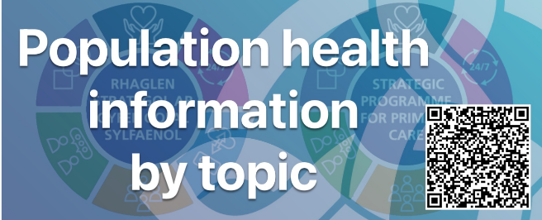
- Population Health Information by Topic Tool - Created by Primary Care Division, Public Health Wales providing information and offers a public health perspective about selected health priorities for cluster populations. It emphasises the primacy of prevention and takes a topic/ condition-based approach to considering population needs which can be used to inform needs assessments and local planning.


- Cluster population profiles - Published in 2013 and updated during 2023, the Public Health Wales Observatory has produced a set of profiles which provide information on a number of key indicators to support the development of clusters. The profiles also contain information on recorded disease burden and age adjusted variation for a number of chronic conditions.

Prioritising need and cluster planning

The best way to prioritise the areas of need is through cluster planning. Clusters are required to submit annual Cluster Plans according to the NHS Wales Planning Framework. Cluster plans should reflect the priorities identified to meet the population need according to any local assessments delivered through implementation of the Primary Care Model for Wales.

Cluster plans should inform the Pan Cluster Planning Group plans and priorities, the health board Integrated Medium Term Plans (IMTPs) and vice versa and should align to the RPB Population Needs assessment and PSB Wellbeing Assessments.
The Cluster Planning Support Portal provides further information about planning in general and specifically cluster planning.

Section C: Tools and techniques to help you as a leader

Agenda setting

Although it appears formal, it may be a good idea to set an agenda for any cluster or collaborative meetings you are chairing or organising.

The agenda tells the participants who are attending what to expect during a meeting and how they can prepare for it. It can also help to keep the meeting on track and to time. It allows you to focus on the meeting’s purpose, assign tasks or items to group members, and plan for a realistic amount of time to each agenda item. A great meeting agenda maximizes the meeting’s effectiveness and keeps your team on track.

Some Chair’s call for agenda items in advance of the meeting and allow time to discuss the topics that have been put forward by group members. This can sometime help to facilitate engagement of the group members.

A typical agenda may include the following:

AGENDA
Date, time and venue of the meeting (or link if virtual)

Time | Agenda item | Lead
9.00am | Welcome and introductions | Chair
9.05am | Apologies | Secretariat
9.10am | Agenda item 1 …….(for discussion) | Member
TBC | Agenda item 2 …….(for decision) | Member
TBC | Agenda item 3 …….(for action) | Member
TBC | Review of actions from previous meeting | Chair
TBC | Any other business | All
 | Close | Chair

Top Tips to agenda setting

- Allow enough time for each item on your agenda.
- Confirm with any speakers they are happy to lead that agenda item.
- Share the meeting agenda as early as possible before the meeting time. This allows everyone to prepare for what’s going to happen.
- Send papers or link to any relevant pre-reading materials in advance.
- Define and prioritise the agenda items: for information, discussion or decision.
- Stick to the agenda.

Chairing meetings

As a Cluster Lead or a Professional Collaborative Lead, it is usually expected that you will Chair the meeting. It is worth planning ahead of the meeting, from the venue and room set up to how to manage the meeting and encourage everyone to contribute, how to take decisions and which rules you need to adhere to.

This section will provide some tips on how to get the best out of the limited time during meetings by good preparation before, effective chairing during and following up actions after the meeting.

Tips when holding meetings
Before
- Have a process for seeking agenda items from members.
- Clarify the meeting’s objectives & prepare agenda.
- Check that the right people are invited.
- Make sure that equipment needed for the meeting is set up and available.
- Decide the setup of the meeting room and where visitors will sit.
- Decide if notes are to be taken and who will be writing these.
- Check enough members are present for decisions to be made.
- Prepare yourself by knowing about the purpose of each agenda item.
- Where possible, circulate relevant documents in advance.
- Prepare by knowing who can contribute to the discussions, how and when.
During
- Arrive early to check the room.
- Create a good first impression, welcome people and clarify everyone’s role.
- Establish any ground rules.
- Steer discussions in a structured way and manage the time and the personalities.
- Encourage different views and opinions.
- Summarise discussions and any decisions made after each agenda item.
- Thank everyone for their contributions.
- Agree details for any follow up meetings.
- Finish the meeting on time.
After
- Ensure that the meeting notes or minutes record the key decisions and actions.
- Make sure that any meeting notes or minutes are circulated to participants and anyone else who needs to know what was decided.
- Check progress on any actions agreed at the meeting

(Note: the suggestions in the table above can be applied to any meeting scenario by any person(s) and not just specifically for cluster or collaborative meetings)

A record of the meetings

It is good practice to make a record of what was discussed and agreed at meetings. This is particularly relevant where independent contractor contracts require evidence of attendance at cluster /collaborative meetings for remuneration.

Firstly it is necessary to record who was present in the meeting, who chaired the meeting and any apologies given. Then you need to record the discussions and any actions. There are numerous ways to do this.

- If the meeting is virtual, with the consent of members, you could record the meeting e.g via TEAMS. Beware the recording will only be available for a limited period of time unless saved somewhere other than the TEAMS channel.

- Formal minutes – Some meetings require formal written minutes. For further information about formal minute taking see here.

- Verbatim minutes are a word for word written transcript of who said what during the meeting. They are often lengthy and difficult to read and are rarely used unless required by law or very formal meetings. Verbatim minutes are probably not suited to capture cluster and collaborative meeting proceedings.

- Meeting notes. These tend to be chattier and less official than formal minutes. They tend to contain more bullets points and abbreviations.

- Some meetings only require action notes which can be a simple bullet point list of actions agreed by who and when or can be presented as an action log using word or excel. This tends to be a project management tool and would typically contain the following:

Action Ref | Meeting Date | Action | Lead | Status | Progress
1 | 01/01/2023 | Agree cluster plans | All | Open | Awaiting……

- It may be a good idea to find a set of notes that have been written for a different purpose that are suitable and copy the intended format for the notes of your meeting.

Developing yourself as a leader

A Healthier Wales, the long-term vision and plan for a whole system approach to health and social care suggests the need for stronger leadership to enable the full potential of the integrated system and planning approach proposed. Cluster and Professional Collaborative Leads play a key role in leading this agenda.

Health Education and Improvement Wales (HEIW) through its Gwella Leadership Portal provide a variety of leadership development resources and programmes.

There are a variety of ways individuals can develop their leadership skills such as attending taught courses, self-directed learning and experiential learning.

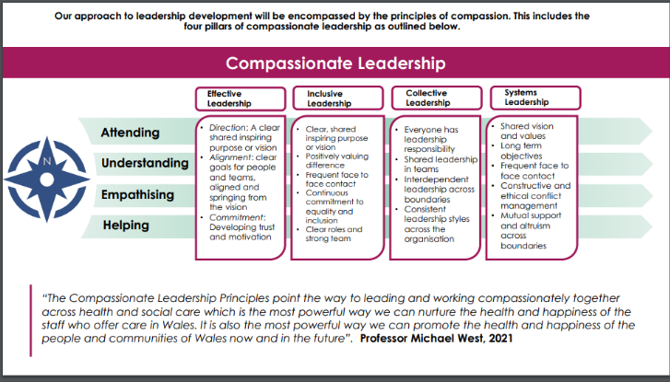
Compassionate leadership describes four leadership behaviours of:
- Effective leadership
- Inclusive leadership
- Collective leadership
- Systems leadership
Aligned to four leadership principles of
- Attending
- Understanding
- Empathising, and
- Helping
Sometimes it is helpful to explore your development with others such as a coach, mentor or peer network. This may offer you a safe, confidential space to explore possible issues, difficulties and questions you face and identify solutions quicker and more efficiently than you might be able to achieve on your own.

- A coach will facilitate your learning, development and performance.
- A mentor is usually a more experienced colleague that has the knowledge and understanding of the work or workplace to support your development.
- Peer support networks can also serve as a useful forum to share and learn with others in a similar role to yourself to help you develop your leadership skills.
For information about how to find or become a coach or mentor:
- Wales Coaching Network hosted by Academi Wales
- Your health board may have a mentoring scheme in place.

Principles of team working

As the leader, it is likely you are a part of a number of teams, some of which may include your own practice, within your local health board, your professional collaborative and / or your cluster. On an individual basis, colleagues may possess unique skills and knowledge which are valuable. When different skills and knowledge are combined and individuals start to work together in pursuit of a common goal/objective, then the real benefits of team working can be seen.

The theory of team development has been described in four key stages illustrated in figure 2 (Tuckman 1965).

Figure 2 – Stages of team development

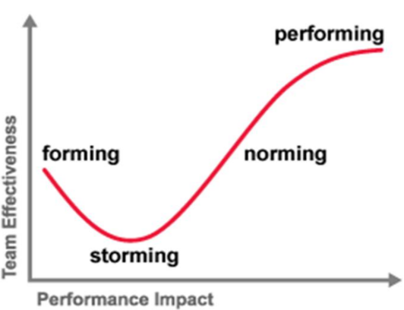

In order for a team to be most effective it needs to reach the ‘performing’ stage.

The various stages are described in more detail below and overleaf:

Forming – getting to know each other
The goal at the end of the forming stage is to have a team that is comfortable with one another and excited to begin work on a project.

Can occur when new team forms or new team member joins an existing team. Individuals will be unsure of:

- The team's purpose
- How they fit in, their role, their work clarified
- Whether they'll work well with one another.

This may take some time, as people get to know their new colleagues and ways of working.

Storming - working together to come up with ideas
Brainstorming

- Puts the team to the test
- May cause a lot of tension if people disagree
- People start to push against the established boundaries and question
- Conflict or friction can also arise between team members

True characters come through and individual’s preferred ways of working start to surface and sometimes may clash.

Norming - learned how to work together, creating a sense of normalcy.
Norming is a great stage for a team, since many barriers will have been broken down and the team can really start working in harmony.

Team members are adjusting to each other

- Settling into their roles
- There will be a lot less arguing and planning
- More working with one another.
- Friendships will be formed in this stage as well.

Performing - at peak efficiency
Performing is also the final stage of forming teams. At the end of the performing stage, the task assigned to the team will be completed.

- Team members have all learned each other’s strengths and weaknesses
- Use this knowledge to everyone’s advantage.

Every member of the team knows their role and is able to complete their tasks efficiently

This is a final stage known as ‘adjourning’ that was introduced by then PhD student Mary Ann Jensen 1977, she added the last stage.

Adjourning
Encourages teams to reflect on their past projects together, discuss their strengths and weaknesses and make plans for improvement in the future – can sometimes mean the end of the project.

In order for clusters and professional collaboratives to be performing as a team, there has to be a clear purpose from the start and an understanding of everyone’s role within the team.
There are a variety of resources available online that describe in further detail each stage.
An example is available here.

Managing change

Change is the act or process through which something becomes different: it can be planned or unplanned, immediate or phased, optional or not. The process of moving from the old to the new is referred to as transition and can be considered in both the physical and psychological sense.
Figure 3 – Kubler-Ross curve

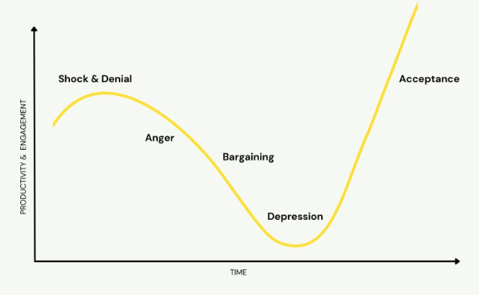
The Kubler-Ross change curve describes a five stage change model of:

- Denial
- Anger
- Bargaining
- Depression
- Acceptance
This was initially developed in 1969 to explain an individual’s normal response to death and grief. This has since been used to understand normal reactions to change and use to help change management in the work place in its broader sense. In line with our emotional or psychological response to change, there will be differing paces at which we move between the stages. Some people will move quickly, others less so and some may struggle with letting go at all. Acknowledging this and employing strategies to support and help will be essential in managing and/or delivering change.

The way in which individuals respond to a change can depend on how they are personally impacted by it and whether the brain perceives a threat or reward. The SCARF Model is a good resource for understanding the brain’s response to change.

- Status: Our relative importance to others
- Certainty: Our being able to predict the future
- Autonomy: Our sense of control over events
- Relatedness: Our sense of safety with others
- Fairness: Our perception of fair exchanges between people
For further information:
- Kubler-Ross Change Curve
- SCARF Model

Nolan principles

Otherwise known as The Seven Principles of Public Life, the Nolan Principles outline the ethical standards expected of anyone working in the public sector. They were first set out by Lord Nolan in 1995 and introduced by the UK government, Committee on Standards in Public Life the same year. The principles are:

- Selflessness: Holders of public office should act solely in terms of the public interest. They should not do so in order to gain financial or other benefits for themselves, their family or their friends.

- Integrity: Holders of public office should not place themselves under any financial or other obligation to outside individuals or organisations that might seek to influence them in the performance of their official duties.

- Objectivity: In carrying out public business, including making public appointments, awarding contracts, or recommending individuals for rewards and benefits, holders of public office should make choices on merit.

- Accountability: Holders of public office are accountable for their decisions and actions to the public and must submit themselves to whatever scrutiny is appropriate to their office.

- Openness: Holders of public office should be as open as possible about all the decisions and actions that they take. They should give reasons for their decisions and restrict information only when the wider public interest clearly demands.

- Honesty: Holders of public office have a duty to declare any private interests relating to their public duties and to take steps to resolve any conflicts arising in a way that protects the public interest.

- Leadership: Holders of public office should promote and support these principles by leadership and example.
These apply to anyone elected or appointed to public office, Civil Service, local government, the police, courts and probation services, non-departmental public bodies, and in the health, education, social and care services.
For further information:
- The Good Governance Pocket Guide for NHS Wales Boards, Academi Wales P.10
- The Seven Principles of Public Life

Business cases

A business case is the way you prove to the person or organisation you are asking for investment from that the product or project you are pitching is a sound investment. Across NHS Wales, it is commonplace for health boards and other stakeholders to require a written bid or business case proposal before committing resources.
The term bid or business case tends to be used interchangeably and the format and the detail they contain will vary depending on who the audience for the bid or business case is.
A business case can be simple or complex. Some people present business cases using visual presentations or video, but usually cluster bids tend to be focused on the basic documentation.
Two tips in writing a business case:
Tip 1
Before you start, check with the stakeholder if they have a standard template for you to use or if the bid or business case needs to follow a particular format or contain specific information.

This will save you valuable time trying to identify information not required by the person reading the business case.

Tip 2
Tell a story. The facts and numbers are important but what will really connect with your audience on an emotional level is the story.

Emphasise the need. Refer to user feedback or patient stories to bring the case to life and make it real.

This may be in person when introducing your proposal or in writing as part of the documentation.

For some professional service specification developments there is a requirement to negotiate with the relevant contractor representative organisation e.g GPC Wales, Community Pharmacy Wales and Optometry Wales.

Generally when writing the proposal (business case) consider the following:

- What is your case?
- The justification for the investment
- Describe the problem you are trying to address
- Support with any evidence or data to date to back this up
- How does this link to the stakeholders priorities/align with policy?
- Give options and possible solutions
- Include any options for addressing the problem / need
- Describe what some of the solutions might look like
- What would happen if nothing was done and no investment was made?
- List expected impact and benefits
- What will be the impact of your proposal?
- What positive outcomes might be expected?
- Are there benefits that will be realised elsewhere?
- How could you quantify these?
- Is there published evidence to back up your claims?
- The project and its risks
- What is the scope of the proposal?
- What will the main goal be?
- How long will it take to accomplish it?
- What actions are included in achieving the goal? Which are excluded?
- What are the risks of taking on this work, include opportunistic costs?
- Does the benefit outweigh the risk?
- Describe resources required
- What resources are being requested and are these labour or capital investment?
- Are you asking for all the resources or will some come from other sources?
- What amount of money will go to each resource needed?
- What’s the lowest vs the highest resource required?
- Address where you expect the funds to come from?
6. Outline a project plan
- Overall goal/aim: clear and direct connection to your problem
- Objectives: SMART (specific, measurable, achievable, relevant, timely)
- Scope: a bit more detail on boundaries. What’s in and what’s not?
- Scheduling: your proposed timeline
- Deliverables: tangibles, what are the final impact / product expected?
- Milestones: are there phases? What needs to be done at each phase? Measures: how will we measure success of each deliverable?
- Communication: how and who are you going to communicate with?
- Staff: who is involved and actively working on the project?
- Dependencies: what are the dependencies of the tasks in our project?
- Budget: an estimate breakdown of costs
- The Executive Summary
- It goes first in the documentation but write it last
- Should be a one page summary of the proposal
- Think of your ‘elevator pitch’ on paper, or a cover letter for your C.V.
- The simplest is to give quick summaries of the problem, solution, cost, benefits and any potential return, timeframe and who is involved
- Finally
- Use the right medium: think about slides, infographics and other visuals.
- Go back through each part of your proposal and reference this need often.
- Plan some likely questions: prepare your answers with statistics and facts.

Project Management

A project is temporary; it should have a defined beginning and end. A project is a series of interrelated activities undertaken to achieve a specific result within a set time frame and budget.

Projects, regardless of topic all have common characteristics, namely they:
- are unique and not part of ‘business as usual’ processes
- are temporary with a defined start, duration and finish
- consist of a series of pre-defined activities designed to deliver a service
- use pre-defined resources
- deliver change
- carry risk
Typically, projects have five key stages:

Each stage should be underpinned with project management documentation tailored to suit the specific project.

A simple project would typically include:
- plan on a page
- project brief
- project structure
- project initiation document (including a project schedule and risks/issues log)
- progress and/or exception reports
- closure report (including any evaluation, lessons learned and follow on actions)

More complex projects may also require:
- business case
- communications plan
- stakeholder map
- equality & health impact assessments
- decisions log
- risk log
- project board reports
- gateway reviews
- benefits review

Further information on each of the stages and a variety of templates are available in the Project Management Toolkit designed to support cluster and collaborative working.

Measuring success and evaluation

Measuring success is important for the following reasons:

- To assess whether a project has achieved its intended goals
- To understand how the project has achieved its intended purpose, or why it may not have
- To identify how efficient the project was in converting resources into activities, objectives and goals
- To assess how sustainable and meaningful the project was for participants
- To inform decision makers to build on, improve or discontinue a project

A simple representation of the evaluation process is illustrated below:

What would good look like? What is it you are trying to achieve?
So what?
How will findings be shared?
Skills required, timescales, resources, specialist support
What evidence & data is needed and is available? Any special research processes?
Qualitative, quantitative, economic, formative or summative?
What is the evaluation question?

Economic evaluation is also often used to assess a project’s or intervention’s value for money or return on investment.
Although evaluation is often thought of as an activity at the end of a project, it is important to start thinking and planning for evaluation at the earliest opportunity, usually at the design stage and very beginning of the project.
As clusters test new ways of working, evaluation provides a means to ensure identify benefits and allows you to decide whether to continue, improve or stop something you are introducing or implementing. Evaluation is vital in demonstrating cluster working, safety, effectiveness, equity of services and value for money and is critical when seeking funds for continuation or mainstreaming of services.

The following stages will help to shape the evaluation:
Stage | Example
- Identify the context | What is the evaluation question?  Can you describe the situation/problem?  What is the activity/population need/diagnosis?
- Identify the outcome(s) and/or benefit(s) | What is it you want to evaluate?  What are the most important/relevant activities /benefits/outcomes that can be attributed to the intervention?
- Measurement of outcome(s) and/or benefit(s) | How can you demonstrate success?  What data do you need?  Can you define the activities/benefits/outcomes and are they measurable?
- Re-measurement | When can and should you evaluate?  Can you gather information of the activities/benefits/outcomes over time, person and place?

To evaluate a project, it is helpful to have an agreed reference to measure success. A visual representation of the planned activities, outputs and expected results can help you think through the evaluation. One of the simplest types and commonly used frameworks is a logic model. An example of a Logic Model Framework is shown below:

Input | Activities | Outputs | Outcomes | Impact
Resources e.g. material, people, time | If you have access to the resources then what activities are planned to be undertaken? | If you accomplish your planned activities, what will be delivered the amount of product/ service intended and to who? | If you accomplish your planned activities then what difference will the project make and what will be the benefits in the short, medium and long term? | If these benefits are achieved then certain changes and impacts will occur

Further information available:
- Accelerated Cluster Development Toolkit. 7. Evaluation
- Data Cymru has developed an online Introductory Guide to Evaluation.
- Evaluation resources prepared by the Primary & Community Care Development & Innovation Hub are hosted on Primary Care One here and here.

Quality improvement

There are many definitions of Quality Improvement (QI). It may be helpful to think of QI as a set of principles to enable a systematic continuous approach that aims to identify and overcome problems in healthcare, improve service provision, and provide better outcomes for patients.

Training in this method is delivered throughout Wales and can be accessed via the health board or via the national Improvement Cymru programme.

The six dimensions of quality can be described as STEEEP:

- S - Safe,
- T - Timely
- E - Effective
- E – Efficient
- E – Equitable
- P - Person centred
The main principles underpinning QI include:
- Understanding the problem(s)
- Designing improvement intervention(s)
- Collecting data and measures for improvement
- Improving reliability
- Understanding variation, demand, capacity and flow
- Involving and engaging staff
- Co-producing improvement
Many of today’s QI approaches and methods were originally developed in industry in 1920, 40’s and 50’s and have been adapted for use in other sectors, such as health care. One approach that is commonly used in healthcare is the Model for Improvement.
The Model for Improvement with PDSA Cycles was developed by Associates in Process Improvement (www.apiweb.org) in 1996, promoted widely by the Institute of Healthcare Improvement and was adopted by NHS Wales as the roadmap and compass to improvement.

Figure 4 – The Model for Improvement
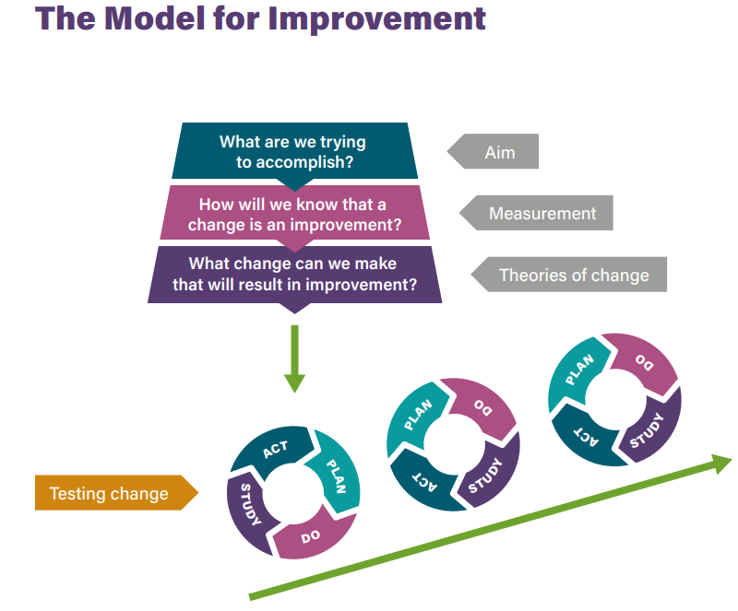

The Model for Improvement with PDSA cycles is structured as two sections:
The first section, framed as 3 questions:

- What are we trying to accomplish?
This is the AIM and provides direction.

- How will we know that a change is an improvement?
These are the MEASURES and describe our current and future position.

- What changes can we make that will result in an improvement?
These are the CHANGES that tell us how we are going to get there.

- The second section involves the testing of improvement activity using PDSA cycles: Plan, Do, Study and Act.
For further information:
- Quality Improvement Made Simple. The Health Foundation.
- Improvement Cymru and Improvement Cymru Academy
- The Quality Improvement Journey Resource Library - Public Health Wales (nhs.wales)

Section D: Who you work with

Health board who’s who

As a Cluster Lead, there are key individuals in your health board area that would be useful to familiarise yourself with or get to know (Figure 4 and 5). These are mainly employees or members of your health board committees but also include people working in your area but employed by other organisations.

Figure 5- Health board persons of interest *

Local Public Health Team
Safeguarding
Team
Medicines Management Team
Primary Care
Team
Cluster Support
Officers

*The chart does not list all the roles within the health board.

Different health boards have different structures. You will find that the hierarchy for the positions in the shaded boxes vary between health boards, nevertheless, there will be people you may wish to get to know or familiarise yourself with.
In every health board area there will be a Cluster Development Manager and/or team as part of the Primary Care Team or Heads of Service Team who will be able to support you. Please contact your health board to identify your Cluster Development Manager/team.

Figure 6: Map of different health board areas and ‘who’s who’ in that area

Betsi Cadwaladr University Health Board
- Board Members & Executive Directors
- Primary Care [no link available]
- Safeguarding
- Local Public Health

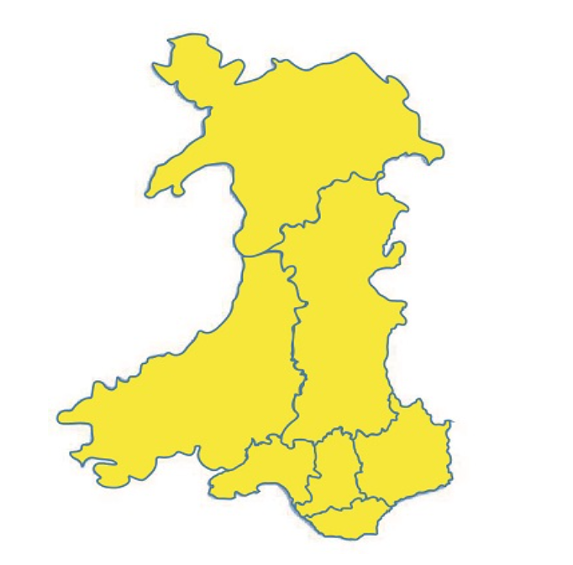
Aneurin Bevan University Health Board
- Board Members
- Primary Care [NHS intranet only]
- Safeguarding [NHS intranet only]
- Local Public Health [no link available]

Hywel Dda University Health Board
- Board Members
- Primary Care [NHS intranet only]
- Safeguarding [NHS intranet only]
- Local Public Health [NHS intranet only]

Swansea Bay University Health Board
- Board Members
- Primary Care [no link available]
- Safeguarding [NHS intranet only]
- Local Public Health

Powys Teaching Health Board
- Board Members
- Primary Care [no link available]
- Safeguarding [NHS intranet only]
- Local Public Health [no link available]

Cardiff and Vale University Health Board
- Board Members
- Primary Care
- Safeguarding Team [no link available]
- Local Public Health

Cwm Taf Morgannwg University Health Board
- Board Members
- Primary Care
- Safeguarding [no link available]
- Local Public Health

Regional Partnership Board

There are seven statutory Regional Partnership Boards (RPBs). Each RPB reflects the health board geographical boundaries and provides leadership to the planning and delivery of integrated health and social services.
Individual RPB information can be found at:
- Cardiff and Vale of Glamorgan Integrated Health and Social Care Partnership
- Cwm Taf Morgannwg (Rhondda Cynon Taf & Merthyr)
- Gwent
- North Wales Social Care and Well-being Improvement Collaborative
- Powys
- West Glamorgan (Neath Port Talbot & Swansea)
- West Wales Care Partnership (Pembrokeshire, Carmarthen and Ceredigion)

Public Service Board

It is also worth finding out details about the Public Service Board (PSB) members covering your area. There are 22 PSBs across Wales aligned to each local authority boundary. They improve joint working across all public services in each local authority area in Wales.
For further information.
- Public Service Boards

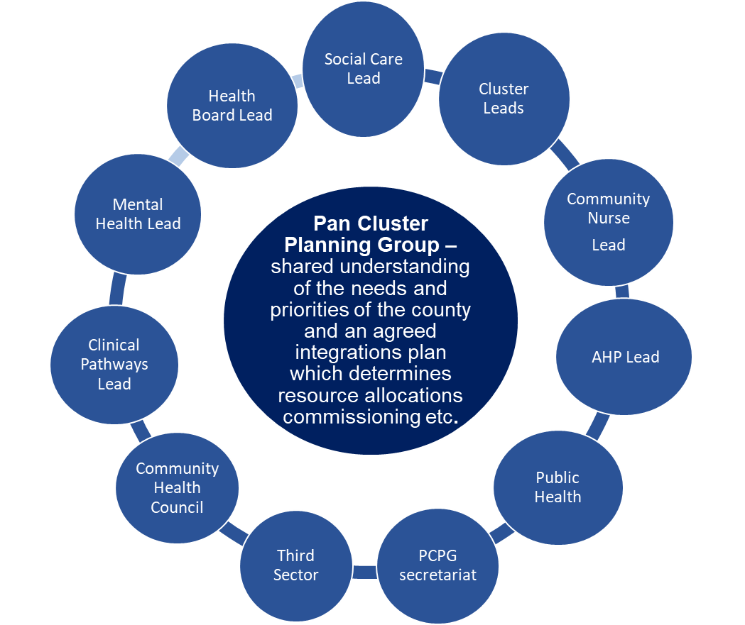
Pan Cluster Planning Groups

Pan Cluster Planning Groups (PCPGs) work at county level to bring together cluster priorities with the decision makers who have statutory responsibility for planning and funding services.

Decision makers will be from the NHS (health board, cluster lead, local authority and key partners in the third sector).

Your PCPG should develop an integrated plan which addresses the

health, care and wellbeing needs of the county population. This should take into account cluster level analysis and priorities. From this, services can be commissioned by the PCPG to deliver innovative outcomes. These may be directly from clusters or delivered on a cluster geographical footprint.

What are professional collaboratives?

Professional collaboratives are networks of professionals working together to use their unique skills to assess the population needs of the population where they work. Usually the collaborative is supported by a professional collaborative lead.

The purpose of the professional collaboratives are to:
- Identify the needs of their population for their area of expertise
- Develop and use quality indicators, professional and public experience to identify service gaps, quality and safety issues of local services
- Develop and prioritise opportunities to improve services
- Share experience and good practice
- Advocate for appropriate provision of care for the most vulnerable
- Respond to national strategic intent and funding opportunities
- Collaborate with each other and with other professions in the planning and delivery of local services, through the cluster

For some independent contractor professions, collaborative working is mandated in their contract e.g General Practice, community pharmacy and optometry.

Professional collaboratives are also being established for professions other than the independent contractors, such as Allied Health Professionals and Nursing.

Support for professional collaborative leads is available from a range of sources:

- Virtual uni-professional online leads networks established by Health Education Improvement Wales (HEIW) via their Gwella platform.

- Guidance and infrastructure developed by contractor bodies e.g. Community Pharmacy Wales facilitate a national group of Community Pharmacy Professional Collaborative Leads. Optometry Wales are looking to provide something similar for Optometry Professional Collaborative Leads.
For further information:
- Professional Collaboratives – ACD Toolkit
- Model Terms of Reference for primary care professional collaboratives
- Gwella professional collaborative networks
- Collaborative Working Scheme Frequently Asked Questions – Community Pharmacy Wales
- Community Pharmacy Collaborative Lead (CPCL) Frequently Asked Questions

Local service providers

It may be useful to understand the range of health and care services that can be provided to the local population from a variety of service providers. These may be public sector (health or social care), independent contractors, third sector agencies or voluntary organisations. All contribute to the Primary Care Model for Wales and have a role in supporting individuals with their health and well-being.

In developing the wider cluster working it is worth finding out what services are available from fellow healthcare professionals and what each independent contractor can offer. There will be a range of services provided as core, advanced, enhanced or extended dependant on the contractor, the contract and what has been commissioned in your area. For example:

- Community pharmacies may be able to offer the following services:
  - Common ailments
  - Smoking cessation
  - Influenza vaccine
  - Emergency contraception
  - Substance misuse
  - Emergency supply
  - Care homes
  - Independent prescribing
  - Others depend on the areas

- Community dental practices may be able to offer:
  - Urgent treatment
  - Non-urgent treatment
  - Patients with special dental needs

- Optometry practices may be able to offer:
  - Low Vision Services
  - Eye Health Examinations
  - Glaucoma services
  - Others depend on the areas

- General practices offer a range of additional clinical services.
The Professional Collaborative Lead should be able to inform you about the different services available.

Expanding the portfolios and the services offered by the local contractor professions and others means that patients may not need to visit the GP Practice if their condition or ailment can be managed elsewhere in primary care. Familiarising yourself with what is available locally and signposting patients is key to helping people choose the right health service for their needs.
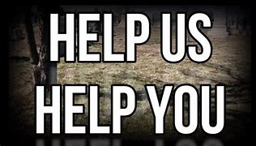
The Help Us Help You campaign encourages people to think and pick the right health service for their illness or injury to get the right care, in the right place, first time.

Further details of the services available can be found at:
- Help Us Help You – Local Services
- Community Pharmacy Wales
- Welsh Eye Care Service
- NHS Dental Services

Cluster based staff

Over the years both clinical and not clinical staff have been employed to provide services or support cluster development. Often the member of staff is employed by the health board from health board resources and allocated for cluster work. This may be in one cluster or across clusters. Other models involve the employment of staff from cluster funds and work directly with a cluster.

There has been a significant increase in MDT working in the last 20 years in various clinical areas and settings. There are many examples of the expanding roles and their contribution to MDT working in and outside of Wales.

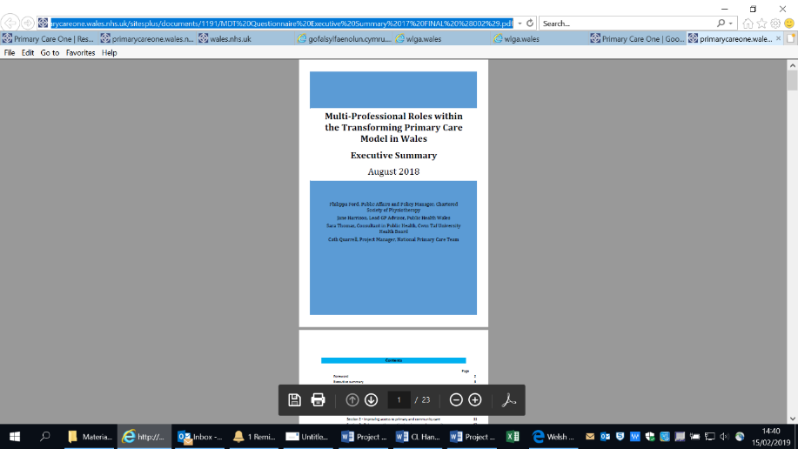
The potential that the wider MDT in Wales can offer to transforming care, treatment and access to services was reported in a survey Multi-Professional Roles within the Transforming Primary Care Model in Wales (2018).

The report highlights key messages and learning for anyone developing MDT working plus recommendations of how to embed MDT working.

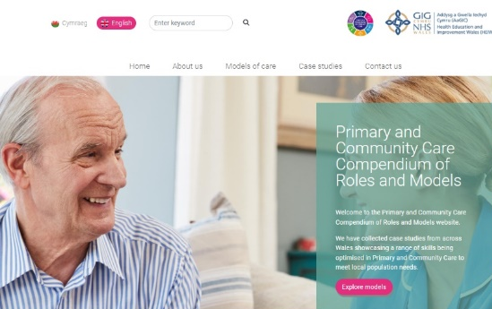
The Primary and Community Care Compendium of Roles and Models resource provides examples of different models of care and a collection of case studies from across Wales. It showcases a range of skills being optimised in Primary and Community Care to meet local population need.

As clusters are not legal entities, direct employment of members of staff and multi-disciplinary teams to work across the cluster footprint can prove challenging. Several different employment options are emerging, enabling the recruitment of staff to work across all practices in the cluster and in the wider community. In some way these provide a greater flexibility in terms of employment for both GPs and the wider primary care team such as pharmacists, physiotherapists and advanced paramedics. These employment options vary between clusters and health board areas and all carry some element of responsibility and risk.

Examples include:

- Health board directly employed staff
- Staff employed by one practice on behalf of all the practices
- Alternative models, such as federations of practices within, or between, cluster networks or establishing the cluster as charitable status

It is important to understand the responsibilities of the employer and the rights of the people employed such as working hours, continuous service, types of contracts, pensions and paid leave etc. The employment status helps determine the rights and the employer’s responsibilities.

The type of rights that may need to be considered includes the following:

- Statutory Sick Pay
- Statutory maternity, paternity, adoption and shared parental leave and pay (workers only get pay, not leave)
- Minimum notice periods if their employment will be ending, for example, if an employer is dismissing them
- Protection against unfair dismissal
- The right to request flexible working
- Time off for emergencies
- Statutory Redundancy Pay

Some rights require a minimum length of continuous employment before an employee qualifies for them. An employment contract may state how long this qualification period is. Within the NHS this qualifying period tends to be two years. This is important if employing staff on short term contracts that are continuously renewed. Potentially staff may be eligible for continuous employment rights and claims for unfair dismissal if the contract is terminated a two-year time period.
Further information about employing cluster staff can be found at GOV.UK.

Information governance

As new models of care emerge and collaborative working becomes the norm in primary care, it is likely that GP clinical systems are being accessed and used by a range of health professionals not employed by the practice for the purpose of providing direct care. It is imperative therefore that everyone is aware of their legal responsibilities regarding information handling.

Information governance focuses on ensuring that information is handled in a confidential and secure manner. It is a framework that brings together legal, ethical and quality standards that apply to the handling of information. It applies to sensitive and personal information of both employees and patients. All staff have a responsibility regarding the security of information they access, use and store.
In addition, please refer to your own health board website for further information about information governance.
For further information:
- Information Governance - NHS Wales Shared Services Partnership

Cluster Maturity Matrix

The maturity matrix was first developed in 2019 and is the agreed approach, to measure the maturity of cluster working against the components of the Primary Care Model for Wales. A review and refresh of the 2019 maturity matrix is underway (Summer 2023). It will incorporate each of the 13 Primary Care Model for Wales outcomes, has three levels of maturity.

- Level one is foundation maturity,
- Level two is developing maturity
- Level three is mature

Using the matrix, clusters can identify areas for development and actions necessary to achieve sustainable and accessible local health and well-being care in their area.

In order, to assess Cluster maturity and the journey towards achieving the Primary Care Model for Wales, a unified approach to monitoring and evaluating the delivery of the Primary Care Model for Wales was developed.

Once finalised, the cluster maturity matrix will can be accessed via Primary Care One.
Further details of the individual components of the Model can be found here.

Cluster Peer Review

The peer review process was introduced to support the 2022/23 Accelerated Cluster Development (ACD) transition year. A developmental approach to the introduction of peer reviews for clusters was introduced. The intention being that the peer review process would be informed by the experience from the first year of a single cluster review for each health board area.

The process for 2022/23 involved each health board identifying and nominating a single cluster to be engaged in the peer review. The nominated cluster and respective health board agreed who would be participants, including a wide representation of stakeholders and the reviewers of another health board cluster.

The conversation was structured around three outcomes - two of the thirteen Primary Care Model for Wales (PCMW) outcomes and one of the seven ACD outcomes. An independent chair and representative from the Strategic Programme for Primary Care guided the participants and reviewers through the process. The discussions were conducted remotely via Teams.

The peer review process will be put in place for 2023/24 and include a review of the cluster self-reflection tool findings for the respective Health Board area.

The self-reflection tool will be introduced in 2023/24 and will be completed by all 60 clusters in Wales. The clusters will use the tool to self-assess the maturity of cluster working in their area. Each cluster will be asked to rate the level of maturity for two PCMW outcomes and one ACD outcome. These will be the same three outcomes as assigned to their respective health board area, for the peer review process. In addition, clusters will be asked to provide their views on enables and barriers to cluster working and be invited to share examples of good practice.

Acknowledgements

The development of the handbooks has been a collaborative process. We would like to thank everyone who has contributed, authored and provided advice to inform the development of the handbooks.

Disclaimer

We have taken all reasonable steps to identify the sources of information provided above. If you believe any information to be incorrect, would like to make comment or provide input to any revisions of the handbook, please contact primarycare.one@wales.nhs.uk.

