
CLUSTER WORKING IN
WALES

Summary & handbooks content

A set of handbooks for Cluster Leads, Professional Collaborative Leads and other staff working in or with clusters

Updated September 2023



Introduction

This is a Summary & handbooks content for a collection of three CLUSTER WORKING IN WALES Handbooks produced by the Primary and Community Care Development and Innovation Hub, Public Health Wales.

This summary provides an overview of the contents all the set of handbooks. Each handbook has been designed to cover a different theme.

The handbooks as a set of resources

The handbooks provide practical advice for use by anyone new to a cluster or professional collaborative leadership role or anyone who wants to include cluster working as part of their work. The ideas and advice provided outlines a foundation for your cluster work and will give you the basic tools and techniques for working in or with clusters.

These handbooks provide an initial ‘go to’ resource and complement any other resources that may be produced locally or nationally.

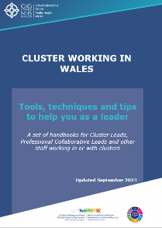
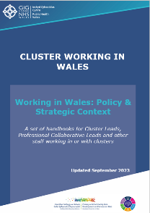
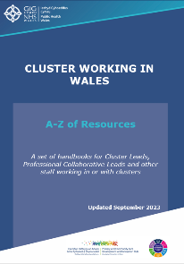
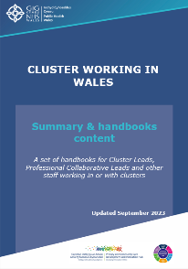

Although separate handbooks, they are designed to be complementary and will be most effective if used collectively. The handbooks provide ideas, give advice and signpost to information and resources for creating the best conditions for cluster working and development.

All handbooks contain hyperlinks which signpost you to further information and resources. To access the hyperlinks, please click on the blue underlined text or image.

To download the handbooks go to Primary Care One.

Handbook themes

Summary & Quick Read Guide
An index of the contents of the 3 handbooks
Provides:
- An overview of all the handbooks.
- A detailed list of the contents of each handbook to help you navigate to. the most relevant section and resource.

A-Z of resources
Summaries of key policy and strategies influencing health & wellbeing in Wales
Provides:
- An image of each publication, resource or tool.
- A short description about each resource.
- A link is to the full resource or document.

Working in Wales: Policy & Strategic Context
Describes the political and strategic landscape of Wales

Provides:
- Details about policy, strategy, and governance of the health & care system relevant to primary care.
- Information about structures & responsibilities for health, wellbeing & care in Wales.
- Details about organisations supporting primary care and services primary health and care providers in Wales offer.

Tools, techniques and tips to help you as a leader
Contains range of ideas, tips, basic information and signposting to a variety of resources to help you develop yourself and lead
Provides:
- General information about clusters.
- Tools to help how you work.
- Information, ideas and techniques to help you as a leader including a collection of resources to support your cluster work from project management, writing business cases to information governance.
- Ideas of how to find out and understand who you work with.

Summary of handbook contents

A-Z Resources
- Approximately 50 resources relevant to primary care and cluster development in Wales
Working in Wales: Policy and strategic context
Section A: National structure
- Working with the UK Government
- Senedd Cymru
- Welsh Government
- NHS Wales Executive
- Strategic Programme for Primary Care
- National supporting organisations
- Special Health Authorities
- All Wales NHS Trusts
- Special Health Authorities
- Other organisations with a national supporting role
- Online health and well-being information services
- Inspection and regulation bodies
Section B: Local delivery
- NHS Wales
- Health Boards
- Local authorities
- Primary care clusters
- Structure of clusters
- Background to clusters
- The Accelerated Cluster Development programme
- Accelerated Cluster Development Timeline
- Health & care providers in Wales
- Primary care independent contractors
- Out of hours services
- Urgent Primary Care
- Hospitals
- Local Authorities
- The Third Sector
- Citizens Advice Body – Llais
Section C: Mechanisms for collaborative planning and for integrated delivery
- Regional Partnership Boards
- Public Service Boards
- Pan Cluster Planning Groups
- Health Boards
- Clusters

Tools, techniques and tips to help you as a leader
Section A: General information about clusters
- What are clusters?
- What is Accelerated Cluster Development (ACD)?
- How much funding is available to clusters?
- Cluster meetings
- Cluster governance
Section B: How you work
- What is the Primary Care Model for Wales?
- All about population need and local priorities
- Prioritising need and cluster planning
Section C: Tools and techniques to help you as a leader
- Agenda setting
- Chairing meetings
- A record of the meetings
- Developing yourself as a leader
- Principles of team working
- Managing change
- Nolan principles
- Business cases
- Project Management
- Measuring success and evaluation
- Quality improvement
Section D: Who you work with
- Health board who’s who
- Regional Partnership Board
- Public Service Board
- Pan Cluster Planning Groups
- What are professional collaboratives?
- Local service providers
- Cluster based staff
- Information governance
- Cluster Maturity

Disclaimer

We have taken all reasonable steps to identify the sources of information provided above. If you believe any information to be incorrect, would like to make comment or provide input to any revisions of the handbook, please contact primarycare.one@wales.nhs.uk.

