
CLUSTER WORKING IN
WALES

Working in Wales: Policy & Strategic Context

A set of handbooks for Cluster Leads, Professional Collaborative Leads and other staff working in or with clusters

Updated September 2023



Contents

Section A: National structure 4
Working with the UK Government 4
Senedd Cymru 4
Welsh Government 5
NHS Wales Executive 6
Strategic Programme for Primary Care 6
National supporting organisations 8
Special Health Authorities 8
All Wales NHS Trusts 8
Other organisations with a national supporting role 9
Online health and well-being information services 9
Inspection and regulation bodies 10

Section B: Local delivery 11
NHS Wales 11
Health Boards 11
Local Authorities 11
Primary care clusters 12
Structure of clusters 12
Background to clusters 13
The Accelerated Cluster Development programme 14
Accelerated Cluster Development Timeline 15
Health & care providers in Wales 16
Primary care independent contractors 16
Out of hours services 17
Urgent Primary Care 17
Hospitals 18
Local Authorities 18
The Third Sector 19
Citizens Advice Body - Llais 19

Section C: Mechanisms for collaborative planning and for integrated delivery 20
Regional Partnership Boards 20
Public Service Boards 20
Pan Cluster Planning Groups 21
Health Boards 22
Clusters 22

Introduction

This is the Working in Wales: Policy & Strategic Context handbook of a collection of CLUSTER WORKING IN WALES Handbooks, produced by the Primary and Community Care Development and Innovation Hub, Public Health Wales.

This handbook provides a summary of the policy and strategic landscape in Wales which may be helpful to you in developing your cluster or professional collaborative. It consist of three sections:

Section A: National structure
- Section B: Local delivery
- Section C: Mechanisms for collaborative planning and for integrated delivery

The handbooks as a set of resources

The handbooks provide practical advice for use by anyone new to a cluster or professional collaborative leadership role or anyone who wants to include cluster working as part of their work. The ideas and advice provided outlines a foundation for your cluster work and will give you the basic tools and techniques for working in or with clusters.

These handbooks provide an initial ‘go to’ resource and complement any other resources that may be produced locally or nationally.

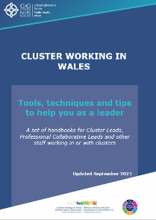
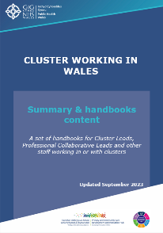
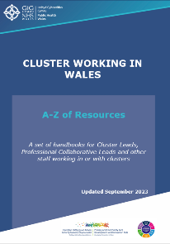
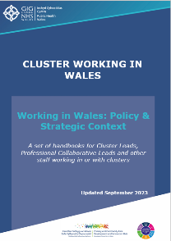

Although presented as separate handbooks, they are designed to be complementary to each other and will be most effective if used collectively.

All handbooks contain hyperlinks which signposts you to further information and
resources. To download the handbooks go to Primary Care One.

Key policy and strategies

A brief summary of the key policies and strategies that have guided developments in primary care over recent years is available in the CLUSTER WORKING IN WALES Handbook - Summary & quick read guide.

Section A: National structure

Working with the UK Government

Despite powers vested in the Senedd, otherwise known as the Welsh Parliament, the UK Government maintains an influence over Welsh affairs. By agreement, it does not usually legislate on devolved matters. In relation to the health system, examples of areas which are not devolved include; relations with the EU, regulation of doctors or dentists, and the health and safety of medicines.

For further information click here.

Senedd Cymru


Senedd Cymru consists of 60 Members made up of 40 constituency Members and 20 regional Members. Each person in Wales is represented by five Members of the Senedd, one for the local area and four for the region.

The 40 constituency Members represent the same local constituencies whilst the other 20 regional Members represent one of the five regions of Wales, North Wales, Mid and West Wales, South Wales West, South Wales Central, South Wales East.

The Senedd oversees and scrutinises Welsh Government policy and performance, agrees the taxes set in Wales and has the right to pass laws it has responsibility for (known as Acts of the Senedd). The Senedd can make laws for Wales for matters relating to health and health services (excluding the areas reserved for UK law). The relationship between the Senedd and other parts of the health system in Wales is illustrated in Figure 1.

For further information about Senedd business, the role and how the Senedd works click here.

Figure 1: The structure of healthcare in Wales

Welsh Government
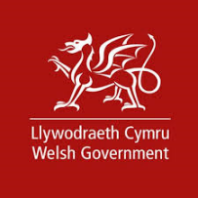
The Welsh Government is the devolved Government for Wales. It consists of the First Minister, Welsh Ministers and the Counsel General, who are supported by civil servants working across devolved areas. Health is a devolved area. To find out other areas that are devolved click here.

The Minister for Health and Social Services is responsible for the health portfolio and is held to account by the Senedd, and the Health and Social Care Committee.

NHS Wales Executive

The NHS Wales Executive operates a hybrid model between Welsh Government and NHS Wales rather than a standalone organisation. It comprises of a small Welsh Government team, the NHS Wales Health Collaborative, NHS Wales Finance Delivery Unit, NHS Wales Delivery Unit and NHS Wales Improvement Cymru. Its function is to provide leadership and strategic direction to enable support and direct NHS organisations to deliver national priorities and standards, and safeguard and improve the quality and safety of care.

The National Primary Care Board

The Board is responsible for overseeing and monitoring the programmes of work to support the transformation of primary care.

Accountable to the NHS Wales Leadership Board and chaired by a Health Board Chief Executive for Primary Care, the purpose of the Board is to provide a strong collaborative mechanism to steer the implementation of the Primary Care Model for Wales.

Strategic Programme for Primary Care
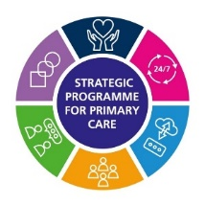
The Strategic Programme for Primary Care (SPPC) was established in November 2018 in response to the 2018 Parliamentary Review of Health and Social Care in Wales report and subsequently the A Healthier Wales: our Plan for Health and Social Care report.

The aim of the programme is to establish specific, All Wales primary care work. This is currently achieved through a set of six key work streams (2023).

Work stream 1: Prevention and Wellbeing

Work stream 2: 24/7 Model

Work stream 3: Data and Digital Technology

Work stream 4: Workforce and Organisational Development

Work stream 5: Communication and Engagement

Work stream 6: Transformation and the Vision for Clusters

The work of the SPPC is supported by input from a Primary Care Reference Group and reported to the National Primary Care Board which in turn reports to the NHS Wales Leadership Board. This is illustrated in Figure 2.

Figure 2: Governance of the Strategic Programme for Primary Care

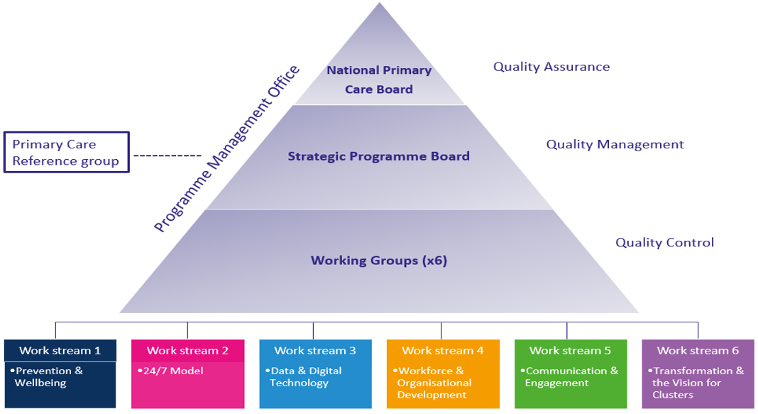
Information about the background to the SPPC can be found here.

Information about the overall programme and details of the work streams can be found here.

National supporting organisations

Special Health Authorities

There are two special health authorities and a number of other Wales-wide organisations that provide national support for health and care in Wales.

- Health Education and Improvement Wales (HEIW) was established in October 2018 bringing together the Wales Deanery; NHS Wales’s Workforce Education and Development Services (WEDS) and the Wales Centre for Pharmacy Professional Education (WCPPE). The Special Health Authority has a leading role in the education, training, development and shaping of the healthcare workforce in Wales, supporting high-quality care for the people of Wales.

- Digital Health and Care Wales (DHCW) was established in 2021 replacing the NHS Wales Informatics Service. DHCW provides the national technology and data services needed by health and care professionals and the people of Wales helping to achieve better health and well-being.

All Wales NHS Trusts

There are currently 3 NHS Trusts in Wales with a national remit:

- The Welsh Ambulance Services Trust (WAST) provides high quality pre-hospital emergency care and treatment throughout Wales, available 24 hours a day, 365 days a year. It operates from 90 ambulance stations, three control centres, three regional offices and four vehicle workshops. WAST also hosts NHS 111 Wales.

- Velindre University NHS Trust provides specialist cancer and blood services across South and Mid Wales through Velindre Cancer Centre and the Welsh Blood Service. The Welsh Blood Service collects voluntary, non-remunerated blood donations from the public whilst Velindre Cancer Centre provides specialist cancer services to over 1.5 million people in South East Wales and beyond.

- Public Health Wales NHS Trust provides professionally independent public health advice and services to protect and improve the health and wellbeing of the population of Wales. Public Health wales also hosts the NHS Wales Executive.

Other organisations with a national supporting role

- All Wales Therapeutics and Toxicology Centre (AWTTC) advises on new medicines, provide guidance on safe, effective and appropriate use of medicines and develops innovative partnerships to help patients in Wales get the best outcomes from their medicines.

- NHS Wales Shared Services Partnership (NHSWSSP) delivers a wide range of professional, technical, and administrative services for and on behalf of NHS Wales also working with the wider public services, including Welsh Government.

- Welsh Health Specialised Services Committee (WHSSC) was established to ensure that the population of Wales has fair and equitable access to the full range of specialised and tertiary services and is responsible for the joint planning of these services on behalf of the seven Local Health Boards in Wales.

- NHS 111 Wales is the amalgamation of NHS Direct Wales and the GP out-of-hours services. The service is free of charge from landlines and mobiles and is available 24 hours a day, seven days a week, for health information and advice and to access urgent primary care. NHS 111 Wales also has an online option where the following can be accessed: free advice via symptom checkers, Health A-Z and Living and Feeling Well, general health information and NHS services such as dentists, pharmacies or local support groups.

Online health and well-being information services

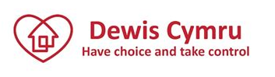
- DEWIS CYMRU - An online directory of well-being services available in Wales. It provides information and advice about well-being and directs users to services that can give help and support. It provides information on a number of areas including: where an individual lives, feeling safe and secure, getting out and about and keeping in touch. It links users to local people and services that can provide help and support.

- INFOENGINE - The directory of third sector services in Wales was established by County Voluntary Councils and Wales Council for Voluntary Action in partnership.

Inspection and regulation bodies

Healthcare is managed and regulated differently in England, Scotland and Wales.

Within Wales, various regulators have powers to secure improvement and/or justice. Some regulators may also have patient/service user safety within their remit. Where regulators do not have these powers, the Health and Safety Executive (HSE) may get involved, investigate or take action.

Within Wales there are two main regulators for health and social care:

- Care Inspectorate Wales (CIW)
- Healthcare Inspectorate Wales (HIW)

Medicines, medical devices, blood and blood products are regulated by the UK wide Medicines and Healthcare Products Regulatory Agency (MHRA).

In addition to these three regulatory bodies, there are a number of professional regulatory bodies which aim to ensure that proper standards are maintained by health and social care professionals.

The roles and links to the health and social care regulators, professional bodies and others can be found here.

Section B: Local delivery

NHS Wales

NHS Wales delivers services locally through seven health boards and the NHS Trusts in Wales.

Health Boards

Established in October 2009, the seven health boards in Wales have a statutory responsibility for the provision of health care services within their area. They are responsible for planning, funding and delivering health care services including primary care such as General Medical Services and services contracted through pharmacies, dentists, optometrists and community services.

Leadership and governance in each health board is provided by a Chairman, a Chief Executive and is supported by an Executive Board comprising of individuals from a range of backgrounds. The Board provides corporate responsibility for all decisions and plays a key role in monitoring the performance of the organisation.
Information about each health board can be found at:

- Aneurin Bevan University Health Board
- Betsi Cadwaladr University Health Board
- Cardiff & Vale University Health Board
- Cwm Taf Morgannwg University Health Board
- Hywel Dda University Health Board
- Powys Teaching Health Board
- Swansea Bay University Health Board

Further information about key roles in each health board is covered in the Who’s who section of the CLUSTER WORKING IN WALES Handbook - Tools, techniques and tips to help you as a leader.

Local Authorities

Providing over 700 services across Wales, local authorities (councils) provide the local leadership and a range of services for their communities. Some are statutory or regulatory which means that they must provide, for example, social care, environmental health inspection, refuse collection and planning.

Others are discretionary, which councils may choose to provide, such as the promotion of tourism, leisure and art centres.

Many of the services provided by local authorities can affect or support both health and the wider determinants of health such as education, housing and social services.

5
For further information
- Local Authorities and the services they provide here.
- Individual Local Authorities click here

Primary care clusters

The concept of primary care clusters, where primary care services are co-ordinated on a geographical locality basis in Wales, was first introduced in 2010.

The current description* of a cluster is as follows:

A cluster brings together all local services involved in health and care across a geographical areas, typically serving a population between 25,000 and 100,000.
Working as a cluster ensures care is better co-ordinated to promote the wellbeing of individuals and communities.

Source: The Strategic Programme for Primary Care, 2018

*Refreshed by the Directors of Primary and Community Care September 2018.

Across Wales, there are 60 primary care clusters. The geographical area and size of the population that a cluster covers is determined by individual local health boards. The number of clusters in each health board area varies e.g. Betsi Cadwaladr University Health Board hosts fourteen clusters with Powys Teaching Health Board only hosting three.
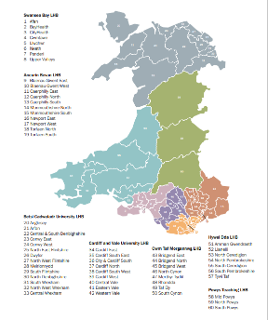
Some health boards have subdivided the clusters further into small or larger localities and given them a variety of titles e.g. Neighbourhood Care Networks in Aneurin Bevan University Health Board.

To view the map of all clusters in Wales click here. Specific detail about individual clusters by health board is available via Find a cluster - Primary Care One.

Background to clusters

2010 Clusters were first established in 2010 in response to the Primary & Community Services Strategic Delivery Programme, Setting the Direction. The intention was for clusters to be used as local planning mechanisms by grouping several adjacent GP practices together to plan services for the specific population registered with them.

2014 Formal arrangements were put in place via the General Medical Services contract to enable GP practices to work collaboratively as clusters to develop services in their locality in April 2014.

Local Health Boards developed formal arrangements for GP practices to work collaboratively as clusters. These became known as GP clusters despite the intention being for a cluster to work with all local services involved in health and care.

At this time no provision was made in the other independent contractor professional contracts to engage or work together on a cluster footprint.

2017 The Health, Social Care and Sport Committee Inquiry into Primary Care Clusters in October 2017, advised the Welsh Government should publish a refreshed model for primary care clusters.

‘Collaborative working’ on a cluster footprint was introduced into the community pharmacy contract.

2018 The new description of a cluster emerges.

2021 Accelerated Cluster Development (ACD) programme established as a result of an All Wales Cluster Survey conducted in December 2020.

2022 Transition year for the revised ACD arrangements to be implemented.

Contract drivers for cluster working were being worked through for the other professional groups during 2022.

The Accelerated Cluster Development programme

The Accelerated Cluster Development programme was established in 2021 to take forward the findings of a cluster survey that was conducted in December 2020.

It was designed to strengthen clinical and community engagement in the planning and delivery arrangements, through a suite of mechanisms and infrastructure improvements. Its aim was to accelerate the wider implementation of successful local projects to meet cluster population health and wellbeing needs.

In most areas, the ACD programme will involve adapting what is already in place.

The programme was designed to achieve the following:

- Clarity of purpose of clusters (planning & delivery).
- Clusters influencing mainstream planning and decision making.
- Bringing Local Authorities and other stakeholders together with clusters.
- Ability to deliver local approaches to HB / RPB strategy.
- To meet cluster population health need through effective and robust planning and service delivery and local flexibility based upon local circumstances.

The programme introduces professional collaboratives and Pan Cluster Planning Groups (PCPGs) to broaden and strengthen clinical engagement and to increase the influence from the community to Regional Partnership Boards, as well as signalling a clearer separation of planning and delivery functions (Figure 3). Professional collaboratives and PCPGs may be given a different titles by different health boards but their core function will be the same.

The ACD does not affect the geographical boundaries of the 60 clusters which will remain as before the introduction of ACD. Some PCPGs however may span more than one local authority or cluster boundary. The boundaries of the PCPGs are determined locally. The footprint of the professional collaboratives may also vary between professionals and locality with many following the geographical footprint of the cluster boundaries.

Figure 3: Architecture underpinning Accelerated Cluster Development
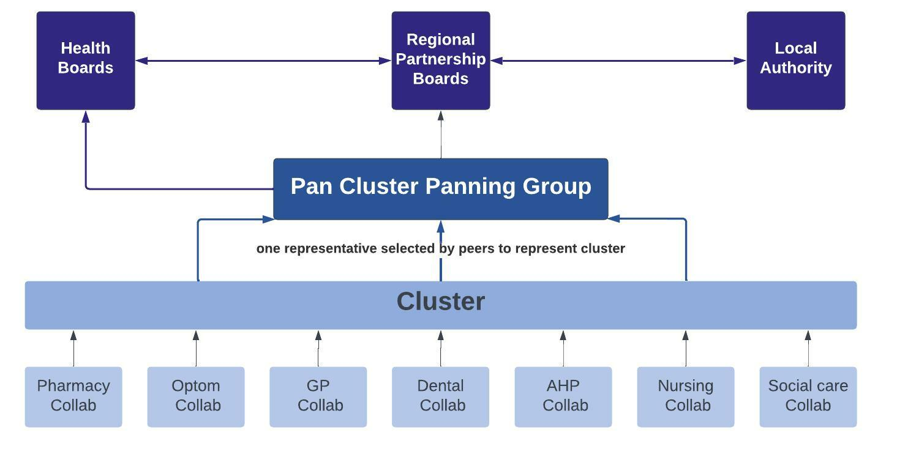
For 2022/23, the ACD programme introduced a Transition Year as health boards put foundations in place for April 2023.

A series of products have been developed to support the ACD programme:
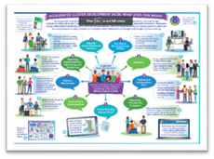
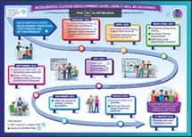
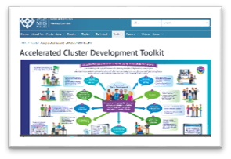
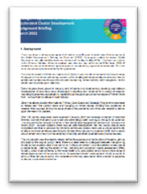

Accelerated Cluster Development Background | Accelerated Cluster Development Toolkit | Accelerated Cluster Development What does it means for me? | Accelerated Cluster Development Timeline

Health & care providers in Wales

Across Wales, care to support health and well-being is provided by a variety of providers. The main providers of care tend to be within the NHS or local authority social services. The third sector (charities, voluntary originations and community agencies) play a vital role in supporting the health and well-being of our population and this role is expanding very quickly with increasing demand on all care providers.

Primary care independent contractors

Primary care services are provided by a wide range of different staff. Some staff groups work as independent contractors, rather than being directly employed by health boards; namely GPs, dentists, community pharmacists and optometrists.

General Practice

 | There are 390 General Practices in Wales providing a range of NHS services according to the General Medical Services (GMS) contract. Annual contract details can be found here.

Dentists
 | NHS General Dental Services (GDS) are provided by 452 Dental Practices in Wales and are outlined by dental regulations in Wales. Changes are being introduced in a step wise approach to the dental contract via the General Dental Services (GDS) Reform Programme for Wales. Designed to Smile works with NHS Dental Practices in Wales to increase dental attendance in early childhood. The Role of the Community Dental Service and Services for Vulnerable People WHC (2019) 021 provides updated guidance on the role of the community dental service to those unable to access GDS services.

Community pharmacists

 | 711 community pharmacies are located across Wales, providing a range of NHS services in accordance with the Presgripsiwn Newydd: A New Prescription contractual framework, which came into effect in April 2022. The new contract describes services that are available in every community pharmacy in Wales including the Choose Pharmacy Common Ailment Service, which can be accessed by any patient who lives in Wales or who is registered to a Welsh GP.

Optometrists

 | Based in the community, 331 optometrists, also known as ophthalmic opticians, provide NHS eye tests according to the General Ophthalmic Services (GOS) contract. The contract for primary care optometry services is under review to support implementation of The Future Approach for Optometry Services (March 2021) and a new contractual framework is expected to be implemented late 2023. This may change the way the Wales Eye Care Service is provided.

Source: NHSWSSP - Data correct June 2022

Out of hours services

Urgent Primary Care

 | Normal working hours for patients to access care via their GP is Monday to Friday 8.00am to 6.30pm (excluding bank and public holidays).

Where an individual has an urgent medical problem outside normal GP surgery hours, each health board provides an NHS Urgent Primary Care service from 6.30pm on a weekday to 8am the following day and at weekends.

This should provide care, healthcare information and advice to people with urgent care needs. This service is available for urgent medical situations but not for emergencies. The model of service delivery may be provided differently in different parts of Wales and may operate out of different settings such as primary care centres, A&E departments, or Minor Injuries Units. Out of hours services usually involves multi-disciplinary teams of healthcare professionals and support staff such as GPs, nurses, allied health professionals, pharmacists, paramedics, call handlers, drivers, healthcare support workers and receptionists, working together to provide the service for their community.

Patients requiring a GP after surgery hours can be directed to their local out of hours service by telephoning their local surgery and listening to the recorded message which should direct them to the out of hours service covering that practice.

Where a patient does not need to see a GP they may be able to access care, advice and pharmacy medicines via one of the other primary care contractors. This may be through the Choose Pharmacy Common Ailment Service or via the Eye Health Examination Wales service.

Further information is online at NHS 111 Wales: Out-of-hours services.
For more information...

- Right care, right place, first time Six Goals for Urgent and Emergency Care, A policy handbook 2021–2022

Hospitals

Most people in Wales will have access to a hospital providing a range of services including outpatients, inpatients and day cases. There is also a network of community hospitals across Wales that provide a limited range of services. Specialised services such as cardiac surgery, cancer treatment, burns and plastics services are provided in specialist centres based in hospitals throughout Wales.

For further information about the health and care provided by hospitals in Wales, please access the NHS Wales Directory of hospitals.

Local Authorities

Local authorities (councils) provide the local leadership and services necessary for their communities. The range of services are extensive and not only include the provision of social services and social care but also services which are known to have a longer term effect on health and its wider determinants e.g. education, environment, economic development and housing. They provide a range of services either directly or by working in partnership with other organisations and/or by commissioning others to provide services on their behalf.

Councils also work with public service partners such as:
- Fire and Rescue Authorities
- Police and Crime Commissioners
- National Park Authorities
- National Resources Wales
More information about local authority services and responsibilities can be found here.

The Third Sector

The third sector makes a huge contribution to the health and well-being of people living in Wales and is described as community associations, self-help groups, voluntary organisations, charities, faith-based organisations, social enterprises, community businesses, housing associations, cooperatives and mutual organisations.

Displaying a range of institutional forms, each organisation has its own aims, culture, values and way of doing things.

Third sector organisations share some important common characteristics including: being independent, non-governmental bodies established voluntarily by citizens who choose to organise and are motivated by the desire to further social, cultural or environmental objectives, rather than making a profit.

Citizens Advice Body - Llais

The Citizen Voice Body for Health and Social Care, Wales operationally known as Llais was established in April 2023. It replaced the Community Health Councils which previously operated in relation to health services only. It is an independent body whose role is to seek the views and represent the interests of the public, in all parts of Wales, across health and social care.

The main aims of the body are to:

- listen to and represent the interests of the public, in all parts of Wales, in matters related to health and social services;
- support individuals throughout Wales with advice and assistance when making a complaint in relation to their care; and
- provide an effective mechanism to raise people’s experiences to drive improvement in services – influencing local, regional and national policy
Further information can be found at:

- Citizen Voice Body for Health and Social Care
- Llais

Section C: Mechanisms for collaborative planning and for integrated delivery

Regional Partnership Boards

In April 2016, as a result of the Social Services and Well-being (Wales) Act 2014, seven statutory Regional Partnership Boards (RPBs) were established. Each RPB reflects the health board geographical boundaries and provides leadership, planning and delivery of integrated health and social services. Membership must include elected representatives from the local authority, local health board, two third sector organisations, a representative of people with care and support needs, a representative of carers, with additional co-opted members if appropriate. The expectation of engagement between RPBs and clusters is set out in A Healthier Wales.
Individual RPB information can be found at:

- Cardiff and Vale of Glamorgan Integrated Health and Social Care Partnership
- Cwm Taf Morgannwg (Rhondda Cynon Taf & Merthyr)
- Gwent
- North Wales Social Care and Well-being Improvement Collaborative
- Powys
- West Glamorgan (Neath Port Talbot & Swansea)
- West Wales Care Partnership (Pembrokeshire, Carmarthen and Ceredigion)

For more information...

- Map of RPBs in relation to health board and local authority boundaries
- Welsh Health Circular WHC (2016) 028

Public Service Boards

Each local authority areas in Wales has a Public Service Board (PSB) whose purpose is to assess the state of economic, social, environmental and cultural well-being in its area. In relation to the health system, each PSB develops a local well-being plan. This sets out the objectives, delivered through joint working across public services to maximize the PSB’s contribution to the well-being goals set out in the Well-being of Future Generations (Wales) Act 2015.

The statutory members of a PSB are the local authority, the local health board, the fire and rescue authority and Natural Resources Wales.

The following are also invited to participate: Welsh Ministers, Chief Constables, the Police and Crime Commissioner, certain probation services and at least one body representing relevant voluntary organisations.
For more information...

- Public Service Boards

Pan Cluster Planning Group

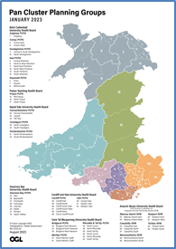
Pan Cluster Planning Groups (PCPGs) bring together senior leaders from the NHS, Local Authority and key partners in the Third Sector to provide integrated system leadership and enable collaboration between organisations. PCPGs are the mechanisms by which representatives of clusters come together at county population footprint.

PCPGs should be established as sub-groups of Health Boards and have a formal relationship to the Regional Partnership Board. This gives a direct route for information sharing and decision making between frontline services and strategic leadership.

PCPGs will agree the population health needs at county level and lead the development of integrated county level plans. These should inform the planning activity at health board and at cluster level and vice versa.
Further information available at Index 4 – Plan Cluster Planning Groups of the Accelerated Cluster Development Toolkit.

Health Boards

Health boards in Wales are responsible for managing and delivering health services in their areas. This includes hospital-based healthcare, primary care services, mental health, and community services.

Health boards have a statutory duty to develop a three year intermediate medium plan (IMTP). IMTPs describe the actions the health board plan to take over the forthcoming one to three year period to deliver against and meet the health needs of the local population. This is a rolling planning cycle and every year the health board develops an IMTP for the forthcoming three year cycle. Health board IMTPs should be available via each health board website.
The requirements and guidance to help health boards complete their IMTPs are set out in the NHS Wales Planning Framework. This guidance is published annually.

For further information about the NHS Wales Planning Frameworks click here.

Clusters

A cluster brings together all local services involved in health and care across a geographical area, typically serving a population between 25,000 and 100,000. Clusters are therefore important mechanisms in coordinating care to meet the needs of individuals and communities they serve. Clusters however have developed in different ways across Wales based on their understanding of local needs and circumstances.

Clusters are provided with core funding to support their development and the development of their services. To support this clusters have been developing plans since 2014/15. Cluster planning was initially introduced via the Quality and Outcomes Framework Guidance for the GMS Contract when clusters were essentially GP clusters. Additional funding is often accessed through range of transformational funds. Depending on the criteria of the fund this is used to deliver innovation or care on a cluster geographical footprint.

A range of tools issued at national level such as cluster planning guidance and the Cluster Planning Support Portal help clusters in their planning arrangements and to implement specific aspects of their service plans.

Acknowledgements

The development of the handbooks has been a collaborative process. We would like to thank everyone who has contributed, authored and provided advice to inform the development of the handbooks.

Disclaimer

We have taken all reasonable steps to identify the sources of information provided above. If you believe any information to be incorrect, would like to make comment or provide input to any revisions of the handbook, please contact primarycare.one@wales.nhs.uk.

