
CLUSTER WORKING IN
WALES

A-Z of Resources

A set of handbooks for Cluster Leads, Professional Collaborative Leads and other staff working in or with clusters

Updated September 2023



Contents

Introduction………………………………………………………………………………………………………………………………………… | 3
A More Equal Wales: The Socio-economic Duty Equality Act 2010…………………………………………………. | 4
Accelerated Cluster Development (ACD) Toolkit……………………………………………………………………………… | 4
Accelerated Cluster Development Glossary of Terms | 4
Achieving Quality and Safety Improvement | 4
A Healthier Wales | 4
Allied Health Professions Framework for Wales | 5
A Planned Primary Care Workforce for Wales | 5
Critical Appraisal of the Pacesetter Programme: Executive Summary | 5
Cluster development framework | 5
Cluster Planning Support Portal | 6
Duty of Candour | 6
Greener Primary Care Wales Framework and Award Scheme | 6
Good Governance Pocket Guide to NHS Wales Boards | 6
Gwella | 6
Inquiry into Primary Care Clusters | 6
Introductory Guide to Evaluation | 7
Managing Welsh Public Money | 7
Multi-Professional Roles within the Transforming Primary Care Model in Wales | 7
National Clinical Framework | 7
NHS Wales Decarbonisation Strategic Delivery Plan | 7
NHS Wales Directory of Hospitals | 8
NHS Wales Executive | 8
NHS Finance (Wales) Act (2014) | 8
NHS Wales Governance E-Manual | 8
NHS Wales Planning Frameworks | 8
Our Plan for a Primary Care Service in Wales | 9
Our programme for transforming & modernising planned care & reducing waiting lists in Wales | 9
Pacesetters | 9
Parliamentary Review of Health and Social Care Wales | 9
Primary and Community Care Compendium of Roles and Models | 9
Population health information by topic | 10
Primary Care One | 10
Primary Care Model for Wales | 10
Primary Care cluster workforce planning | 10
Primary care services in Wales | 10
Programme for Government | 11
Prescription Newydd / A New Prescription | 11
Prudent Healthcare | 11
Quality and Safety Framework | 11
Quality Improvement Guides | 11
Setting the Direction - Primary & Community Services Strategic Delivery Programme | 12
Report on Signposting / Triage / Telephone First Survey, July 2018 | 12
Social Prescribing in Wales | 12
Short film - the proposed model of social prescribing | 12
Social Services and Well-being (Wales) Act | 12
Standing Financial Instructions (SFIs) | 12
Strategic Programme for Primary Care | 13
Welsh Value in Health Centre, Value Based Healthcare | 13
Well-being of Future Generations (Wales) Act | 13
Welsh Information Governance Toolkit | 13

Introduction

This is the A-Z of resources handbook of a collection of three CLUSTER WORKING IN WALES Handbooks produced by the Primary and Community Care Development and Innovation Hub, Public Health Wales.

This handbook provides a summary of publications, toolkits, websites and resources which may be helpful to you in developing your cluster or professional collaborative.

The handbooks as a set of resources

The handbooks provide practical advice for use by anyone new to a cluster or professional collaborative leadership role or anyone who wants to include cluster working as part of their work. The ideas and advice provided will outline a foundation for your cluster work and will give you the basic tools and techniques for working in or with clusters.

These handbooks provide an initial ‘go to’ resource and complement any other resources that may be produced locally or nationally.

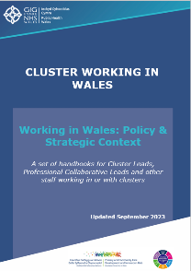
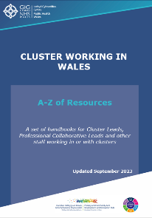
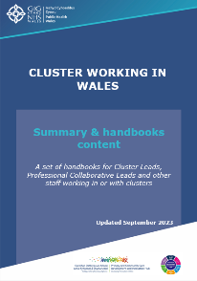
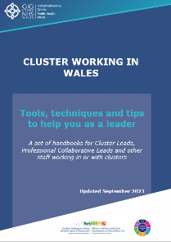

Although presented as separate handbooks, they are designed to be complementary and will be most effective if used collectively. The handbooks provide ideas, give advice and signpost to information and resources for creating the best conditions for cluster working and development.

All handbooks contain hyperlinks which signposts you to further information and resources. To download the handbooks go to Primary Care One.

A-Z of resources
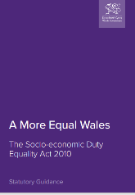
A More Equal Wales: The Socio-economic Duty Equality Act 2010 statutory guidance (March 2021) is aimed at helping public bodies named in the Act to improve decision making, ensuring more equal and better outcomes for those that are socio-economically disadvantaged.

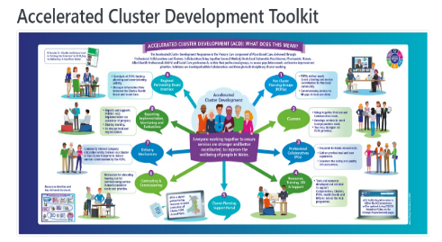
The Accelerated Cluster Development (ACD) Toolkit provides information and resources for stakeholders who will be supporting and driving forward Cluster Development. The toolkit enables stakeholders to learn about the ACD programme including Professional Collaboratives, Clusters and Pan Cluster Planning Groups.

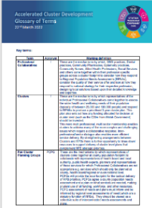
Developed to support the Accelerated Cluster Development programme, the Accelerated Cluster Development Glossary of Terms provides a list of 13 definitions to key terms used as part of the programme.

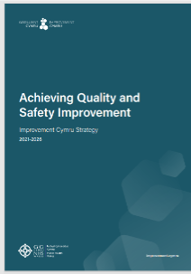
Achieving Quality and Safety Improvement outlines the new focus of Improvement Cymru. The five year strategy describes the move away from national improvement programmes of work to regional improvement.


A Healthier Wales published in response to the Parliamentary Review of Health and Social Care in Wales. It sets out the future vision of a whole system approach to health and social care through a model which is focussed on health, well-being, and preventing illness. The plan is based on the quadruple aim of improved population health and wellbeing; better quality and more accessible health and social care services; higher value health and social care; and a motivated and sustainable health and social care workforce.


The Allied Health Professions Framework for Wales sets out the strategic response to A Healthier Wales (2018) from the Allied Health Professions (AHPs). It describes the challenges that need to be addressed, the value that AHPs offer and the actions needed to help maximise their value and impact.

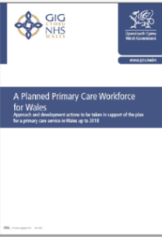
A Planned Primary Care Workforce for Wales (2015) describes the actions needed to develop the primary care workforce in Wales, in order to progress the plan for Primary Care. (Note: this expired in March 2018 and is superseded by the Strategic Programme for Primary Care 2018).

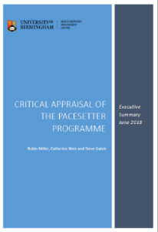
The Critical Appraisal of the Pacesetter Programme: Executive Summary (2018) describes the methods used and the questions asked to inform the independent appraisal. Key findings and six enablers were reported which give a clear direction to the success of future innovations including pacesetter programmes and individual projects and implications for future primary care transformation.

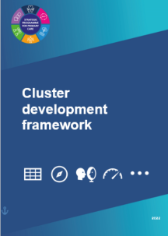
The Cluster development framework is a tool supporting monitoring and evaluation of Primary Care Model for Wales and Accelerated Cluster Development (ACD) implementation. Consisting of two modules covering the above, the framework sets out criteria for maturity assessment against predetermined outcomes.

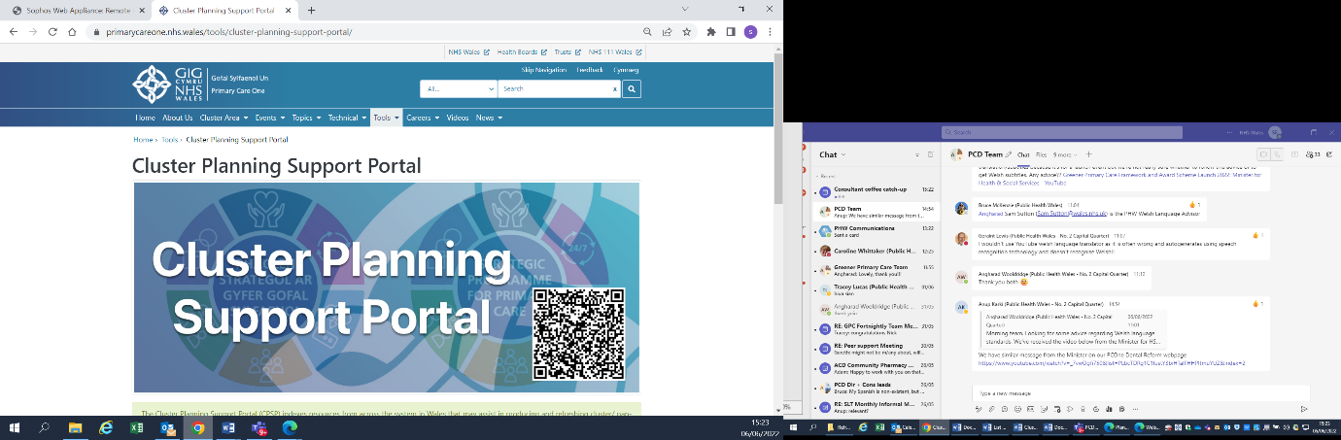
The Cluster Planning Support Portal indexes resources that may assist in producing and refreshing cluster/ pan-cluster planning group (PCPG) annual plans. Presented as an online tool, grouped by topic heading, the tool provides topic- specific content and direct signposting links.

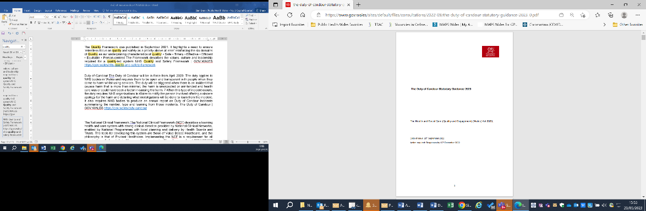
The Duty of Candour came into force April 2023. It applies to NHS bodies in Wales and requires them to be open and transparent with people when they come to harm whilst using services. It also requires NHS bodies to produce an annual report on Duty of Candour incidents.


Launched in June 2022 by Public Health Wales. The Greener Primary Care Wales Framework and Award Scheme supports the four independent primary care contractor services in Wales (community pharmacy, dental, general practice and optometry) to improve the environmental sustainability and reach the Welsh
Government decarbonisation targets.
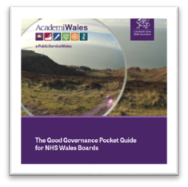
The Good Governance Pocket Guide to NHS Wales Boards is aimed at NHS Wales Boards, but also provides key principles of good governance that can aid good decision making in NHS Wales.

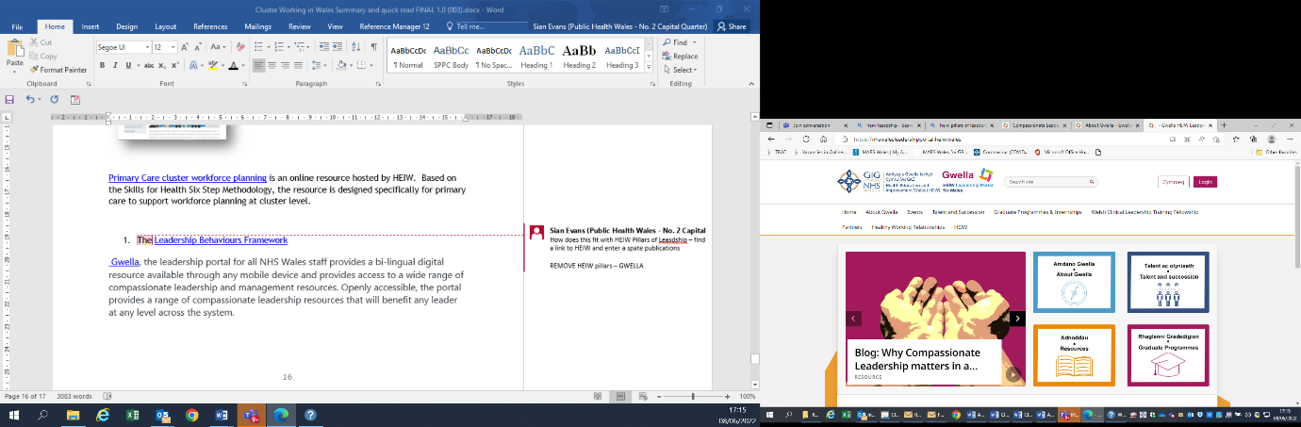
Gwella, the leadership portal for all NHS Wales staff provides a bi-lingual digital resource, available through any desktop or mobile device, and provides access to a wide range of compassionate leadership and management resources. Openly accessible, the portal provides a range of leadership resources that will benefit any leader at any level across the system.

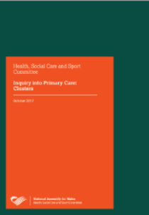
Inquiry into Primary Care Clusters (2017) investigated and reported on the model of cluster working in delivering improved services to patients. The inquiry heard evidence from a wide range of health care organisations, professional groups and individual clinical staff. The inquiry concluded that further work is required in order to realise the ambitions for systematic change that meets local need. A suite of 18 recommendations was made.


The Introductory Guide to Evaluation is a simple online tool to support understanding of what evaluation is and why it is important. It provides the basic principles of evaluation, gives direction as to the approaches and processes that can be used and signposts to further guidance and support.

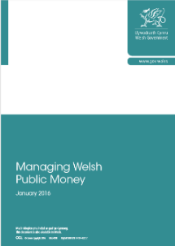
Managing Welsh Public Money sets out the main principles for managing resources for the whole of the Welsh public sector. This document aims to explain how to manage public funds with probity and in the public interest.

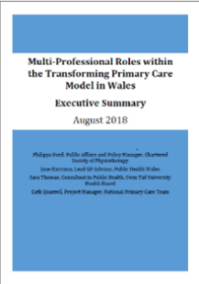
The Multi-Professional Roles within the Transforming Primary Care Model in Wales (2018) reports the responses to a survey designed to capture the potential of wider multidisciplinary team working. The report identifies opportunities and makes recommendations for supporting the transformation of primary and community care.

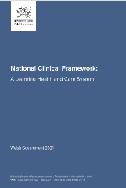
Published in 2021, the National Clinical Framework sets out a vision for the strategic and local development of NHS clinical services in Wales. Presented through a life course approach to service delivery and aligned to the burden of disease facing the population, it aims to help with the way clinical services are planned and delivered. The intention is to make things easier for the workforce, make services more resilient in meeting the needs of their population and more responsive to priorities set.

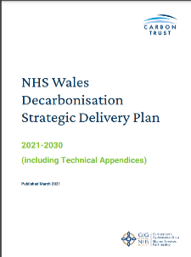
Published in March 2021, the NHS Wales Decarbonisation Strategic Delivery Plan in response to the Welsh Government declaring a Climate Emergency in 2019. It sets out 46 ambitious initiatives and targets for the decarbonisation of NHS Wales to be addressed up to 2030.

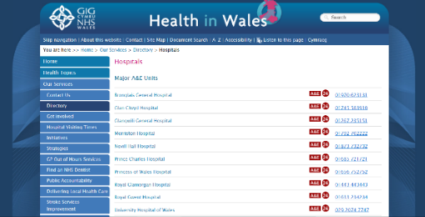
NHS Wales Directory of Hospitals provides a list of all hospitals in Wales together with a list of major A & E units, minor A & E units, and minor injuries units.

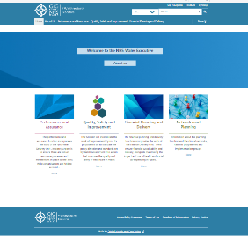
Operational from 1 April 2023, the NHS Wales Executive provides a national support function. It’s key purpose being to ‘drive improvements in the quality and safety of care - resulting in better and more equitable outcomes, access and patient experience, reduced variation, and improvements in population health.’

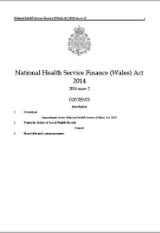
The NHS Finance (Wales) Act (2014) is legislation which aims to target NHS funding at those services and interventions providing best value for money and to improve the health outcomes of the Welsh population in short, medium and long-term. It makes provision in relation to the financial duties of health boards in Wales to ensure expenditure does not exceed funding over a period of three years.

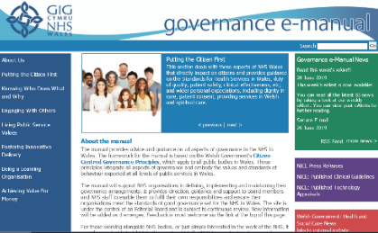
The NHS Wales Governance E-Manual provides advice and guidance on all aspects of governance in the NHS in Wales.

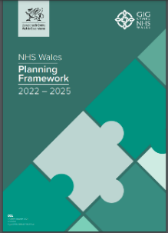
The NHS Wales Planning Frameworks sets out the principles that underpin Integrated Medium Term Plans (IMTPs), as well as providing the necessary guidance to empower NHS organisations to produce approvable plans.

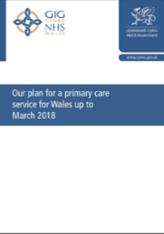
Our Plan for a Primary Care Service in Wales (2014-2018) set out a social model of health, promoting physical, mental and social well-being. It aimed to draw in all relevant organisations, services and people to ensure the root causes of poor health were addressed. Five priority areas were identified to help organisations plan their approach to primary care: planning care locally, improving access and quality, equitable access, a skilled local workforce and strong leadership.
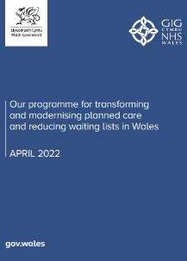
Published in April 2022, Our programme for transforming and modernising planned care and reducing waiting lists in Wales sets out the intentions to recover, reset and transform planned care services following the disruption caused during the COVID-19 pandemic. It focuses mainly on the planned care which is linked to waiting lists, but recognises other areas that require attention such as dentistry and primary care.

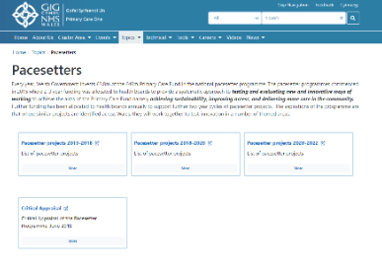
Hosted on Primary Care One, the Pacesetters pages provide details of the various schemes invested from the annual £3.8m national Pacesetter Programme. Schemes are listed by health board covering the period 2015- 2022. For 2022-2024 the fund has been repurposed as the SPPC Fund.

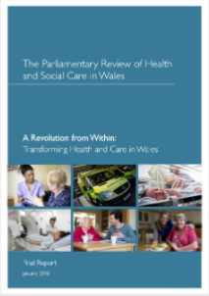
The Parliamentary Review of Health and Social Care Wales describes the health and care system in Wales, as it was in 2018. It describes the challenges facing NHS Wales and the vision for care aspired to be delivered by the care system in Wales. It offered a series of recommendations to Welsh Government for consideration in achieving the vision.

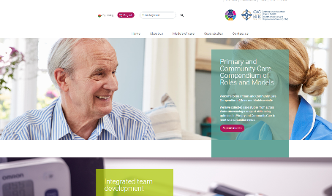
The Primary and Community Care Compendium of Roles and Models provides a collection of case studies from across Wales showcasing a range of skills being optimised in Primary and Community Care to meet local population needs.

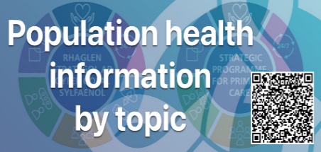
Information to help inform cluster/ pan-cluster planning group plans. The Population health information by topic online tool offers a public health perspective on health priorities for cluster populations and takes a topic / condition-based approach to considering population needs.

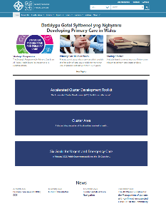
Launched in November 2017, Primary Care One provides an all-Wales online resource for those working in or with an interest in primary care clusters. Intended to promote primary care cluster collaborative working in Wales and support cluster development at a national level, the website provides sources of information specific to clusters and cluster leads across Wales, as well as the wider primary and community care audience.

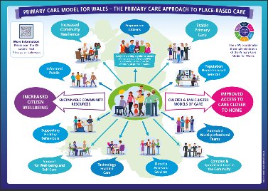
The Primary Care Model for Wales, first emerging in 2018, was formerly known as Components the Transformational Model for Primary and Community Care in Wales and the Model for Primary Care in Wales. Consisting of 13 components, health boards are working to deliver the Model through their IMTPs and in collaboration with their Regional Partnership Boards.

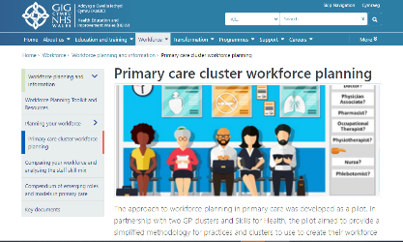
Primary Care cluster workforce planning is an online resource hosted by HEIW. Based on the Skills for Health Six Step Methodology, the resource is designed specifically for primary care to support workforce planning at cluster level.

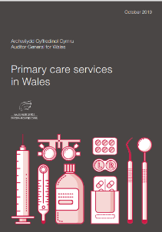
A report prepared by the Auditor General for Wales in 2019, Primary care services in Wales describes the range of steps the NHS and Welsh Government are taking to strengthen primary care and emphasising the need for change needs to happen at greater pace and scale to tackle longstanding challenges and ensure sustainability of vital primary care services.

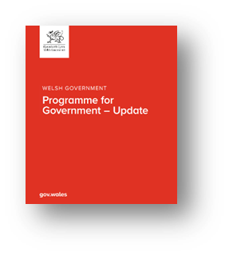
The Programme for Government sets out the five year plan of how the new Welsh Government will deliver on the promises made to voters during the Senedd 2021 election. It makes a series of commitments on how big challenges will be tackled in Wales including healthcare, services for vulnerable people, economy, decarbonisation, climate change, education, inequalities, cities, town and village development and the Welsh language.

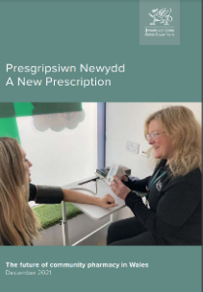
Prescription Newydd / A New Prescription describes the community pharmacy contractual framework that came into play 1 April 2022 as a result of contract reform. It describes the role of community pharmacy in Wales under four broad themes of expanding the clinical role, increasing skills, a commitment to quality, collaboration and integration and valuing the contribution of community pharmacies.

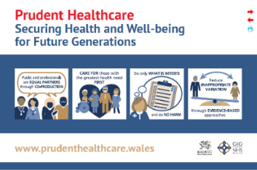
Prudent Healthcare promotes four Prudent Principles: achieving health and wellbeing through co-production; care for those with the greatest health need first; do only what is needed and do no harm; reduce inappropriate variation using evidence-based practice.

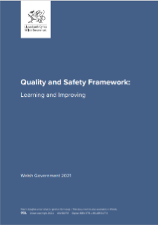
Published in 2021, the Quality and Safety Framework sets out a robust quality assurance framework that brings all the information surrounding quality together so it is utilised to implement effective change and improvement in care. The Framework contains a series of actions for organisations at every level to ensure that care meets the domains of Quality, Safety, Timeliness, Effectiveness, Efficiency, Equity and Person-centred.


Quality Improvement Guides published by 1000Lives (now Improvement Cymru) brings together learning from around Wales, and further afield, to explain how a simple set of techniques can be applied to improve the quality of service.


Setting the Direction - Welsh Government’s Primary & Community Services Strategic Delivery Programme published in 2010, set out a framework aimed at assisting health boards in the development and delivery of improved primary care and community-based services for their local populations; particularly for those individuals who are frail, vulnerable and who have complex care needs.

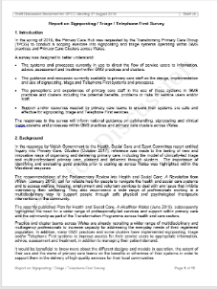
The Report on Signposting / Triage / Telephone First Survey, July 2018 presents the findings of a survey designed to better understand the systems and processes in use to direct the flow of service users to information, advice, assessment and treatment within GMS practices and clusters in Wales.

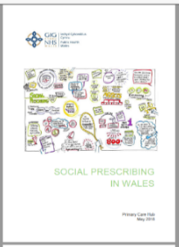
Social Prescribing in Wales (2018) presents the progress made on social prescribing in Wales over the previous two years and highlights arrangements put in place to build on this work going forward.

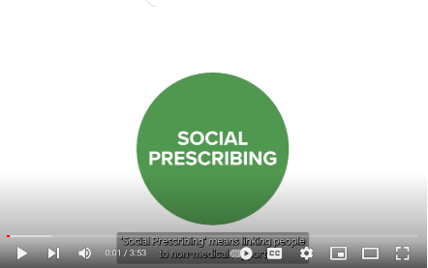
A short film on the proposed model of social prescribing for Wales was launched by the Deputy Minister for Mental Health and Wellbeing in July 2022. It describes a framework for access to non-clinical, community-based support, which can include a range of activities, each playing a role in an early preventative approach by enhancing people’s wellbeing.
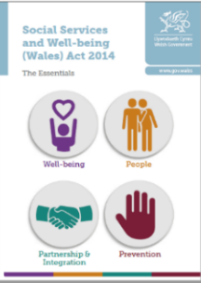
The Social Services and Well-being (Wales) Act came into force in April 2016. Made up of 11 sections, it provides a legal framework for social services law. The Act sets out duties on local authorities, health boards and Welsh Ministers, requiring them to promote the well-being of those who need care and support, or carers who need support within their work.

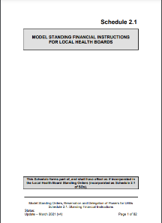
Health boards in Wales must agree Standing Financial Instructions (SFIs) for the regulation of their financial proceedings and business. Designed to achieve probity, accuracy, economy, efficiency, effectiveness and sustainability in the conduct of business, they translate statutory and Welsh Government financial requirements for the NHS in Wales into day-to-day operating practice.

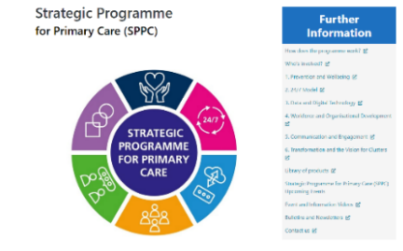
The Strategic Programme for Primary Care 2018 sets out the programme of work for primary care through six key work streams in response to A Healthier Wales. The programme describes the continuation of previous work, recognising the need for increased pace and scale and details the new work needed to fully implement the Primary Care Model for Wales.

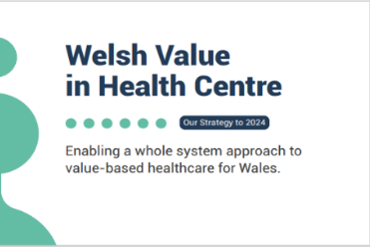
Led by the Welsh Value in Health Centre, Value Based Healthcare is key to achieving value for our patients and citizens across a whole system of health and social care. Underpinned by the Prudent Healthcare principles, the strategy aims to enable a whole system approach to value-based healthcare for Wales.

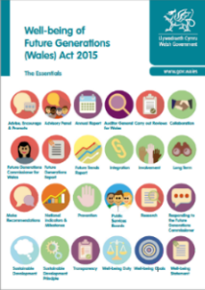
The Well-being of Future Generations (Wales) Act 2015 is legislation that aims to improve the social, economic, environmental and cultural well-being of Wales. The Act also provides a key link to other legislation in Wales, including the Public Health (Wales) Act, Equality Act, Planning (Wales) Act, Active Travel (Wales) Act, Social Services and Well-being (Wales) Act and Housing (Wales) Act.

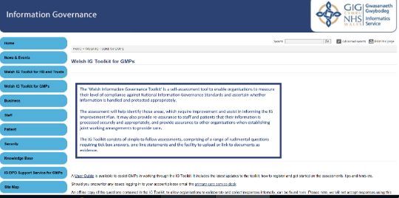
The Welsh Information Governance Toolkit is a self-assessment tool to enable organisations to measure their level of compliance against National Information Governance Standards. It also provides key information about how to handle and protect information.

Acknowledgements

The development of the handbooks has been a collaborative process. We would like to thank everyone who has contributed, authored and provided advice to inform the development of the handbooks.

Disclaimer

We have taken all reasonable steps to identify the sources of information provided above. If you believe any information to be incorrect, would like to make comment or provide input to any revisions of the handbook, please contact primarycare.one@wales.nhs.uk.

